Aim:
To explore and understand the functionalities of the WEKA Data Mining/Machine Learning toolkit by installing and navigating its various interfaces (Explorer, Knowledge Flow, Experimenter, and Command-line). The objective is to analyze datasets (such as Weather and Iris) in ARFF format by examining their attributes, records, and class distribution, and by applying data visualization techniques (histograms, multi- dimensional plots) to gain insights into data preprocessing, classification, clustering, and association rule mining using WEKA.

Features of WEKA Toolkit
- Explorer Interface
  - The Explorer is the primary graphical user interface of WEKA.
  - It allows users to load datasets, preprocess data, select algorithms, build models, and evaluate results interactively.
  - Provides tabs such as Preprocess, Classify, Cluster, Associate, Select attributes, and Visualize to streamline the machine learning workflow.
- Knowledge Flow Interface
  - The Knowledge Flow interface uses a drag-and-drop approach to design machine learning workflows.
  - It visually represents the data processing pipeline, allowing users to connect components such as data sources, filters, classifiers, and visualizers.
  - It is useful for automating repetitive tasks and experimenting with different data processing sequences.
- Experimenter

  - The Experimenter is designed for running and managing large-scale experiments.
  - Supports systematic testing of multiple algorithms on multiple datasets.
  - Provides tools for statistical analysis to compare algorithm performance rigorously.
  - Useful for benchmarking and detailed experimentation.
- Command-Line Interface (CLI)
  - WEKA also offers a command-line interface for users who prefer scripting and automation.
  - Enables batch processing of datasets and integration into other systems.
  - Supports running classifiers, filters, and other WEKA functionalities via command line arguments.
Navigating WEKA Explorer Panels Preprocess Panel
  - This panel allows users to load datasets and perform data cleaning or filtering.
  - Users can apply filters to remove unwanted attributes, discretize numeric data, or select specific instances.
  - It displays basic statistics about the dataset such as the number of instances, attributes, and data types.
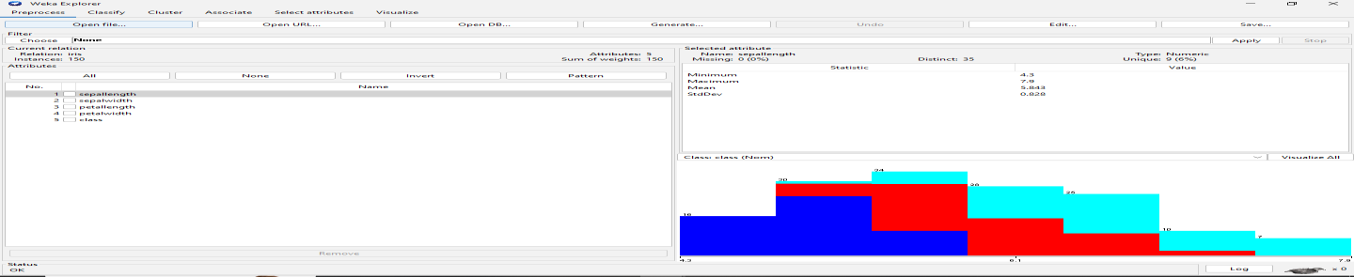
Select Attributes Panel
  - Helps in attribute selection to improve model performance by identifying the most relevant features.
  - Various attribute evaluators and search methods are available to choose the best subset of attributes.
  - This reduces dimensionality and improves efficiency.
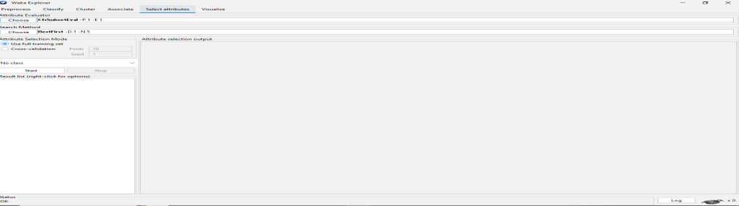

Classify Panel
  - This panel is used to build classification and regression models.
  - Users can select different algorithms, configure their parameters, and run cross-validation or training/testing.
  - Results include accuracy, confusion matrix, and detailed performance metrics.
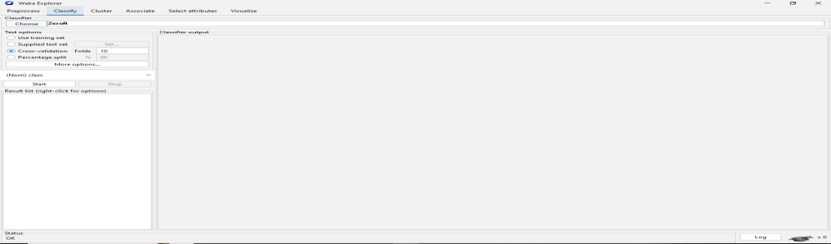
Cluster Panel
  - Allows users to perform clustering tasks on datasets.
  - Offers algorithms like k-means and EM clustering.
  - Users can evaluate the clustering results and visualize clusters.
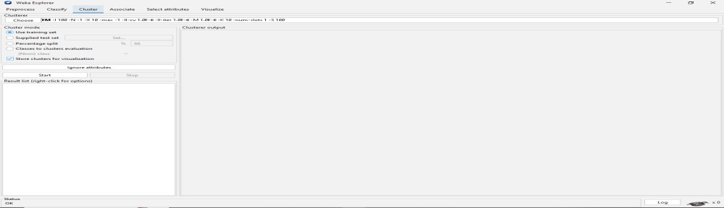
Associate Panel
  - Used for association rule mining.
  - Helps discover interesting relationships between attributes in the dataset.
  - Users can set parameters to control rule generation such as support and confidence thresholds.
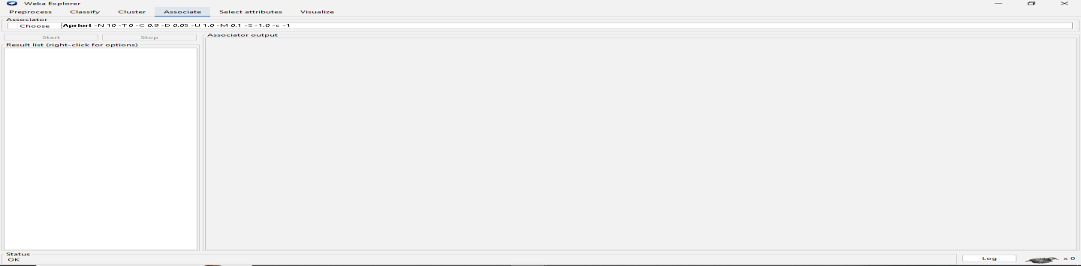
Visualize Panel

    - Provides visualization tools for both raw data and model results.
    - Users can plot scatter plots, histograms, and other charts to better understand data distribution and model behavior.
    - Helpful in identifying patterns and outliers.
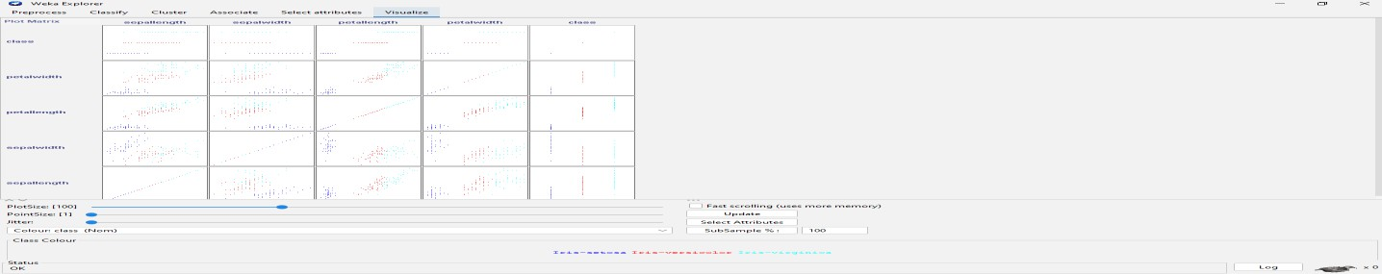

ARFF File Format
    - ARFF (Attribute-Relation File Format) is WEKA’s native data file format.
    - It is a plain text format consisting of two sections:
      - Header: Defines the dataset’s name (@relation) and lists attributes with their
data types (@attribute).
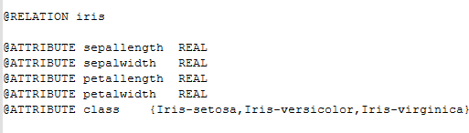
      - Data: Contains the actual data instances starting after the @data tag.

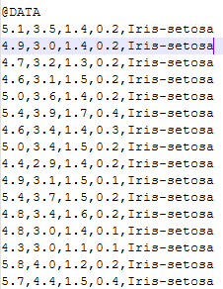
Exploring and Loading Datasets in WEKA
    - WEKA comes bundled with several sample datasets such as Iris, Weather, Diabetes, etc.
    - To explore datasets:
      - Open WEKA Explorer.
      - Click Open file in the Preprocess panel.
      - Navigate to the data folder within the WEKA installation directory.
      - Select a dataset like iris.arff or weather.arff.
    - Loading a dataset allows you to view the attributes and instances and apply preprocessing, classification, clustering, and more.

Example: Loading the Iris Dataset
    - Open WEKA Explorer.
    - In the Preprocess panel, click Open file.
    - Select the iris.arff file.
    - The dataset loads and displays attributes such as sepal length, sepal width, petal length, petal width, and class.
    - You can now proceed to classify, cluster, or visualize this dataset.
Loading and Exploring Datasets in WEKA Datasets Used
    - Iris dataset
Steps and Observations

- List Attribute Names and Their Types
- Open the dataset in WEKA Explorer under the Preprocess panel.
- The attribute list and types are displayed on the left side.
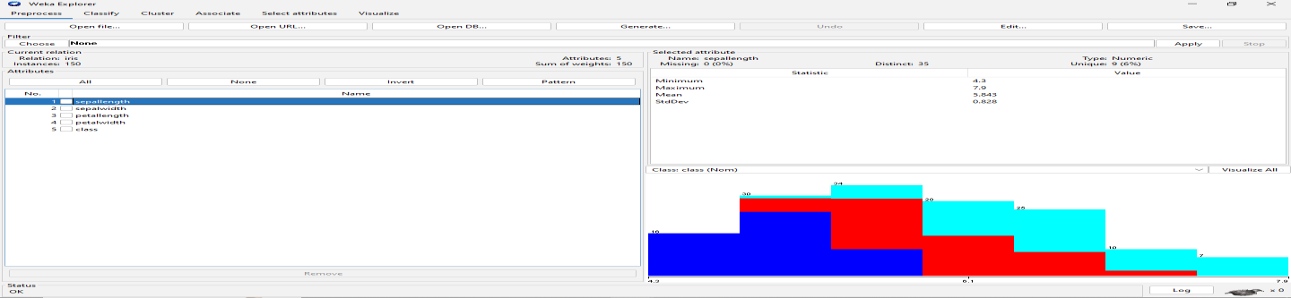
- Number of Records in Each Dataset
  - The number of instances (records) is shown at the top of the Preprocess panel after loading the dataset.
- Identify the Class Attribute
  - The class attribute is usually the target variable for classification.
  - In WEKA, the class attribute is selected by default or can be chosen manually.
- Plot Histogram
  - In the Preprocess panel, select an attribute.
  - Click on the Visualize button to view a histogram showing the distribution of values for that attribute.
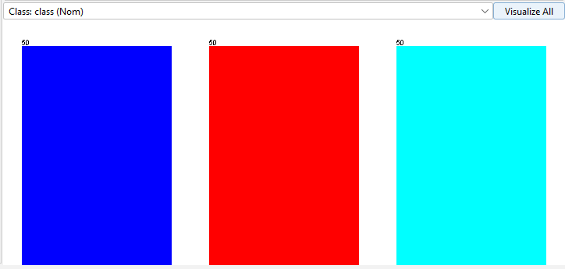
- Determine Number of Records for Each Class
  - Select the class attribute in the Preprocess panel.
  - The distribution of instances across classes is shown in the right pane, displaying counts for each class.

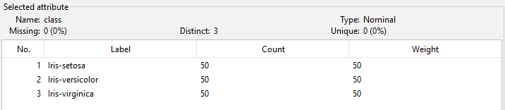
- Visualize Data in Various Dimensions
- Go to the Visualize panel in WEKA Explorer.
- This panel plots scatter plots between different pairs of attributes.
- Use this to observe relationships, clusters, and class separability in 2D.

