SOFTWARE REQUIREMENTS

SPECIFICATION

**ON**

**“RETINA BASED BIOMETRIC RECOGNITION SYSTEM”**

**Submitted To:**

**Submitted by:**

|  |
| --- |
| **PUNEETH GJ** |
| **Assistant Professor,**  **Computer Science and Engg. Dept.,**  **R.Y.M.E.C,**  **Ballari – 583104** |

|  |
| --- |
|  |
|  |

|  |  |  |
| --- | --- | --- |
| **Batch.No : A9** | | |
| **Sl.No** | **USN** | **NAME** |
| **1** | **3VC15CS053** | **Meghana K** |
| **2** | **3VC15CS050** | **Manjula G P** |
| **3** | **3VC15CS027** | **G.Ramya** |
| **4** | **3VC14CS112** | **Veluru Eswari** |

SOFTWARE REQUIREMENTS SPECIFICATION

|  |  |  |  |
| --- | --- | --- | --- |
| CONTENTS | | | |
| 1 | Introduction | | 3 |
|  | 1.1 | Problem Statement | 3 |
|  | 1.2 | Solution | 3 |
| 2 | Specific Requirements | | 3 |
|  | 2.1 | Functional Requirements | 3 |
|  | 2.2 | Non-Functional Requirements | 4 |
| 3 | Block Diagram/System Architecture | | 4 |
| 4 | Data Flow Diagrams | | 5 |
| 5 | Object-Oriented Analysis and Modeling(OOAM) | | 6 |
|  | 5.1 | Use Case Diagram | 6 |
|  | 5.2 | System Sequence Diagram | 7 |
| 6 | Conclusion | | 8 |
| 7 | References | | 8 |

1. **Introduction**:

In today’s world, among various biometric modalities, iris, arguably, is one of the most reliable, universal, measurable, accurate and inimitable. Over the years, it has been established that every iris is unique, particularly in the detailed structure of the front or anterior layer. Not only are the irises of identical twins different, but the iris of the two eyes of the same person are also different. Although specific details of the appearance of an iris vary depending on the level and direction of illumination, it has been claimed that the basic and significant features of iris remain stable and do not change over a long time. Generally, covariates in iris recognition are image quality (i.e. noise, blur), illumination (specular reflection), off angle, occlusion, and resolution. In recent years, several approaches have been developed to advance the state of- art in iris recognition and address these covariates. However, there can be potentially many other covariates in iris recognition which have not yet been identified

A biometric system is a pattern recognition system that checks the authenticity of a person using biometric measures. There are two types of authentication: - verification (checking the validity of a given identity) and identification (checking if a given pattern is associated with any of the enrolled identities stored in the database).

The retina is an internal protected organ of the body. The human retina consists of blood vessels that form a unique pattern and the pattern does not change through the individual’s life. So it is impossible to forge that pattern. Retina based security system works by tracking an image of an individual's retinal blood vessel network and comparing it to a previously authenticated scan of the same individual. The uniqueness and stability of retina guarantees a strong biometric authentication. Also, it is less vulnerable to identity theft.

The primary application for retinal pattern recognition till date has been for physical access entry for high-security facilities such as military installations, nuclear facilities, sophisticated laboratories, etc. It is also used in access control systems at high-security facilities. There are many advantages of retina biometry:- it has a low occurrence of false positives, also offer extremely low (almost 0%) error rates, since no two people have a same retinal pattern it is highly reliable and it can provide speedy results that are identity of a person can be verified very quickly.

**1.1 Problem Statement:**

Biometric Security has become more important because of the increasing activities of terrorism and hackers. Retina recognition technology is continuously growing over years, this technology can resolve Biometric security has become more important because of the increasing activities of terrorism the identification of a person’s identity, the main purpose of this project is to develop a retina based biometric recognition system for authenticating individual’s.

**1.2 Solution:**

The general solution to a system of linear equations Ax = b describes all Possible solutions. You can find the general solution by:

1. Solving the corresponding homogeneous system Ax = 0. Do this using the null command, by typing null (A). This returns a basis for the solution

2. Space to Ax = 0. Any solution is a linear combination of basis vectors.

3. Finding a particular solution to the non-homogeneous system Ax = b

1. **Specific Requirements:**

**2.1 Functional requirements:**

System to satisfy the business needs and be acceptable to the users. Based on this, the functional requirements that the system must require are as follows:

1. System Functional requirements are the functions or features that must be included in any must detect the individual on the basis of Iris.

2. System should process the input given by the user only if it is an image file.

**2.2. Non-Functional requirements:**

Non-functional Requirements is a description of features, characteristics and attribute of the system as well as any constraints that may limit the boundaries of the proposed system. The non-functional requirements are essentially based on the performance, information, economy, control and security efficiency and services. Based on these, non-functional requirements are as follows:

1. User friendly

2. System should provide better accuracy

3. To perform with efficient throughput and response time.

|  |  |  |
| --- | --- | --- |
| **3.** | **Block Diagram/System Architecture:** |  |

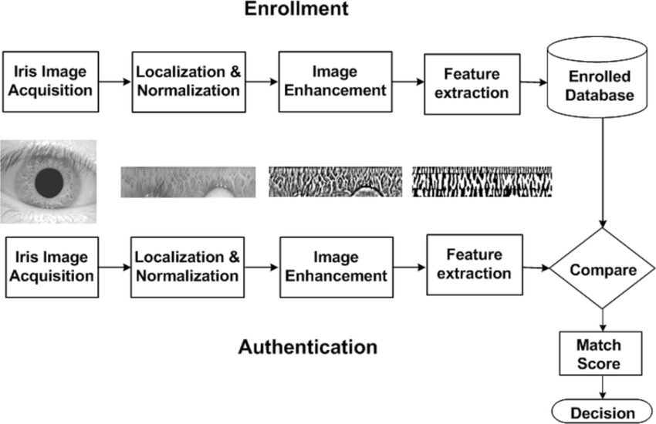

Fig: 1 System architecture

**4. Data Flow Diagram:**

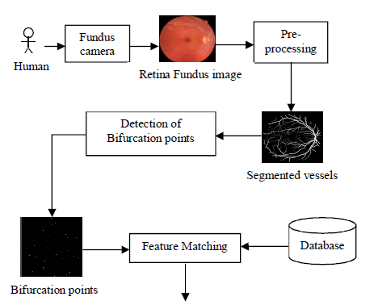

Fig: 2 Data flow diagram

|  |  |  |
| --- | --- | --- |
|  |  | |
|  |  |  |

1. **Object-Oriented Analysis and Modeling(OOAM):**

**5.1. Use Case Diagram:**

 

user system

Fig: 3 Use case diagram

5.2.System Sequence Diagram:

Feature matching

Result

Bifurcation

Preprocessing

Retina Image

Preprocessing stage Finding the

bifurcation Feature matching

Result

Fig: 4 System sequence diagram

1. **Conclusion:**

The proposed Retina based personal identification system using skeletonization and simlarity transformation, is a simple and efficient system for identifying authenticity of people. The use of hessian based vessel segmentation method helps to extract the complete retinal vessel tree from fundus image. Thus we can extract almost all features. Skeletonization helps to construct the skeletal structure of retinal vessels. From the result of skeletonization, the pixel classification method detects all bifurcation points in the image.

These detected bifurcation points are used as features in matching stage. In the matching stage, the acquired pattern is matched with the reference one stored in database of the system. Here, the degree of similarity is measured using similarity metric. Thus the proposed system is able to produce an accurate result. Also it offers extremely low error rate. The system requires less computation time. It is a simple and efficient method for checking authentication of user.

**7. References:**

[1] Robust Vessel Segmentation in Fundus Images, A. Budai, R. Bock, A. Maier, J. Honegger, and G.Michelson. Hindawi Publishing Corporation International Journal of Biomedical Imaging Volume 2013, Article ID 154860, 11 pages <http://dx.doi.org/10.1155/2013/154860>

[2] A Combined Method to Detect Retinal Fundus Features V. Bevilacqua S. Cambo L. Cariello G. Mastronardi, Politecnico Di Bari (Italy)

[3] Retinal Verification Using a Feature Points-Based Biometric Pattern, M. Ortega, M. G. Penedo, J. Rouco, N. Barreira, and M. J. Carreira, Hindawi Publishing Corporation EURASIP Journal on Advances in Signal Processing Volume 2009, Article ID 235746, 13 pages DOI:10.1155/2009/235746.

[4] Alejandro F. Frangi, Wiro J.Niessen, et al. “Multiscale vessel enhancement filtering,” Medical Image Computing and computer-Assisted Intervention-MICCAI’98. 1998,1496:130:137.

[5] Digital image processing, third edition, Rafael C Gonzales and Richard E Woods.

[6] Retinal Fund us Biometric Analysis for Personal Identifications, Vitoantonio Bevilacqua, Lucia Cariello, Donatello Columbo, Domenico Daleno, Massimiliano Dellisanti Fabiano, Marco Giannini, Giuseppe Mastronardi, and Marcello Castellano, D.-S. Huang et al. (Eds.): ICIC 2008, LNAI 5227, pp. 1229–1237, 2008.

[7] Retinal Fundus Features Hybrid Detection based on a Genetic Algorithm, Vitoantonio Bevilacqua, Lucia Cariello, Simona Cambo, Domenico Daleno, Giuseppe Mastronardi, DEE Polytechnic of Bari, Via Orabona 4, 70125 Bari, Italy00

[8] J. Daugman, “How iris recognition works,” *IEEE Trans. Circuits Syst.Video Technol.*, vol. 14, no. 1, pp. 21–30, Jan. 2004.

[9] J. Daugman, “Probing the uniqueness and randomness of IrisCodes:Results from 200 billion iris pair comparisons,” *Proc. IEEE*, vol. 94,no. 11, pp. 1927–1935, Nov. 2006.

[10] *Unique Identification Authority of India*. [Online]. Available:http://uidai.gov.in, accessed Nov. 1, 2015.

[11] K. R. Nobel, “The state of the art in algorithms, fast identificationsolutions and forensic applications,” MorphoTrust USA,Billerica, MA, USA, Tech. Rep., Jan. 2013. [Online]. Available:http://www.planetbiometrics.com/article-details/i/1446/.

[12] P. E. Peterson *et al.*, “Latent prints: A perspective on the state of thescience,” *Forensic Sci. Commun.*, vol. 11, no. 4, pp. 1–9, 2009.

[13] C. Champod, “Edmond Locard—Numerical standards and ‘probable’ identifications,” *J. Forensic Identificat.*, vol. 45, no. 2, pp. 136–163,1995.

[14] K. McGinn, S. Tarin, and K. W. Bowyer, “Identity verification usingiris images: Performance of human examiners,” in *Proc. IEEE 6thInt. Conf. Biometrics, Theory, Appl., Syst. (BTAS)*, Sep./Oct. 2013,pp. 1–6.

[15] H. Proenca, “Iris recognition: On the segmentation of degraded imagesacquired in the visible wavelength,” *IEEE Trans. Pattern Anal. Mach.Intell.*, vol. 32, no. 8, pp. 1502–1516, Aug. 2010.

[16] H. Proenca, S. Filipe, R. Santos, J. Oliveira, and L. A. Alexandre, “TheUBIRIS.v2: A database of visible wavelength iris images captured onthe-move and at-a-distance,” *IEEE Trans. Pattern Anal. Mach. Intell.*,vol. 32, no. 8, pp. 1529–1535, Aug. 2010.

[17] Z. Sun, L. Wang, and T. Tan, “Ordinal feature selection for iris andpalmprint recognition,” *IEEE Trans. Image Process.*, vol. 23, no. 9,pp. 3922–3934, Sep. 2014.

[18] M. S. Sunder and A. Ross, “Iris image retrieval based onmacro-features,” in *Proc. 20th Int. Conf. Pattern Recognit.*, 2010,pp. 1318–1321.

[19] J. De Mira and J. Mayer, “Image feature extraction for applicationof biometric identification of iris—A morphological approach,”in *Proc. Brazilian Symp. Comput.Graph. Image Process.*, 2003,pp. 391–398.

[20] F. Shen, “A visually interpretable iris recognition system with crypt features,”Ph.D. dissertation, Dept. Comput. Sci. Eng., Univ. Notre Dame,Notre Dame, IN, USA, 2014.

[21] F. Shen and P. J. Flynn, “Using crypts as iris minutiae,” *Proc. SPIE*,vol. 8712, p. 87120B, May 2013.

[22] F. Shen and P. J. Flynn, “Iris matching by crypts and anti-crypts,” in*Proc. IEEE Conf. Technol. Homeland Secur.*, Nov. 2012, pp. 208–213.

[23] F. Shen and P. J. Flynn, “Are iris crypts useful in identity recognition?”in *Proc. IEEE 6th Int. Conf. Biometrics, Theory, Appl., Syst.*,Sep./Oct. 2013, pp. 1–6.

[24] F. Shen and P. J. Flynn, “Iris crypts: Multi-scale detection and shapebasedmatching,” in *Proc. IEEE Winter Conf. Appl. Comput. Vis.*,Mar. 2014, pp. 977–983.=

[25] J. Chen, C. W. Harvey, M. S. Alber, and D. Z. Chen, “A matchingmodel based on earth mover’s distance for tracking Myxococcusxanthus,”in *Proc. Med. Image Comput. Comput.-Assist. Intervent.*, 2014,pp. 113–120.

[26] J. Chen, F. Shen, D. Z. Chen, and P. J. Flynn, “Iris recognition based onhuman-interpretable features,” in *Proc. IEEE Int. Conf. Identity, Secur.Behavior Anal. (ISBA)*, Mar. 2015, pp. 1–6.

[27] P. J. Phillips, K. W. Bowyer, P. J. Flynn, X. Liu, and W. T. Scruggs, “Theiris challenge evaluation 2005,” in *Proc. 2nd IEEE Int. Conf. Biometrics,Theory, Appl., Syst.*, Sep./Oct. 2008, pp. 1–8.

[28] *CASIA Iris Image Database*. [Online]. Available: http://biometrics.idealtest.org/, accessed Nov. 14, 2015.

[29] Y. Rubner, C. Tomasi, and L. J. Guibas, “A metric for distributions withapplications to image databases,” in *Proc. IEEE 6th Int. Conf. Comput.Vis.*, Jan. 1998, pp. 59–66.

|  |  |
| --- | --- |
|  | |
|  |  |
|  |  |
|  | |
|  |  |
|  |  |
|  |  |
|  |  |