| **HTTP/1.1** | **HTTP/2** |
| --- | --- |
| Transfer all the requests & responses in the plain text message form.  It works on the textual format. | It works on the binary protocol.  works on the binary framing layer instead of textual that converts all the messages in binary format |
| There is head of line blocking in which TCP connection is blocked all other requests until the response does not receive | It allows multiplexing so one TCP connection is required for multiple requests. |
| It uses requests resource Inlining for use getting multiple pages | It uses PUSH frame by server that collects all multiple pages  The server sends all the other files like CSS & JS without the request of the client using the PUSH frame. |
| It compresses data by itself.  All the information related to the header  file is repeated in every request. | It uses HPACK for data compression. which is used to split data from header and the header. |

The Window Object

The window object is supported by all browsers. It represents the browser's window.

All global JavaScript objects, functions, and variables automatically become members of the window object.

Global variables are properties of the window object.

Global functions are methods of the window object.

Even the document object (of the HTML DOM) is a property of the window object:

Two properties can be used to determine the size of the browser window.

Both properties return the sizes in pixels:

* window.innerHeight - the inner height of the browser window (in pixels)
* window.innerWidth - the inner width of the browser window (in pixels)

The browser window (the browser viewport) is NOT including toolbars and scrollbars.

## Window Methods

* window.open() - open a new window
* window.close() - close the current window
* window.moveTo() - move the current window
* window.resizeTo() - resize the current window

## The HTML DOM (Document Object Model)

When a web page is loaded, the browser creates a Document Object Model of the page. The document object represents the whole html document as a tree of Objects(HTML, HEAD, BODY, and other HTML tags). It is the root element that represents the html document.

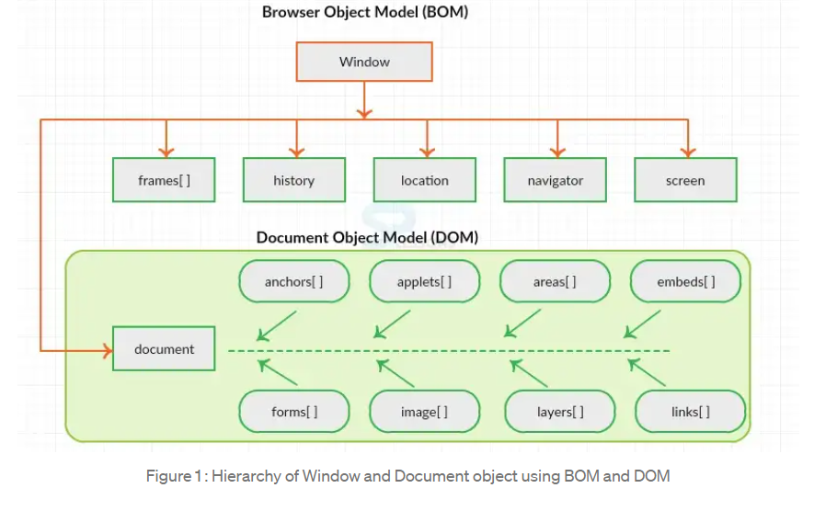

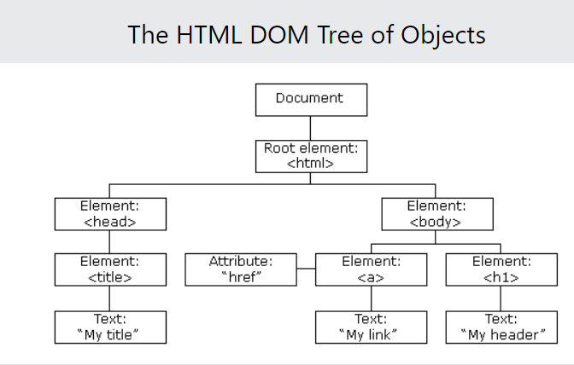

HTML DOM methods are **actions** you can perform (on HTML Elements).

HTML DOM properties are **values** (of HTML Elements) that you can set or change.

The DOM Programming Interface

The HTML DOM can be accessed with JavaScript (and with other programming languages).

In the DOM, all HTML elements are defined as **objects**.

The programming interface is the properties and methods of each object.

A **property** is a value that you can get or set (like changing the content of an HTML element).

A **method** is an action you can do (like add or deleting an HTML element).