**Data Analysis - IP – 3022**

**Problem Statement:**

Absence of Insights for the Relationship between student's Economic Background, academic performance, Competence and Expected Salary.

**Question and Answers:**

**1) how many unique students are included in the dataset:**

We can either check by *data[data['First Name'].duplicated()]* or *data[data['First Name'].unique()]*

And the answer is 2324

**2) what is the average CGPA of the students:**

We can check that by *data['CGPA'].mean()* and the answer is 8.038475684511647

**3)** **Distribution of students across each year:**

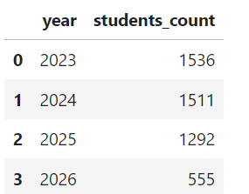

This is the Distribution of students across each year seems like the year 2023 has a lot of students

It can be also represented in a bar chart

**4)** **what is the distribution of student’s python experience:**

This is the Distribution of Python experience across students seems like there are 1242 students with python experience of 5 months

Which can be also represented by

**5)** **what is the average Family income of the students:**

Since the Family income attribute is in categorical ,we have to take the maximum assumptions and compute the mean across

This gives us the average was around 2.3134450347364117 and it might fall under the category of 2-5l

**6)** **How does the gpa vary among different colleges:**

And the list goes

**7)** **The average CGPA of the students from each city:**

**8)** **Can we identify any relationship between family income and cgpa:**

There is not much of a Relationship between Family Income and CGPA but students comes from the background of 7+lkh as family income has an average CGPA of 8.149438