**TASK 1.1 Research and list atleast five benefits of cloud computing over traditional on-premises infrastructure**

**Cloud computing offers several advantages for bank management system including:**

1.Scalability:Banks can easily scale their computing resources based on demand,ensuring optimal performance during peak times and cost savings during lower usage periods

2.Cost Efficiency: Cloud computing eliminates the need for significant upfront investments in hardware and infrastructure.Banks can pay for the resources they use,promoting costefficiency and flexibility in bydget management

3.Accessibility: Cloud-based systems enable access to banking services and data from anywhere with an internet connection,fostering greater accessibility for both customers and staff.

4.Security:Reputable cloud providers invest heavily in security measures,offering robust data protection,encryption and regular updates.This can enhance the overall security of bank management systems compared to relying solely on on-premises solutions

5.Automatic Updates and maintenance: Cloud service providers handle routine system updates and maintenance

**TASK 1.2- Describe the CapEx and OpEx models of financing IT infrastructure, providing examples of when each model is preferred.**

**Operating Expense (Op Ex) Model** Operating Expenses (Op Ex) are the costs that a business incurs as a part of its daily operations. [In the context of IT infrastructure, Op Ex refers to expenses incurred for services that are consumed on an ongoing basis and paid for as they are used*1*](https://iwv.works/blogs/transforming-your-it-infrastructure-into-an-opex-model/). [Examples include costs for Software-as-a-Service (SaaS) licenses, Infrastructure-as-a-Service (IaaS) subscriptions, internet, utilities, and maintenance](https://www.kaseya.com/blog/capex-vs-opex/) , GoKhana App of Capgemini, Uber, Zomato etc.

The Op Ex model is often preferred when:

* [The company wants to preserve capital and maintain flexibility](https://www.investopedia.com/ask/answers/112814/whats-difference-between-capital-expenditures-capex-and-operational-expenditures-opex.asp).
* [The company has limited capital for upfront investment](https://feniceenergy.com/decoding-opex-vs-capex-solar-models-in-india/).
* [The company experiences spikes in operating costs or a sudden surge in end-users or demand](https://www.liquidweb.com/blog/capex-vs-opex/).

**Capital Expense (Cap Ex) Model** Capital Expenditures (Cap Ex) are the funds used by a company to acquire, upgrade, and maintain physical assets. [In the context of IT, Cap Ex corresponds to the costs incurred for the purchase of infrastructure, such as hardware (e.g., servers) and equipment, that generally have a lifespan of two to 10 years](https://www.kaseya.com/blog/capex-vs-opex/), Netflix subscription for a year , Google Drive etc.

The Cap Ex model is often preferred when:

* [The company is prepared to make a substantial upfront investment](https://ornatesolar.com/blog/capex-vs-opex-solar-differences-benefits-and-how-to-choose-the-right-model)
* [The company is trying to invest in its future and wants to be most efficient with its long-term capital](https://www.investopedia.com/ask/answers/112814/whats-difference-between-capital-expenditures-capex-and-operational-expenditures-opex.asp).
* [The company wants to have more control and autonomy over its IT infrastructure](https://www.liquidweb.com/blog/capex-vs-opex/)

**Part-2: Understanding Public,Private and Hybrid Clouds**

**TASK 2.1- Create a brief report differentiating between public, private and hybrid clouds. Include a diagram that represents each cloud model.**

**Public Cloud**

[A Public Cloud is a cloud computing model in which the infrastructure and services are owned and operated by a third-party provider and made available to the public over the internet](https://www.geeksforgeeks.org/public-cloud-vs-private-cloud-vs-hybrid-cloud/). [Examples of public cloud providers are Amazon Web Services (AWS), Microsoft Azure, and Google Cloud Platform (GCP)](https://www.geeksforgeeks.org/public-cloud-vs-private-cloud-vs-hybrid-cloud/).

**Advantages**:

* [**Cost Efficient**: You only pay for what you use](https://www.geeksforgeeks.org/public-cloud-vs-private-cloud-vs-hybrid-cloud/).
* [**Automatic Software Updates**: No need to manually update the software](https://www.geeksforgeeks.org/public-cloud-vs-private-cloud-vs-hybrid-cloud/).
* [**Accessibility**: Users can access their resources and applications from anywhere in the world](https://www.geeksforgeeks.org/public-cloud-vs-private-cloud-vs-hybrid-cloud/).

**Disadvantages**:

* [**Security and Privacy Concerns**: Public clouds can be vulnerable to data breaches and cyber attacks](https://www.geeksforgeeks.org/public-cloud-vs-private-cloud-vs-hybrid-cloud/).
* [**Limited Control**: Users have limited control over the infrastructure and resources](https://www.geeksforgeeks.org/public-cloud-vs-private-cloud-vs-hybrid-cloud/).
* [**Reliance on Internet Connectivity**: A reliable and stable internet connection is required](https://www.geeksforgeeks.org/public-cloud-vs-private-cloud-vs-hybrid-cloud/).
* [**Service Downtime**: There may be service downtime due to hardware failures, software issues, or maintenance activities](https://www.geeksforgeeks.org/public-cloud-vs-private-cloud-vs-hybrid-cloud/).
* [**Compliance and Regulatory Issues**: May not meet certain compliance or regulatory requirements](https://www.geeksforgeeks.org/public-cloud-vs-private-cloud-vs-hybrid-cloud/).
* [**Cost Overruns**: Usage exceeding anticipated levels can result in unexpected costs](https://www.geeksforgeeks.org/public-cloud-vs-private-cloud-vs-hybrid-cloud/).

**Private Cloud**

[Private Cloud is a cloud computing model that is dedicated solely to your organization](https://www.bmc.com/blogs/public-private-hybrid-cloud/). [It is stored on the organization’s own infrastructure](https://www.geeksforgeeks.org/public-cloud-vs-private-cloud-vs-hybrid-cloud/).

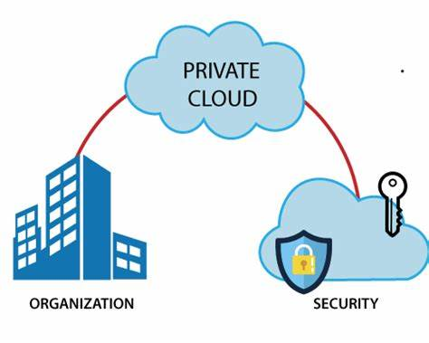

**Hybrid Cloud**

[Hybrid Cloud is an environment that uses both public and private clouds](https://www.bmc.com/blogs/public-private-hybrid-cloud/). [It offers the benefits of both public and private clouds](https://www.geeksforgeeks.org/public-cloud-vs-private-cloud-vs-hybrid-cloud/).

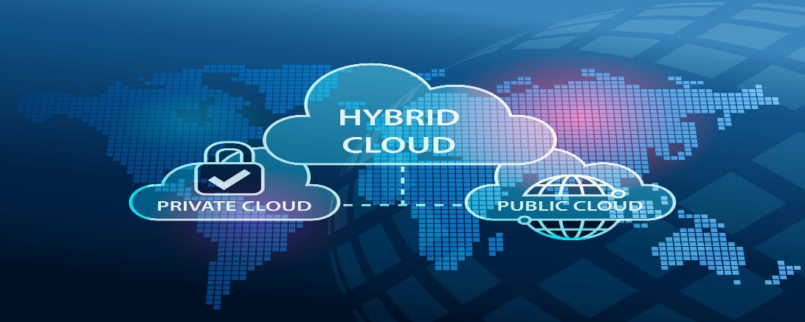

**Public cloud**

Public Cloud provides a **shared platform** that is accessible to the **general public** through an Internet connection.

Public cloud operated on the **pay-as-per-use model** and administrated by the **third party**, i.e., Cloud service provider.

In the Public cloud, the same storage is being used by multiple users at the same time.

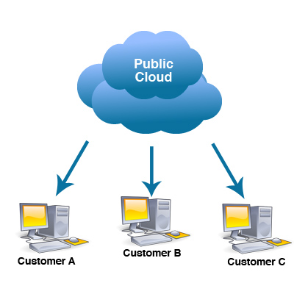

**Difference between Private ,Public and hybrid clouds**

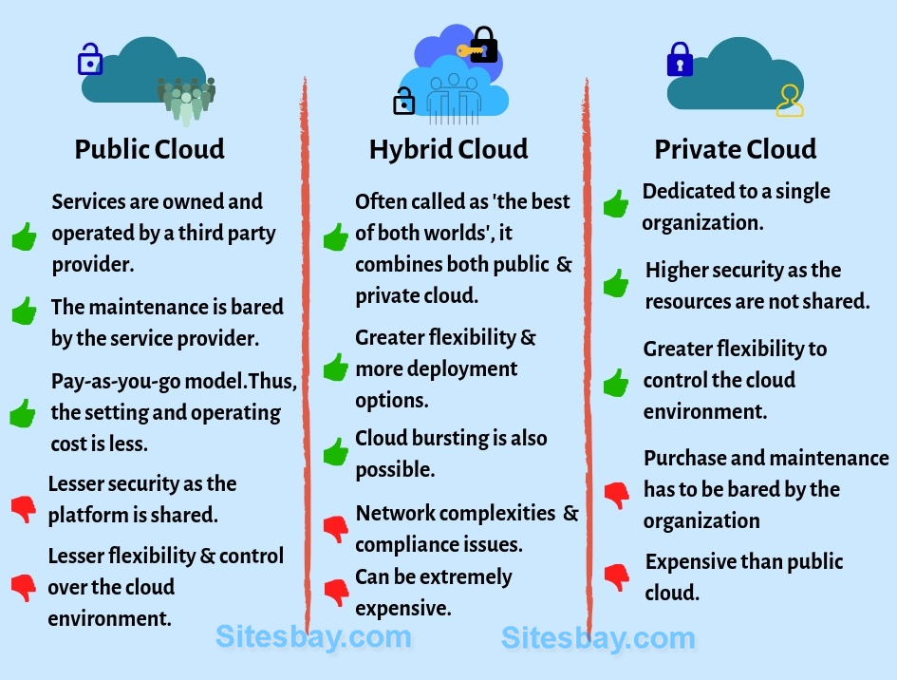

**TASK 3.2 For each cloud model,list one real-world application or scenario where that model would be the most appropriate choice.**

1.Public Cloud:

Real-World Application: A startup company developing a new mobile app chooses to host their app on a public cloud platform. The company has limited resources and wants to minimize upfront costs. They also anticipate a variable and potentially high volume of users, making the scalability of public cloud resources ideal for their needs.

2.Private Cloud:

Real-World Application: A financial services firm with strict regulatory requirements decides to build a private cloud to host its financial data and applications. The firm needs to ensure data privacy, security, and compliance with regulations such as GDPR and HIPAA. A private cloud allows the firm to have full control over its infrastructure and data, meeting its security and compliance needs.

3.Hybrid Cloud:

Real-World Application: A retail company uses a hybrid cloud model to manage its e-commerce platform. The company uses the public cloud for hosting its website and handling peak shopping seasons when traffic is high. It uses a private cloud for sensitive data such as customer financial information, ensuring security and compliance with industry regulations. The hybrid cloud model allows the company to scale resources up or down based on demand while maintaining control over sensitive data.