Week 1: Logistics Data Analytics Internship Report
Project: Logistics Data Analytics — Delivery Performance, Cost Analysis, and Optimization

1. Executive Summary
This project proposes a practical Python-based workflow to analyze shipment delivery performance, transportation cost, and delay patterns. The data are simulated for learning and do not represent a real logistics company.

2. Business Scenario and Problem Statement
A regional logistics provider manages shipments with different distances, weights, transport modes, traffic conditions, and weather. Management wants to understand why some shipments are late or expensive and how forecasts can improve dispatch planning. The core problem is the lack of a consistent, data-driven view of delivery performance and its possible drivers.

3. Project Objectives
- Define a clear logistics problem and measurable KPIs.
- Identify relevant data fields and potential data sources.
- Design a reproducible cleaning and analysis process.
- Propose regression, classification, clustering, and optimization methods.
- Build a plan for reporting findings and monitoring operational improvements.

4. Key Performance Indicators
On-time delivery rate = on-time shipments / eligible shipments × 100. Average delivery time = mean actual delivery hours. Average shipment cost = total transportation cost / shipment count. Delay rate = delayed shipments / total shipments × 100. Cost per kilometre = shipment cost / distance, for positive distances. Define the on-time rule before calculating these indicators.

5. Background Research and Dataset Plan
A public dataset can be searched through Kaggle or a public data portal using terms such as shipment delivery time, logistics, transportation, or supply chain. Record the source, license, download date, units, and limitations. For a beginner-friendly reproducible exercise, this project also provides a simulated dataset generator. Consult official pandas documentation for data manipulation, scikit-learn documentation for modeling, and Matplotlib/Seaborn documentation for charts.

6. Data Science Methods
Regression predicts a continuous value such as delivery hours. Classification estimates a category such as late/on-time. Clustering groups similar shipment profiles or routes. Optimization identifies feasible decisions that minimize cost or improve service subject to constraints. EDA should be performed before modeling to understand distributions and data quality.

7. End-to-End Roadmap
1) Define the business question and KPIs. 2) Collect or simulate shipment data. 3) inspect schema and data quality. 4) clean and transform fields. 5) calculate KPIs and perform EDA. 6) engineer useful features. 7) split data into training and testing sets. 8) train baseline and candidate models. 9) evaluate errors and inspect failures. 10) propose operational changes and monitor results.

8. Python Code Illustration
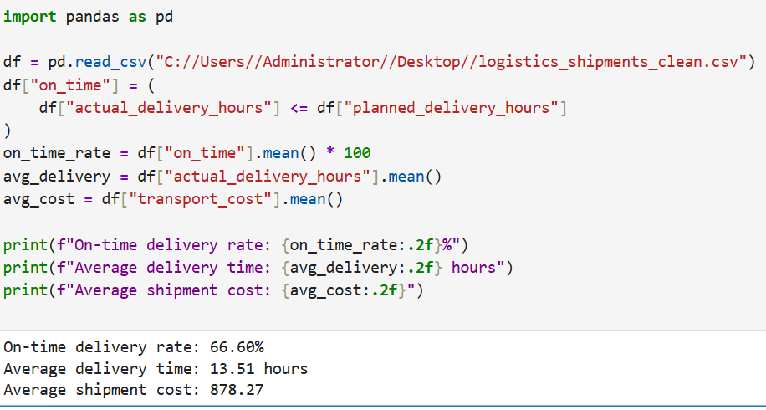

9. Expected Outcomes
The expected outcomes are a consistent KPI report, a clearer view of potential delay and cost drivers, a reproducible analysis pipeline, and a baseline for delivery-time prediction. Correlation alone does not establish causation, so recommendations should be tested through operational pilots.

10. Conclusion
Strategic planning makes the technical work relevant to business needs. Clear KPIs, documented data assumptions, reproducible Python code, and measurable follow-up actions form the foundation of useful logistics analytics.

