WEEK 3 INTERNSHIP REPORT
Advanced Data Analysis and Visualization in Logistics

Internship Domain: Logistics Data Analyst
Internship Task: Week 3
Student Name: ______________________________
Organization: YuvaIntern
Submission Date: ____________________________

1. Introduction
Logistics operations involve the movement, storage, and delivery of goods. Analysing shipment data helps an organisation understand delivery performance, transportation expenses, warehouse workload, and possible operational bottlenecks. This task demonstrates a practical Exploratory Data Analysis (EDA) workflow using Python.
The analysis uses a hypothetical dataset created specifically for this educational exercise. It is not real company or customer data.

2. Objectives
- Create and inspect a structured logistics dataset.
- Summarise shipment volumes, delivery times, distances, and costs.
- Identify missing values, duplicate records, distributions, and correlations.
- Create visualizations that communicate operational patterns.
- Translate analytical observations into practical recommendations.

3. Dataset Description
The simulated dataset contains 600 shipment records and 9 columns. Each row represents one shipment.
Variable | Description | Type
Shipment_ID | Unique shipment reference | Text
Shipment_Date | Date assigned to the shipment | Date
Warehouse | Origin warehouse location | Categorical
Distance_km | Distance travelled in kilometres | Numeric
Shipment_Volume | Number of packages in shipment | Numeric
Delivery_Time_days | Elapsed delivery duration in days | Numeric
Fuel_Cost_INR | Estimated fuel expense in INR | Numeric
Transportation_Cost_INR | Total estimated transportation cost in INR | Numeric
Delivery_Status | Delivered or Delayed | Categorical

4. Tools and Technologies
Python was used as the programming language. Pandas handled data loading, grouping, and statistical summaries; NumPy supported reproducible data simulation; Matplotlib and Seaborn produced charts; and Microsoft Word was used to prepare this report.

5. Methodology and Data Preparation
- Generated 600 reproducible hypothetical shipment records using a fixed random seed.
- Loaded the CSV dataset with Pandas and inspected its shape, column names, and data types.
- Checked missing values and duplicate rows.
- Selected numerical columns for descriptive statistics and correlation analysis.
- Grouped shipment volume by warehouse and compared delivery status categories.
- Created six visualizations and saved them as PNG files.
Data quality check: the generated dataset contains 0 missing cells and 0 duplicate rows. The numeric columns were analysed separately from categorical fields.

6. Exploratory Data Analysis and Statistical Summary
The table below presents selected descriptive statistics calculated from the simulated data.
Metric | Mean | Median | Standard deviation
Distance (km) | 245.26 | 213.65 | 162.48
Shipment volume | 39.20 | 38.00 | 23.15
Delivery time (days) | 2.41 | 2.37 | 0.86
Transport cost (INR) | 1,606.09 | 1,432.90 | 856.69
The average delivery time is 2.41 days, while the median transportation cost is INR 1,432.90. The average transportation cost is INR 1,606.09. The average shipment volume is 39.2 packages. Means and medians provide complementary views of typical values; a difference between them can indicate skewness or the influence of extreme observations.

7. Visualizations and Interpretation

7.1 Delivery Time Distribution
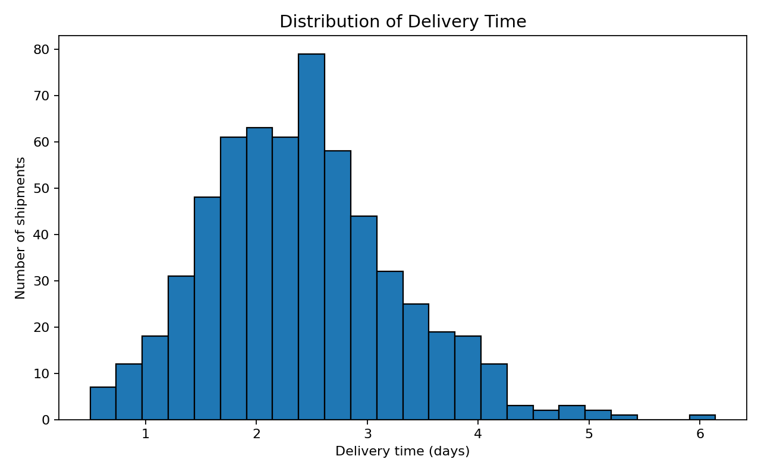
Figure 1. Histogram of delivery duration.
A histogram is suitable for continuous numerical data because it groups delivery durations into intervals. It helps identify the most common delivery-time range, spread, and any long-duration tail. The average delivery time in this dataset is 2.41 days. Operations teams could investigate shipments in the upper tail to understand causes of longer delivery durations.

7.2 Transportation Cost Distribution
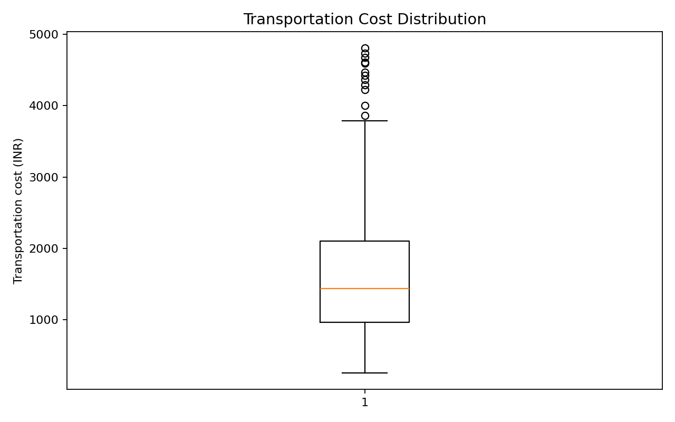
Figure 2. Box plot of transportation costs.
A box plot summarises the median, quartiles, spread, and potential outliers. It is useful for identifying shipments with unusually high costs that may need review. Outliers should be investigated rather than automatically removed because they may represent genuine long-distance or special-handling shipments.

7.3 Shipment Volume by Warehouse
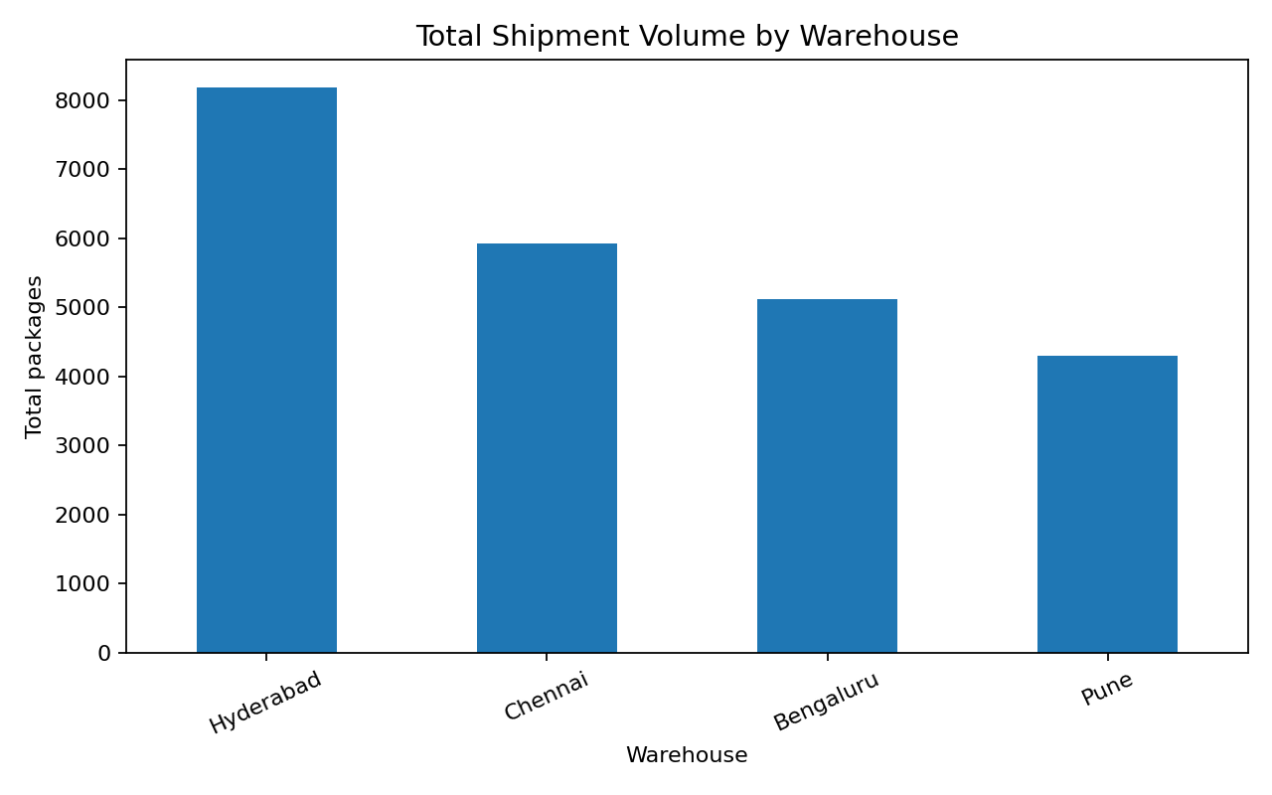
Figure 3. Total package volume by warehouse.
A bar chart makes it easy to compare workload across discrete warehouse categories. Hyderabad has the highest total package volume in this simulated sample (8,179 packages). Warehouse-level workload comparisons can support staffing, capacity planning, and dispatch scheduling.

7.4 Correlation Heatmap
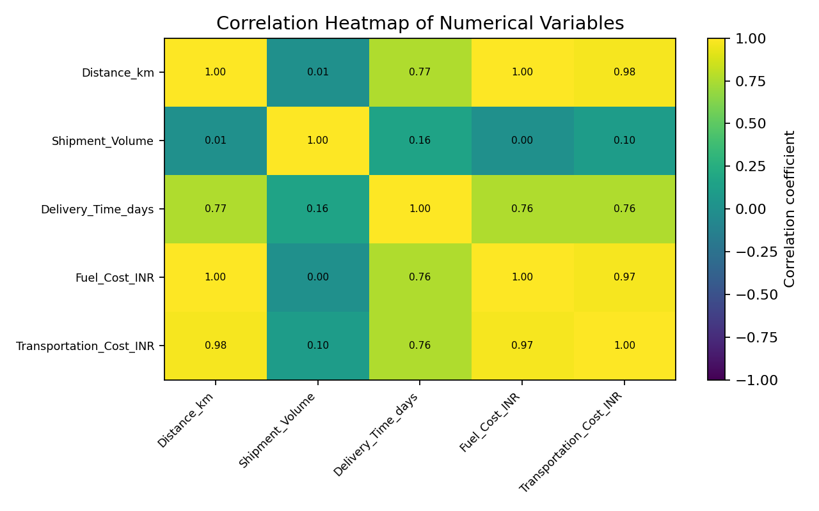
Figure 4. Correlation matrix for numerical variables.
A heatmap encodes correlation coefficients using colour and printed values, allowing several pairwise relationships to be reviewed together. Distance and transportation cost have a Pearson correlation of 0.98; distance and delivery time have a correlation of 0.77. Correlation describes association, not proof that one variable causes another.

7.5 Delivery Status
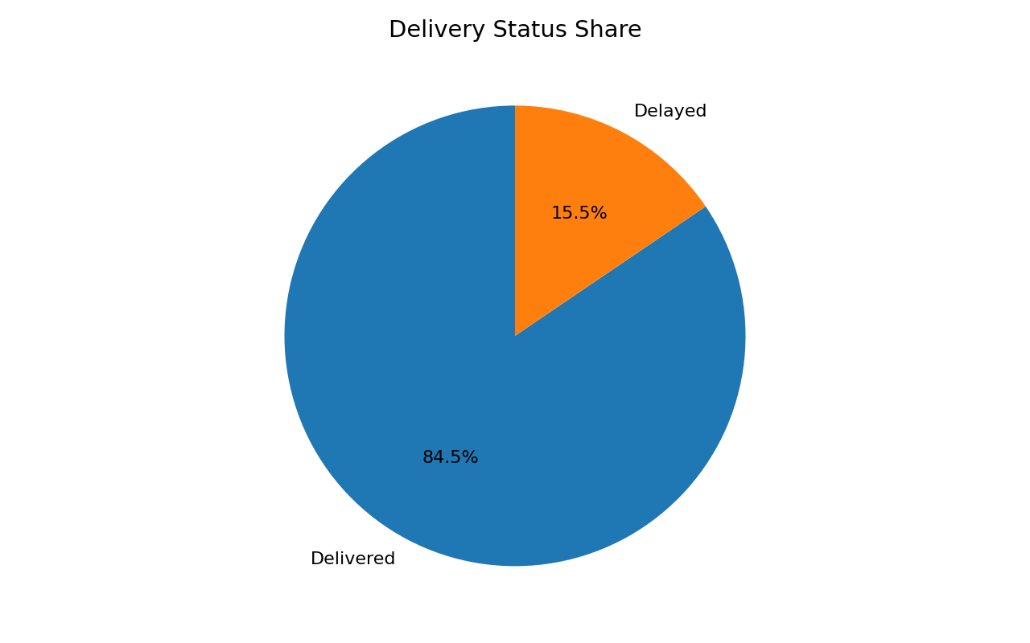
Figure 5. Share of delivered and delayed shipments.
The pie chart shows the proportion of shipments in each delivery-status category. In this dataset, 15.5% of shipments are labelled delayed. This percentage is a simple service-performance indicator. A real operation should also define the promised delivery window and measure on-time performance against that commitment.

7.6 Distance versus Transportation Cost
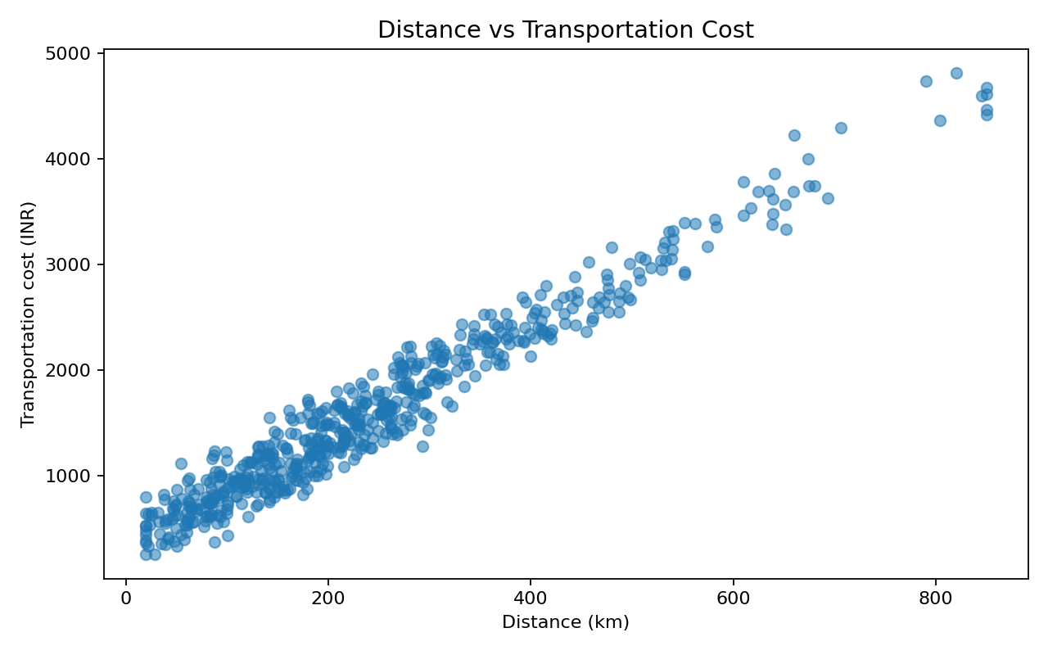
Figure 6. Scatter plot of distance and transportation cost.
A scatter plot is appropriate for examining the relationship between two numerical variables. The overall upward association is consistent with longer journeys tending to require more transportation expenditure. The spread around the trend suggests that distance is not the only cost driver; volume, fuel prices, route conditions, and vehicle utilisation may also matter.

8. Key Analytical Findings
- The simulated delayed-shipment share is 15.5%, providing a baseline for service-level monitoring.
- Distance and transportation cost show a positive correlation of 0.98 in this sample.
- Distance and delivery time show a correlation of 0.77, suggesting longer routes are associated with longer delivery durations.
- Hyderabad handles the largest total package volume among the four simulated warehouses.
- The cost box plot and scatter plot can help flag high-cost shipments for further operational investigation.

9. Recommendations
- Monitor delivery-time distributions by route, warehouse, and shipment category rather than relying only on an overall average.
- Review high-cost outlier shipments to check route selection, fuel use, vehicle utilisation, and special handling requirements.
- Use warehouse-level shipment volume to support workforce and dispatch-capacity planning.
- Track on-time delivery against an agreed service-level target and review recurring delay reasons.
- Combine distance, volume, fuel price, route, and vehicle data in future cost models to improve cost estimates.
- Repeat the analysis on actual, validated operational data before making business decisions.

10. Limitations
This is a simulated dataset created for an internship learning task. Its patterns are artificial and may not reflect actual logistics operations. The dataset does not include carrier identity, promised delivery date, traffic, weather, vehicle type, route-level events, or customer service outcomes. Correlation does not establish causation. The findings should therefore be treated as a demonstration of analytical methods, not as claims about a real organisation.

11. Conclusion
This task demonstrated an end-to-end EDA workflow for logistics data using Python. Descriptive statistics and visualizations were used to examine delivery duration, transportation costs, warehouse workload, delivery status, and relationships among numerical variables. The results show how data analysis can help identify patterns and guide questions for operational improvement. Future analysis should use real, validated shipment records and include route, carrier, and service-level information.

12. How to Run the Python Code
Keep the Python script and CSV file in the same folder. Install the libraries listed in requirements.txt and run the following commands in Command Prompt:
pip install -r requirements.txt
python week3_exploratory_data_analysis.py
The script prints the EDA summaries and saves the six charts in the visualizations folder. The report charts included here were generated from the supplied CSV dataset.

13. References
- Pandas documentation: https://pandas.pydata.org/docs/
- Matplotlib documentation: https://matplotlib.org/stable/
- Seaborn documentation: https://seaborn.pydata.org/
- NumPy documentation: https://numpy.org/doc/

