|  |
| --- |
| College LaSalle |
| Project - Internet Programming Technical Manual |
|  |
| Presented to: Mihai Miftai |

|  |
| --- |
| Author:Ramya Jupaka  7/25/2019 |

Start by adding a short description of my project, and the languages (technologies) used

Languages:

1. HTML
2. CSS
3. JAVASCRIPT
4. JQuery
5. Cookie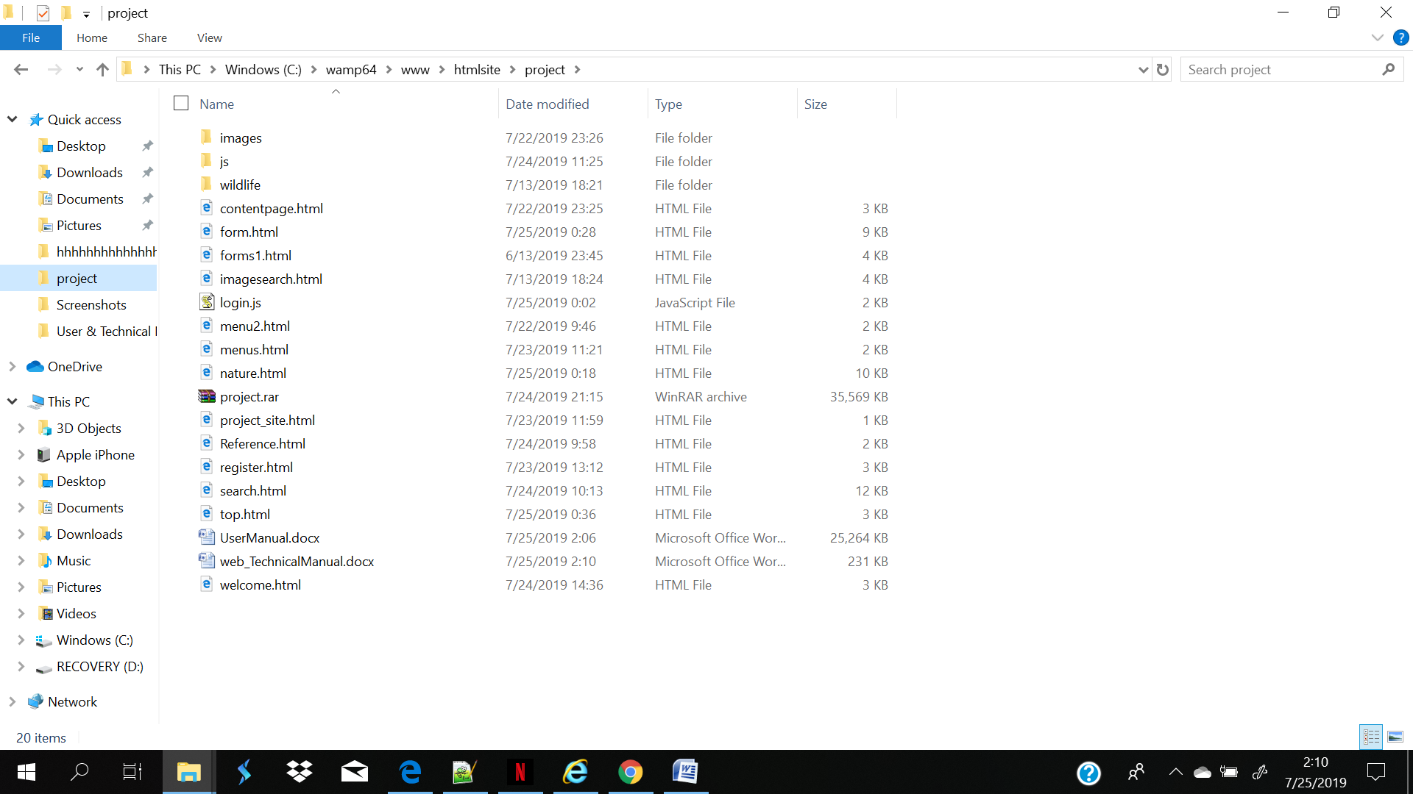

The folders of Project

Project_site.html

Welcome.html(home)

Nature.html(describe the subject , why and what)

ImageSearch.html(use an image gird and links to show some information in other page)

Search.html(image mapping and search the animals)

RegisterForm.html(Registration)

References.html(References)

The folder of wildlife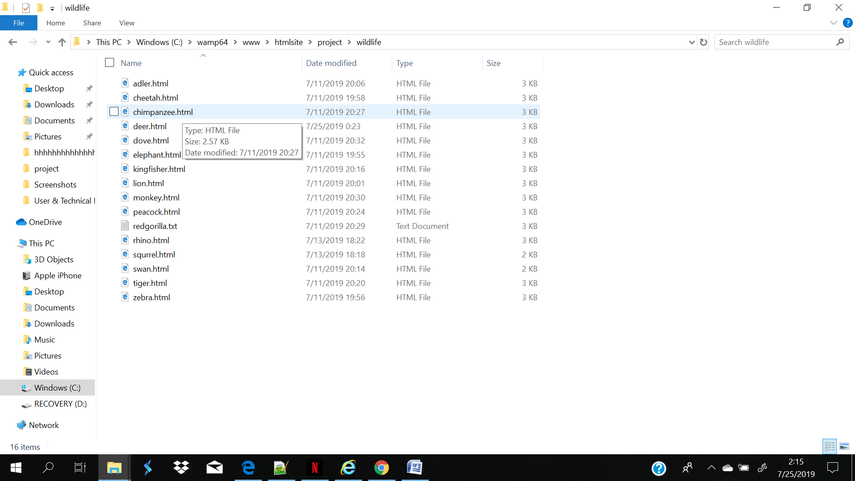

The folder of images

all the image

The folder of js

login.js

Present the functions and/or methods that you create or did use in the web project.

|  |  |
| --- | --- |
| **Function/Method** | **Description** |
| 1. function longin () | To check username and password, if username and password it is right, and then user can use menu to display each page. |
| 1. function longout() | To logout, if logout ,the user can not use menu. |
| 1. function setCookie(); | setCookie to store user name in webpage. |
| 1. function getCookie(); | getCookie to catch the variable from user |
| 1. function checkCookie(); | checkCookie (first it get cookie from user and it stores in website and if we login for second time it verifies the user and display welcome else display no cookie for you) |
| 1. $(document).ready(function()   $(".log").hide() | To hide label and input, just leave the button of logout |
| 1. $(document).ready(function()   $(".log").show() | To show label and input, before the hided. |
| 1. setCookie("admin",username,1); | To set the username |
| 1. setCookie("admin",defautusername,-1); | To delete the username |
| 1. function timedCount() | To calculator the time |
| 1. function stopCount() | To stop timer and clear at the same time |
| 1. $ = function(el) | To read the variable from the array and make iterations in function(el) |
| 1. function checkValue(ele) | To validate each input from user whether follow the format. |
| 1. for (var i = 0; i < inputEles.length; i++) | When the cursor moveto other input field show error, check the whether input is correct or not |
| 1. inputEles[i].addEventListener('focus', function(e) | When the cursor in the input, under the input display the hint about the format |
| 1. $('#check').addEventListener('click', function(e) | Submit button, check every input it is right or wrong ,if wrong not allowed to submit |

Error:

Contentpage: **Almost standards mode doctype. Expected**<!DOCTYPE html>**.**

**Attribute**source**not allowed on element**[img](https://html.spec.whatwg.org/multipage/#the-img-element)**at this point.**

**Attribute**type**not allowed on element**[img](https://html.spec.whatwg.org/multipage/#the-img-element)**at this point.**

Menu2: **Start tag seen without seeing a doctype first. Expected**<!DOCTYPE html>**.**

**A document must not include both a**meta**element with an**http-equiv**attribute whose value is**content-type**, and a**meta**element with a**charset**attribute.**

**Element**[hr](https://html.spec.whatwg.org/multipage/#the-hr-element)**not allowed as child of element**[ul](https://html.spec.whatwg.org/multipage/" \l "the-ul-element)**in this context. (Suppressing further errors from this subtree.)**