https://www.youtube.com/watch?v=KuM6OtuaYRs&list=PLGRDMO4rOGcNLnW1L2vgsExTBg-VPoZHr

https://www.javaguides.net/2020/07/spring-boot-react-js-crud-example-tutorial.html

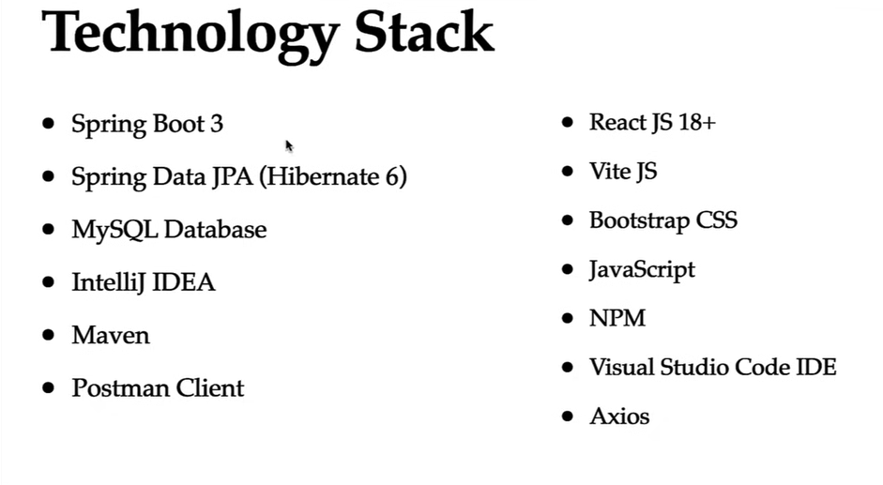
Employee Management System – Fullstack Project (React+SpringBoot)

Requirement 1 - Build CRUD REST APIs for
Employee Management Module
· Add Employee
· Get Employee
. Get All Employees
· Update Employee
· Delete Employee

Requirement 2 - Build Frontend React App for
Employee Management Module
User should able perform below CRUD operations:
· Add New Employee
. List All Employees
· Update Existing Employee
· Delete Existing Employee

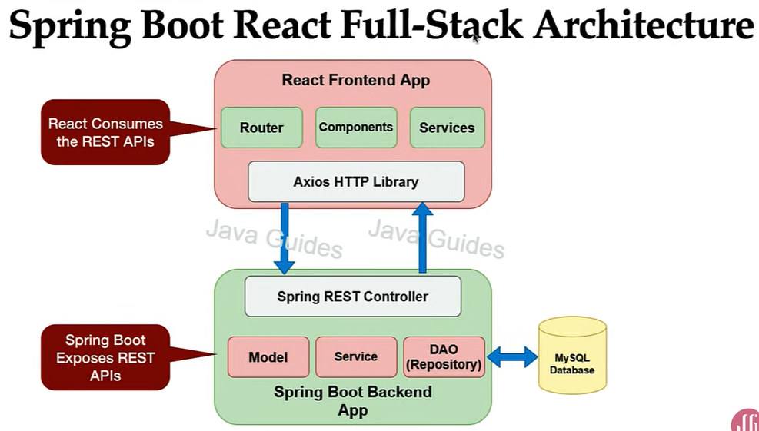

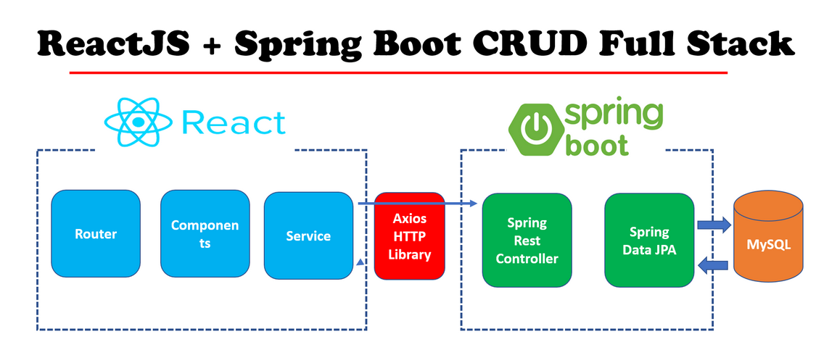

It follows client-server architecture. Both application are loosely coupled.
React JS doesn’t have inbuilt http library. So it uses 3rd party Axios http library to make API call.

JPARepository interface is implemented by SimpleJPARepo class. This class is annotated with @Repo So we no need to annotate again in our custom interface. And class is annotated with @transactional so by default all the methods in the class are transactional. So we no need to provide transactional in service layer.

DTO classes are used to transfer data between different layers such as controller, service and repository.[In Spring Boot,
DTOs (Data Transfer Objects) are classes (or Java records) used to transfer data between different application layers, such as the controller, service, and data access layers.] . In JSON we provide data in the form of dto. And display to client in the form of dto.
While fetching from db it comes as entity we have to convert it to dto using mapper.

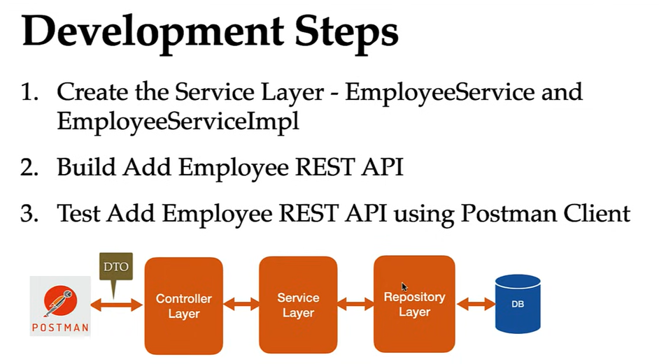

React:

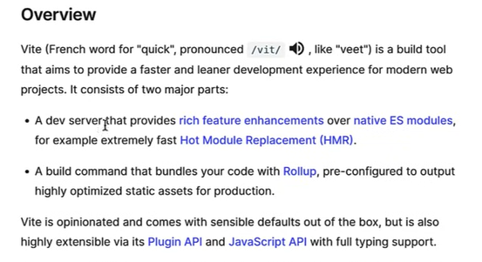

http://localhost:5173/

1. npm create vite@latest ems-frontend – command type in VS terminal to create ems react app.

2.cd ems-frontend
npm install
npm run dev

3. Now the application runs in dev server 5173. we can change it to 3000 in vite.config.js
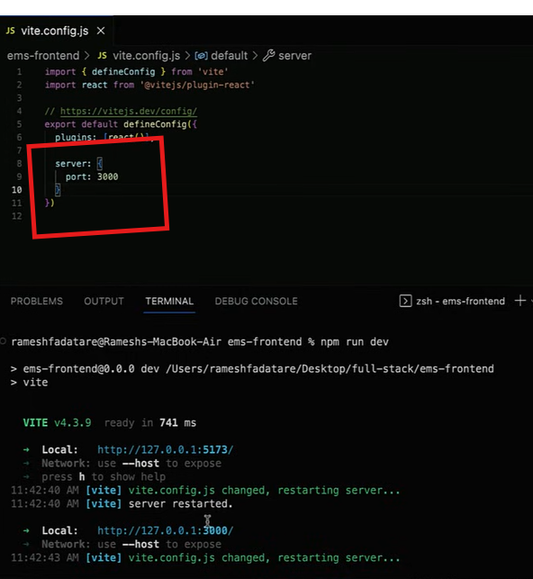

Now application is up and running in server port no. 3000 ..
http://localhost:3000/

Adding Bootstrap using npm in React
To install Bootstrap in React using npm create another terminal
cd ems-frontend
npm install bootstrap –save

Now bootstrap is installed in dependencies folder of package.json. Bootstrap version 5.3.8

import 'bootstrap/dist/css/bootstrap.min.css'
in main.jsx since it is entry point of js.

List Employee Feature - Frontend Implementation
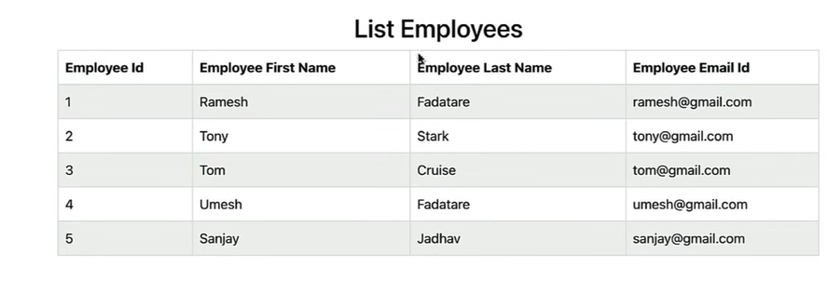
List Employee Feature - Create React ListEmployeeComponent

Development Steps
1. Create React Functional Component -ListEmployeeComponent
2. Prepare Dummy Data (List of Employees) to Display in an
HTML Table
3. Write JSX Code to Display List of Employees in HTML Table
4. Import and Use ListEmployeeComponent in App Component
5. Run and Test React App

List Employee Feature -Connect React App with Get
All Employees REST API

Development Steps:
1. Install axios Library
2. Create EmployeeService.js File
3. Write REST Client code to make a REST API call using axios API
4. Change ListEmployeeComponent to Display Response of the REST API (List of Employees)
5. Test the above changes

In EmployeeService.js we write RestClient code to call external API’s.

AXIOS library:
Axios is a popular, promise-based JavaScript library used in React applications to make HTTP requests to external APIs and servers. It simplifies data fetching and handling compared to the native fetch API, offering features like automatic JSON parsing, clearer error handling, and request/response interceptors.

Key Features and Advantages
- Promise-based: Axios uses JavaScript Promises, allowing for the use of async/await syntax, which makes asynchronous code more readable and maintainable.
- Automatic JSON Data Handling: It automatically transforms incoming JSON data, eliminating the need for manual parsing with .json().
- Better Error Handling: Axios automatically throws errors for HTTP response codes outside the 2xx range (e.g., 404, 500), unlike fetch, which requires manual status checks.
- Interceptors: Developers can use request and response interceptors to add custom logic globally, such as authentication tokens, logging, or error management, before requests are sent or after responses are received.
- Request Cancellation: Axios supports canceling in-flight requests, which is crucial for managing requests when components unmount to prevent memory leaks.
- Browser Compatibility: It works across all modern and older browsers without needing polyfills.
How to Use Axios in a React Application
1. Installation
Install the Axios library in your React project using npm or yarn:
bash
npm install axios
# or
yarn add axios

2. Making Requests
You can use Axios in functional components with useEffect and useState hooks for data fetching.
Example: GET Request in a Functional Component
This example fetches a list of users from a placeholder API when the component mounts.
You can find an example of a GET request in a functional component using useEffect and useState in the referenced document. This example demonstrates fetching data, handling loading states, and managing potential errors.
3. Creating an Axios Instance (Best Practice)
For more complex applications, creating a custom Axios instance allows you to configure a base URL, headers, and interceptors in one place. An example of creating a custom instance can be found in the referenced document. This instance can then be used throughout your application for making requests.

useEffect

In React, the
useEffect Hook allows you to perform side effects in functional components. Side effects are tasks that happen "outside" the normal rendering process, such as fetching data, setting up subscriptions, or manually changing the DOM.
Basic Syntax
The hook takes two arguments: a setup function containing your logic and an optional dependency array.
javascript
import { useEffect } from 'react';

function MyComponent() {
useEffect(() => {
// Side effect logic goes here

return () => {
// Optional: Cleanup logic goes here
};
}, [dependencies]); // Optional: Dependency array
}

Controlling When the Effect Runs
The dependency array determines how often the effect is triggered.
Dependency Array | Behavior | Common Use Case
No array | Runs after every render. | Logging, general sync.
Empty array [] | Runs only once, after the initial mount. | API calls on load, starting timers.
With values [prop, state] | Runs on mount and whenever any value in the list changes. | Responding to specific user input.

The Cleanup Function
You can return a function from useEffect to "clean up" after the effect. This is crucial for avoiding memory leaks.
- When it runs: Before the component unmounts and right before the effect re-runs (if dependencies changed).
- What to clean up: Timers (using clearInterval), event listeners (removeEventListener), or canceling network requests.
Example: Timer with Cleanup
javascript
useEffect(() => {
const timer = setInterval(() => {
console.log('Tick');
}, 1000);

return () => clearInterval(timer); // Stops the timer when component is removed
}, []);

Common Use Cases in 2026
- Data Fetching: Fetching information from an API when a component loads.
- External Subscriptions: Connecting to a WebSocket or a chat service.
- Event Listeners: Tracking window resizing, mouse movements, or scroll positions.
- Direct DOM Access: Using a 3rd-party library that needs to manipulate a specific element after it renders.
Key Rules & Best Practices
- Call at Top Level: Never call hooks inside loops, conditions, or nested functions.
- Don't Overuse: If you can calculate a value during rendering (e.g., filtering a list based on a prop), you don't need useEffect.
- Exhaustive Dependencies: Always include every reactive value (props, state) used inside the effect in the dependency array to avoid stale closures.
- Effect vs. LayoutEffect: While useEffect runs after the browser paints the screen, useLayoutEffect runs synchronously before the paint. Use the latter only for measuring layout to prevent flickering

EmployeeService.js
Create service folder in src folder.. Then Create EmployeeService.js
1.import axios component from axios library
2.Create base URL to make REST API call.

Since React and Springboot runs in different server it is blocked by CORS Policy
This CORS Policy issue solved in Springboot side to add @CrossOrigin(“*”)
So now all the client application can call the RestApi’s.

Adding Header and Footer to React App

Development Steps
1. Create HeaderComponent (functional component)
2. Import and Use HeaderComponent in App Component
3. Create FooterComponent (functional component)
4. Import and Use FooterComponent in App Component

Configure Routing in a React App

Development Steps
1. Install react-router-dom library using NPM
2. Configure Routing in App Component
3. Configure Route for ListEmployeeComponent
4. Test Route for ListEmployeeComponent

1. type comment npm install react-router-dom
2. import {BrowserRouter} from ‘react-router-dom’ in App.jsx

What is React Router?
React Router is a library that provides routing capabilities for React applications.
Routing means handling navigation between different views.
React Router is the standard routing library for React applications. It enables you to:
- Create multiple pages in your single-page application
- Handle URL parameters and query strings
- Manage browser history and navigation
- Create nested routes and layouts
- Implement protected routes for authentication
Without a router, your React application would be limited to a single page with no way to navigate between different views.

Wrap Your App with BrowserRouter
Your application must be wrapped with the BrowserRouter component to enable routing:
function App() {
return (
<BrowserRouter>
{/* Your app content */}
</BrowserRouter>
);
}

Basic Routing
React Router uses three main components for basic routing:
- Link: Creates navigation links that update the URL
- Routes: A container for all your route definitions
- Route: Defines a mapping between a URL path and a component
Let's add navigation links and routes for each link:

Example
Note that we need to import BrowserRouter, Routes, Route, Link from 'react-router-dom'.
import { BrowserRouter, Routes, Route, Link } from 'react-router-dom';

function Home() {
return <h1>Home Page</h1>;
}

function About() {
return <h1>About Page</h1>;
}

function Contact() {
return <h1>Contact Page</h1>;
}

function App() {
return (
<BrowserRouter>
{/* Navigation */}
<nav>
<Link to="/">Home</Link> |{" "}
<Link to="/about">About</Link> |{" "}
<Link to="/contact">Contact</Link>
</nav>

{/* Routes */}
<Routes>
<Route path="/" element={<Home />} />
<Route path="/about" element={<About />} />
<Route path="/contact" element={<Contact />} />
</Routes>
</BrowserRouter>
);
}

Add Employee Feature – Create React EmployeeComponent

Development Steps
1. Create React Functional Component - EmployeeComponent
2. Add "Add Employee" button in ListEmployeeComponent
3. Configure Route for EmployeeComponent
4. Test the above changes

ReactCode Snippet- rafec for step:1

ReactJS useNavigate() Hook

React Router v6 introduces the useNavigate() hook, making it easier and more flexible to navigate between different pages in your app. It replaces the older useHistory() hook.
With the useNavigate() hook, you can:
- Go to a different page in your app.
- Navigate based on actions like button clicks.
- Send data or parameters when moving to another page.

Step:2. Import useNavigate() in ListEmployeeComponent
It is coming from ReactRouterDOM
This is javascript function. So we assign that to the const variable.
Then use var in the addNewEmployee action method.

Step:3.
Now we have added add-Employee in navigator but not yet configured.
So go to App.jsx
configure url and component using Route component

step:4
So whenever user clicks AddEmployee button it goes to Employee component. It happens using useNavigate() component in the App.jsx we have configured Route component , there we configured path and component

Add Employee Feature - AddEmployee Form Handling

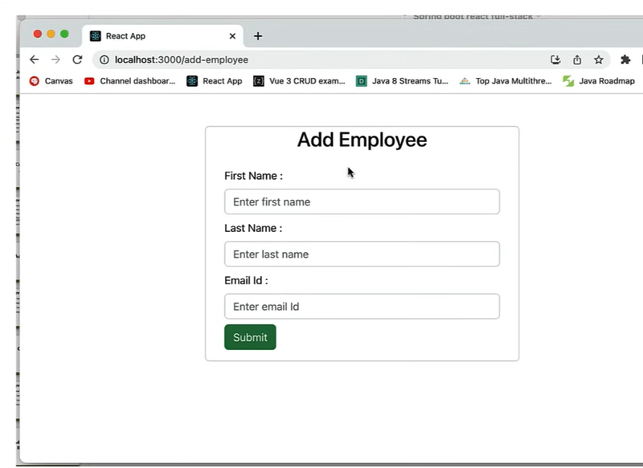
Development Steps
1. Define state variables (firstName, lastName and emailId) in
EmployeeComponent using useState Hook.
2. Design Add Employee Form using HTML and Bootstrap
3. Create JavaScript Function to handle onClick Event
(Form submit)
4. Test React App (print form data in browser console)

Step:2 Add Employee
1.Create form using html and Bootstrap. Create form within a card.

For each setFirstName method instead of writing named function we can make it as arrow function and directly provide in the OnChange={(event)=>event.target.value}

Add Employee Feature -Connect React to Add
Employee REST API

Development Steps
1. In EmployeeService, write a code to call Add Employee REST API using axios.
2. Change EmployeeComponent to call EmployeeService method
3. Navigate to List Employees Page After Form Submission Done
4. Test above changes

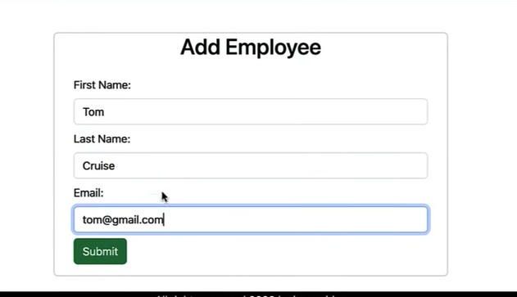

tom data added in the table and listing in the list all employee
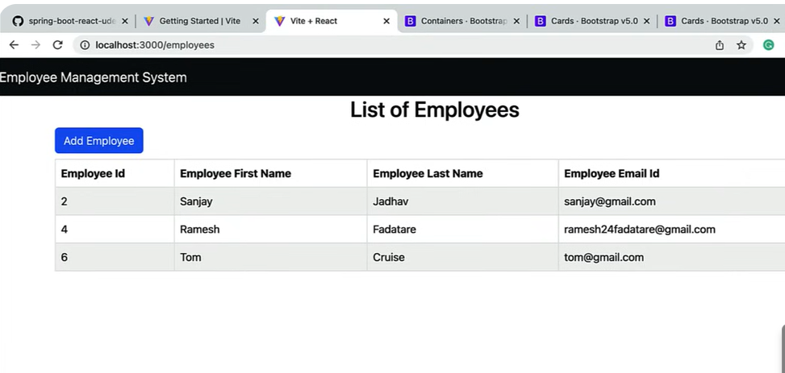

Add Employee Feature – Add Employee Form
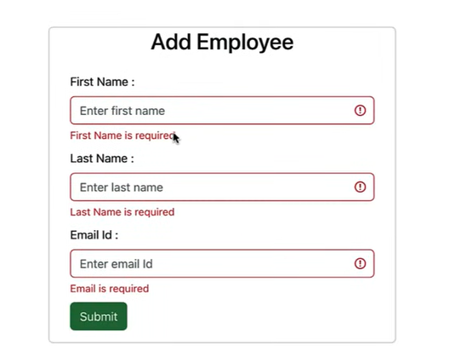
Validation

Form should be validated before submission to prevent entering empty or null values.

Development Steps
1. Use the useState hook to initialize state variables that will hold validation errors
2. Write a validation function that checks the form data and returns validation errors
3. Validate Form on Submission
4. Display Validation Errors
5. Test above changes

add bootstrap validation errors in each field className

Update Employee Feature - Adding
Update Button, Title and Route
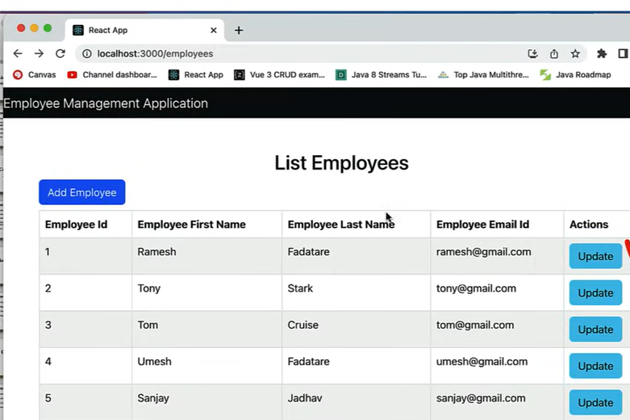

Development Steps
1. Add Update button to list employees page
2. Add Route for Update Employee in App component
3. Change Page Title Dynamically (EmployeeComponent supports both Add and Update)
4. Test above changes

useParams:
The useParams hook from the React Router library is used to access dynamic parameters from the current URL within functional components. It returns an object of key/value pairs, where the keys are the parameter names defined in the route path and the values are the corresponding segments from the URL.

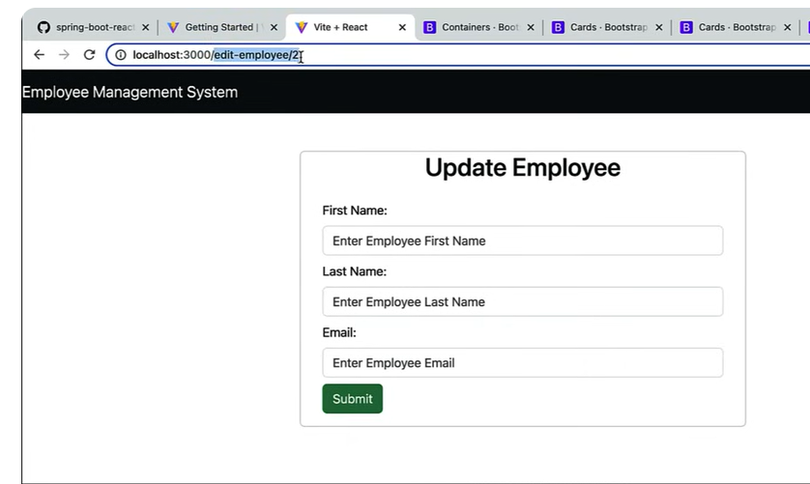

Update Employee Feature - Connect React App to Get Employee REST API
To update employee details it has to fetch employee details from server and populate in front end. SO connect with Get Employee Rest Api.

Development Steps
1. In EmployeeService, write a code to call Get Employee REST API using axios.
2. Use useEffect hook to populate the employee data in the form for update
3. Test above changes

Update Employee Feature - Connect React App to Update Employee REST API

Development Steps
1. In EmployeeService, write a code to call Update
Employee REST API using axios.
2. Change EmployeeComponent.saveOrUpdateEmployee()
method to perform both add and update employee
operations
3. Test above changes
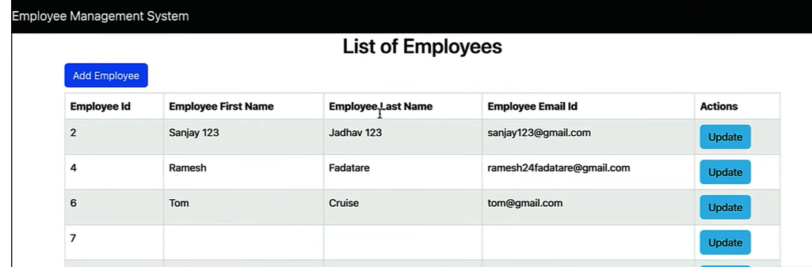
Both adding new employee and update employee works very well.

Implement Delete Employee Feature in React App

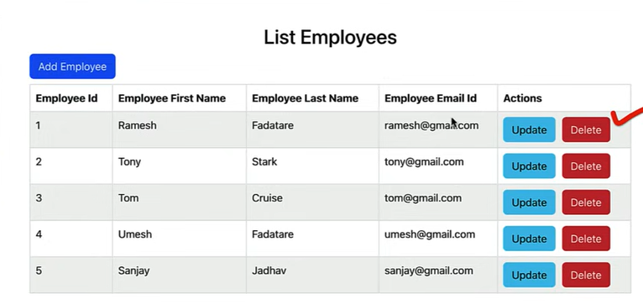

Development Steps
1. In EmployeeService, write a code to call DeleteEmployee REST API using axios.
2. Add Delete button to list employees table
3. Create JavaScript function to handle Delete button event
4. Test above changes

