|  |
| --- |
| nopCommerce – Live Project |
| **Project Functional Requirement Specification Version 1** |
|  |
| **Prepared by: Ramya**  **Reviewed by: Raghavendra** |
|  |

Contents

1. Purpose of the document: 3

2. Project Overview: 3

2.1 Audience: 3

2.2 Hardware and Softwarerequirements: 3

3. Information Architecture 4

3.1 Registration 4

3.2 Login 6

3.3 Add to Cart 7

3.3.1 Billing Address 8

3.3.2 Shipping Address 9

3.3.3 Shipping Method 10

3.3.4 Payment Method .11

3.3.5 Payment Information .12

3.3.6 Confirm Order 13

3.4 Delete from Cart………………………………………………………………………………………………………………….14

4. Sign-Off Document………………………………………………………………………………………………………………………..15

# Purpose of the document:

nopCommerce is the best open-source eCommerce shopping cart solution. nopCommerce is free, and it is the most popular ASP.NET eCommerce platform. The first nopCommerce version was released in 2008. At that time there were no free and open-source shopping carts that would not impose the limitations on business processes and flow hence the essential goal for nopCommerce was to fix that.

The high quality of the product and its constant development led to creating the global nopCommerce community of over 250,000 members. The philosophy of the open-source product allows us to receive the contribution of developers and businesses from around the world. That helps us to grow faster and meet the highest security and technology standards.

**2.Project Overview:**

## 2.1 Audience:

This document is intended as a complete guide for user who is using nopCommerce. This document is specially designed for the user as a useful point of reference. By reading this guide, you will learn how to use nopCommerce through the elements of the graphical user interface and what's behind some of the advanced features that are not always obvious at first sight. It will hopefully guide you around some common problems that frequently appear for users of nopCommerce.

## 2.2 Hardware and Software requirements:

## Supported operation systems

Windows 7 or above

Windows Server 2008R2 or above

## Supported browsers

Microsoft Internet Explorer 9 and above (IE6 and IE7 were supported in versions prior 3.60, IE8 was support in versions prior 4.10)

Mozilla Firefox 2.0 and above

Google Chrome 1.x

Apple Safari 2.x

**Hardware Requirements**

Hard Ware requirements are Computer, Laptop or Mobile, Internet.

**3.Information Architecture**

## 3.1 Registration

User can register in to nopCommerce by giving the details such as name ,Email, country as shown in figure 1. User has to set username and password to use them as login credentials.

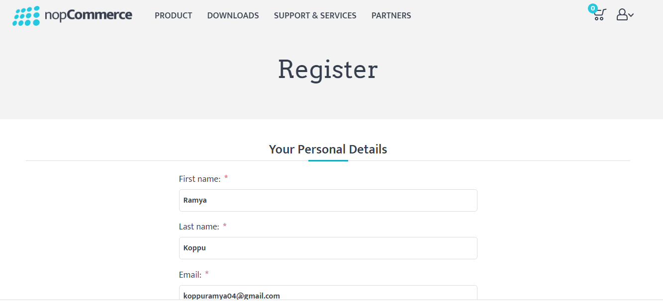

Figure 1

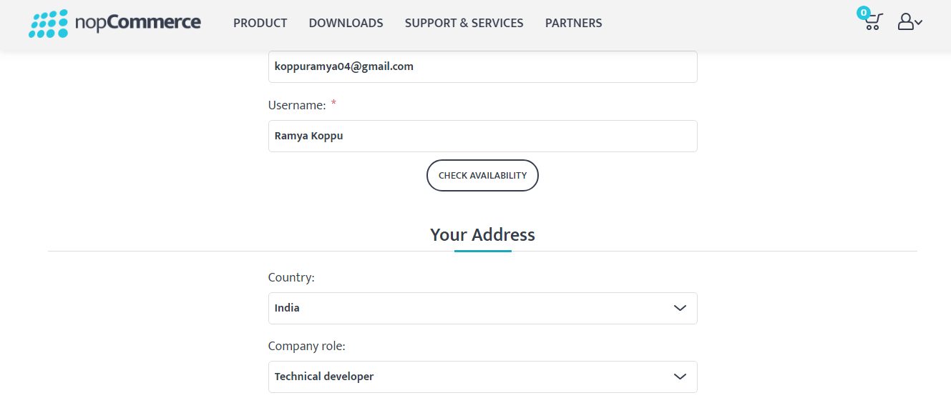

Figure 2

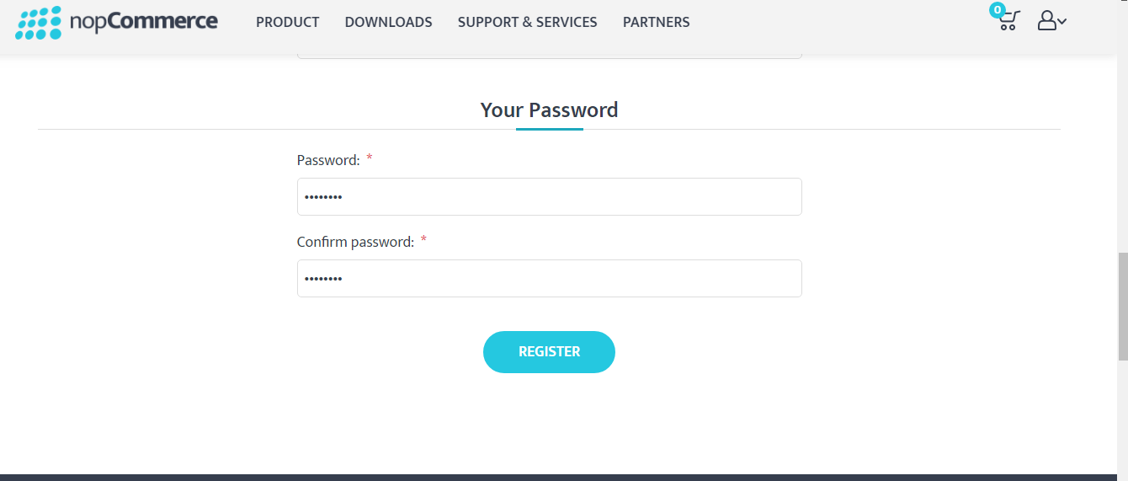

Figure 3

### 3.2 Login

By using the credentials username and password log in to the nopCommerce as shown in figure 4.

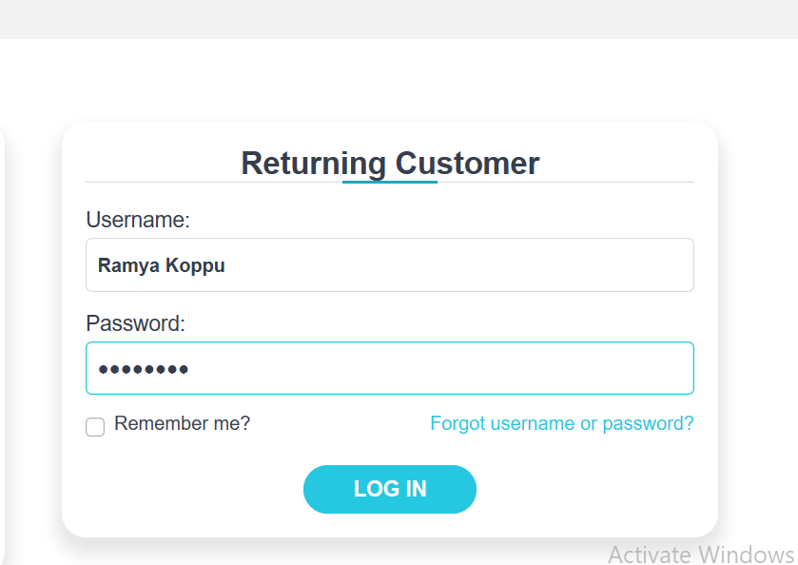

Figure 4

**3.3. Add to Cart**

There are many categories such as Apparel, Books, Digital Downloads, GiftCards, Jewellary.User can select the required item and after that he/she can add that item in to the cart. Any number of items can be added

as shown in figure 5.

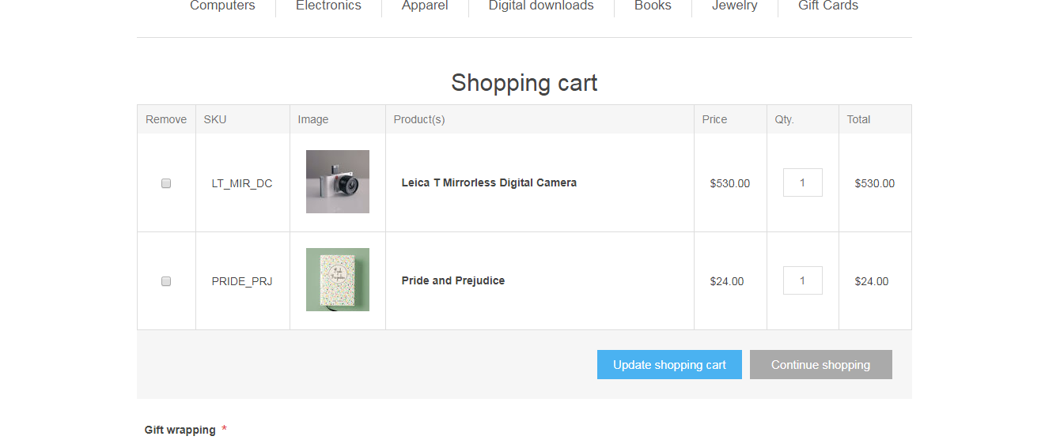

Figure 5

**3.3.1.Billing Address**

In Billing Address user has to enter their Name, EmailId, Company, Country, City, Address, PostalCode, Phonenumber as shown in figure 6 and 7.User should give the correct credentials so that the product will be delivered to the correct Address you have given.

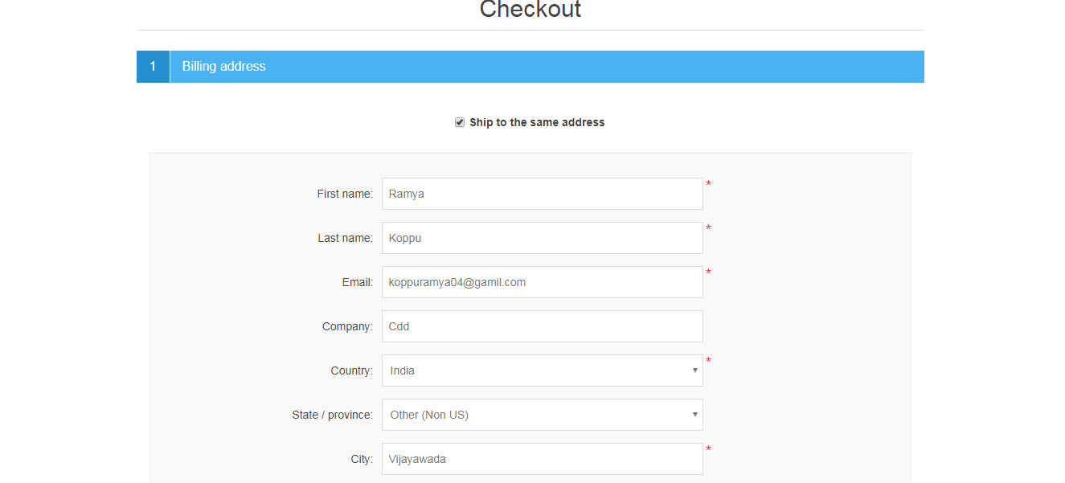

Figure 6

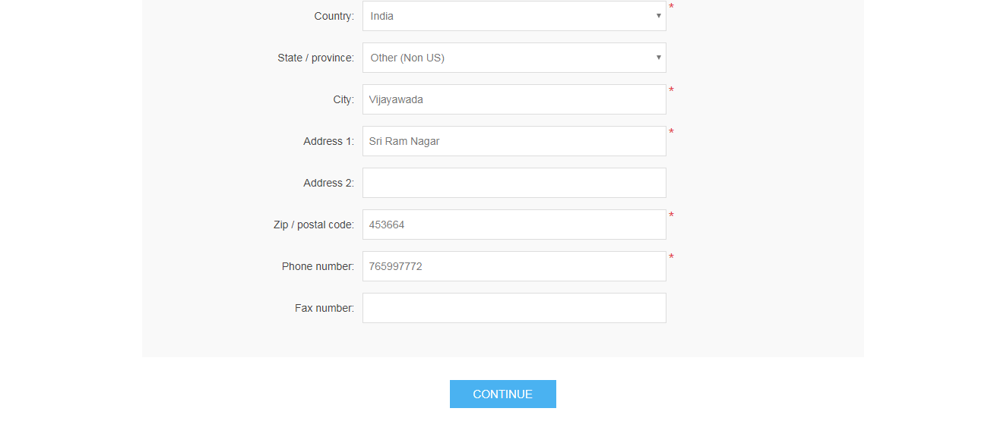

Figure 7

**3.3.2.Shipping Address**

If the billing address and Shipping Address are same then we should tick the checkbox. Otherwise we should give the shipping address separately by clicking on new address as shown in figure 8. Again we should enter Name, Email, Company, Country, City, Address, Postal code, PhoneNumber.

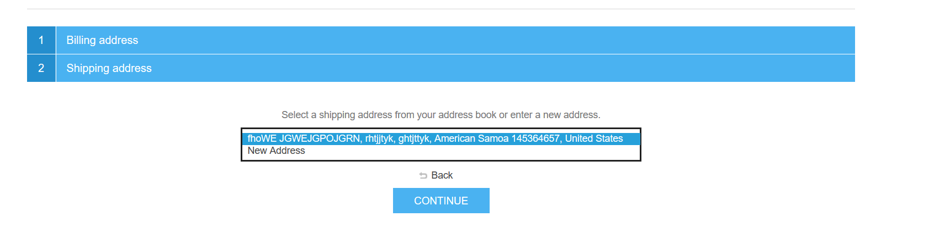

Figure 8

**3.3.3 Shipping Method**

In this user will have three options. User can choose any one of the option as shown in figure 9. The options available are Ground, Next day Air, Second Day Air. Ground is for Road Transport. Next day air is for one day shipping and two day air is for two day shipping.

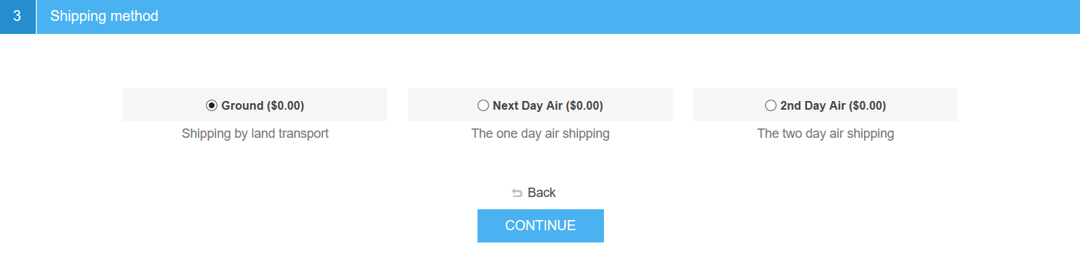

Figure 9

**3.3.4 Payment Method**

Here the user can select either Cash on Delivery or Debit card Payment as shown in figure 10.

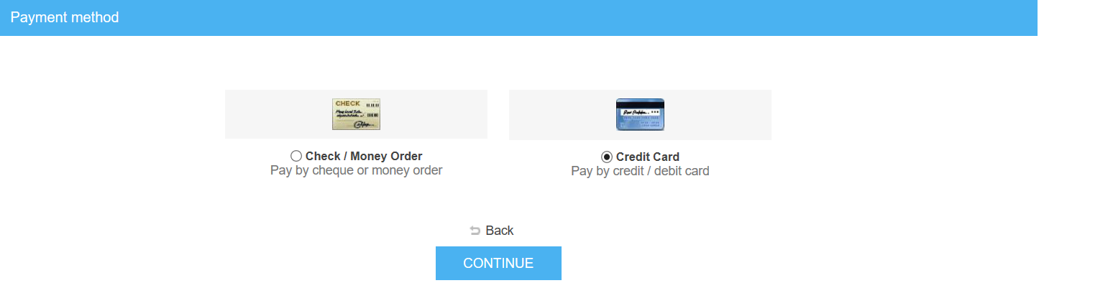

Figure 10

**3.3.5 Payment Information**

If we use the debit card for payment then we should give our bank details such as Card holder name, Card Number, Expiration date and Card Code. And we should click continue.

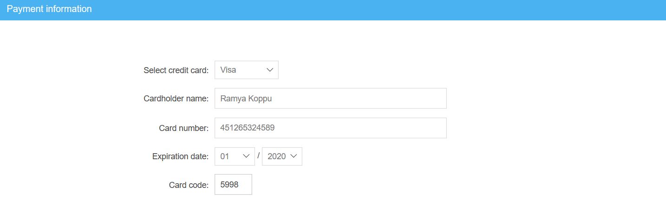

Figure 11

**3.3.6 Confirm Order**

After entering the payment information click continue then go to confirm order it will display the shipping and billing details. Once you cross check the information given in the billing and shipping address.If the given address are correct then click confirm as shown in figure 12

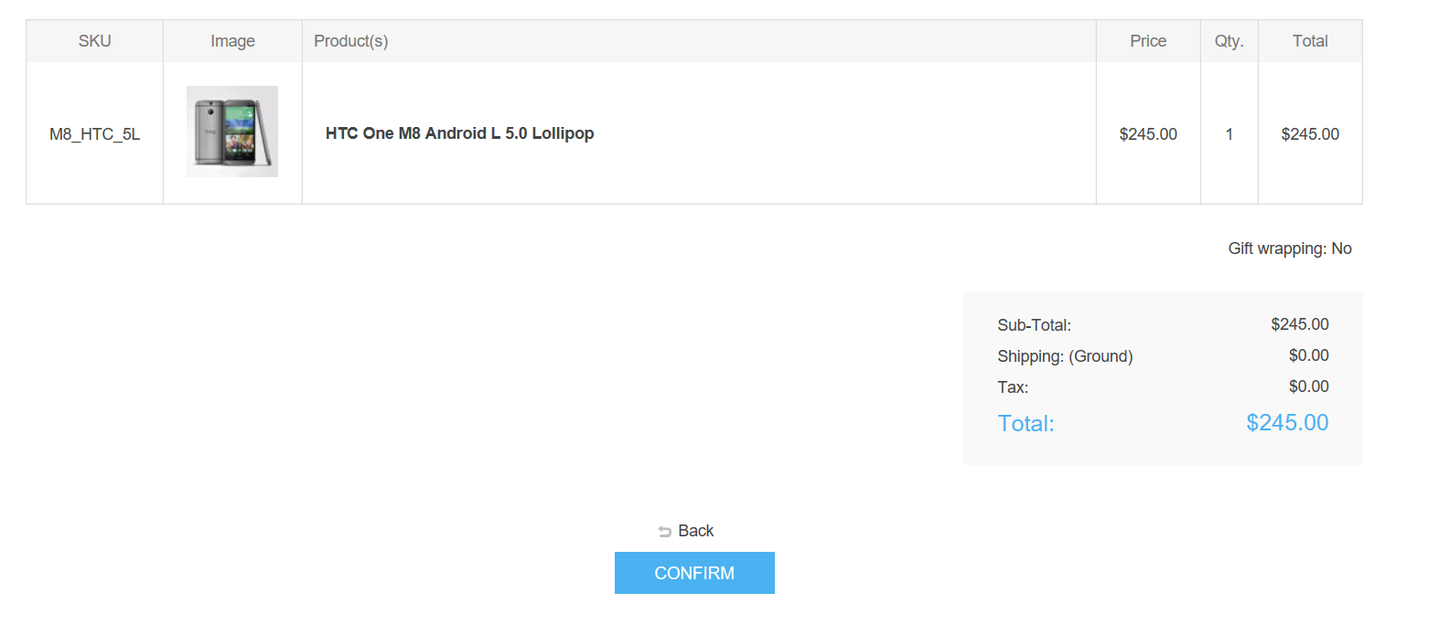

Figure 12

**3.4.Delete from Cart**

We can remove the items which were added in to the card at anytime by clicking on the check box and then click on update Shopping Cart.



Figure 13

**4 Sign-Off Document**

_____________________________________________________________________________

The following parties have read and agree with this Requirements Definition document for the nopCommerce application account module functionality.

After approval of this Requirements Definition phase, any significant changes in the scope of this project will require validation of existing project costs and schedules.

_______________________________________________________________________

Name Date

Business Lead

______________________________________________________________________

Name Date

Project Manager

**Prepared by: Ramya**