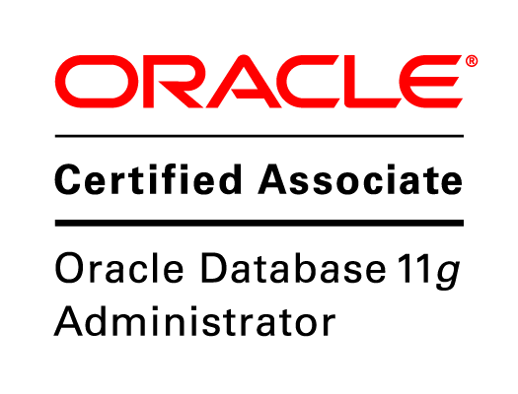
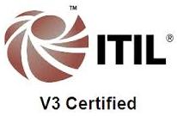

Purneet Kumar Satapathy
Mob: +91 973-184-6761
Email: purneetsse@gmail.com

PROFESSIONAL SNAPSHAOT Ready to Join Immediately
- Having around 8.4 of years experience in Build & release, Production / Application Support, DevOps solution and object-oriented analysis and Oracle Database Administration.
- Proficient in Build & Release Management / Incident /Change Management and DevOps Tool chain implementation.
- Worked as Release/Operations Engineer with good understanding of the DevOps principles.
- Worked on implementing, Provisioning and Troubleshooting Continuous Integration (CI), Continuous Delivery (CD) with DevOps Tool chain.
- Worked on POC of Secure DevOps implementation with Coverity, HeartBleed, SAST, SonarCube and CheckMarx and Docker.
- Monitoring in ITRS and AppDynamics for Services, jobs, Transactions , Environments.
- Working on Reporting (Jira / Wiki Page) / ITSM tool (Service Now).
- Proficient on Build & Release tools (uDeploy, Jenkins, Maven).
- To achieve Continuous Delivery goal on high scalable environment, used Docker coupled with load-balancing tool Nginx .
- Virtualized the servers using Docker for the test environments and dev-environments needs, also configuration automation using Docker containers.
- Implemented a production ready, load balanced, highlyavailable , faulttolerantKubernetes infrastructure.
- Proficient in designing the deployment process using uDeploy on different platforms like UNIX and Windows.
- Understanding of SDLC and DevOps solution.
- Working in Source Control too like SVN, TFS and CA- Harvest, GitHub, Artifactory.
- Strong Knowledge in Project creation and Provisioning the Ms- AD groups.
- Strong Knowledge on Oracle DB Architecture & Database creation for production environment.
- Knowledge on Oracle network configuration which includes Listener configuration and TNS configuration.
- Knowledge on Disaster Recovery of Database and Load balancer for Jenkins and GitHub.

Cloud Experience:

- Hands on knowledge in AWS Cloud computing and in various cloud Platform like IAAS and PAAS.
- Worked on creating EC2, IAM, EBS, Load Balancer, S3 on AWS.
- Involved in creating AWS instances along with Installation and Configuration of Amazon Cloud AWS (EC2, S3, cloud watch).
- Involved in implementation of cloud (AWS) design and strategy.
- Well aware of AWS services and layers for data movement.

EMPLOYEEMENT SUMMARY

- Worked as Senior Technology specialist (ASE4) with Wells Fargo Pvt Ltd, Bangalore (2016-2019)
- Worked as Senior Software Engineer with HCL Technologies, Bangalore. (2013 - 2016)
- Worked as Jr Oracle Consultant with Sysinnova Pvt Ltd, Bangalore. (Got permanent position after 8 months)
(2011 - 2013)

TECH STACK

Database | Oracle 10g/11g r2
Operating Systems | UNIX, Linux, Windows
Program language | SQL, PL/SQL
Tools | Toad 8.5, Team City, Putty0.6, VC, PERFORCE P4, uDeploy, SVN 1.9.4, TFS2015,CA-Harvest, GitHub, AWS, Jenkins,Docker , Kubernetes, Maven, Artifactory, BlackDuck.
Monitoring | AppDynamics, SERVICENOW, SharePoint, Jira, Confluence
Methodologies | DevOps ( AWS/Azure ) and Agile

EDUCATION DETAILS

- Completed B-Tech in Computer Science and Engineering in 2010.

PROFESSIONAL EXPERIENCE

Wells Fargo India Solutions Pvt Ltd Duration: 2nd May 2016 to till date

Designation: Lead Technology Specialist - DevOps

Responsibilities:
- Proactively involve in L2/SME level administrative Support for Source Control, CI and CD tools.
- Providing Solution for a new Project / Repository /New Organization in TFS, SVN, Artifactory and GitHub.
- Provide guide lines for Source Control management.
- Actively participating in B&R, Change Management (CAB call, Code Freeze calendar schedule).
- Owning the Source Control like SVN, TFS and CA-Harvest, GitHub, Artifactory.
- Supporting to Deployment tool like uDeploy (IBM Urban Code) and Anthill.
- Creating and Managing Projects / Repositories for the Developer..
- Implementing, Provisioning and troubleshooting on Jenkins.
- Working with different region /platform / application team to setup new environment for a robust and streamlined process w.r.t DevOps Guidelines.
- Responsible for installation & configuration of Jenkins to support various Java builds and Jenkins plugins to automate continuous builds and publishing Docker images to the Arfy repository.
- Used CI/CD tools Jenkins, Git, Jira and Docker registry/daemon for configuration management and automation using Ansible .
- Created Containers in Docker .
- Monitoring the User and service Account Authorization and Authentication.
- Involved in TFS integration and Migration activity with Microsoft Team.
- Knowledge of Microsoft Azure w r t TFS2015.
- Monitoring the Alerts from ETFS Server and notifying the Server Engineer.
- Engage Dev team and users to ITIL Process for Release and Problem Management.
- Supporting to .Net and Java bases Applications.

HCL Technologies , Bangalore Duration: July 2013 to Apr 2016

Designation: Technology Lead (SSE)

Responsibilities:
- Provided B&R and L2 – Prod support
- Active involvement in the project management in terms of planning the parallel releases and merge.
- Coordinating with Application Owner for Change Life cycle with ITSM - Service Now
- Strong Knowledge in Creating Template, Change Request, Task Acceptance, Approval, Implementation, Submit, Report generate, Mailing to SR Mgmt from SN.
- Worked as DDL /DML/SP script reviewer & approver from DEV.
- Provided access/permission to Resource/Env/Application/Components in UCD.
- Performed Administrative activities in UCD, SVN, GitHub, TFS and CA- Harvest.
- Supported in Admin domain to Deployment tool like uDeploy , Perforce.
- Create and track daily release schedule, identify problems & track them to closure.
- Creating tablespaces and assign quotas for users and managing the user's roles and profiles

Sysinnova Pvt Ltd Duration: August 2011 to June 2013

Designation: Oracle Consultant

Roles and responsibilities:
- Provided L1 support for multiple Oracle Databases.
- Granting / Revoking the user Permissions/Roles /Profiles.
- Involved in automation task for daily health checkup / Space alert / Job Failure
- Involved in Health Monitoring and Bug Verification for 1st level support.
- Fixing the Prod DB issue with Sr DBAs.
- Estimate Storage requirement, Creation of Tablespace and other Database Primary Objects.
- Responsible for Oracle 10g/11g logical and physical databases design, implementation and maintenance on UNIX.
- Creating tablespace and assign quotas for users and managing the user's roles and profiles.
- Periodically DB monitoring performance using (Oracle Tools) ADDM, AWR and inform to the Senior Oracle database team..

PERSONAL INFORMATION

Nationality : Indian
Languages known : English, Hindi, Oriya

Bangalore
Purneet Kumar Satapathy

