ASSIGNMENT 2

1. Create a webpage using following html tags
a. Marquee
b. List
c. video and audio
d. anchor
e. image

<!DOCTYPEhtml>
<html>
<head>
<title>7 Wonders</title>
</head>
<body>
<h1><marquee>7 Wonders of World</marquee></h1>
<center><img src="c1.jpeg" width="150" height="150">
<img src="c2.jpeg" width="150" height="150">
<h4 align="center">7 Wonders are:</h4>
<dl>
<dt>Great Wall of China</dt>
<dt>Christ the Redeemer Statue</dt>
<dt>Machu Picchu</dt>
<dt>Chichen Itza</dt>
<dt>The Roman Colosseum</dt>
<dt>Taj Mahal</dt>
<dt>Petra</dt>
</dl>
<a href="table1.html">CLICK HERE</a>
<br>
<audio controls>
<source src="lp.mp3" type="audio/mpeg">
</audio>
<video width="200" height="200" loop controls><source src="o.mp4" type="video/mp4"></video>
</body>
</html>

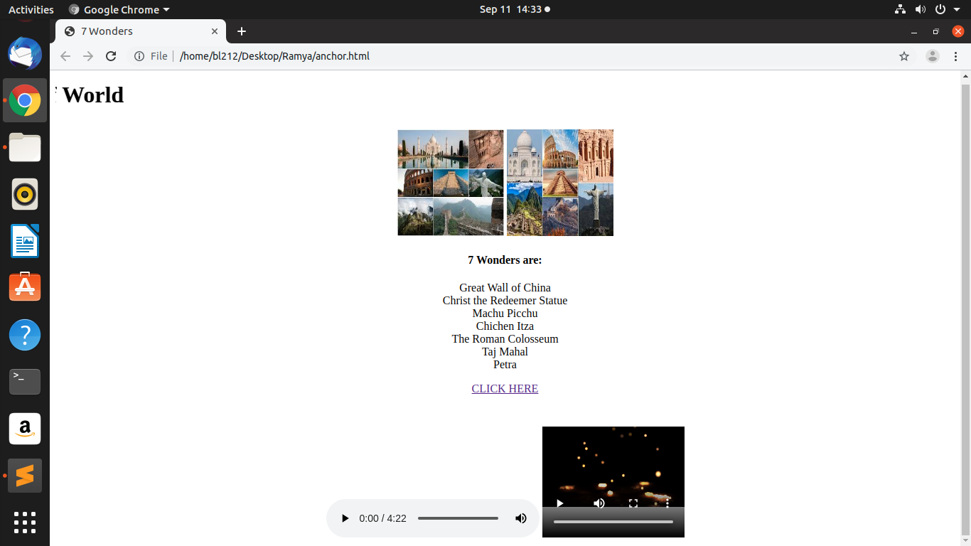

2. Create a webpage using all the elements of form tag.

<!DOCTYPE html>
<html>
<head>
<title>registration form></title>
</head>
<center>STUDENT REGISTRATION FORM</center>
<body bgcolor="Green">
<form>
<table>
<tr>
<td>First Name</td>
<td><input type="text" maxlength="15" placeholder="Enter your name"></td>
</tr>
<tr>
<td>Last Name</td>
<td><input type="text" required="true"></td>
</tr>
<tr>
<td>Mobile Number</td>
<td><input type="tel" maxlength="10"></td>
</tr>
<tr>
<td>Gender</td>
<td>
<input type="radio" name="gen" checked>Male
<input type="radio" name="gen">Female
</td>
</tr>
<tr>
<td>Date Of Birth</td>
<td><input type="date"></td>
</tr>
<tr>
<td>address</td>
<td><input type="text" placeholder="Mention your door number"></td>
</tr>
<tr>
<td>City</td>
<td><input type="text" name="city"></td>
</tr>
<tr>
<td>Pin Code</td>
<td><input type="tel"></td>
</tr>
<tr>

<td>State</td>
<td><input type="text" name="state"></td>
</tr>
<tr>
<td>Country</td>
<td><input type="text"></td>
</tr>
<tr>
<td>Hobbies</td>
<td>
<textarea placeholder="Write your hobbies" rows="10" cols="50"></textarea></td>

</tr>
<tr>
<td>Mode of transportation</td>
<td><input type="checkbox">Public
<input type="chechbox">Private
<input type="checkbox">Own
</td>
</tr>

<tr>
<td>Qualification</td>
<td><input list="study"></td></tr>
<datalist id="study">
<option value="SSLC">
<option value="II PUC">
<option value="Phd">
</datalist>

<tr>
<td>
<center>
<input type="submit" value="Submit">
</center>
</td>
<td>
<center>
<input type="Reset">
</center>
</td>
</tr>
</table>
</form>
</div>
</body></html>

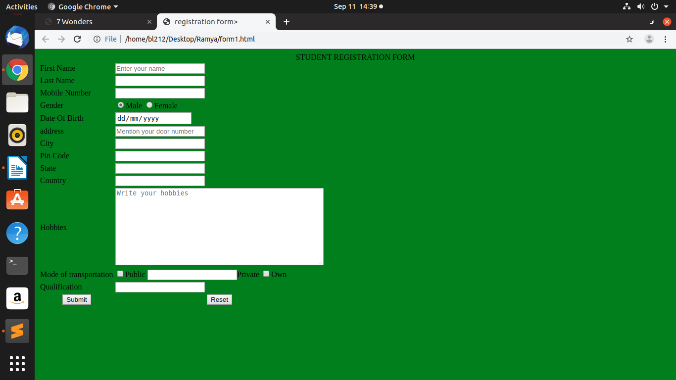

3. Create a webpage using following html tags
a. frameset b.frame

a.main
<!DOCTYPE html>
<html>
<head>
<title>CMR</title>
<FRAMESET ROWS="30%,70%">
<FRAME SRC="FRAME1.HTML" NAME="FRAME1" NORESIZE="NORESIZE">
<FRAME SRC="frame2.html" name="frame2">
</FRAMESET>
</head>
</html>

b.frame1
<!DOCTYPE html>
<html>
<head>
<title>FRAME1</title>
</head>
<BODY>
<CENTER><IMG SRC="logo.jpeg" WIDTH="150" HEIGHT="150">
<TABLE align="center" spacing="50">
<TR>
<TD><A HREF="project1.html" target="frame2">visit campus</A></TD>
<TD><A HREF="program structure.html" target="frame2">program schedule</A></TD>
<TD><A HREF="CONTACT US.HTML" target="frame2">contact us</A></TD>
</TR>
</TABLE>
</BODY>
</HTML>

c. frame2

<!DOCTYPE html>
<html>
<head>
<title>FRAME2</title>
</head>
<body bgcolor="pink">
<h1>WELCOME TO CMR</h1>
</body>
</html>
d. project1

<!DOCTYPE html>
<html>
<head>
<title>CMR UNIVERSITY</title>
</head>
<body bgcolor="lavender">
<center>
<marquee>
<img src="i1.jpeg" width="100" height="100">
<img src="12.jpeg" width="100" height="100">
<img src="i3.jpeg" width="100" height="100"></marquee></center>
<h1>CMR History</h1>
<p>CMR University is a private university located in Bangalore, Karnataka, India.CMR University (CMRU) has been established and is governed by the CMR University Act of 2013.</p>
<h1>Academics</h1>
<p>There are various programs under any disciplines:

School of Architecture and
School of Economics and Commerce and School of Legal Studies
School of Engineering & Technology and
School of Management and
School of Research & Innovation and
School of Social Sciences and Humanities</p>

</body>
</html>

e. program structure

<!DOCTYPE html>
<html>
<head>
<title>PROGRAM STRUCTURE</title>

</head>
<body bgcolor="lavender"><CENTER><H1>COMPUTER SCIENCE</H1></CENTER></body>
<p><h1>PROGRAM STRUCTURE</h1></p>
<table ALIGN="CENTER">
<tr>
<td>
<h4>I SEMESTER</h4>
<UL>
<LI>Engineering Mathematics – I</LI>
<LI>Engineering Chemistry</LI>
<LI>Computer Aided Engineering Drawing and Rapid Prototyping</LI>
<LI>Making With Electronics</LI>
<LI>Environment and Sustainability</LI>
<LI>Professional Communication-I</LI>
<LI>Induction program</LI>
</UL>
</td>
<TD>
<H4>II SEMESTER</H4>
<UL>
<LI>Engineering Mathematics-II</LI>
<LI>Basic Electrical Engineering</LI>
<LI>Engineering Workshop Practice</LI>
<LI>Programming with Python</LI>
<LI>Professional Communication – II</LI>
<LI>Modern History of Engineering</LI>
</UL>
</TD>
</tr>

</html>

f. contact us

<!DOCTYPE html>
<html>
<head>
<title>CONTACT US</title>
</head>
<body bgcolor="lavender">
<TABLE BORDER="1">
<TR>
<TD>NAME</TD>
<TD><INPUT TYPE="TEXT" MAXLENGTH="10" PLACEHOLDER="ENTER YOUR NAME"></TD>
</TR>
<TR>
<TD>EMAIL</TD>
<TD><input type="email" pattern="[a-z0-9,%+-]+@[a-z0-9.]+\.[a-z0{2,}$"></TD>
</TR>
<TR>
<TD>SUBJECT</TD>
<td>
<select>
<option value="COMPUTER SCIENCE">COMPUTER SCIENCE</option>
<option value="MECHANICAL">MECHANICAL</option>
<option value="CIVIL">CIVIL</option>
<option value="ELECTRONICS">ELECTRONICS</option>
</select>
</td>
</TR>
<TR>
<TD>DESCRIPTION</TD>
<TD><TEXTAREA PLACEHOLDER="ENTER YOUR VIEWS" ROWS="10" COLS="30"></TEXTAREA></TD>
</TR>
<TR>
<TH COLSPAN="2"><INPUT TYPE="SUBMIT" VALUE="SEND"></TH>

</TR>
</TABLE>
</body>
</html>

Output:

