**Beat The Calamity**

**Topic:** Disaster Management using Satellite Images and Social Media Analysis

**College**: R.V. College Of Engineering, Bangalore

**Team Member**: Ramya Ramanathan, Sindhu B Dinesh, Malika Makker

**Problem Statement** : To build a robust disaster management system, which can be used to analyse an area post disaster and to assist the people in distress, by drawing helpful insights from the satellite images and the social media posts of people regarding their state

**Components:**

1. **Road Detection in Flooded Areas**

Input to this component is a satellite image of a flooded area. The image is converted to its binary with thresholding. To find roads, concept of maximum number of connected pixels has been used. Any connected pixels of area lesser than 1000 are removed. The obtained pixels are skeletonized followed by edge detection. The obtained pixels are then overlaid on the original image.

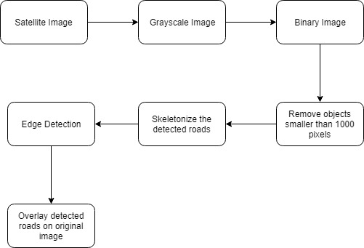

**2. Stranded people detection**

To detect the presence of stranded people, we have used a flood dataset which contains images taken during the flood along with their metadata. To detect the presence of people in the dataset, we perform object detection of people using the faster rcnn coco model and the Tensorflow Object Detection API.The detected people are then plotted on a map using the folium mapping tool

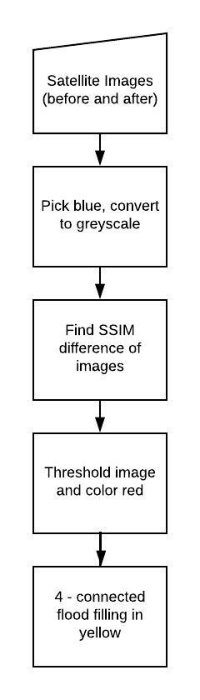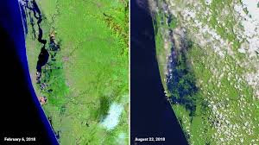

**3. Detection of Areas of damage**

This module takes input of satellite images before the flood, and during the flood, and compares them to find the areas of damage.The pictures are initially preprocessed by picking only the blue areas, in order to avoid the presence or absence of clouds.The difference between the images is calculated using SSIM and are thresholded to mark the most affected areas in red. 4 - connected filling is used to find the areas that might end up in danger, and are marked in yellow. Other areas are colored green to show safety.

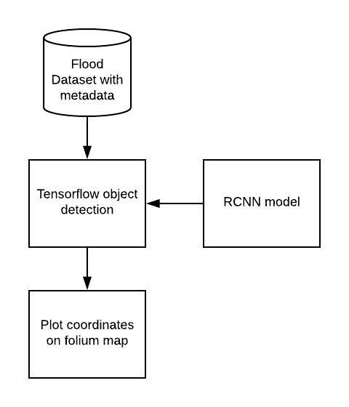

**4. Identifying items necessary for relief operations**

This module scrapes a flood helpline website entries and processes the output to obtain list of items that are basic necessities for relief operations.

It uses Tweepy API to scrape tweets containing hashtags that are most used with the disaster. The tweets are then tokenized and compared to list of items obtained from the previous section to obtain final list of items.

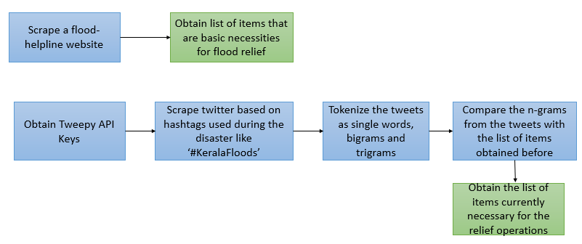

**5. Locate help centers and forward list of necessary items**

The list of necessary items thus obtained are forwarded to the help centers so that they can provide whatever they can for the relief operations and the remaining items are forwarded to the other help centers.

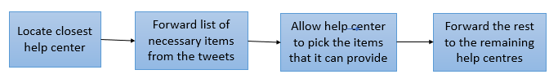

**6. Sentiment Analysis using Azure Text Analytics API**

Tweets are scraped from twitter from an account based on flood relief and the sentiment of the tweets are analysed using Azure Text Analytics API and plotted across the different dates to show the variation in sentiment.

