**Movie Dataset Analysis**

**Problem Statement** : Movie dataset analysis

**Team size** : 3

**Team members** :Ramya Ramanathan, Aakanksha Ashok, Malika Makker

**Problem statement defined in simple terms** : To draw intelligence and trends from the Bollywood Dataset consisting of poster, trailer, wikipedia and script data.

**Technologies/Platforms/APIs planned to use** : Python 3.5, IBM Watson, nltk, wordcloud, scikit, matplotlib, shapely etc.

**Role of each team member** :

Malika Makker – Word cloud, get frequent characters, and graph based trend analysis

Ramya Ramanathan – UI, Clustering and graph based trend analysis

Aakanksha Ashok – System integration and graph plotting

**Scope of work/ component design in the opted problem statement** :

For the dataset provided, we decided to do the following analysis:

1. Character analysis of various actors in a movie using the script of the movie and displaying the result in the form a word cloud
   * The script of the movie is tokenized and divided into dialogues and narratives
   * The narrative is analysed to pick the top three main actors in the movie
   * The verbs and the adverbs used for a particular character are put in respective lists
   * Those lists are used to create word clouds of different actors, giving an overview of the character being portrayed in the movie
   * Further, IBM Tone Analyzer API is used to find the tone of the ending of the movie as well as that of the character.

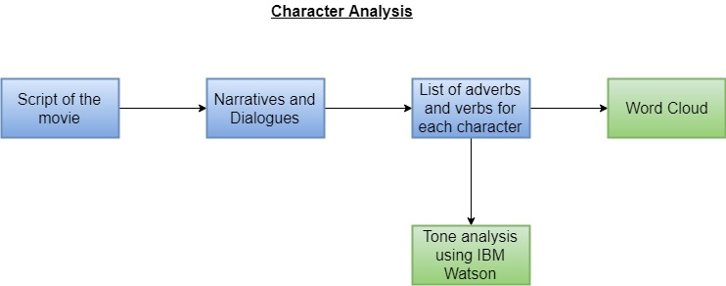

1. Predicting climax of a movie
   * To predict the climax of the movie, we used the trailer data of individual movies present in the *individual-trailers-data* folder. The data consisted of frame number, emotion of the frame and the gender of the actor present in the frame.
   * We made a range of various emotions varying from negative to positive. Angry being 0 and happy being 6
   * The graph was plotted with frame number being x-axis and emotion being y-axis
   * The graph had a line for the emotion variance of both man and woman
   * The points where the emotion of both man and woman intersected and showed a great variation after the point of intersection was predicted as the frame of climax

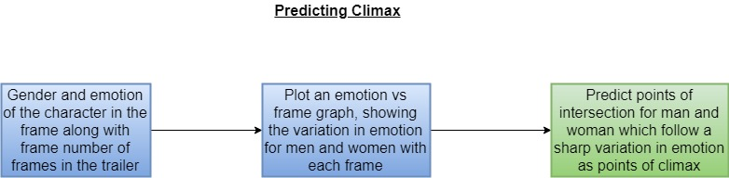

1. Predicting emotion of male and female in movies in future years
   * To predict emotion, we used complete data dataset available in trailers datawhich contains male and female emotion information over the years
   * After grouping by the year of release, the emotion was scaled using above mentioned scale having 0 for anger and 6 for happiness and plotted.
   * The trend was then extended to year 2020, by using the Linear Regression Model.

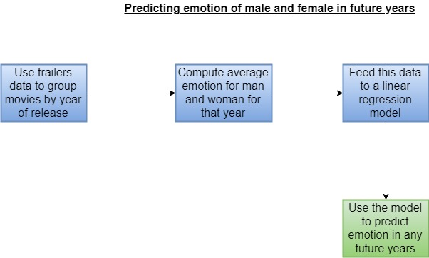

1. Tracking male and female centrality using Sentiment Analysis
   * To predict emotion, we used commonly used adjectives of male and female over the years, present in Wikipedia data
   * To get the value of emotion, Vader sentiment of the nltk package was used on adjectives..
   * The compound score of sentiment was plotted for men and women.

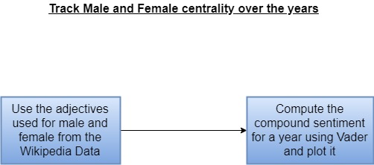

1. Genre detection using information extracted from poster images
   * From the images of poster data, we extracted image features such as brightness, and average RGB values
   * The most prevalent emotion of the people in the poster is also calculated.
   * The data is then clustered using K-means algorithm to identify thriller, action, comedy and romance as the respective classes.
   * These classes were selected because of their significance in Bollywood industry

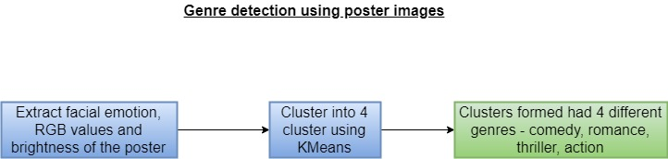

6. Songs DB male vs female plotting

* SongsDB.csv file was used for the analysis.
* The movies were grouped by the year of release.
* The male and female singers count for each of those movies was summed and plotted for that particular year.