|  |  |  |  |
| --- | --- | --- | --- |
|  | **Sigmoid** | **Tanh** | **Relu** |
| **Train.CSV and Test.CSV** | After 1000 iterations, the total error is 1.99806531391  Test error is 1.0197498266 | After 1000 iterations, the total error is 2.0  Test error is 0.693357325052 | After 1000 iterations, the total error is 1.5  Test error is 0.847741468638 |
| **IRIS Dataset** | After 1000 iterations, the total error is 5.37512668062  Test error is 2.17052501344 | After 1000 iterations, the total error is 1.89709886072  Test error is 0.588088895715 | After 1000 iterations, the total error is 10.3632272999  Test error is 2.42278646277 |
| **Car Evaluation Dataset** | After 1000 iterations, the total error is 78.4769604264  Test error is 20.8071673903 | After 1000 iterations, the total error is 631.232518913  Test error is 166.373153718 | After 1000 iterations, the total error is 89.7896572085  Test error is 21.3931193132 |
| **Adult Census Income Dataset** | After 1000 iterations, the total error is 1096.41729058  Test error is 268.455617405 | After 1000 iterations, the total error is 11700.343088  Test error is 2925.3125349 | After 1000 iterations, the total error is 1089.11842557  Test error is 275.754482415 |

**1. Train.CSV and Test.CSV**

In this case relu activation function works better as it gives comparatively less train and test errors

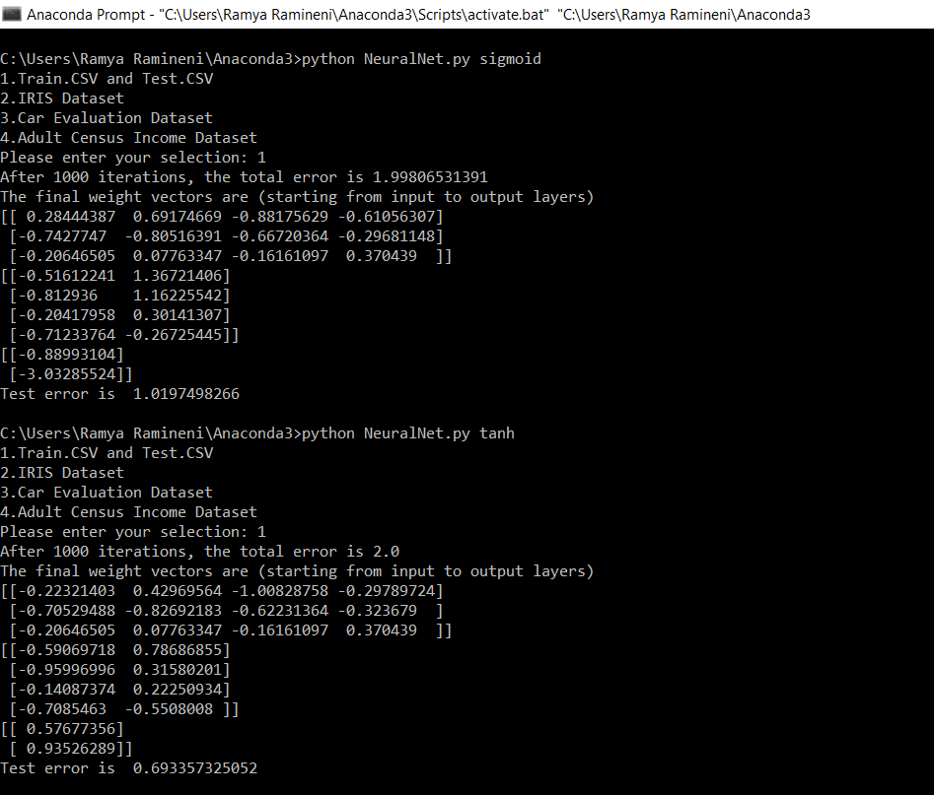

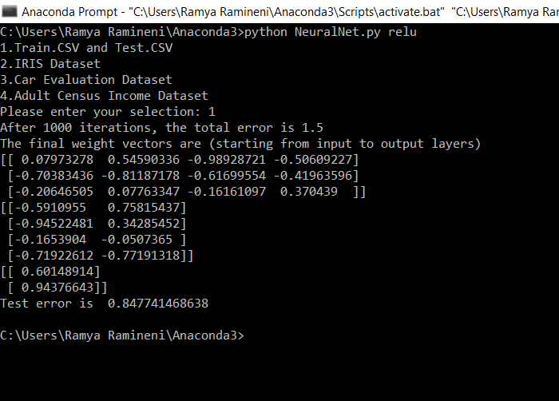

**2. IRIS Data Set**

In this case Tanh activation function works better as it gives less test error

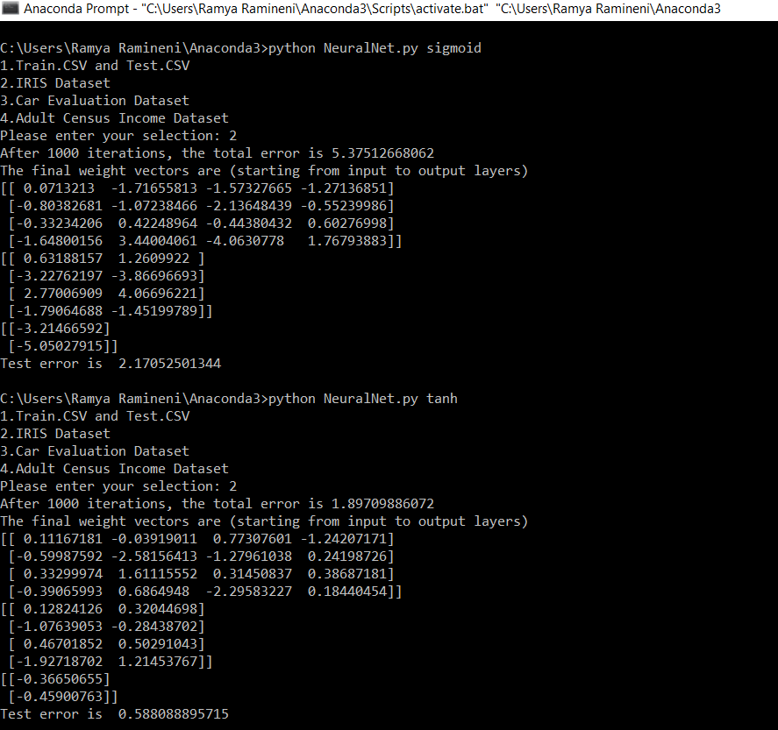

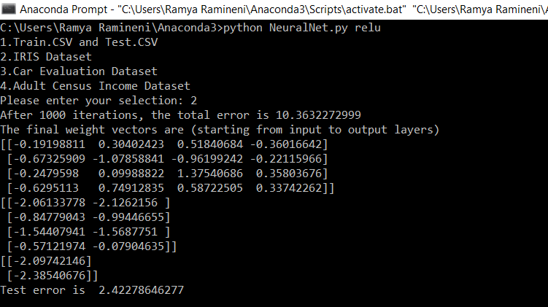

**3. Car evaluation Dataset**

In this case Sigmoid activation function works better as it gives less test error

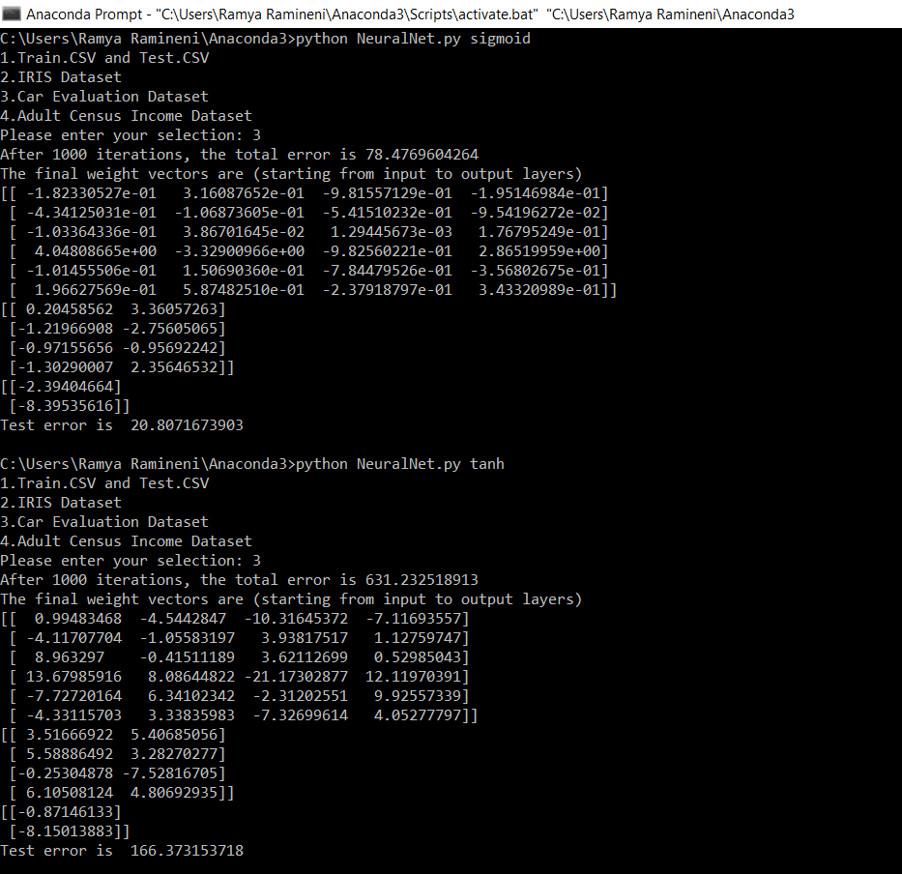

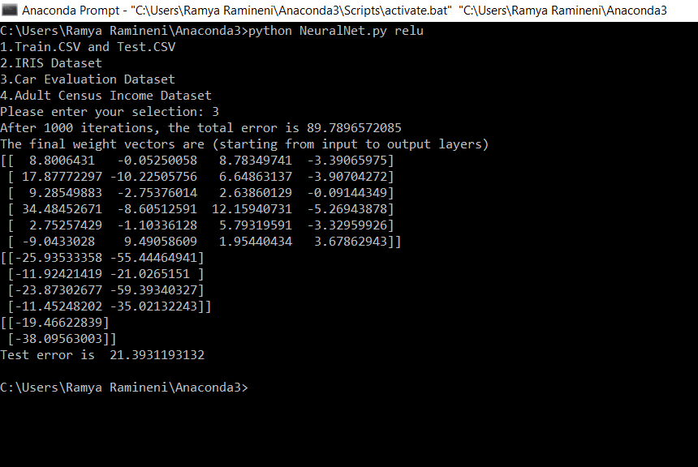

**4. Adult Senses Income Dataset**

In this case sigmoid activation function works better as it gives less train and test errors

