**How to setup Ansible and SSH keys in AWS**

1. Create 3 AWS ec2 instance in ubuntu

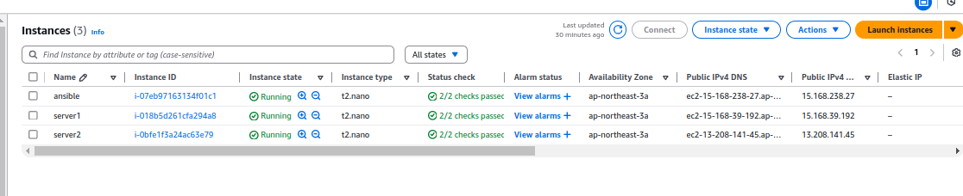

First instance - Ansible

Two instance - Server1 and server2

1. Login in Ansible EC2 instance and use these commands

→ switch as root

**sudo su -**

→ update packages

**apt update -y**

**→** run the following command to include the official project’s PPA (personal package archive) in your system’s list of source

**apt-add-repository ppa:ansible/ansible**

→ Next, refresh your system’s package index so that it is aware of the packages available in the newly included PPA:

**apt update**

→ Following this update, you can install the Ansible software with:

**apt install ansible -y**

→ Check ansible version

**ansible --version**

→ Go the hosts and add your server1 and server2

**nano /etc/hosts**

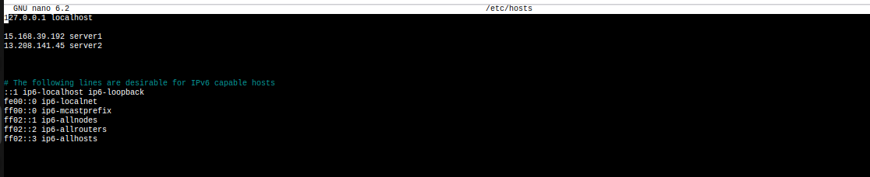

Add : **15.168.39.192 server1**

**13.208.141.45 server2**

→ Generate ssh key from ansible server

**ssh-keygen -t rsa**

And

**Press - Enter → Enter → Enter**

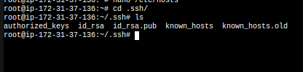

Your you can see ssh keys of public key and private key

→ Copy the public key (id_rsa.pub) and paste it in athuorized_key on server1 and server2

**cat id_rsa.pub**



→ Go to the server 1 and server 2

→ Login server1 and paste this public key in .ssh/athuorized_key

**nano .ssh/authorized_keys**



Save it and come out from the shell

→ Login server1 and paste this public key in .ssh/athuorized_key

**nano .ssh/authorized_keys**



Save it and come out from the shell

→ Return to the Ansible server and check if the ping is working on server1 and server2.

**ping server1**

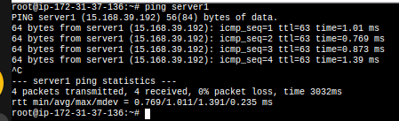

**ping server2**

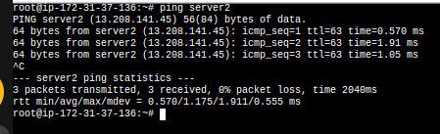

It is working fine in Ansible server

→ Create a directory in the name of Ansbile

**mkdir ansible**

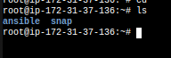

→ Get in the Ansible directory

**cd ansible**

→ Create a inventory file and add these hosts

**nano inventory**

**[webservers]**

**server1**

**server2** (save it and come out from the shell)

→ Create ansible.cfg file and these lines

**nano ansible.cfg**

**[defaults]**

**inventory=/root/ansible/inventory**

**remote_user=ubuntu**

**ask_pass=false** (save it and come out from the shell)

→ For testing purpose, we need to install nginx in server 1 and apache in server2 from ansible server

→ Create a yml file for install nginx and apache in server1 and server2

**nano install_webservers.yml**

**---**

**- name: Install Web Servers**

**hosts: webservers**

**become: true**

**tasks:**

**- name: Install Nginx on server1**

**apt:**

**name: nginx**

**state: present**

**when: inventory_hostname == 'server1'**

**- name: Install Apache on server2**

**apt:**

**name: apache2**

**state: present**

**when: inventory_hostname == 'server2'**

**- name: Ensure Nginx is started and enabled on server1**

**service:**

**name: nginx**

**state: started**

**enabled: yes**

**when: inventory_hostname == 'server1'**

**- name: Ensure Apache is started and enabled on server2**

**service:**

**name: apache2**

**state: started**

**enabled: yes**

**when: inventory_hostname == 'server2'**

(save it and come out from the shell)

→run ansible yml file following this command

**ansible-playbook -i /root/ansible/inventory install_webservers.yml**

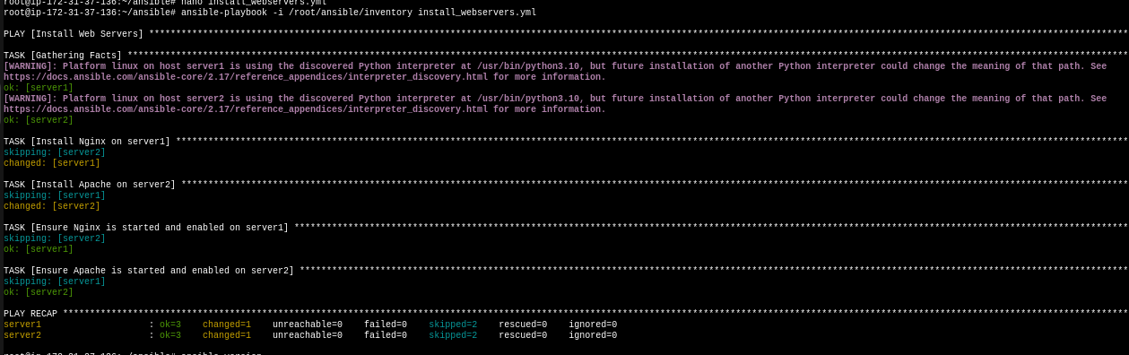

Here you can see installing nginx and apache each servers and you can test by copy each servers ip and paste it browser.