1)Question no:1

Answer:

//Creating Database

create database employee;

use employee;

//Creating Table

create table employee(

EmpNo int,

Employeename varchar(10),

job varchar(10),

Mgr int,

Hiredate date,

salary int,

commesion varchar(10),

Deptno int );

//Insert the values

INSERT INTO employee

VALUES

(8369, 'Ramya', 'Manager', 8902, '1990-12-18', 800.00, NULL, 20),

(8499, 'Velu', 'Salesman', 8698, '1991-02-20', 1600.00, 300.00, 30),

(8521, 'Rithu', 'Salesman', 8698, '1991-02-22', 1250.00, 500.00, 30),

(8566, 'Salman', 'Clerk', 8836, '1991-04-02', 2985.00, NULL, 20),

(8654, 'Hari', 'Salesman', 8698, '1991-09-28', 1250.00, 1400.00, 30),

(8698, 'Bina', 'Manager', 8839, '1991-05-01', 2850.00, NULL, 30),

(8882, 'Shivansh', 'Manager', 8839, '1991-06-09', 2450.00, NULL, 10),

(8888, 'Scott', 'Analyst', 8566, '1992-12-09', 3000.00, NULL, 20),

(8839, 'Amir', 'President', NULL, '1991-11-18', 5000.00, NULL, 10),

(8844, 'Kuldeep', 'Salesman', 8698, '1991-09-08', 1500.00, 0.00, 30);

//display the table

select *from employee;

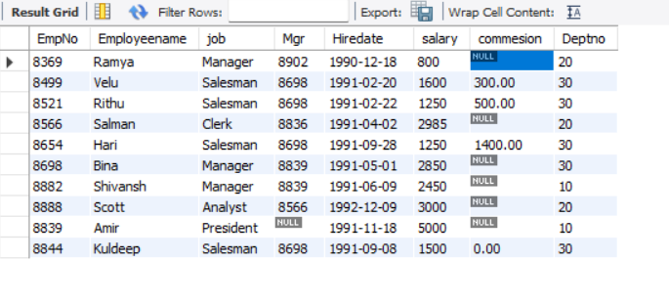

a)Write q query to display Employeename and salary of employee whose salary are greater then or equal to 2200?

Answer:

SELECT Employeename, salary

FROM employee

WHERE salary >= 2200;

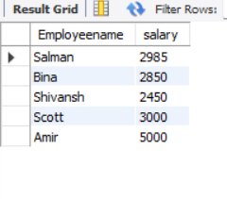

B)write a query to display details of employee who are not getting commission?

Answer:

SELECT *

FROM employee

WHERE commesion IS NULL OR commesion = '0.00';

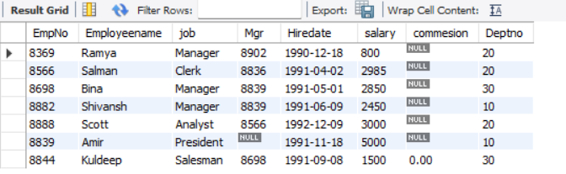

c) Write q query to display Employeename and salary of those employee who don’t have their salary in range 2500 to 4000?

Answer:

SELECT Employeename, salary

FROM employee

WHERE salary < 2500 OR salary > 4000;

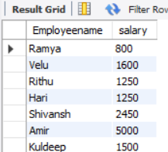

d)write a query display employeename,job,salary of employee who don’t have a manager?

Answer:

SELECT Employeename,job,salary

FROM employee

WHERE job!='Manager';

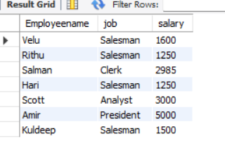

e)Write a query to display to name of the employee whose name contain “A” as third alphabet?

Answer:

SELECT *

FROM employee

WHERE employeename LIKE '__a%';



f) Write a query to display to name of the employee whose name contain as the last alphabet?

Answer:

SELECT *

FROM employee

WHERE employeename LIKE '%t';

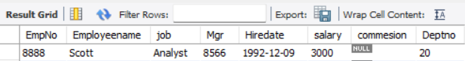

Question no:2(Database connectivity)

Source code github link: <https://github.com/RamyaRithu/databaseconnectivity.git>

Output:

