**COEN 275 – Spring 2017**

**Object Oriented Analysis, Design and Programming**

**So Safe Home Security System**

Deliverable-1

(Use Case Diagram, Use Cases, CRC Cards)

**Submitted By**

Haritha Mannuru

Ramya Sivaraman

**Table of contents:**

**1. Use Case Diagram** **3**

**2. Use Cases** **4**

2.1 Use Case 1 4

2.2 Use Case 2 5

2.3 Use Case 3 6

2.4 Use Case 4 7

2.5 Use Case 5 8

2.6 Use Case 6 9

2.7 Use Case 7 10

2.8 Use Case 8 11

**3. CRC Cards** **12**

### 1. Use Case Diagram

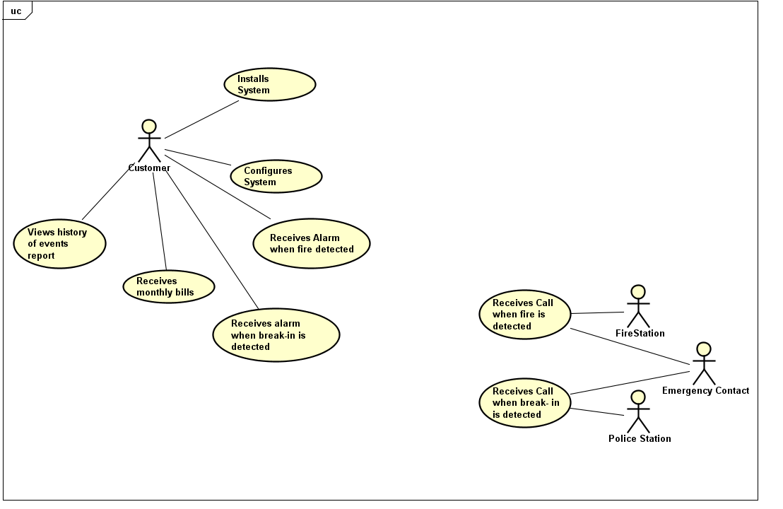

### 2. Use Cases

#### 2.1 Use Case 1

|  |  |
| --- | --- |
| Use-Case: (Goal): Install SoSafe Home security system in the building | |
| Actors: Customer | |
| Type: Primary, Essential | |
| Description: Customer wants to install the SoSafe Home security system in the building | |
| Cross-references: | |
| Scenario Details (Typical course of events): | |
| Actor Action:  1. Customer presses the power button ON on the SoSafe Home security system.  3. Customer enters all the details as requested by the system  5. Customer chooses the Service_Type as required.  7. Customer chooses the location.  9.Customer presses save button | System Response:  2. Prompts the customer to enter the Customer details, password set up, emergency contact and phone numbers.  4. Prompts the Customer to choose the Service_Type   * Breakin * Fire * Both   6. System displays the building layout to the customer for sensors installation.  8. Prompts the customer to press save button  10. Sensors are installed accordingly |

Alternative Courses:

Line 9: Customer exits without pressing save button, system displays installation failed message and exits.

#### 2.2 Use Case 2

|  |  |
| --- | --- |
| Use-Case: (Goal): Configuring the system for activating and deactivating the sensors. | |
| Actors:Customer | |
| Type: Primary, Essential | |
| Description: Customer wants to configure the system. | |
| Cross-references: | |
| Scenario Details (Typical course of events): | |
| Actor Action:  1. Customer selects the activate/deactivate option from the control panel display  3. Customer enters the Username and password.  5. Customer either Checks or Unchecks the sensors (activate / deactivate)  7. Customer enters the details as per the requirement and selects Save. | System Response:  2. Prompts the customer to enter the Username and password.  4. Login details OK, System displays a list of sensors that are installed in the building.  6. System prompts to select from_time and to_time or manually enter the start date and time and end date and time of the sensors to be activated.  8. System saves the details and displays the success message. |

Alternative Courses:

Line 4: Login details fails. Indicates customers to enter correct login details.

Line 7: Customer exits without pressing save button, system displays configuration failed message and exits.

#### 2.3 Use Case 3

|  |  |
| --- | --- |
| Use-Case: (Goal): Receive a phone call in case of fire. | |
| Actors: Fire Station, Emergency Contact | |
| Type: Primary, Essential | |
| Description: Monitoring Service receives a phone call in the event of fire breakout. | |
| Cross-references: | |
| Scenario Details (Typical course of events): | |
| Actor Action:  2. Monitoring Service enters the response code | System Response:  1. Sprinklers ON, Alarm On, calls monitoring service every 1 minute until response with time of the call, service number, location and nature of the problem details.  3. Call and Alarm stops on receiving the code. Logs the information about the problem including when the call is made and the time of response. |

#### 2.4 Use Case 4

|  |  |
| --- | --- |
| Use-Case: (Goal): Receive alarm in case of fire. | |
| Actors: Customer | |
| Type: Primary, Essential | |
| Description: Customer receives an alarm in the event of fire breakout. | |
| Cross-references: | |
| Scenario Details (Typical course of events): | |
| Actor Action:  2. Customer enters the Response code. | System Response:  1. Sprinklers ON, Alarm ON  3. Alarm Stops. |

#### 2.5 Use Case 5

|  |  |
| --- | --- |
| Use-Case: (Goal): Receive alarm in case of a breakin. | |
| Actors: Customer | |
| Type: Primary, Essential | |
| Description: Customer receives an alarm in the event of an intruder break in. | |
| Cross-references: | |
| Scenario Details (Typical course of events): | |
| Actor Action:  2. Customer enters the Response code. | System Response:  1. Alarm ON  3. Alarm Stops. |

#### 2.6 Use Case 6

|  |  |
| --- | --- |
| Use-Case: (Goal): Receive phone call in case of a breakin to the building. | |
| Actors: Police Station, Emergency Contact | |
| Type: Primary, Essential | |
| Description: Monitoring Service receives an alert in the event of a breakin to the building. | |
| Cross-references: | |
| Scenario Details (Typical course of events): | |
| Actor Action:  2. Monitoring Service enters the response code | System Response:  1. Alarm ON, calls monitoring service every 1 minute until response with time of the call, service number, location and nature of the problem details.  3. Alarm and call stops on receiving the code. Logs the information about the problem including when the call is made and the time of response. |

#### 2.7 Use Case 7

|  |  |
| --- | --- |
| Use-Case: (Goal): Receive monthly bills. | |
| Actors:Customer | |
| Type: Primary, Essential | |
| Description: Customer receives bills monthly for the events occurred. | |
| Cross-references: | |
| Scenario Details (Typical course of events): | |
| Actor Action:  2. Customer accesses the bill ,views the details of the bill and selects the Pay option on the display. Customer enters the password and Card details for validation. | System Response:  1. System generates bills monthly based on the events occurred in the building in that month and sends a pop up displayed on the System’s control panel.  3. Validates password and card details. Payment Ok, processes the payment and displays the payment success message. Stores the payment as a log to the database for the Customer to access in future. |

Alternative Courses:

Line 3: Validation of password or card details unsuccessful. Prompts payment failure message.

#### 2.8 Use Case 8

|  |  |
| --- | --- |
| Use-Case: (Goal): Access logged info to view the history of incidents occurred. | |
| Actors:Customer | |
| Type: Primary, Essential | |
| Description: Customer views the history of incidents occurred. | |
| Cross-references: | |
| Scenario Details (Typical course of events): | |
| Actor Action:  1. Customer selects the Log info screen.  2. Customer enters details as per the requirement and selects submit. | System Response:  1. System prompts the user to enter details as From_date and To_date, Event types (Fire/Breakin), all history.  3. System provides the below information:   * Event Type * Event Time * Event Location * Call Time(time when call made) |

### 3. CRC Cards

|  |  |
| --- | --- |
| **Class Name: Sensor** | |
| ***Super Classes:*** | |
| ***Sub Classes:* TempSensor, MotionSensor** | |
| **Responsibility** | **Collaborator** |
| Knows its type |  |
| Identifies its location | Location |
| Enables/Disables based on schedule | Schedule |
| Identifies Fire/Breakin events | Event |

|  |  |
| --- | --- |
| **Class Name: Schedule** | |
| ***Super Classes:*** | |
| ***Sub Classes:*** | |
| **Responsibility** | **Collaborator** |
| Identifies manual/automated schedule type |  |

|  |  |
| --- | --- |
| **Class Name: Bill** | |
| ***Super Classes:*** | |
| ***Sub Classes:*** | |
| **Responsibility** | **Collaborator** |
| Generates monthly invoice | Event, Sensor |

|  |  |
| --- | --- |
| **Class Name: Location** | |
| ***Super Classes:*** | |
| ***Sub Classes:*** | |
| **Responsibility** | **Collaborator** |
| Represents location information |  |

|  |  |
| --- | --- |
| **Class Name: Event** | |
| ***Super Classes:*** | |
| ***Sub Classes:* FireEvent , BreakinEvent** | |
| **Responsibility** | **Collaborator** |
| Identifies Fire/Break in Events |  |

|  |  |
| --- | --- |
| **Class Name: LoggedInfo** | |
| ***Super Classes:*** | |
| ***Sub Classes:*** | |
| **Responsibility** | **Collaborator** |
| Displays history of events, sensors and their locations | Event, Sensor, Location |

|  |  |
| --- | --- |
| **Class Name: System** | |
| ***Super Classes:*** | |
| ***Sub Classes:*** | |
| **Responsibility** | **Collaborator** |
| Gets login info, customer info. |  |
| Generates monthly bills | Bill |
| Monitors events, calls monitoring service | Sensor, Event, Location |
| Interacts with databases, fetch values, responds to UI requests. | LoggedInfo |