Dataset: Song Popularity Dataset
Submitted by: Ramya S
Project Details:
Humans have greatly associated themselves with Songs & Music. It can improve mood, decrease pain and anxiety, and facilitate opportunities for emotional expression. Research suggests that music can benefit our physical and mental health in numerous ways.
Lately, multiple studies have been carried out to understand songs & its popularity based on certain factors. Such song samples are broken down & their parameters are recorded to tabulate.
Objective:
To predict the Song Popularity based on energy, acoustics, instrumentals, liveness, danceability, etc.
- Understand the Dataset & cleanup (if required).
- Build Regression models to predict the song popularity.
- Also evaluate the models & compare their respective scores like R2, RMSE, etc.

Description about the project:
Data Description:
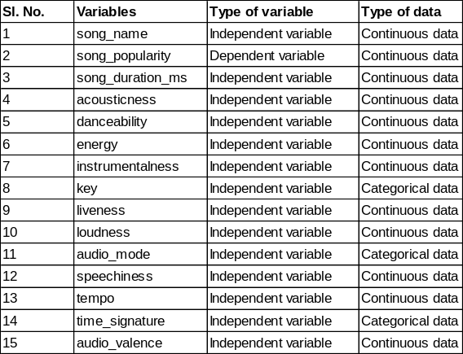
Target Variable: Song Popularity (variable2)
R Packages & libraries used:
- fastDummies – to convert categorical data into dummies
- psych – to visualize the correlation between continuous data
- caTools – to split the training and test data
- caret – for classification problem, predict and build model
- car – to check the multicollinearity of independent variables

Step-by-Step approach followed in data analysis:
- Exploratory Data Analysis
- Data Pre-Processing
- Data split into Training & Test (Validation) data
- To perform Linear Regression, 10-fold cross validation, Ridge, Lasso & Elastic net
- Compare the models and identify the lowest RMSE (root mean square error)
- Predict the best model on the Test data
- Final recommendation

- Exploratory Data Analysis and Data Pre-processing:
- We read the data using read.csv(). Dataset has 18835 observations and 15 variables including 1 Target variable (Song popularity which is a continuous data)
- Removed first column which is Song name
- There were no missing values in the dataset
- Performed a chi-square test to check the relationship between the categorical variables and target variable. We assumed alpha as 0.05 and if output p-value is greater than alpha, those variables will be removed as they are not significant. Lesser the p-value highly significant it is to the model.
We have 3 categorical variables (key, audio mode, time signature). After the test, we found that column “time signature” resulted in high p-value (0.02>0.05) since pvalue is greater than alpha we decided to exclude this variable.
- Using pairs.panels, checked for the correlation between the continuous data. Below is the screenshot of the same. There is correlation between “energy” and “loudness”. However, we shall not drop the variable at this stage.
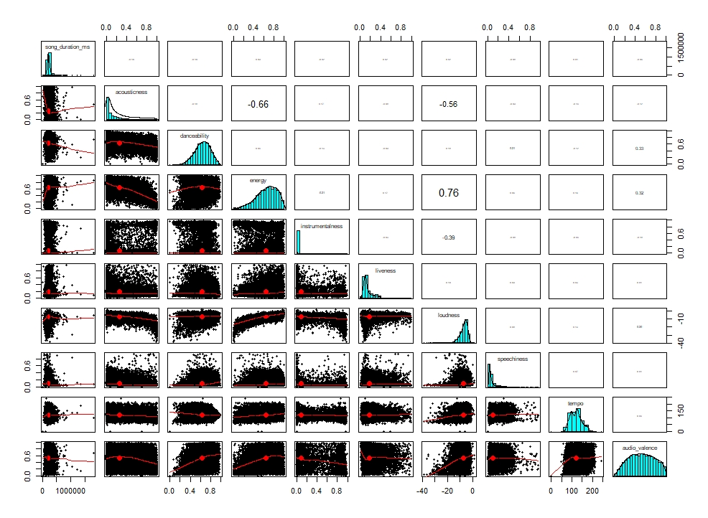

- Split the data into Training & Test (validation data)
- Split the data into training and test (validation data) with 80:20 ratio
- Performed Linear Regression, Stepwise Regression, 10-fold cross validation, Ridge, Lasso & Elastic net
- Performed Logistic regression and stepwise regression to overcome multicollinearity issue and below is the screenshot of the summary and vif of the model
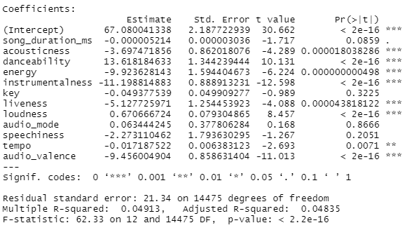
- From the summary and vif of linear regression, we observed that there were a greater number of insignificant variables hence we deleted those insignificant variables from our main dataset, train and test data.
- Following variables were dropped as they were insignificant from our first round of Linear Regression:
- song_duration_ms
- key
- audio_mode
- speechiness
- tempo

- Re-ran the linear regression and stepwise regression. We found that the variables were significant. Hence, we will proceed further with the analysis.

- Perform 10-fold cross validation, below is the summary and visualization on the important variables
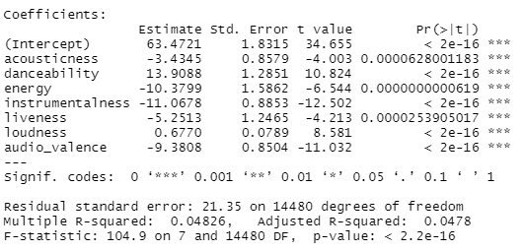
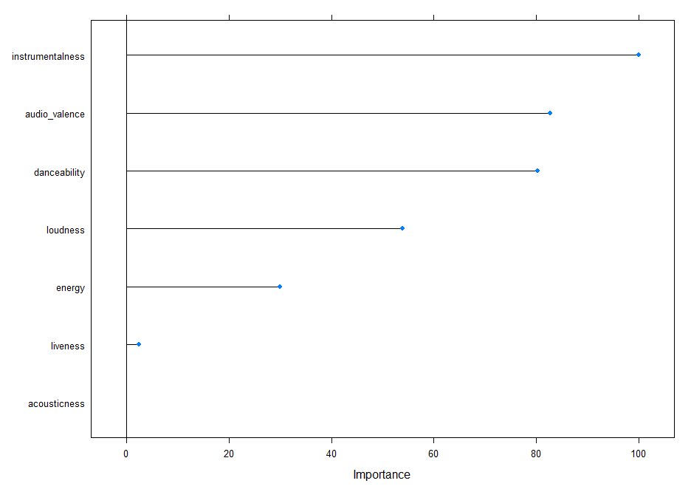

- Performed Ridge regression with the parameter tuning lambda (ranging from 0.01 to 1) and below are the results:
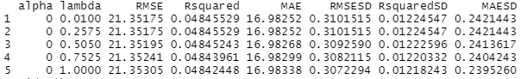

Observations are: alpha=0, lambda=0.2575, RMSE=21.35
Visualization on the important variables:
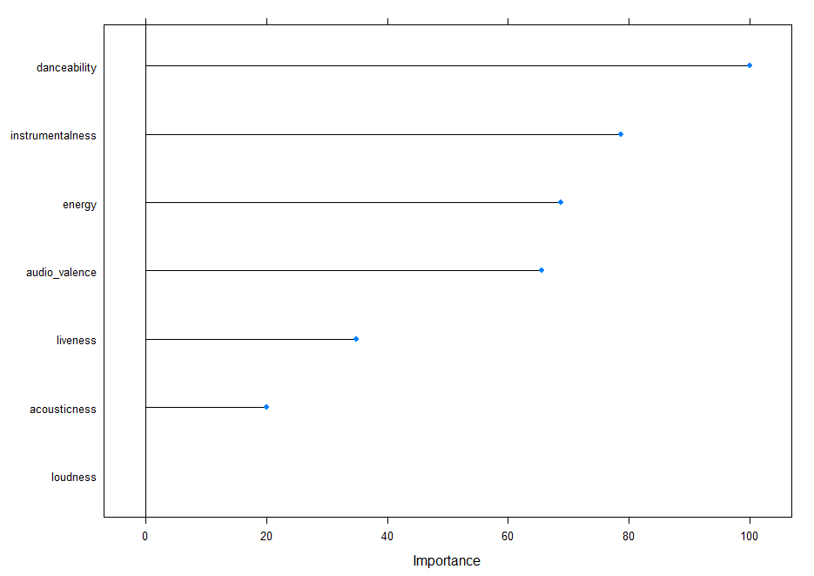
- Performed Lasso regression with alpha and parameter tuning lambda (ranging from 0.01 to 1) and below are the results:
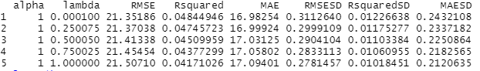
Observations are: alpha=1, lambda=0.0001, RMSE=21.35
Visualization on the important variables:
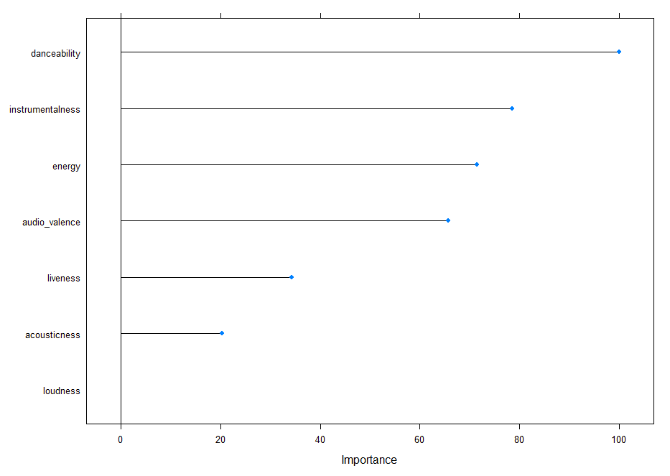
- Performed Lasso regression with alpha and parameter tuning lambda (ranging from 0.01 to 1) and below are the results:
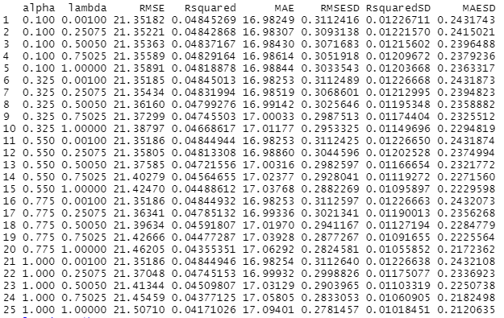
Observations are: alpha=0.1, lambda=0.001, RMSE=21.35
Visualization on the important variables:

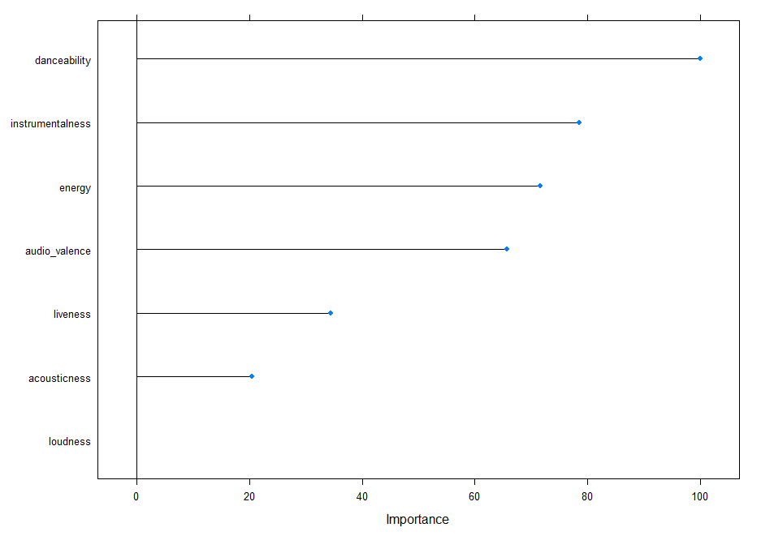
- Compare the Regression models (Linear via 10-fold Cross validation, Ridge, Lasso, Elastic net)
- We compared the Regression models and below is the summary of comparison. We used metrics such as MAE, RMSE, R-squared
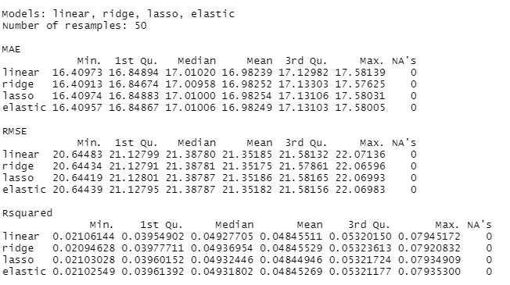
- From comparison, we understood that Linear Regression via 10-fold cross validation is the best model with low RMSE or MAE. However, we shall predict all the models on test data before recommending a model
- Final Recommendation
Estimated the difference between Actual vs Predicted values, and the difference is the error. We used RMSE as the evaluation metrics to understand the error percentage. Linear Regression model via 10-fold cross validation method has low RMSE=21.61

