**Assignment #2**

**Pre requisites:**

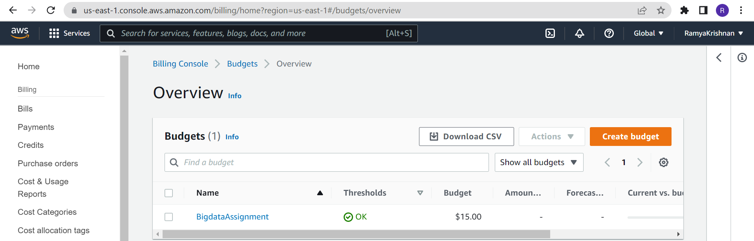

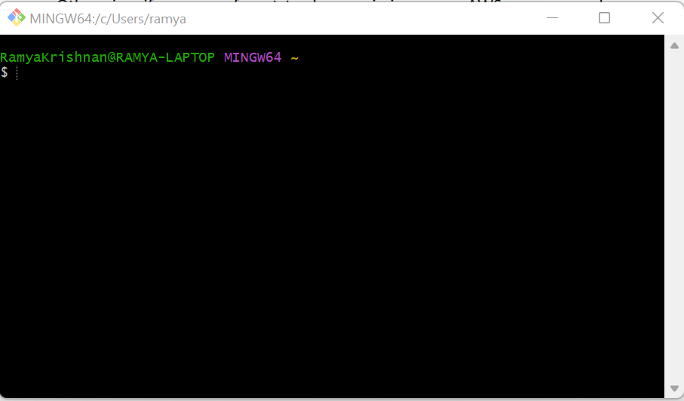

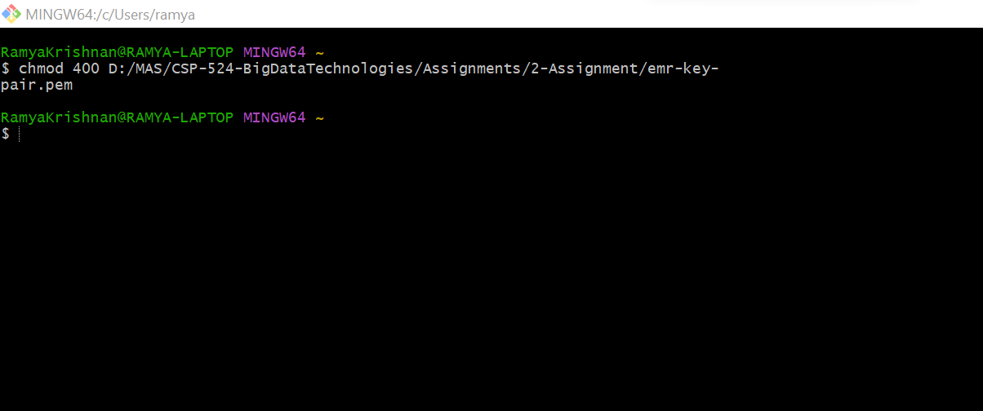

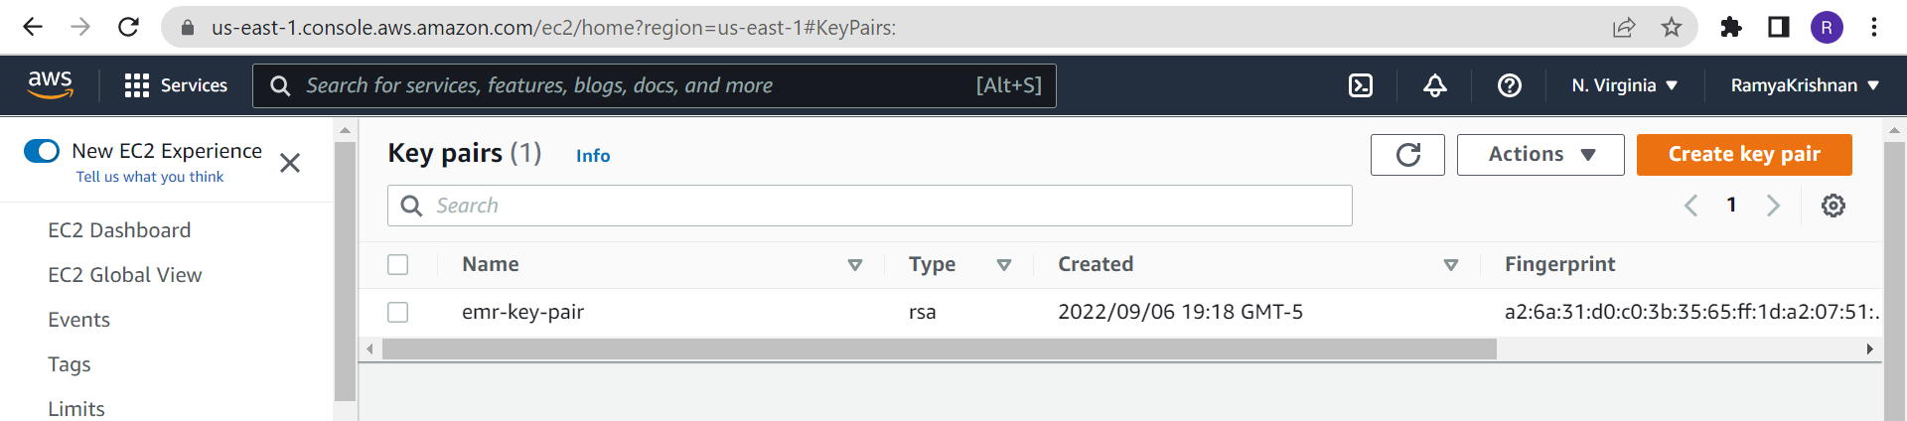

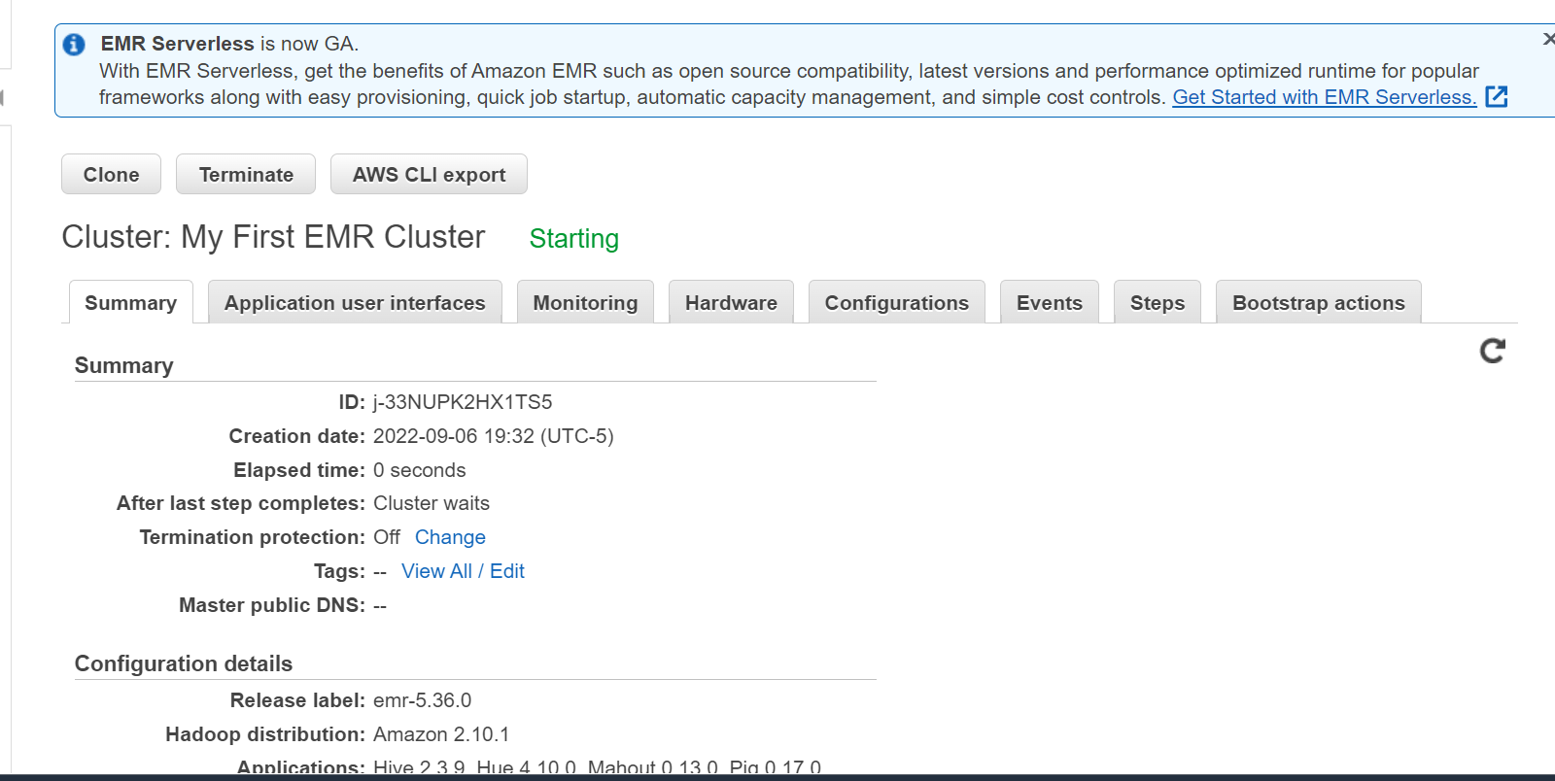

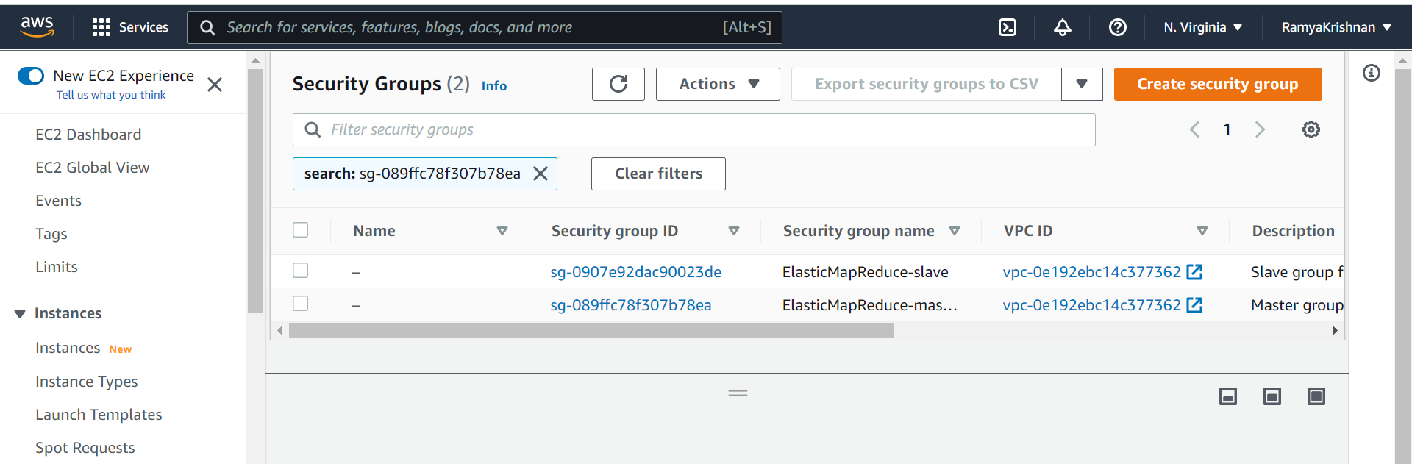

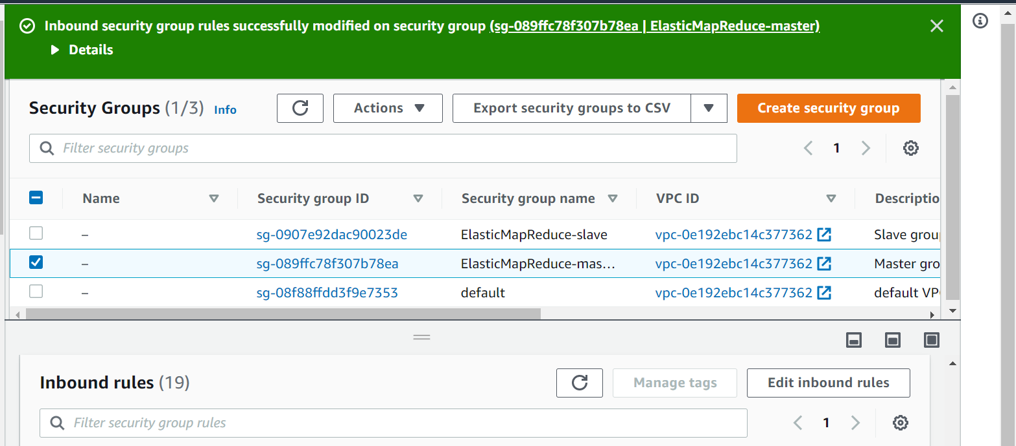

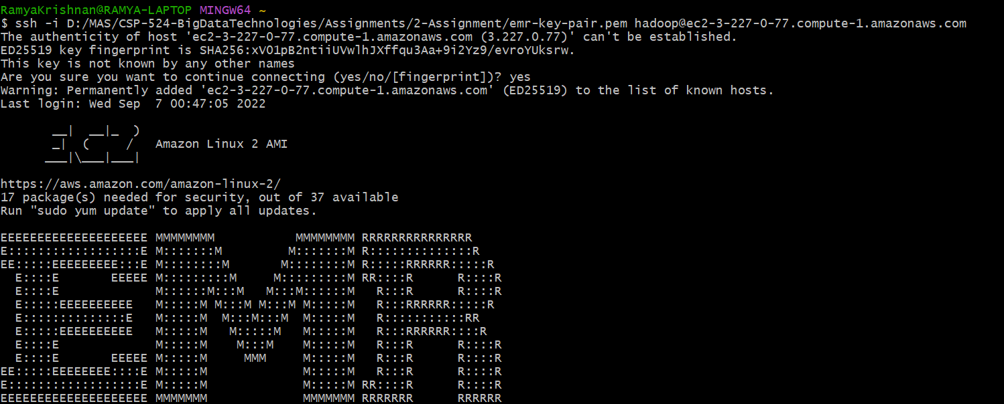

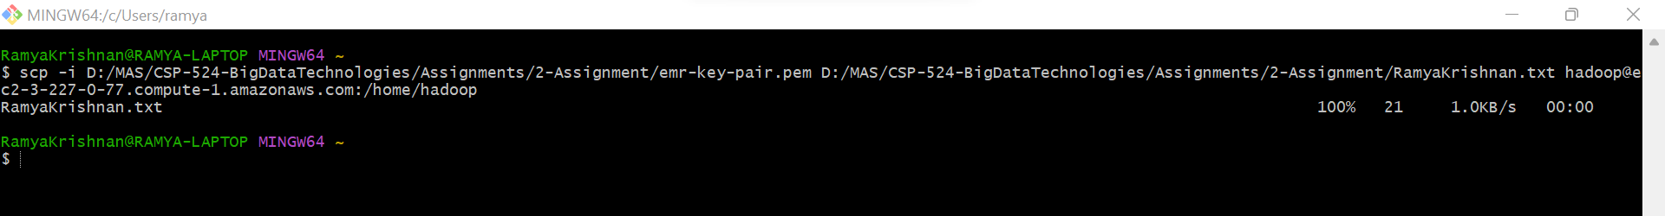

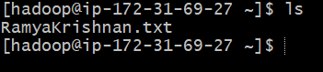

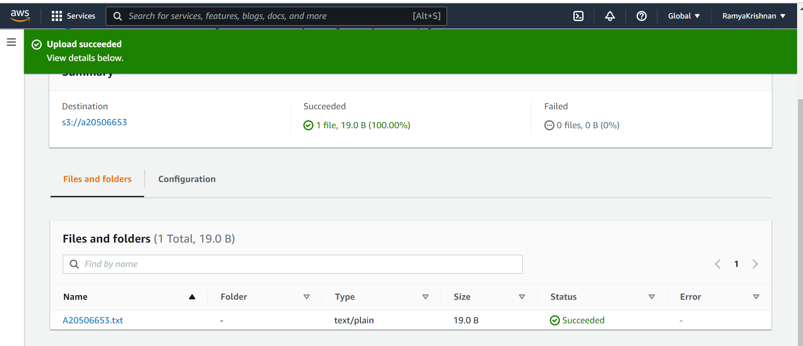

9. (2 points) Execute the following hdfs command to list the files or directories that are listed (also indicating which is a file and which a directory): hadoop fs –ls /

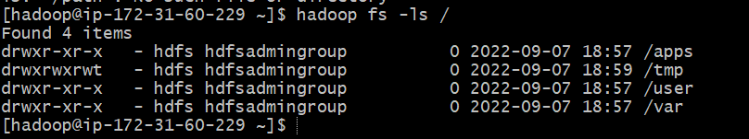

10. (2 points) Execute a command (you needed to figure out which one) to list the files and directories under the hdfs directory listed below: /user

***hadoop fs -ls /user/***

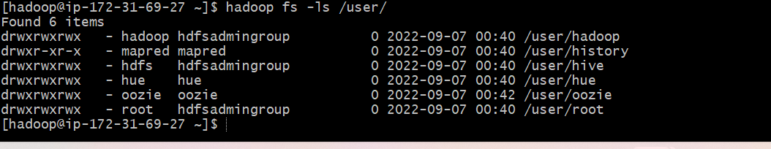

11. (2 points) Execute a command to create the following HDFS directory: /user/csp554

***hadoop fs -mkdir /user/csp554***

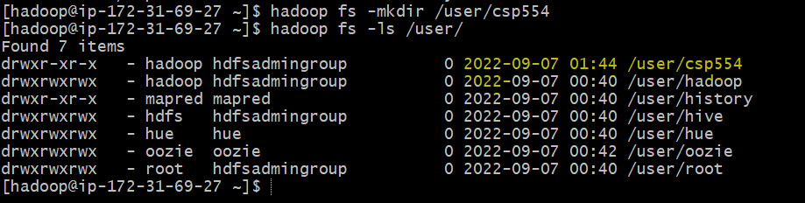

12. (2 points) Execute a command to create the following HDFS directory:

***hadoop fs -mkdir /user/csp554-2***

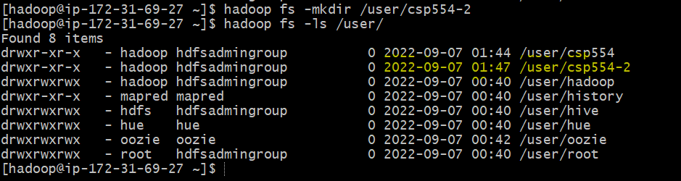

13. (2 points) Execute a command that copies a given local file to the given hdfs directory : Source local file: /home/hadoop/myname.txt (where the actual name is your name as described above) Destination HDFS directory: /user/csp554

***hadoop fs -put /home/hadoop/RamyaKrishnan.txt /user/csp554/***

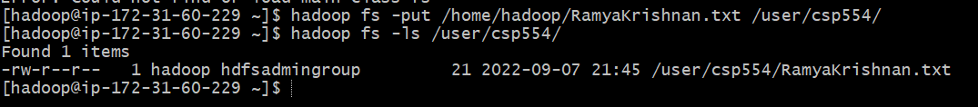

14. (2 points) Copy a file from one hdfs directory to another hdfs directory and write down the command. Source hdfs file: /user/csp554/myname.txt (where the actual name is your name as described above) Destination HDFS directory: /user/csp554-2 Record the command you executed and include it in your assignment submission.

***hadoop fs -cp /user/csp554/RamyaKrishnan.txt /user/csp554-2/***

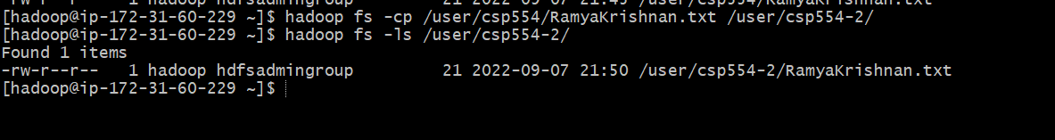

15. (2 points) Copy the object myid.txt you uploaded to an S3 bucket into the Hadoop master node Linux file system. The actual object includes your student id as above

***aws s3 cp s3://a20506653/A20506653.txt /home/hadoop/A20506653.txt***

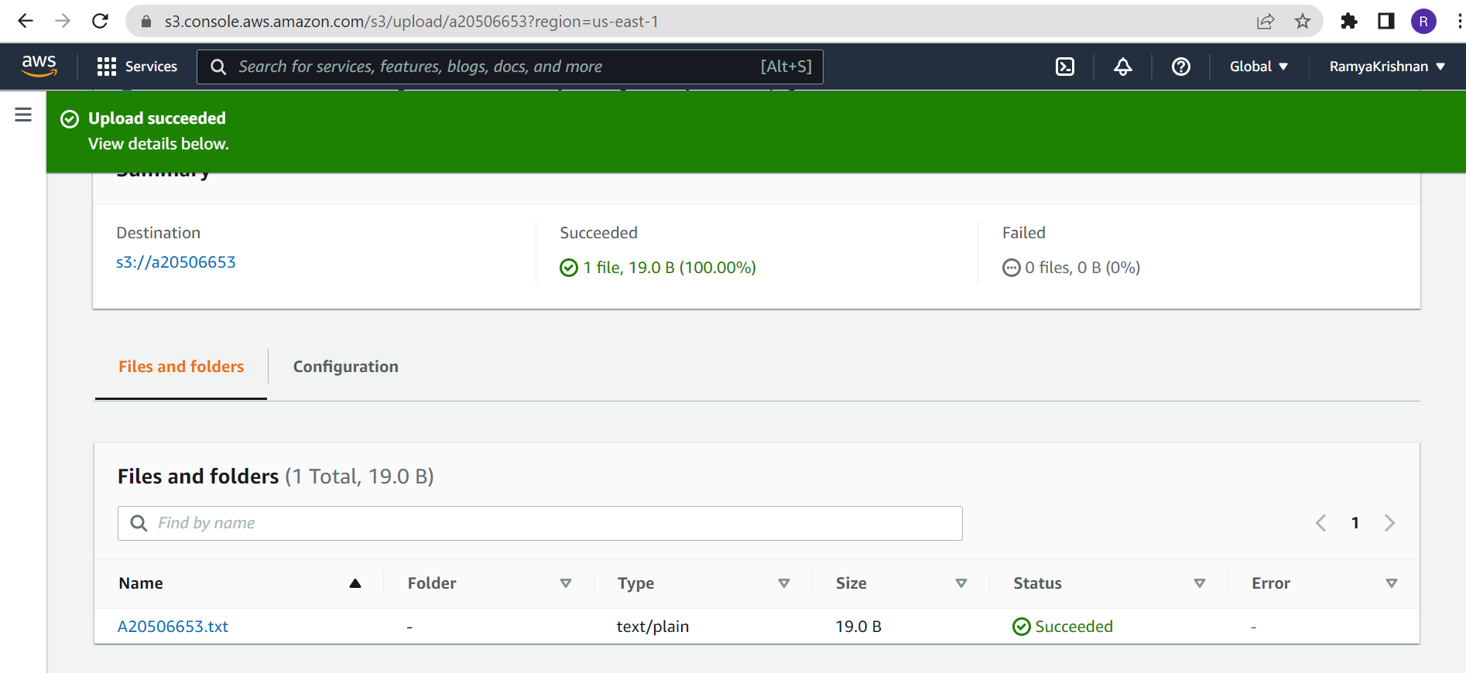

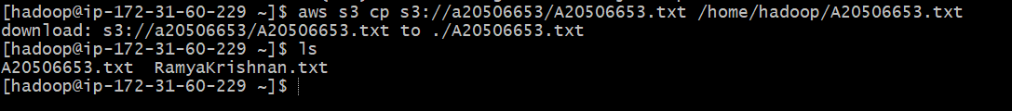

16. (2 points) Copy the same object myid.txt you created in an S3 bucket into HDFS into the directory /users/csp554-2

hadoop fs -cp s3://mybucket/myid.txt hdfs:///user/csp554-2

Note, the three slashes after the “hdfs:”

After you executed the above command, execute another command (you needed to figure out which one) to list the files and directories under the hdfs directory listed below:

/user/csp554-2

Commands:

***hadoop fs -cp s3://a20506653/A20506653.txt hdfs:///user/csp554-2***

***hadoop fs -ls /user/csp554-2***

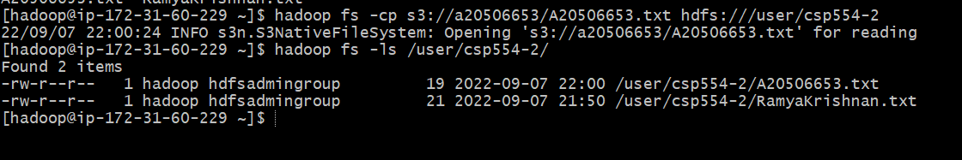

Write down the command you executed and also take a screen snapshot of names of the files or directories that are listed and include it in your assignment submission

17. (2 points) Execute a command to show the contents of the myid.txt file in the hdfs directory /user/csp554-2 Clue: look up about how to use the “cat” command in the file system shell document. Write down the command you executed and also take a screen snapshot of the listed content of the file and include it in your assignment submission.

***hadoop fs -cat /user/csp554-2/A20506653.txt***



18. (2 points) Execute a command to remove the myid.txt file in the hdfs directory /user/csp554-2 Clue: look up about how to use the “rm” command in the file system shell document. Write down the command you executed, then list the content of the /user/csp554-2 HDFS directory and take a screen snapshot of the listed content of the directory and include it in your assignment submission.

***hadoop fs -rm /user/csp554-2/A20506653.txt***

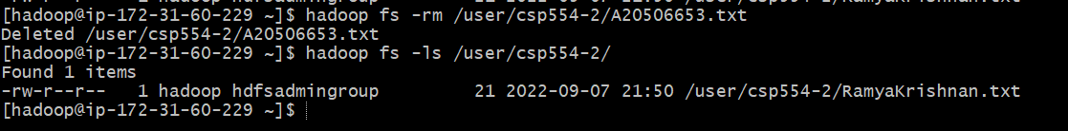

19. This might be very important to your wallet J. Follow Step 7 in the AWS EMR Instructions document to terminate your cluster and delete any buckets you have created. If you forget you may end up paying (a lot) more than you need to

