|  |  |
| --- | --- |
|  | **PES UNIVERSITY**  **(Established under Karnataka Act No. 16 of 2013)**  **100 Ft. Road, BSK III Stage, Bengaluru – 560 085**  **DEPARTMENT OF COMPUTER SCIENCE AND ENGINEERING** |

|  |  |  |
| --- | --- | --- |
| **Course Title: Problem Solving with C Laboratory** | | |
| **Course code: UE19CS152** | | |
| **Semester : II** | **Section : G** | **Team Id : 11** |
| **SRN : PES1UG19CS411** | **Name : Sahana B Manjunath** | |
| **SRN : PES1UG19CS379** | **Name : Ramya C** | |
| **SRN : PES1UG19CS502** | **Name : Sravya Yepuri** | |
| **SRN : PES1UG19EC322** | **Name : Sabah Syeda** | |

**PROJECT REPORT**

**Problem Statement**

Bringing into picture the all time games using C Language. These games include Tic Tac Toe, Snake, Hangman and Guessing game (Chase your mouse).

**Description**

**Goals and Objectives to be reached, Problem to be addressed :-**

* The main goal of this project is to bring entertainment, adversarial environment, vocabulary development, concentration, strategy, statistics and nostalgia to the players. They prove to be addictive to kids and even adults.

**Tic Tac Toe**

* Also known as *“Noughts and Crosses”*, a two-player game wherein, the players get an alternate chance to choose a position and mark their symbol (X or O). The first player who makes his/her symbol aligned in a row or column or diagonal of a 3X3 board (usually) wins.

**Snake**

* Snake is an old-fashioned game from the old Nokia phones, programmed by *Taneli Armanto* in 1997. *“ How long can you last before your tail becomes your dinner? ”*. The snake in this game is set up in a boundary where the food is produced once the previous food is eaten. The game continues as long as the snake does not eat it’s own body. This game may have few variations like the life of snake, death when it touches the boundary etc.

**Hangman**

* Hangman is a [paper and pencil](https://en.wikipedia.org/wiki/Paper-and-pencil_game) guessing game for two or more players. One player thinks of a [word](https://en.wikipedia.org/wiki/Word), [phrase](https://en.wikipedia.org/wiki/Phrase) or [sentence](https://en.wikipedia.org/wiki/Sentence_(linguistics)) and the other(s) tries to guess it by suggesting [letters](https://en.wikipedia.org/wiki/Letter_(alphabet)) within a certain number of guesses.

**Chase your mouse**

* This game has a rat that is hidden in one of the three holes available. The player bets in some/all of the cheese cube he has as a trap and the rat runs into a hole to eat it. The player has to guess where the mouse is after the deed is done. In a win situation the player earns double the amount of cheese he had betted.

**Approaches and Execution methods**

* Game Development in C is challenging but exciting. We aim to create a cluster of games using C, which as of now stands complete. Those games include Tic Tac Toe, Snake, Hangman and Chase your mouse.
* We are using Modular programming, Functions, Signal handling and Exception handling.
* It is windows platform dependent and uses command line/terminal. It can be made to work on linux, but with quite a number of changes in the program.

**C-concepts used**

1. **Arrays**

Character arrays (in hangman and chase your mouse) and Integer array(tictactoe and) are used. An array in C or C++ is a collection of items stored at contiguous memory locations and elements can be accessed randomly using indices of an array.

Syntax : **datatype <array_name> [size];**

Eg : **int a[10];**

1. **Structures**

It is used in snake game. A structure creates a data type that can be used to group items of possibly different types into a single type.

Syntax : **struct <struct_name>**

**{**

**datatype <variable>;**

**...**

**};**

1. **Pointers**

Pointers store addresses of variables or a memory location.

Syntax : **datatype *<variable_name>;**

Eg : **int *a;**

1. **Strings**

Strings are defined as an array of characters. The difference between a character array and a string is the string is terminated with a special character ‘\0’ which is termed as the ‘NULL CHARACTER’

Syntax : **char <string_name>[size];**

Eg : **char name[10];**

1. **Functions**

A function is a set of statements that take inputs, do some specific computation to produce desired output. The idea is to put some commonly or repeatedly done tasks together and make a function so that instead of writing the same code again and again for different inputs, we can call the function.

Syntax : **returntype <function_name> (datatype of parameter variables assigned)**

**{**

**Statements;**

**[return data;]**

**}**

Eg : **int max(int x,int y)**

**{**

**int c;**

**(x > y) ? (c = x) : (c = y);**

**return c;**

**}**

1. **Preprocessor Directive**

Preprocessor directives are mostly used in defining macros, evaluating conditional statements, source file inclusion, pragma directive, line control, error detection etc. They start with # and the end of these lines are identified by the newline character ‘\n’ , no semicolon ‘;’ is needed to terminate these lines.

Syntax : **#directive variable_name condition**

Eg : **#define n 5**

The preprocessor directives used in the games are stdio.h, stdlib.h, time.h, windows.h, conio.h, ctype.h, math.h, stdbool.h, string.h and define.

* 1. **stdlib.h**

stdlib.h is the header of the general purpose standard library of C programming language which includes functions involving memory allocation, process control, conversions and others.

1. **rand()**

The rand() function is used to generate random numbers. If we generate a sequence of random numbers with the rand() function, it will create the same sequence again and again every time the program runs.

1. **exit()**

This function terminates the calling process without executing the rest code which is after the exit() function.

1. **File Handling**

Creation of the new file, Opening an existing file, Reading from the file, Writing to the file, Deleting the file, Moving to a specific location in a file, all these are done using File handlers.

**“r”** - Searches file. If the file is opened successfully fopen() loads it into memory and sets up a pointer which points to the first character in it. If the file cannot be opened fopen() returns NULL.

**“w”** - Searches file. If the file exists, its contents are overwritten. If the file doesn’t exist, a new file is created. Returns NULL, if unable to open the file.

**“a+”** - Searches file. If the file is opened successfully fopen( ) loads it into memory and sets up a pointer which points to the last character in it. If the file doesn’t exist, a new file is created. Returns NULL, if unable to open the file.

Syntax : **FILE *variable;**

**variable = fopen(“filename.txt”,”operation”);**

Eg : **FILE *a;**

**a = fopen(“read.txt”,”r”);**

1. **Multiple Files**

One of the main files includes many other files, basically consisting of functions which should be included to the main file to access the contents of other files in the main file.

**Learning Outcome**

1. **windows.h**

It is a Windows - specific header file for the C and C++ programming languages which contains declarations for all the functions in the Windows API, all the common macros used by Windows programmers, and all the data types used by the various functions and subsystems. It defines a very large number of Windows specific functions that can be used in C.

1. **HANDLE**

This is a handle defined in windows.h header file that handles the standard or console output using GetStdHandle(STD_OUTPUT_HANDLE).

1. **COORD**

This is a structure which is used to get the cursor position using SetConsoleCursorPosition(<handle_variable, <coordinate/position>).

**typedef struct _COORD**

**{**

**SHORT X;**

**SHORT Y;**

**} COORD, *PCOORD;**

1. **GetStdHandle(STD_OUTPUT_HANDLE)**

Basically, it gets a handle you can use to write to the console.

1. **SetConsoleCursorPosition(<handle_variable>, <coordinate/position>)**

This uses the handle and the coordinates specified to place the blinking cursor in the terminal.

1. **conio.h**

It is a [C](https://en.wikipedia.org/wiki/C_(programming_language)) header file used mostly by MS-DOScompilers to provide console input/output[]](https://en.wikipedia.org/wiki/Conio.h#cite_note-1) It is not part of the C standard library.This header declares several useful library functions for performing "console input and output" from a program. The functions used from conio.h are :

**a) getch():**

getch() is a nonstandard function and is present in conio.h header file, it reads a single character from the keyboard. But it does not use any buffer, so the entered character is immediately returned without waiting for the enter key.

1. **kbhit():**

kbhit() is present in conio.h and used to determine if a key has been pressed or not. To use kbhit() function in your program you should include the header file “conio.h”. If a key has been pressed then it returns a non zero value otherwise returns zero.

**3. ASCII values**:

ASCII abbreviated from American Standard Code for Information Interchange, represents text in computers, and other devices. Most modern character-encoding schemes are based on ASCII, although they support many additional characters.

The ascii values that are used are

ENTER : 13.

BORDER DRAWING CHARACTERS : 200, 201, 188, 187, 205, 186.

BODY OF SNAKE : 176, 178

FOOD FOR SNAKE : 176.

**4. ctype.h**

The ctype.h header file of the C Standard Library declares several functions that are useful for testing and mapping characters. All the functions accept int as a parameter, whose value must be EOF or representable as an unsigned char.

1. **tolower()**

This function converts a letter from uppercase to lowercase character.

1. **toupper()**

This function converts a letter from lowercase to uppercase character

.

**5. stdlib.h**

1. **srand()**

To avoid getting the same sequence again and again, the srand() function is used. The srand() function sets the starting point for producing a series of pseudo-random integers.

1. **system(“cls”)**

This is used to clear the terminal/console window created by the software used.

1. **system(“pause”)**

This is used to halt the execution and displays *Press any key to continue…* It waits for the user to press any key to resume the execution.

**6. time.h**

The **time.h** header file contains definitions of functions to get and manipulate date and time information.

1. **time_t**

This represents the clock time as integer which is a part of the calendar time.

During the whole process of learning, we not only learnt things needed for the project but also things that weren’t used in the project. The cycle of coding, testing, debugging, the repeated course of trial and errors was tedious, challenging but on clearing them, the joy was no less. We learnt many other funtionalities like memcpy (a function), a header file process.h, GUIs like SDL and Open GL also.

**Output Screenshots**

Main Menu

**Tic Tac Toe**

Tic Tac Toe Board

Tic Tac Toe Execution

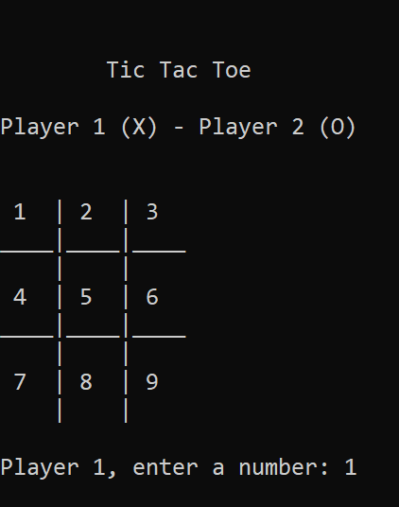 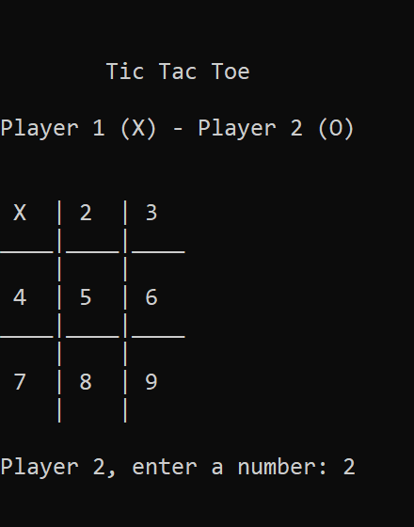

Case : Win

Invalid Input

Case : Draw

Case : Press Enter to Play Again

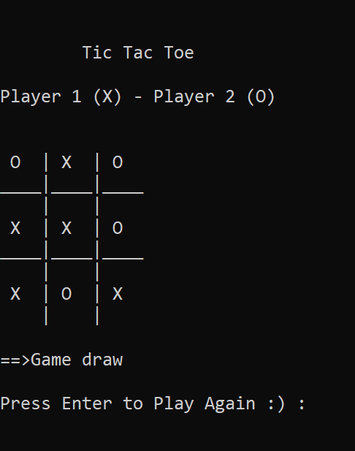 

Return to Main Menu

**Snake**

Welcome Message

Game Instructions

Game Arena

Death Note

High Score recorded

Game Over Declaration

Player Name Entry

Previous Records

Record History

Record File

High Score File

High Score is updated from 0 to 11

New High Score

Displaying Records

High Score is overwritten

Record File is appended

Snake Body can pass through Arena boundaries and HighScore is updated from 11 to 16

Return to Main Menu

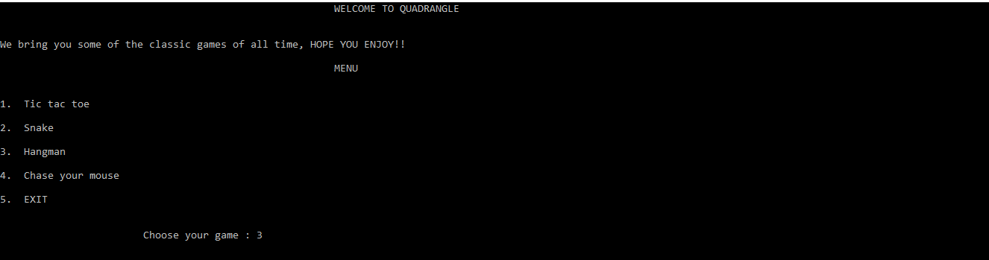

**HANGMAN**

Topic 1: TV SHOWS

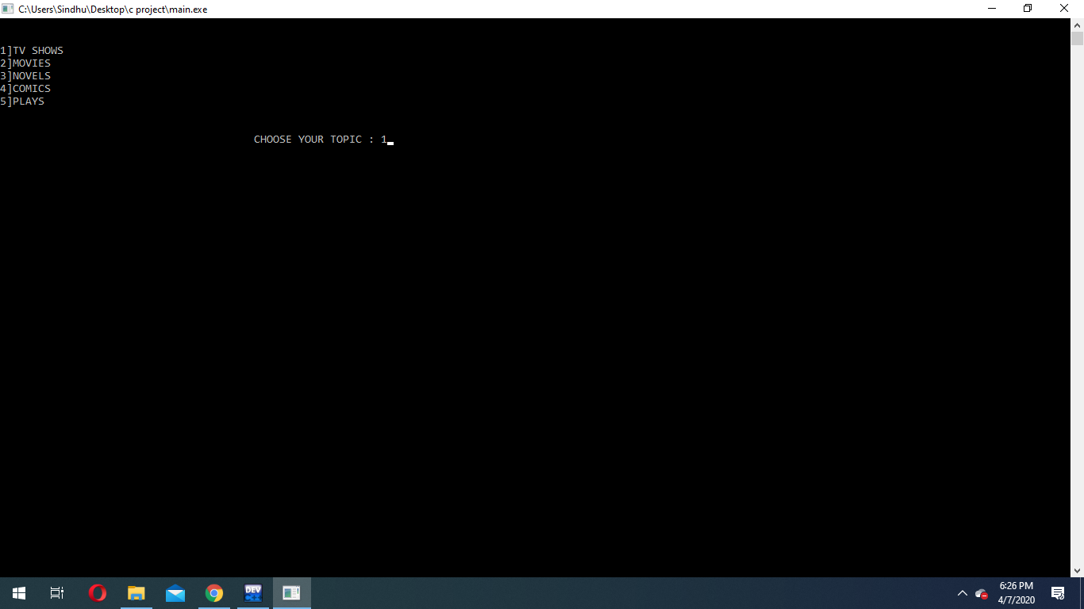

Game execution

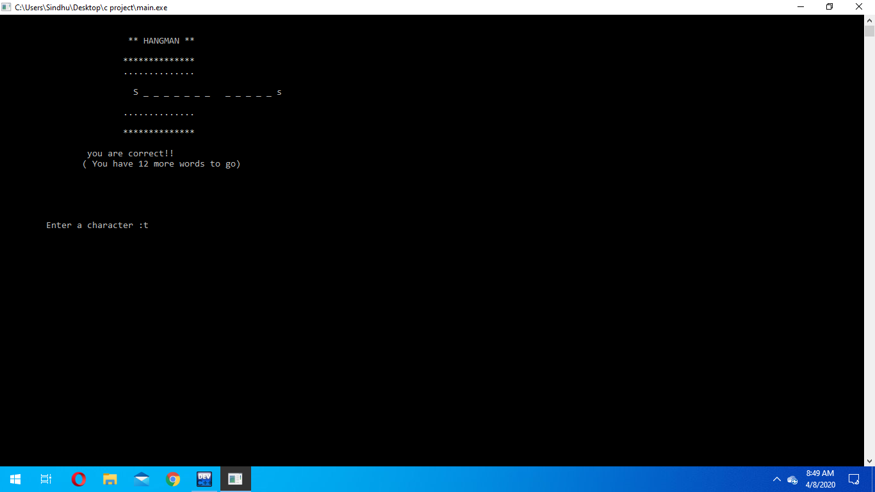 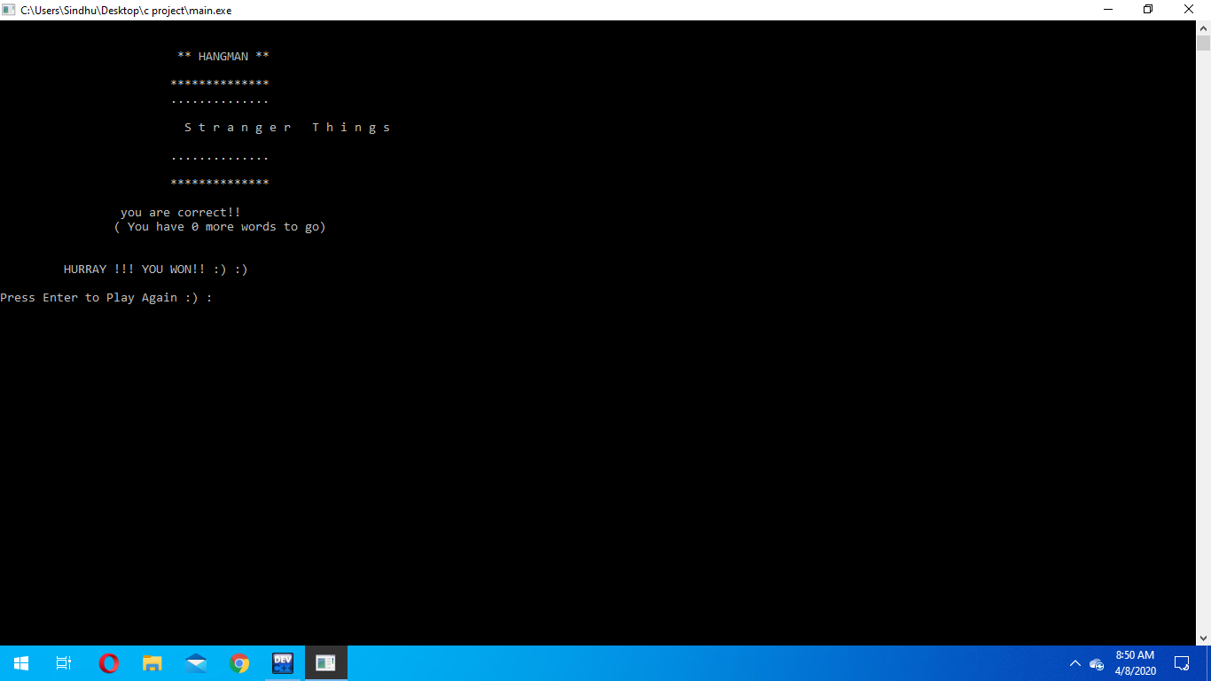

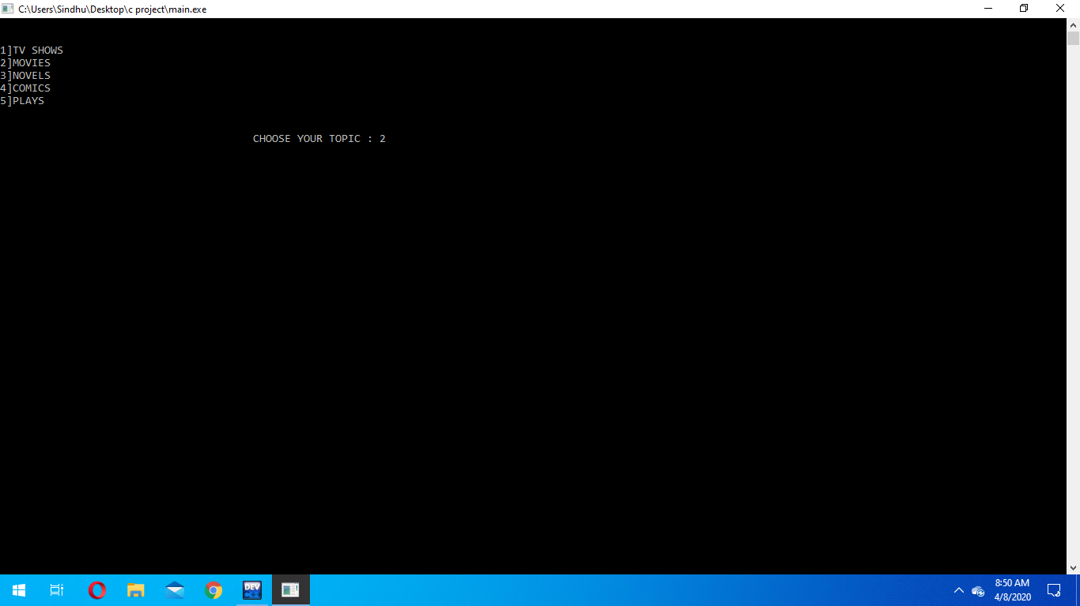

Topic 2: MOVIES

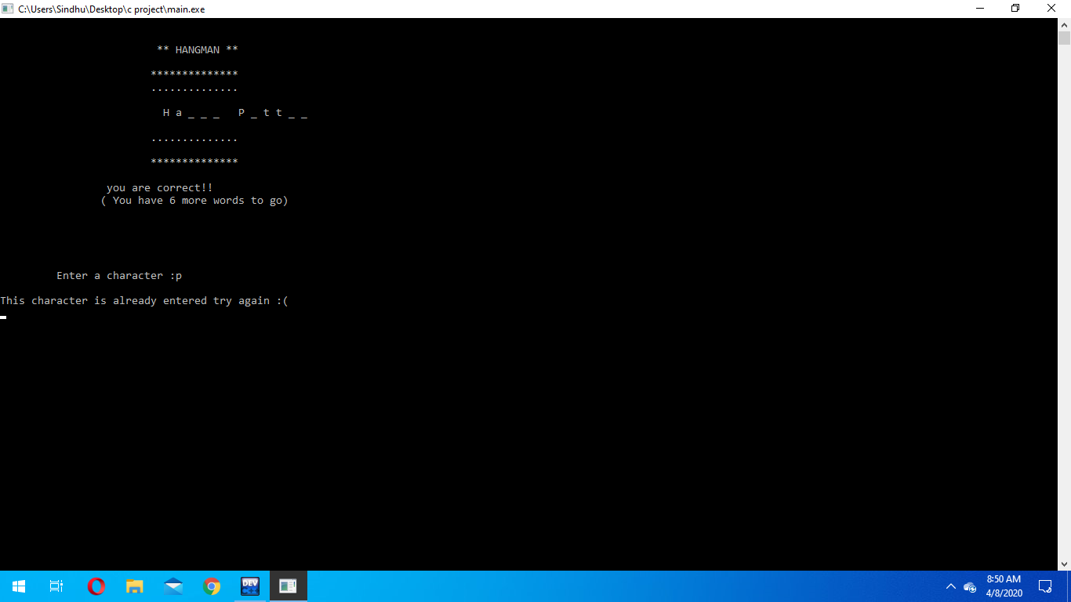 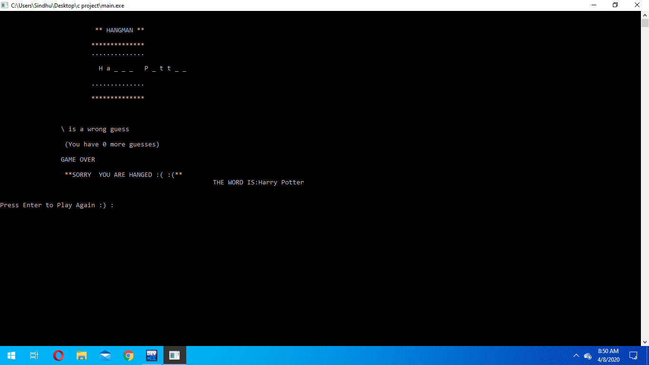

Game execution

Topic 3: NOVELS

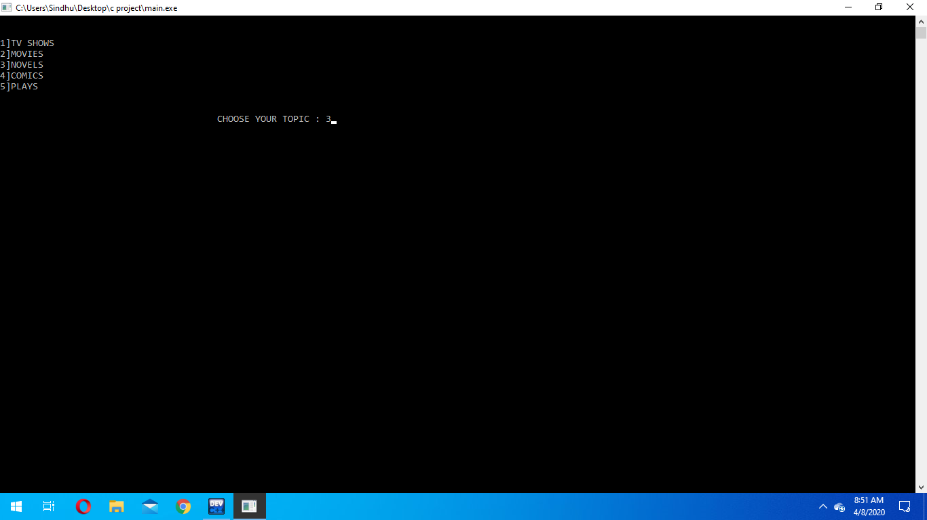

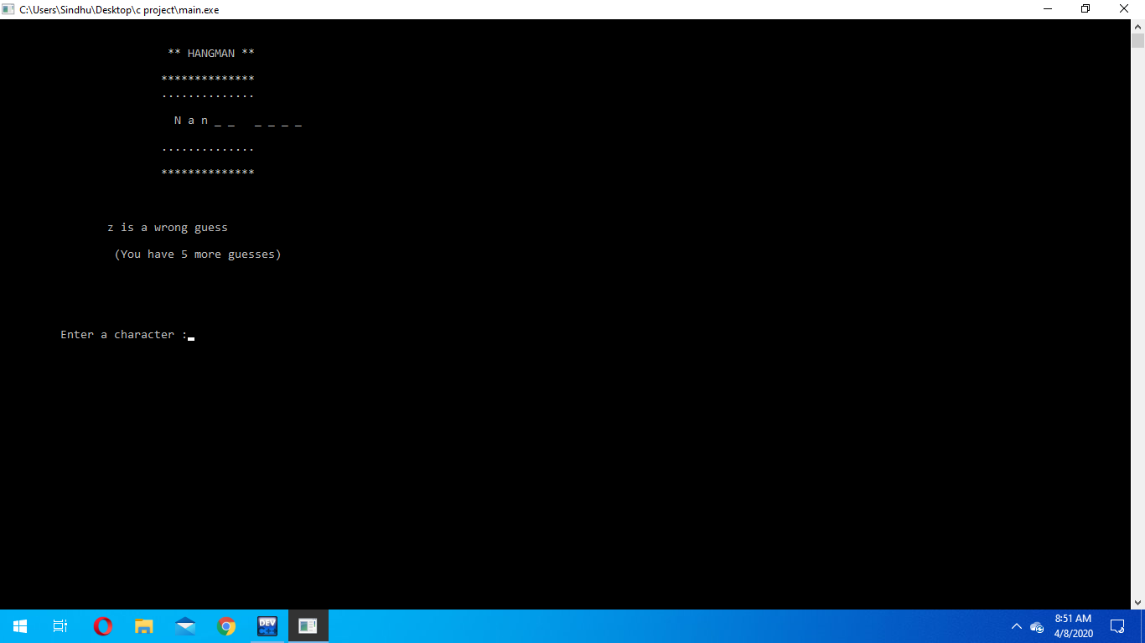

Wrong guess

Return to Main Menu

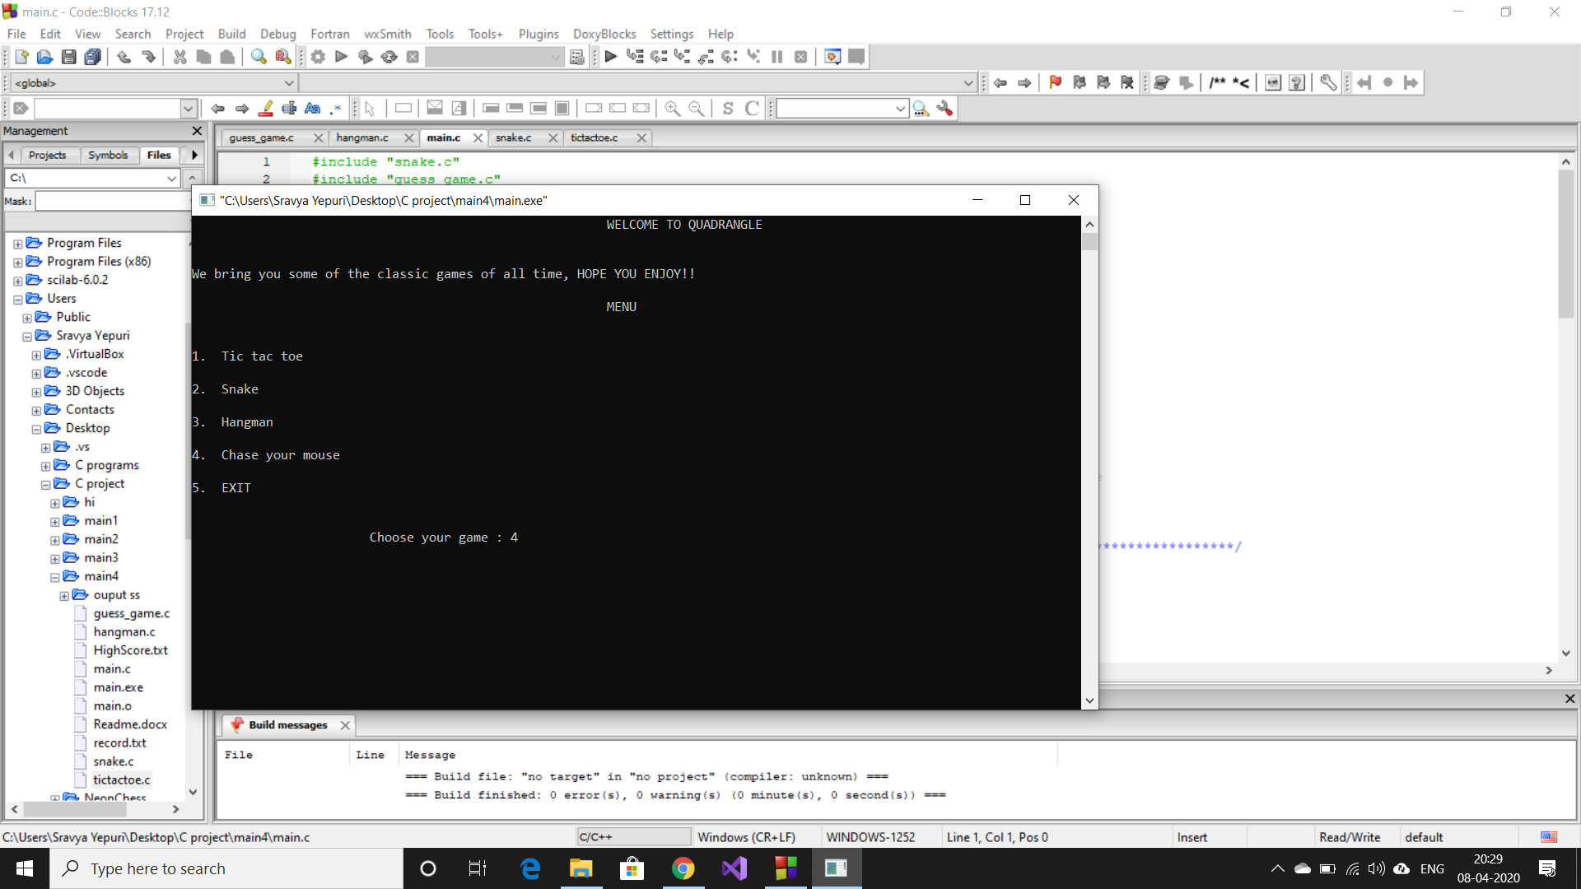

**GUESS GAME**

Game Instructions

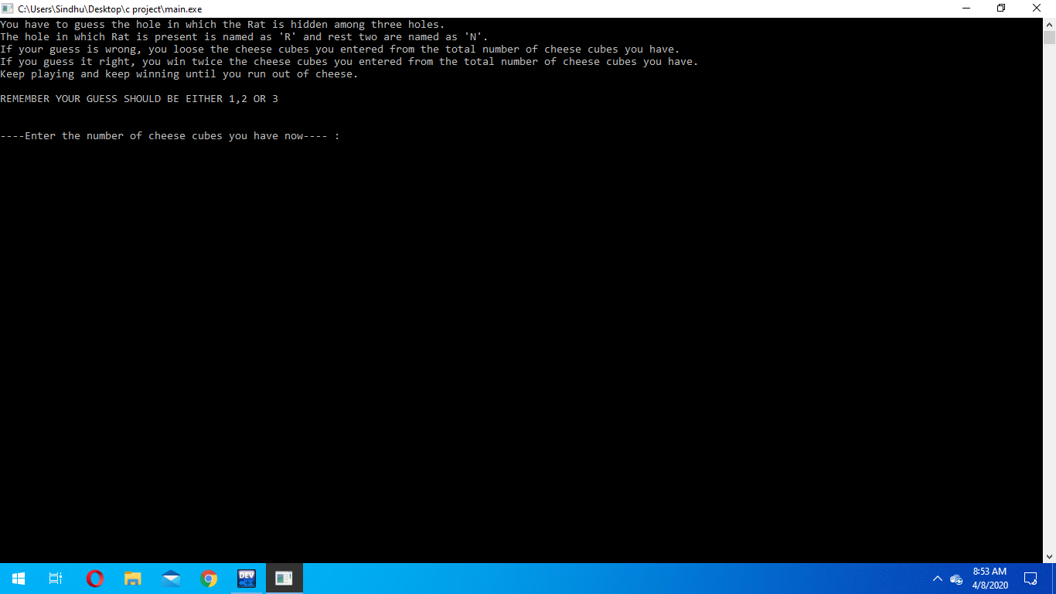

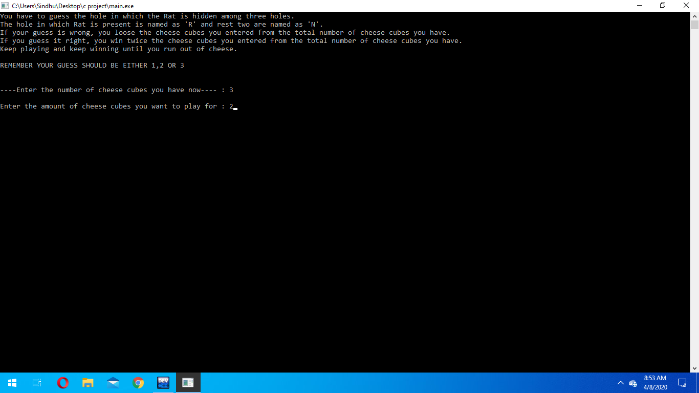

Invalid Move

Game execution

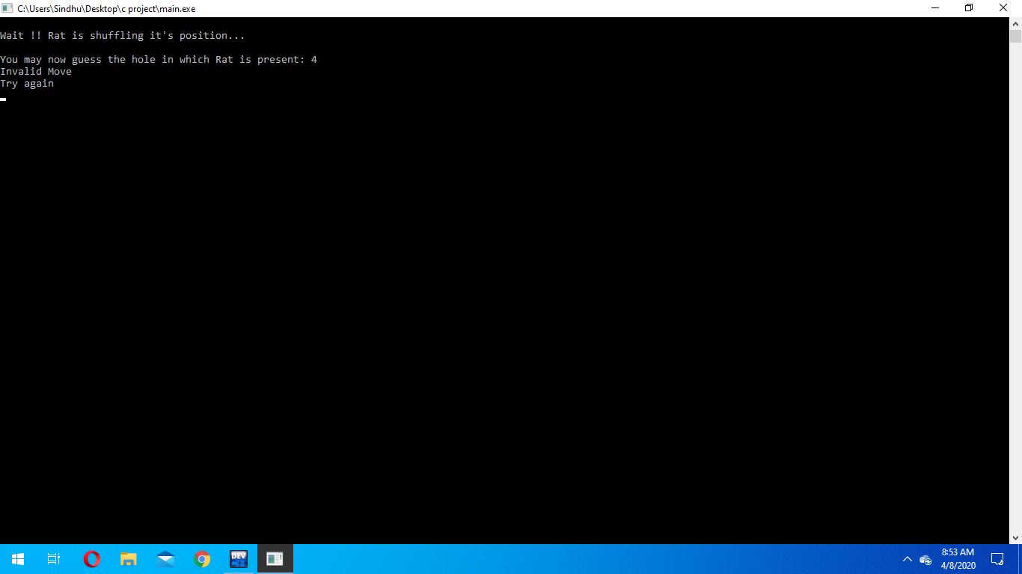 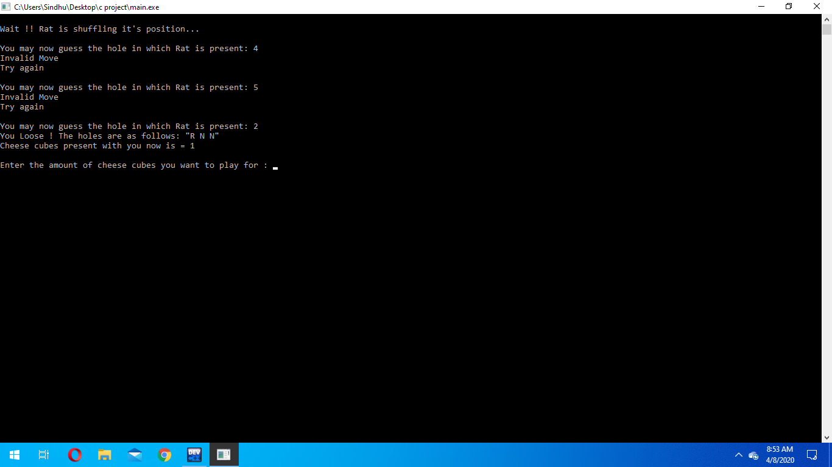

Correct Guess

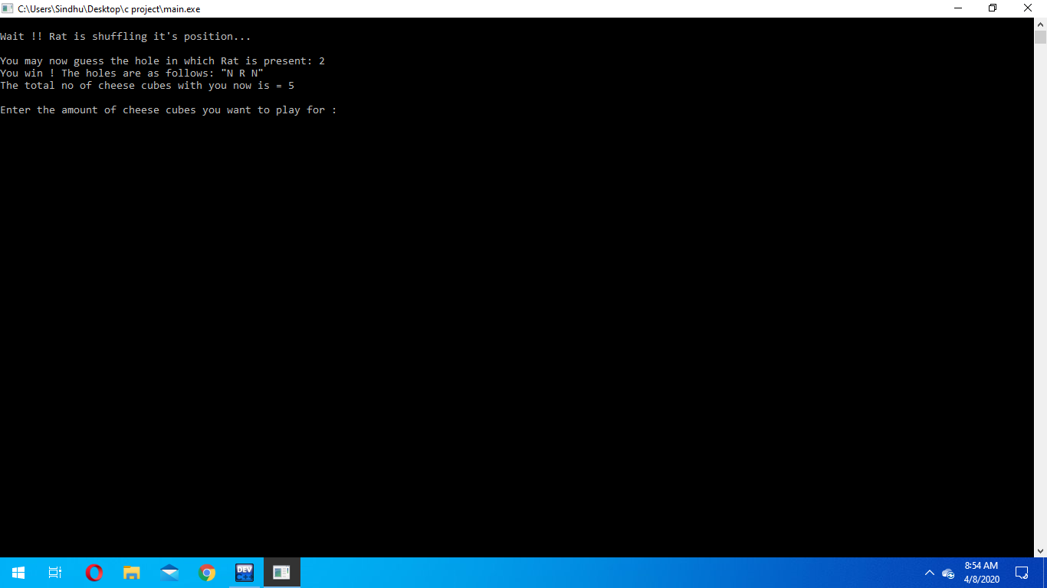

No cheese left

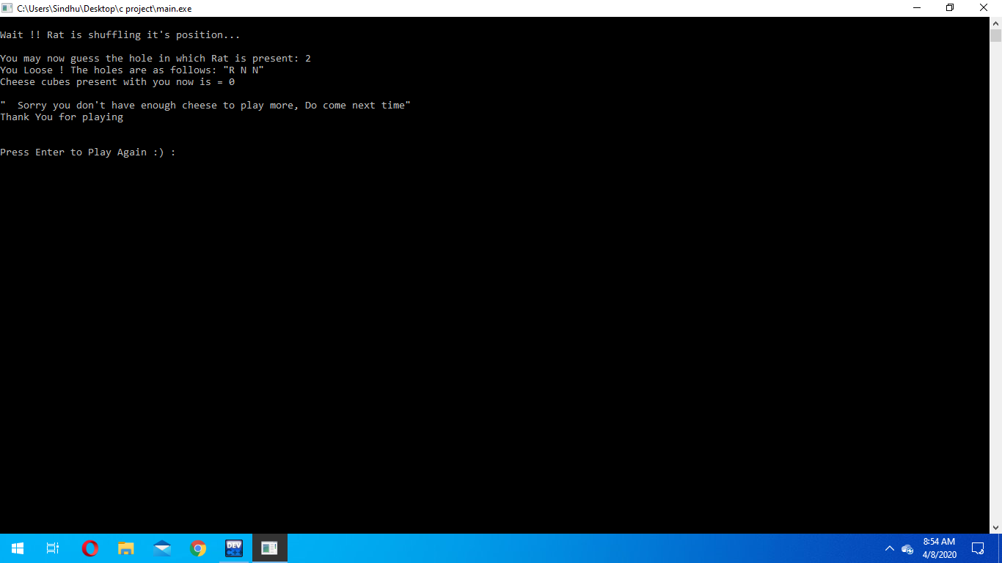

Case : Cheese cubes = 0

Return to Main Menu

Leaving Note

**Name and Signature of the Faculty**