**BDA LAB**

**Hive Program**

**Ramyashree BV**

**1BM18CS416**

**1. Write Queries in Hive to do the following – (19s/12/2020)**

**i.** **Create an external table named with the following attributes -> Empl_ID - >Emp_Name -> Designation -> Salary**

Query :

CREATE DATABASE IF NOT EXISTS EMPLOYEE COMMENT 'EMPLOYEE Details' WITH DBPROPERTIES('creator'='Abc');

SHOW DATABASES;

DESCRIBE DATABASE EMPLOYEE;

USE EMPLOYEE;

CREATE EXTERNAL TABLE IF NOT EXISTS EMPLOYEE_TB (Emp_ID INT,Emp_Name STRING,Designation STRING,Salary FLOAT) ROW FORMAT DELIMITED FIELDS TERMINATED BY '\t' LOCATION '/EMPLOYEE_INFO';

DESCRIBE FORMATTED EMPLOYEE_TB;

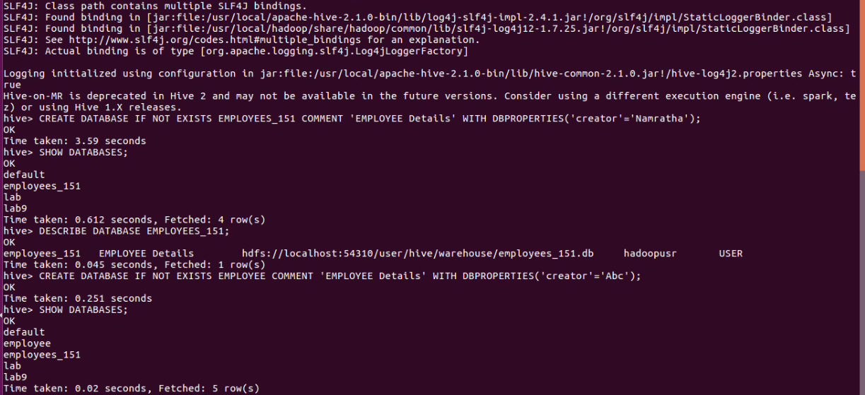

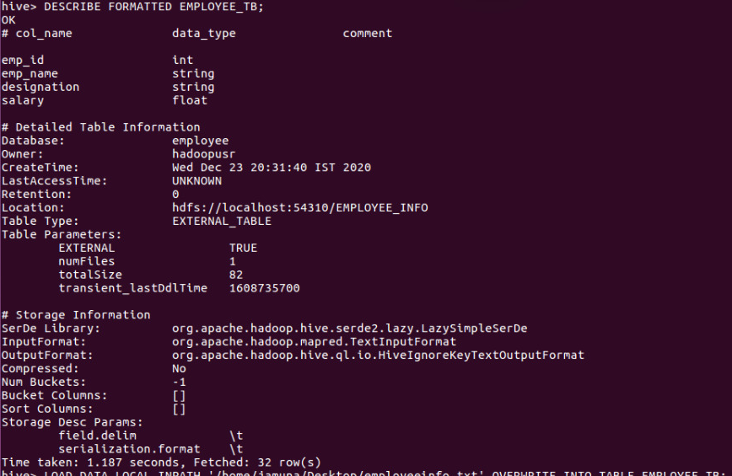

**ii. Load data into table from a given file**

Query :

LOAD DATA LOCAL INPATH '/home/jamuna/Desktop/employeeinfo.txt' OVERWRITE INTO TABLE EMPLOYEE_TB;

SELECT * FROM EMPLOYEE_TB;

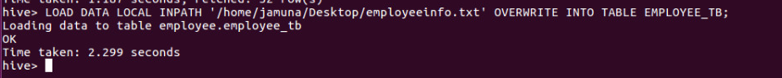

**iii. Create a view to Generate a query to retrieve the employee details who earn a salary of more than Rs 30000**

Query :

CREATE VIEW emp AS SELECT * FROM EMPLOYEE_TB WHERE Salary>30000;

SELECT * FROM emp;

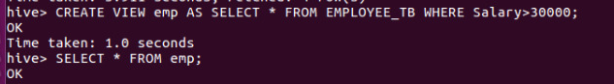

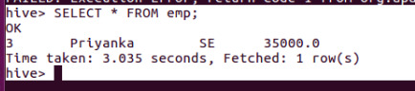

**iv. Alter the table to add a column Dept_Id and Generate a query to retrieve the employee details in order by using Dept_Id**

Query :

ALTER TABLE EMPLOYEE_TB ADD COLUMNS(DeptiD INT);

LOAD DATA LOCAL INPATH '/home/jamuna/Desktop/employeeinfo.txt' OVERWRITE INTO TABLE EMPLOYEE_TB;

SELECT * FROM EMPLOYEE_TB;

SELECT * FROM EMPLOYEE_TB ORDER BY Deptid;

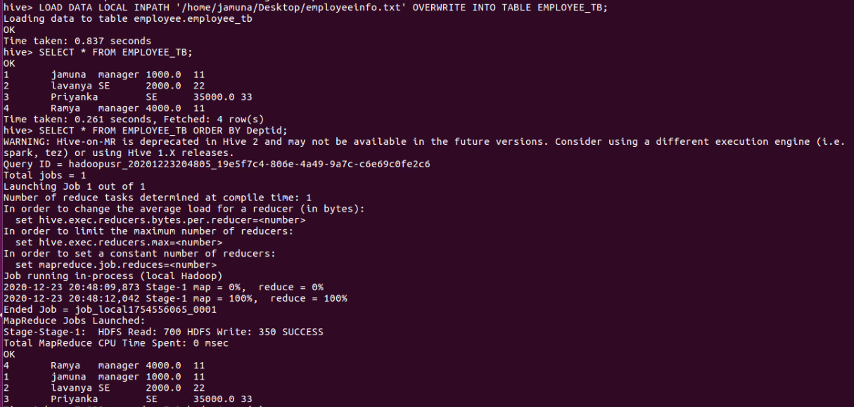

**v. Generate a query to retrieve the number of employees in each department whose salary is greater than 30000**

Query :

SELECT DeptiD,count(*) FROM EMPLOYEE_TB WHERE Salary>=30000 GROUP BY DeptiD;

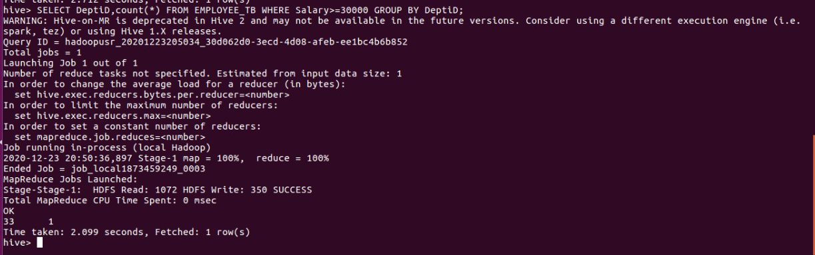

**vi. Create another table Department with attributes -> Dept_Id ->Dept_name -**

**>Emp_Id**

Query :

CREATE EXTERNAL TABLE IF NOT EXISTS Department(Deptld INT, DeptName STRING) ROW FORMAT DELIMITED FIELDS TERMINATED BY '\t' LOCATION '/EMPLOYEE_INFO';

LOAD DATA LOCAL INPATH '/home/jamuna/Desktop/deptinfo.txt' OVERWRITE INTO TABLE Department;

SELECT * FROM Department;

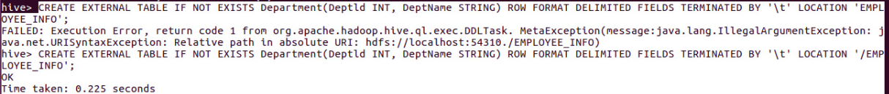

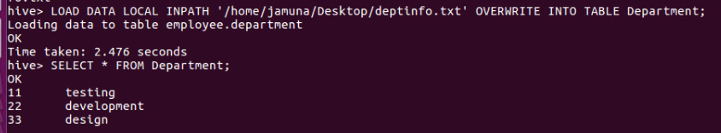

1. **Display the cumulative details of each employee along with department details.**

Query :

SELECT a.Emp_ID,a.Emp_Name,a.Designation,a.Salary,b.DeptName FROM EMPLOYEE_TB a JOIN Department b ON a.DeptiD=b.Deptld;

