THYROID DISEASE CLASSIFICATION

USING ML

1. INTRODUCTION

* 1. Overview:

The project is Thyroid Disease Classification Using ML. The project is about Thyroid disease. Basically Thyroid disease detection used for blood. A Thyroid related Blood test is used to detect this disease but it often blurred and noise will be present. So, we create a application for used to Machine Learning with Python.

1.2 purpose:

* Mechine learning plays a very deciding role in disease predition. So detect the Thyroid disease in a patient quickly cured. The thyroid disease can then be easily identified based on the symptoms in the patient`s history.
* The business requirements for a mechine learning models to predict thyroid disease include the ability to accurately predict thyroid disease based on the scan results, Minimise the number of false positives and false negatives.

Provide an explanation for the model`s decision, to comply with regulations and improve transparency.

## 2.problem Definition & Design Thinking

2.1 Empathy map: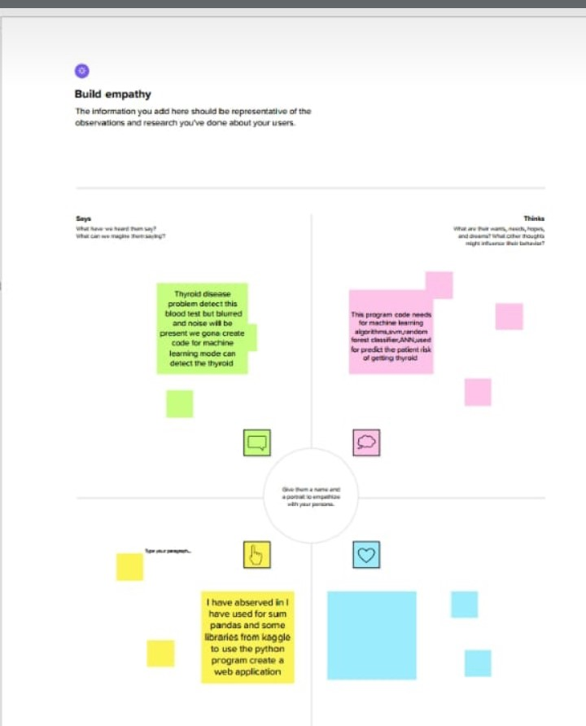

4.Advantages & Disadvantage

# Advantages:

* Dedect the problem easy and quickly.
* Reduces your workload.
* Short time work

# Disadvantages:

* Error problem

# Application:

* This method used for hospital , lab and medicals and pharmacy

# Conclusion:

* Thyroid Detection using Machine Learning is a project idea that aims a smart and precise way to predict thyroid disease. We have made use of logistic regression algorithm to train our dataset and to predict thyroid disease with more accuracy. Here the machine is trained to detect whether the person normal, hyper-hypothyroidism based on the user’s input. So when user enters data in web app the data will be processed in backend (model) and the result will be displayed on the screen. Our objective was to give society an efficient and precise way of machine learning which can be used in applications aiming to perform disease detection.
* Further development can be do by using image processing of ultrasonic scanning of thyroid image processing of ultrasonic scanning of thyroid images to predict thyroid nodules and cancer, which cannot be recognized in blood test report.
* By combining both the results, thyroid disease prediction can cover all thyroid related disease.

# Future scope:

* The model are tested on an overall dataset containing 2211 instances referring to a total of 247 patients. A contribution of this work consists in the use of a dataset that collected real information belonging to subjects under treatment at the Naples hospital.
* Another fundamental step involves the pre-processing of the data to be included in the classifiers, in particular, that relating to the use of the SMOTE method, a minority oversampling technique.

# Link:

### https://docs.google.com/document/d/1bBbyeJQ1Q1KkPTpJs_KVUJ5HQ2jV67Ra/edit?usp=drivesdk&ouid=112251886709873119095&rtpof=true&sd=true