**CANCER VISION: ADVANCED BREAST CANCER PREDICTION WITH DEEP LEARNING**

**Team Members:**

1. **NAKKA RAMYA**
2. **SURYADEVARAYA SRIVIDYA**
3. **RAYAPATI PAVANI**
4. **BELLAMKONDA PRIYNKA**

Contents

1. Introduction 2

A. Purpose: 2

B. Scope: 2

C. Audience: 2

D. Document Overview: 2

2. Background 2

A. Cancer Diagnosis: 2

B. Artificial Intelligence in Medical Diagnosis: 3

C. Model Overview: 3

3. Project Flow 3

A. Data Collection: 3

B. Create Train and Test Folders: 3

C. Data Preprocessing: 4

D. Model Building: 4

E. Training and Testing the Model: 4

F. Save the Model: 5

G. Application Building: 5

4. How to Use the Model 6

A. Input: 6

B. Output: 7

5. Limitations and Risks 7

5.1 Data Limitations: 7

5.2 False Positives and False Negatives: 7

5.3 Interpretability and Explainability: 8

5.4 Overfitting and Generalization: 8

5.5 Ethical Considerations: 8

5.6 Hardware and Computational Requirements: 8

5.7 Continuous Monitoring and Updates: 8

5.8 Regulatory and Legal Aspects: 8

6. Conclusion 8

7. References 9

# 1. Introduction

A. Purpose:  
Breast cancer remains a significant health concern worldwide, and early detection plays a crucial role in improving survival rates and treatment outcomes. The purpose of this project is to develop an Artificial Intelligence (AI) model that aids in the early diagnosis of breast cancer by accurately predicting whether a given cell image is malignant or benign. This model aims to complement the expertise of medical professionals, providing them with an efficient and reliable tool to assist in the diagnostic process.

B. Scope:  
The scope of this project encompasses the creation of a deep learning-based model using Convolutional Neural Networks (CNNs) to analyze breast cell images and classify them as cancerous or non-cancerous. The model will be designed to handle a diverse range of images, allowing it to generalize well and provide accurate predictions on unseen data.

C. Audience:  
This documentation is designed for a wide range of individuals, including:

* Developers: Who are interested in understanding the technical implementation of the AI model, its architecture, and the libraries used.
* Data Scientists: Who wish to explore the data preprocessing techniques, training procedures, and evaluation metrics applied to achieve optimal model performance.
* Medical Professionals: Who are interested in understanding how AI can be used as an adjunctive tool to aid in breast cancer diagnosis and treatment planning.

D. Document Overview:  
This documentation provides a comprehensive guide to the Breast Cancer Prediction AI model, covering its background, implementation flow, usage, limitations, and conclusion. It outlines the steps taken to collect and preprocess the dataset, build the CNN architecture, train and evaluate the model's performance, and create an application interface for user interactions.

This project aspires to bridge the gap between medical expertise and cutting-edge AI technology, with the ultimate goal of contributing to better patient care and potentially saving lives through early detection and accurate diagnosis of breast cancer.

# 2. Background

A. Cancer Diagnosis:  
Breast cancer is a complex and potentially life-threatening disease characterized by the uncontrolled growth of abnormal cells in the breast tissue. It is the most common cancer in women worldwide and a significant cause of cancer-related mortality. Early detection plays a crucial role in improving patient outcomes and increasing the chances of successful treatment.

Traditionally, cancer diagnosis involved manual examination of biopsy samples by pathologists under a microscope. While this method is accurate, it is time-consuming and heavily dependent on the expertise and experience of the pathologist. The need for faster and more consistent diagnostic methods led to the exploration of computational approaches, such as Artificial Intelligence, in the field of medical diagnosis.

B. Artificial Intelligence in Medical Diagnosis:  
Artificial Intelligence (AI), particularly deep learning, has gained immense popularity in medical imaging and diagnosis. Deep learning models, particularly Convolutional Neural Networks (CNNs), have demonstrated remarkable capabilities in image classification tasks. They can automatically learn to identify intricate patterns and features from medical images, making them suitable candidates for cancer detection.

In the context of breast cancer diagnosis, AI models can analyze mammograms, ultrasounds, and histopathology images to aid in identifying cancerous regions. By leveraging large datasets and advanced computational techniques, AI models can potentially augment the diagnostic accuracy of medical professionals.

C. Model Overview:  
The Breast Cancer Prediction AI model is built on the foundations of deep learning and CNNs. CNNs are a class of neural networks specifically designed to process images effectively. They utilize convolutional layers to extract features hierarchically, followed by pooling layers to downsample the feature maps, reducing computational complexity.

The model is trained on a dataset containing breast cell images, where each image is labeled as either malignant or benign. During training, the model optimizes its parameters to minimize the classification error, and it learns to differentiate between the visual patterns associated with cancerous and non-cancerous cells.

The ability of AI models to learn from vast amounts of data and identify subtle patterns that might escape the human eye makes them a promising tool in the fight against breast cancer. However, the successful implementation of AI in medical diagnosis requires rigorous evaluation, validation, and continuous improvement to ensure patient safety and reliability. As such, this project aims to develop a robust and accurate AI model for breast cancer prediction to complement and enhance the capabilities of healthcare professionals in their diagnostic efforts.

# 3. Project Flow

## Data Collection:

Collecting a high-quality and diverse dataset of breast cell images with corresponding labels indicating whether the cells are malignant or benign is essential for training the breast cancer prediction model. The dataset should include a sufficient number of samples to enable the model to learn representative features of both malignant and benign cells.

## Create Train and Test Folders:

After obtaining the dataset, it needs to be divided into two main subsets: the training set and the testing set. The training set is used to train the model, while the testing set is used to evaluate the model's performance on unseen data. Typically, about 70-80% of the data is used for training, and the remaining 20-30% is used for testing.

## Data Preprocessing:

Before feeding the images into the CNN model, data preprocessing is performed to enhance the model's performance and make the training process more effective. The following steps are taken:

1. Normalization: The pixel values of the images are scaled to a range between 0 and 1, which helps in speeding up the training process and stabilizing the model.
2. Augmentation: Data augmentation techniques are applied to the training set to increase its size and diversity. This involves randomly applying transformations such as rotation, zooming, flipping, and shifting to generate new variations of the existing images. Augmentation helps in improving the model's generalization and prevents overfitting.

## Model Building:

The breast cancer prediction model is built using a Convolutional Neural Network (CNN), a type of deep learning architecture specifically designed for image recognition tasks. The model consists of the following components:

1. Initializing the Model: The CNN model is initialized as a sequence of layers.
2. Adding Input Layer: The input layer is the first layer of the model, which receives the preprocessed images as input.
3. Adding Hidden Layers: The hidden layers form the core of the CNN and are responsible for learning the relevant features from the input images. Typically, a CNN contains multiple convolutional layers, followed by activation functions and pooling layers, which help in capturing hierarchical features.
4. Adding Output Layer: The output layer is the final layer of the model, which produces the prediction results. In this case, it will have a single neuron with a sigmoid activation function to provide a probability score between 0 and 1 for the presence of breast cancer.
5. Configure the Learning Process: The model is configured with an optimizer, a loss function, and an evaluation metric. The optimizer determines how the model is updated based on the calculated loss during training. The loss function measures the difference between the predicted outputs and the actual labels. The evaluation metric helps to assess the model's performance during training and testing.

## Training and Testing the Model:

With the model architecture and configurations set up, the training process begins. During training, the model iteratively updates its parameters to minimize the loss function and make accurate predictions. The training process continues for multiple epochs (complete passes through the training dataset).

After training, the model is tested on the separate testing dataset to evaluate its performance on unseen data. The evaluation metrics, such as accuracy, precision, recall, and F1-score, are used to assess the model's ability to correctly classify images.

## Save the Model:

Once the training is complete and the model has achieved satisfactory performance, it is saved for future use. Saving the model allows for easy deployment and use in other applications or environments.

## Application Building:

To make the model accessible and user-friendly, a simple web application is built. The application consists of an HTML file that provides an interface for users to upload images. The uploaded images are then processed by the model, and the predicted results (malignant or benign) are displayed back to the user.

Additionally, a Python code handles the backend of the web application, including loading the saved model, processing the uploaded images, and returning the prediction results to the HTML interface.

This completes the Project Flow for the Breast Cancer Prediction AI model. The developed model can now be deployed and utilized to assist medical professionals in diagnosing breast cancer and potentially contribute to improved healthcare outcomes.

# 4. How to Use the Model

A. Input:  
1) Users can upload breast cell images to the web interface provided in the application.

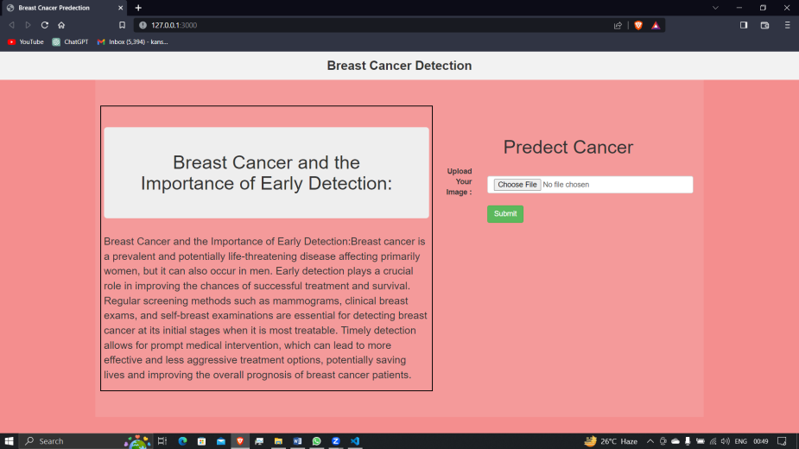

2) Users can directly upload the image .

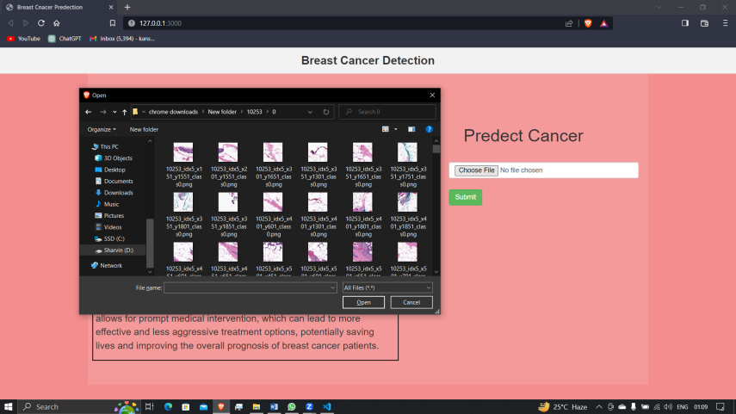

3) After Uploading click on predict button.

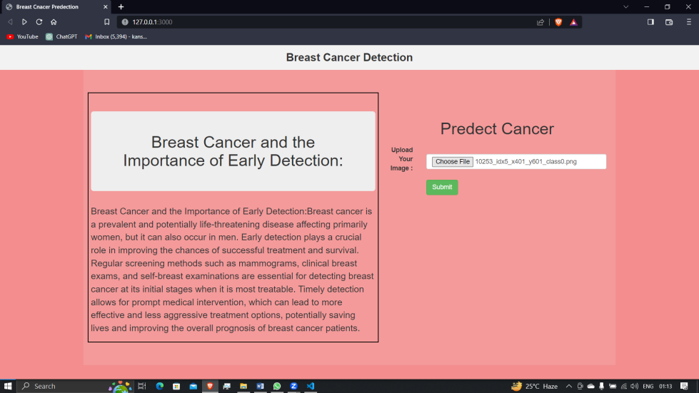

B. Output:  
The model will process the uploaded image and classify it as either 1) benignor 2) malignant. The result will be displayed on the web interface.

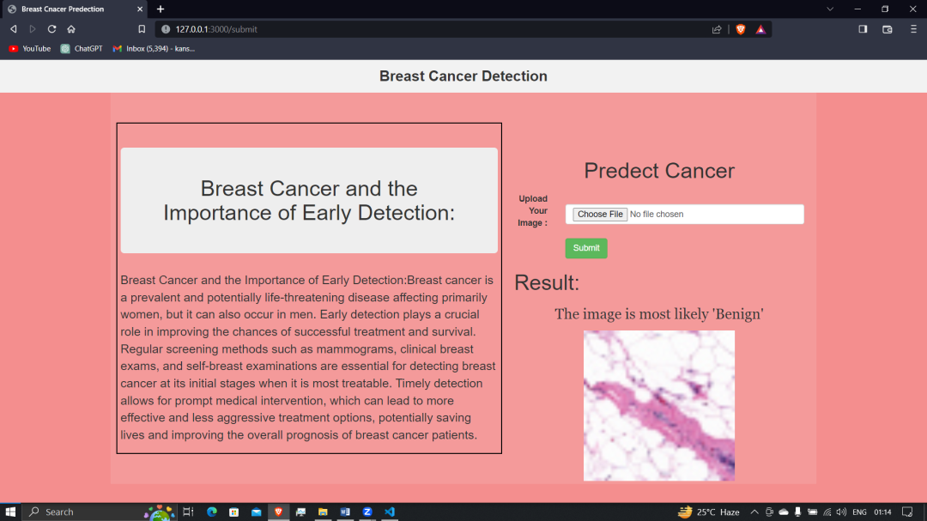

or

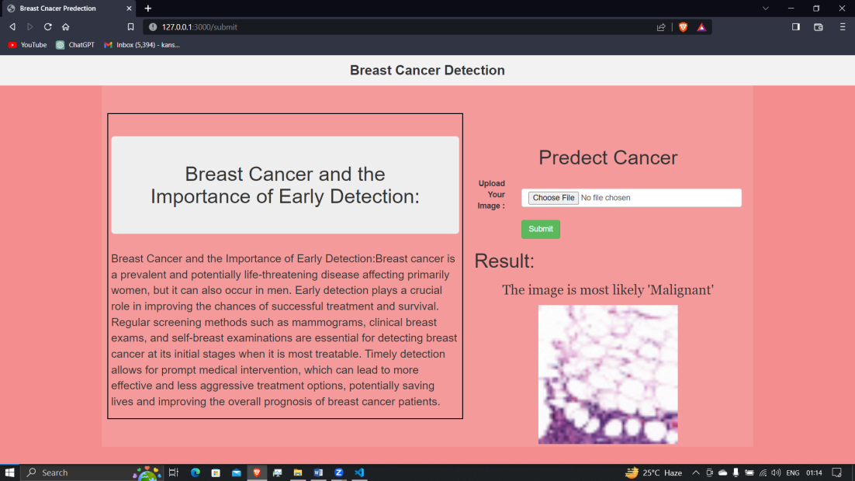

# 5. Limitations and Risks

## 5.1 Data Limitations:

The accuracy and reliability of the breast cancer prediction model heavily depend on the quality and representativeness of the training data. If the dataset used for training is small, unbalanced, or contains noisy or biased samples, it may lead to suboptimal model performance. Additionally, the model might not generalize well to new, unseen data if the training data does not adequately cover the entire spectrum of variations in breast cell images.

## 5.2 False Positives and False Negatives:

Like any medical diagnostic tool, the AI model is not infallible, and there is always a risk of false positives and false negatives in the predictions. A false positive occurs when the model incorrectly identifies a benign image as malignant, potentially leading to unnecessary stress and medical interventions for the patient. On the other hand, a false negative occurs when the model incorrectly classifies a malignant image as benign, delaying the necessary medical attention and treatment.

## 5.3 Interpretability and Explainability:

Deep learning models, especially complex ones like CNNs, are often considered black-box models due to their intricate internal representations. Interpreting and explaining the reasons behind the model's predictions can be challenging. This lack of interpretability might make it difficult for medical professionals to trust and understand the model's decisions fully.

## 5.4 Overfitting and Generalization:

During the training process, there is a risk of the model overfitting to the training data. Overfitting occurs when the model memorizes the training data rather than learning general patterns, leading to poor performance on new, unseen data. Ensuring proper data augmentation, regularization techniques, and validation strategies are essential to mitigate the risk of overfitting and improve the model's generalization capabilities.

## 5.5 Ethical Considerations:

The use of AI in medical diagnosis raises ethical concerns. It is crucial to ensure that the model is deployed and used responsibly, with clear guidelines on its application. The potential consequences of false predictions must be carefully evaluated, and patients' privacy and data security must be safeguarded throughout the model's lifecycle.

## 5.6 Hardware and Computational Requirements:

Deep learning models, particularly CNNs, can be computationally intensive and require powerful hardware for training and inference. Deploying the model in resource-constrained environments might be challenging, and optimizations may be necessary to make it feasible for real-world applications.

## 5.7 Continuous Monitoring and Updates:

The medical field is constantly evolving, and new research findings might lead to updates in the diagnosis and treatment of breast cancer. The AI model should be continuously monitored and updated to incorporate the latest medical knowledge and advancements, ensuring its relevance and accuracy over time.

## 5.8 Regulatory and Legal Aspects:

The deployment of AI models in medical settings might be subject to regulatory approvals and compliance with legal requirements. Ensuring that the model meets the necessary standards and guidelines is essential to avoid potential legal and liability issues.

It is important to acknowledge these limitations and risks when using the breast cancer prediction AI model and to always involve qualified medical professionals in the decision-making process to ensure the best possible patient care.

# 6. Conclusion

The Breast Cancer Prediction AI model offers a promising tool for assisting medical professionals in diagnosing breast cancer. However, it should be used as a supplementary tool and not a replacement for human expertise. Continuous refinement and improvement of the model are necessary to enhance its accuracy and reliability.

# 7. References

Referred From: https://apsche.smartinternz.com/Student/guided_project_info