**JAVA FULL STACK DEVELOPMENT**

ASSIGNMENT – 1

Question 1:

Create a local Git repo with the name "MyRepo".

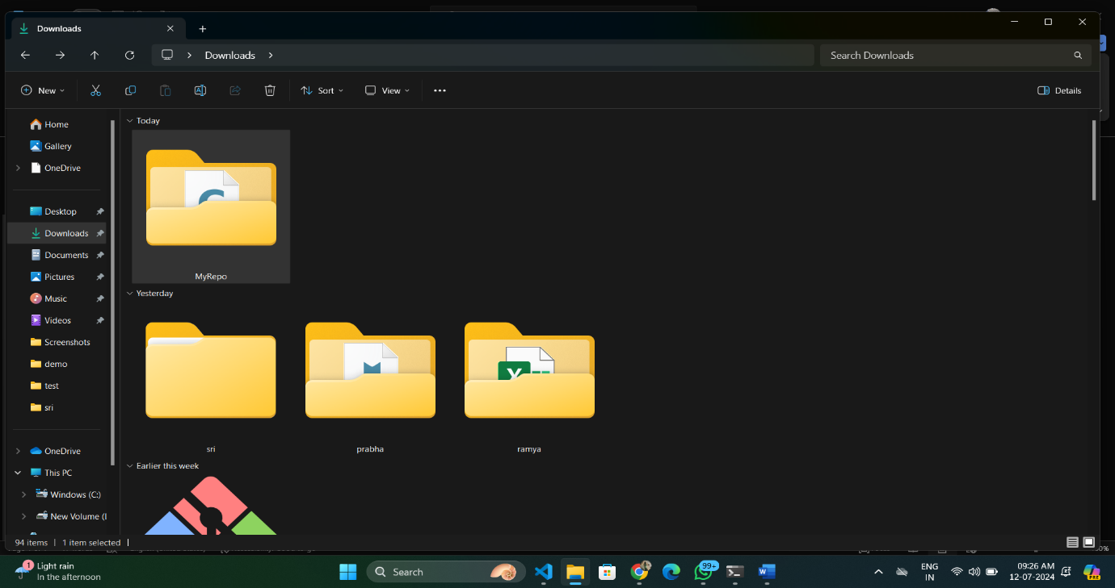

Question 2:

Create one .txt file, five .c files and five .java files in the working area.

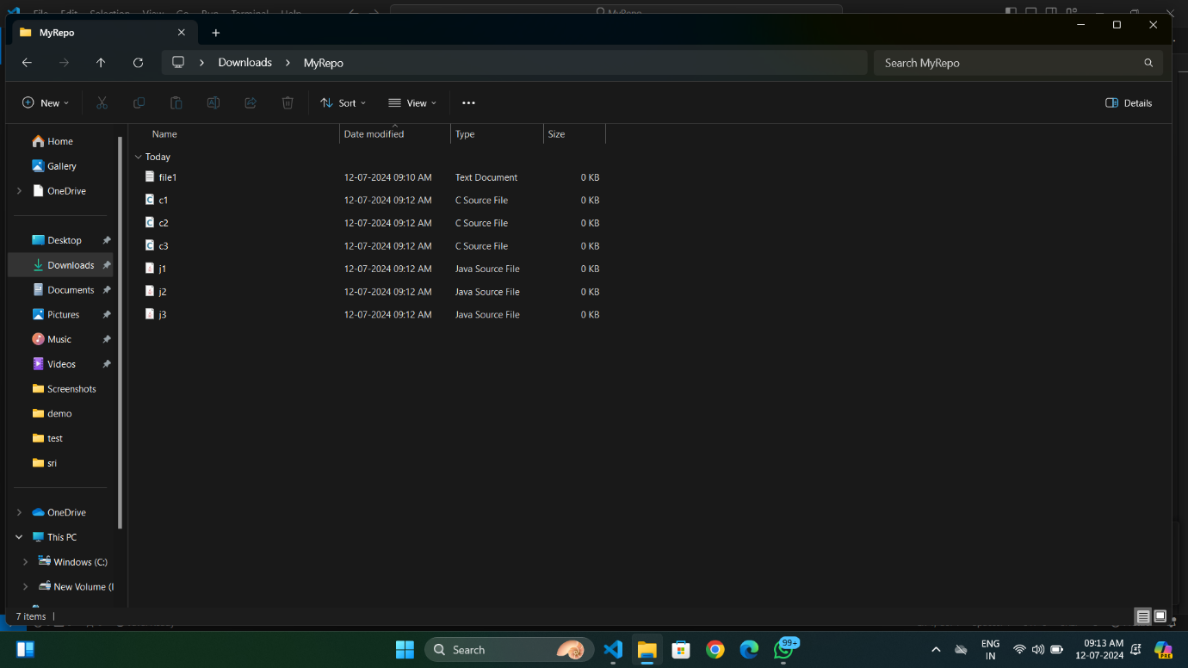

Question 3:

Verify the git status.

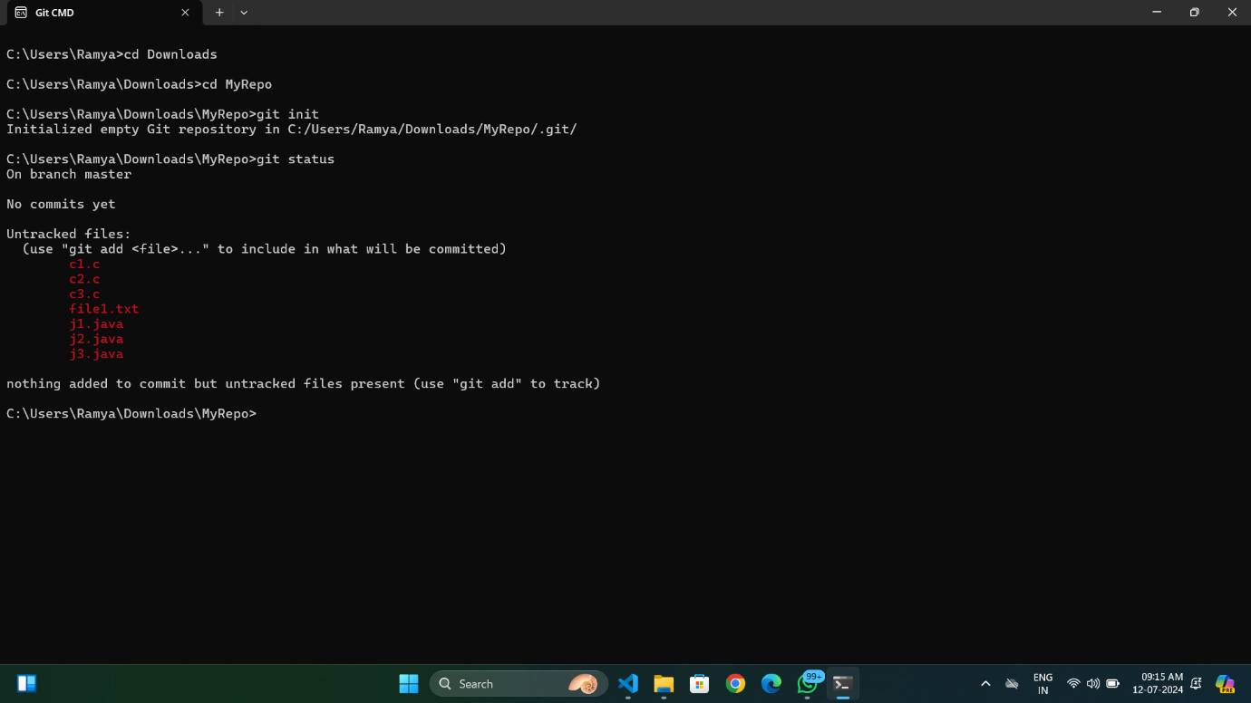

Question 4:

Add only the .txt into the staging area.

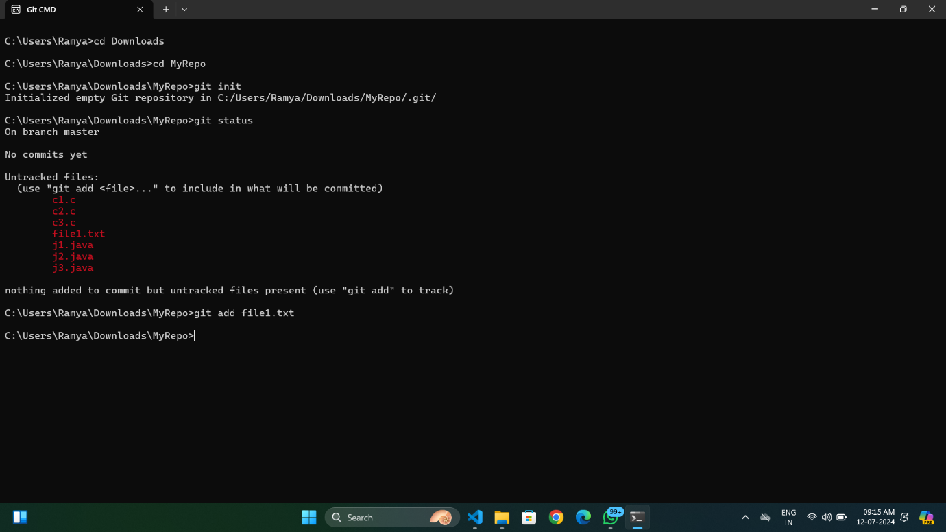

Question 5:

Verify the git status.

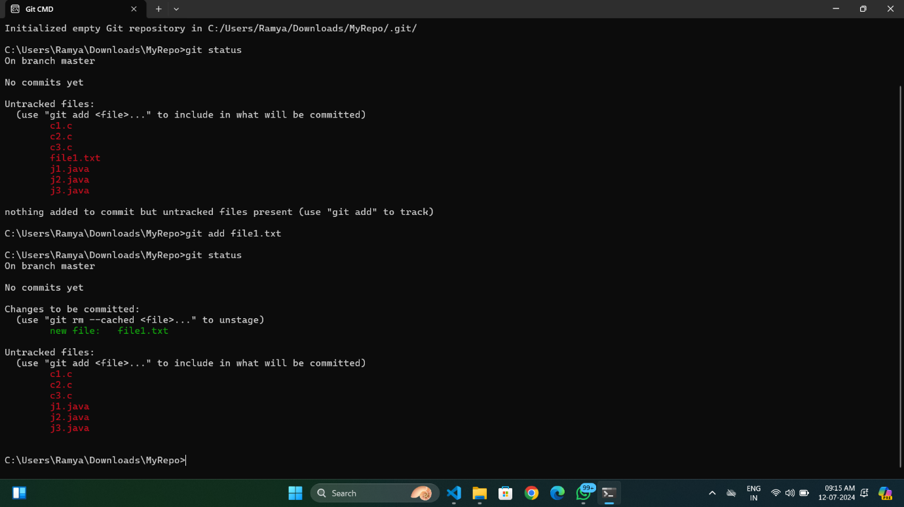

Question 6:

Make a commit with the name "TXT Commit".

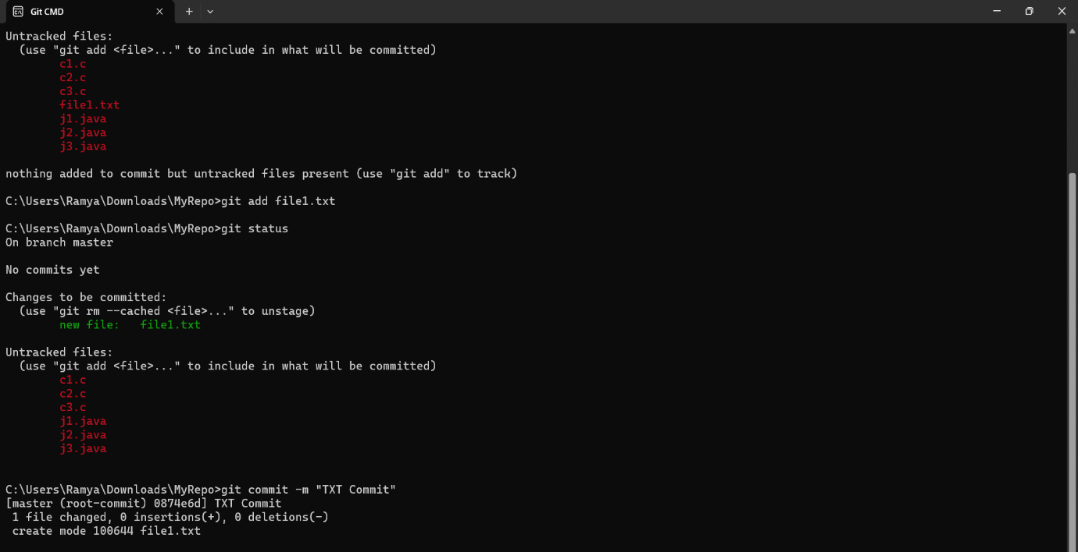

Question 7:

Add all .c files into the staging area.

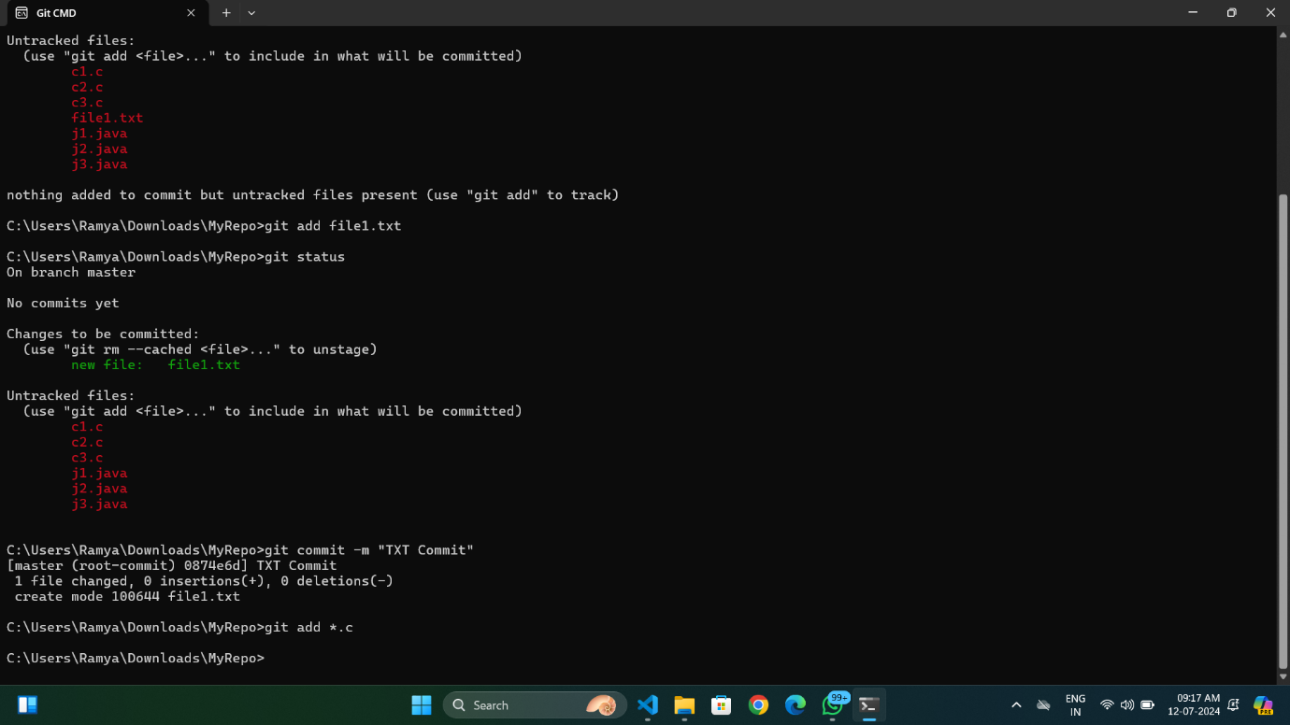

Question 8:

Verify the git status.

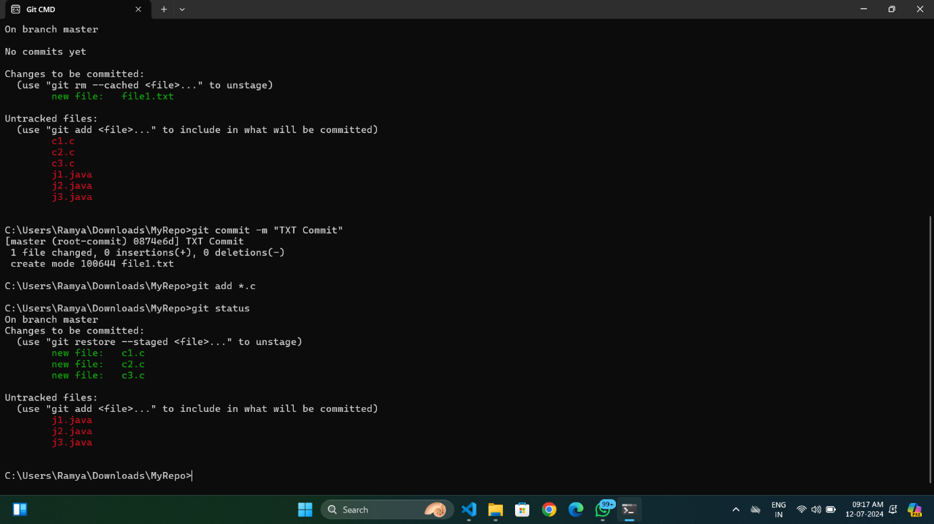

Question 9:

Make a commit with the name "C Commit".

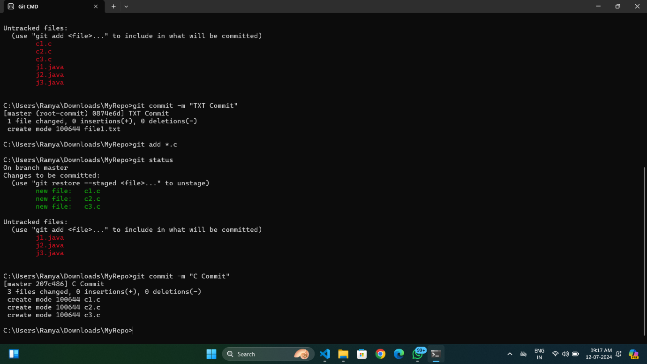

Question 10:

Add all .java files into the staging area.

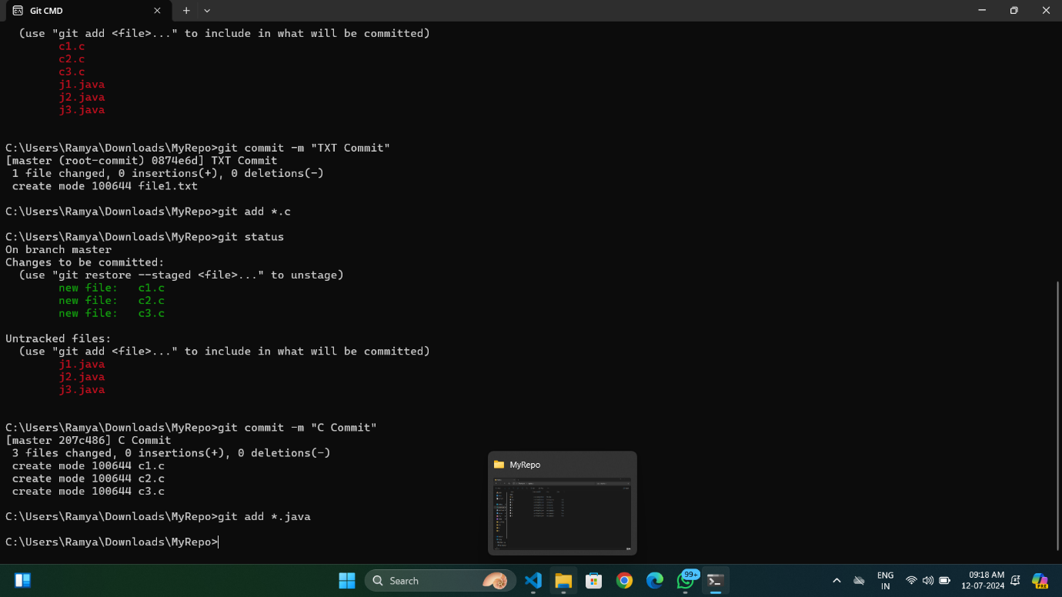

Question 11:

Verify the git status.

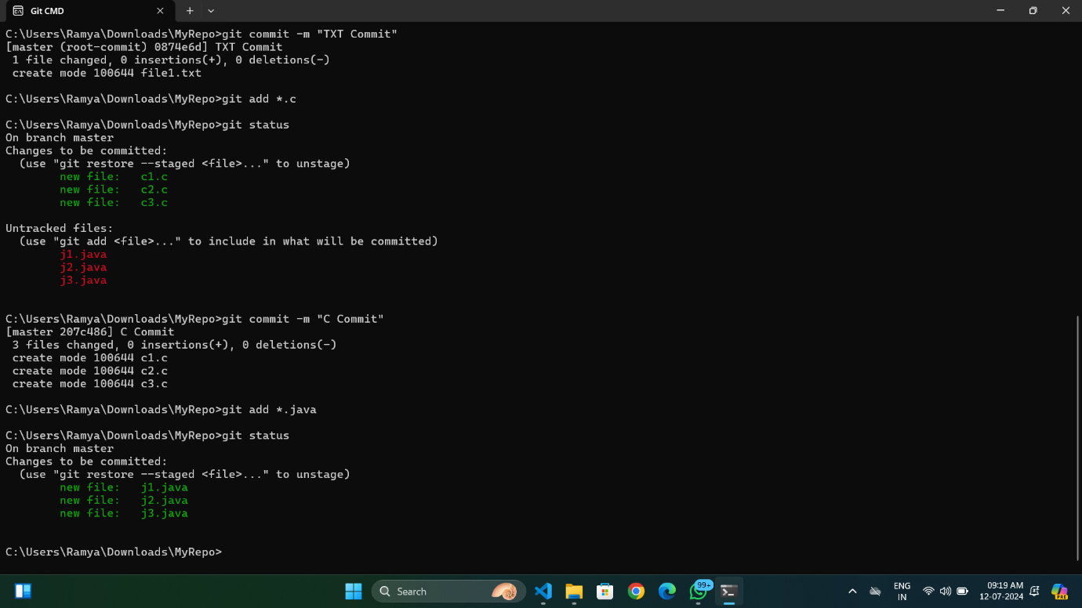

Question 12:

Make a commit with the name "Java Commit".

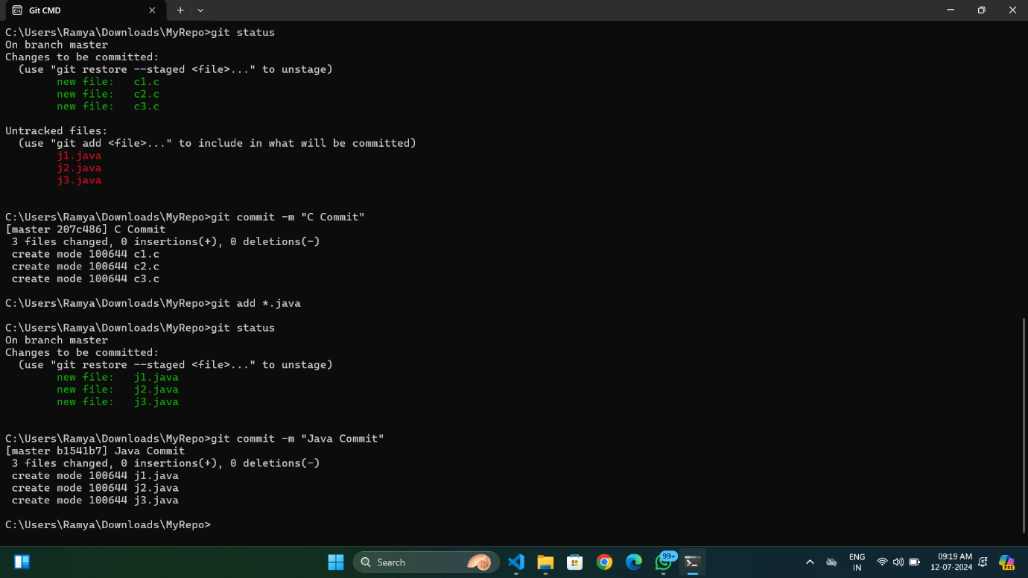

Question 13:

Delete all .java files from working area.

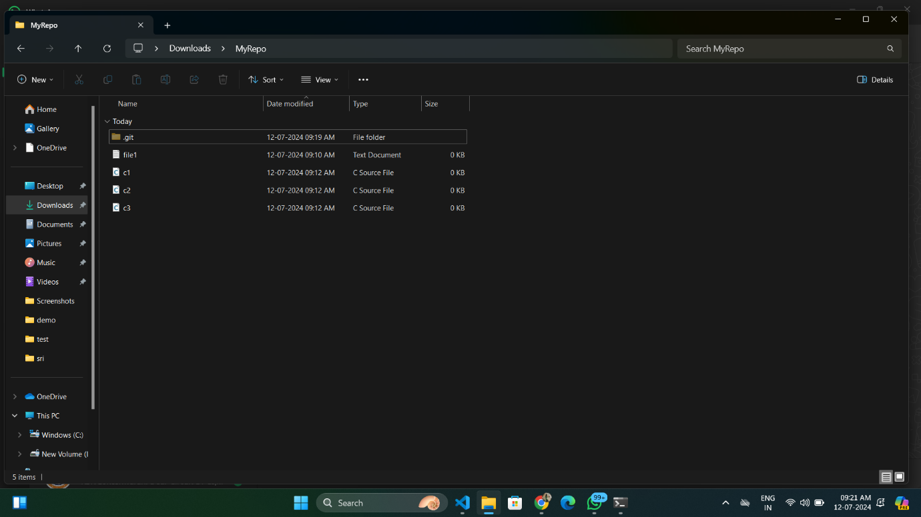

Question 14:

Verify the status.

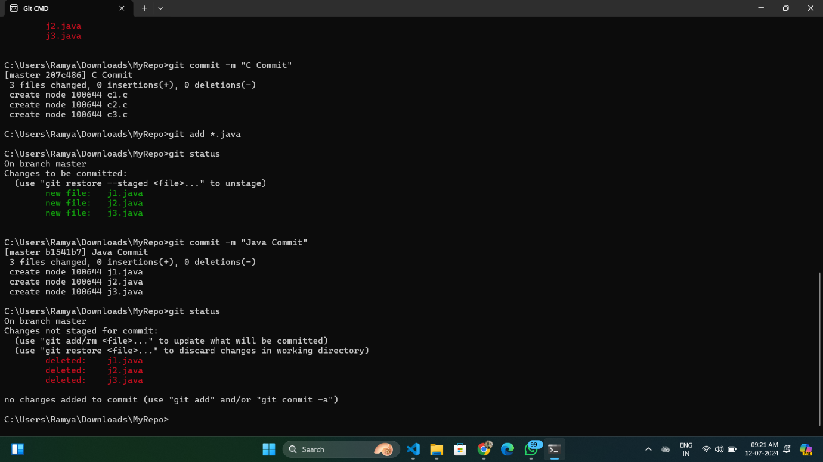

Question 15:

Add the changes into the staging area.

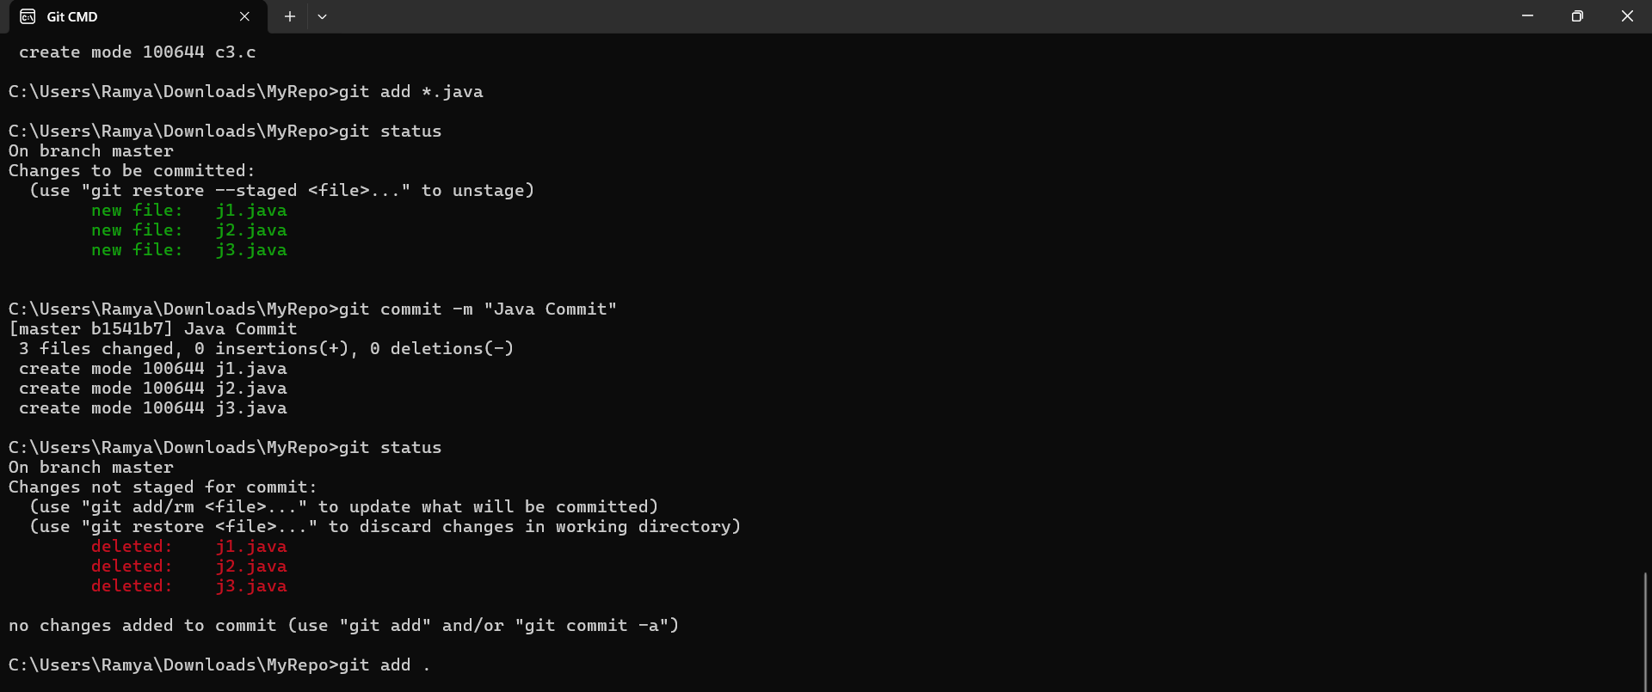

Question 16:

Make a commit with the name "Delete Java Commit".

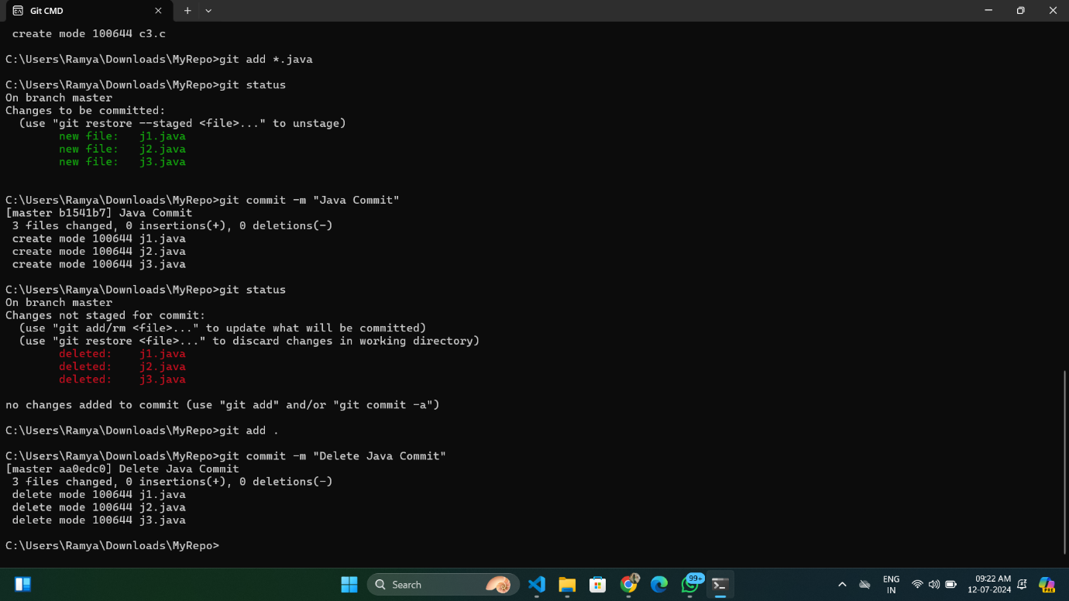

Question 17:

Display all commit.

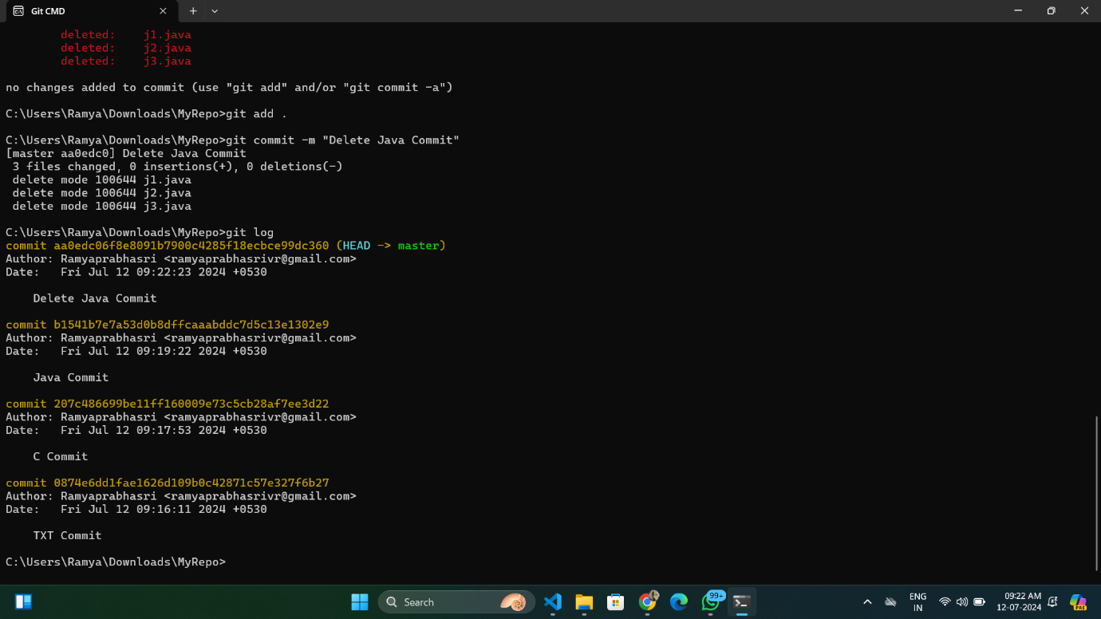

Name: Ramyaprabhasri V R

Reg No.: 73772114185

Department: Computer Science

and Engineering

Year / Sec: IV / B