WEEK 3

**Spring Core and Maven & Spring Data JPA with Spring Boot, Hibernate**

**Spring Core and Maven**

**Exercise 1: Configuring a Basic Spring Application**

**Scenario:**

Your company is developing a web application for managing a library. You need to use the Spring Framework to handle the backend operations.

**Steps:**

1. **Set Up a Spring Project:**
   * Create a Maven project named **LibraryManagement**.
   * Add Spring Core dependencies in the **pom.xml** file.
2. **Configure the Application Context:**
   * Create an XML configuration file named **applicationContext.xml** in the **src/main/resources** directory.
   * Define beans for **BookService** and **BookRepository** in the XML file.
3. **Define Service and Repository Classes:**
   * Create a package **com.library.service** and add a class **BookService**.
   * Create a package **com.library.repository** and add a class **BookRepository**.
4. **Run the Application:**
   * Create a main class to load the Spring context and test the configuration.

CODE

**BookRepository.java**

package com.library.LibraryManagementSpring;

public class BookRepository {

public void saveBook(String bookName) {

System.out.println("Book '" + bookName + "' saved to the database.");

}

}

**BookService.java**

package com.library.LibraryManagementSpring;

public class BookService {

private BookRepository bookRepository;

public void setBookRepository(BookRepository bookRepository) {

this.bookRepository = bookRepository;

}

public void addBook(String bookName) {

System.out.println("BookService: Adding book...");

bookRepository.saveBook(bookName);

}

}

**MainApp.java**

package com.library.LibraryManagementSpring;

import org.springframework.context.ApplicationContext;

import org.springframework.context.support.ClassPathXmlApplicationContext;

public class MainApp {

public static void main(String[] args) {

ApplicationContext context = new ClassPathXmlApplicationContext("applicationContext.xml");

BookService bookService = (BookService) context.getBean("bookService");

bookService.addBook("Spring in Action");

}

}

**ApplicationContext.xml**

<?xml version="1.0" encoding="UTF-8"?>

<beans xmlns="http://www.springframework.org/schema/beans"

xmlns:xsi="http://www.w3.org/2001/XMLSchema-instance"

xsi:schemaLocation="

http://www.springframework.org/schema/beans

https://www.springframework.org/schema/beans/spring-beans.xsd">

<bean id="bookRepository" class="com.library.LibraryManagementSpring.BookRepository" />

<bean id="bookService" class="com.library.LibraryManagementSpring.BookService">

<property name="bookRepository" ref="bookRepository" />

</bean>

</beans>

OUTPUT

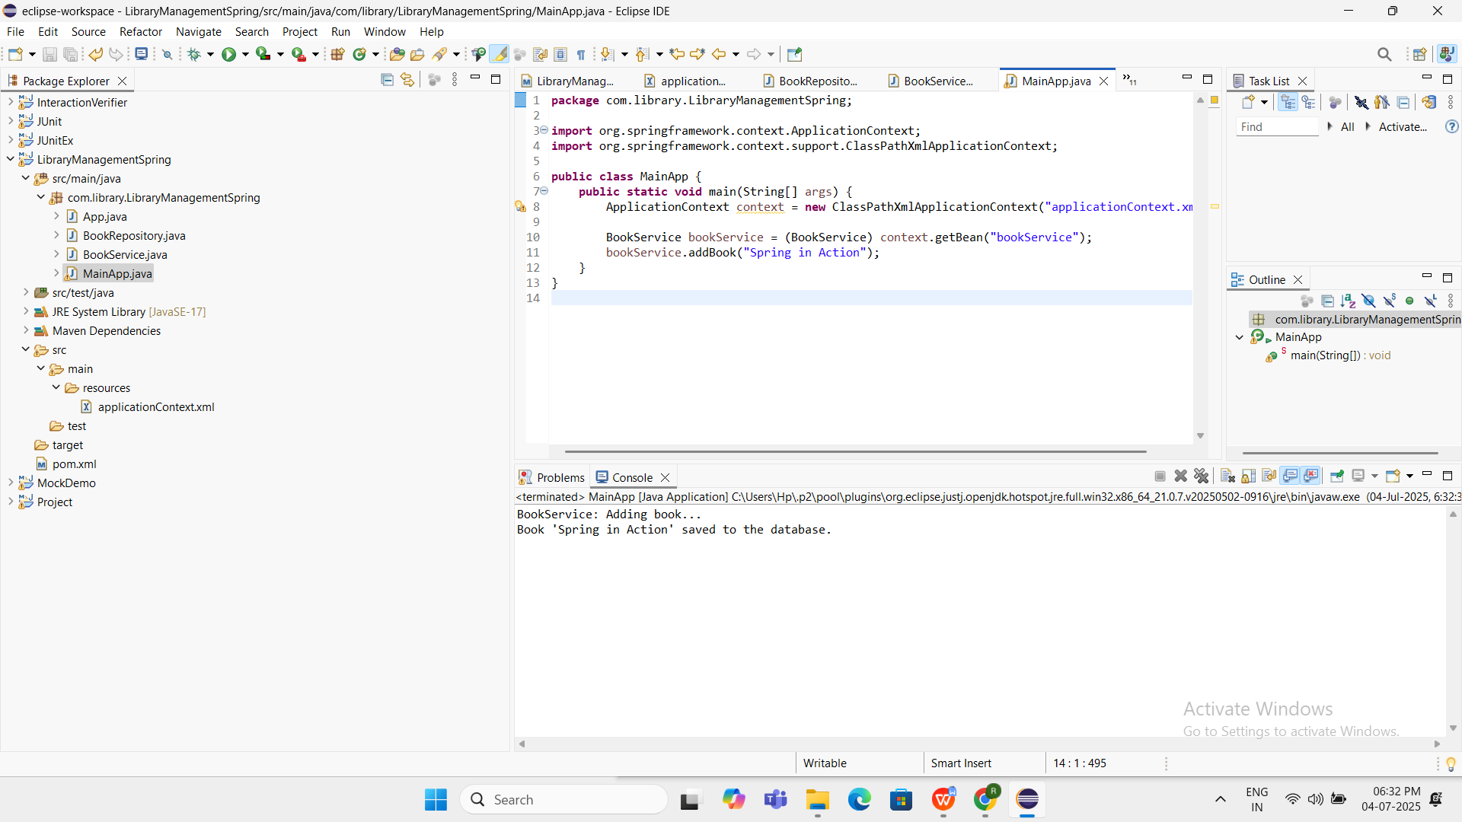



**Exercise 2: Implementing Dependency Injection**

**Scenario:**

In the library management application, you need to manage the dependencies between the BookService and BookRepository classes using Spring's IoC and DI.

**Steps:**

1. **Modify the XML Configuration:**
   * Update **applicationContext.xml** to wire **BookRepository** into **BookService**.
2. **Update the BookService Class:**
   * Ensure that **BookService** class has a setter method for **BookRepository**.
3. **Test the Configuration:**
   * Run the **LibraryManagementApplication** main class to verify the dependency injection.

CODE

**ApplicationContext.xml**

<?xml version="1.0" encoding="UTF-8"?>

<beans xmlns="http://www.springframework.org/schema/beans"

xmlns:xsi="http://www.w3.org/2001/XMLSchema-instance"

xsi:schemaLocation="

http://www.springframework.org/schema/beans

https://www.springframework.org/schema/beans/spring-beans.xsd">

<bean id="bookRepository" class="com.library.LibraryManagementSpring.BookRepository" />

<bean id="bookService" class="com.library.LibraryManagementSpring.BookService">

<property name="bookRepository" ref="bookRepository" />

</bean>

</beans>

**BookRepository.java**

package com.library.LibraryManagementSpring;

public class BookRepository {

public void saveBook(String bookName) {

System.out.println("BookRepository: Book '" + bookName + "' saved.");

}

}

**BookService.java**

package com.library.LibraryManagementSpring;

public class BookService {

private BookRepository bookRepository;

public void setBookRepository(BookRepository bookRepository) {

System.out.println("DI: BookRepository has been injected into BookService.");

this.bookRepository = bookRepository;

}

public void addBook(String bookName) {

System.out.println("BookService: Adding book...");

bookRepository.saveBook(bookName);

}

}

**LibraryManagementApplication.java**

package com.library.LibraryManagementSpring;

import org.springframework.context.ApplicationContext;

import org.springframework.context.support.ClassPathXmlApplicationContext;

public class LibraryManagementApplication {

public static void main(String[] args) {

ApplicationContext context = new ClassPathXmlApplicationContext("applicationContext.xml");

BookService bookService = (BookService) context.getBean("bookService");

bookService.addBook("Spring in Action");

}

}

OUTPUT

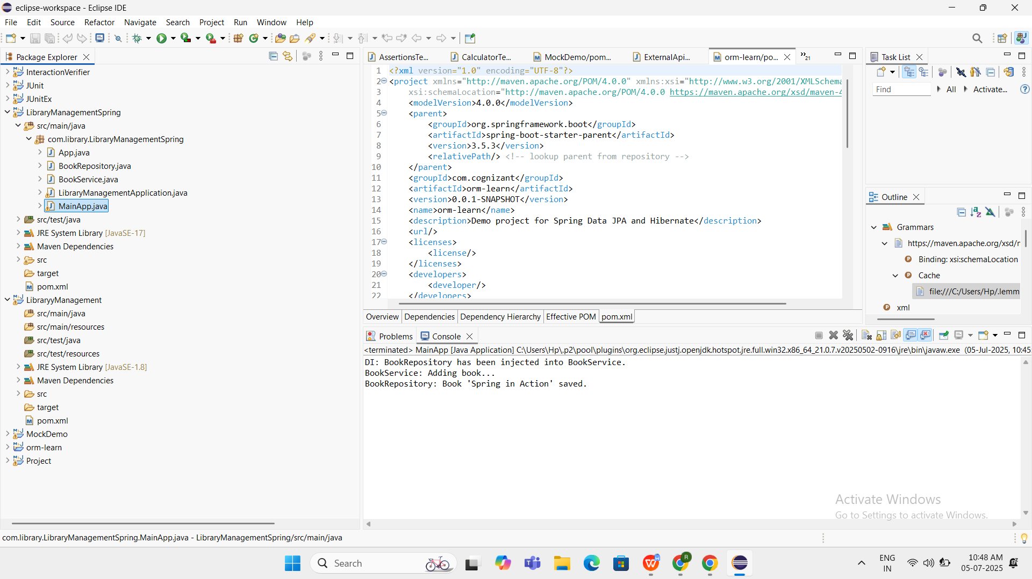



**Exercise 4: Creating and Configuring a Maven Project**

**Scenario:**

You need to set up a new Maven project for the library management application and add Spring dependencies.

**Steps:**

1. **Create a New Maven Project:**
   * Create a new Maven project named **LibraryManagement**.
2. **Add Spring Dependencies in pom.xml:**
   * Include dependencies for Spring Context, Spring AOP, and Spring WebMVC.
3. **Configure Maven Plugins:**
   * Configure the Maven Compiler Plugin for Java version 1.8 in the pom.xml file.

CODE

**Pom.xml**

<project xmlns="http://maven.apache.org/POM/4.0.0"

xmlns:xsi="http://www.w3.org/2001/XMLSchema-instance"

xsi:schemaLocation="http://maven.apache.org/POM/4.0.0

http://maven.apache.org/xsd/maven-4.0.0.xsd">

<modelVersion>4.0.0</modelVersion>

<groupId>com.library</groupId>

<artifactId>LibraryyManagement</artifactId>

<version>0.0.1-SNAPSHOT</version>

<packaging>jar</packaging>

<name>LibraryyManagement</name>

<properties>

<maven.compiler.source>1.8</maven.compiler.source>

<maven.compiler.target>1.8</maven.compiler.target>

<project.build.sourceEncoding>UTF-8</project.build.sourceEncoding>

</properties>

<dependencies>

<dependency>

<groupId>org.springframework</groupId>

<artifactId>spring-context</artifactId>

<version>5.3.34</version>

</dependency>

<dependency><groupId>org.springframework</groupId>

<artifactId>spring-aop</artifactId>

<version>5.3.34</version>

</dependency>

<dependency><groupId>org.springframework</groupId>

<artifactId>spring-webmvc</artifactId>

<version>5.3.34</version>

</dependency>

<dependency>

<groupId>commons-logging</groupId>

<artifactId>commons-logging</artifactId>

<version>1.2</version>

</dependency>

</dependencies>

<build>

<plugins>

<plugin>

<artifactId>maven-compiler-plugin</artifactId>

<version>3.10.1</version>

<configuration>

<source>1.8</source>

<target>1.8</target>

</configuration>

</plugin>

</plugins>

</build>

</project>

OUTPUT

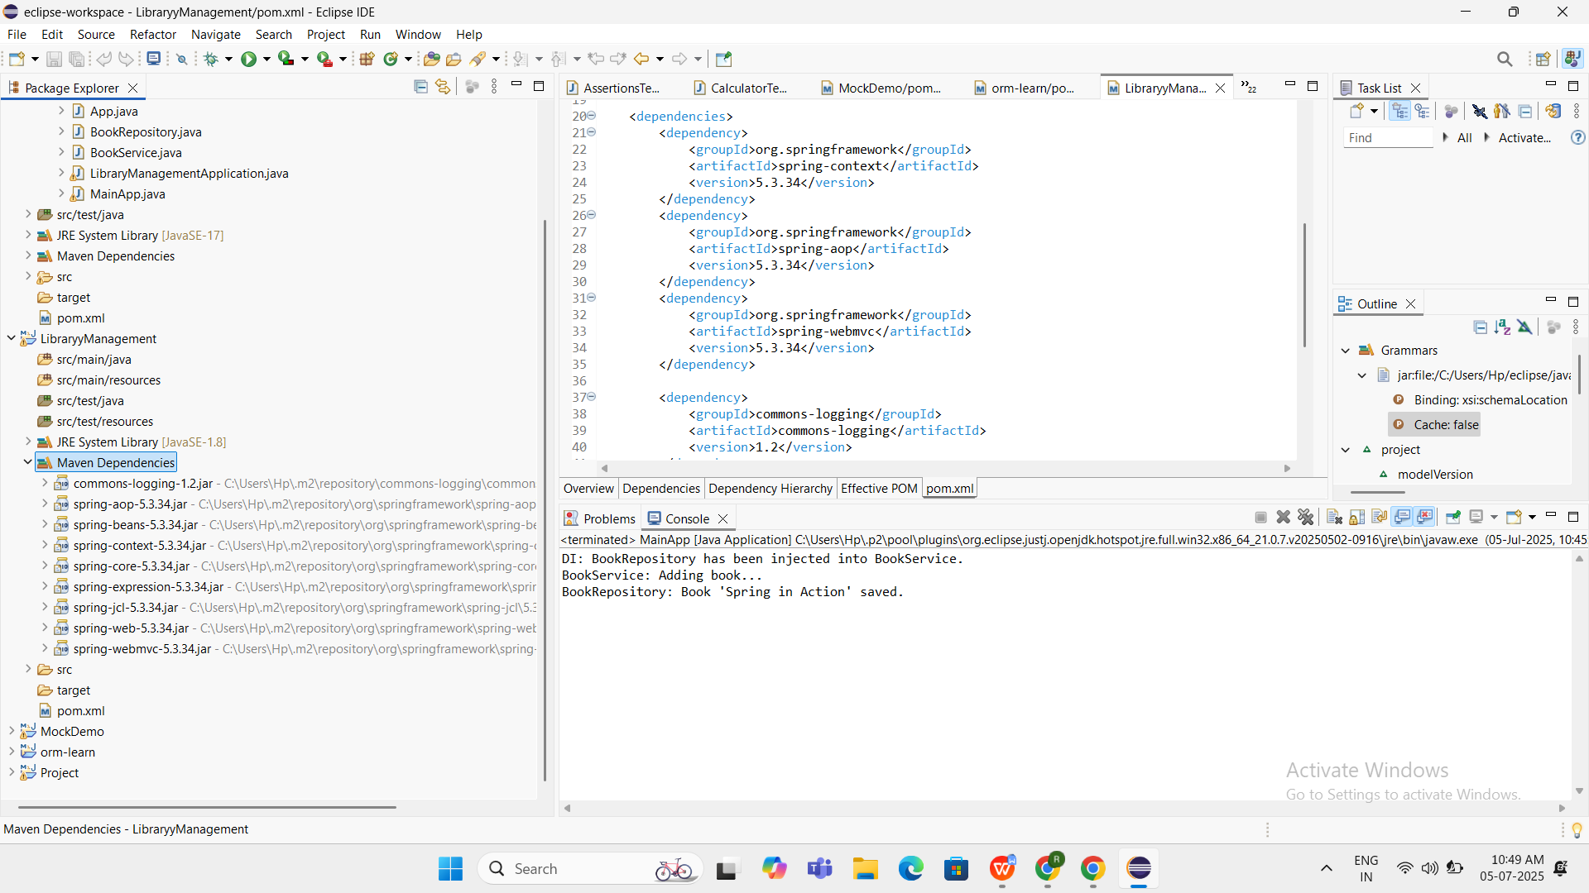

MAVEN DEPENDENCIES ARE VISIBLE UNDER THE FOLDER

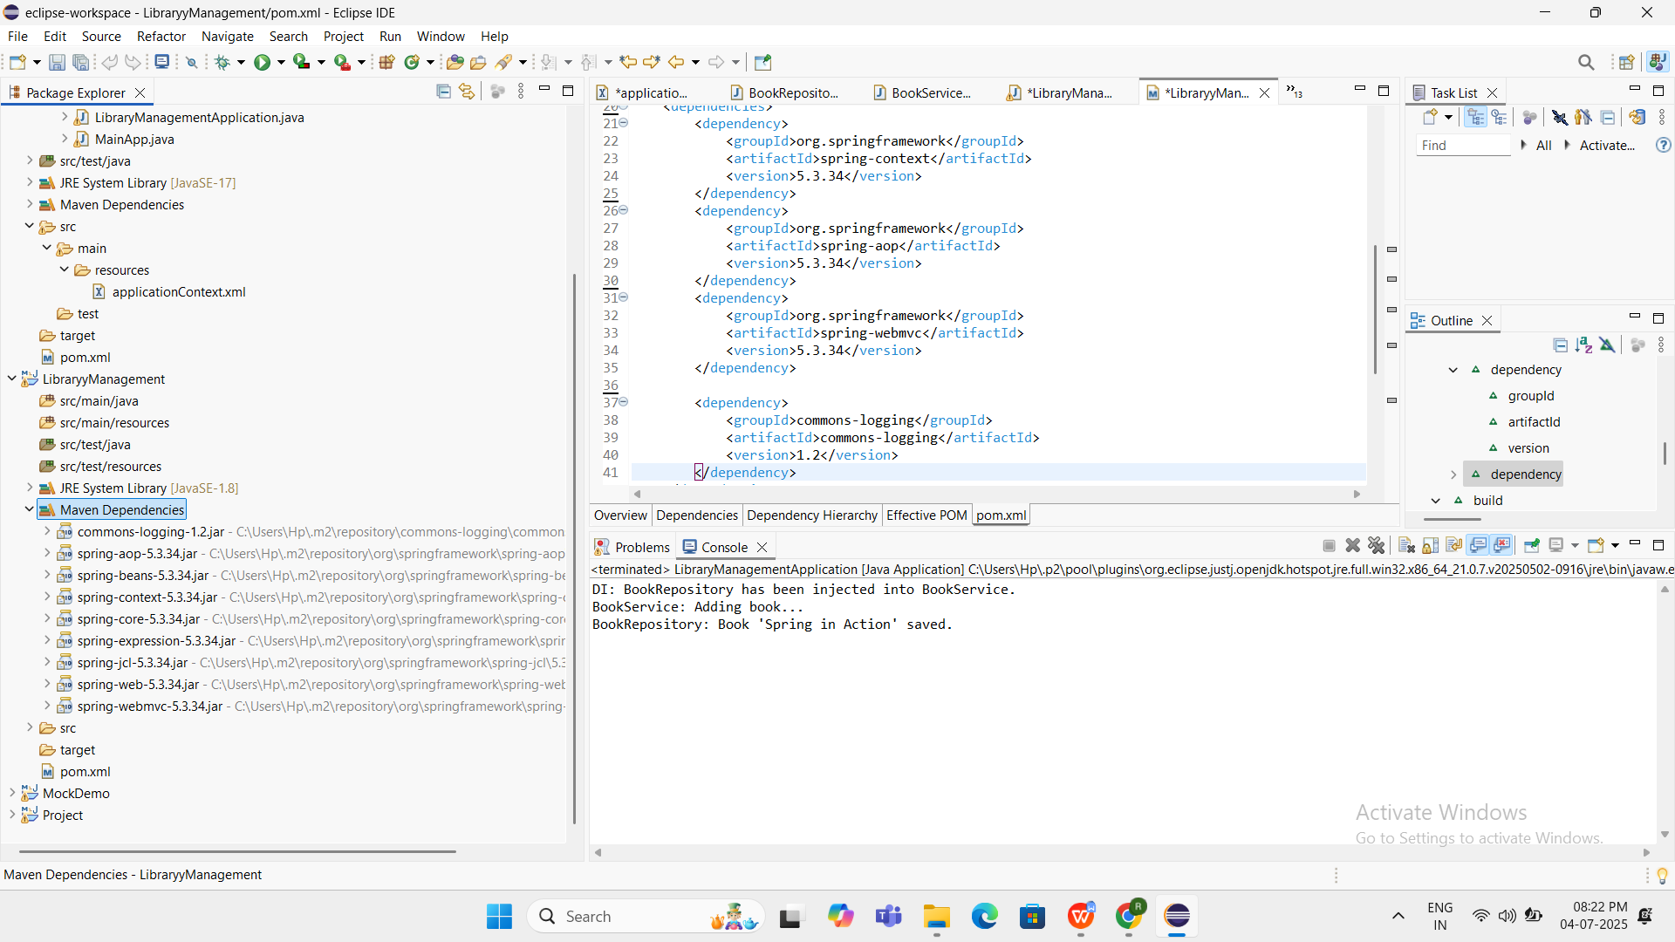

**Spring Data JPA with Spring Boot, Hibernate**

**HandsON 1**

**Spring Data JPA - Quick Example**

**CODE**

**OrmLearnApplication.java**

package com.cognizant.orm_learn;

import org.springframework.boot.SpringApplication;

import org.springframework.boot.autoconfigure.SpringBootApplication;

import org.springframework.context.ApplicationContext;

import com.cognizant.orm_learn.model.Country;

import com.cognizant.orm_learn.service.CountryService;

@SpringBootApplication

public class OrmLearnApplication {

public static void main(String[] args) {

ApplicationContext context = SpringApplication.run(OrmLearnApplication.class, args);

System.out.println("Inside main");

CountryService countryService = context.getBean(CountryService.class);

System.out.println("CountryService Bean is working correctly!");

Country country1 = countryService.findCountryByCode("IN");

System.out.println(country1);

Country country2 = countryService.findCountryByCode("US");

System.out.println(country2);

}

}

**Country.java**

package com.cognizant.orm_learn.model;

import jakarta.persistence.Entity;

import jakarta.persistence.Id;

import jakarta.persistence.Table;

@Entity

@Table(name = "country")

public class Country {

@Id

private String code;

private String name;

// Constructors

public Country() {}

public Country(String code, String name) {

this.code = code;

this.name = name;

}

// Getters and Setters

public String getCode() {

return code;

}

public void setCode(String code) {

this.code = code;

}

public String getName() {

return name;

}

public void setName(String name) {

this.name = name;

}

// toString

@Override

public String toString() {

return "Country [code=" + code + ", name=" + name + "]";

}

}

**CountryRepository.java**

package com.cognizant.orm_learn.repository;

import org.springframework.data.jpa.repository.JpaRepository;

import org.springframework.stereotype.Repository;

import com.cognizant.orm_learn.model.Country;

@Repository

public interface CountryRepository extends JpaRepository<Country, String> {

}

**CountryService.java**

package com.cognizant.orm_learn.service;

import org.springframework.beans.factory.annotation.Autowired;

import org.springframework.stereotype.Service;

import com.cognizant.orm_learn.model.Country;

import com.cognizant.orm_learn.repository.CountryRepository;

@Service

public class CountryService {

@Autowired

private CountryRepository countryRepository;

public Country findCountryByCode(String code) {

return countryRepository.findById(code).orElse(null);

}

}

**Application.properties**

# DATABASE CONNECTION

spring.datasource.url=jdbc:mysql://localhost:3306/orm_learn?useSSL=false&serverTimezone=UTC

spring.datasource.username=root

spring.datasource.password=Ramya1706!

spring.datasource.driver-class-name=com.mysql.cj.jdbc.Driver

# JPA / HIBERNATE CONFIG

spring.jpa.hibernate.ddl-auto=update

spring.jpa.properties.hibernate.dialect=org.hibernate.dialect.MySQLDialect

spring.jpa.show-sql=false

spring.jpa.properties.hibernate.format_sql=false

# CLEAN CONSOLE OUTPUT

logging.level.root=ERROR

logging.level.org.springframework=ERROR

logging.level.org.hibernate=ERROR

**Pox.xml**

<?xml version="1.0" encoding="UTF-8"?>

<project xmlns="http://maven.apache.org/POM/4.0.0" xmlns:xsi="http://www.w3.org/2001/XMLSchema-instance"

xsi:schemaLocation="http://maven.apache.org/POM/4.0.0 https://maven.apache.org/xsd/maven-4.0.0.xsd">

<modelVersion>4.0.0</modelVersion>

<parent>

<groupId>org.springframework.boot</groupId>

<artifactId>spring-boot-starter-parent</artifactId>

<version>3.5.3</version>

<relativePath/> <!-- lookup parent from repository -->

</parent>

<groupId>com.cognizant</groupId>

<artifactId>orm-learn</artifactId>

<version>0.0.1-SNAPSHOT</version>

<name>orm-learn</name>

<description>Demo project for Spring Data JPA and Hibernate</description>

<url/>

<licenses>

<license/>

</licenses><developers>

<developer/>

</developers><scm>

<connection/>

<developerConnection/><tag/>

<url/>

</scm>

<properties>

<java.version>17</java.version>

</properties>

<dependencies><dependency>

<groupId>org.springframework.boot</groupId>

<artifactId>spring-boot-starter-data-jpa</artifactId>

</dependency>

<dependency><groupId>org.springframework.boot</groupId>

<artifactId>spring-boot-devtools</artifactId>

<scope>runtime</scope>

<optional>true</optional>

</dependency><dependency>

<groupId>com.mysql</groupId>

<artifactId>mysql-connector-j</artifactId>

<scope>runtime</scope>

</dependency>

<dependency>

<groupId>org.springframework.boot</groupId>

<artifactId>spring-boot-starter-test</artifactId>

<scope>test</scope>

</dependency>

</dependencies>

<build><plugins><plugin>

<groupId>org.springframework.boot</groupId>

<artifactId>spring-boot-maven-plugin</artifactId>

</plugin>

</plugins>

</build>

</project>

OUTPUT

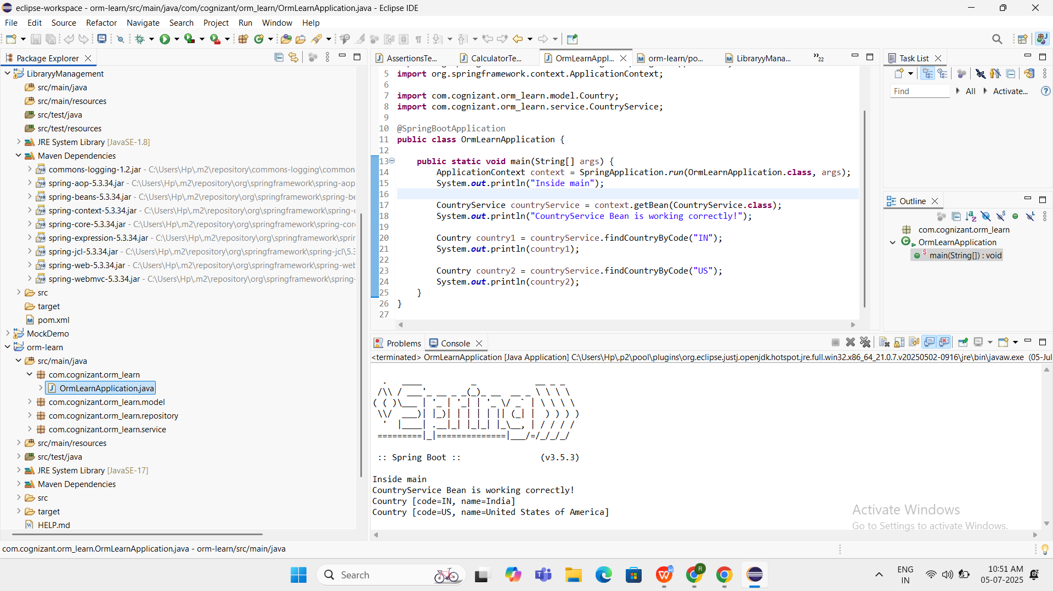



**Hands On 4**

**Difference between JPA, Hibernate and Spring Data JPA**

**CODE**

**OrmlearnApplication.java**

package com.cognizant.orm_learn;

import org.springframework.boot.SpringApplication;

import org.springframework.boot.autoconfigure.SpringBootApplication;

import org.springframework.context.ApplicationContext;

import com.cognizant.orm_learn.model.Employee;

import com.cognizant.orm_learn.service.EmployeeService;

@SpringBootApplication

public class OrmLearnApplication {

public static void main(String[] args) {

ApplicationContext context = SpringApplication.run(OrmLearnApplication.class, args);

EmployeeService employeeService = context.getBean(EmployeeService.class);

System.out.println("Inside main");

Employee emp = new Employee();

emp.setName("Ramyaraahashri");

emp.setSalary(100000.0);

employeeService.addEmployee(emp);

}

}

**Employee.java**

package com.cognizant.orm_learn.model;

import jakarta.persistence.*;

@Entity

@Table(name = "employee")

public class Employee {

@Id

@GeneratedValue(strategy = GenerationType.IDENTITY)

private int id;

private String name;

private double salary;

public int getId() { return id; }

public void setId(int id) { this.id = id; }

public String getName() { return name; }

public void setName(String name) { this.name = name; }

public double getSalary() { return salary; }

public void setSalary(double salary) { this.salary = salary; }

@Override

public String toString() {

return "Employee [id=" + id + ", name=" + name + ", salary=" + salary + "]";

}

}

**EmployeeRepository.java**

package com.cognizant.orm_learn.repository;

import org.springframework.data.jpa.repository.JpaRepository;

import org.springframework.stereotype.Repository;

import com.cognizant.orm_learn.model.Employee;

@Repository

public interface EmployeeRepository extends JpaRepository<Employee, Integer> {

}

**EmployeeService.java**

package com.cognizant.orm_learn.service;

import org.springframework.beans.factory.annotation.Autowired;

import org.springframework.stereotype.Service;

import org.springframework.transaction.annotation.Transactional;

import com.cognizant.orm_learn.model.Employee;

import com.cognizant.orm_learn.repository.EmployeeRepository;

@Service

public class EmployeeService {

@Autowired

private EmployeeRepository employeeRepository;

@Transactional

public void addEmployee(Employee employee) {

employeeRepository.save(employee);

System.out.println("Employee saved: " + employee);

}

}

**Application.properties**

# DATABASE CONNECTION

spring.datasource.url=jdbc:mysql://localhost:3306/orm_learn?useSSL=false&serverTimezone=UTC

spring.datasource.username=root

spring.datasource.password=Ramya1706!

spring.datasource.driver-class-name=com.mysql.cj.jdbc.Driver

# JPA / HIBERNATE CONFIG

spring.jpa.hibernate.ddl-auto=update

spring.jpa.properties.hibernate.dialect=org.hibernate.dialect.MySQLDialect

spring.jpa.show-sql=false

spring.jpa.properties.hibernate.format_sql=false

# CLEAN CONSOLE OUTPUT

logging.level.root=ERROR

logging.level.org.springframework=ERROR

logging.level.org.hibernate=ERROR

OUTPUT

