**WEEK 1**

**DATA STRUCTURES AND ALGORITHMS**

**Exercise 2: E-commerce Platform Search Function**

**Scenario:**

You are working on the search functionality of an e-commerce platform. The search needs to be optimized for fast performance.

**Code:**

import java.util.Arrays;

import java.util.Comparator;

public class Main {

static class Product {

int productId;

String productName;

String category;

public Product(int id, String name, String category) {

this.productId = id;

this.productName = name;

this.category = category;

}

@Override

public String toString() {

return productId + " - " + productName + " (" + category + ")";

}

}

public static Product linearSearch(Product[] products, String name) {

for (Product p : products) {

if (p.productName.equalsIgnoreCase(name)) {

return p;

}

}

return null;

}

public static Product binarySearch(Product[] products, String name) {

int left = 0, right = products.length - 1;

while (left <= right) {

int mid = (left + right) / 2;

int compare = products[mid].productName.compareToIgnoreCase(name);

if (compare == 0) {

return products[mid];

} else if (compare < 0) {

left = mid + 1;

} else {

right = mid - 1;

}

}

return null;

}

public static void main(String[] args) {

Product[] products = {

new Product(101, "Laptop", "Electronics"),

new Product(102, "Shoes", "Fashion"),

new Product(103, "Phone", "Electronics"),

new Product(104, "Watch", "Accessories"),

new Product(105, "Backpack", "Bags")

};

String searchTarget = "Phone";

System.out.println("🔍 Linear Search:");

Product foundLinear = linearSearch(products, searchTarget);

System.out.println(foundLinear != null ? "Found: " + foundLinear : "Product not found");

Arrays.sort(products, Comparator.comparing(p -> p.productName.toLowerCase()));

System.out.println("\n🔍 Binary Search (after sorting):");

Product foundBinary = binarySearch(products, searchTarget);

System.out.println(foundBinary != null ? "Found: " + foundBinary : "Product not found");

}

}

**OUTPUT:**

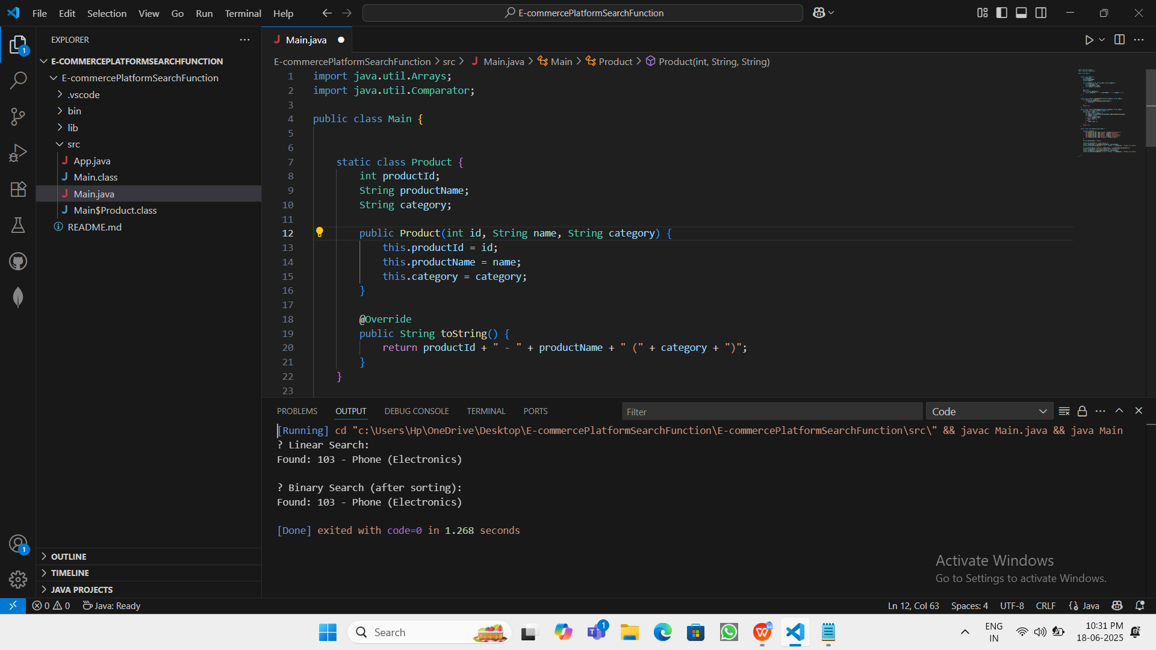

? Linear Search:

Found: 103 - Phone (Electronics)

? Binary Search (after sorting):

Found: 103 - Phone (Electronics)