**WEEK 1**

**DATA STRUCTURES AND ALGORITHMS**

**Exercise 7: Financial Forecasting**

**Scenario:**

You are developing a financial forecasting tool that predicts future values based on past data.

**Code:**

public class Main {

public static double forecast(double value, double growthRate, int years) {

if (years == 0) {

return value;

}

return forecast(value * (1 + growthRate), growthRate, years - 1);

}

public static double forecastMemo(double value, double growthRate, int years, double[] memo) {

if (years == 0) {

return value;

}

if (memo[years] != 0) {

return memo[years];

}

memo[years] = forecastMemo(value * (1 + growthRate), growthRate, years - 1, memo);

return memo[years];

}

public static void main(String[] args) {

double initialValue = 1000;

double growthRate = 0.10;

int years = 5;

double result = forecast(initialValue, growthRate, years);

System.out.println("Future Value (recursive): ₹" + result);

double[] memo = new double[years + 1];

double resultMemo = forecastMemo(initialValue, growthRate, years, memo);

System.out.println("Future Value (memoized): ₹" + resultMemo);

}

}

**OUTPUT:**

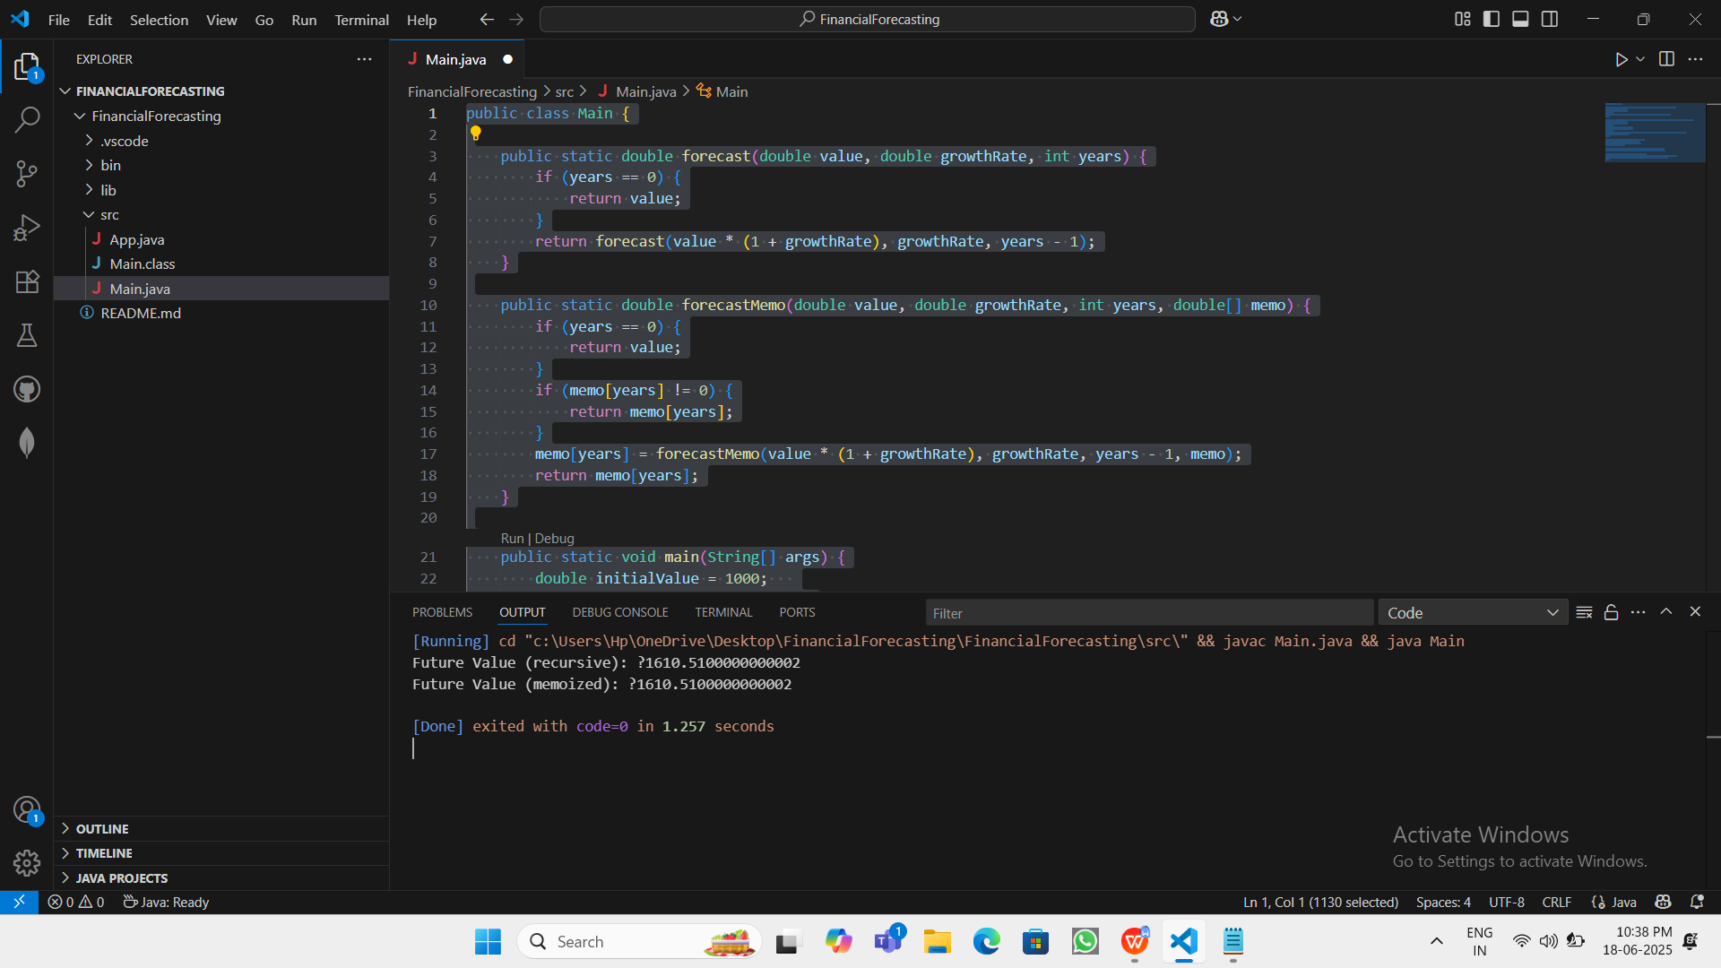

Future Value (recursive): ?1610.5100000000002

Future Value (memoized): ?1610.5100000000002