LINUX PROGRAMMING
LAB – 1 : Basic Shell Commands in Linux

Name : M.Ramya sai Date : 5/12/19
Reg No : 17MIS1148
Faculty : Prof . Harini

Here are few work out of basic linux shell commands.

1)Date
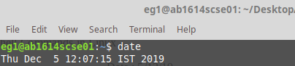

2)Calendar

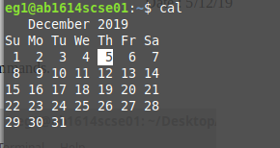

3)pwd
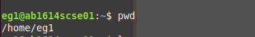

4)ls
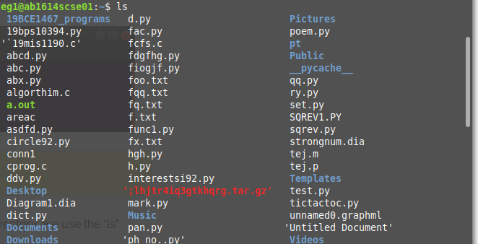

5)cd
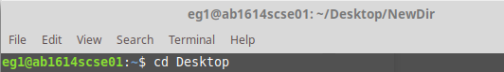

6)cd my/folder : If you want to create a new directory, then use the command mkdir.
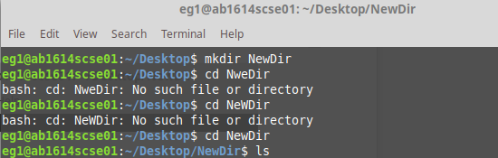

7)touch filename : the touch command will change both the access and modification timestamps if the file is already existing. If the file doesn’t exist, then touch command will create an empty file.

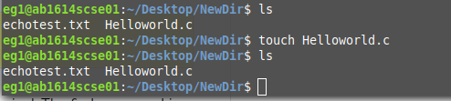

8)cat : cat command is used to concatenate files and display the contents of a file on standard output i.e. the terminal. It is an easy way to view the contents of a file without the worry of making any changes to the file.

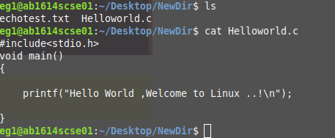

9)echo : echo command is used to display a line of text on the terminal. You can also move some text data into a file using the echo command. If you have an empty text file and want to add a line of text to it, then use echo “text to be inserted” > filename.txt.

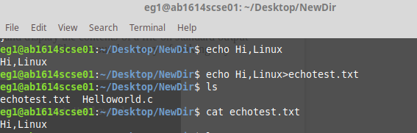
10)rm : the rm command will only delete the files. But if you want to remove folders which are not empty, then use the command rm –r foldername.

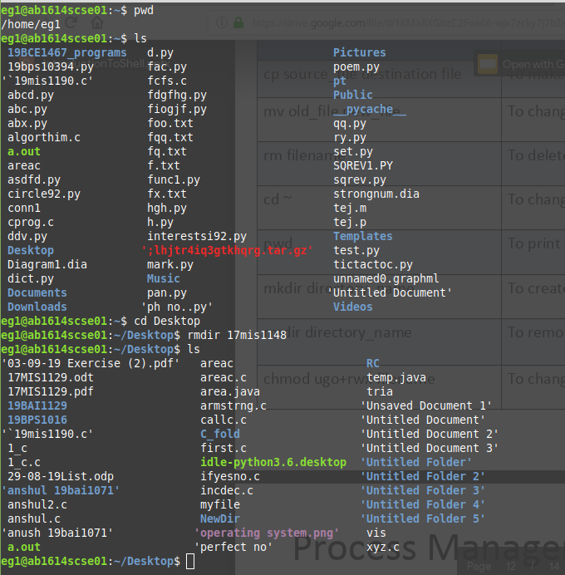

11)ls : list out all files ,ls -l : Long format listing with additional details like owner, file type, size, timestamps, etc.

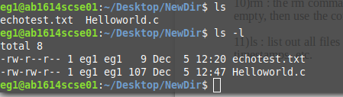

12) mv :

mv file1 file2 | Rename or move file1 to file2. To move, file2 directory should be existing.

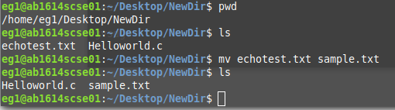
13)ifconfig : to list ip address of node

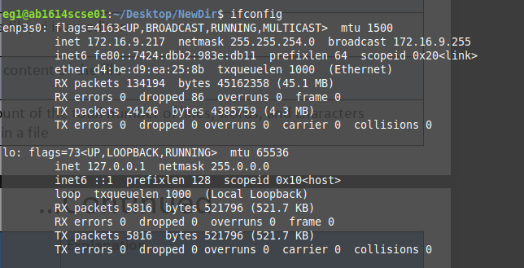
14)ps : list running processes , ps -f : more info about running processes

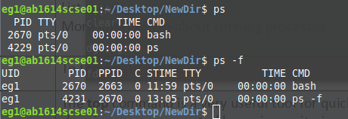

15) wc filename : to get the count of total number of words,lines ,characters in file

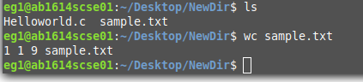

16)cp source_file destination_file : move contents from source file to destination file

