Linux lab 9

Process Management

Name : M Ramya Reg No : 17mis1148
Faculty : Prof P Rukmani Date : 27/2/2020

1. Fork Creation :

#include<stdio.h>
#include<unistd.h>
int main()
{
int pid;
pid = fork();
if(pid==0)
{
printf("Hello world from child \n");

}
else
{
printf("Hello from parent \n");
}
return 0;
}

Output :

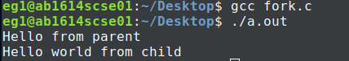

2. Execve : Addition of 5 numbers with execve function

#include<stdio.h>
#include<stdlib.h>
#include<unistd.h>
int main()
{
int a=fork();
if(a==0)
execve("/home/Documents/linux/add2.out",NULL,NULL);
}

File Add2.c
#include<stdio.h>
#include<stdlib.h>
#include<unistd.h>
int main()
{
int sum=0;
for(int i=0;i<=5;i++)
sum+=i; //i=1+2+3+4+5
printf("%d\n",sum);
exit(1);
return 0;
}

Output :

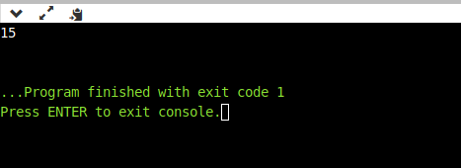

3. File:Fork2.c

Executing cat command using execve:

Code :

#include<stdio.h>
#include<stdlib.h>
int main(int argc, char const *argv[])
{
char *new[3];
new[0]="cat";
new[1]="new.c";
int i=execve("/bin/cat",new[0],NULL);
return 0;
}
Output :

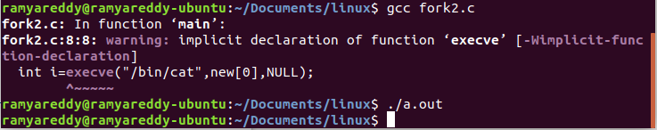

4.Process blocking:

Wait command is used to block the parent until atleast one child is terminated.
Code:
#include<stdio.h>
#include<unistd.h>
#include<stdlib.h>
#include<sys/wait.h>
int main(void)
{
pid_t pid;
int status;
if((pid = fork())<0)
{
printf("Fork error \n");
}
else if(pid == 0)
{
printf("Child has terminated \n");
exit(0);
}
if(wait(&status)!=pid)
{
printf("wait error \n");
}
else {
printf("parent has terminated\n");
}
return 0;
}
Output :
