**E-Commerce Website for Sporty Shoes**

**Document contains:**

* Project and developer details
* Sprints planned and the tasks achieved in them
* Algorithms and flowcharts of the application
* List of core concepts used
* Links to the GitHub repository to verify the project completion
* Conclusions

**Project and developer details:**

Project objective:

As a Full Stack Developer, design and develop an E-Commerce website named as Sporty Shoes.Use the GitHub repository to manage the project artifacts.

Background of the problem statement:

Sporty shoes is an E-Commerce Website that lets people to Buy their Products.

The website needs to have the following features:

Sporty Shoes is a company that manufactures and sells sports shoes. They have a walk-in store, and now, they wish to launch their e-commerce portal sportyshoes.com.

● Presenting the specification document which has the product’s capabilities, appearance, and user interactions  
● Setting up Git and GitHub account to store and track your enhancements of the prototype   
● Explaining the Java concepts used in the project   
● Discussing the generic features of the product:  
● There will be an admin to manage the website. An administrator login will be required to access the admin page.

The flow and features of the application:

● Plan more than two sprints to complete the application  
● Document the flow of the application and prepare a flow chart   
● List the core concepts and algorithms being used to complete this application  
● Implement the appropriate concepts, such as exceptions, collections, and sorting techniques for source code optimization and increased performance

**Developer Details**: M.Ramya Sarojini.

**Sprints planned and the tasks achieved in them**

There are three sprints for this project

Sprint-1: Studied the Features of project and prepared the flow chart and created Git Repository

Sprint-2: created Jsp pages and written spring boot java program for Website sporty shoes and All the features are being implemented.

Sprint-3: Final testing of website using different inputs and pushing it to GitHub.

**Algorithms and flowcharts of the application**

1.Display the product &buy nd payment is done

User Login & New User Registration.

Admin Login

Welcome Page

**Login as User**

**Login as Admin**

L

1.see all the products.

2.add,update,delete product

3.See all the User details.

4.Edit and delete the product details.

**List Of Files**

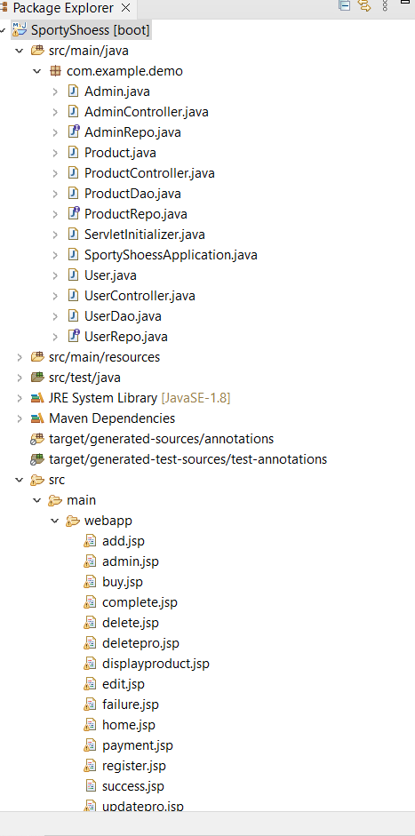

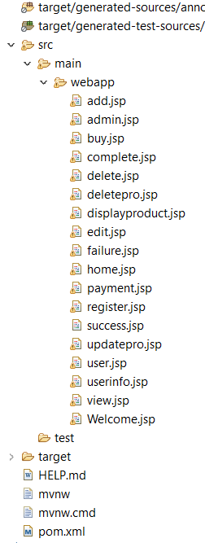

**1.Welcome Page is created Using Jsp.**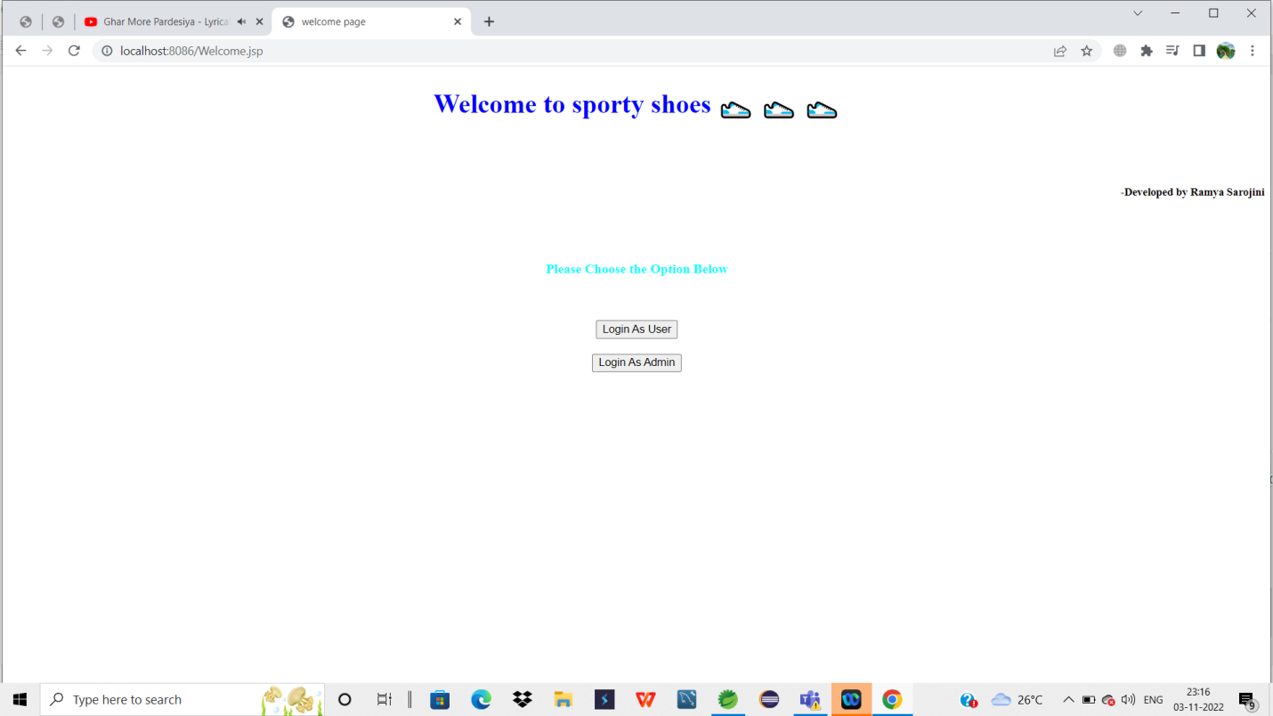

2.Here the Customer Have to click the Login as user Button,it directs them to New User Login Page.

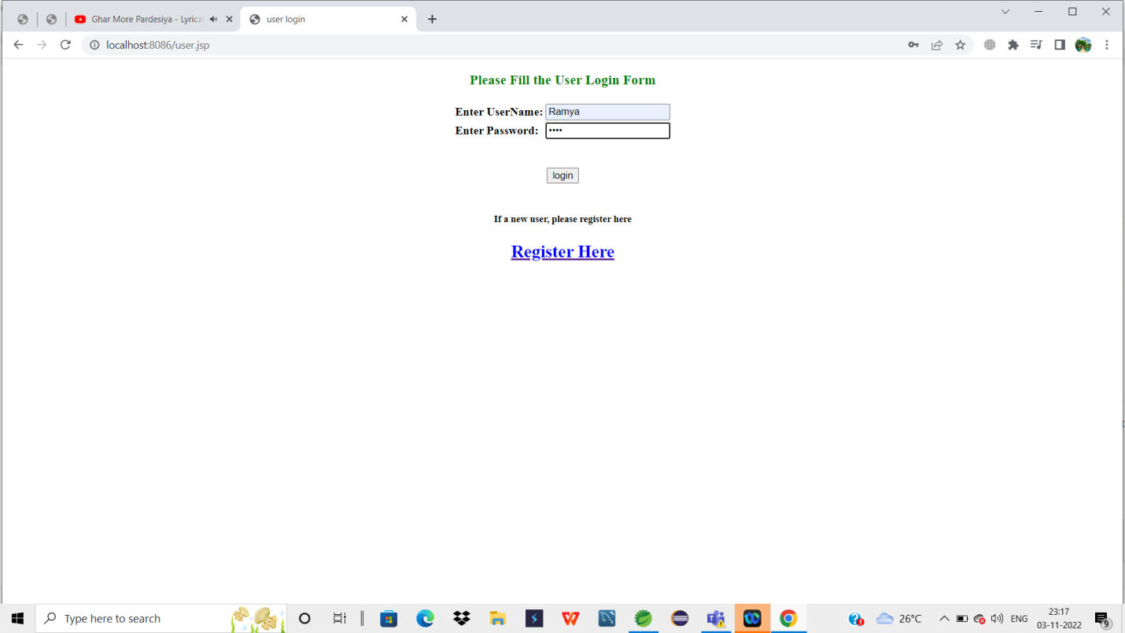

3. If a New user can register their details, via a Register here link.

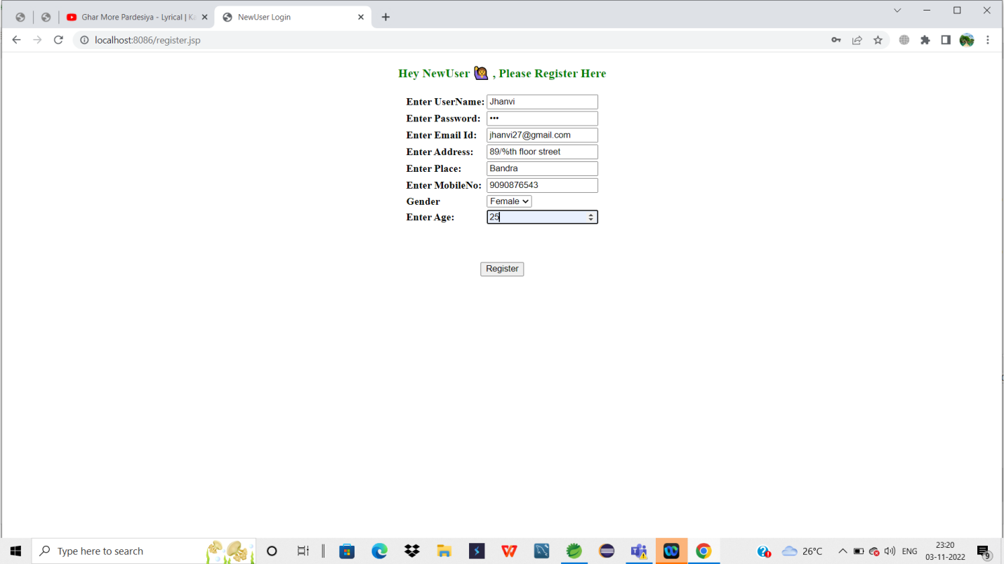

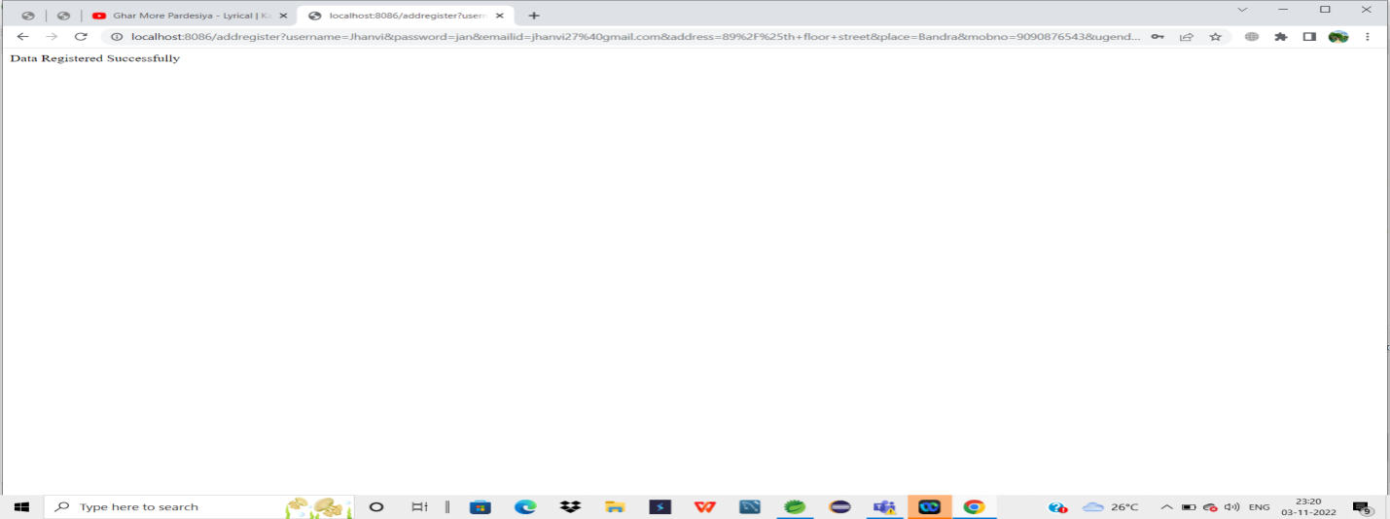

5. Now User can Login the page with their Username and Password.



6.if login is pressed, it takes the customers to shop now page nd search the products page.

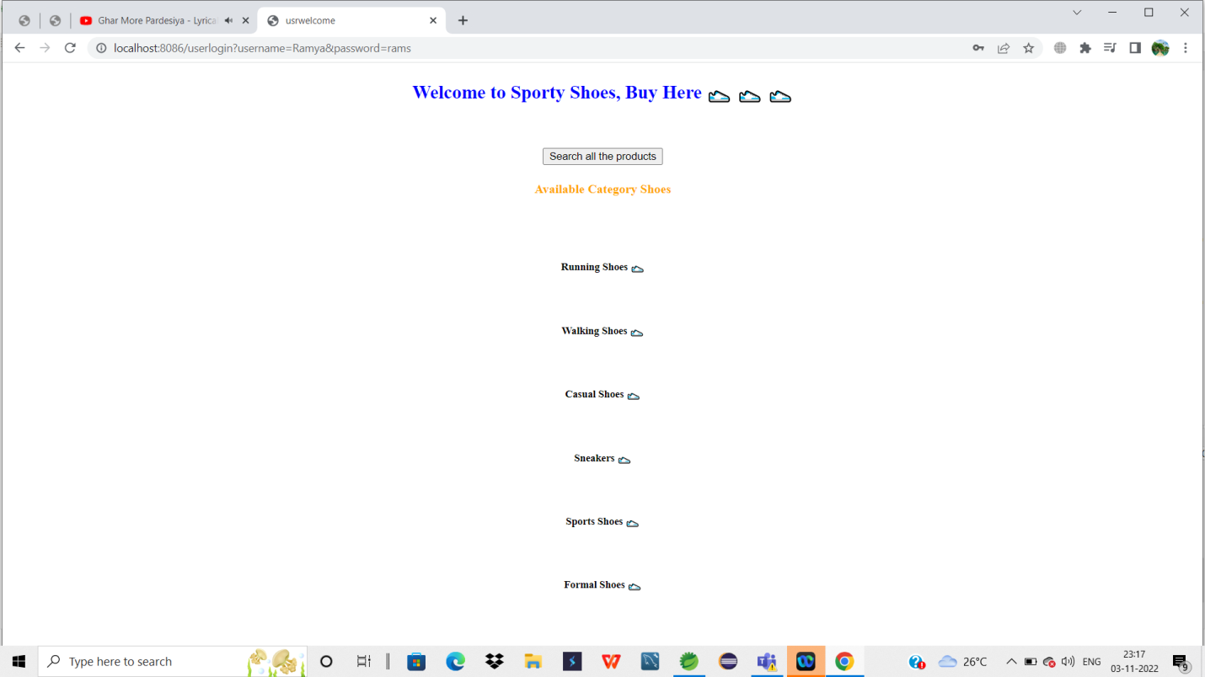

7.Now the Available Product with the Product Details nd all shown with the buy now option.

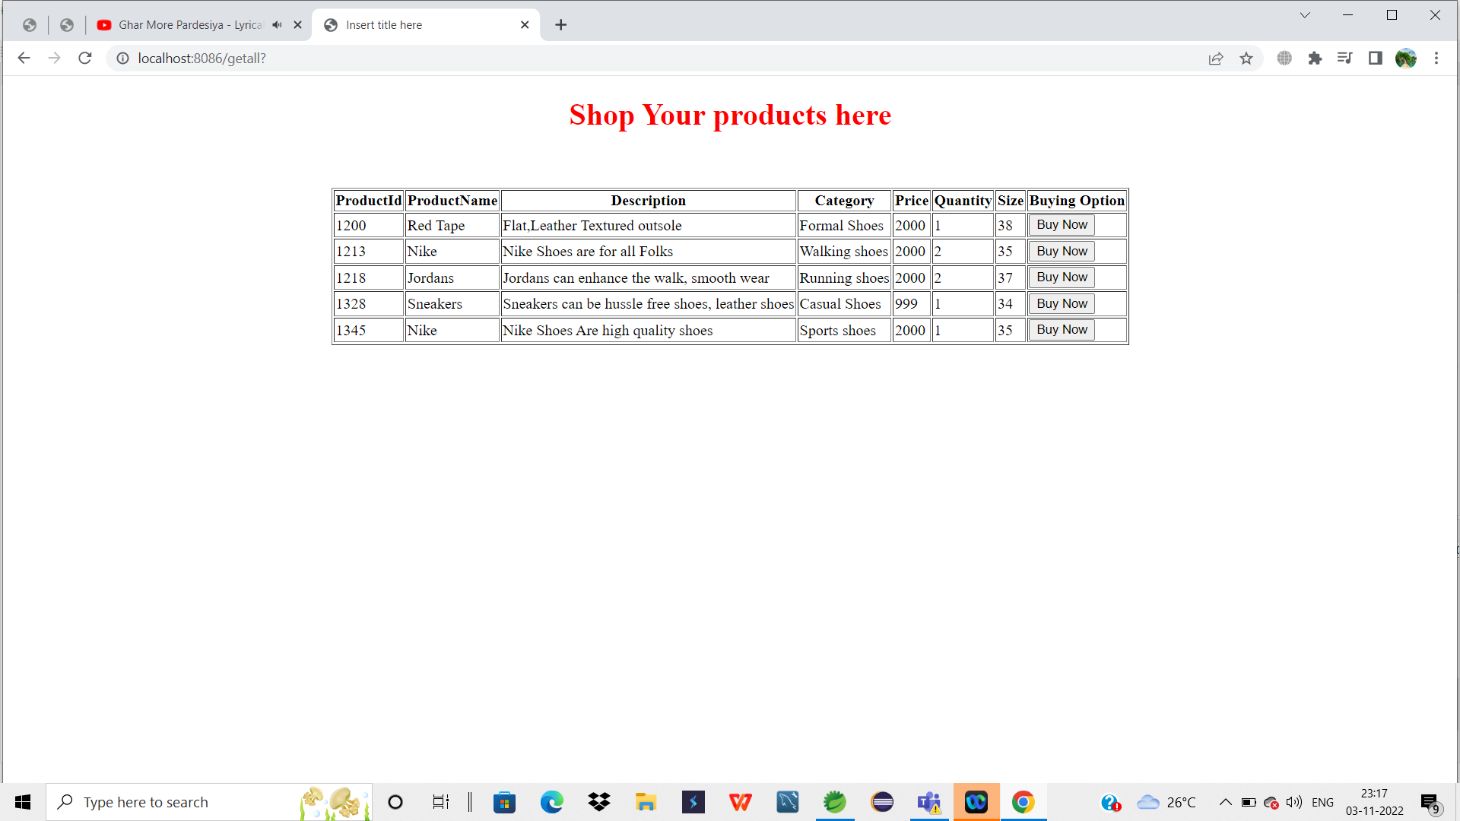

8. Buy Now button is clicked, then Payment page is shown, the customer have to fill the required details.

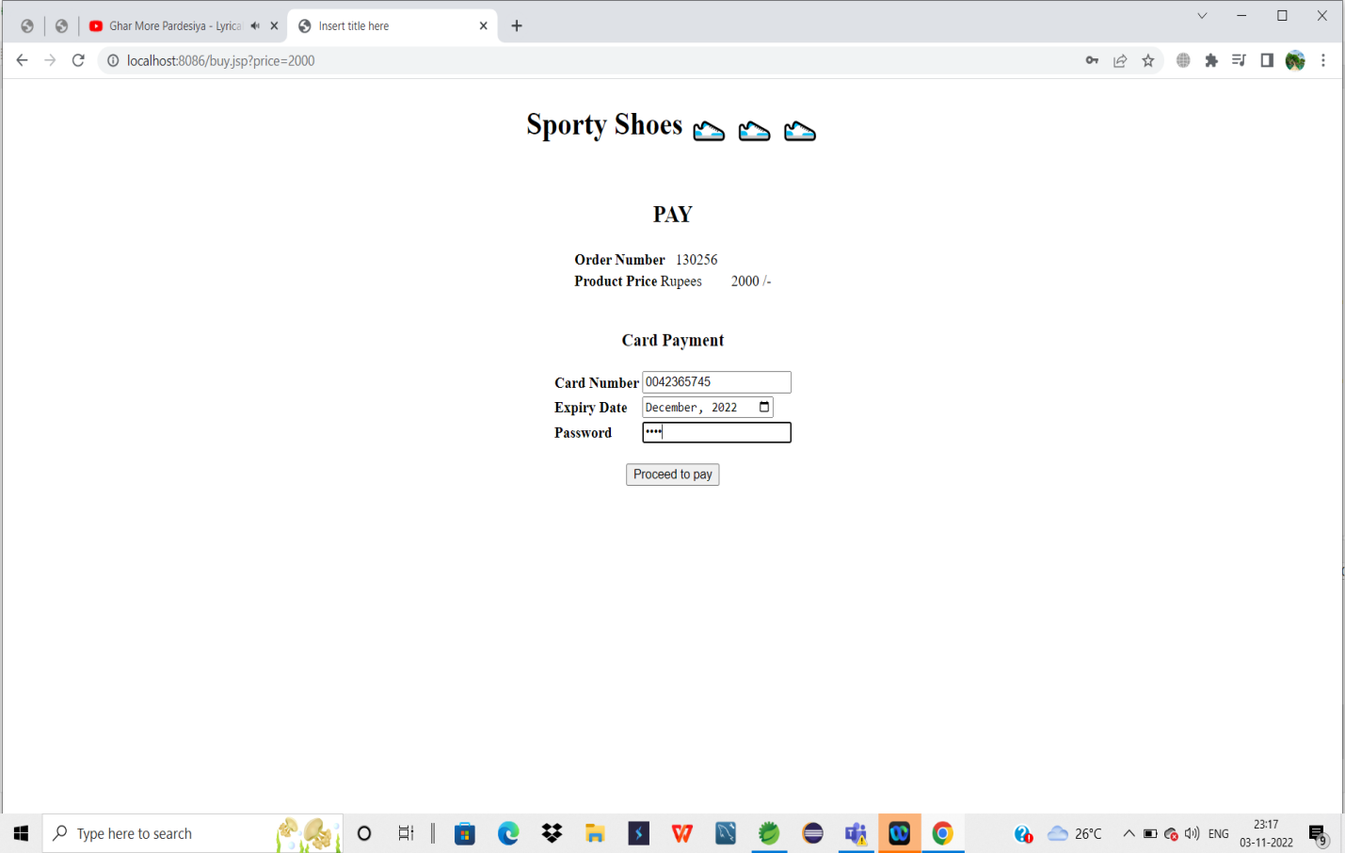

9. Now Successful Payment is displayed , after the Sporty shoes is purchased by the Customer.

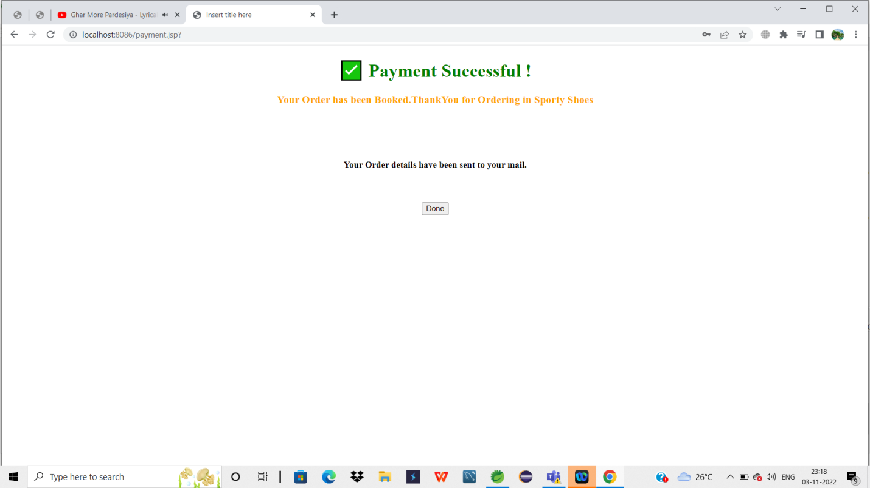

10.if a User incase enter the invalid Username and Password, it directs the user to Failure page.

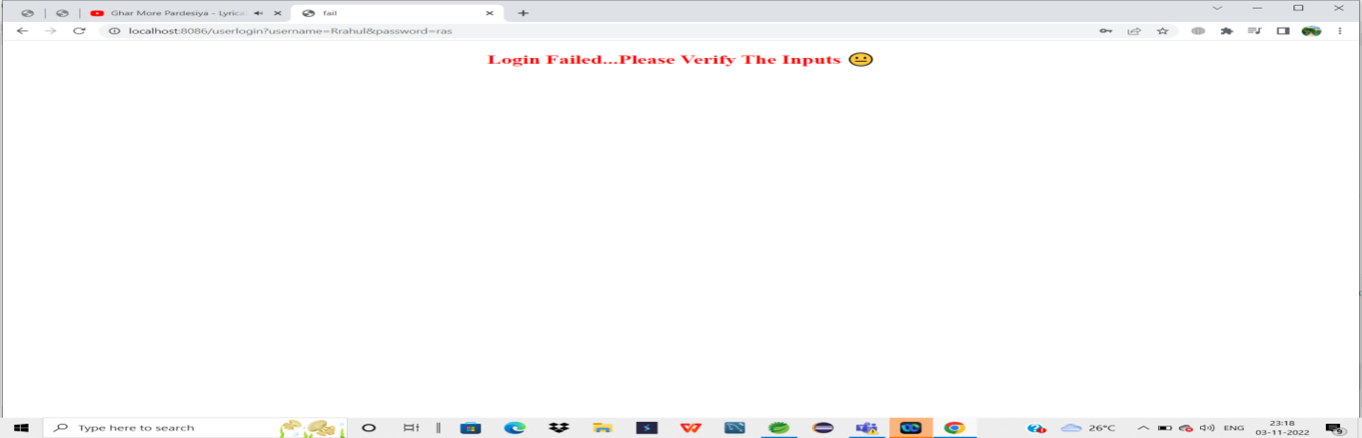

11.Now if a admin has to Login by clicking the Login as admin with their Username and Password.



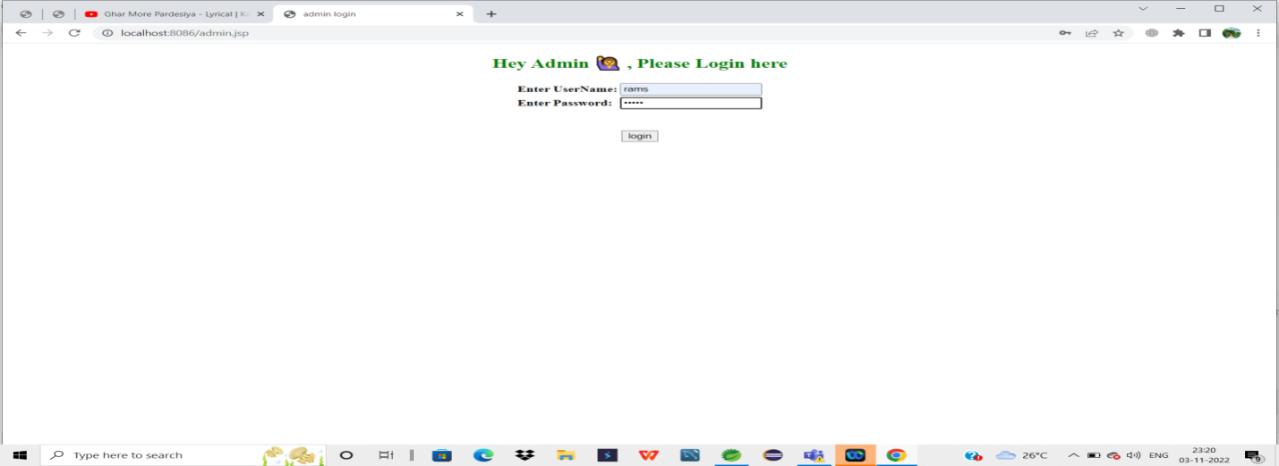

12.After login, the admin can view the content through which he can do the appropriate action.1

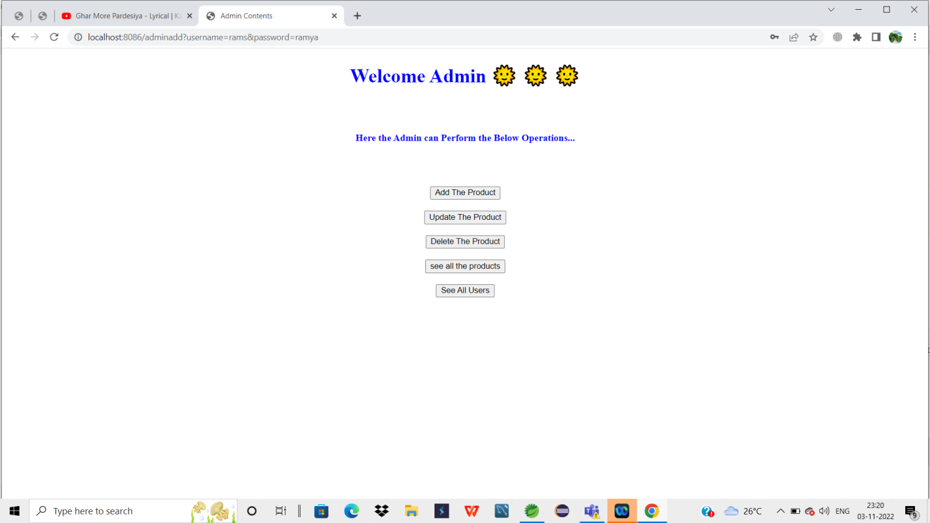

13. Here add the product is clicked by the admin, a new product is added to the existing product list.

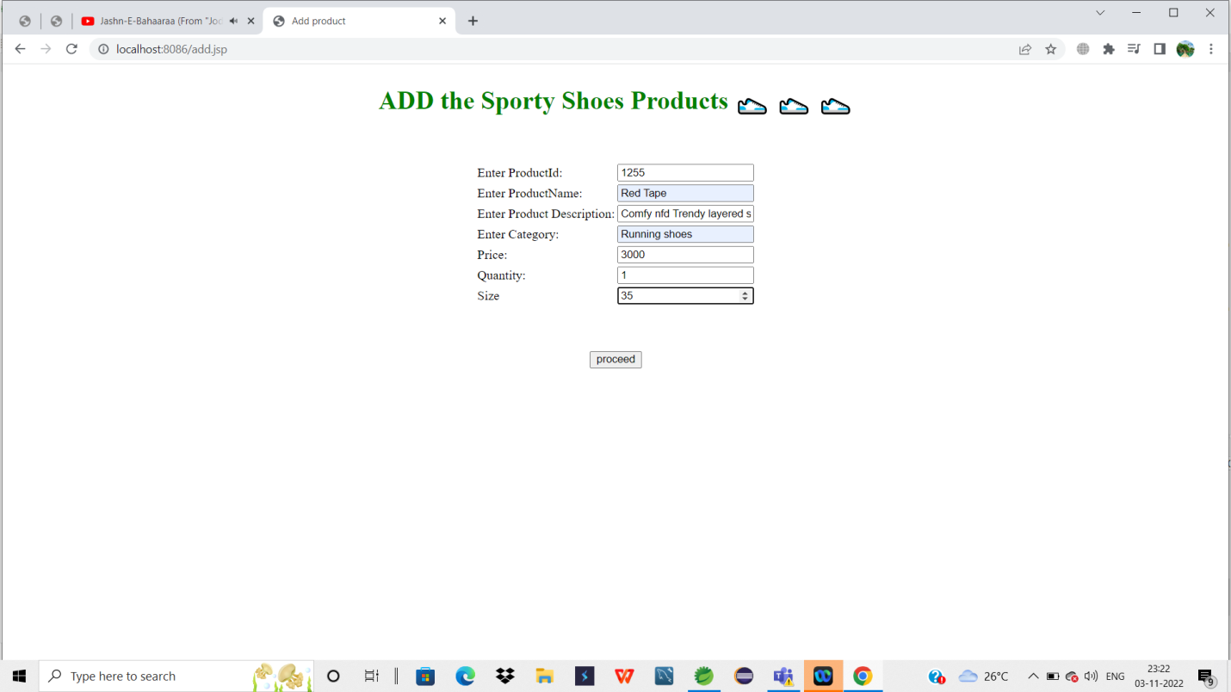

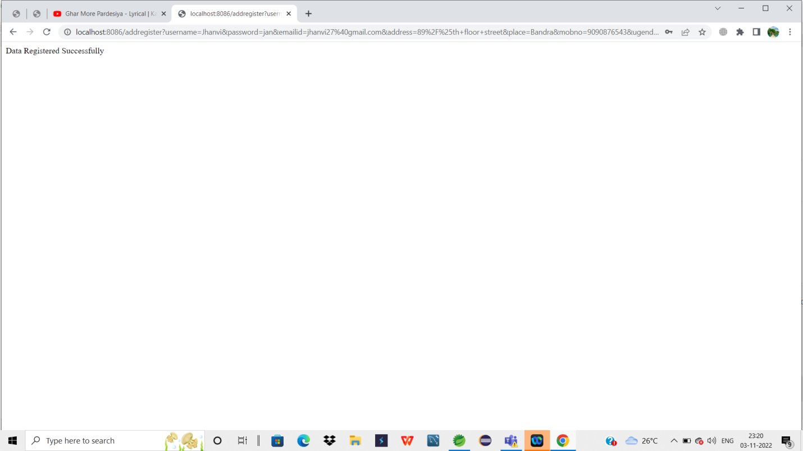

.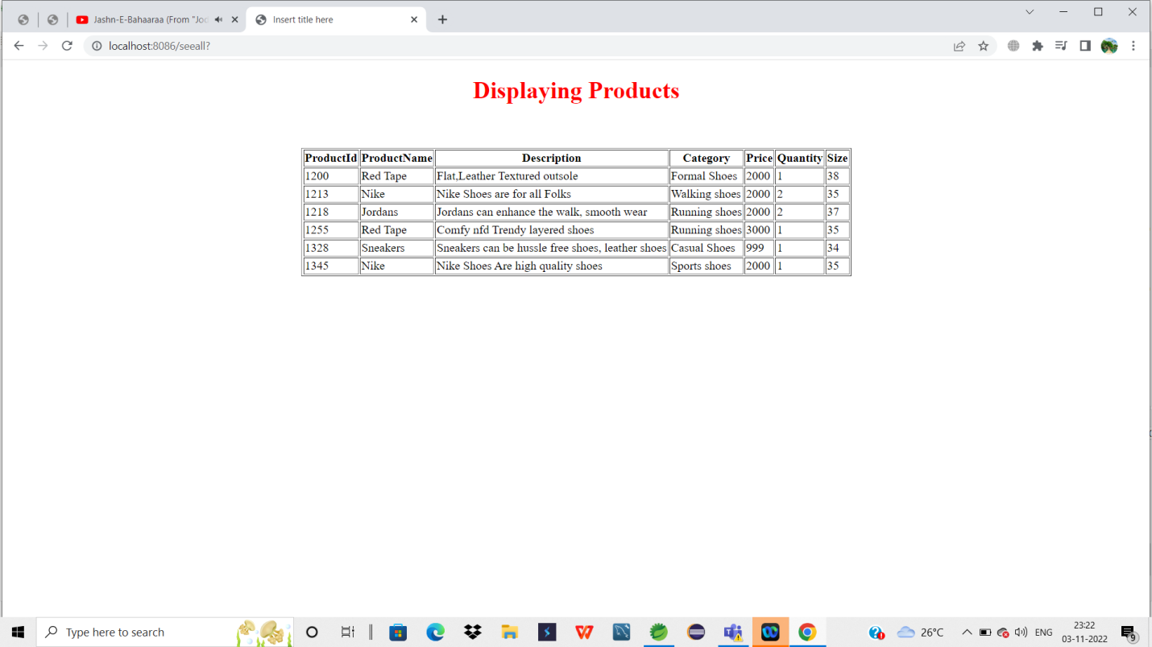

14. deleting the product.

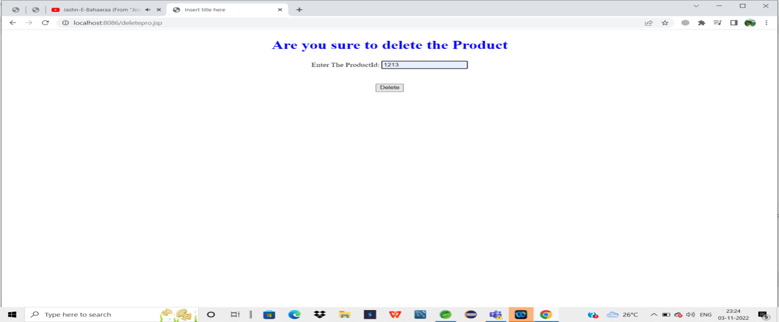

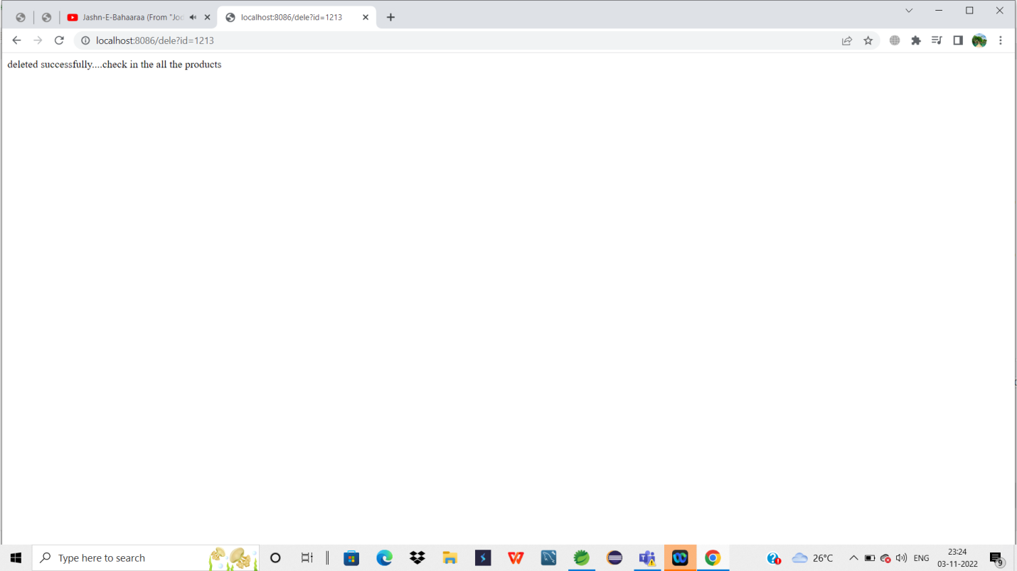

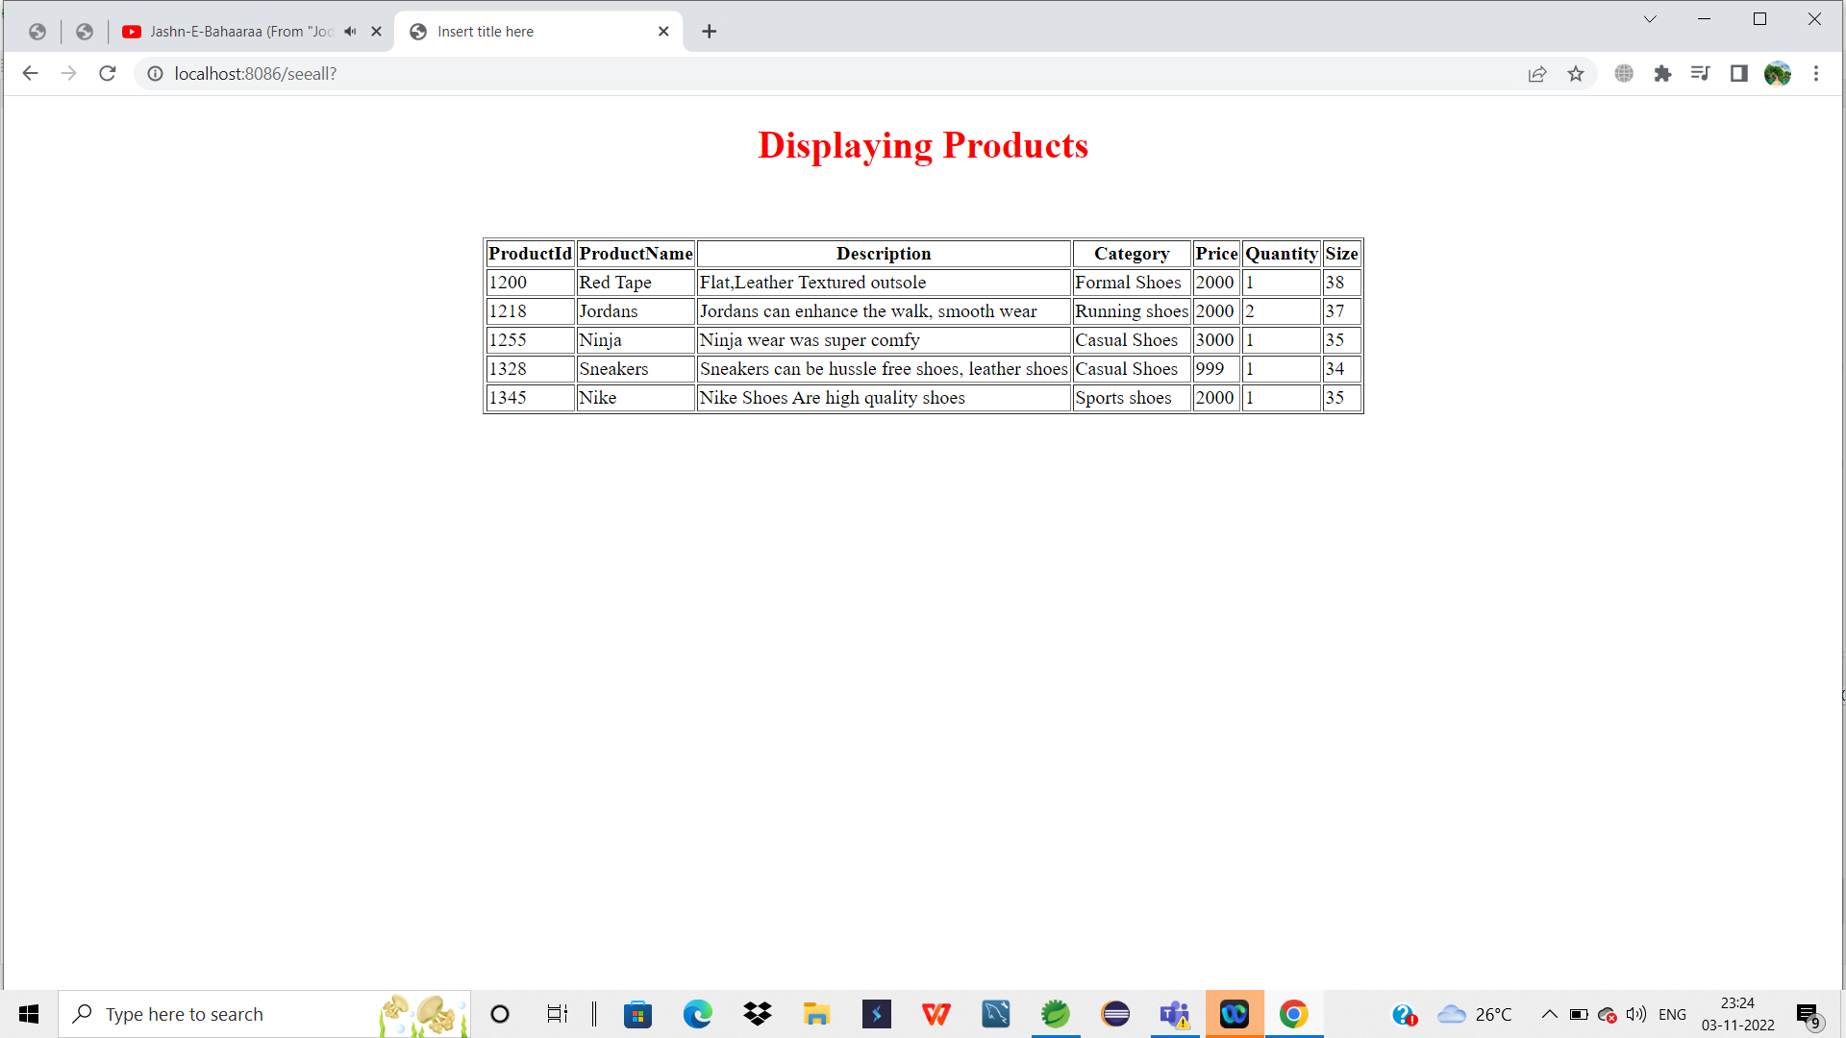

15. Updating the product:

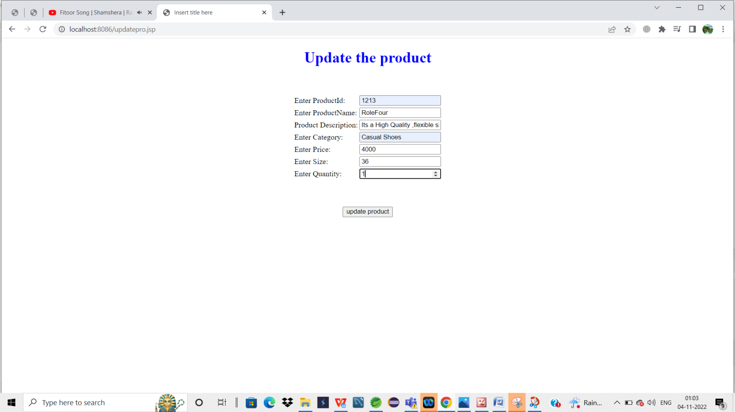

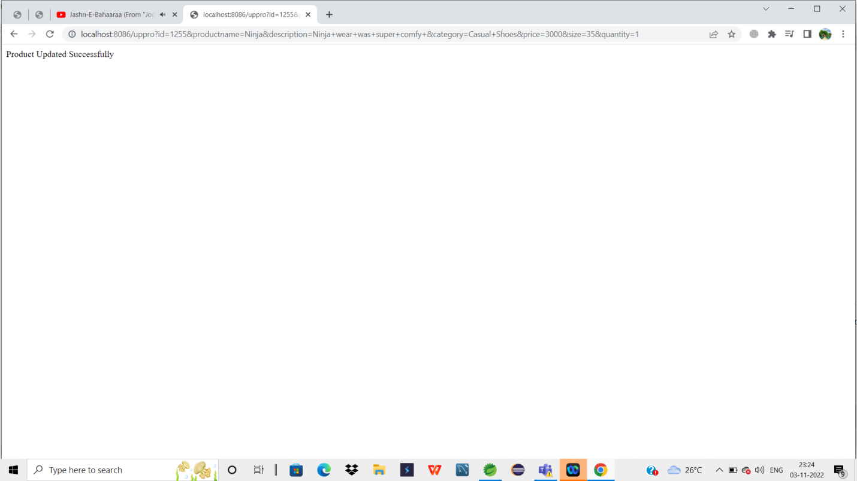

16.if see all the user is clicked, here the admin can view all the user information.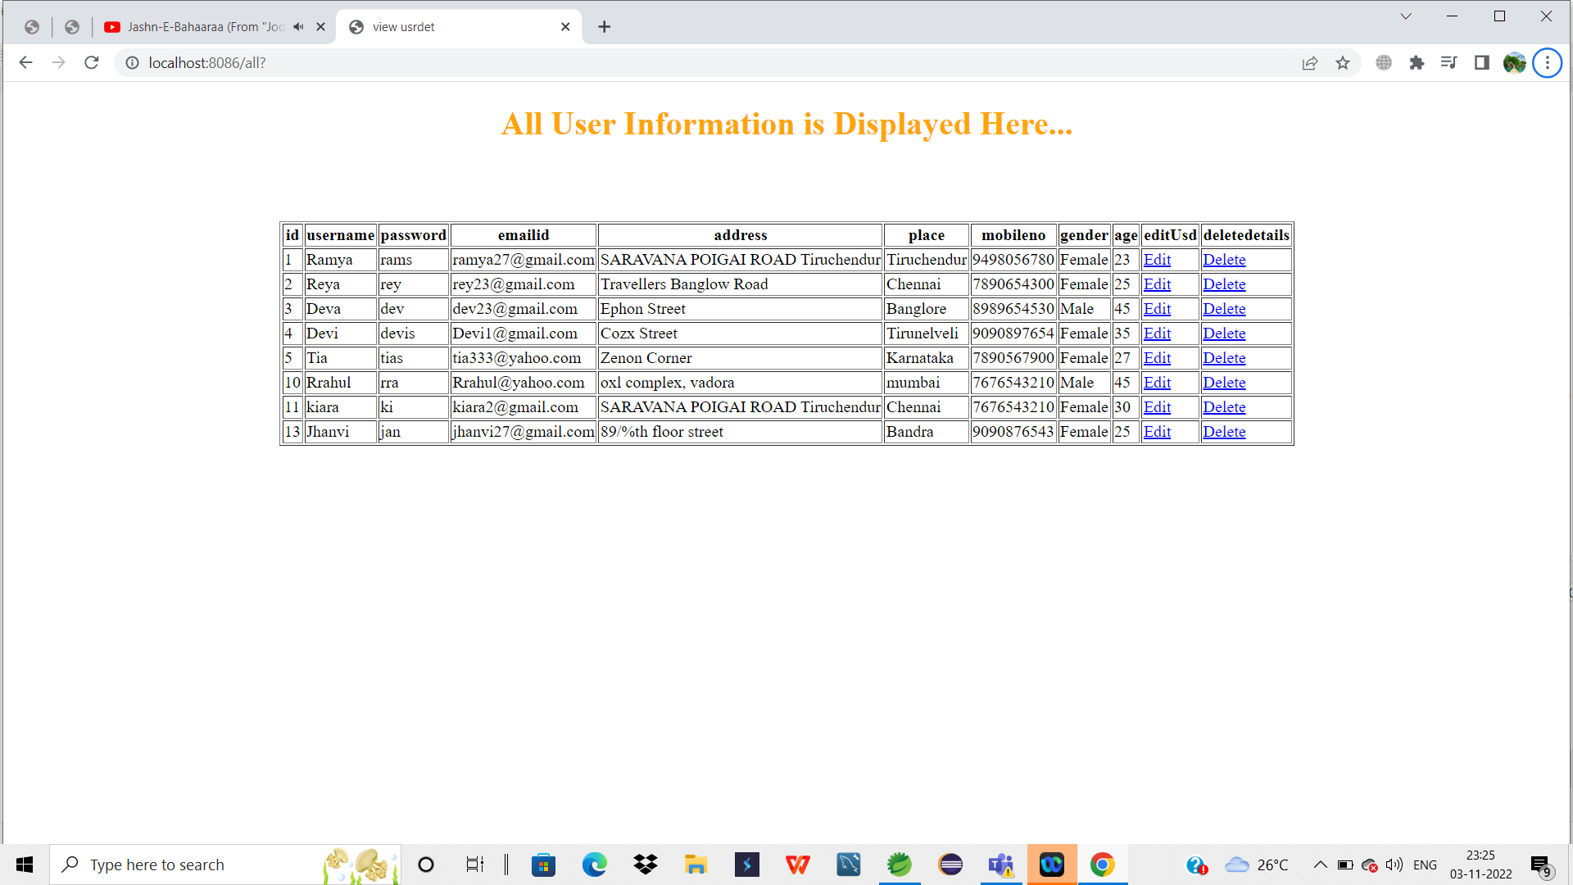

17. Edit nd deleting the User details.

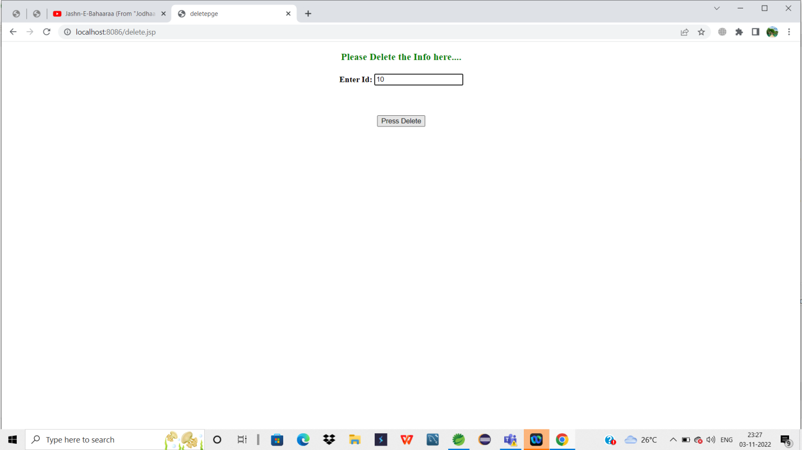

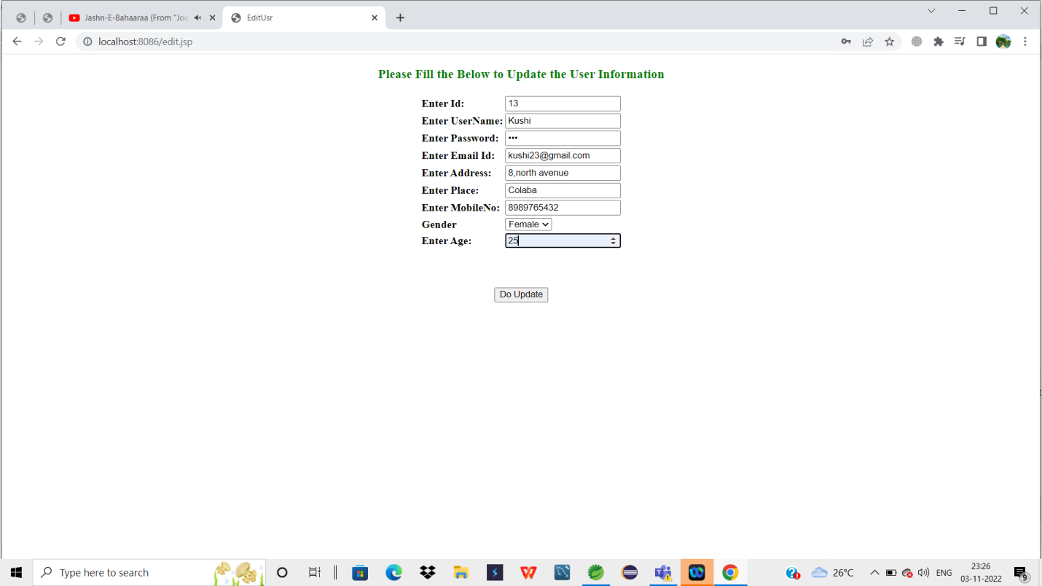

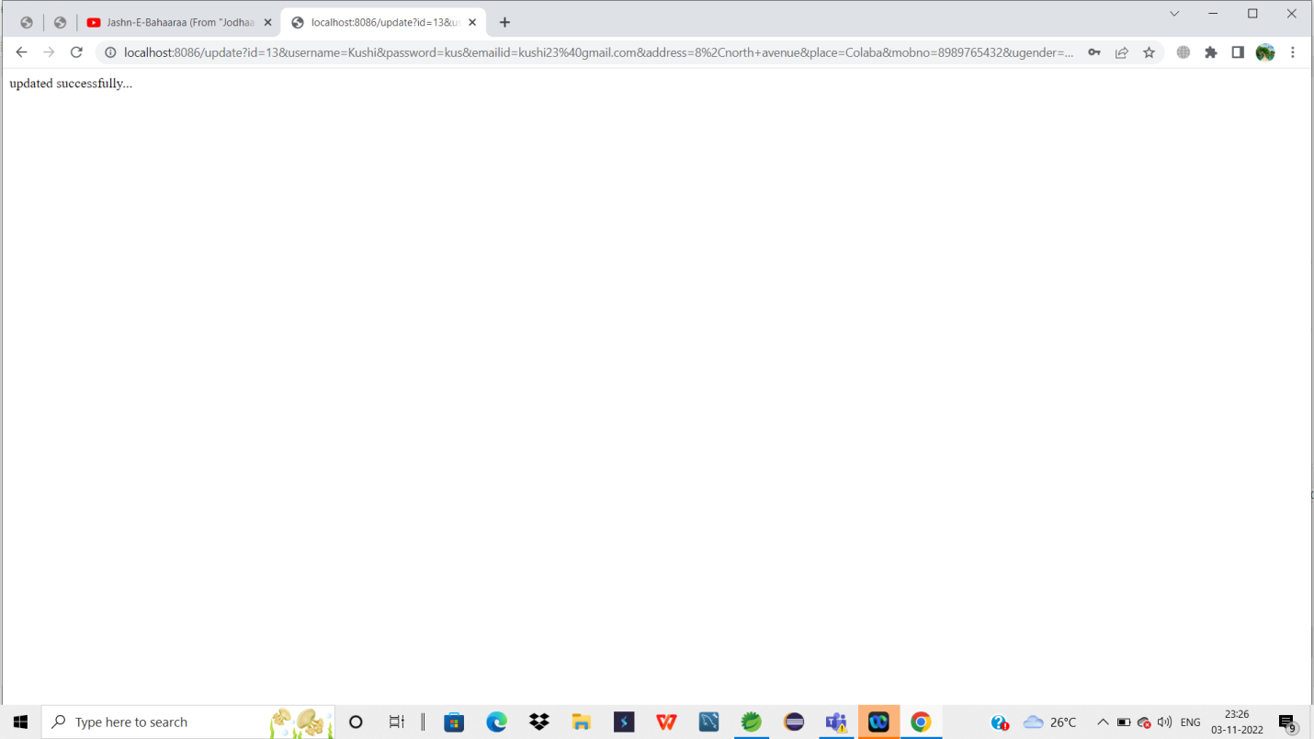

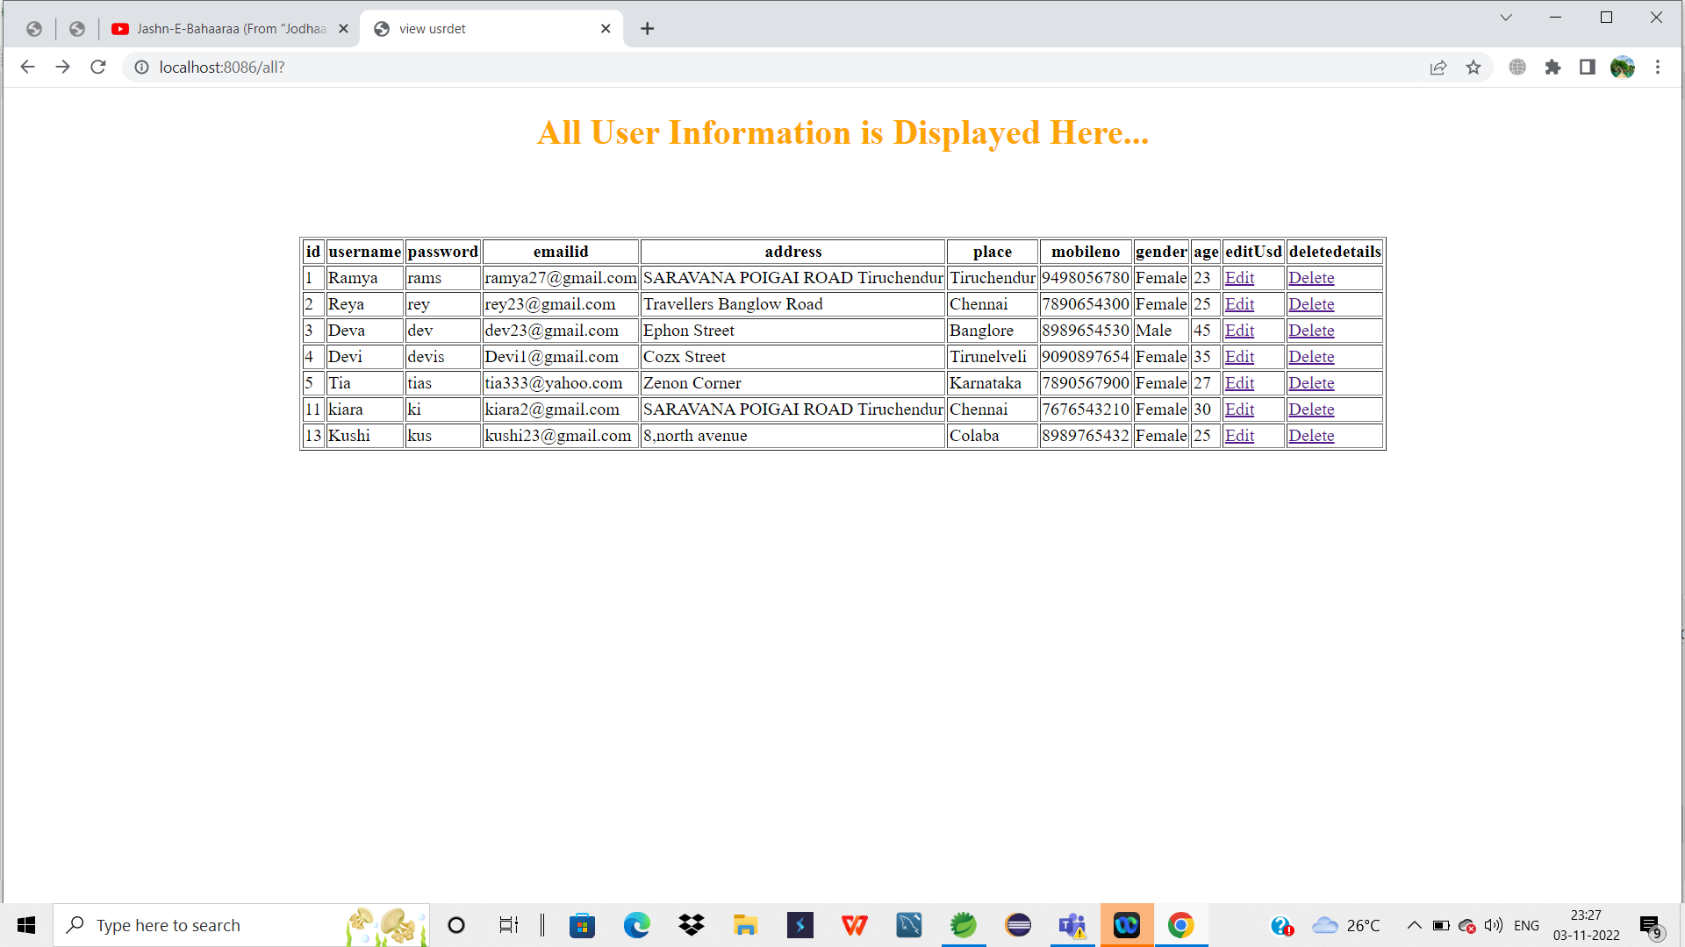

19.Displaying all the products for the admin



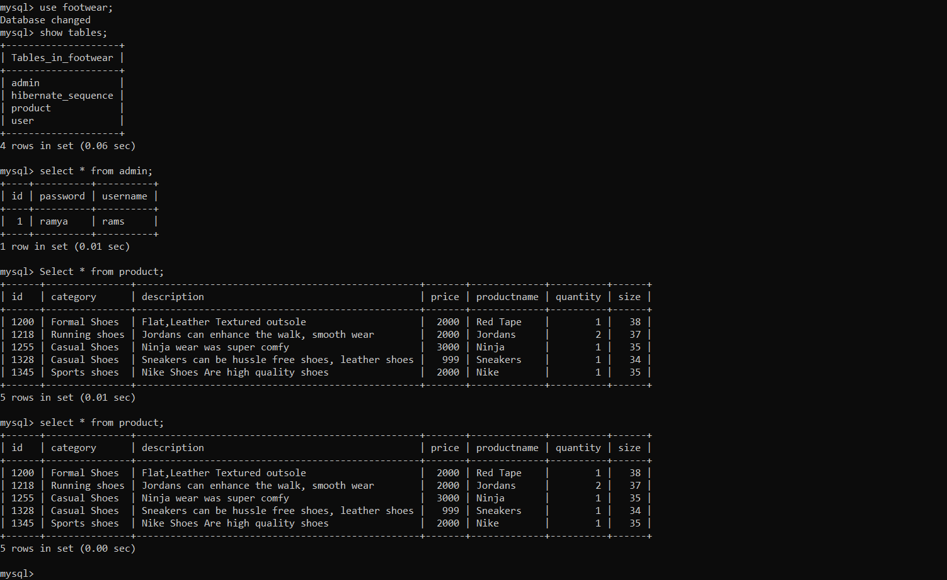

The Above is the Sql Database was created for the Project.

**List Of Core Concepts Used:**

**Jsp, Lombok, Spring Web, Spring Boot, Spring JPA,Hibernate , Mysql.**

**Links to the GitHub repository to verify the project completion:**

**https://github.com/Ramyasarojini/SportyshoesSS.git**

**Conclusion:**

The Web application is prepared according to the provided flow and features of the application and everything followed according to the instructions.