Assignment #1

Name

ID

Institution

Machine Learning

Instructor

September 1, 2022

Question 1

Code

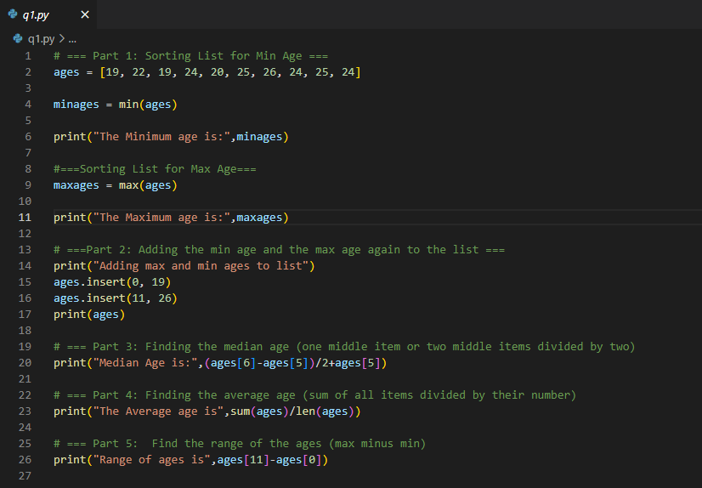

Output

To show the output run “python q1.py” on cmd or terminal

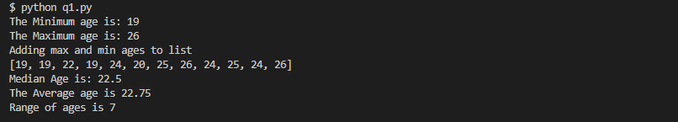

Description of code execution

To find the min and max ages in the list, the max(), and min() methods are called which both print the min and max ages respectively.

Inserting min and max ages is done using insert methods. The indexes for the first and last elements are called so that the min and max ages can be inserted at the beginning and end of the list.To find the median age, we divide the middle items by 2. To find the average we compare the sum of all items and then divide by the number of items.

The range was found by the difference between the largest and smallest values.

Question 2

Code

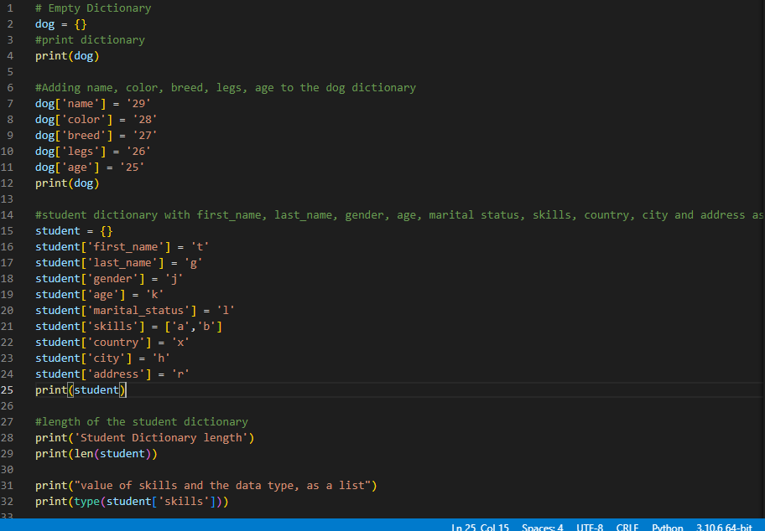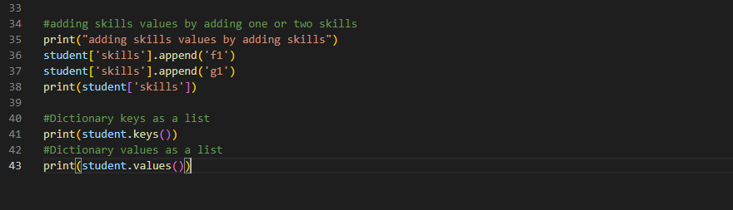

Output

To show the output run “python q2.py” on cmd or terminal

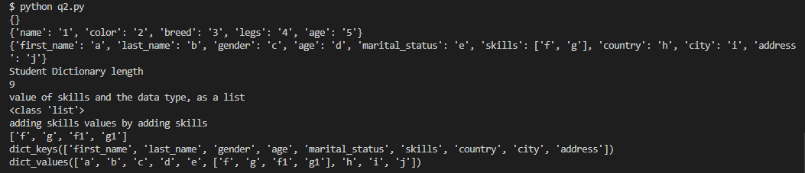

I assigned values for the dog dictionary. The same with the student dictionary. The len() is used to check the student dictionary length. The type() method checks for type student skills. Append() method adds values to the end of the student dictionary.

Question 3

Code

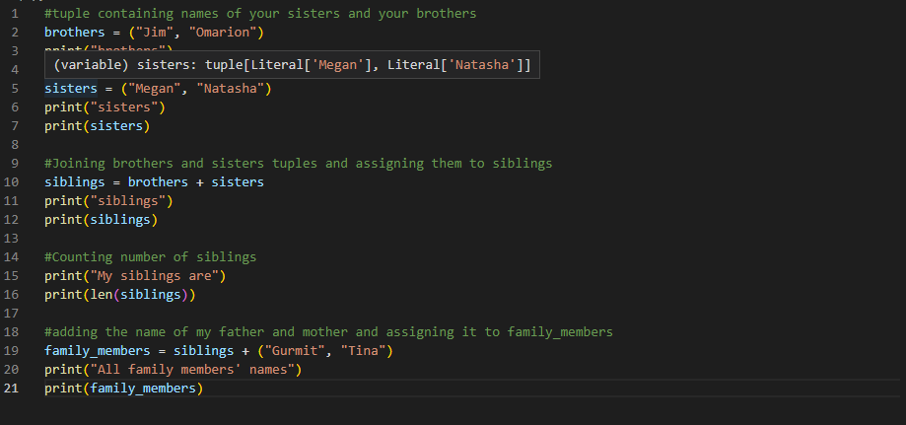

Output

To show the output run “python q3.py” on cmd or terminal

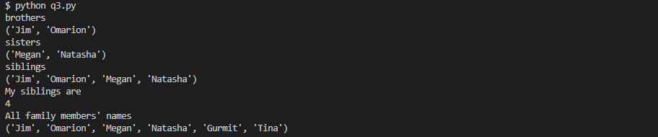

Description

First tuples containing sisters and brother names are printed. The two are then combined in a variable called siblings. The len() method is called to display the number of items (brothers & sisters) in siblings. A variable called family_members is declared that contains siblings plus parents.

Question 4

Code

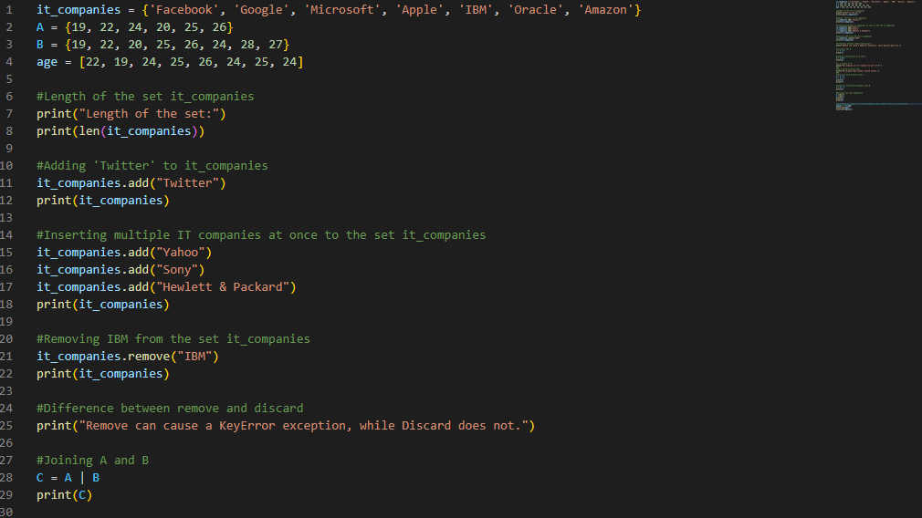 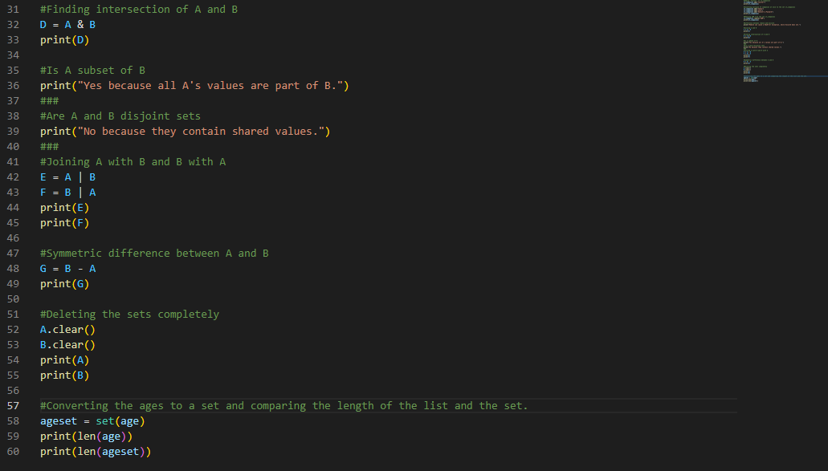

Output

To show the output run “python q4.py” on cmd or terminal

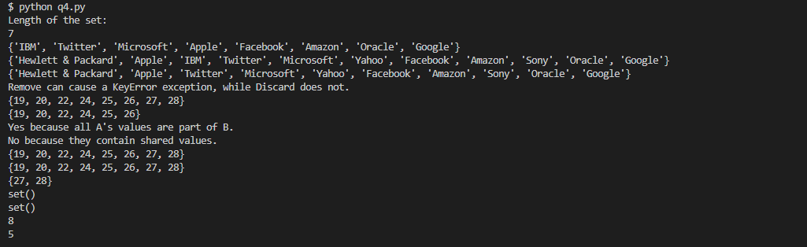

Questions

1. Difference between remove and discard

Remove can cause a KeyError exception, while Discard does not.

1. Is A subset of B

Yes, because all A's values are part of B.

1. Are A and B disjoint sets

No, because they contain shared values.

Description

We find the length of the it_companies using the len() method. We then call the add() method on it_companies set to add “Twitter”, “Yahoo”, and “Hewlett & Packard” to the set. We then call the remove() method on it_companies set to remove “IBM” in the set.

Question 5

Code

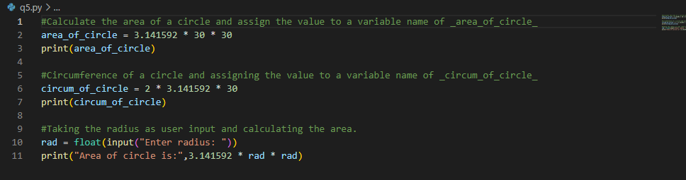

Output

To show the output run “python q5.py” on cmd or terminal

0 an

Description

The formula for the area of a circle is assigned to the variable area_of_circle. The radius of the circle is calculated by multiplying pi by 30 and by 2. The float method converts the user input into a floating-point number. The program then takes the user input, squares it, and multiples it by pi.

Question 6

Code

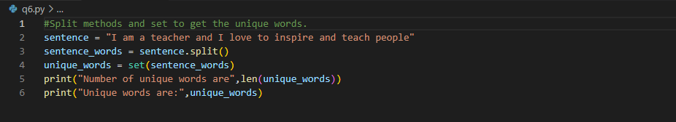

Output

To show the output run “python q6.py” on cmd or terminal



Description

The split() string method breaks down the sentence by separating the words where there are spaces. The variable unique_words is assigned to set method that is used to pick individual words in the sentence. The len() method calculates the total words/ items/

Question 7

Code

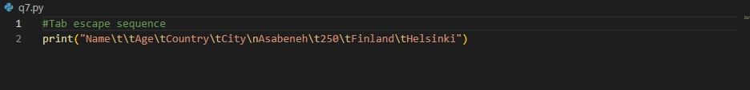

Output

To show the output run “python q7.py” on cmd or terminal



Description

The Name, Age, Country, and City are separated by \t\ which is a horizontal tab. The \n escape sequence is then used to start a new line for the items. The \t\ escape sequence is then applied on Asebeneh, Finland, and Helsinki to create another horizontal tab

Question 8

Code

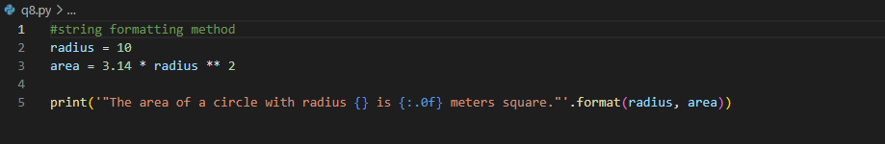

Output

To show the output run “python q8.py” on cmd or terminal



Description

The String formatting is used in this case. Double quotation marks are nested inside single quotation marks to bring out the output.

Question 9

Code

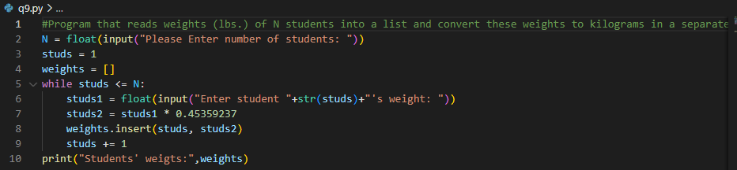

Output

To show the output run “python q9.py” on cmd or terminal

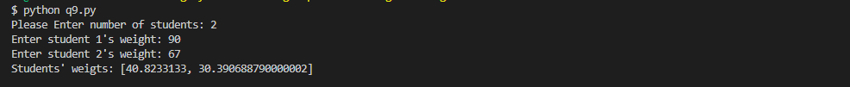

Description

The variable N captures the number of students and is set to user input and is a float. An empty list called weights is initialized. The number of students is set to one and assigned stud variable. The while loop checks if number of students is less than or equal to number that the user entered. While true, the code asks the user to enter weights for the number of times they entered. Each weight is converted to kilograms and inserted into the weights list. The program then prints the list with weights in kgs.

Question 10

Code

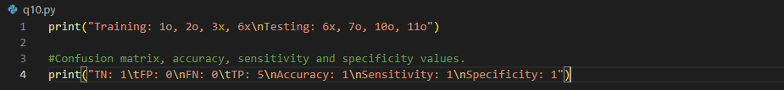

Output

To show the output run “python q10.py” on cmd or terminal

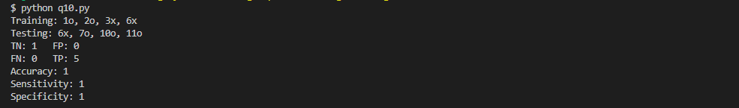

Question

Divide this data equally into two parts. Use first part as training and second part as testing. Using KNN classifier, for K=3, what would be the predicted outputs for the test samples? Show how you arrived at your answer.

The predicted test results would be 8 and 9, respectively, with the former being directly between 6 and 10 and the latter being between 7 and 11, the two potential k=3 midpoints. Instead of being x points, both would be o points.

Divide the data values into two categories of testing data and training data.

The program prints out the accuracy metrics of the model, TN means true negative, FN stands for false negative, FP means False positive TP means true positive.

The accuracy, sensitivity and specificity are all equal to 1.