11.1) Develop a C++ program for handling Exceptions

Program:

#include<iostream>

using namespace std;

int main()

{

try

{

int a,b;

cout<<"enter values of a,b";

cin>>a>>b;

if(b==0)

throw b;

else

cout<<a/b;

}

catch(int x)

{

cout<<"zero division error";

}

}

Output:

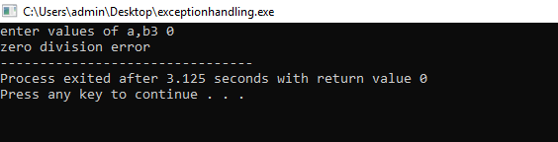

11.2) Develop a C++ program to illustrate the use of multiple catch statements.

Program:

#include<iostream>

using namespace std;

int main()

{

try

{

int a[5]={1,2,3,4,5};

int index;

cout<<"enter index";

cin>>index;

if(index>5)

throw index;

else if(index<0)

throw "index should not be negative";

else

{

a[index]=100;

cout<<a[index];

}

}

catch(int x)

{

cout<<"array index out of bounds";

}

catch(const char \*m)

{

cout<<m;

}

}

Output:

