To-do List

A PROJECT REPORT

Submitted by

Avinash Yadav(20BCS1330)

Selendra Kumar(20BCS9960)

Yashveer Choudhary(20BCS9934)

**TODO LIST APP**

**A PROJECT REPORT**

***SUBMITTED BY***

**SYDU RAMYASRI**

**PRASANNA**

**SUPRIYA**

**CHANDRASREE**

SHRI VISHNU ENGINEERING COLLEGE FOR WOMEN

*SUMITTED FOR III Year II Semester INTERNSHIP Fulfillment*



*Bapuji Nagar Park, 2nd Floor, Plot No 132, Habsiguda Main Rd, above DCB bank, Nacharam, Hyderabad, Telangana 500076*

**INTRODUCTION**

The Todo List project is a task management application designed to help users efficiently organize and track their daily tasks, appointments, and deadlines. The application offers a user-friendly interface, allowing users to easily add, edit, and delete tasks, set due dates, and prioritize tasks according to their importance. The primary objective of the project was to develop a modern and intuitive application to improve productivity and time management for users.

Todo List project has achieved its primary objectives, providing users with a reliable and efficient task management application. With planned future improvements, the application aims to continually evolve and cater to the needs of its users, further enhancing their productivity and task management capabilities.

A few of the features of a good to-do list application include:

•Plan and execute simple actions.

•Prioritize, manage, and reason about tasks.

•Record notes, action items and ideas

A few of the features of a good to-do list application include:

•Plan and execute simple actions.

•Prioritize, manage, and reason about tasks.

•Record notes, action items and ideas

**LITERATURE REVIEW**

Task management applications, commonly known as Todo list apps, have become increasingly popular tools for individuals and businesses to organize their daily activities, improve productivity, and enhance time management. This literature review provides an overview of key findings and trends related to Todo list apps, including their features, benefits, usage patterns, and the impact on user productivity.

**TASK MANAGEMENT**

Task management is the core functionality of Todo list apps, allowing users to organize, track, and prioritize their activities efficiently. A well-designed task management system is essential for enhancing productivity and helping users effectively manage their daily responsibilities. In this section, we'll explore the key aspects of task management within a Todo list app. From an articulation standpoint, task management entails more than just organizing virtual and physical collections and scheduling activities. Recent research has begun to address the problem of generic task management in the context of email. This development is hardly surprising, given that many digital device users are overloaded by the number of chores done through email. According to this research, any successful productivity tool must be tightly connected with email functionalities. Recent researches looked at task management strategies more generally because email and related technologies are unlikely to be the whole picture.

**To-do List as a solution to task management**

The concept of to-do list has existed for a very long time and it is one of the primary methods for management of tasks, use of a to-dos as a reminder system, to-dos as a system for note management, etc. In the simplest and most primitive form, a to-do list can be implemented on a pen and paper as a checklist of items which can be crossed of or ticked against when completed.

**OBJECTIVES**

The primary objectives of the Todo List project are as follows:

* Develop a user-friendly and intuitive task management application.
* Enable users to create, update, and delete tasks with ease.
* Implement task prioritization and due date settings.
* Improve productivity and time management for users.
* Learn and apply modern software development practices.

**USER INTERFACE**

Designing a user-friendly and intuitive user interface is essential for a todo list app to ensure a seamless user experience.

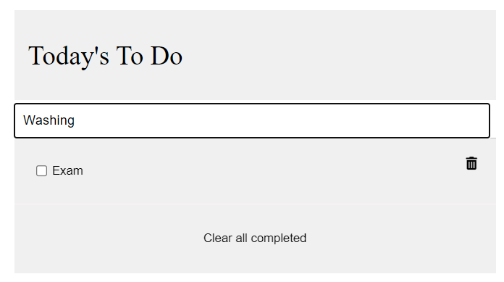

**CONCLUSION**

In conclusion, the Todo List app presents a powerful and efficient solution for task management, offering users an intuitive and user-friendly platform to organize their daily activities, appointments, and deadlines. With features such as task creation, editing, and prioritization, due date setting, categorization, and reminders, the app streamlines the process of managing tasks and enhances productivity. Its clean and accessible user interface ensures a seamless experience across various devices. By fostering better time management and task prioritization, the Todo List app empowers users to stay focused and accomplish their goals effectively. As the app continues to evolve with user feedback and planned future improvements, it will undoubtedly become an indispensable tool for individuals and teams seeking to optimize their productivity and take control of their daily tasks.

**REFERENCES**

* <https://ieeexplore.ieee.org/document/8862073>
* https://medium.com/@annchichi/cast-study-a-simple-todo-app-5f0c69b5a2ee