Legacy System Analysis and Requirements Gathering

Introduction
The rapid evolution of Conversational AI technologies has transformed the way organizations interact with customers. However, many enterprises still rely on legacy Interactive Voice Response (IVR) systems built using VoiceXML (VXML), which primarily support menu-driven and keypad-based interactions. While these systems are stable and deeply integrated into business processes, they lack the flexibility, intelligence, and user-friendly experience offered by modern conversational platforms.
This project focuses on modernizing existing VXML-based IVR systems by integrating them with advanced Conversational AI platforms such as Azure Communication Services (ACS) and BAP Service. Instead of replacing the legacy system entirely, the approach emphasizes reusing and extending existing assets to enable conversational capabilities with minimal redevelopment effort.
By bridging legacy IVR infrastructure with AI-driven workflows, the solution aims to enhance user experience, improve operational efficiency, and reduce the technical burden associated with full system migration.
Problem Statement
Many organizations still use traditional VXML-based IVR systems that operate through fixed, menu-driven call flows. These systems require users to navigate multiple options using keypad inputs, which often leads to a rigid and time-consuming experience.
Such systems:
- Do not effectively support natural language conversations
- Have limited ability to understand user intent or context
- Increase call handling time
- Reduce overall user satisfaction
- Require significant cost and effort if completely replaced
At the same time, fully migrating to a modern AI-driven conversational platform involves high redevelopment effort, infrastructure modifications, and potential service disruption.
Therefore, the core problem addressed in this project is:
How can existing VXML-based IVR systems be enhanced with conversational AI capabilities while preserving current infrastructure and minimizing redevelopment effort?
To solve this, a detailed analysis of the existing system, integration requirements, and technical constraints is necessary.
Objectives
1. To Review the Architecture and Capabilities of Existing IVR Systems
- Analyze legacy IVR implementations and their design logic.
- Study system architecture, workflows, frameworks, and backend integrations.
- Understand how older systems were built based on past technological and market constraints.
2. To Document Integration Requirements for Alignment with Modern Platforms
- Define functional and technical requirements for integrating legacy IVR with modern platforms such as Azure Communication Services (ACS) and BAP Service.
- Identify logic, framework, and workflow changes required for modernization.
- Propose a scalable and extensible architecture for modern IVR integration.

3. To Identify Technical Challenges, Constraints, and Compatibility Gaps
- Examine architectural, security, and cloud-related constraints.
- Identify integration challenges between legacy systems and modern AI platforms.
- Analyze feature gaps and limitations affecting scalability and performance.

TASK 1:
Overview of Existing Legacy IVR Systems
Legacy Interactive Voice Response (IVR) systems are traditional telephony-based automated systems designed to handle customer calls through predefined menu-driven interactions. These systems are typically developed using VoiceXML (VXML) and are widely used in industries such as railways, banking, telecom, and customer service operations.
They were primarily built during a time when menu-based automation was the standard method for handling large call volumes efficiently.

1. Architecture of Legacy IVR Systems
A typical legacy IVR system consists of the following components:
- Caller – The end user who initiates the call.
- Telephony Network (PSTN) – Routes the call to the IVR server.
- IVR Platform / Voice Gateway – Manages call connection, audio prompts, and input collection.
- VXML Application Server – Executes VoiceXML scripts that control call flow logic.
- Database / Backend Systems – Stores and retrieves required information such as ticket details, account data, or transaction records.
Basic Flow:
Caller
→ Telephony Network
→ IVR Platform
→ VXML Script Execution
→ Database Lookup
→ Response to Caller
The VXML scripts define the prompts, input handling, and decision-making logic during the call.
2. Key Capabilities of Legacy IVR Systems
Legacy IVR systems typically provide:
- Menu-driven navigation (Press 1, Press 2 options)
- DTMF (keypad) input handling
- Basic speech recognition (in some cases)
- Database queries for retrieving information
- Call routing to support agents
- Multi-level menu structures
- Pre-recorded voice prompts
These systems are stable and reliable for structured interactions.

3. Limitations of Legacy IVR Systems
Despite their reliability, legacy IVR systems have several limitations:
- Rigid and complex menu navigation
- Limited support for natural language conversations
- Business logic tightly embedded within VXML scripts
- Direct database coupling without middleware
- Limited scalability compared to cloud-native systems
- Difficult integration with modern AI platforms

4. Design Context of Legacy Systems
Legacy IVR systems were designed based on the technological constraints and market trends at the time of development:
- Limited cloud infrastructure availability
- Immature AI and Natural Language Processing (NLP) technologies
- Hardware-based telephony systems
- Focus on cost-effective automation rather than conversational flexibility
As a result, these systems prioritized reliability and structured workflows over intelligent interaction.

Research on Twilio Usage in Existing IVR Implementations
Overview
In recent years, many organizations have adopted Twilio as a cloud-based platform for building and managing IVR (Interactive Voice Response) systems. While traditional IVR systems were built using on-premise telephony hardware and VoiceXML (VXML) servers, Twilio provides a modern, API-driven alternative hosted entirely in the cloud.

Twilio in Existing IVR Systems
Traditional legacy IVR systems (developed 10–20 years ago) typically used:
- Physical telephony servers
- Voice gateways
- VXML-based call flow scripts
- Direct database connectivity
However, many organizations have either:
- Replaced legacy telephony infrastructure with Twilio, or
- Integrated Twilio as a front layer while retaining existing backend systems.
Twilio is commonly used in modern IVR deployments across industries such as banking, telecom, healthcare, and transportation.

How Twilio Works in IVR Implementation
Twilio operates as a cloud telephony provider that manages incoming and outgoing calls. It uses TwiML (Twilio Markup Language) or webhook-based instructions to control call flow.
Basic Call Flow Using Twilio:
Caller
→ Twilio Cloud Platform
→ Twilio executes IVR logic (TwiML/Webhook)
→ Backend API
→ Database
→ Response returned to Twilio
→ Twilio plays response to caller
Twilio handles:
- Call reception
- Audio prompt playback
- DTMF input collection
- Speech recognition (if enabled)
- Call routing
- API communication

Comparison with Traditional VXML-Based IVR

Traditional IVR | Twilio-Based IVR
On-premise telephony hardware | Cloud-based telephony
VXML call flow scripts | TwiML or API-driven logic
Direct database integration | API-based backend integration
Limited scalability | Highly scalable cloud infrastructure
Hardware maintenance required | Managed by Twilio

Role of Twilio in Modernization
Twilio supports modernization in the following ways:
- Eliminates the need for physical telephony hardware
- Enables cloud scalability
- Simplifies integration with APIs and AI platforms
- Allows flexible call flow development
- Supports real-time voice processing
It can either completely replace legacy IVR systems or act as an integration layer during migration.

TASK 2:
Modern IVR Integration – IRCTC Use Case
1. Existing IRCTC IVR System (Current State)
The current IRCTC IVR system is a traditional VXML-based, menu-driven system. It primarily supports:
- PNR status enquiry
- Train schedule enquiry
- Ticket booking information
- Cancellation services
The system relies on:
- DTMF (Press 1, Press 2)
- Fixed call flows
- Direct database/backend access
It lacks conversational capabilities and has limited scalability.
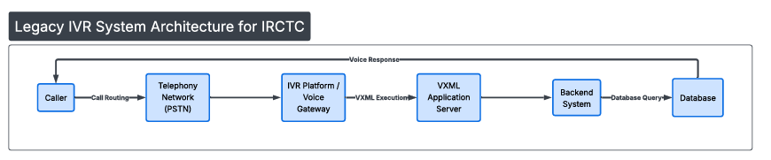
2. Proposed Modern Conversational IVR for IRCTC
The proposed modern IVR system enhances the existing IRCTC legacy IVR by introducing Conversational AI capabilities while preserving the current backend infrastructure. This approach follows a Hybrid Modernization Strategy, where the legacy system remains operational and a conversational layer is added on top.
This ensures minimal disruption, reduced redevelopment effort, and gradual transition toward an AI-enabled system.

Proposed Architecture
The modern conversational IVR architecture is structured as follows:
Caller
→ Cloud Telephony Layer (Twilio / Azure Communication Services)
→ Conversational AI Engine (BAP Platform)
→ Integration Layer (REST API / Middleware)
→ Legacy IRCTC Backend
→ Database
→ Voice Response to Caller
This layered design separates communication, intelligence, and business logic for better scalability and maintainability.

Key Components Explained
1. Cloud Telephony Layer
The telephony layer can be implemented using:
- Twilio
or
- Azure Communication Services
This layer is responsible for:
- Receiving incoming calls
- Converting speech to text (Speech-to-Text)
- Playing voice responses (Text-to-Speech)
- Managing call routing
It replaces traditional hardware-based voice gateways with a scalable cloud-based solution.
2.Conversational AI Engine (BAP Platform)
The BAP platform introduces intelligence into the IVR system. It performs:
- Intent Detection (e.g., PNR status, Train enquiry)
- Entity Extraction (PNR number, Train number, Date)
- Context Management for multi-step conversations
- Routing user requests to appropriate backend services
Unlike traditional IVR, this layer understands natural language instead of relying on fixed menu options.

3.Integration Layer (REST API / Middleware)
The integration layer acts as a bridge between the AI engine and the existing IRCTC backend systems.
Its responsibilities include:
- Validating user inputs
- Calling backend services through secure APIs
- Fetching data from database
- Formatting responses in structured format (JSON/XML)
- Maintaining session information during the call
This layer ensures that legacy systems are not directly exposed to the AI engine.

4. Legacy IRCTC Backend
The legacy backend remains unchanged and continues to manage:
- Ticket booking system
- Payment processing
- PNR status database
- Train schedule data
The modernization approach does not replace the backend but enhances interaction through an intelligent front layer.

Advantages of This Architecture
- Enables natural language interaction
- Maintains legacy system stability
- Supports cloud scalability
- Separates interaction logic from business logic
- Allows gradual modernization
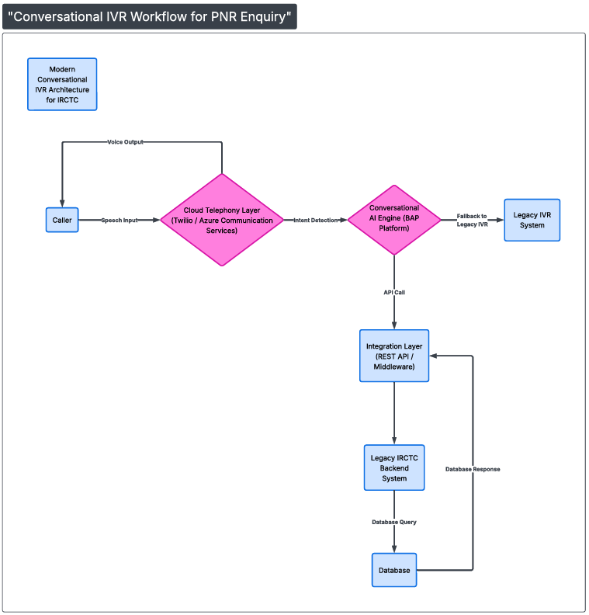
3. Integration Logic and Workflow
The following workflow explains how the modern conversational IVR processes a PNR status enquiry request in the IRCTC system.
This flow corresponds to the diagram shown below.

Step 1: Call Received
The process begins when the user initiates a call to the IRCTC IVR system.
The system receives the call through the Cloud Telephony layer (Twilio / ACS).

Step 2: Speech Recognition
The caller provides voice input.
The telephony layer converts the speech into text using Speech-to-Text (STT) technology.

Step 3: Intent Detection (PNR Status)
The Conversational AI Engine (BAP platform) analyzes the converted text and identifies the user’s intent.
In this case:
Intent Detected: PNR Status Enquiry

Step 4: Extract PNR Number
The AI extracts the relevant entity from the input, such as:
- PNR Number (e.g., 1234567890)
This structured information is required to process the request.

Step 5: Decision – Intent Recognized?
At this stage, the system checks whether the intent has been successfully recognized.
- If Yes, the system proceeds to call the backend API.
- If No, the call is routed to the Legacy IVR system.

Step 6A: Call Backend API (If Yes)
If the intent is recognized:
The AI sends a request to the Integration Layer (REST API / Middleware).
The API:
- Validates the PNR number
- Forwards the request to the backend system

Step 7: Database Lookup
The Legacy IRCTC Backend system queries the database to retrieve:
- Ticket status
- Coach number
- Seat number
The database sends the response back to the API layer.

Step 8: Generate Response
The Integration Layer formats the response and sends it back to the AI engine.
The AI prepares a conversational reply such as:
“Your ticket is confirmed. Coach S3, Seat 45.”

Step 9: Convert Text to Speech
The response text is converted into speech using Text-to-Speech (TTS).

Step 10: End
The system plays the voice response to the caller, and the interaction ends.

Fallback Flow (If Intent Not Recognized)
If the intent is not recognized at the decision stage:
- The system routes the call to the existing Legacy VXML IVR.
- The user continues interaction through traditional menu-based options.
- The call ends after completing the legacy flow.

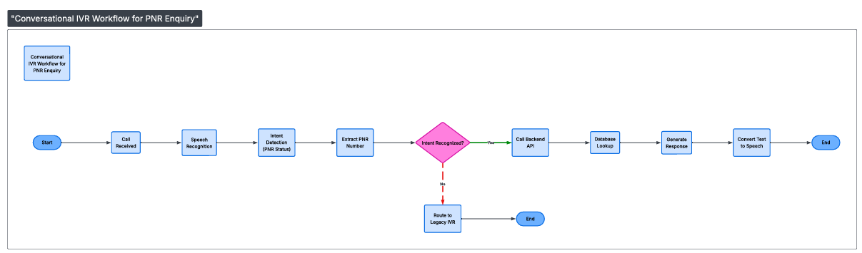

TASK 3:
Technical Challenges, Constraints, and Compatibility Gaps

1. Legacy IVR Technical Challenges
The existing IRCTC IVR system was developed more than a decade ago based on the technology standards and market demands of that period. While it was reliable and stable for structured automation, several technical limitations exist when compared to modern conversational systems.
1.1 VXML-Based Monolithic Design
- Business logic is embedded directly within VXML scripts.
- Interaction logic and backend processing are not clearly separated.
- Modifying or extending individual features is complex and time-consuming.
1.2 Direct Backend Dependency
- Legacy IVR directly interacts with backend systems.
- No dedicated API layer exists for abstraction.
- High dependency between IVR scripts and database structure.
1.3 Limited User Interaction Capability
- Primarily keypad (DTMF) based navigation.
- Limited or no natural language understanding.
- No conversational memory or contextual awareness.
1.4 Infrastructure Limitations
- Dependent on on-premise telephony infrastructure.
- Limited scalability during peak usage periods.
- Higher maintenance effort and operational cost.

2. Historical Design Constraints
Legacy IVR systems were designed according to the technical environment available at that time:
- Cloud infrastructure was not widely adopted.
- AI and Natural Language Processing technologies were not mature.
- Telephony systems were hardware-driven.
- The primary objective was structured call automation, not conversational interaction.
Therefore, menu-based IVR was sufficient to handle high call volumes effectively.

3. Challenges in Modern Integration
When integrating legacy IVR with modern platforms such as ACS and BAP, certain challenges arise.
3.1 Integration Complexity
- Existing VXML logic needs to be adapted into API-based services.
- Backend services may require restructuring.
- Traditional call flows must be mapped to conversational intents.
3.2 Framework Compatibility
- Legacy systems may use older technologies.
- Modern systems require REST-based APIs.
- Differences in data formats (XML vs JSON) may require transformation.
3.3 Session and Context Handling
- Legacy IVR does not maintain conversational context.
- Conversational AI requires session tracking for multi-step interactions.

4. Architectural and Cloud Constraints
Modernization introduces cloud and security considerations.
4.1 Cloud Platform Limitations
If deployed using cloud services such as AWS or Azure:
- There may be execution time limits.
- Resource scaling policies must be configured properly.
- Network latency may affect real-time response.
4.2 Security Requirements
- Secure API communication using HTTPS.
- Authentication and authorization mechanisms.
- Data encryption during transmission.
- Compliance with data protection policies.

5. Compatibility Gaps
5.1 Telephony Compatibility
- Legacy telephony protocols must align with cloud telephony platforms.
- Voice streaming compatibility must be ensured.
5.2 Data Format Differences
- Legacy systems often use XML-based communication.
- Modern APIs typically use JSON format.
5.3 Feature Gaps
Compared to modern IVR systems, legacy IVR lacks:
- Natural language interaction
- Multi-language conversational support
- Real-time analytics
- Context-aware responses

6. Custom Development Challenges
During modernization, the following development efforts are required:
- Creating an API layer to separate logic from VXML.
- Refactoring backend services for reuse.
- Designing conversational workflows aligned with existing services.
- Implementing fallback mechanisms.
- Optimizing performance for real-time voice response.

Conclusion
The analysis of the existing IRCTC legacy IVR system provided a comprehensive understanding of its architecture, operational workflow, and technical limitations. The system, built on a VXML-based, menu-driven framework, was designed to meet the technological standards and market requirements of its time, focusing primarily on structured automation and system stability.
However, with the evolution of cloud technologies and conversational AI platforms, the need for modernization has become evident. The study identified key integration requirements, including API-based communication, conversational intent mapping, session management, and secure telephony integration. Technical challenges such as framework compatibility, data format differences, scalability limitations, and security considerations were also recognized.
Based on this assessment, a Hybrid Modernization approach has been identified as the most suitable strategy. This approach enhances user experience through conversational AI capabilities while preserving the reliability of the existing backend infrastructure.
Overall, the evaluation establishes a strong foundation for implementing a scalable, secure, and future-ready conversational IVR system aligned with modern communication platforms.

