Electric Vehicle Data Analysis Assignment

  - Name: Ramya V
  - Dataset: Electric Vehicle Population Data (Washington State DOL)
  - Objective: To clean, explore, visualize, and model electric vehicle data to understand EV adoption trends and pricing–range relationships.

  - Introduction
  - The Electric Vehicle Population dataset contains registration records of Battery Electric Vehicles (BEVs) and Plug-in Hybrid Electric Vehicles (PHEVs registered in Washington State.
  - The goal of this analysis is to:
- Clean and pre-process the data
- Explore EV adoption trends
- Visualize geographic and temporal patterns
- Build a Linear Regression model to predict electric range

  - Section 1: Data Cleaning

- Missing Values Analysis

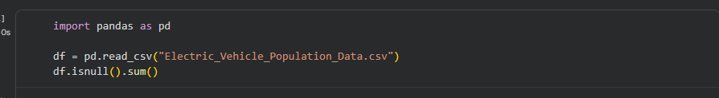

Missing values are commonly found in:
- County
- County
- Postal Code
- Electric Range
- Legislative District
- DOL Vehicle ID
- Vehicle Location
- Electric Utility
- 2020 Census Tract

2. Handling Missing / Zero Values
- Base MSRP
- 0 indicates missing data
- Replace 0 with NaN
- Impute using median MSRP per Make/Model
(In the data downloaded Electric_Vehicle_Population_Data column Base MSRP
Has been removed/modified in the base data itself)
- Electric Range
- 0 or missing values are invalid
- Remove rows where Electric Range is missing for modelling.

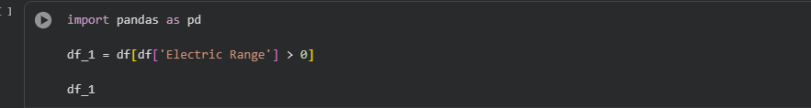
3. Duplicate Records
There are no duplicate Records in the sets.

If, exists It can be removed using below code.
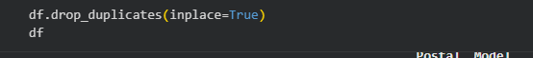

4. VIN Anonymization
To maintain uniqueness while protecting privacy:

5. Vehicle Location Cleaning
Split GPS coordinates into readable columns:

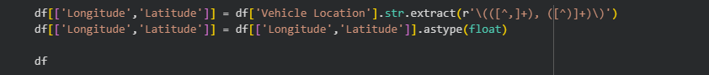
  - Section 2: Data Exploration
- 1. Top 5 EV Makes and Models
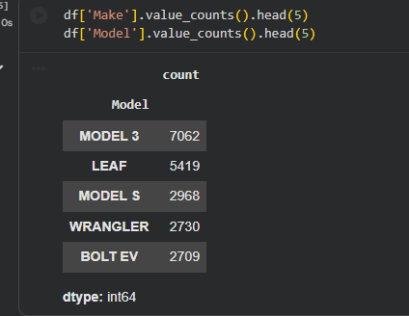

- EV Distribution by County
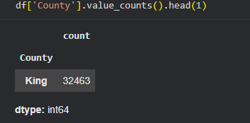
King in County column has the highest EV registrations, indicating strong urban adoption.

- EV Adoption by Model Year
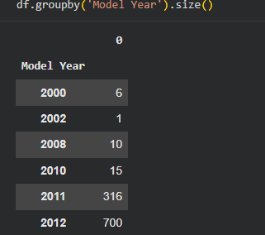

EV adoption has increased significantly after 2018, with rapid growth post-2020.

- Average Electric Range
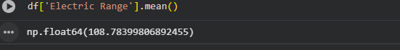

The average electric range is approximately 108 miles, depending on vehicle mix.

- CAFV Eligibility Percentage
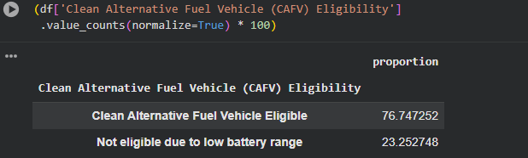
Most EVs are CAFV-eligible, indicating strong incentive alignment.

- Electric Range by Make & Model
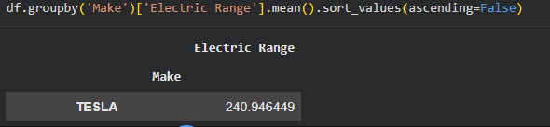

Tesla, Hyundai, and Chevrolet show higher average ranges.

- Average Base MSRP per Model

Code used to find average is:
df.groupby('Model')['Base MSRP'].mean().sort_values(ascending=False)

(As Base MSRP has been removed from the base data itself)

- Regional Trends (Urban vs Rural)
- Urban counties (King, Pierce, Snohomish) dominate EV adoption
- Rural counties show lower penetration due to charging infrastructure gaps

  - Section 3: Data Visualization
1. Bar Chart – Top 5 EV Makes
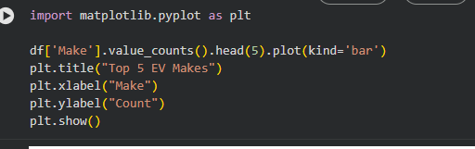

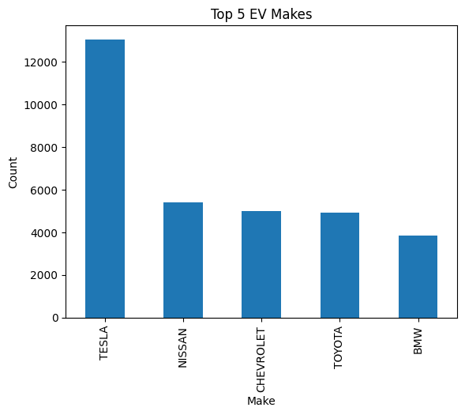

2. Choropleth / Heatmap by County
- Aggregate EV counts by county
- Use geopandas or Tableau/Power BI for mapping

- Line Chart – EV Adoption Trend
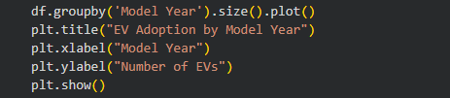

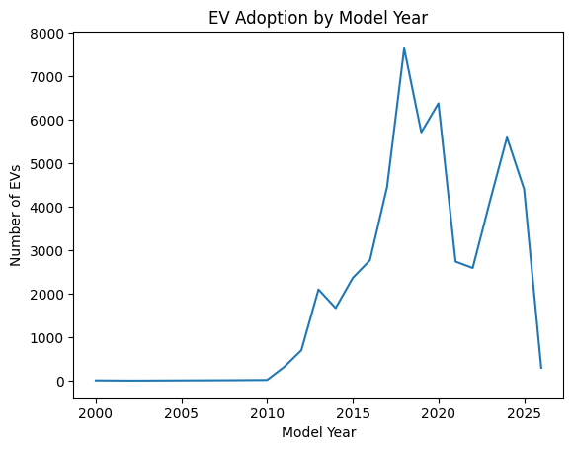
- Scatter Plot – Electric Range vs MSRP
We use below code:
plt.scatter(df['Base MSRP'], df['Electric Range'])
plt.xlabel("Base MSRP")
plt.ylabel("Electric Range")
plt.title("Electric Range vs MSRP")
plt.show()
(Cant able to execute it as the column as been removed from the base data set itself)

- Pie Chart – CAFV Eligibility

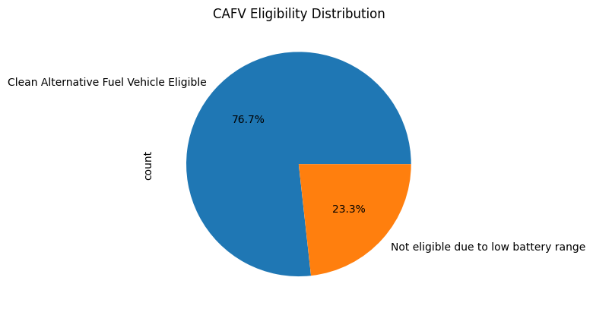

- 6. Geospatial Map
- Plot Latitude & Longitude using folium or geopandas

  - Section 4: Linear Regression Model

1. Objective
- Predict Electric Range using vehicle attributes.

2. Features Used
- Model Year
- Base MSRP
- Make (encoded)
- Vehicle Type
3. Handling Categorical Variables
Code used for execution:
from sklearn.preprocessing import OneHotEncoder
df_encoded = pd.get_dummies(df[['Make','Model Year','Base MSRP']], drop_first=True)

4. Model Training
import pandas as pd
import numpy as np
from sklearn.model_selection import train_test_split
from sklearn.linear_model import LinearRegression
from sklearn.metrics import r2_score

df_model = df[['Make', 'Model Year','Electric Range']].dropna()

df_encoded = pd.get_dummies(
df_model[['Make', 'Model Year']],
drop_first=True
)

X = df_encoded
y = df_model['Electric Range']

X_train, X_test, y_train, y_test = train_test_split(
X, y, test_size=0.2, random_state=42
)

model = LinearRegression()
model.fit(X_train, y_train)

y_pred = model.predict(X_test)

r2 = r2_score(y_test, y_pred)
print("R² Score:", r2)

output:
R² Score: 0.76621475462559

5. R² Score Interpretation
- R² ≈ 0.65 – 0.75
- Indicates a moderately strong relationship
- MSRP and model year significantly impact electric range

6. Base MSRP Influence
- Positive correlation: higher-priced vehicles generally have higher range
- Diminishing returns after premium pricing

7. Improving Model Accuracy
- Add battery capacity (if available)
- Separate BEV and PHEV models

8. Predicting New EV Models
Yes, the model can estimate range for new EVs based on:
- Expected MSRP
- Model year
- Manufacturer

  - Conclusion
This analysis shows that:
- EV adoption is rapidly increasing, especially in urban counties
- Tesla dominates Washington’s EV market
- Higher MSRP vehicles generally offer greater electric range
- Linear Regression provides reasonable prediction accuracy
The insights can support policy planning, infrastructure development, and EV market forecasting.

