- Creating and Renaming Files/Directories
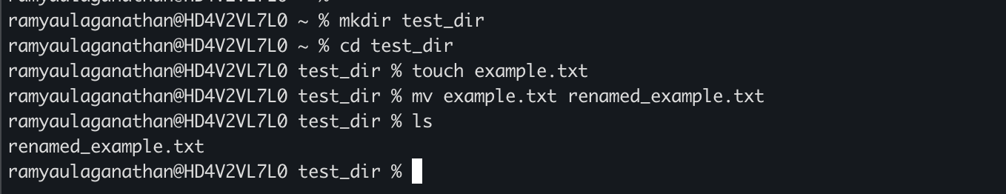

- Viewing File Contents
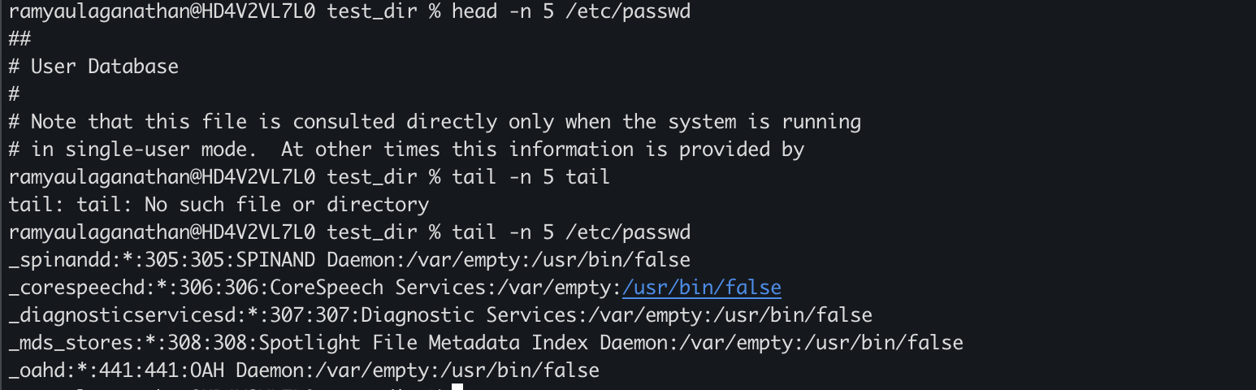

3.Searching for Patterns

4. Zipping and Unzipping
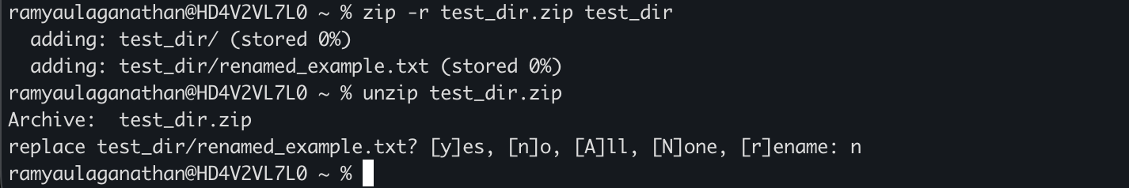

5. Downloading Files

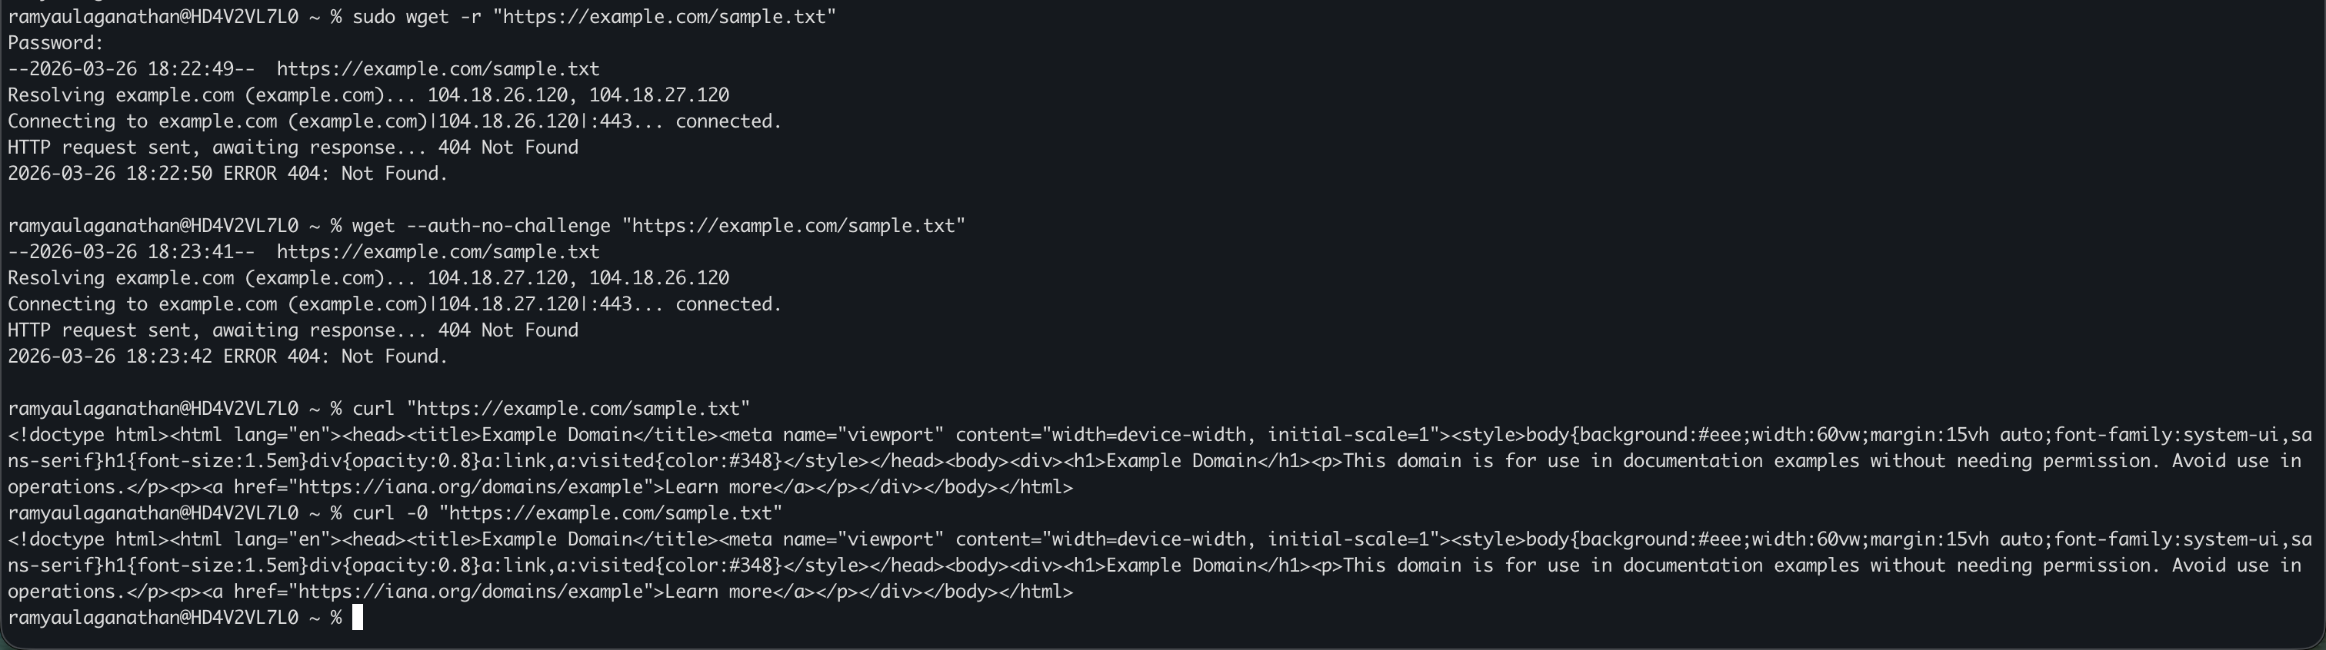

6. Changing Permissions

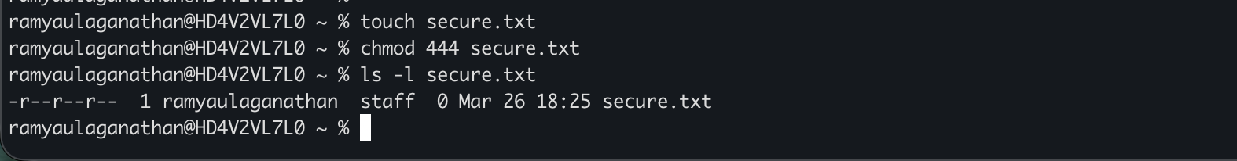

7. Working with Environment Variables

