**ReadMe for HomeKitchen**

# **What the project ‘HomeKitchen’ does?**

This project provides a platform i.e. a website for both cooks and buyers where buyers can see all food items available and can place order online. On the other hand, cooks can place their food items. They can also see their orders to faster the order process.

# **Why the project ‘HomeKitchen’ is useful?**

The purpose of HomeKitchen is to bridge the gap between the demand and supply of homemade food in big metropolitan cities like Lahore, Karachi and Islamabad, where lots of people move in for education or work, with no family to live with. Their only source of food is hotels and dhabas and are in a constant search of homemade food. Moreover, there are many women who want to earn some extra bucks with the skills that they are good at (cooking) but at the same time, they don’t have that much resources and logistics to start their own setup.

# **How users can get started with the project ‘HomeKitchen’?**

User Interface has been kept quite responsive. This way, everyone having a basic understanding of website usage can get started and use the website ‘HomeKitchen’. Following are the webpages designed to serve the purpose.

## **Sign Up**

User has to sign up through the following web page:

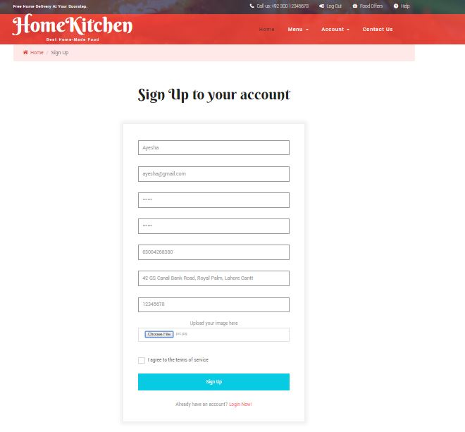

## **Log In**

User has to log in through the following web page:

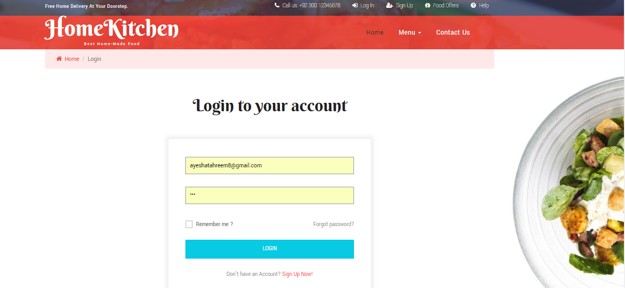

## **Home Page**

User is directed to the following page after logging in or signing up.

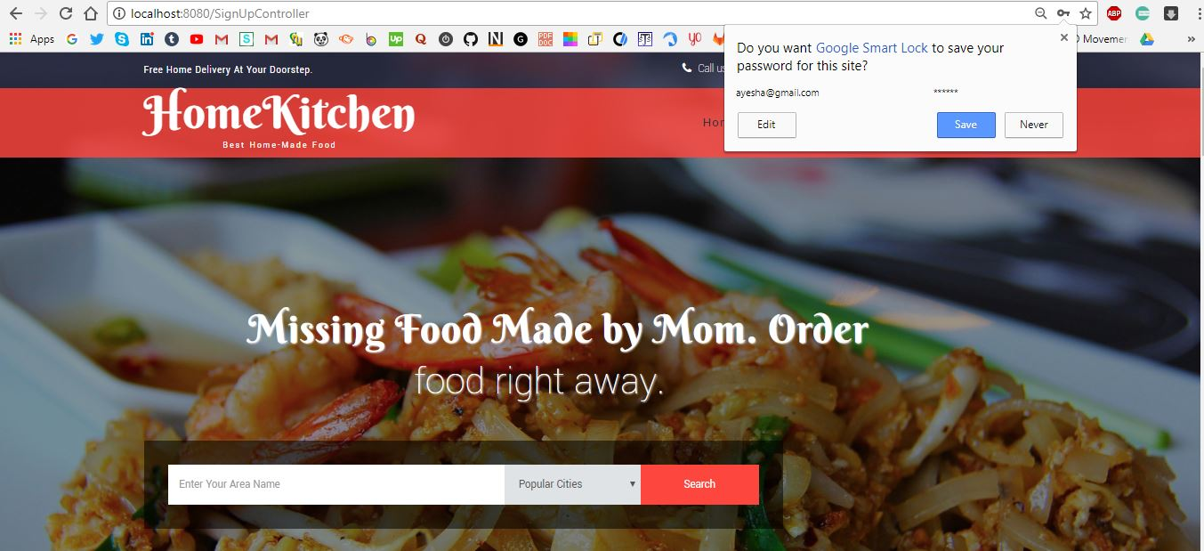

## **Post Food**

User can post his food item through the following webpage.

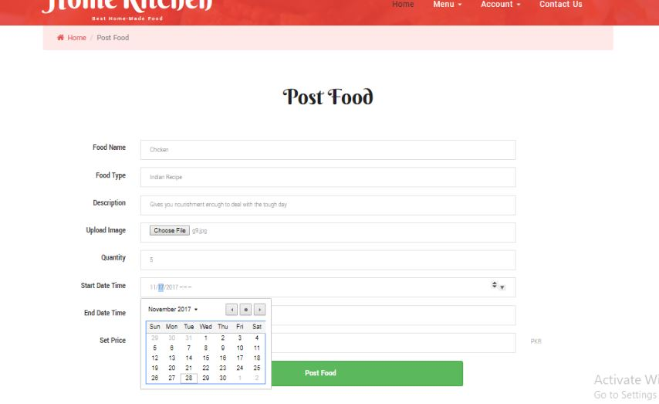

## **Order Food**

User can order his food item by coming on the homepage where all the food items appear. To order a food, he will click on the food post and order the particular item.

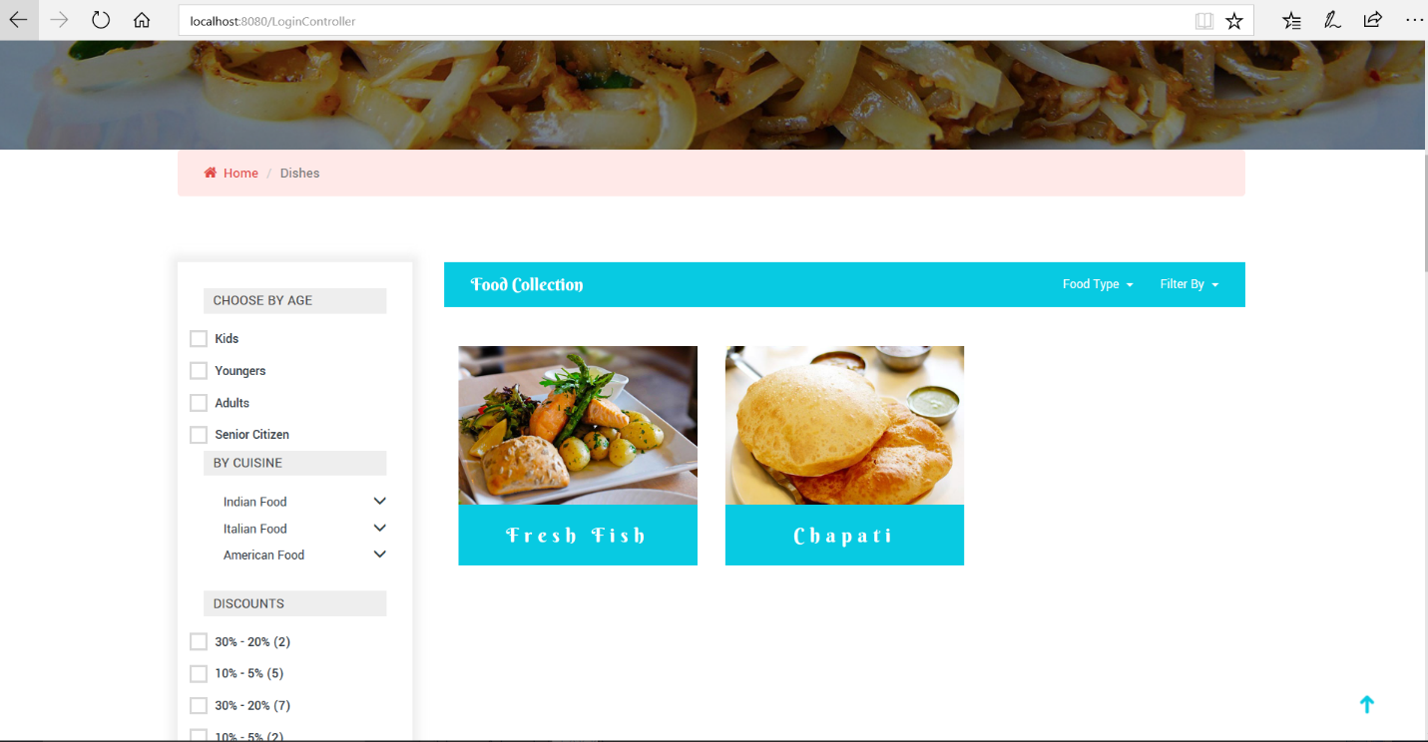

On just placing the mouse over the food post, following details will be hovered onto the webpage so that user can order the food item.

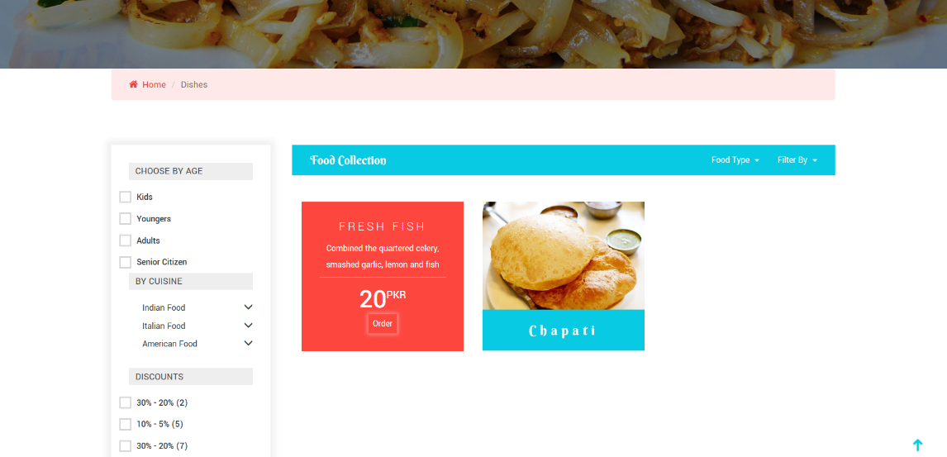

Through this form, user can place his order.

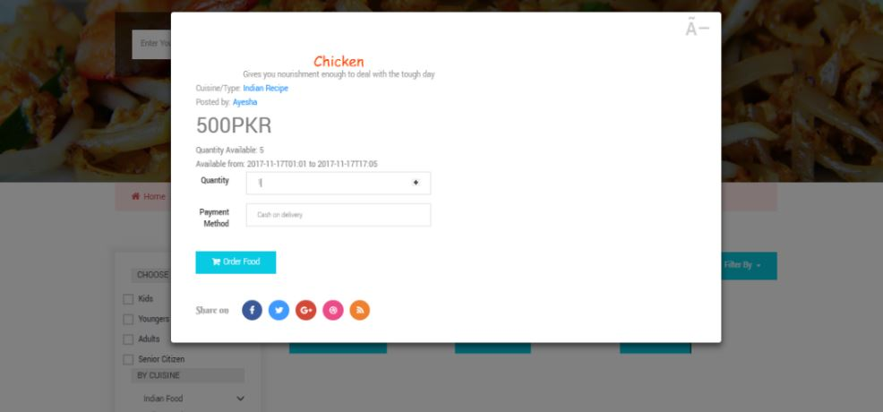

After order has been approved and placed, user will be notified about this change.

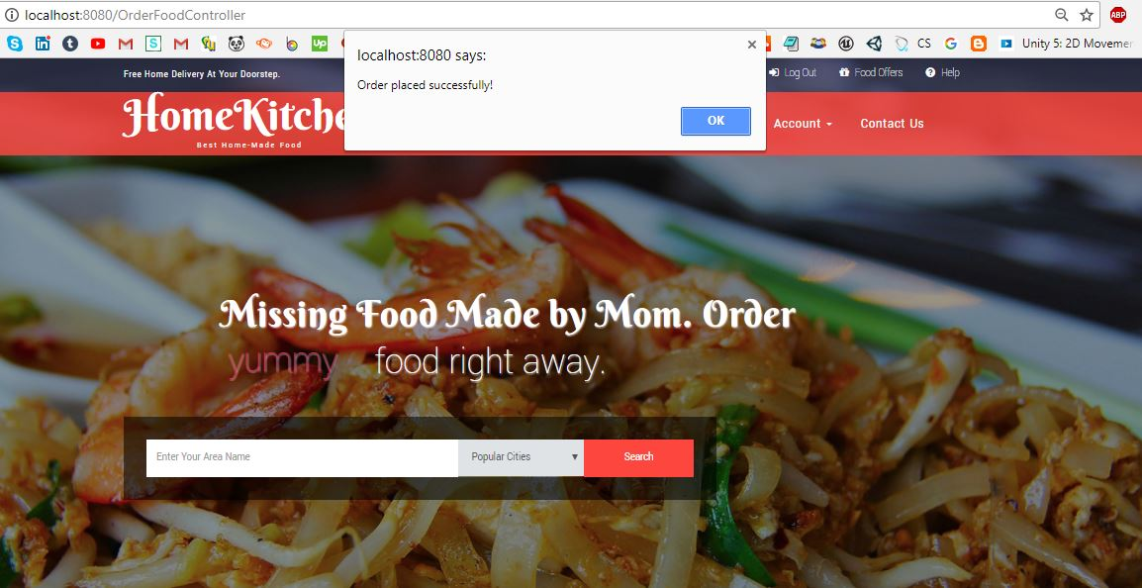

## **Profile (Edit Profile)**

User can edit his profile through the following webpage.

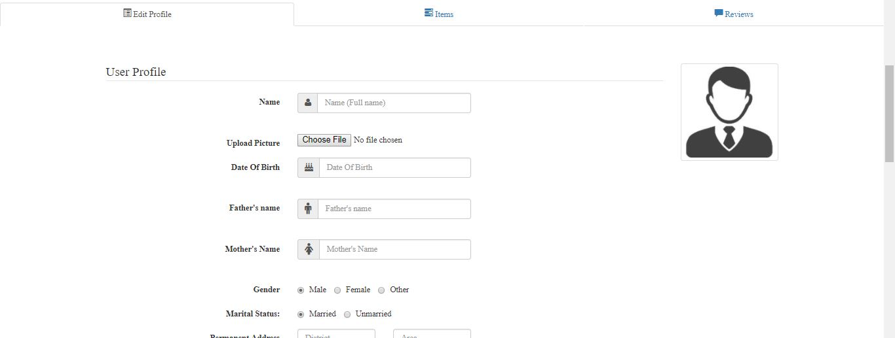

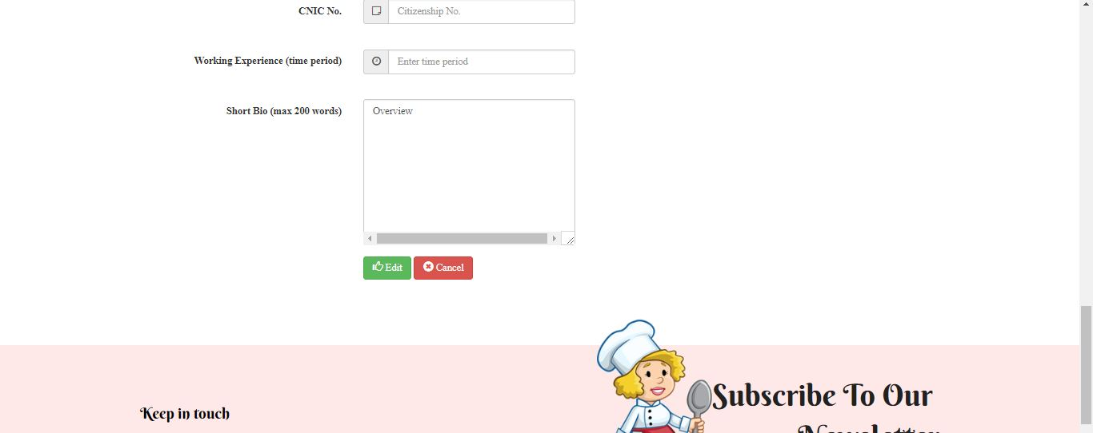

## Profile (View Items)

Seller can view all the items posted by him through the following tabbed carousel.

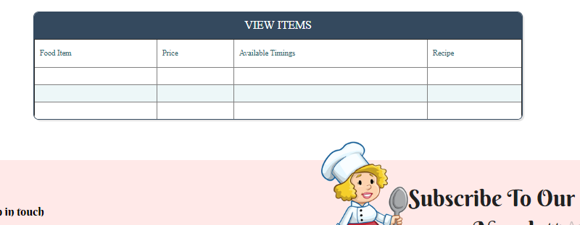

## **Profile (View Review and Rating)**

Seller can view all the reviews and ratings of items given to him through the following tabbed carousel.

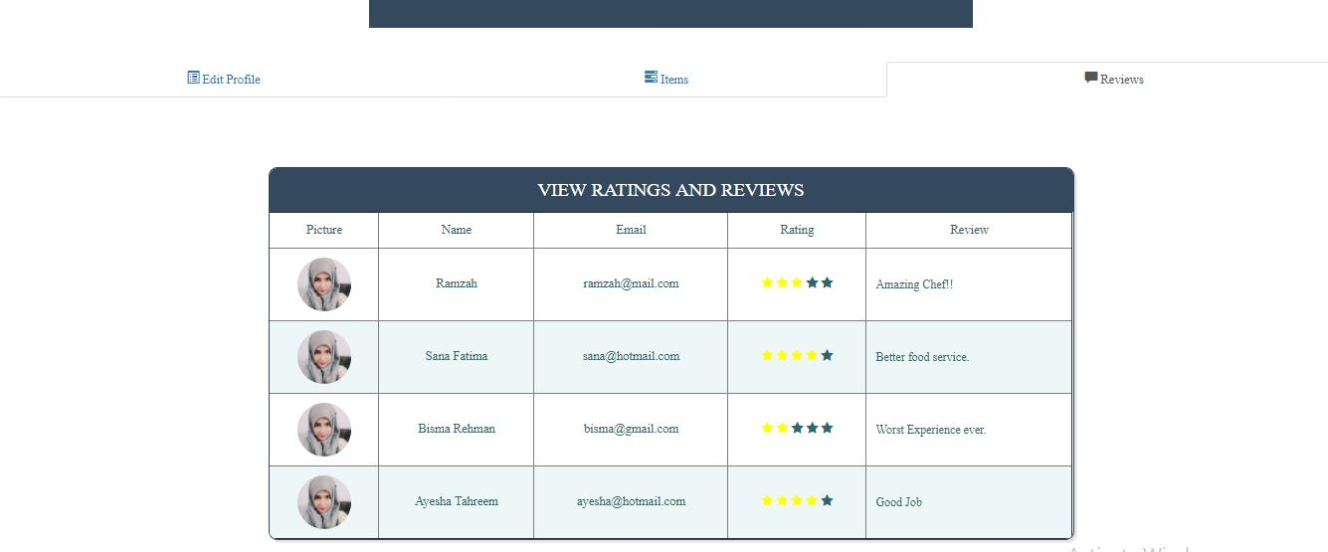

## **History (w.r.t seller previous orders, seller current orders, buyer previous orders, buyer current orders)**

Following is the history webpage.

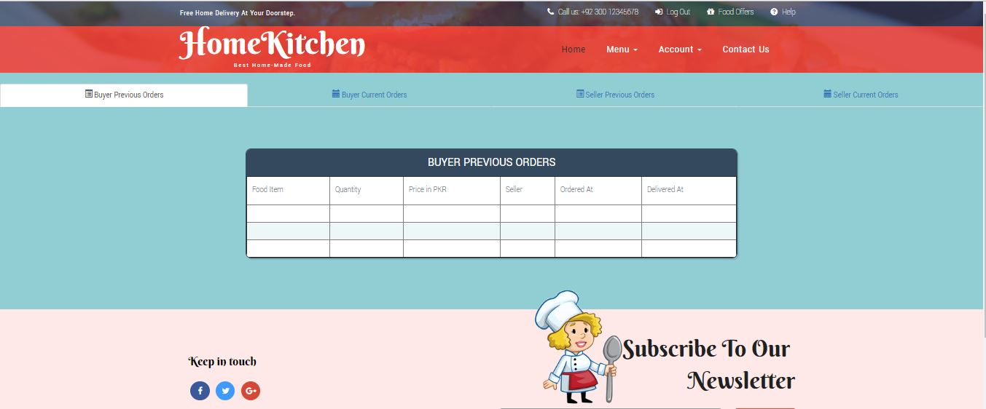

# **Who maintains and contributes to the project ‘HomeKitchen’?**

We (Ayesha Tahreem Aamir, Ramzah Rehman, Sana Fatima and Mahnoor Fatima) contributes towards the project.