AI-Solutions — System Flowcharts
Two separate flowcharts: the customer-facing website flow and the admin panel flow.
Flowchart 1 — Customer / Public Website Flow
Visitor journey: browse pages, choose an action (inquiry, demo, event, chatbot, feedback), validate, store in MySQL, confirm.
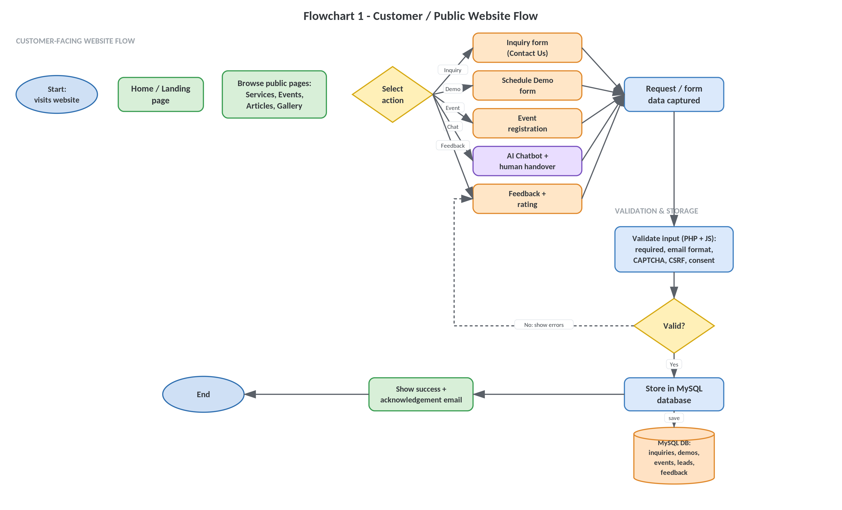
Flowchart 2 — Admin Dashboard / Admin Panel Flow
Secure login with lockout, dashboard analytics, task selection, record CRUD with role checks, and logout.
