AI-Solutions
Solution Design Documentation
CET333 Product Development — Portfolio Section 5
Name: Ramjan Rawal Student No: 250905074
Project: AI-Solutions Customer Engagement & Admin Web System
This section presents the design documentation for the AI-Solutions prototype: page wireframes, system flowcharts, a use case diagram, a Level-1 data flow diagram (DFD), and an entity relationship diagram (ERD). All artefacts reflect the delivered PHP/MySQL system and were produced as editable source files (draw.io and SVG) so they can be revised as the system evolves.

5.1 Wireframes
Low-fidelity wireframes showing the layout, structure, and key interface elements of every page in the delivered prototype. Customer-facing pages share a common header (logo + navigation) and footer; admin pages use a sidebar layout.

5.1.1 Home / Landing Page
Page: index.php
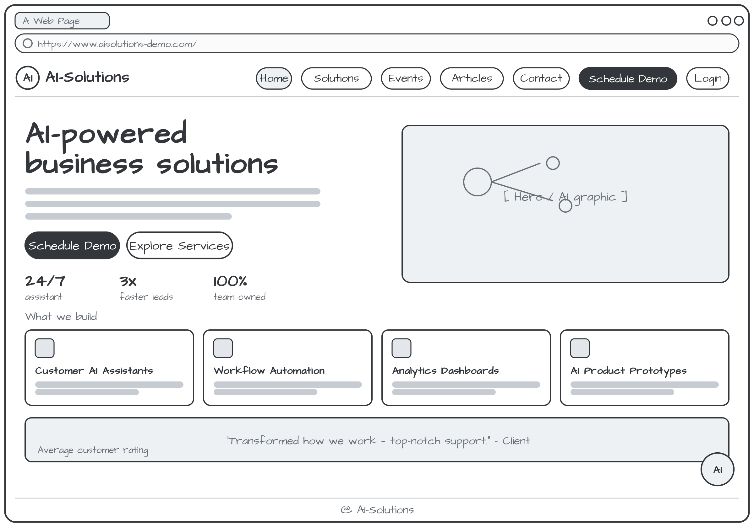

5.1.2 Services / Solutions Page
Page: services.php
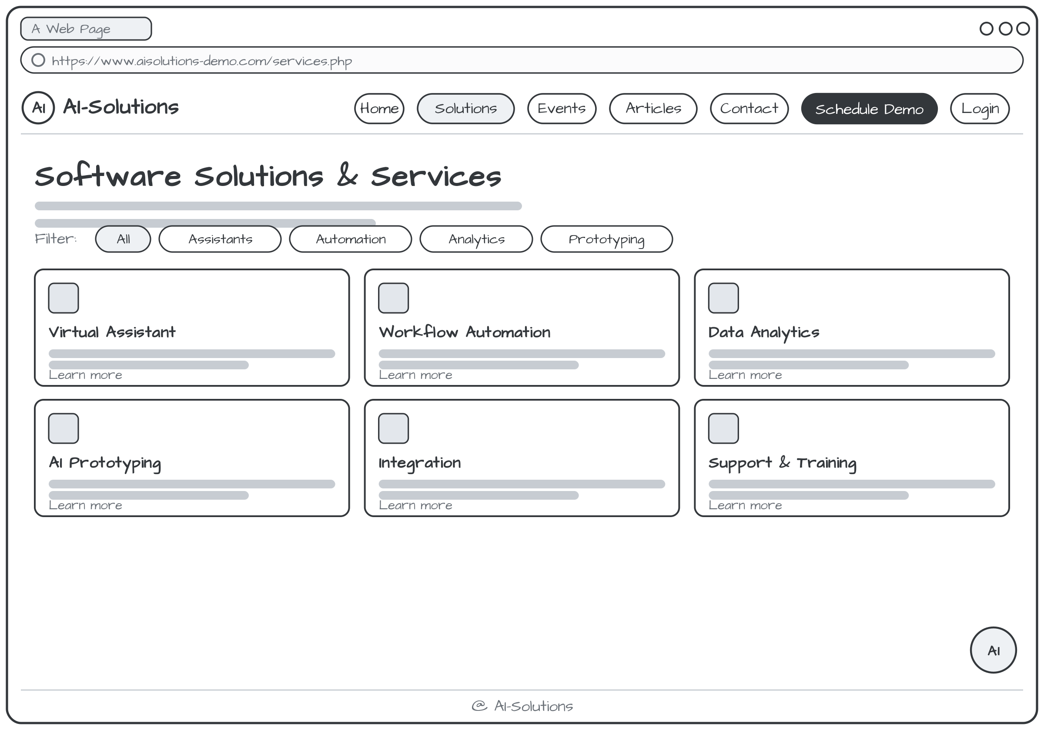

5.1.3 Events & Gallery Page
Page: events.php
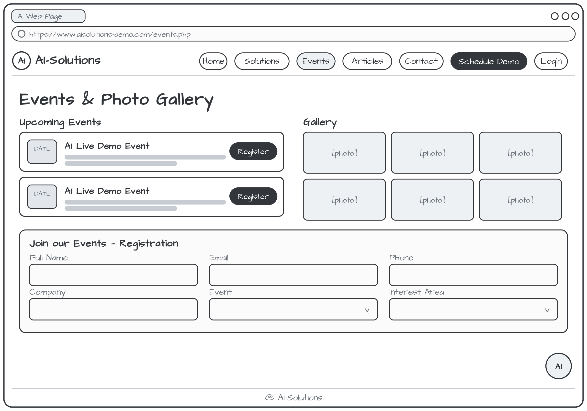

5.1.4 Contact Us / Inquiry Page
Page: contact.php
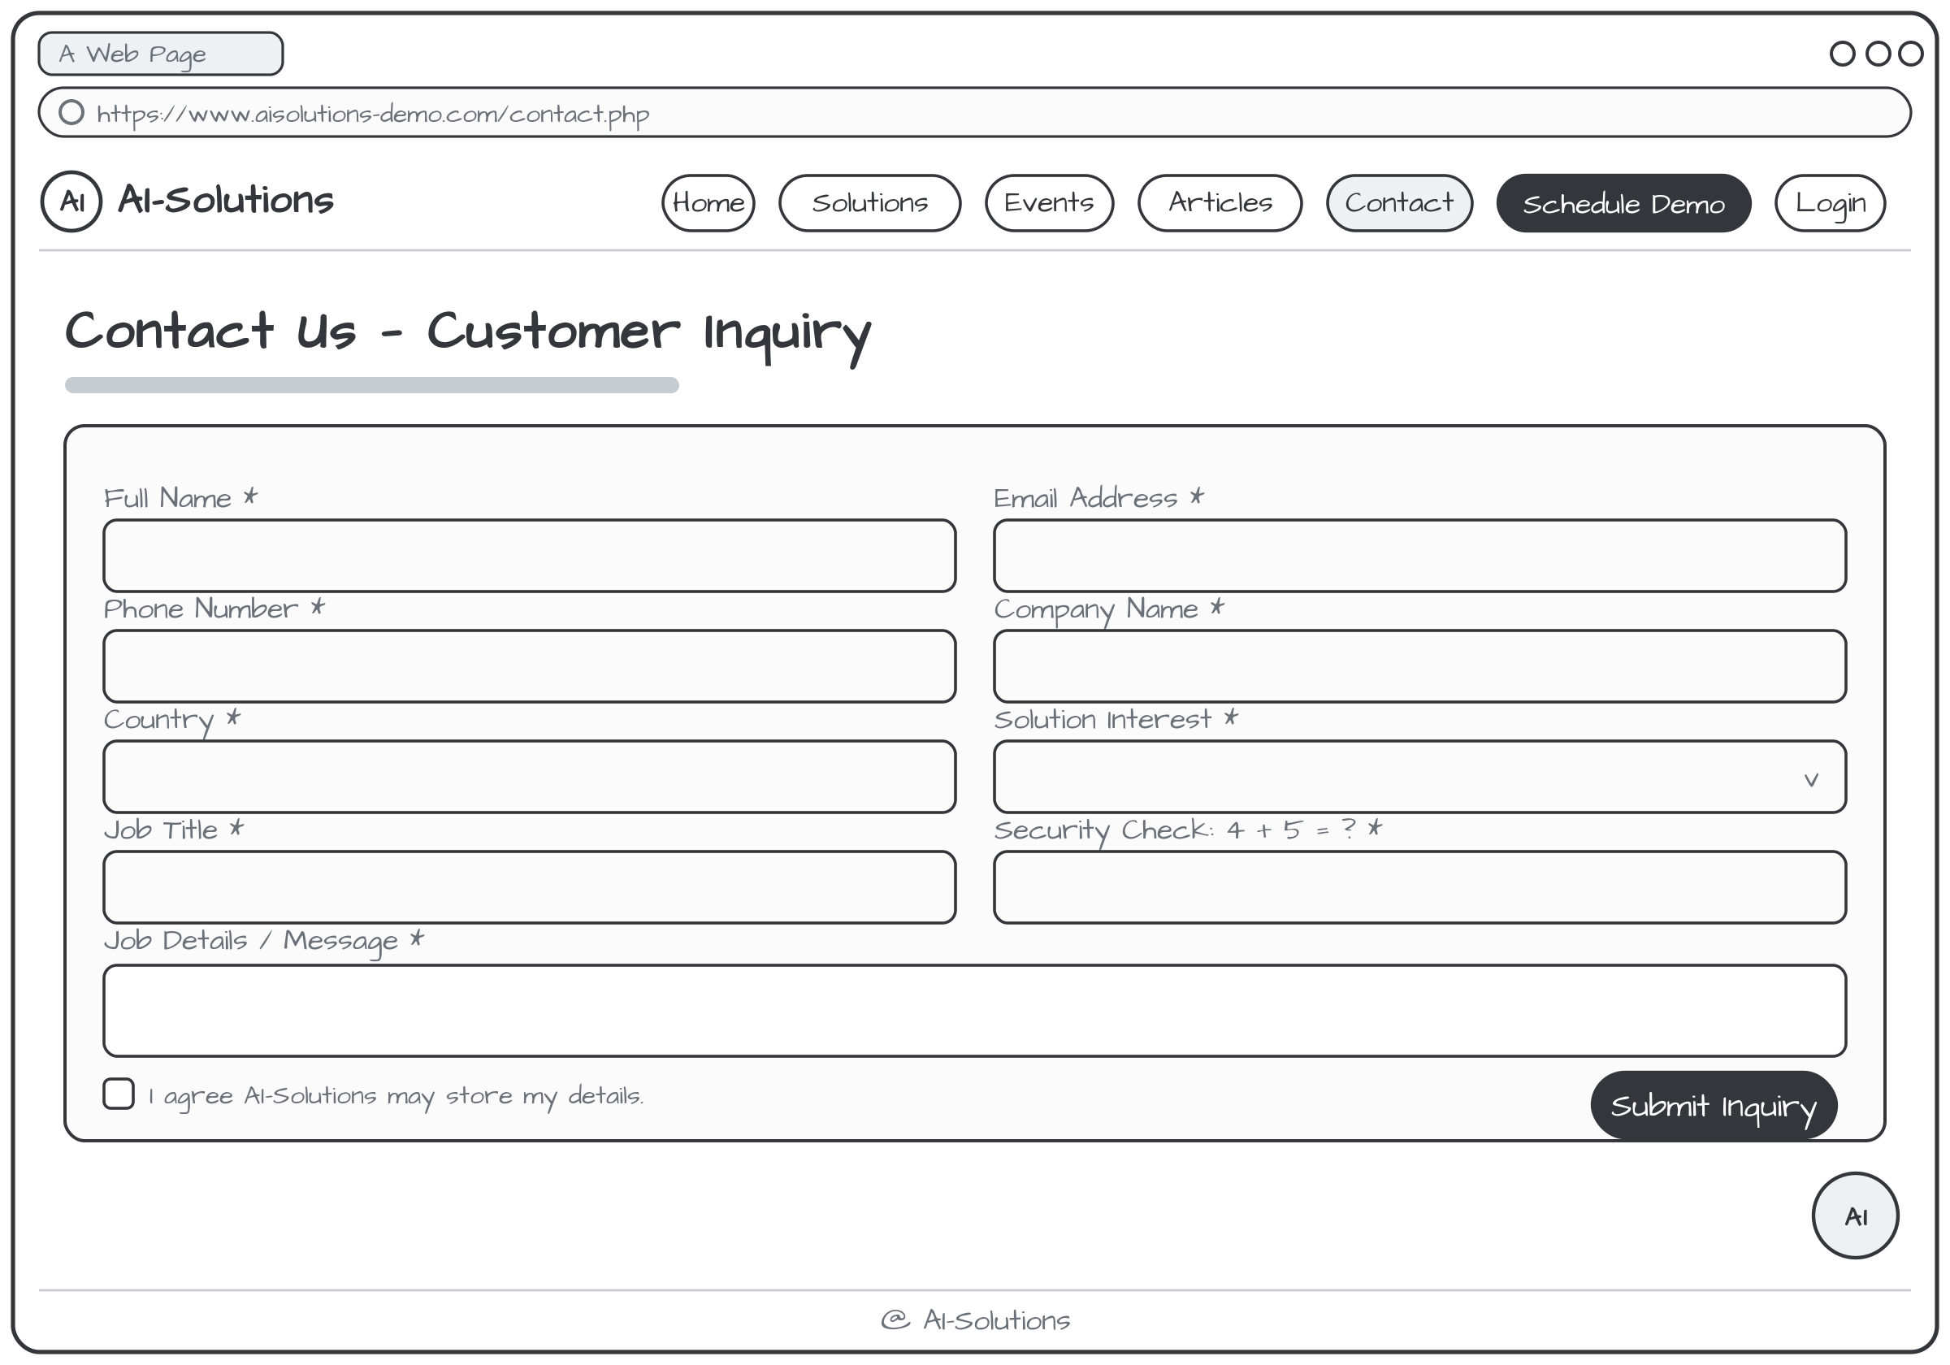

5.1.5 Schedule Demo Page
Page: schedule-demo.php
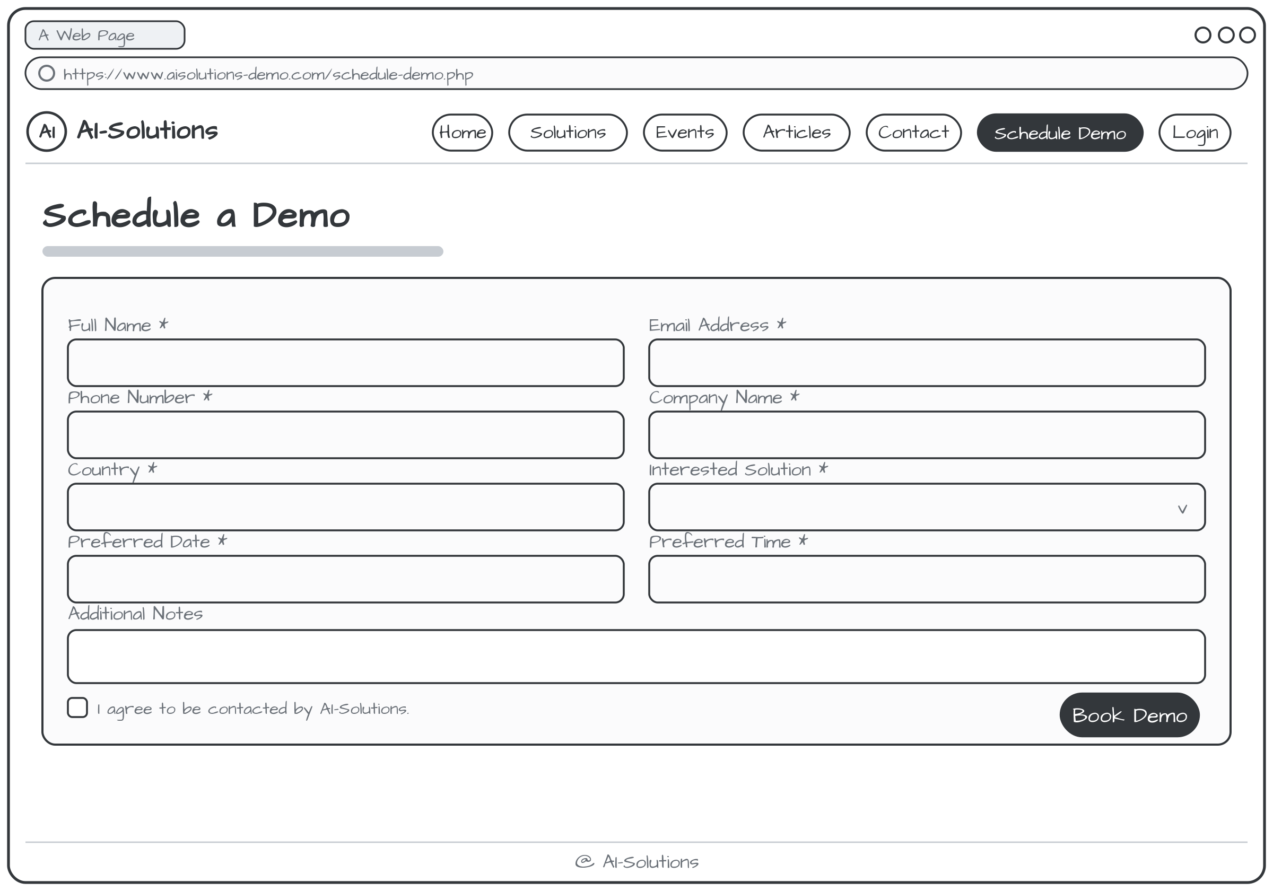

5.1.6 AI Chatbot Page
Page: chatbot.php
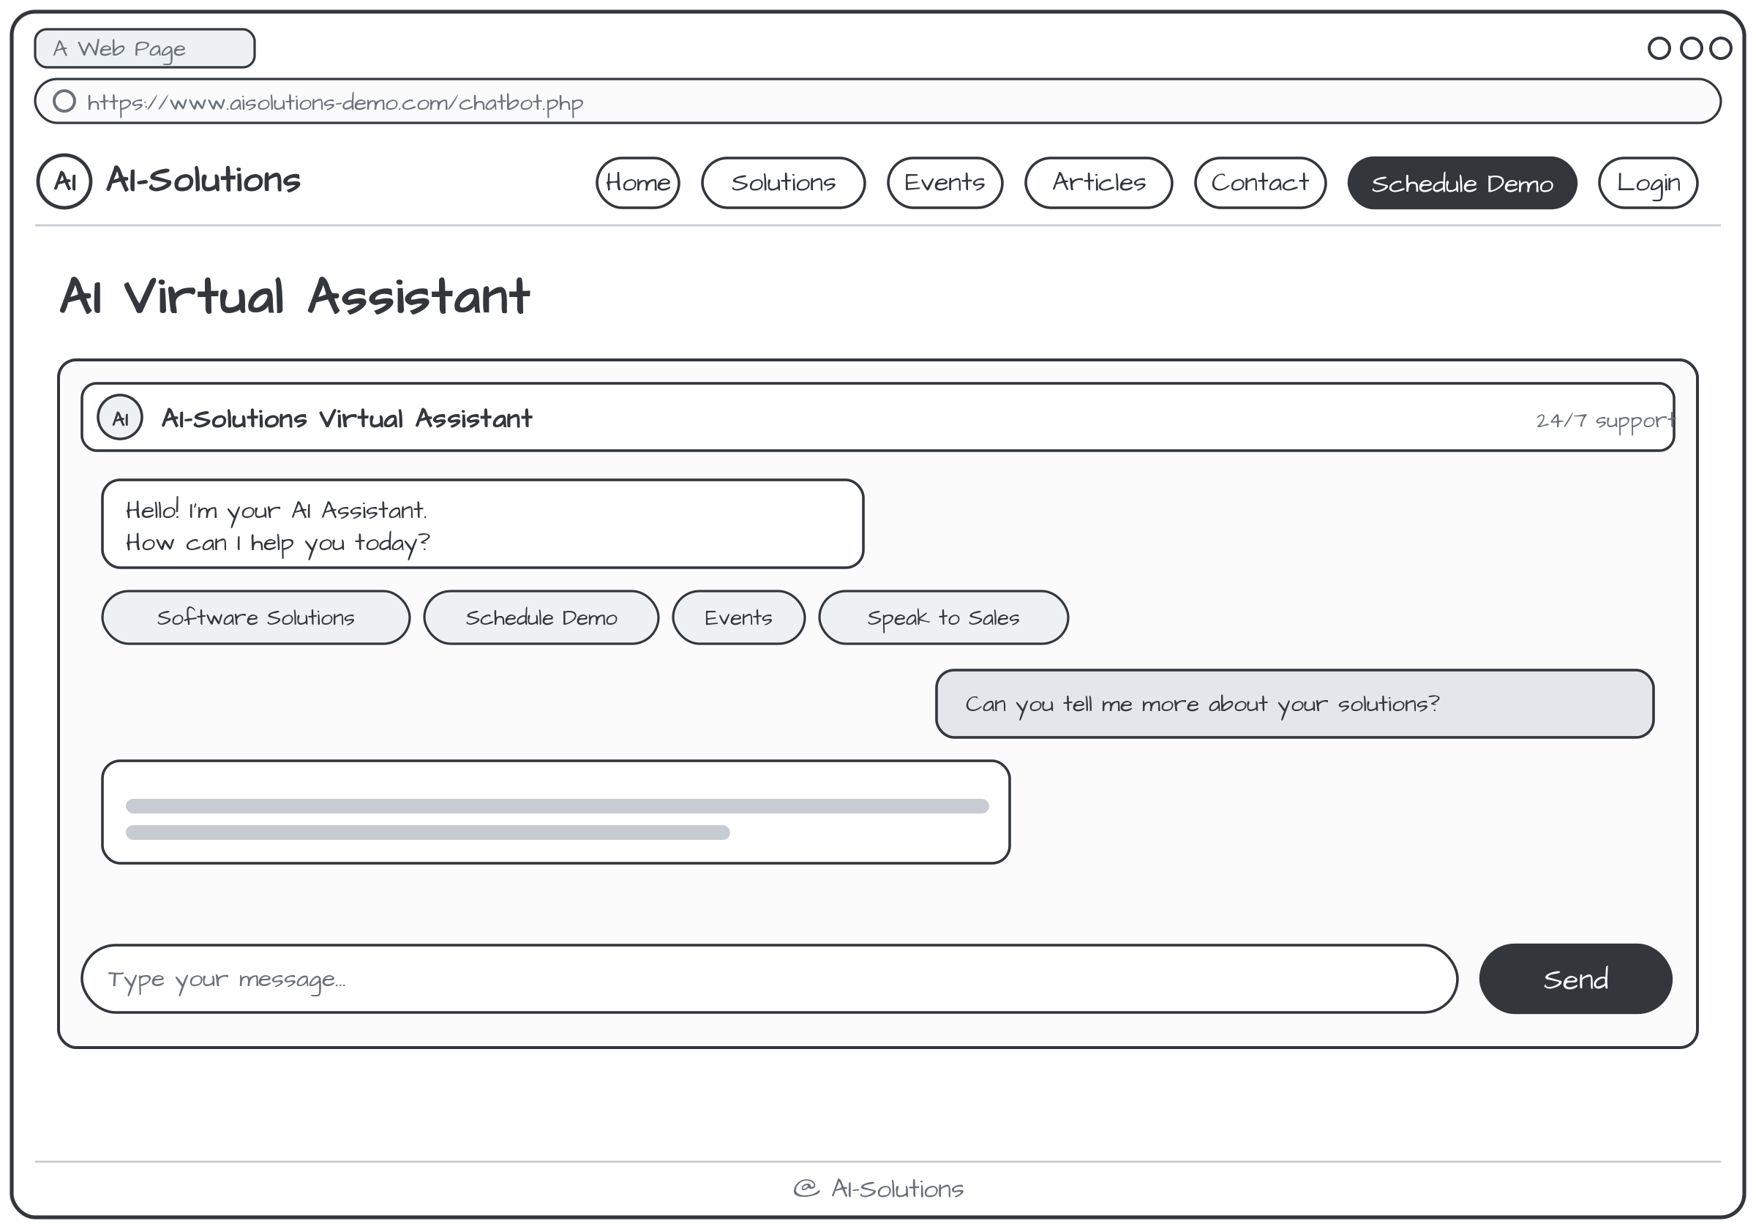

5.1.7 Chatbot Handover Page
Page: chatbot-handover.php
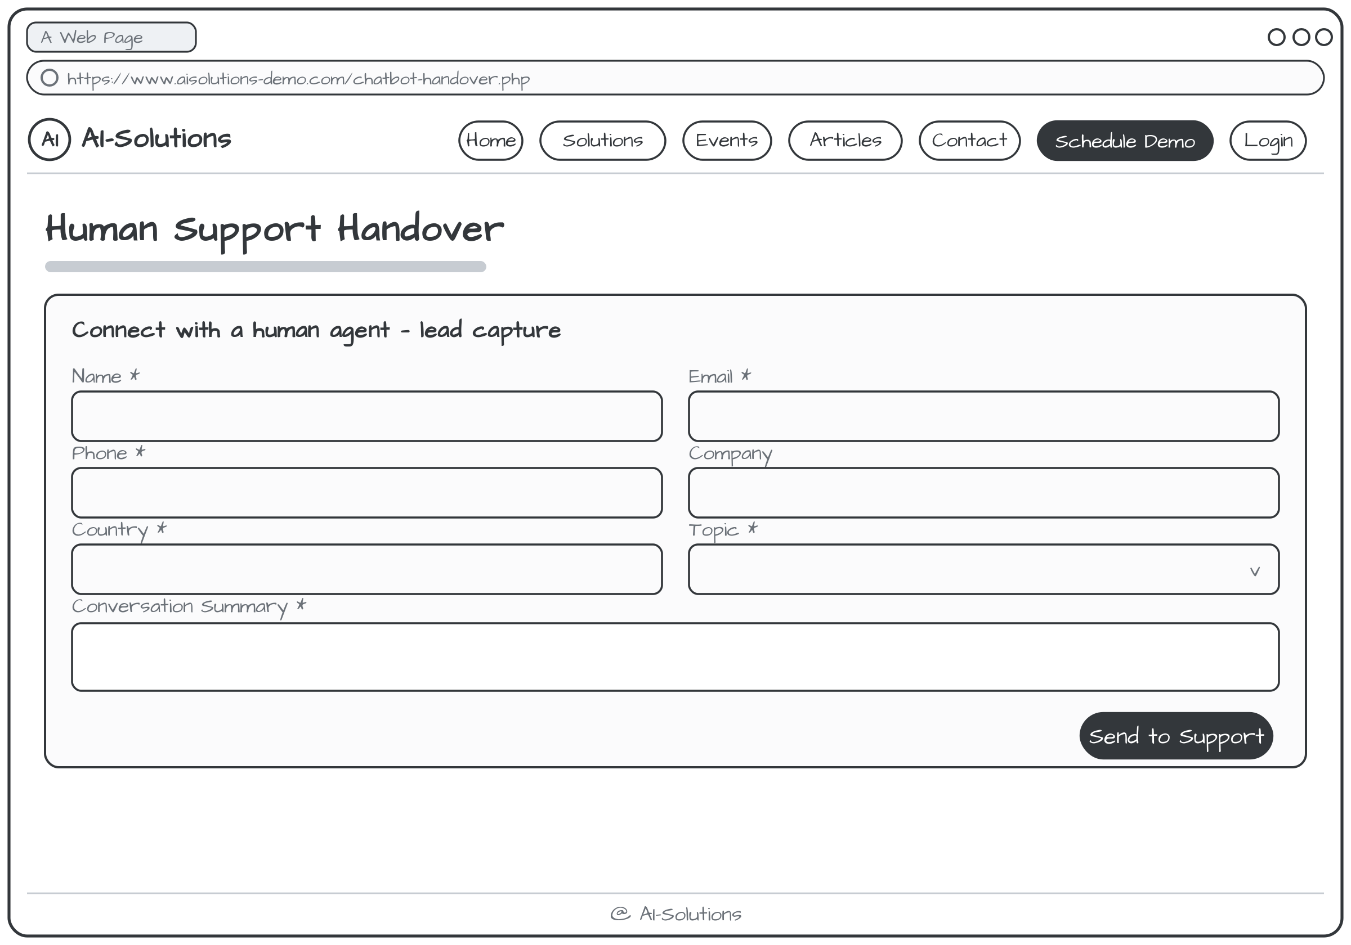

5.1.8 Admin Login Page
Page: admin/login.php
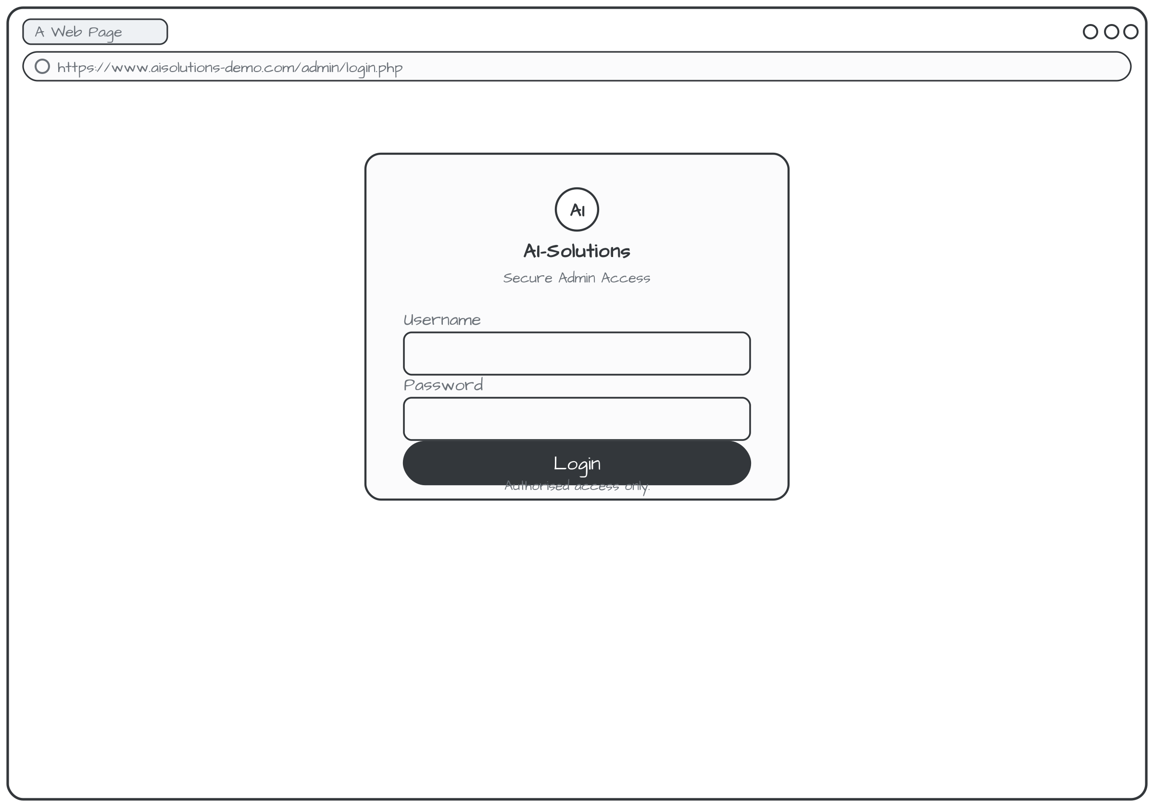

5.1.9 Admin Dashboard Page
Page: admin/dashboard.php
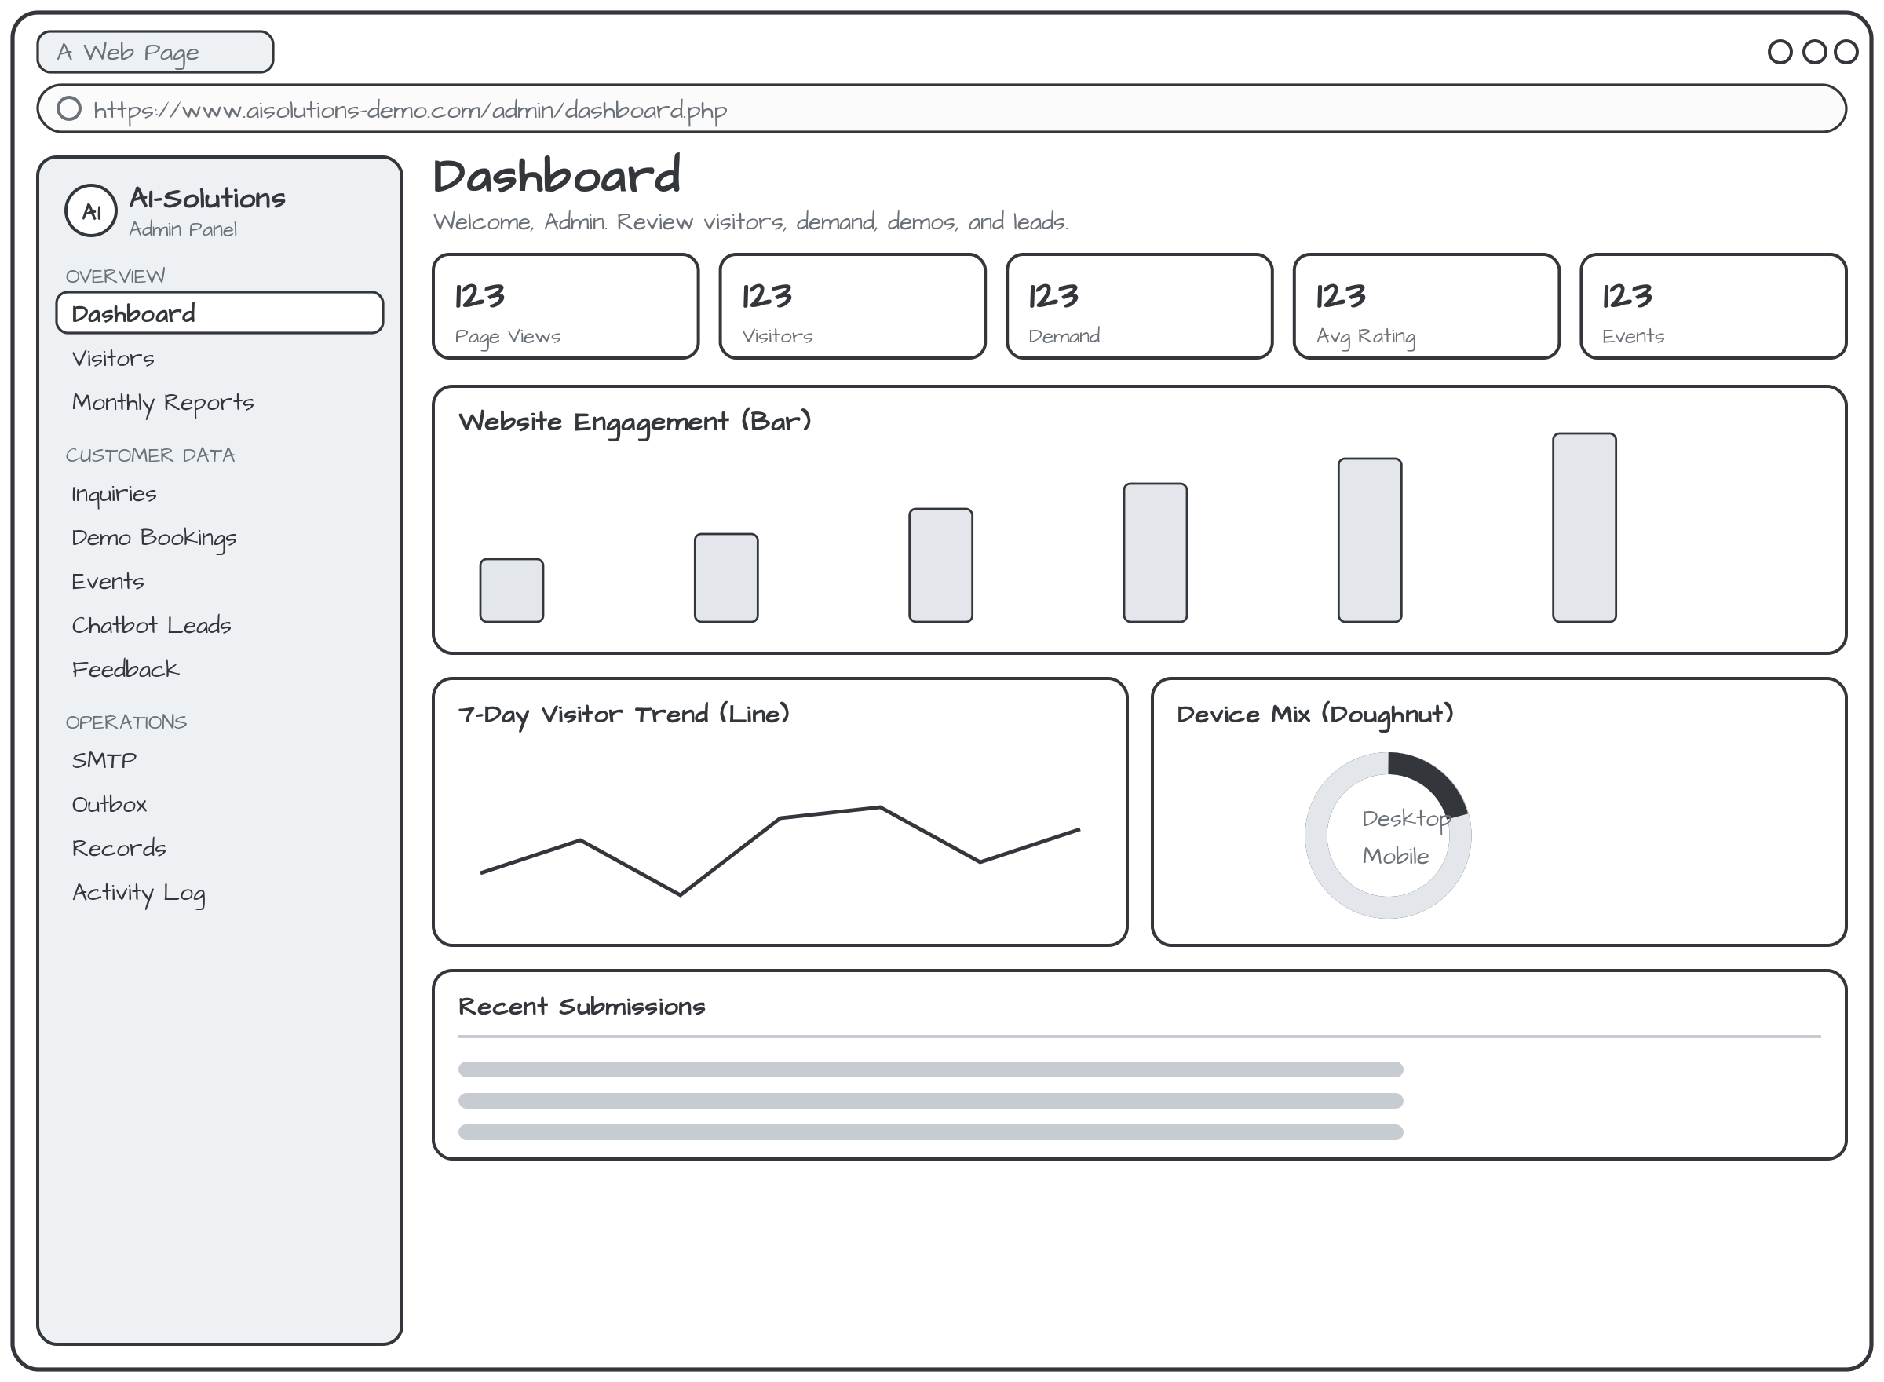

5.1.10 Record Management Page
Page: admin/manage-records.php
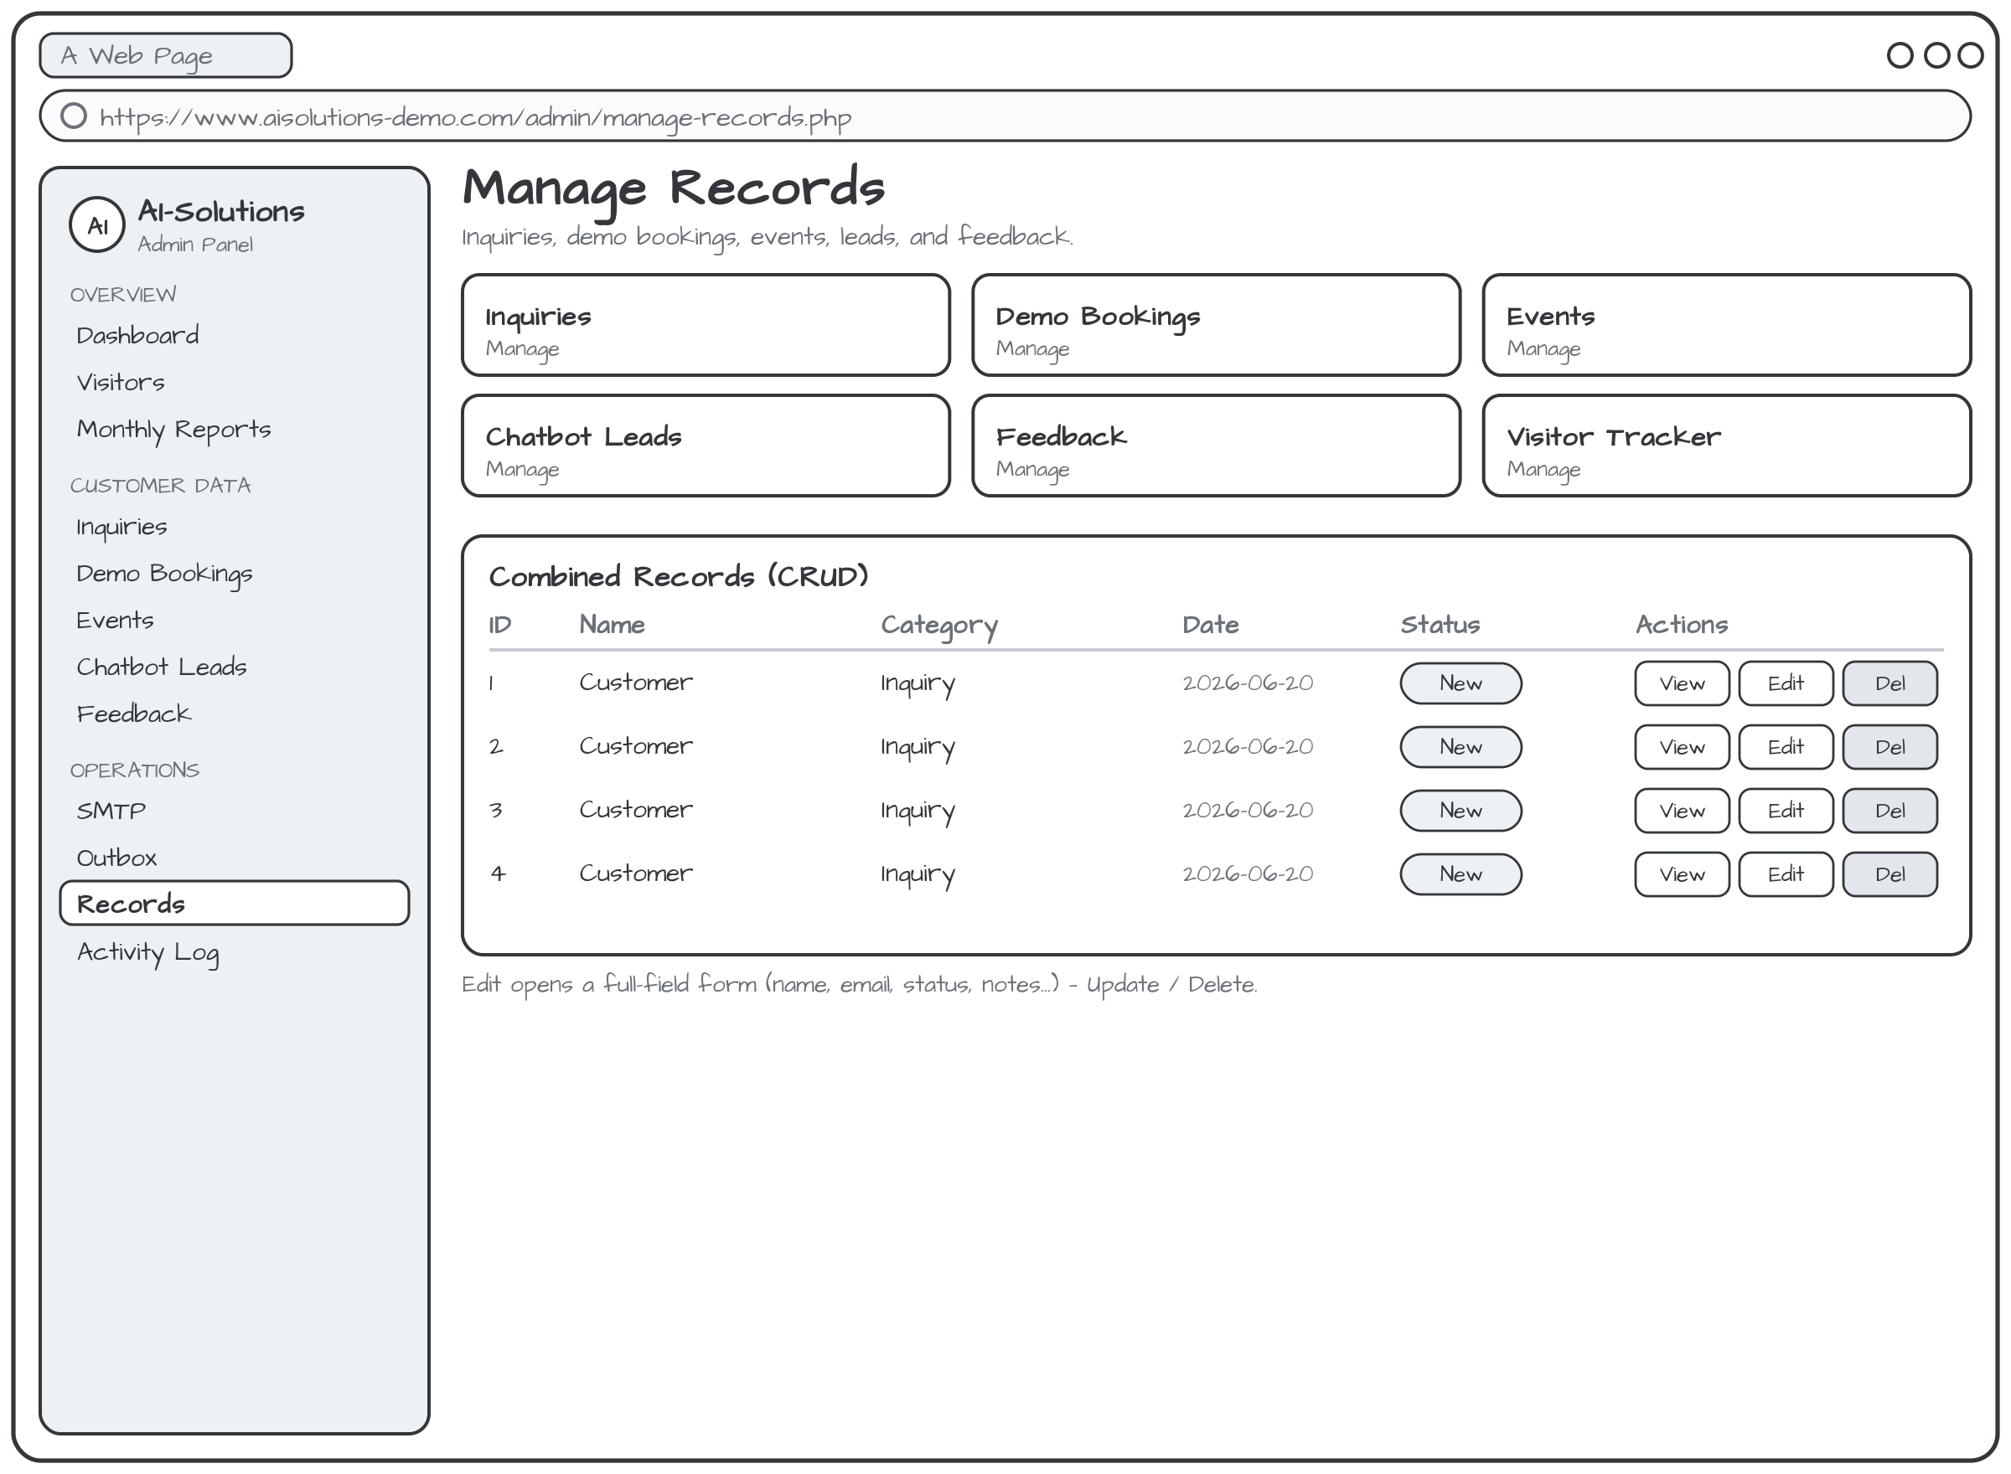

5.1.11 Articles / Blog Page
Page: articles.php
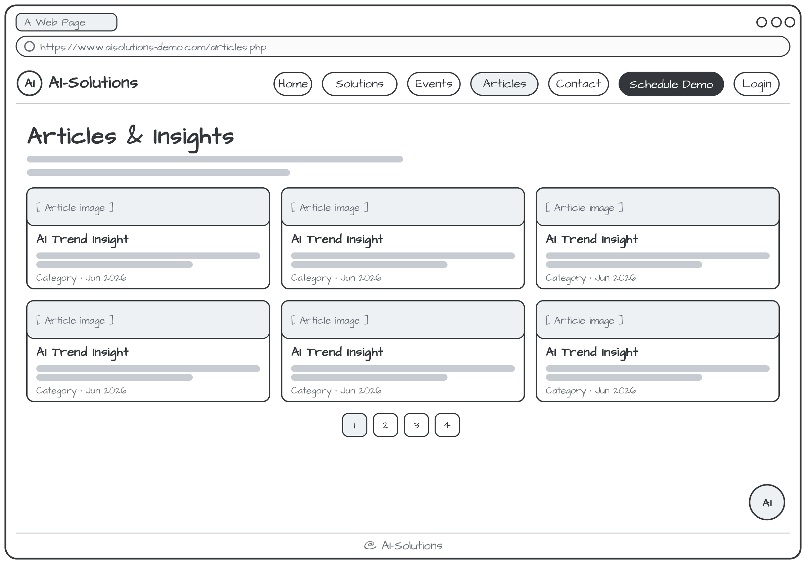

5.2 System Flowcharts
Two flowcharts describe the runtime behaviour of the system: the customer-facing website flow and the password-protected admin panel flow.

5.2.1 Customer / Public Website Flow
The visitor browses public pages and selects an action (inquiry, demo booking, event registration, AI chatbot, or feedback). All submissions pass through server- and client-side validation (CSRF, CAPTCHA, consent), are stored in MySQL, and trigger a success confirmation and acknowledgement email.
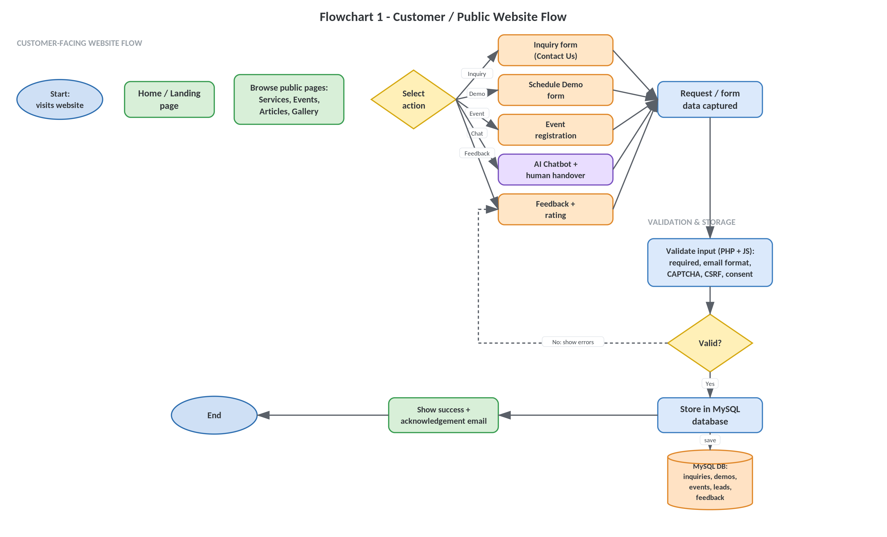

5.2.2 Admin Dashboard / Admin Panel Flow
The admin authenticates with brute-force lockout protection, then reaches the dashboard (totals and analytics charts) and selects a task: view analytics, manage records (view/edit/delete with role checks), export data, or manage email settings, before logging out.
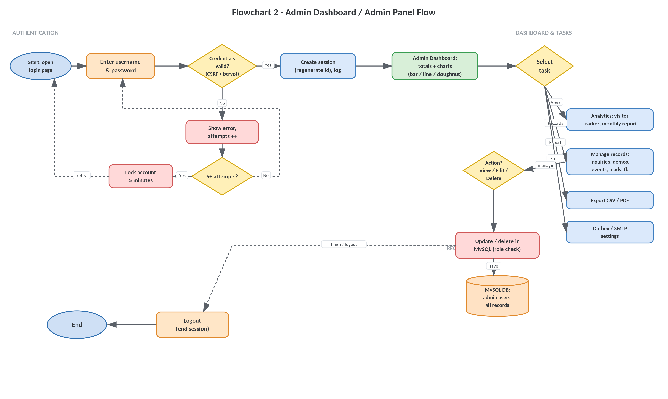

5.3 Use Case Diagram
Actors are the Customer/Visitor, the Admin, and a secondary Email Service. Customer use cases include viewing content, submitting an inquiry, booking a demo, registering for events, chatting with the assistant, and leaving feedback. Admin use cases cover secure login, dashboard analytics, record management, export, visitor tracking, reporting, and email settings. Shared use cases (Validate form input, Send acknowledgement email) are linked with «include», and Request human handover «extend»s the chatbot.
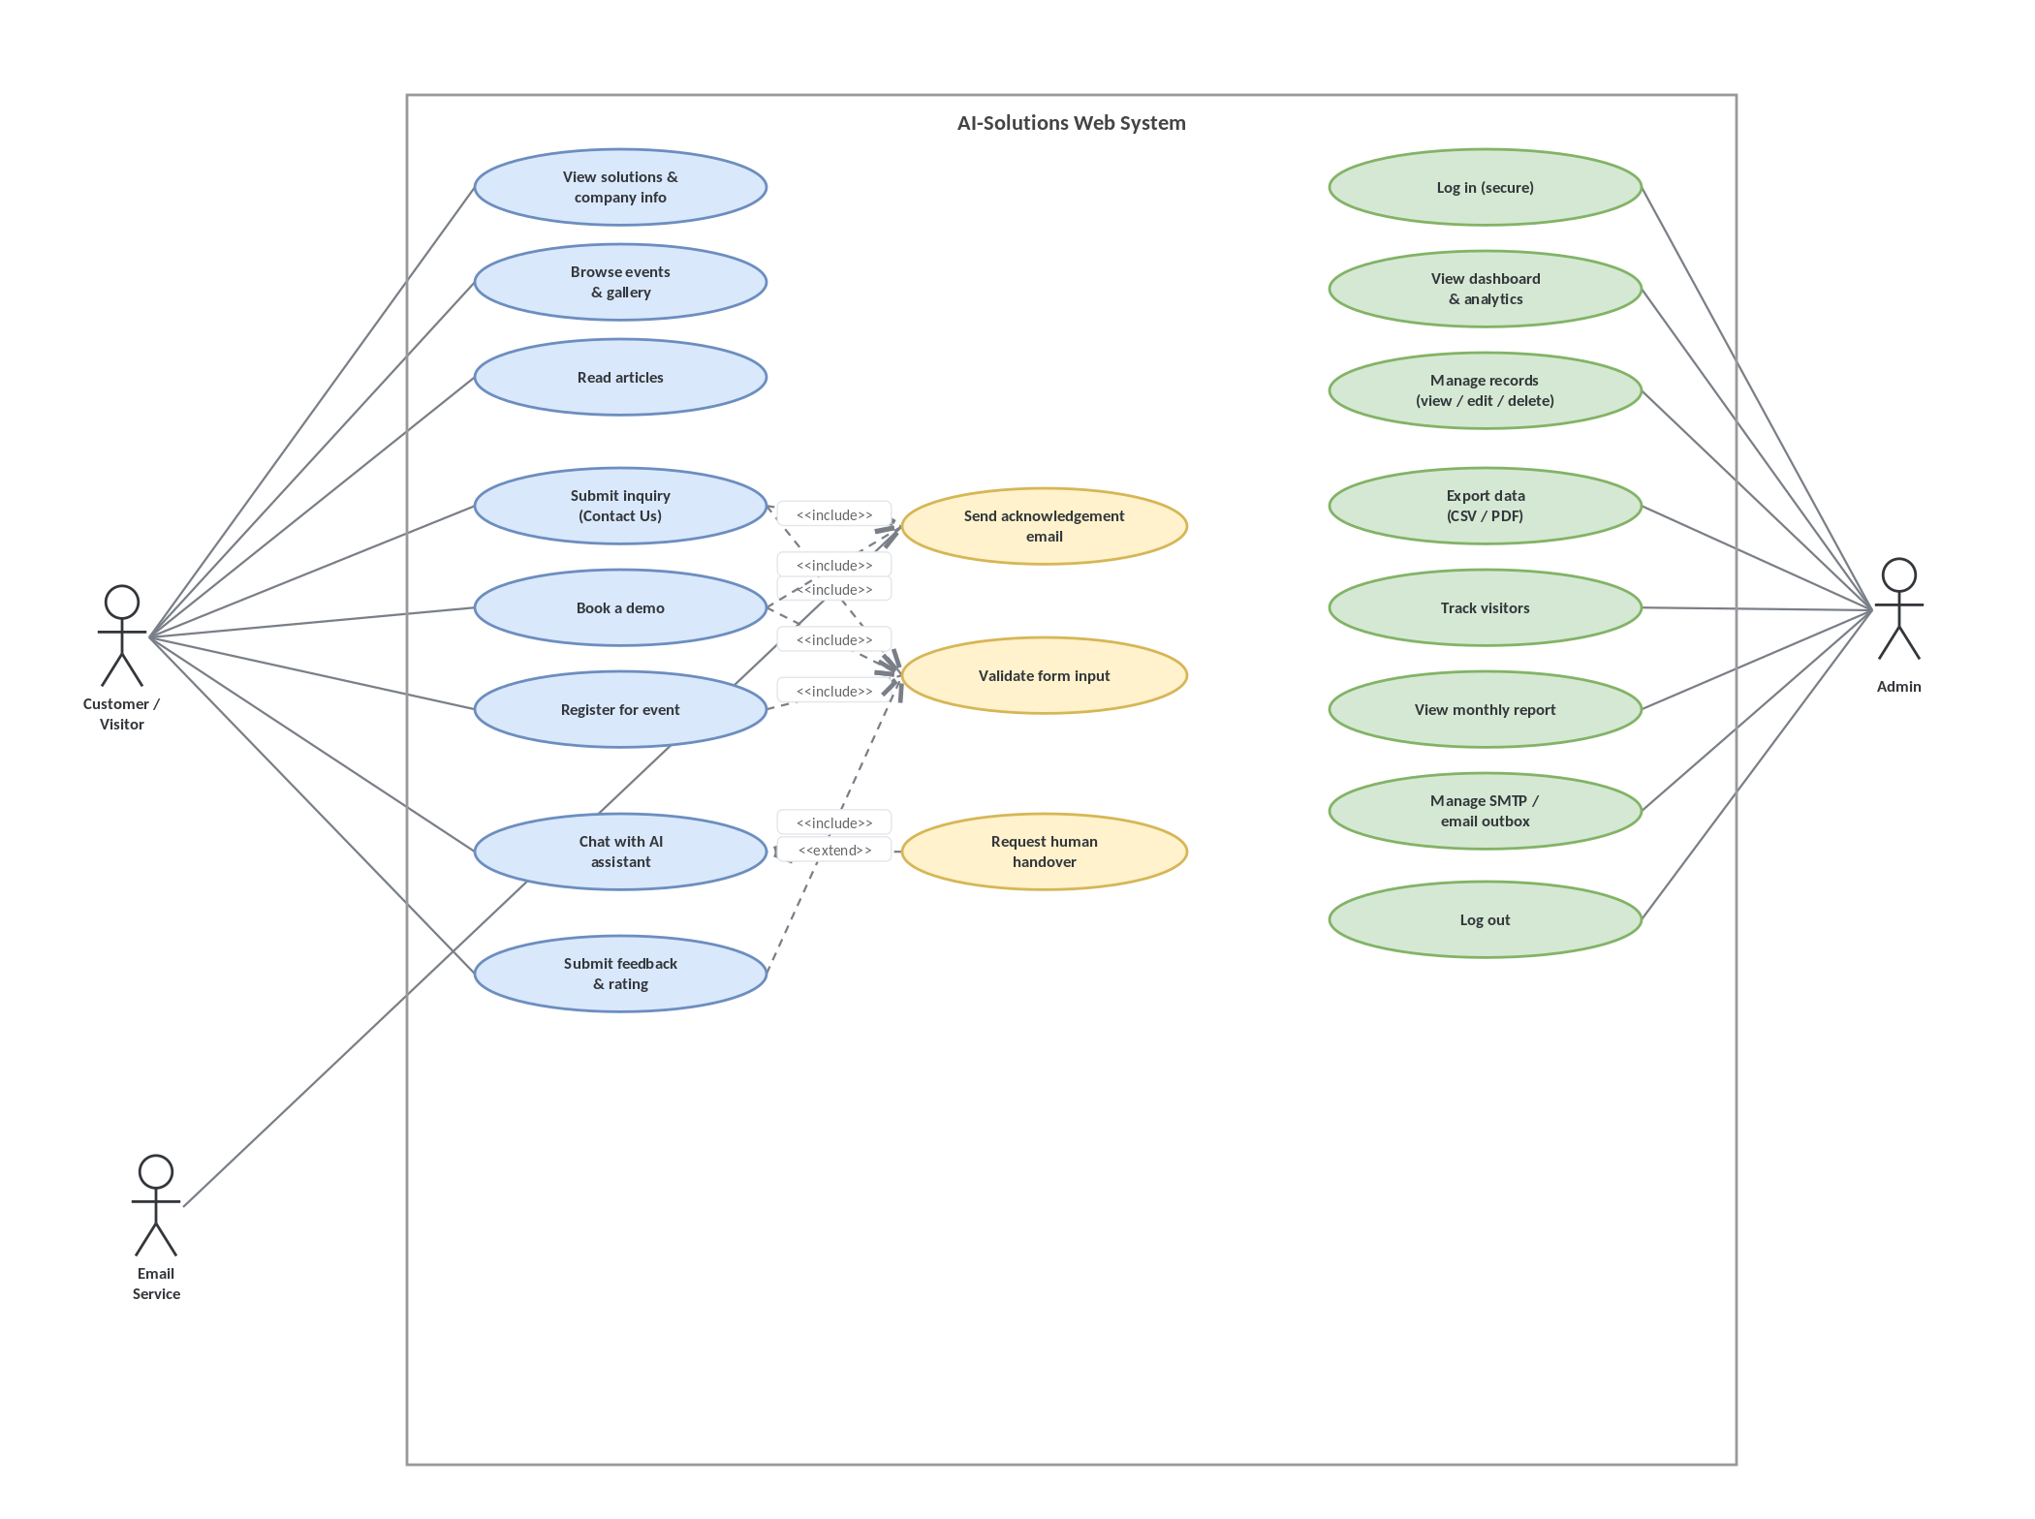

5.4 Data Flow Diagram (Level 1)
The DFD shows the external entities (Customer, Admin/Staff, Email Service), the main processes (serve content, capture submissions, validate & store, chatbot, feedback, visit tracking, authentication, admin dashboard), and the seven data stores that persist content, inquiries, demo bookings, event registrations, chatbot leads, feedback, website visits, and admin users/activity.
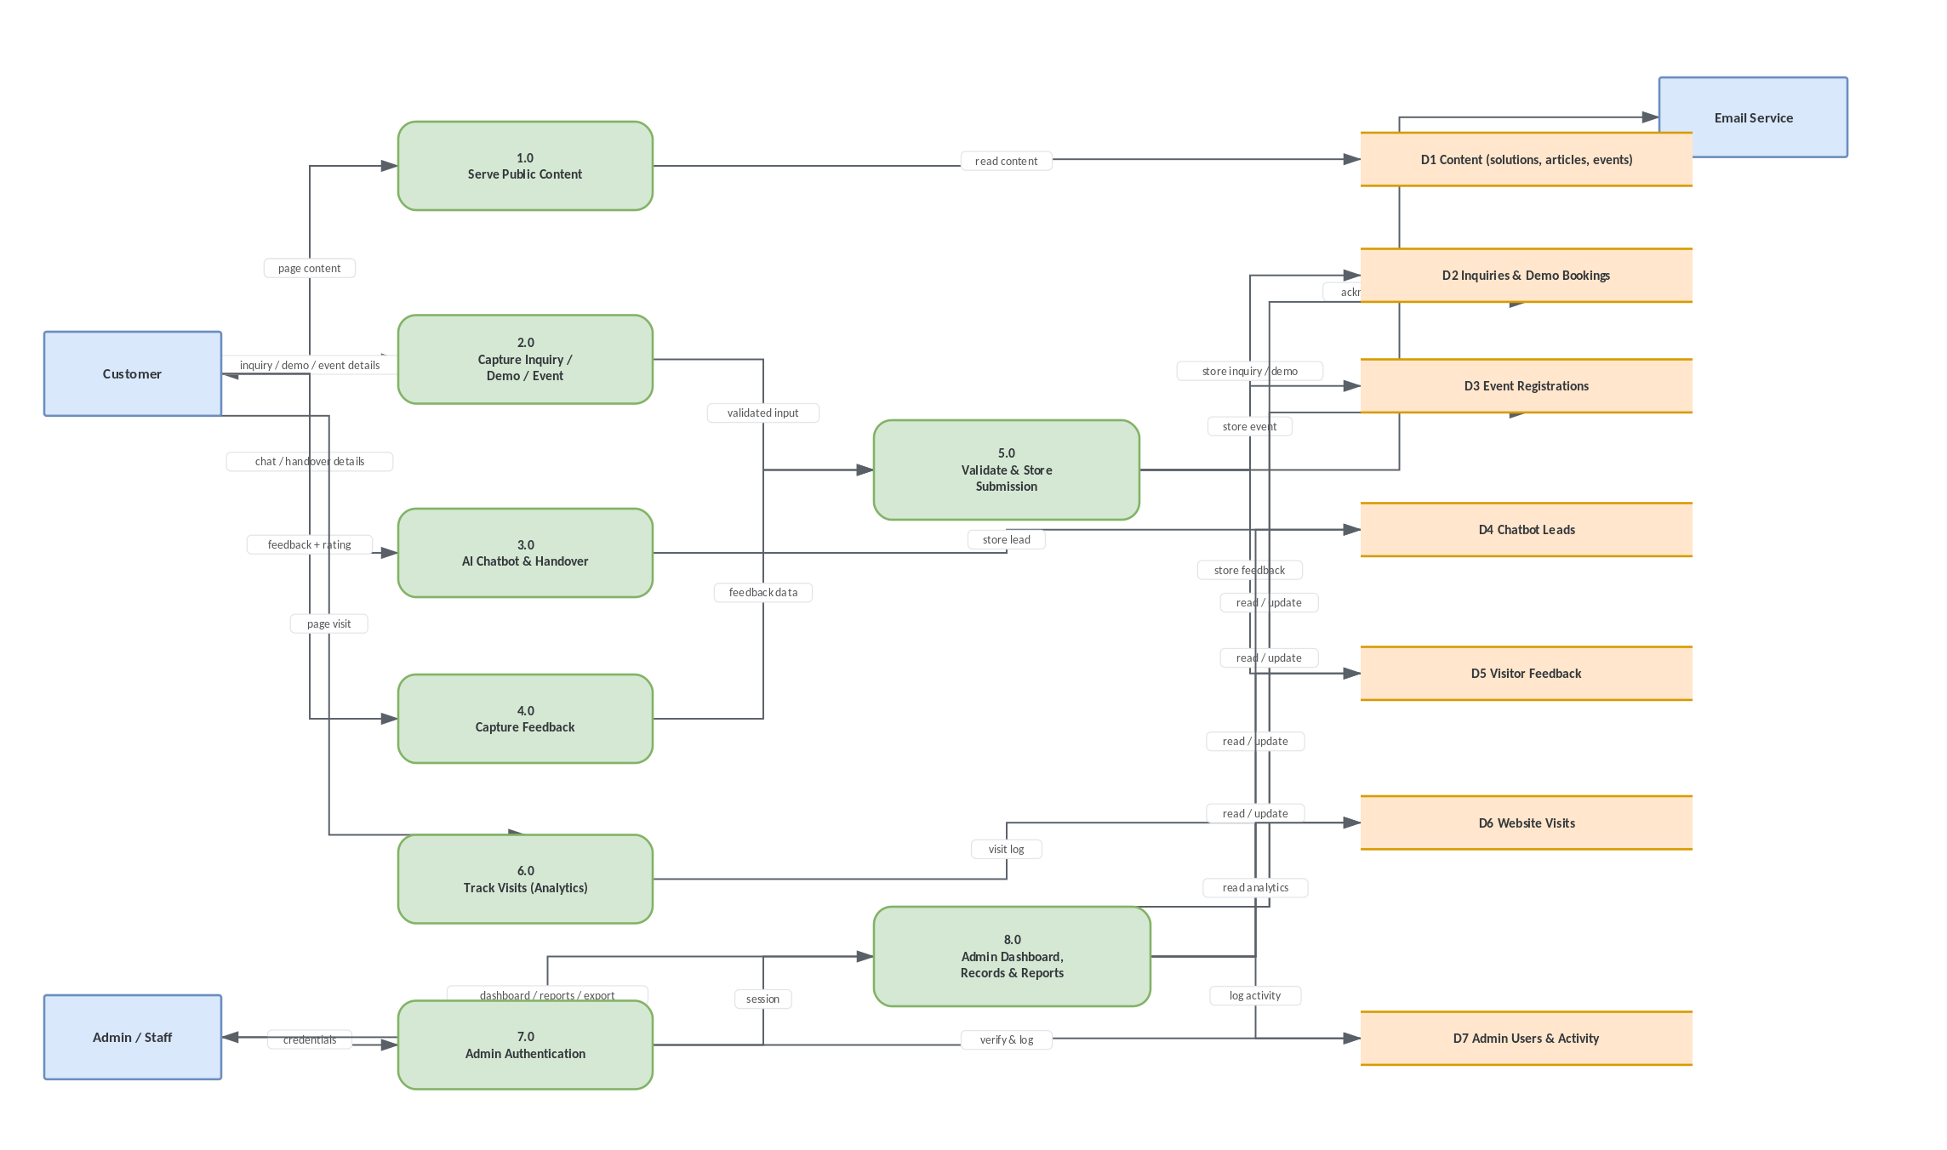

5.5 Entity Relationship Diagram
The ERD documents the MySQL schema: ten tables with their columns, data types, primary keys, and the admin_users → admin_activity foreign-key relationship (1:N). Customer-facing tables are independent submission logs (no customer accounts, hence no customer foreign keys); the admin manages all records through the protected admin interface.
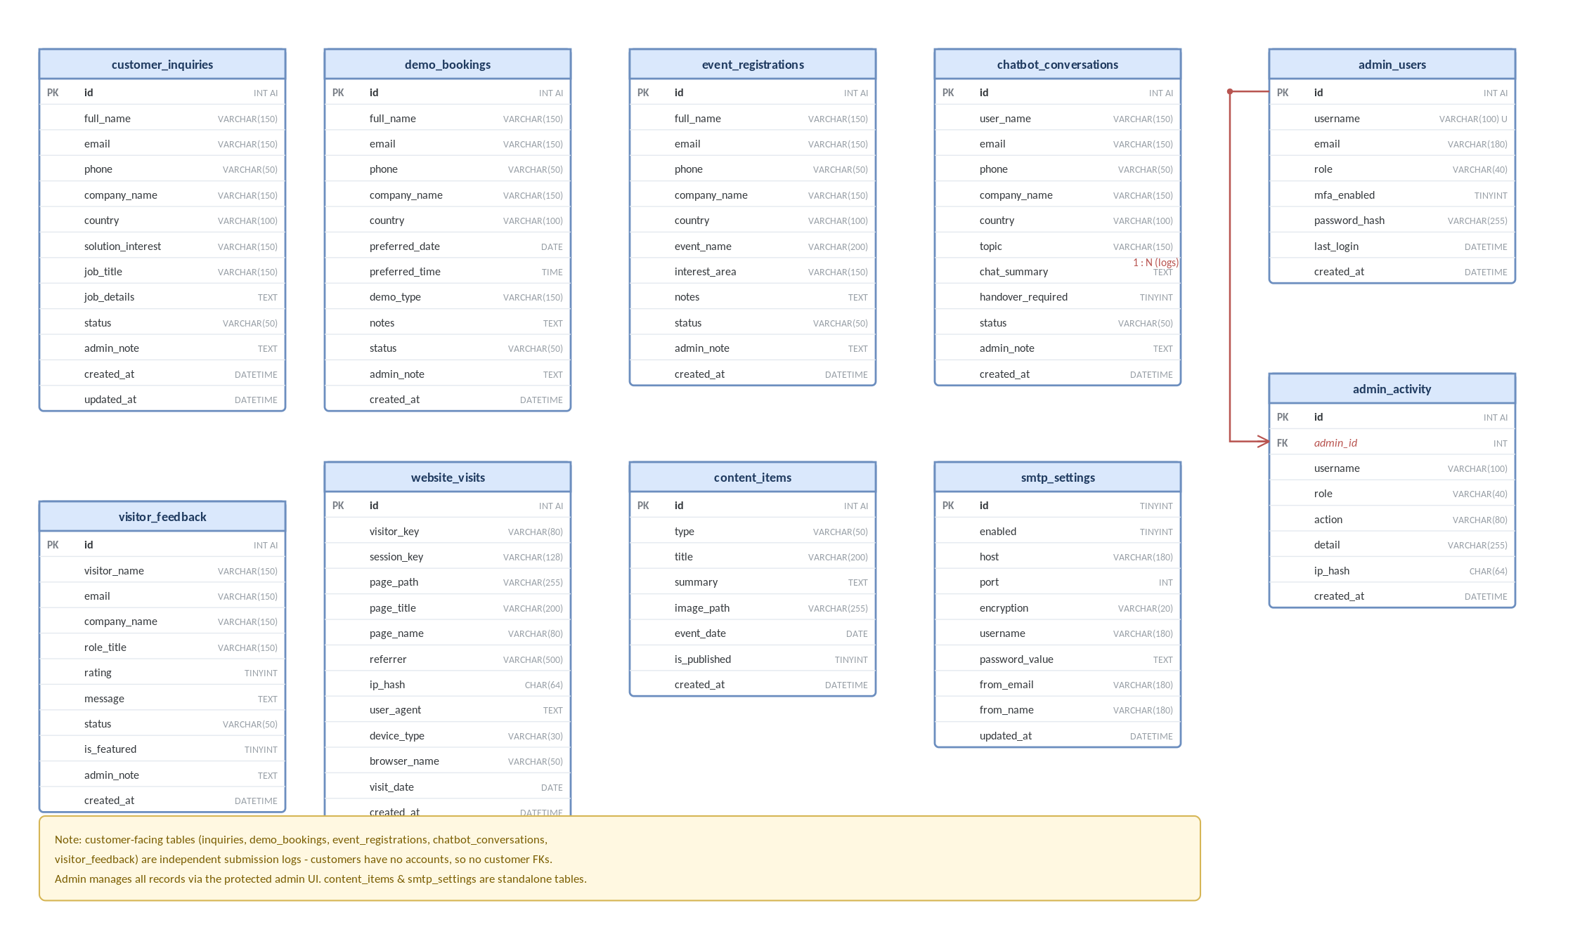

5.6 Editable Source Files
All diagrams are provided as editable source files in the documentation/ folder: the flowcharts, use case, DFD, and ERD as native draw.io (.drawio) files; the wireframes and flowcharts also as SVG for Figma. PNG/preview images are embedded above for the report.

