Testing Documentation
Since the portfolio had to demonstrate that the system fulfilled its agreed requirements from the user and admin perspective, testing has been conducted by black-box testing. The following test cases indicate the action taken, the result that should be expected, and whether the action was successful, with a supporting screenshot as evidence for each test.

User-side functional requirements
Test no. 1: Open website navigation
Description | Expected Result | Performed as Expected
Open the Home page and click each item in the main navigation (Solutions, Events, Articles, Contact, Schedule Demo). | Each page loads with the correct heading and content; the active menu item is highlighted. | Yes
Evidence: Screenshot of the public home page and navigation bar.
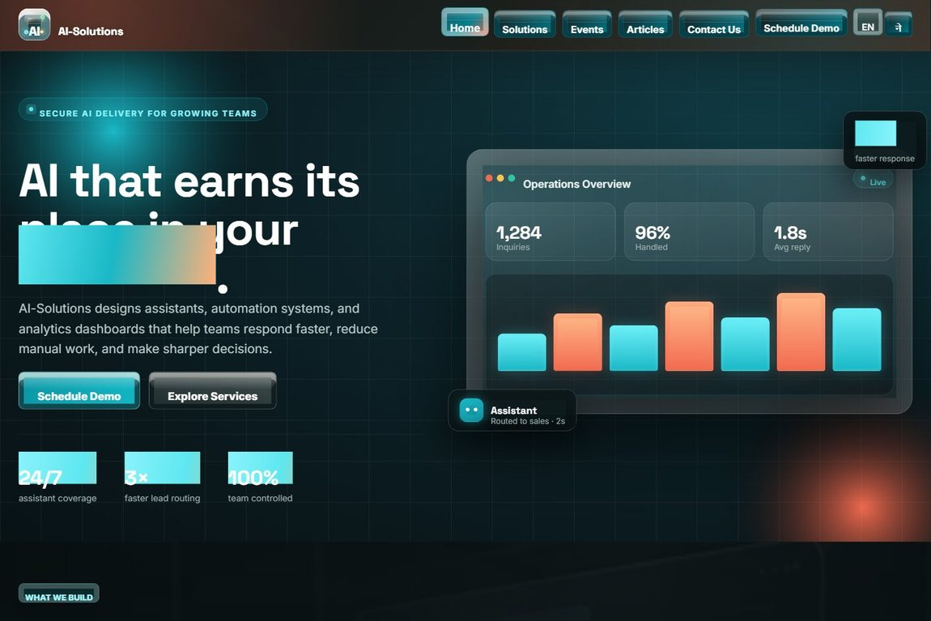

Test no. 2: Contact form empty required field
Description | Expected Result | Performed as Expected
Submit the Contact inquiry form while leaving the required fields blank. | Client and server validation prevent submission and show an error at each empty field. | Yes
Evidence: Screenshot of the inquiry form with required (*) fields and the security check.
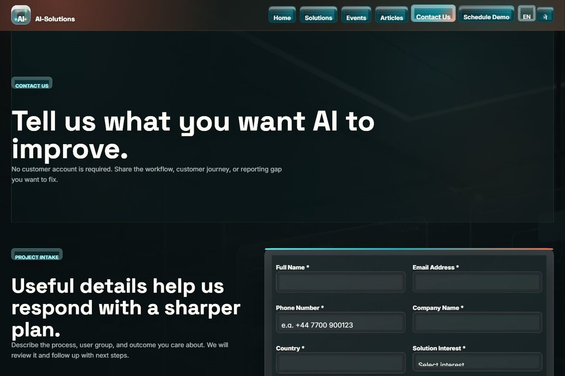

Test no. 3: Submit a complete contact inquiry
Description | Expected Result | Performed as Expected
Fill in all inquiry fields (name, email, phone, company, country, interest, job title, details), pass the security check, tick consent and submit. | A confirmation page is shown and the inquiry is saved to the database for admin review. | Yes
Evidence: Screenshot of the success / confirmation page after a valid submission.
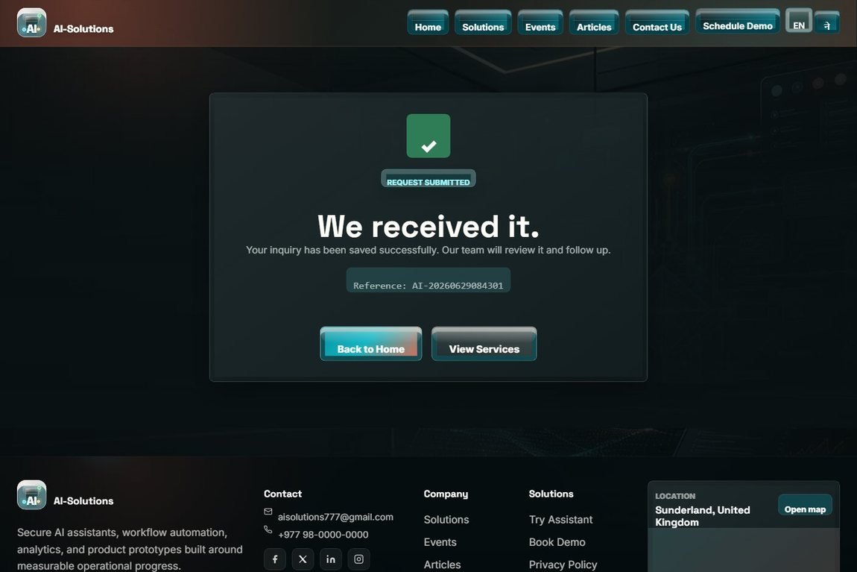

Test no. 4: Schedule a personalised demo
Description | Expected Result | Performed as Expected
Open the Schedule Demo page, choose a date and time, pick a solution, add notes, give consent and submit. | The demo booking is stored and a confirmation is shown; the past-date guard blocks invalid dates. | Yes
Evidence: Screenshot of the schedule-demo booking form.
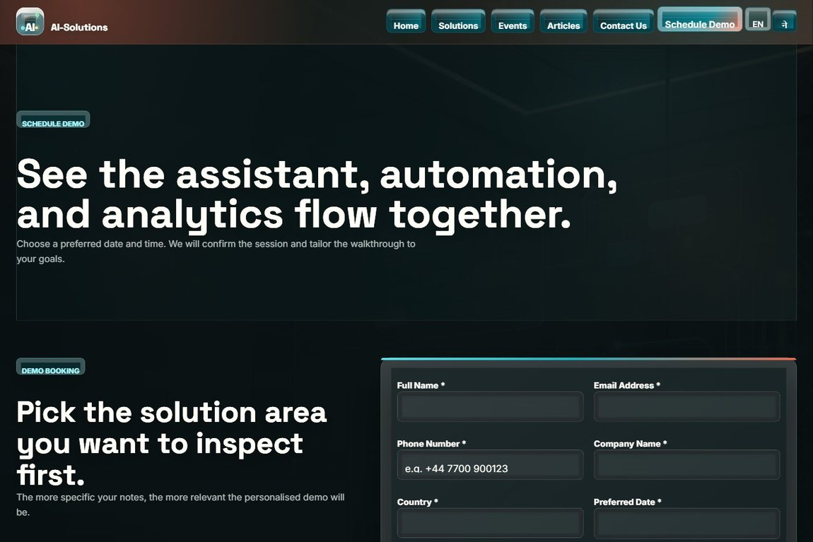

Test no. 5: Event registration (future event)
Description | Expected Result | Performed as Expected
Open an upcoming event and complete the "Join our Events" registration form. | The Register option is available; the registration is stored and a confirmation is shown. | Yes
Evidence: Screenshot of the events page and the registration form.
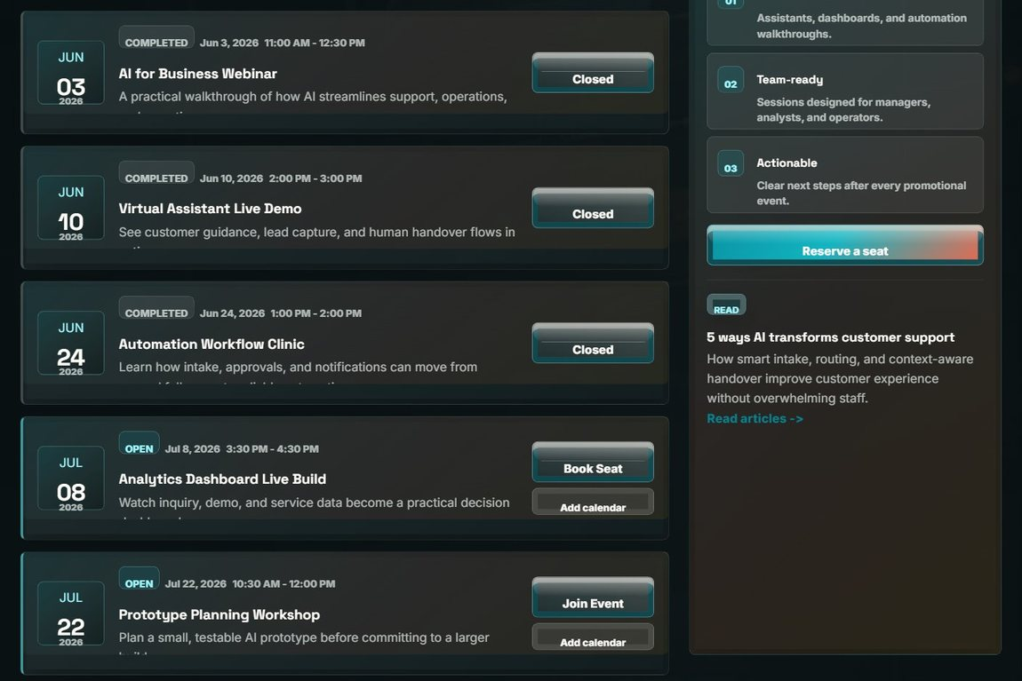

Test no. 6: Photo gallery and upcoming events
Description | Expected Result | Performed as Expected
Open the Events page to view the photo gallery and upcoming events. | The gallery images and the list of upcoming events are displayed correctly. | Yes
Evidence: Screenshot of the events and gallery section.
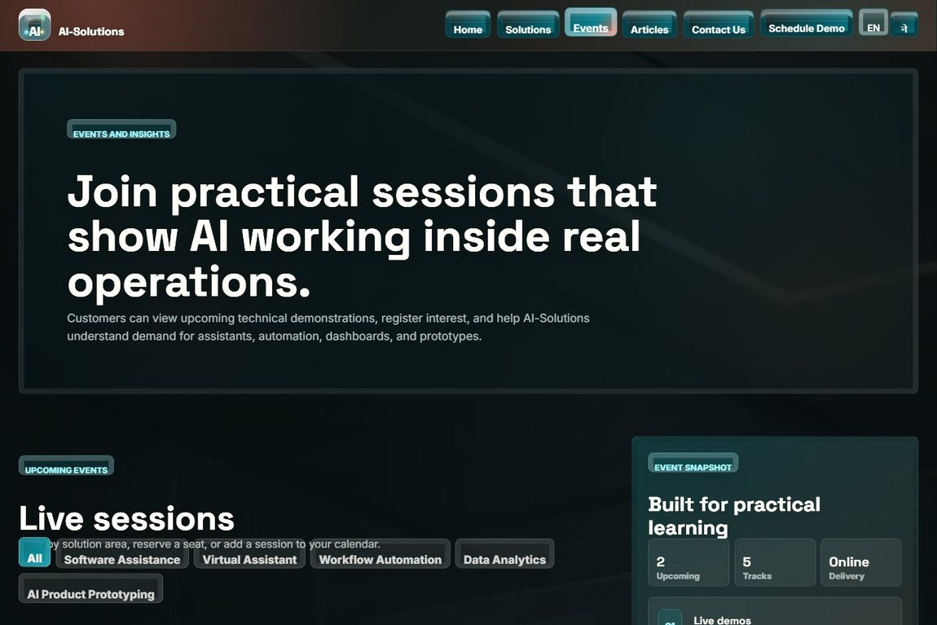

Test no. 7: Browse solutions and filters
Description | Expected Result | Performed as Expected
Open the Solutions page and apply the capability/industry filters. | The solution list narrows to the matching solutions. | Yes
Evidence: Screenshot of the Solutions page with filters and solution cards.


Test no. 8: Submit a solution review and rating
Description | Expected Result | Performed as Expected
Submit a star rating and review for a solution. | The review is stored for admin moderation and a confirmation is shown. | Yes
Evidence: Screenshot of the solution reviews / rating area.
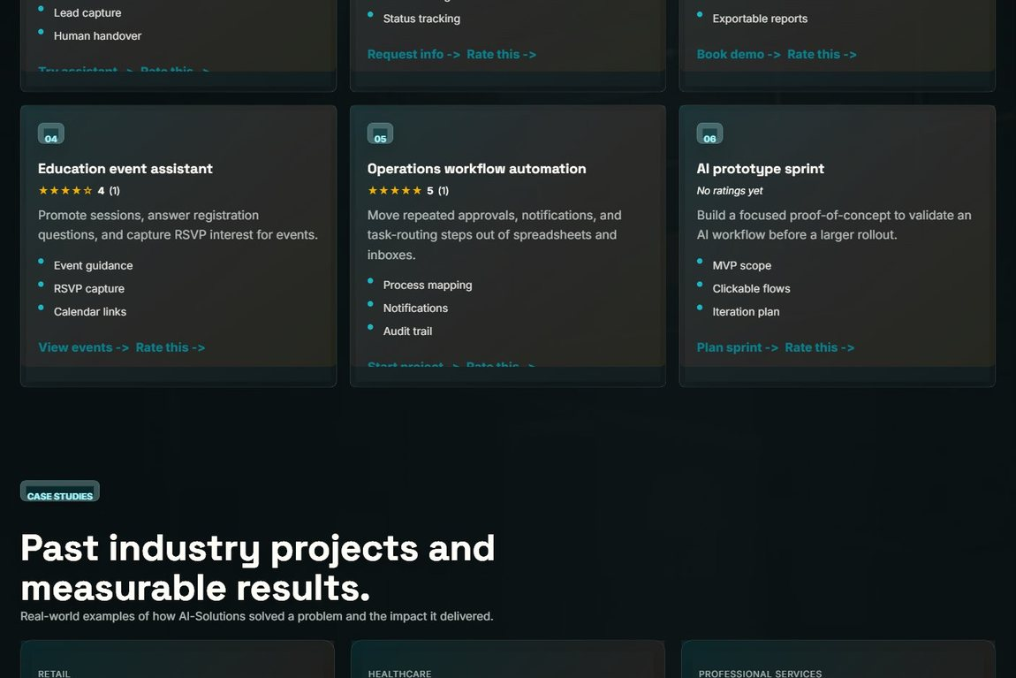

Test no. 9: Submit visitor feedback rating
Description | Expected Result | Performed as Expected
Use the visitor feedback form on the Contact page to leave a rating and message. | The feedback is saved and can be featured by the admin as a testimonial. | Yes
Evidence: Screenshot of the visitor feedback / rating form.
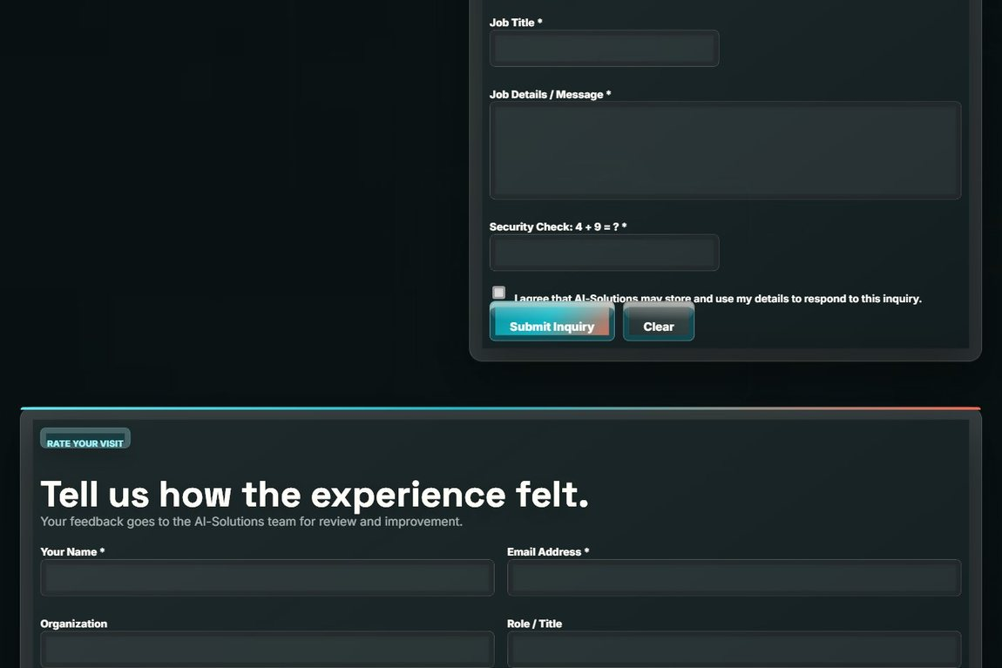

Test no. 10: Read articles and open an article
Description | Expected Result | Performed as Expected
Open the Articles page, page through it, and open a single article. | Article cards with categories and pagination display; the full article opens correctly. | Yes
Evidence: Screenshot of the articles listing (and article detail page).
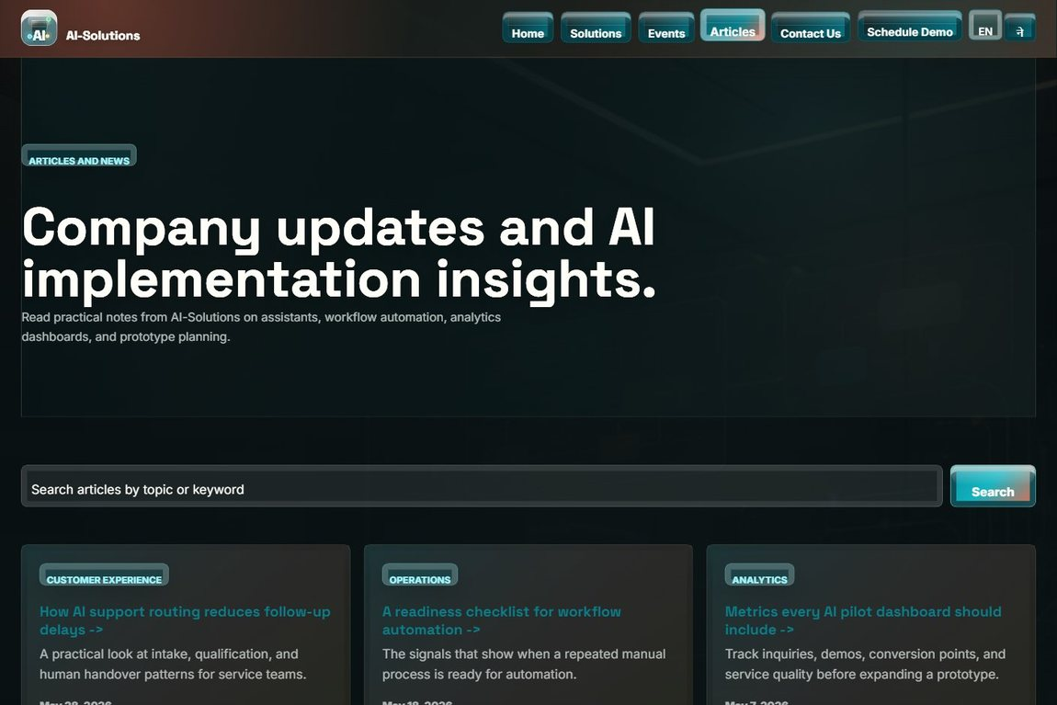

Test no. 11: AI assistant (chatbot) response
Description | Expected Result | Performed as Expected
Ask the AI assistant about services, pricing or demos and use the quick-action buttons. | The assistant returns a relevant answer with quick actions; it can route to pages. | Yes
Evidence: Screenshot of a chatbot conversation.
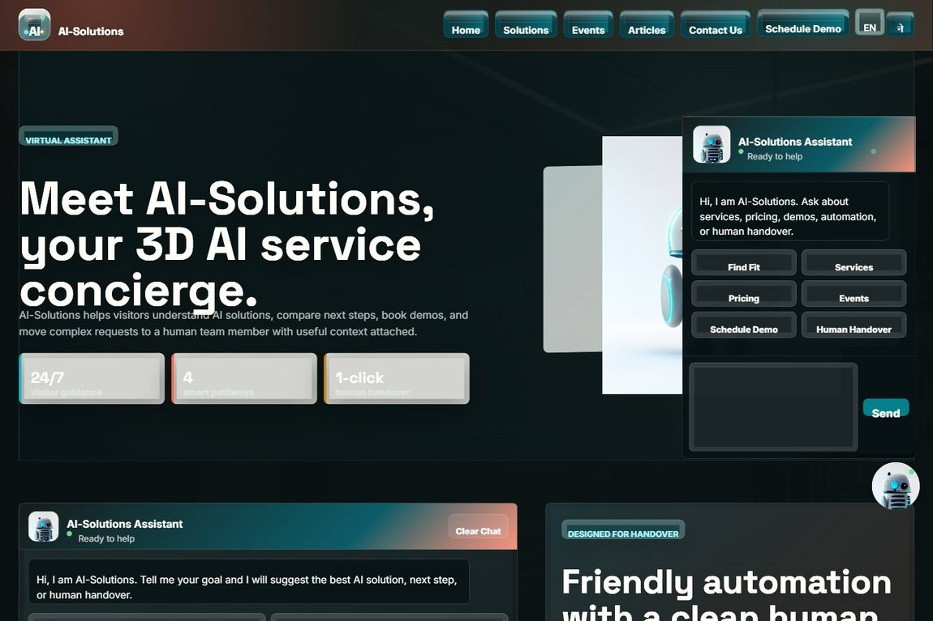

Test no. 12: Chatbot human handover
Description | Expected Result | Performed as Expected
Request a human handover from the assistant and submit the handover form. | The handover form opens pre-filled with the conversation summary; the lead is stored. | Yes
Evidence: Screenshot of the human-support handover form.
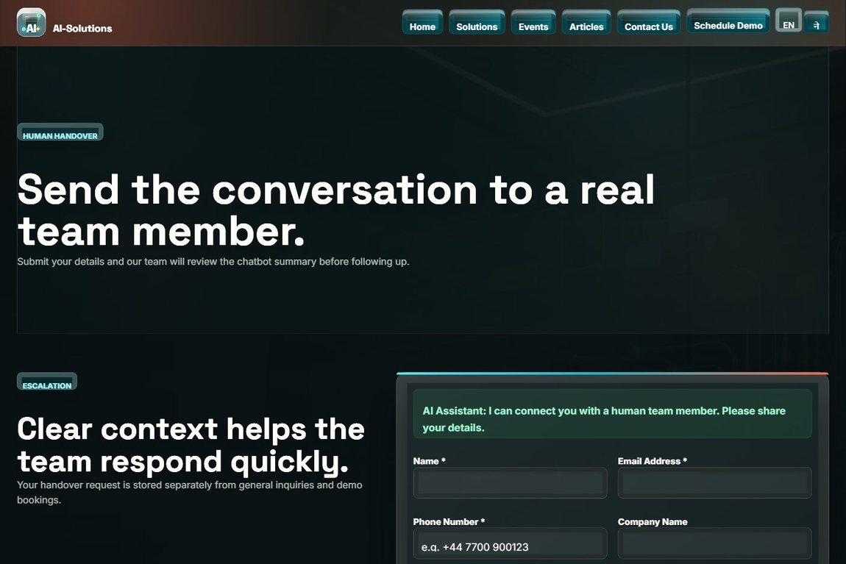

Test no. 13: Language switch (English / Nepali)
Description | Expected Result | Performed as Expected
Use the EN / ने language toggle in the navigation bar. | The configured labels and messages switch language; the choice is applied across pages. | Yes
Evidence: Screenshot of the navigation language toggle (EN / ने).


Test no. 14: Location map (current GPS)
Description | Expected Result | Performed as Expected
Allow location permission for the footer map on any public page. | The map re-centres on the visitor’s current GPS location with a place label. | Yes
Evidence: Screenshot of the footer location map.
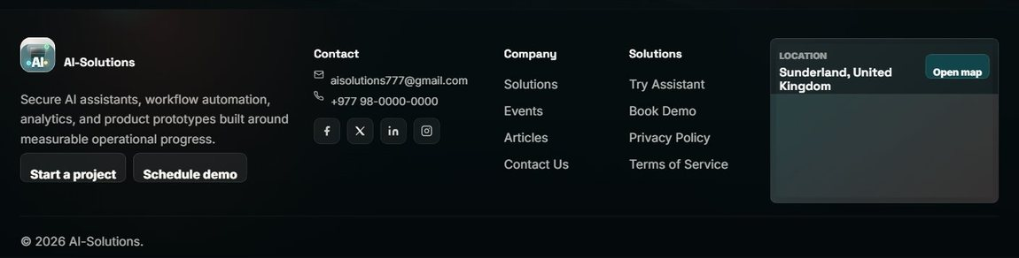

Admin-side functional requirements
Test no. 15: Admin login with wrong password
Description | Expected Result | Performed as Expected
Enter a correct username with an incorrect password on the admin login page. | Login fails with an "invalid username or password" message; repeated failures lock the account. | Yes
Evidence: Screenshot of the admin login page / failed-login message.
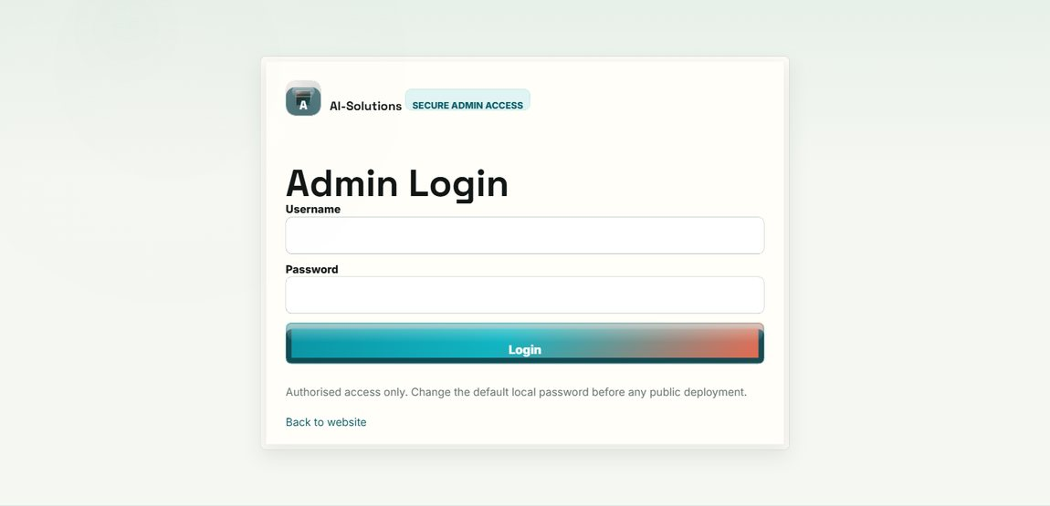

Test no. 16: Admin login with valid credentials
Description | Expected Result | Performed as Expected
Log in with the correct admin username and password. | The admin dashboard opens and a session is created. | Yes
Evidence: Screenshot of the admin dashboard after a successful login.
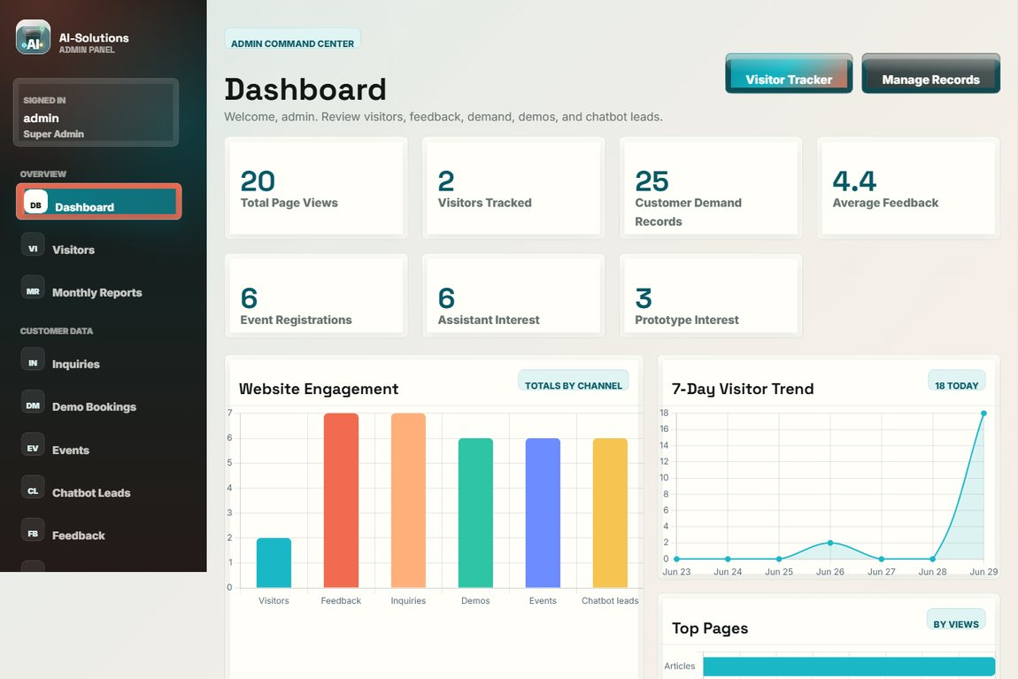

Test no. 17: Dashboard analytics and charts
Description | Expected Result | Performed as Expected
Open the dashboard and review the totals and analytics charts. | Stat cards and bar/line/doughnut charts render from the live data. | Yes
Evidence: Screenshot of the dashboard analytics charts.
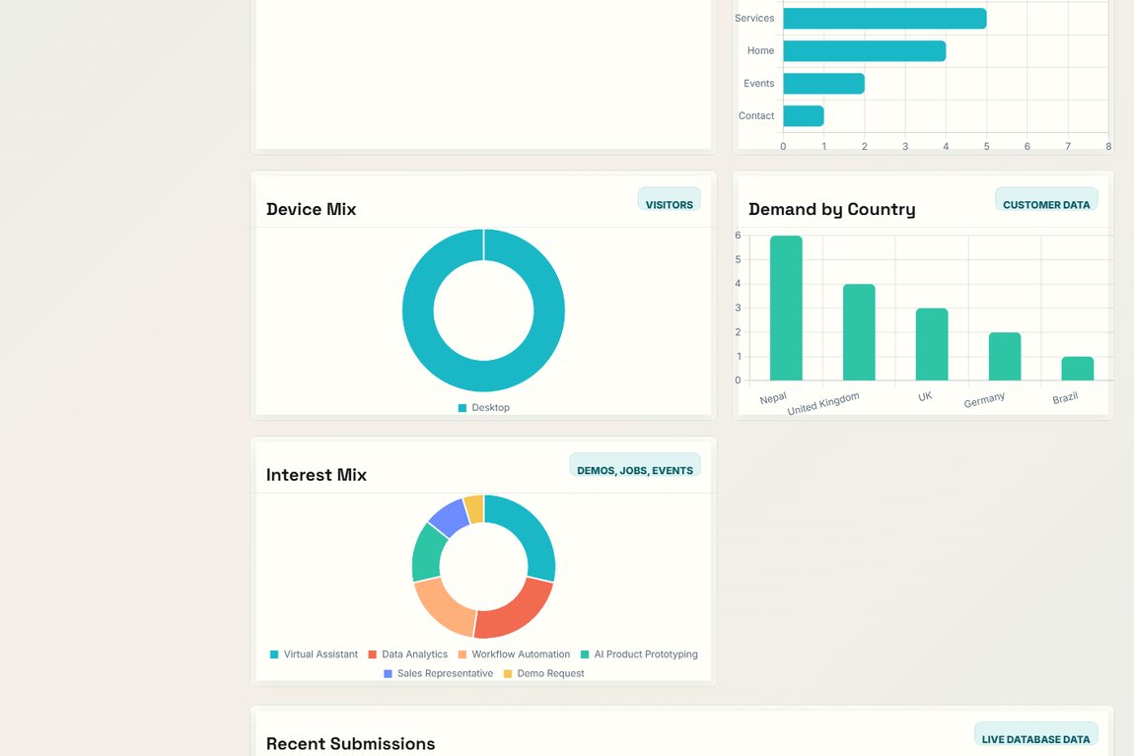

Test no. 18: View and search customer inquiries
Description | Expected Result | Performed as Expected
Open Customer Inquiries and search by name, email, company or country. | All inquiries are listed; the search filters to the matching records only. | Yes
Evidence: Screenshot of the inquiry records list with the search bar.
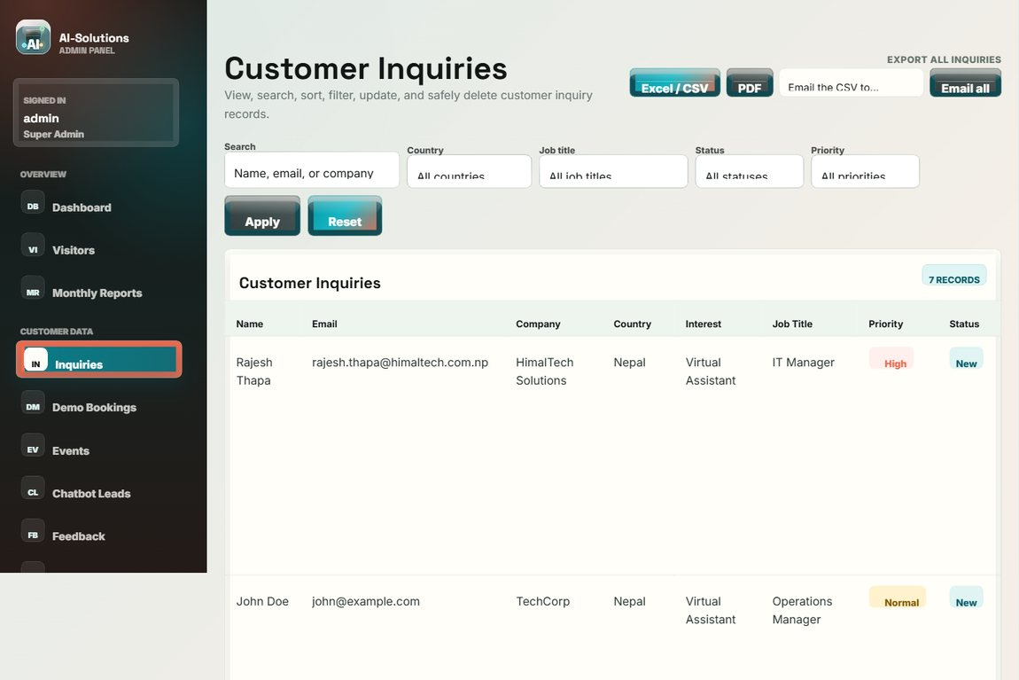

Test no. 19: Edit and delete inquiry records
Description | Expected Result | Performed as Expected
Open a record to edit its fields, status and admin note; then delete a record and confirm the prompt. | Edits are saved (updated_at set); the record is removed only after confirmation; both actions are logged. | Yes
Evidence: Screenshot of the inquiry records with the View / Edit / Delete actions.


Test no. 20: Download inquiry CSV and PDF
Description | Expected Result | Performed as Expected
Export the inquiry records (single and all) to CSV and PDF. | Valid CSV and PDF files download and open correctly. | Yes
Evidence: Screenshot of the records page with the export (CSV / PDF) controls.


Test no. 21: Email a record (CSV) to the customer
Description | Expected Result | Performed as Expected
Use the Email action to send a record as a CSV attachment to the customer. | The email with the CSV attachment is sent via SMTP, or queued to the outbox if SMTP is off. | Yes
Evidence: Screenshot of the email outbox / sent record.
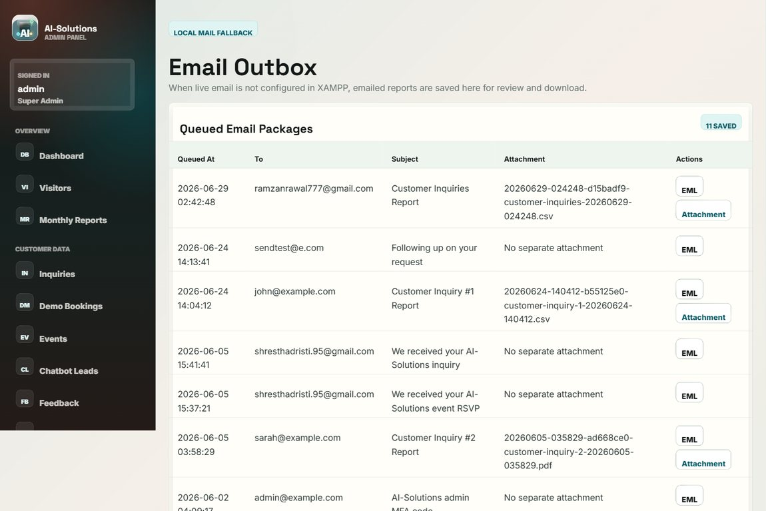

Test no. 22: Manage demo bookings
Description | Expected Result | Performed as Expected
Open Demo Bookings and manage the scheduled demo requests. | Demo bookings are listed with view / edit / delete / export options. | Yes
Evidence: Screenshot of the demo bookings admin page.
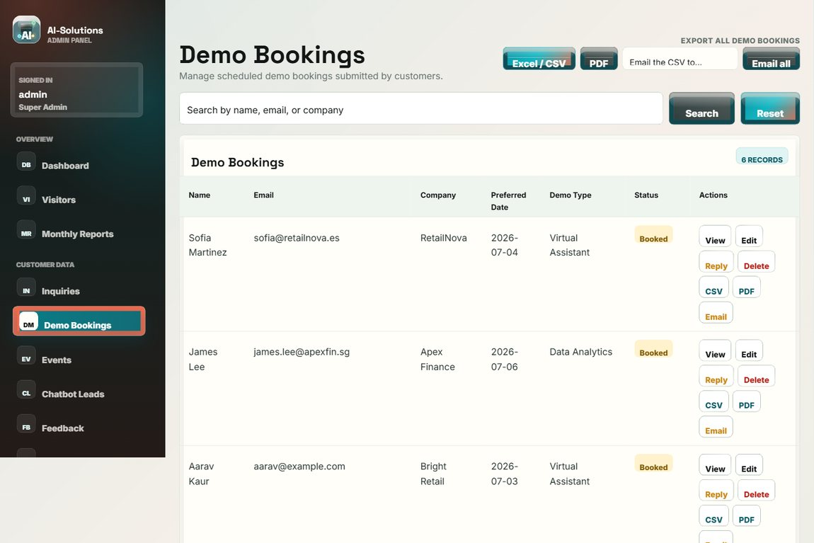

Test no. 23: Manage event registrations
Description | Expected Result | Performed as Expected
Open Event Registrations to review "Join our Events" submissions. | All event registrations are listed for review and export. | Yes
Evidence: Screenshot of the event registrations admin page.
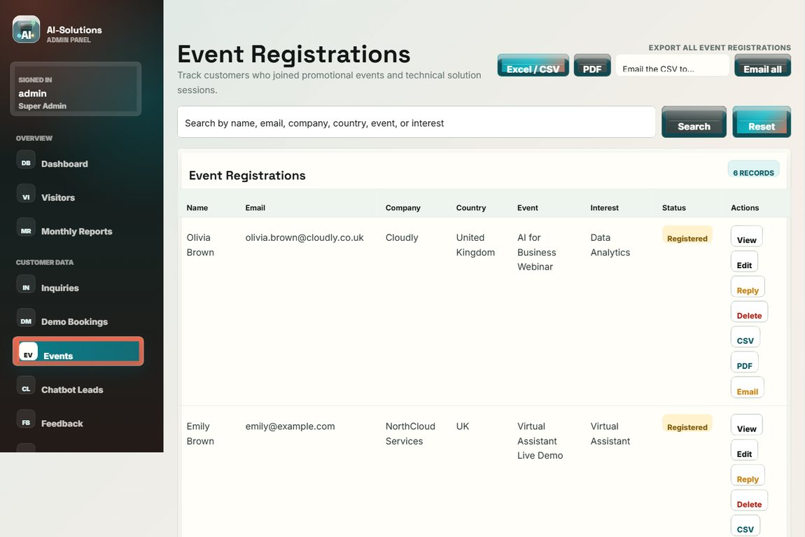

Test no. 24: Manage chatbot leads
Description | Expected Result | Performed as Expected
Open Chatbot Leads to review handover leads. | Leads captured from the assistant (topic and summary) are listed for follow-up. | Yes
Evidence: Screenshot of the chatbot leads admin page.
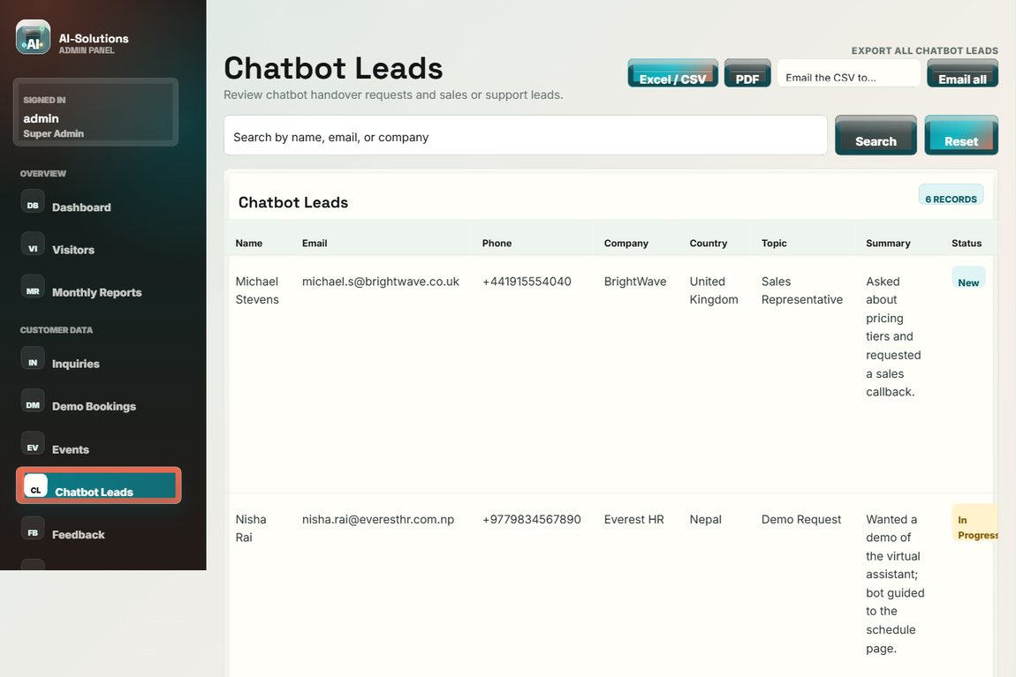

Test no. 25: Moderate visitor feedback
Description | Expected Result | Performed as Expected
Open Visitor Feedback and feature a testimonial. | Ratings and messages are listed; entries can be marked as featured testimonials. | Yes
Evidence: Screenshot of the visitor feedback admin page.
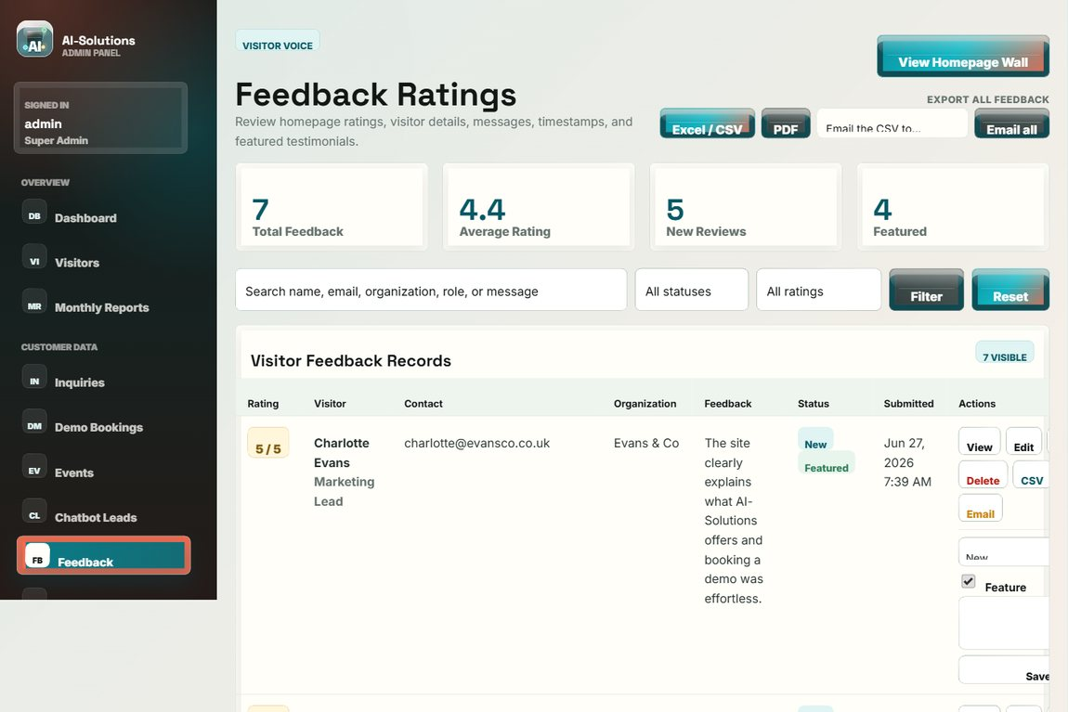

Test no. 26: Moderate solution reviews
Description | Expected Result | Performed as Expected
Open Solution Reviews to approve or remove submitted reviews. | Per-solution reviews can be moderated (approve / feature / remove). | Yes
Evidence: Screenshot of the solution reviews moderation page.
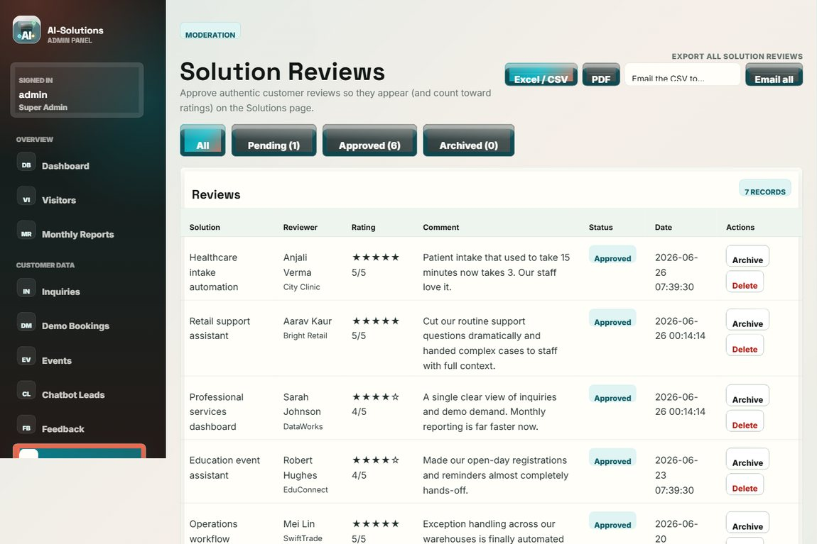

Test no. 27: Manage website content
Description | Expected Result | Performed as Expected
Use the Content Manager to create, edit and delete articles/events/content items. | Content changes are saved and reflected on the public site. | Yes
Evidence: Screenshot of the Content Manager.
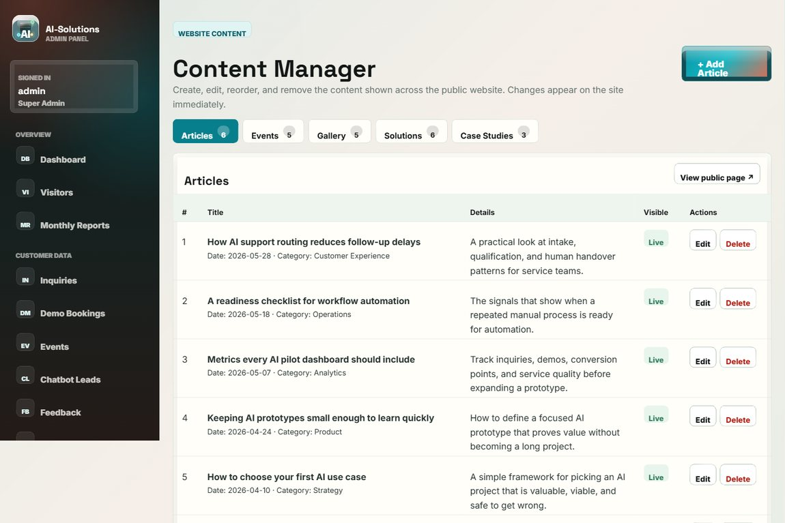

Test no. 28: Visitor tracker
Description | Expected Result | Performed as Expected
Open the Visitor Tracker after browsing public pages. | Each visit is logged with device type, browser and timestamp. | Yes
Evidence: Screenshot of the visitor tracker.
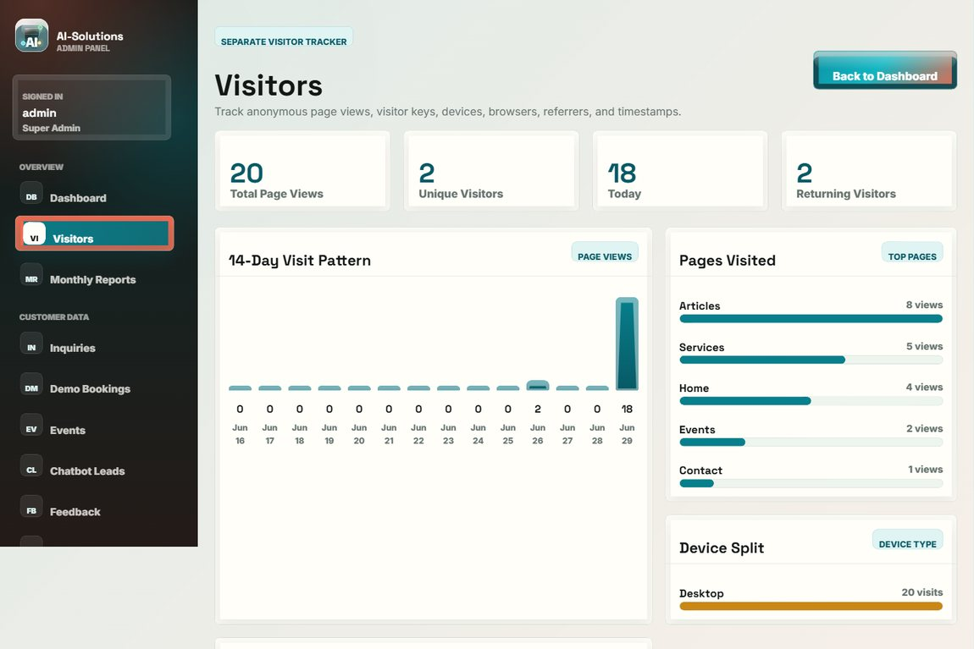

Test no. 29: Monthly report
Description | Expected Result | Performed as Expected
Open the Monthly Report. | Period metrics for customer demand are summarised. | Yes
Evidence: Screenshot of the monthly report.
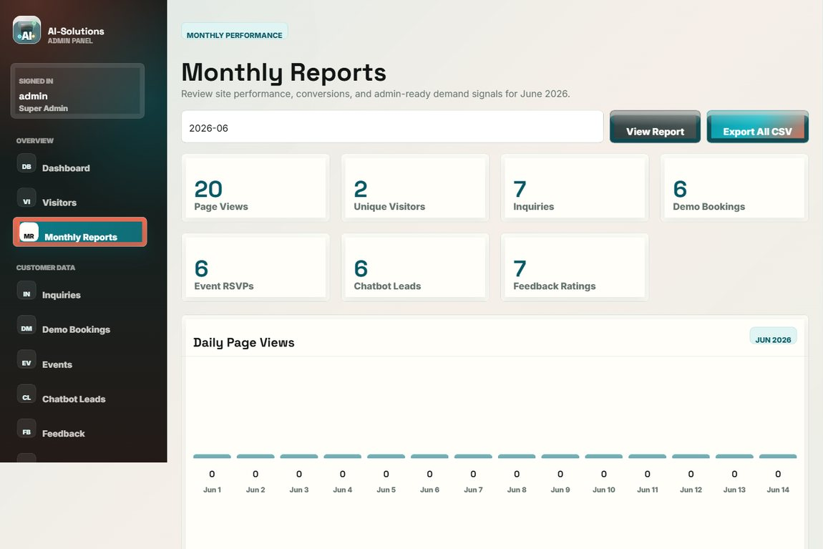

Test no. 30: Send email to a customer
Description | Expected Result | Performed as Expected
Compose and send an email to a customer from the admin panel. | The email is sent (or queued) through the configured SMTP server and the action is logged. | Yes
Evidence: Screenshot of the sent email recorded in the outbox.


Test no. 31: Configure SMTP settings
Description | Expected Result | Performed as Expected
Open SMTP Settings and save the mail-server configuration. | The settings are saved and the stored password is masked. | Yes
Evidence: Screenshot of the SMTP settings page.
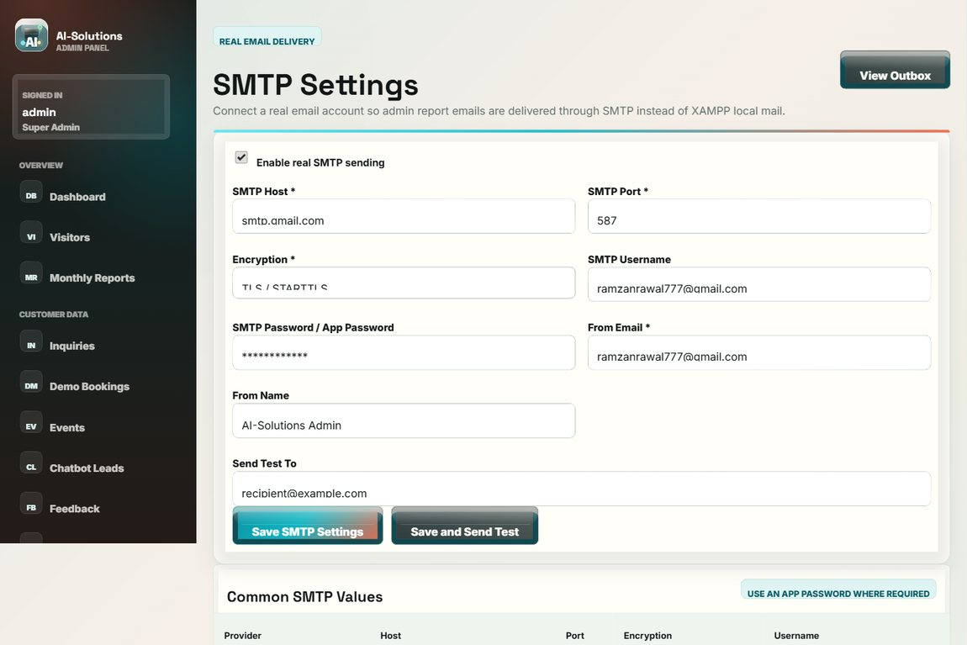

Test no. 32: Security and two-factor authentication
Description | Expected Result | Performed as Expected
Open the Security page to change the password and enable two-factor authentication. | The password can be changed and 2FA can be enabled for stronger admin protection. | Yes
Evidence: Screenshot of the account security / 2FA page.
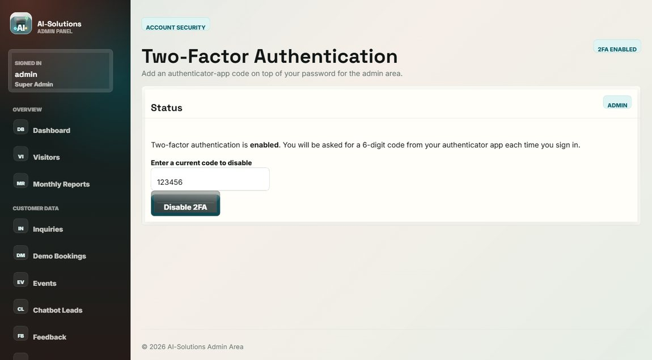

Test no. 33: Activity log (audit trail)
Description | Expected Result | Performed as Expected
Open the Activity Log to review recorded admin actions. | Logins, views, updates, deletions and exports are recorded with timestamps. | Yes
Evidence: Screenshot of the admin activity log.
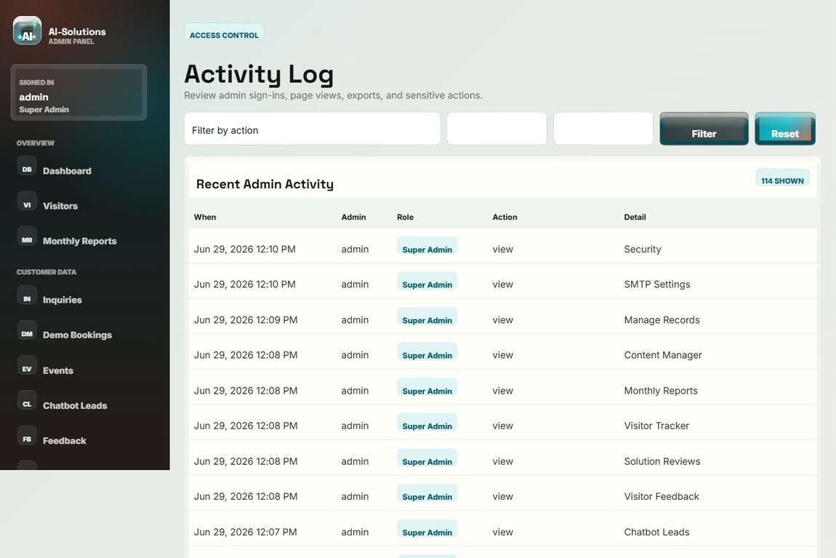

Test no. 34: Logout
Description | Expected Result | Performed as Expected
Click Logout in the admin sidebar. | The session is ended and the login page is shown; protected pages are no longer accessible. | Yes
Evidence: Screenshot of the login page after logout.


Non-functional requirements
Test no. 35: Responsive layout
Description | Expected Result | Performed as Expected
Open the site at desktop, tablet and mobile widths. | The layout adapts to each width and the mobile menu works; no horizontal scrolling. | Yes
Evidence: Screenshot of the layout (tested at desktop / tablet / mobile widths).


Test no. 36: Cross-browser compatibility
Description | Expected Result | Performed as Expected
Open the site in Google Chrome, Microsoft Edge and Mozilla Firefox. | The site renders and behaves consistently across the three browsers. | Yes
Evidence: Screenshot of the site rendering (verified in Chrome / Edge / Firefox).
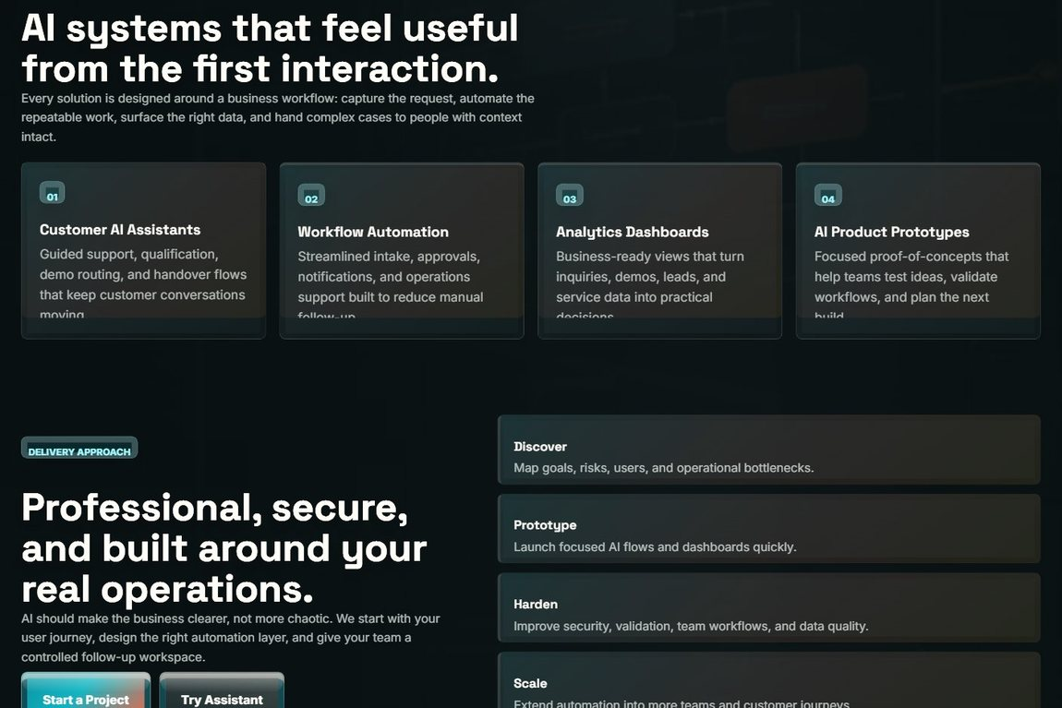

Test no. 37: Performance / page load
Description | Expected Result | Performed as Expected
Open the public pages on the local server and observe load time. | Pages load within approximately three seconds. | Yes
Evidence: Screenshot of a page that loads quickly on localhost.


Test no. 38: Input security (SQL injection / XSS)
Description | Expected Result | Performed as Expected
Enter a SQL-injection string in the admin search and script text in a form field. | No breach occurs (prepared statements); script input is stored and rendered escaped. | Yes
Evidence: Screenshot of the search after a SQL-injection attempt (no breach).


Test no. 39: Admin session protection
Description | Expected Result | Performed as Expected
Open an admin URL directly while logged out. | The user is redirected to the login page; no admin data is exposed. | Yes
Evidence: Screenshot of the redirect to the login page.


Test no. 40: CSV file format
Description | Expected Result | Performed as Expected
Export records and open the generated CSV file in a spreadsheet application. | The CSV has correct headers and one record per row; it opens cleanly in Excel. | Yes
Evidence: Screenshot of the export controls used to generate the CSV file.


Test no. 41: Privacy and GDPR
Description | Expected Result | Performed as Expected
Review the Privacy Policy, Terms and the consent capture on forms. | Policy and terms pages exist; consent is recorded; admin delete/export supports data rights. | Yes
Evidence: Screenshot of the Privacy Policy page.
