Testing Documentation
Since the portfolio had to demonstrate that the system fulfilled its agreed requirements from the user and admin perspective, testing has been conducted by black-box testing. The following test cases indicate the action taken, the result that should be expected, whether the action was successful, and - where a defect was found during development - what happened and whether it was fixed, with a supporting screenshot as evidence for each test.

User-side functional requirements
Test no. 1: Open website navigation
Description | Expected Result | Performed as Expected | If no, what happened? [Fixed / Unfixed]
Open the Home page and click each item in the main navigation (Solutions, Events, Articles, Contact, Schedule Demo). | Each page loads with the correct heading and content; the active menu item is highlighted. | Yes | —
Evidence: Screenshot of the public home page and navigation bar.
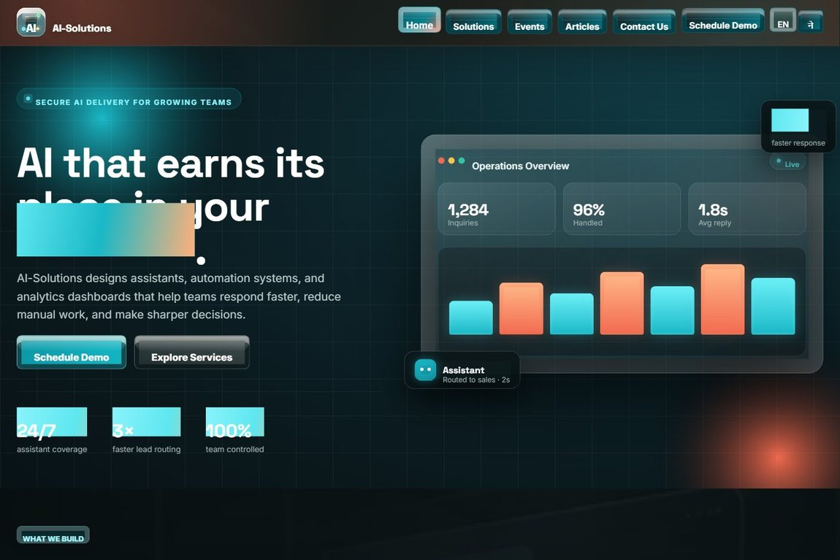

Test no. 2: Form validation (required, email and phone format)
Description | Expected Result | Performed as Expected | If no, what happened? [Fixed / Unfixed]
Submit the Contact inquiry form with required fields blank, then with a malformed email and a non-numeric phone number. | Client and server validation block submission and show an error at each invalid field. | Yes | —
Evidence: Screenshot of the inquiry form with required (*) fields and format hints.
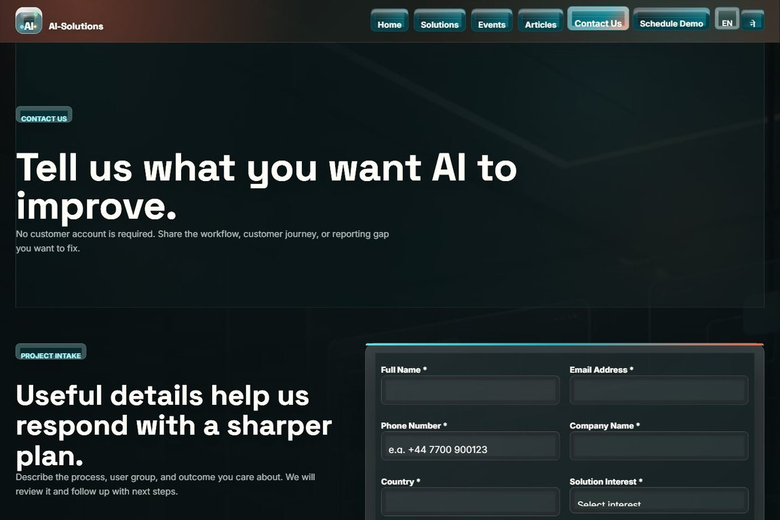

Test no. 3: Anti-spam protection (security check, honeypot, CSRF)
Description | Expected Result | Performed as Expected | If no, what happened? [Fixed / Unfixed]
Answer the security check incorrectly; trigger the hidden honeypot as a simulated bot; submit a form with a missing/invalid CSRF token. | Each attempt is rejected: a security-check error is shown, honeypot/bot submissions are silently dropped, and an invalid token is refused. | Yes | —
Evidence: Screenshot of the form security check (CAPTCHA) and protected submission.


Test no. 4: Submit a complete contact inquiry
Description | Expected Result | Performed as Expected | If no, what happened? [Fixed / Unfixed]
Fill in all inquiry fields, pass the security check, tick consent and submit. | A confirmation page is shown and the inquiry is saved to the database for admin review. | Yes | Live acknowledgement email needs SMTP. Until configured, the message is stored in the Email Outbox so none are lost. [Fixed]
Evidence: Screenshot of the success / confirmation page after a valid submission.
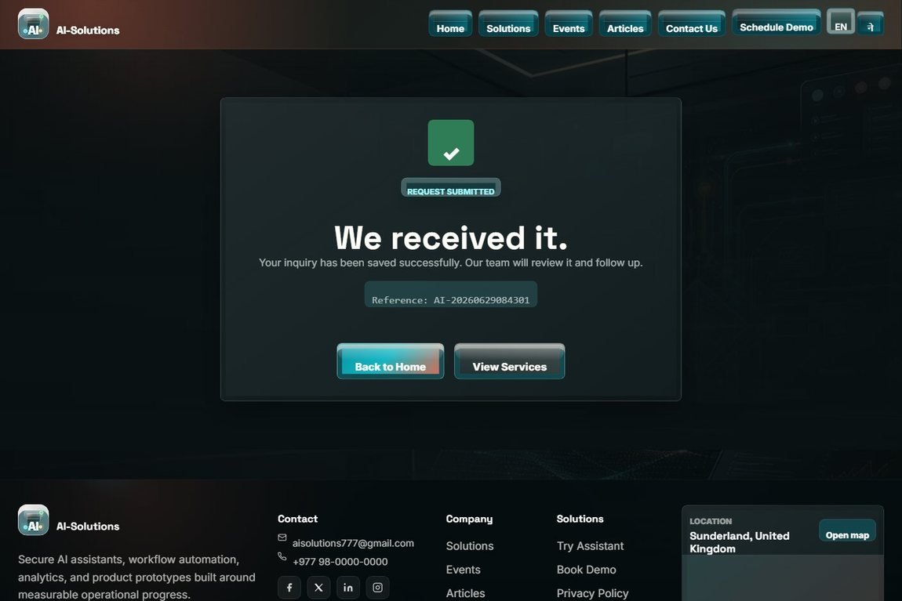

Test no. 5: Consent required before submission
Description | Expected Result | Performed as Expected | If no, what happened? [Fixed / Unfixed]
Try to submit the Schedule Demo form without ticking the data-consent checkbox. | Submission is blocked until consent is given; the consent is then recorded with the booking. | Yes | The demo form first allowed submission with no consent. Added a required checkbox plus a server-side check. [Fixed]
Evidence: Screenshot of the booking form with the required consent checkbox.
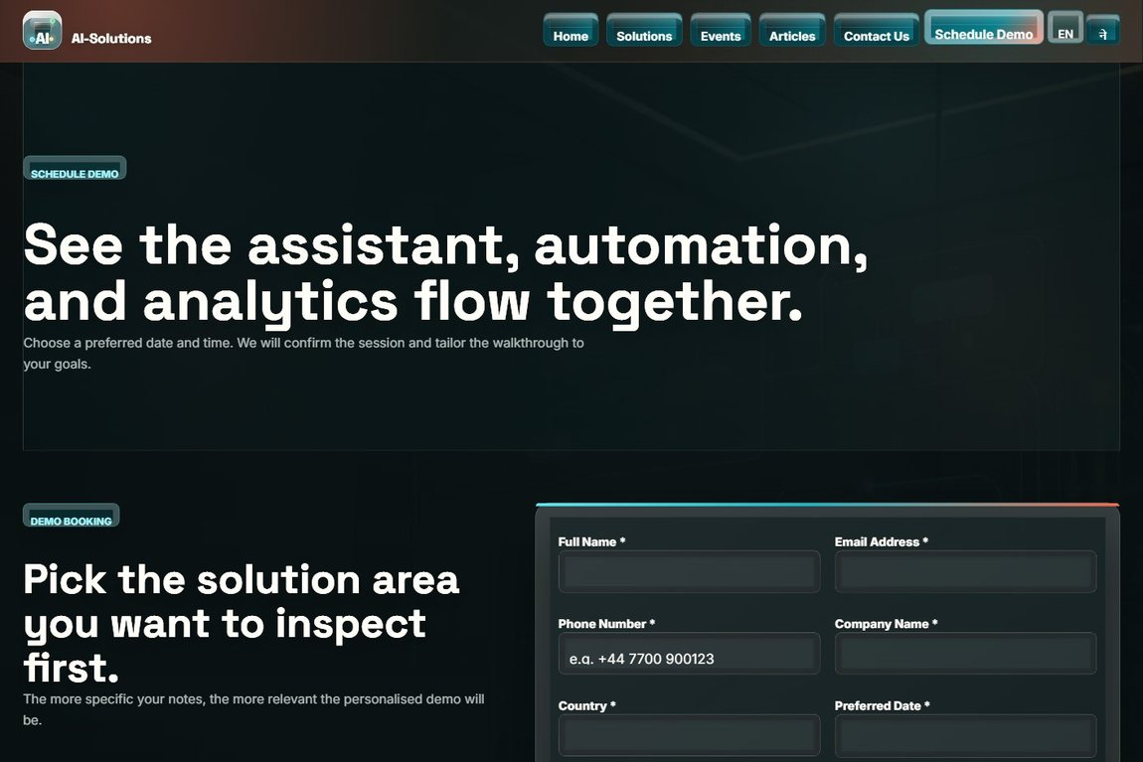

Test no. 6: Schedule a personalised demo
Description | Expected Result | Performed as Expected | If no, what happened? [Fixed / Unfixed]
Open Schedule Demo, choose a date and time, pick a solution, add notes, give consent and submit. | The booking is stored and a confirmation is shown; the past-date guard blocks invalid dates. | Yes | —
Evidence: Screenshot of the schedule-demo booking form.


Test no. 7: Event registration (future event)
Description | Expected Result | Performed as Expected | If no, what happened? [Fixed / Unfixed]
Open an upcoming event and complete the "Join our Events" registration form. | The Register option is available; the registration is stored and a confirmation is shown. | Yes | —
Evidence: Screenshot of the events page and the registration form.
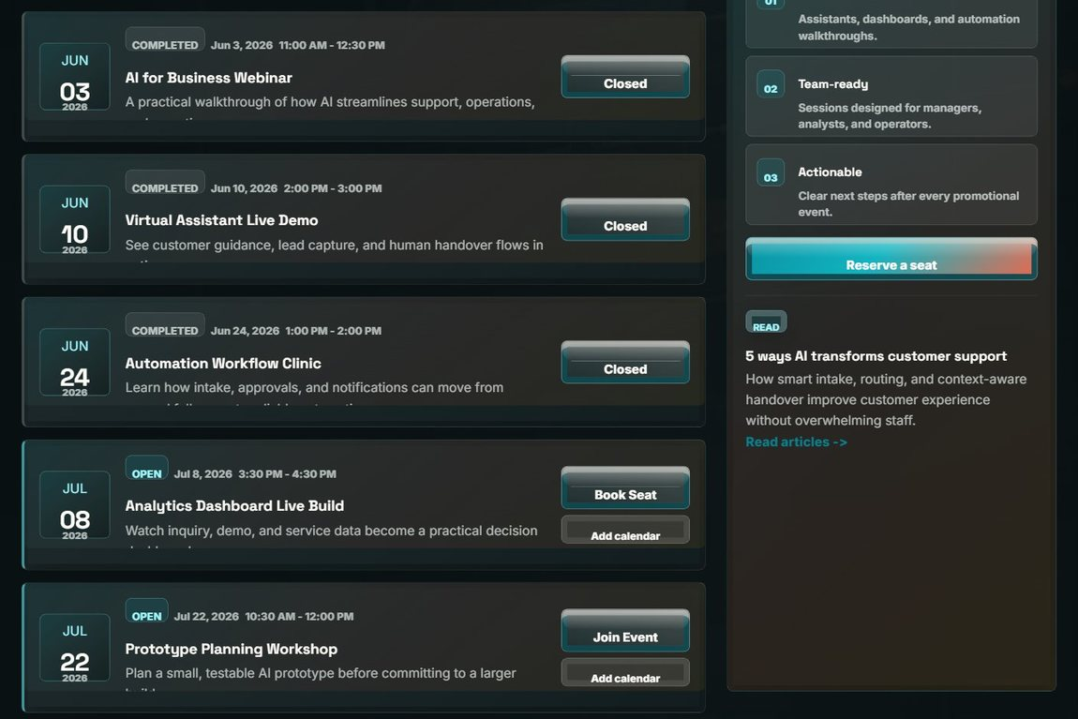

Test no. 8: Add an event to calendar (.ics)
Description | Expected Result | Performed as Expected | If no, what happened? [Fixed / Unfixed]
Use "Add to calendar" on an event. | A valid .ics calendar file downloads and imports into the calendar application with the correct date and time. | Yes | —
Evidence: Screenshot of the events page with the add-to-calendar option.
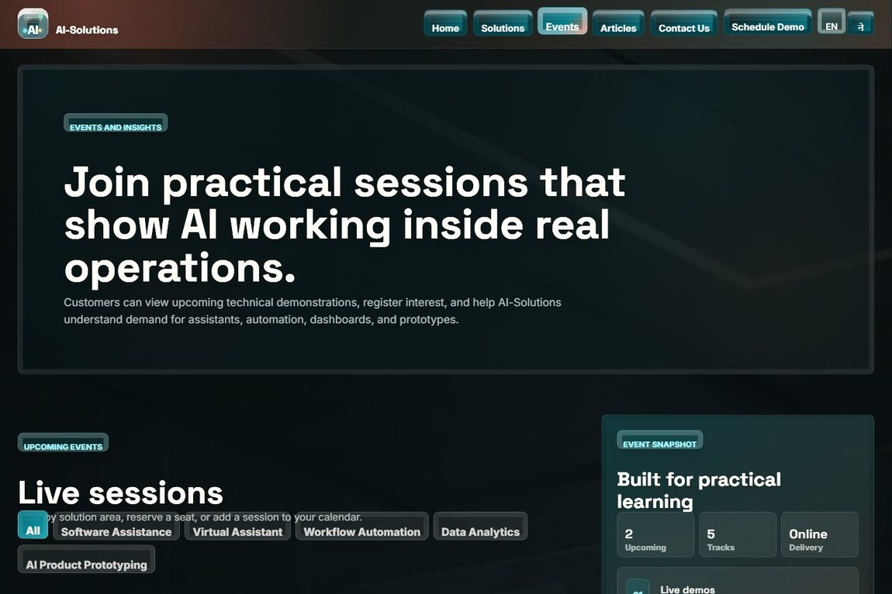

Test no. 9: Photo gallery and upcoming events
Description | Expected Result | Performed as Expected | If no, what happened? [Fixed / Unfixed]
Open the Events page to view the photo gallery and the upcoming events. | The gallery images and the list of upcoming events are displayed correctly. | Yes | —
Evidence: Screenshot of the events and gallery section.


Test no. 10: Browse solutions and filters
Description | Expected Result | Performed as Expected | If no, what happened? [Fixed / Unfixed]
Open the Solutions page and apply the capability/industry filters. | The solution list narrows to the matching solutions. | Yes | —
Evidence: Screenshot of the Solutions page with filters and solution cards.


Test no. 11: Submit a solution review and rating
Description | Expected Result | Performed as Expected | If no, what happened? [Fixed / Unfixed]
Submit a star rating and review for a solution. | The review is stored for admin moderation and a confirmation is shown. | Yes | —
Evidence: Screenshot of the solution reviews / rating area.
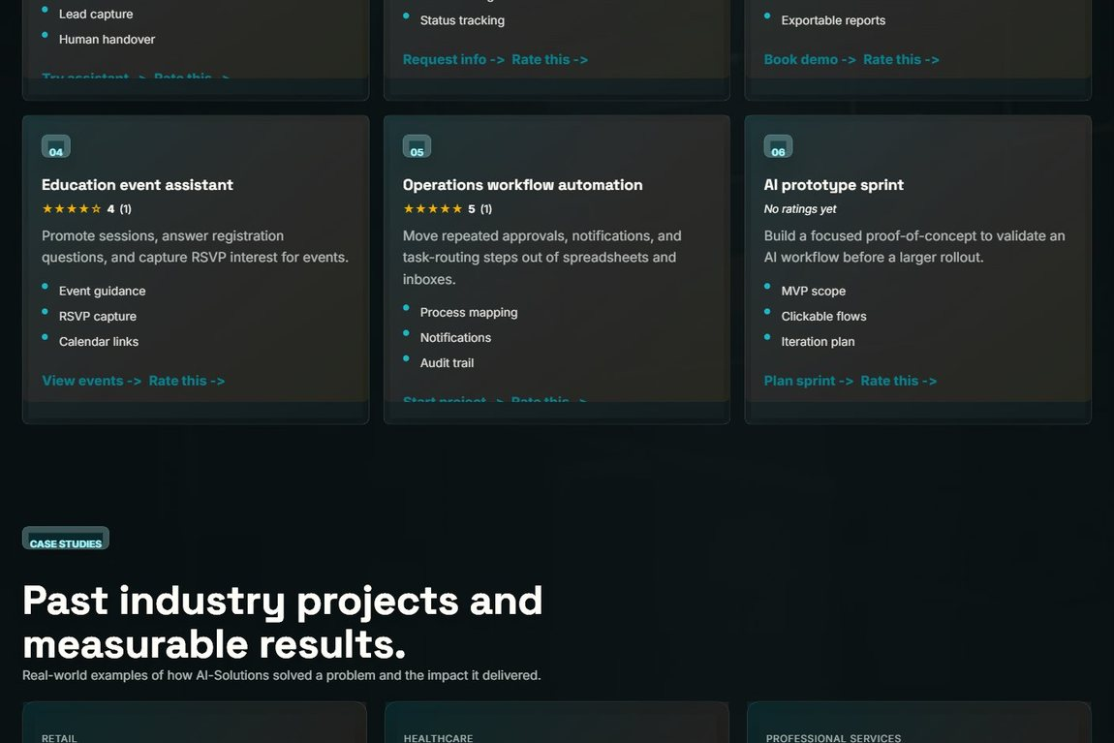

Test no. 12: Submit visitor feedback rating
Description | Expected Result | Performed as Expected | If no, what happened? [Fixed / Unfixed]
Use the visitor feedback form to leave a rating and message. | The feedback is saved and can be featured by the admin as a testimonial. | Yes | —
Evidence: Screenshot of the visitor feedback / rating form.
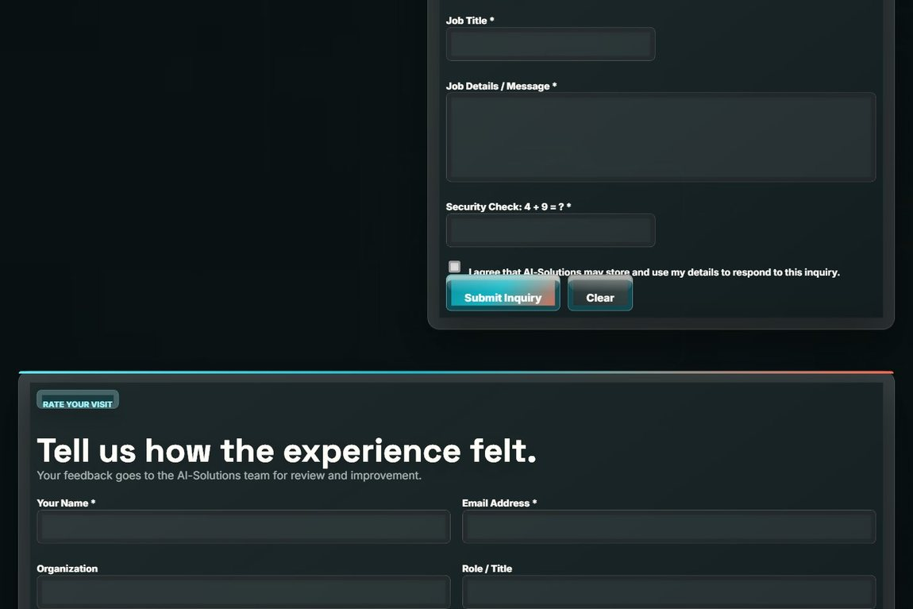

Test no. 13: Read articles and open an article
Description | Expected Result | Performed as Expected | If no, what happened? [Fixed / Unfixed]
Open the Articles page, page through it, and open a single article. | Article cards with categories and pagination display; the full article opens correctly. | Yes | —
Evidence: Screenshot of the articles listing (and article detail page).


Test no. 14: AI assistant (chatbot) response
Description | Expected Result | Performed as Expected | If no, what happened? [Fixed / Unfixed]
Ask the AI assistant about services, pricing or demos and use the quick-action buttons. | The assistant returns a relevant answer with quick actions and can route to pages. | Yes | If the AI API is unreachable on localhost, the built-in knowledge base answers automatically. [Fixed]
Evidence: Screenshot of a chatbot conversation.
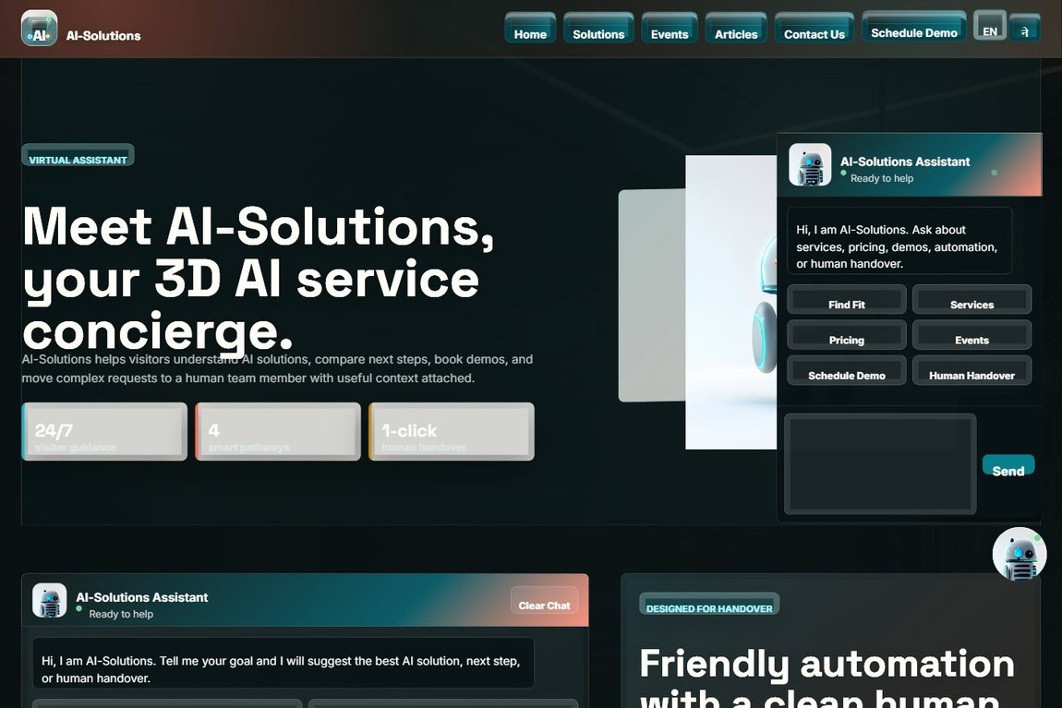

Test no. 15: Chatbot human handover
Description | Expected Result | Performed as Expected | If no, what happened? [Fixed / Unfixed]
Request a human handover from the assistant and submit the handover form. | The handover form opens pre-filled with the conversation summary; the lead is stored. | Yes | —
Evidence: Screenshot of the human-support handover form.
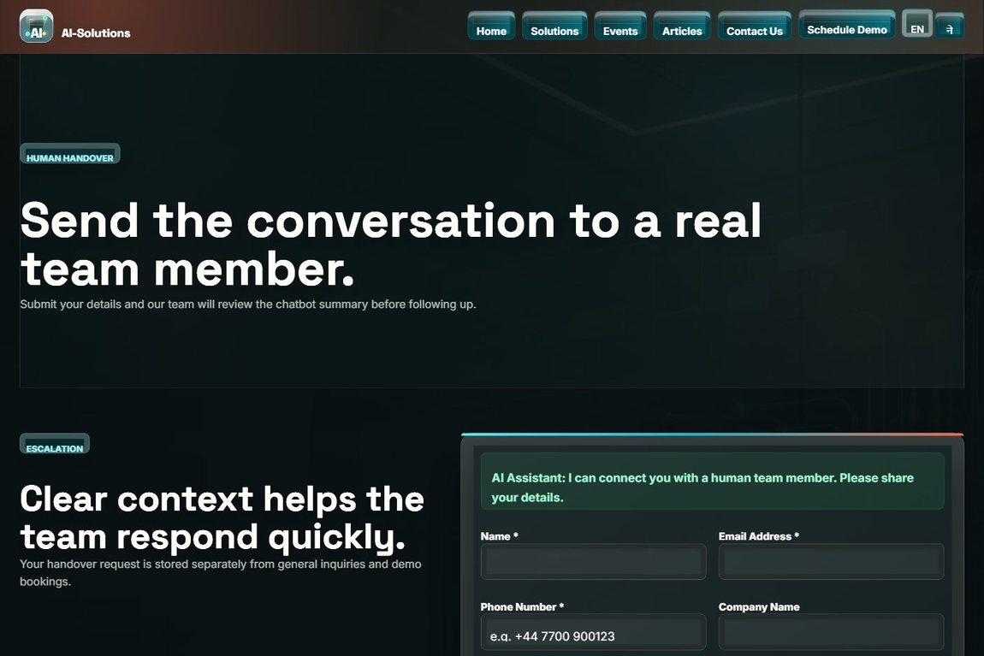

Test no. 16: Cookie consent banner
Description | Expected Result | Performed as Expected | If no, what happened? [Fixed / Unfixed]
Open the site as a first-time visitor and respond to the cookie consent banner. | The banner appears once; the choice is remembered and the banner does not reappear on the next visit. | Yes | —
Evidence: Screenshot of a public page (cookie consent banner shown on first visit).
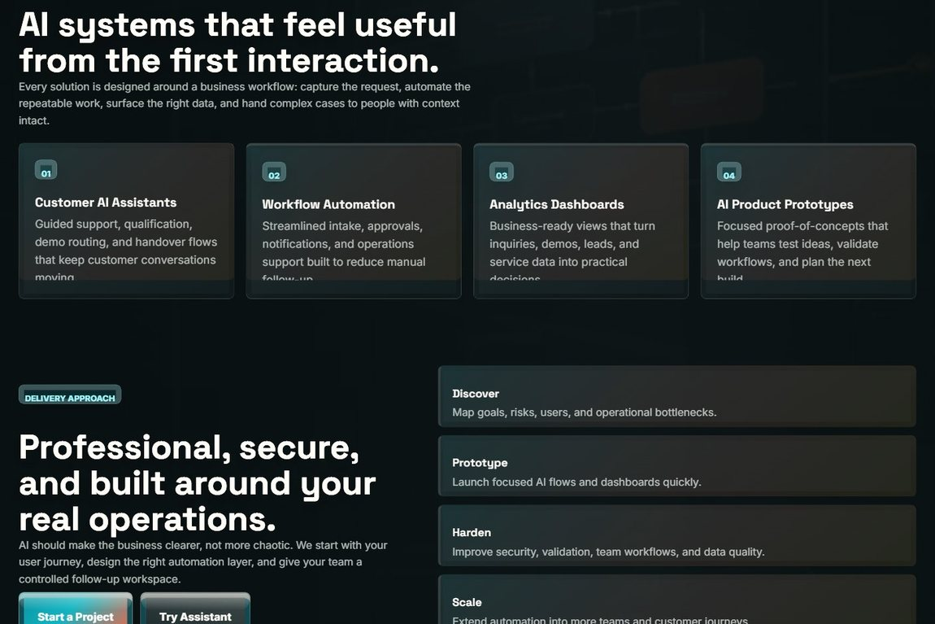

Test no. 17: Language switch (English / Nepali)
Description | Expected Result | Performed as Expected | If no, what happened? [Fixed / Unfixed]
Use the EN / ne language toggle in the navigation bar. | The configured labels and messages switch language and the choice is applied across pages. | Yes | —
Evidence: Screenshot of the navigation language toggle (EN / ne).


Test no. 18: Location map (current GPS)
Description | Expected Result | Performed as Expected | If no, what happened? [Fixed / Unfixed]
Allow location permission for the footer map on any public page. | The map re-centres on the visitor current GPS location with a place label. | Yes | The footer map first showed a fixed pin. Updated to use the browser Geolocation API with an IP-based fallback. [Fixed]
Evidence: Screenshot of the footer location map.
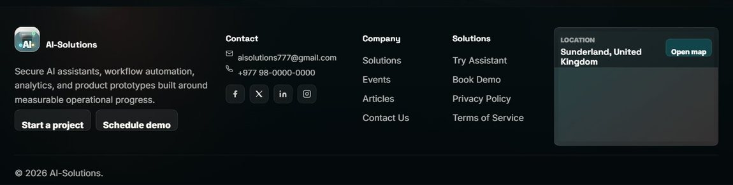

Admin-side functional requirements
Test no. 19: Admin login with wrong password
Description | Expected Result | Performed as Expected | If no, what happened? [Fixed / Unfixed]
Enter a correct username with an incorrect password on the admin login page. | Login fails with an "invalid username or password" message. | Yes | —
Evidence: Screenshot of the admin login page / failed-login message.
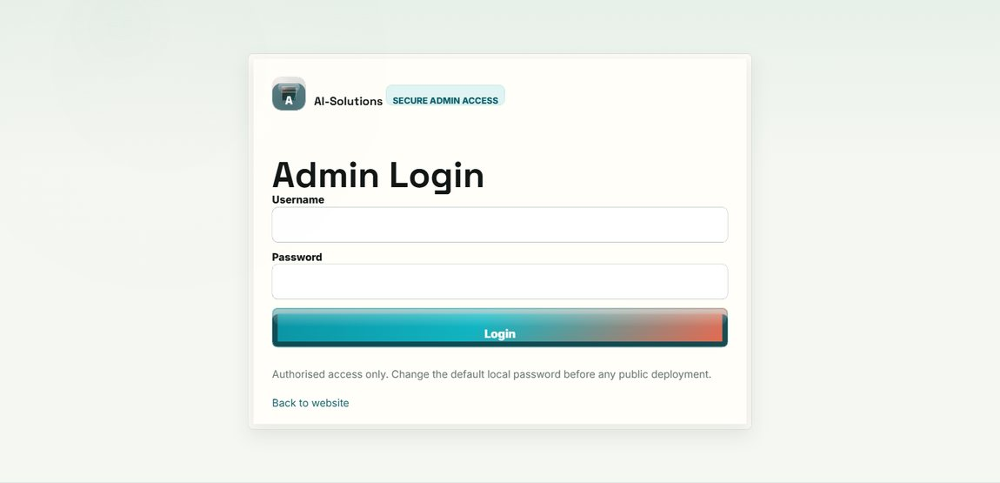

Test no. 20: Brute-force lockout
Description | Expected Result | Performed as Expected | If no, what happened? [Fixed / Unfixed]
Enter the wrong password five times in a row. | The account is temporarily locked (about five minutes) and further attempts are refused. | Yes | —
Evidence: Screenshot of the login page showing the lockout message.


Test no. 21: Admin login with valid credentials
Description | Expected Result | Performed as Expected | If no, what happened? [Fixed / Unfixed]
Log in with the correct admin username and password. | The admin dashboard opens and a session is created. | Yes | —
Evidence: Screenshot of the admin dashboard after a successful login.
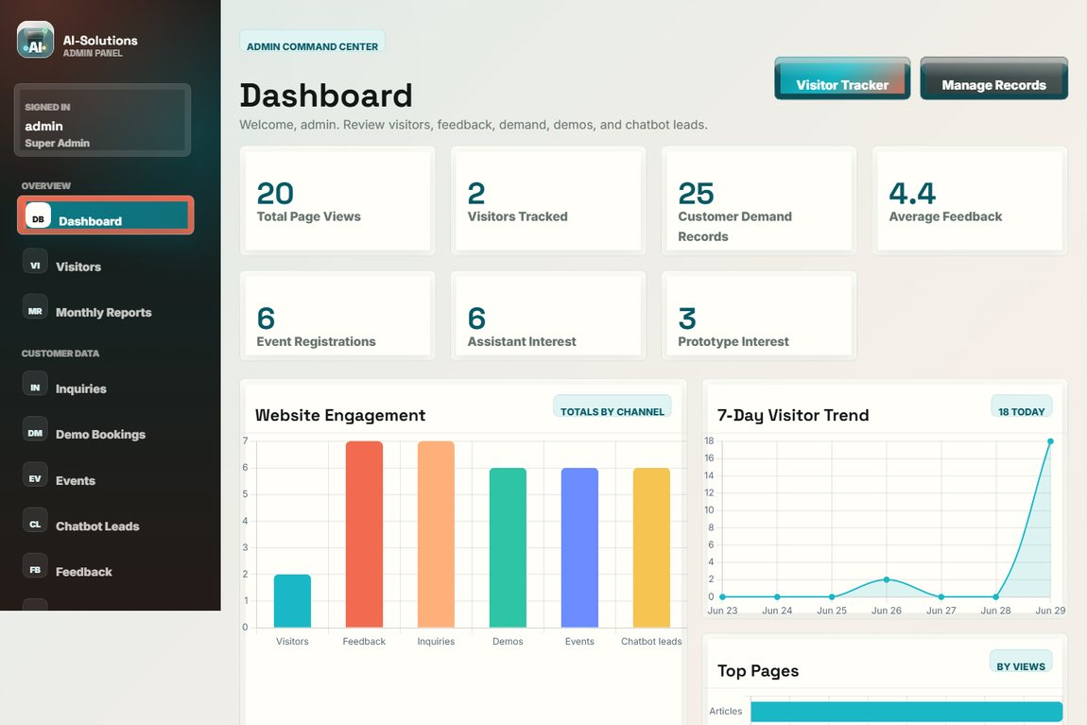

Test no. 22: Dashboard analytics and charts
Description | Expected Result | Performed as Expected | If no, what happened? [Fixed / Unfixed]
Open the dashboard and review the totals and analytics charts. | Stat cards and bar/line/doughnut charts render from the live data. | Yes | —
Evidence: Screenshot of the dashboard analytics charts.
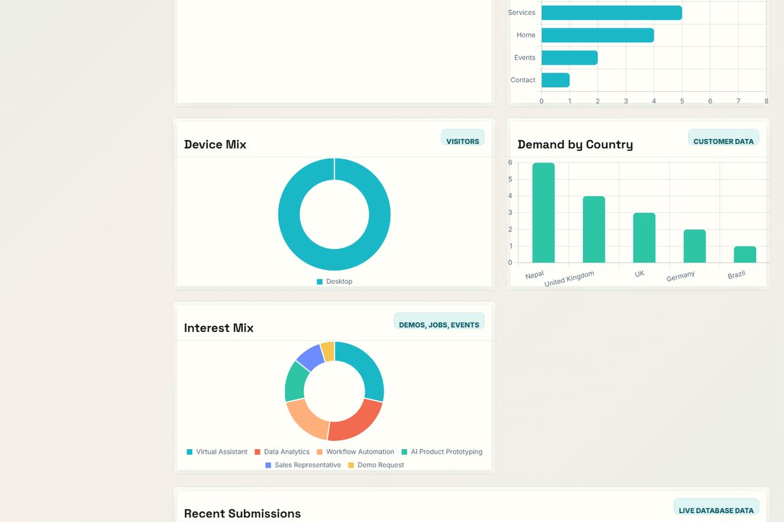

Test no. 23: View and search customer inquiries
Description | Expected Result | Performed as Expected | If no, what happened? [Fixed / Unfixed]
Open Customer Inquiries and search by name, email, company or country. | All inquiries are listed; the search filters to the matching records only. | Yes | —
Evidence: Screenshot of the inquiry records list with the search bar.
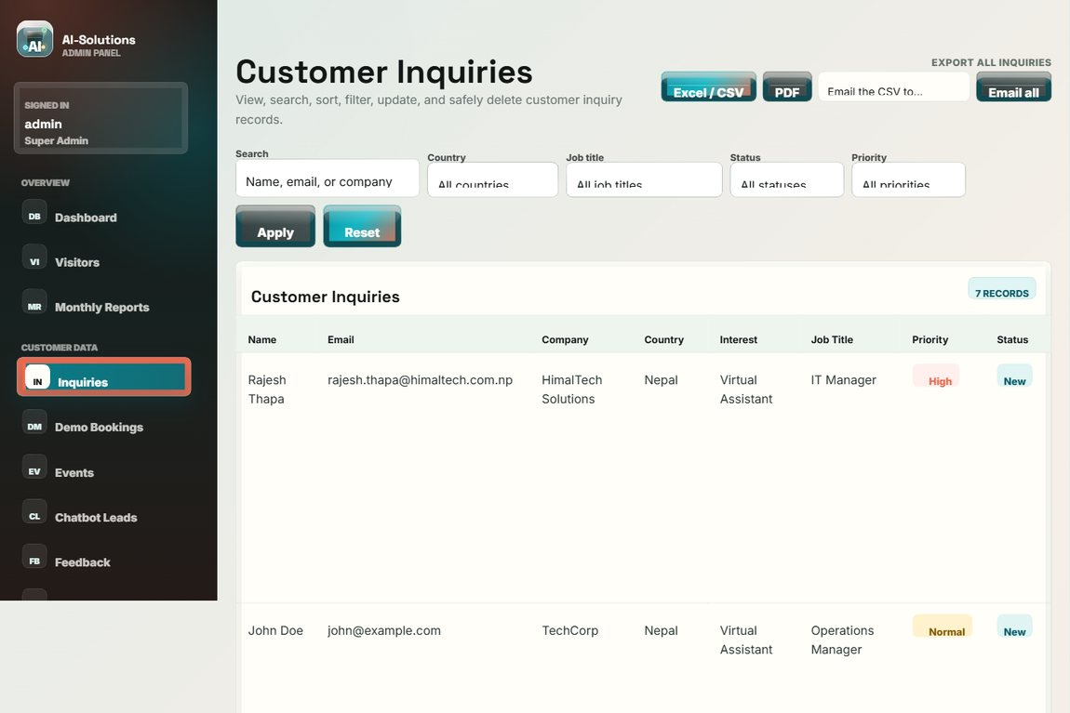

Test no. 24: Edit and delete inquiry records
Description | Expected Result | Performed as Expected | If no, what happened? [Fixed / Unfixed]
Open a record to edit its fields, status and admin note; then delete a record and confirm the prompt. | Edits are saved (updated_at set); the record is removed only after confirmation; both actions are logged. | Yes | The editor first changed only status/note. Extended it to edit every record field. [Fixed]
Evidence: Screenshot of the inquiry records with the View / Edit / Delete actions.


Test no. 25: Download inquiry CSV and PDF
Description | Expected Result | Performed as Expected | If no, what happened? [Fixed / Unfixed]
Export the inquiry records (single and all) to CSV and PDF. | Valid CSV and PDF files download and open correctly. | Yes | —
Evidence: Screenshot of the records page with the export (CSV / PDF) controls.


Test no. 26: Email a record (CSV) to the customer
Description | Expected Result | Performed as Expected | If no, what happened? [Fixed / Unfixed]
Use the Email action to send a record as a CSV attachment to the customer. | The email with the CSV attachment is sent via SMTP, or queued to the outbox if SMTP is off. | Yes | The first version attached a PDF via PHP mail() and failed on XAMPP. Changed to a CSV sent over SMTP. [Fixed]
Evidence: Screenshot of the email outbox / sent record.
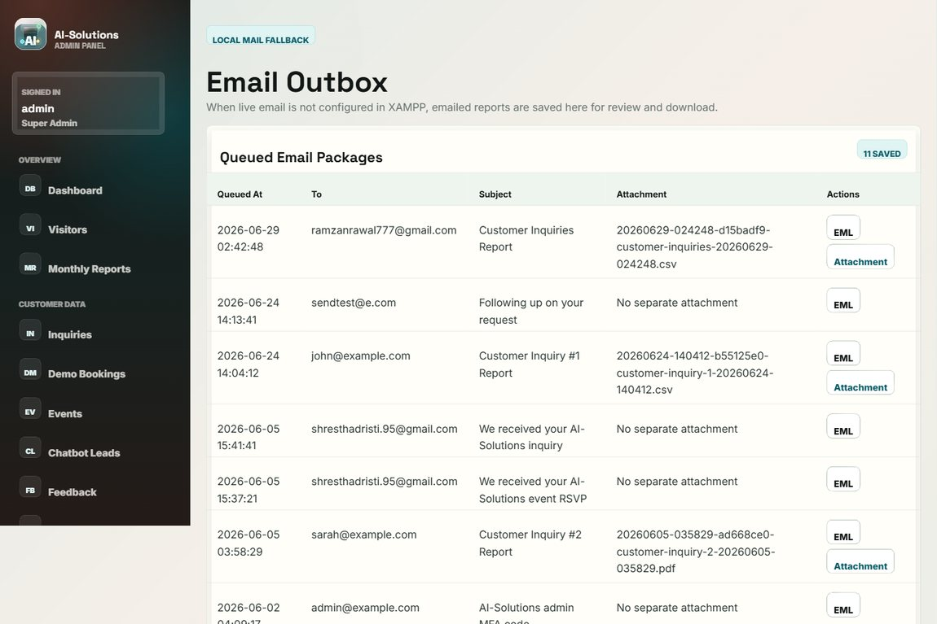

Test no. 27: Manage demo bookings
Description | Expected Result | Performed as Expected | If no, what happened? [Fixed / Unfixed]
Open Demo Bookings and manage the scheduled demo requests. | Demo bookings are listed with view / edit / delete / export options. | Yes | —
Evidence: Screenshot of the demo bookings admin page.
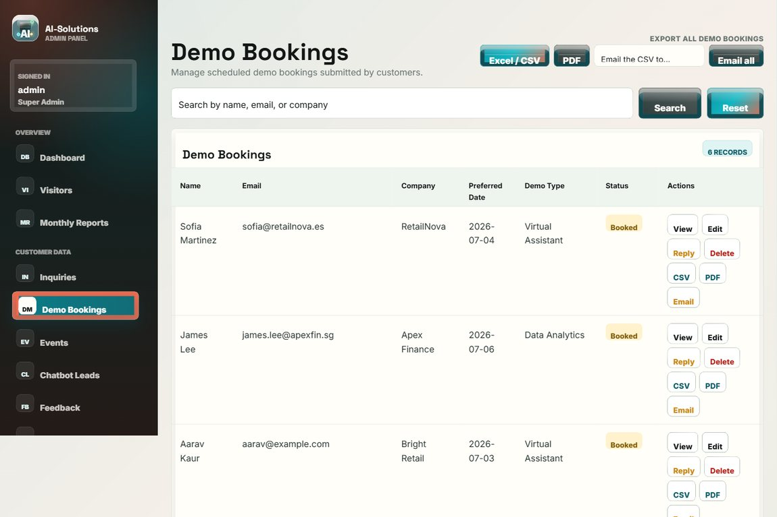

Test no. 28: Manage event registrations
Description | Expected Result | Performed as Expected | If no, what happened? [Fixed / Unfixed]
Open Event Registrations to review "Join our Events" submissions. | All event registrations are listed for review and export. | Yes | —
Evidence: Screenshot of the event registrations admin page.
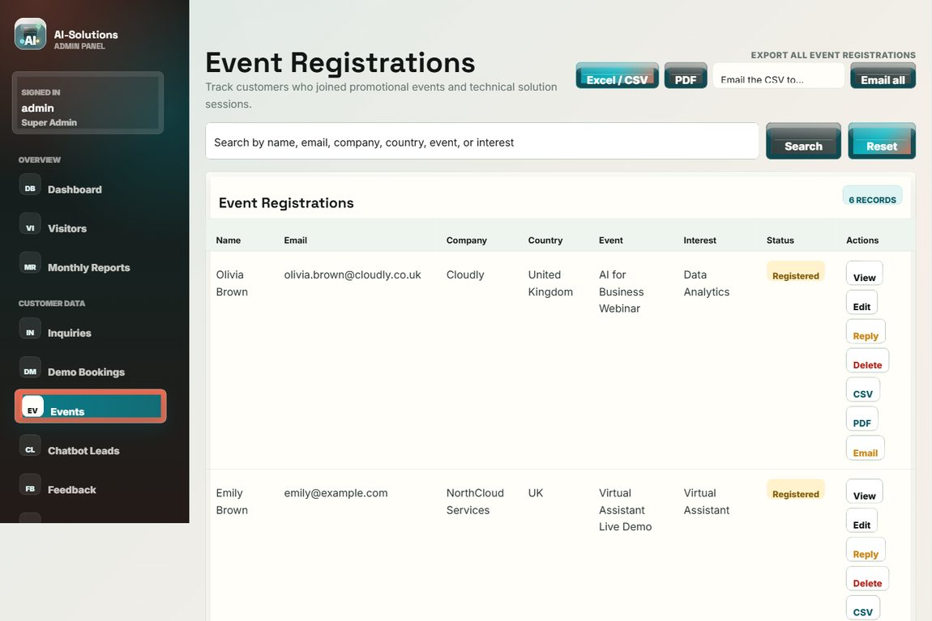

Test no. 29: Manage chatbot leads
Description | Expected Result | Performed as Expected | If no, what happened? [Fixed / Unfixed]
Open Chatbot Leads to review handover leads. | Leads captured from the assistant (topic and summary) are listed for follow-up. | Yes | —
Evidence: Screenshot of the chatbot leads admin page.
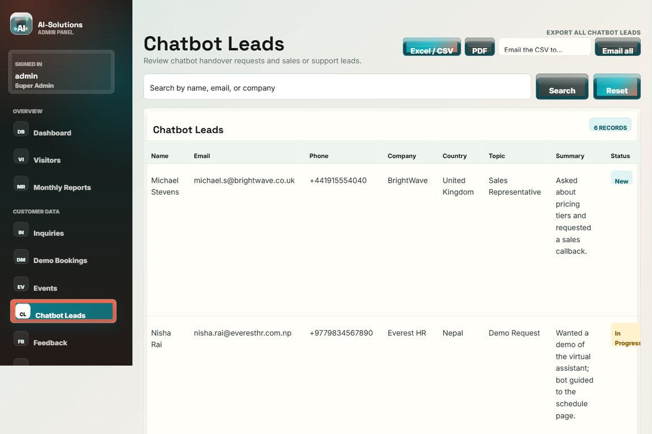

Test no. 30: Moderate visitor feedback
Description | Expected Result | Performed as Expected | If no, what happened? [Fixed / Unfixed]
Open Visitor Feedback and feature a testimonial. | Ratings and messages are listed; entries can be marked as featured testimonials. | Yes | —
Evidence: Screenshot of the visitor feedback admin page.
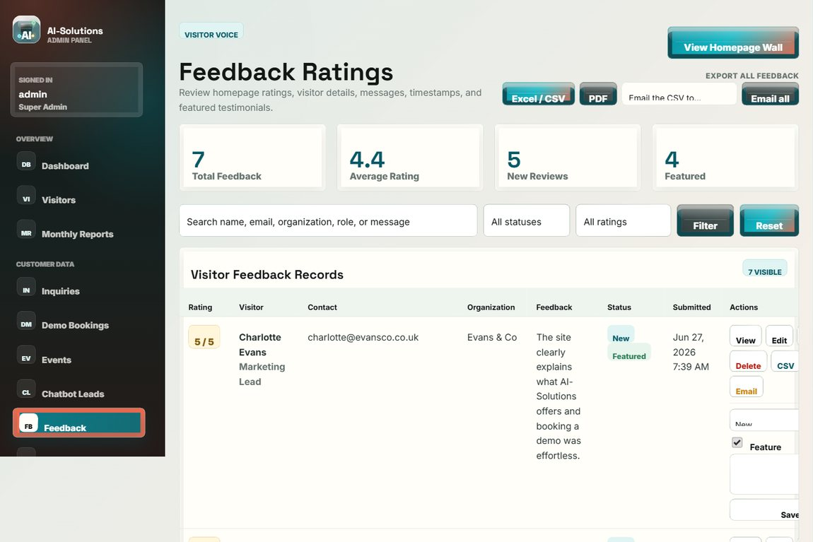

Test no. 31: Moderate solution reviews
Description | Expected Result | Performed as Expected | If no, what happened? [Fixed / Unfixed]
Open Solution Reviews to approve or remove submitted reviews. | Per-solution reviews can be moderated (approve / feature / remove). | Yes | —
Evidence: Screenshot of the solution reviews moderation page.
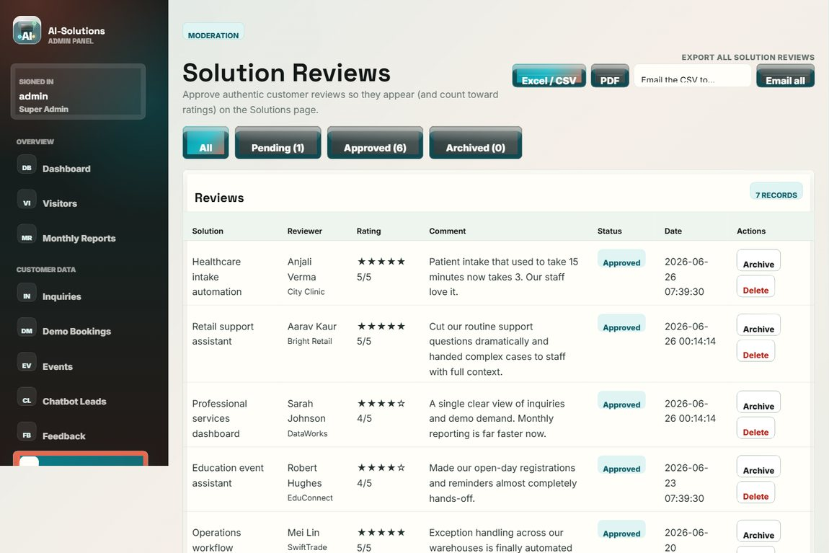

Test no. 32: Manage website content
Description | Expected Result | Performed as Expected | If no, what happened? [Fixed / Unfixed]
Use the Content Manager to create, edit and delete articles/events/content items. | Content changes are saved and reflected on the public site. | Yes | —
Evidence: Screenshot of the Content Manager.
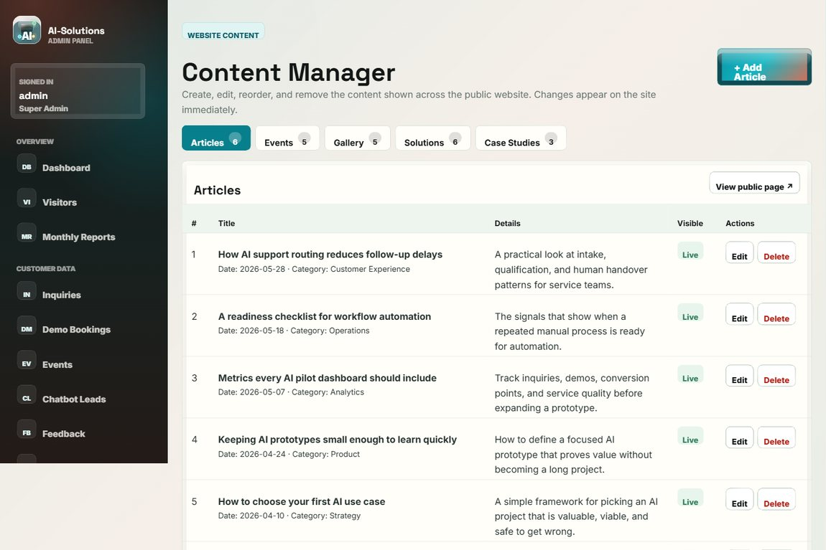

Test no. 33: Visitor tracker
Description | Expected Result | Performed as Expected | If no, what happened? [Fixed / Unfixed]
Open the Visitor Tracker after browsing public pages. | Each visit is logged with device type, browser and timestamp. | Yes | —
Evidence: Screenshot of the visitor tracker.
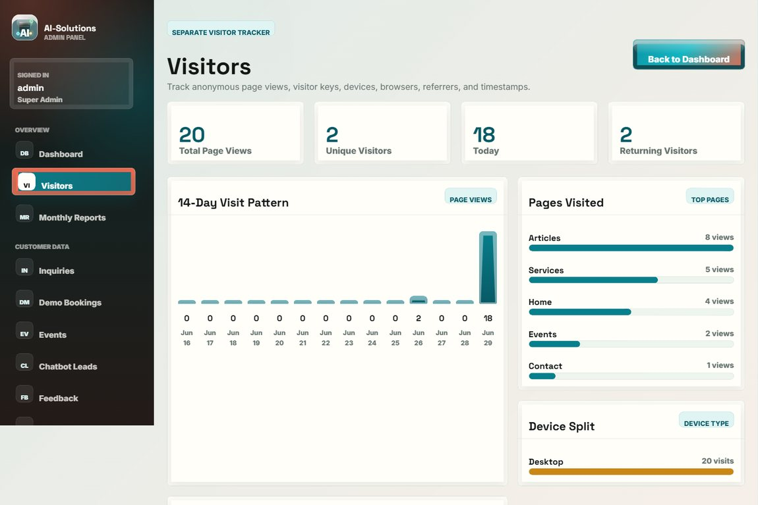

Test no. 34: Monthly report
Description | Expected Result | Performed as Expected | If no, what happened? [Fixed / Unfixed]
Open the Monthly Report. | Period metrics for customer demand are summarised. | Yes | —
Evidence: Screenshot of the monthly report.
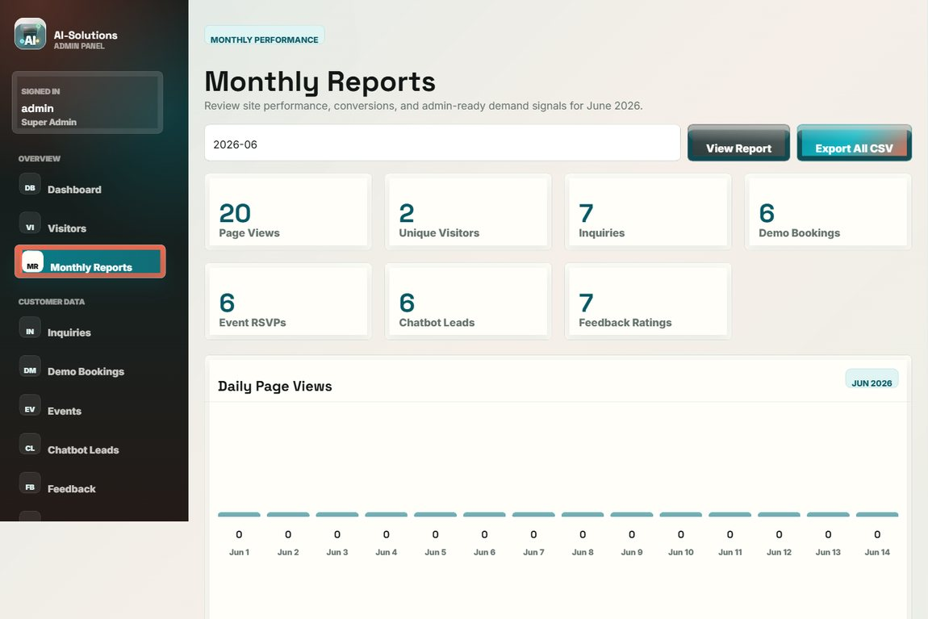

Test no. 35: Send email to a customer
Description | Expected Result | Performed as Expected | If no, what happened? [Fixed / Unfixed]
Compose and send an email to a customer from the admin panel. | The email is sent (or queued) through the configured SMTP server and the action is logged. | Yes | —
Evidence: Screenshot of the sent email recorded in the outbox.


Test no. 36: Configure SMTP settings
Description | Expected Result | Performed as Expected | If no, what happened? [Fixed / Unfixed]
Open SMTP Settings and save the mail-server configuration. | The settings are saved and the stored password is masked. | Yes | —
Evidence: Screenshot of the SMTP settings page.
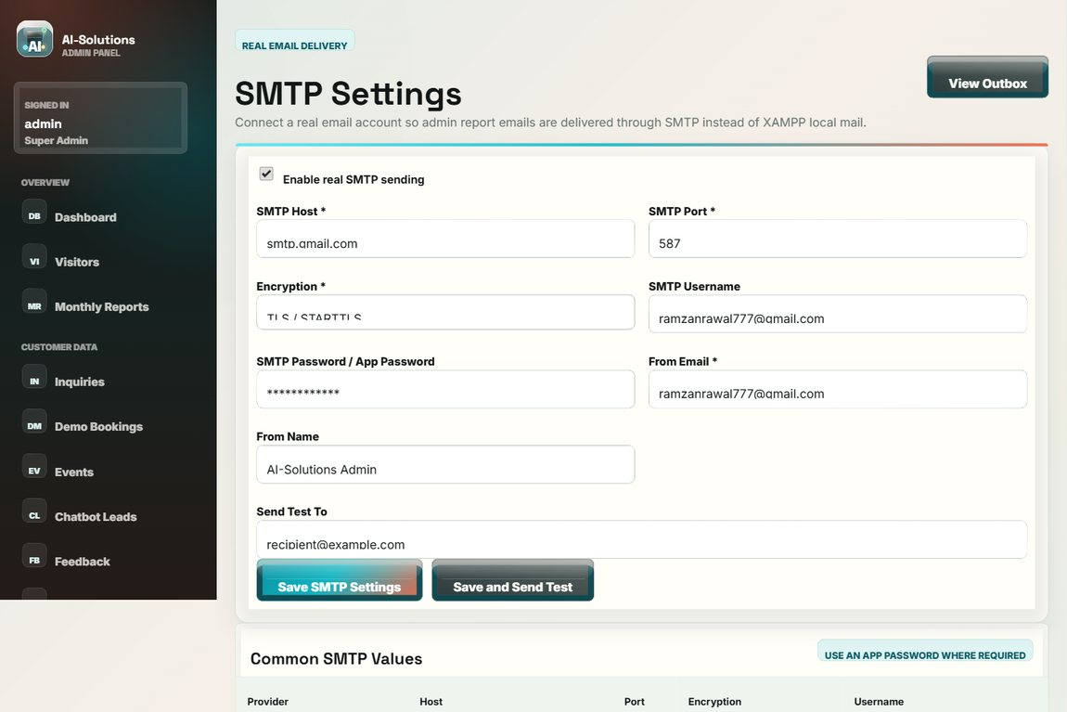

Test no. 37: Security and two-factor authentication
Description | Expected Result | Performed as Expected | If no, what happened? [Fixed / Unfixed]
Open the Security page to change the password and enable two-factor authentication. | The password can be changed and 2FA can be enabled for stronger admin protection. | Yes | —
Evidence: Screenshot of the account security / 2FA page.
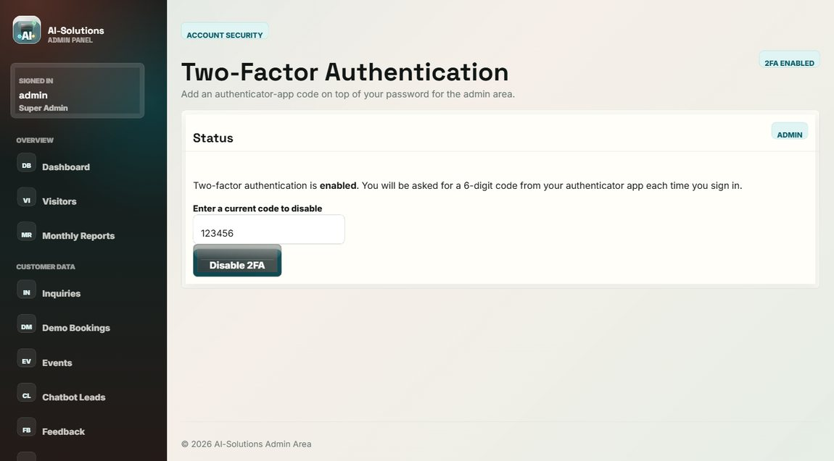

Test no. 38: Activity log (audit trail)
Description | Expected Result | Performed as Expected | If no, what happened? [Fixed / Unfixed]
Open the Activity Log to review recorded admin actions. | Logins, views, updates, deletions and exports are recorded with timestamps. | Yes | —
Evidence: Screenshot of the admin activity log.
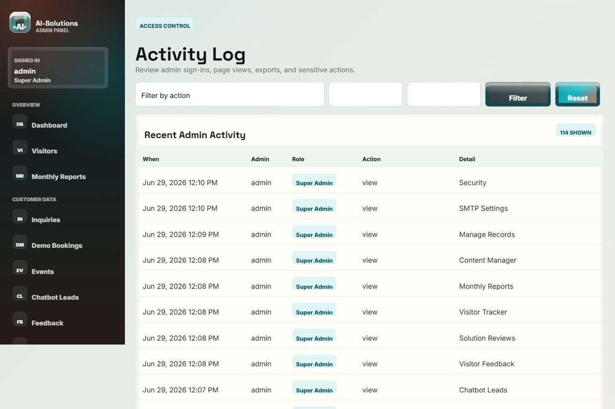

Test no. 39: Logout
Description | Expected Result | Performed as Expected | If no, what happened? [Fixed / Unfixed]
Click Logout in the admin sidebar. | The session is ended and the login page is shown; protected pages are no longer accessible. | Yes | —
Evidence: Screenshot of the login page after logout.


Non-functional requirements
Test no. 40: Responsive layout
Description | Expected Result | Performed as Expected | If no, what happened? [Fixed / Unfixed]
Open the site at desktop, tablet and mobile widths. | The layout adapts to each width and the mobile menu works; no horizontal scrolling. | Yes | —
Evidence: Screenshot of the layout (tested at desktop / tablet / mobile widths).


Test no. 41: Cross-browser compatibility
Description | Expected Result | Performed as Expected | If no, what happened? [Fixed / Unfixed]
Open the site in Google Chrome, Microsoft Edge and Mozilla Firefox. | The site renders and behaves consistently across the three browsers. | Yes | —
Evidence: Screenshot of the site rendering (verified in Chrome / Edge / Firefox).


Test no. 42: Performance / page load
Description | Expected Result | Performed as Expected | If no, what happened? [Fixed / Unfixed]
Open the public pages on the local server and observe load time. | Pages load within approximately three seconds. | Yes | —
Evidence: Screenshot of a page that loads quickly on localhost.


Test no. 43: Input security (SQL injection / XSS)
Description | Expected Result | Performed as Expected | If no, what happened? [Fixed / Unfixed]
Enter a SQL-injection string in the admin search and script text in a form field. | No breach occurs (prepared statements); script input is stored and rendered escaped. | Yes | —
Evidence: Screenshot of the search after a SQL-injection attempt (no breach).


Test no. 44: Admin session protection
Description | Expected Result | Performed as Expected | If no, what happened? [Fixed / Unfixed]
Open an admin URL directly while logged out. | The user is redirected to the login page; no admin data is exposed. | Yes | —
Evidence: Screenshot of the redirect to the login page.


Test no. 45: Accessibility
Description | Expected Result | Performed as Expected | If no, what happened? [Fixed / Unfixed]
Navigate with the keyboard and the skip link, and turn on the operating-system "reduce motion" setting. | All controls are reachable by keyboard, the skip link works, and decorative animations are switched off. | Yes | —
Evidence: Screenshot of the page used for keyboard / skip-link / reduced-motion checks.


Test no. 46: Credential and data security
Description | Expected Result | Performed as Expected | If no, what happened? [Fixed / Unfixed]
Inspect how the admin password and visitor IP addresses are stored. | The password is stored only as a bcrypt hash and visitor IP addresses are stored hashed (privacy / GDPR). | Yes | —
Evidence: Screenshot of the security page (password is hashed, never stored in plain text).


Test no. 47: CSV file format
Description | Expected Result | Performed as Expected | If no, what happened? [Fixed / Unfixed]
Export records and open the generated CSV file in a spreadsheet application. | The CSV has correct headers and one record per row; it opens cleanly in Excel. | Yes | —
Evidence: Screenshot of the export controls used to generate the CSV file.


Test no. 48: Privacy and GDPR
Description | Expected Result | Performed as Expected | If no, what happened? [Fixed / Unfixed]
Review the Privacy Policy, Terms, the consent capture on forms and the cookie banner. | Policy and terms pages exist, consent is recorded, and admin delete/export supports data rights. | Yes | —
Evidence: Screenshot of the Privacy Policy page.
