Testing Documentation
Since the portfolio had to demonstrate that the system fulfilled its agreed requirements from the user and admin perspective, testing has been conducted by black-box testing. The following test cases indicate the action taken, the result that should be expected, whether the action was successful, and - where a defect was found during development - what happened and whether it was fixed, with a supporting screenshot as evidence for each test.

User-side functional requirements
Test no. 1: Open website navigation
Description | Expected Result | Performed as Expected | If no, what happened? [Fixed / Unfixed]
Open the Home page and click each item in the main navigation (Solutions, Events, Articles, Contact, Schedule Demo). | Each page loads with the correct heading and content; the active menu item is highlighted. | Yes | —
Evidence: Screenshot of the public home page and navigation bar.
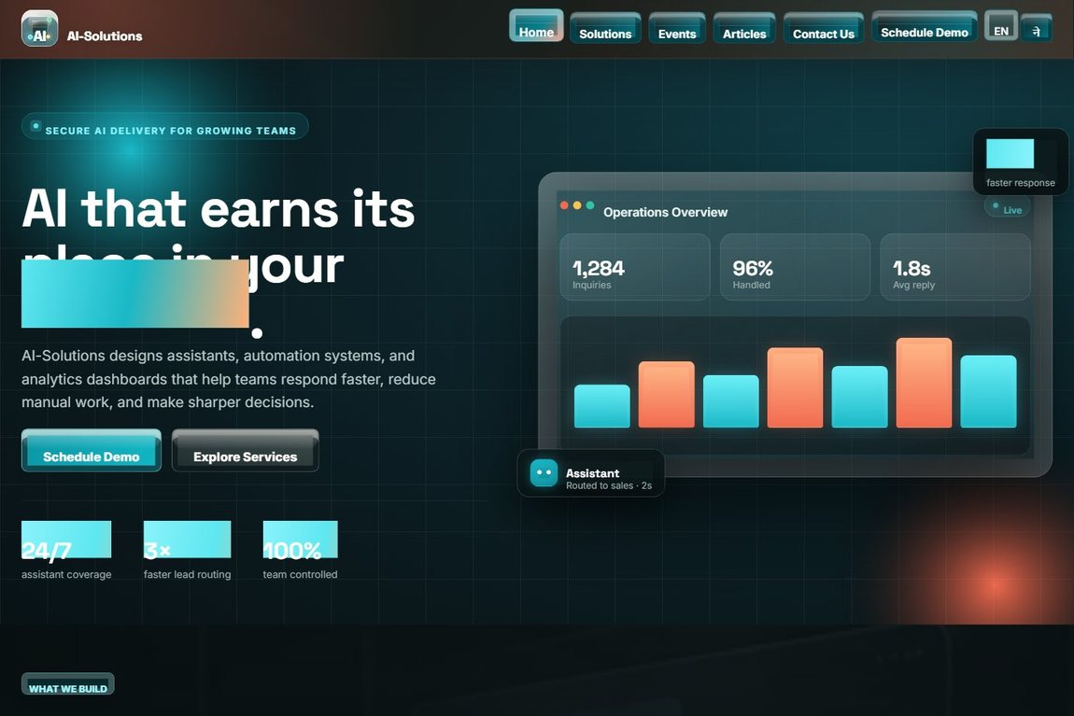

Test no. 2: Form validation (required, email and phone format)
Description | Expected Result | Performed as Expected | If no, what happened? [Fixed / Unfixed]
Submit the Contact inquiry form with required fields blank, then with a malformed email and a non-numeric phone number. | Client and server validation block submission and show an error at each invalid field. | Yes | —
Evidence: Screenshot of the inquiry form with required (*) fields and format hints.
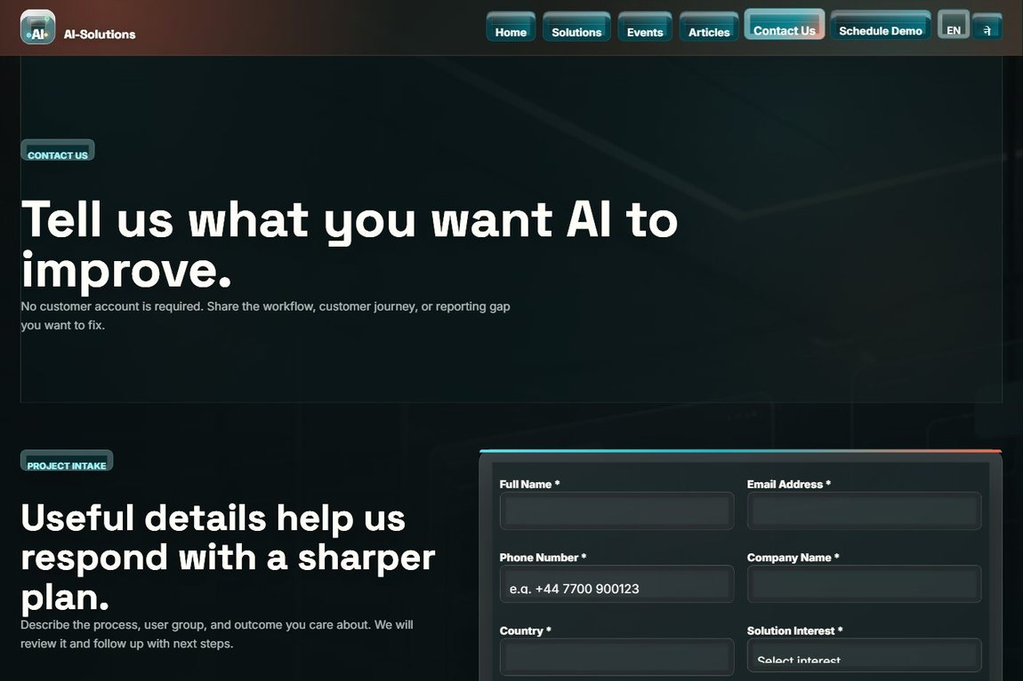

Test no. 3: Anti-spam protection (security check, honeypot, CSRF)
Description | Expected Result | Performed as Expected | If no, what happened? [Fixed / Unfixed]
Answer the security check incorrectly; trigger the hidden honeypot as a simulated bot; submit a form with a missing/invalid CSRF token. | Each attempt is rejected: a security-check error is shown, honeypot/bot submissions are silently dropped, and an invalid token is refused. | Yes | —
Evidence: Screenshot of the form security check (CAPTCHA) and protected submission.


Test no. 4: Submit a complete contact inquiry
Description | Expected Result | Performed as Expected | If no, what happened? [Fixed / Unfixed]
Fill in all inquiry fields, pass the security check, tick consent and submit. | A confirmation page is shown and the inquiry is saved to the database for admin review. | Yes | Live acknowledgement email needs SMTP. Until configured, the message is stored in the Email Outbox so none are lost. [Fixed]
Evidence: Screenshot of the success / confirmation page after a valid submission.
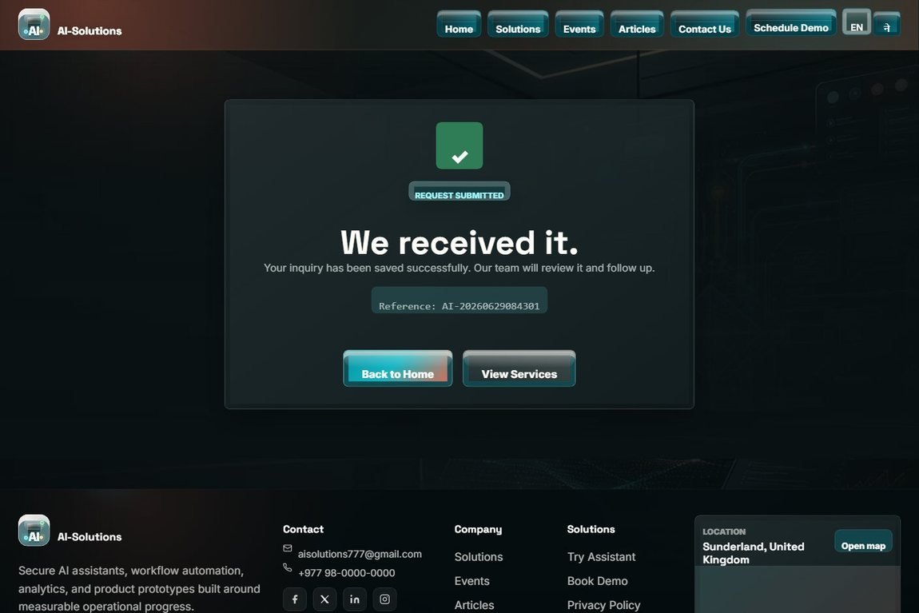

Test no. 5: Consent required before submission
Description | Expected Result | Performed as Expected | If no, what happened? [Fixed / Unfixed]
Try to submit the Schedule Demo form without ticking the data-consent checkbox. | Submission is blocked until consent is given; the consent is then recorded with the booking. | Yes | The demo form first allowed submission with no consent. Added a required checkbox plus a server-side check. [Fixed]
Evidence: Screenshot of the booking form with the required consent checkbox.
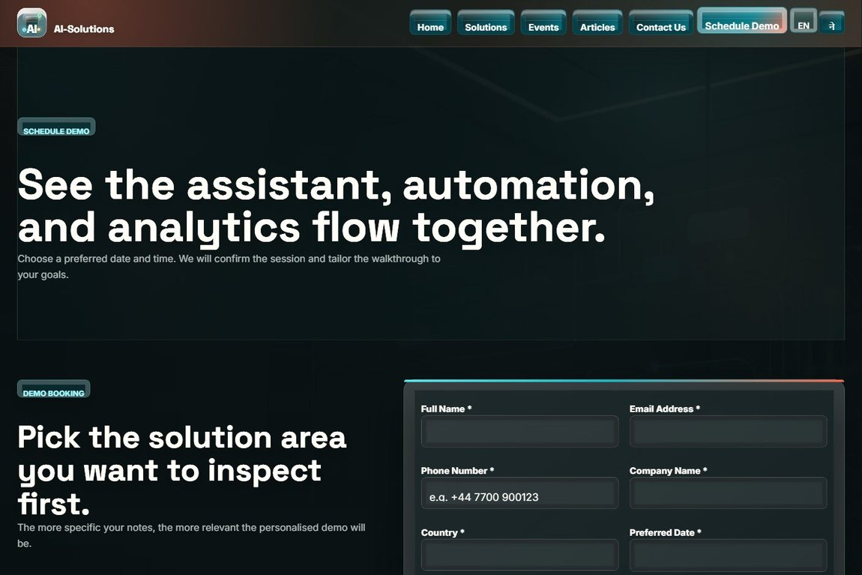

Test no. 6: Schedule a personalised demo
Description | Expected Result | Performed as Expected | If no, what happened? [Fixed / Unfixed]
Open Schedule Demo, choose a date and time, pick a solution, add notes, give consent and submit. | The booking is stored and a confirmation is shown; the past-date guard blocks invalid dates. | Yes | —
Evidence: Screenshot of the schedule-demo booking form.


Test no. 7: Event registration (future event)
Description | Expected Result | Performed as Expected | If no, what happened? [Fixed / Unfixed]
Open an upcoming event and complete the "Join our Events" registration form. | The Register option is available; the registration is stored and a confirmation is shown. | Yes | —
Evidence: Screenshot of the events page and the registration form.
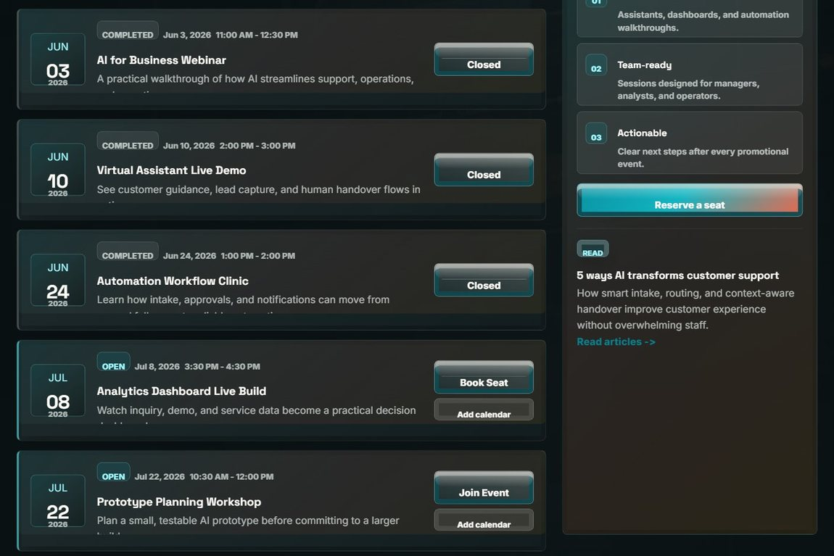

Test no. 8: Add an event to calendar (.ics)
Description | Expected Result | Performed as Expected | If no, what happened? [Fixed / Unfixed]
Use "Add to calendar" on an event. | A valid .ics calendar file downloads and imports into the calendar application with the correct date and time. | Yes | —
Evidence: Screenshot of the events page with the add-to-calendar option.
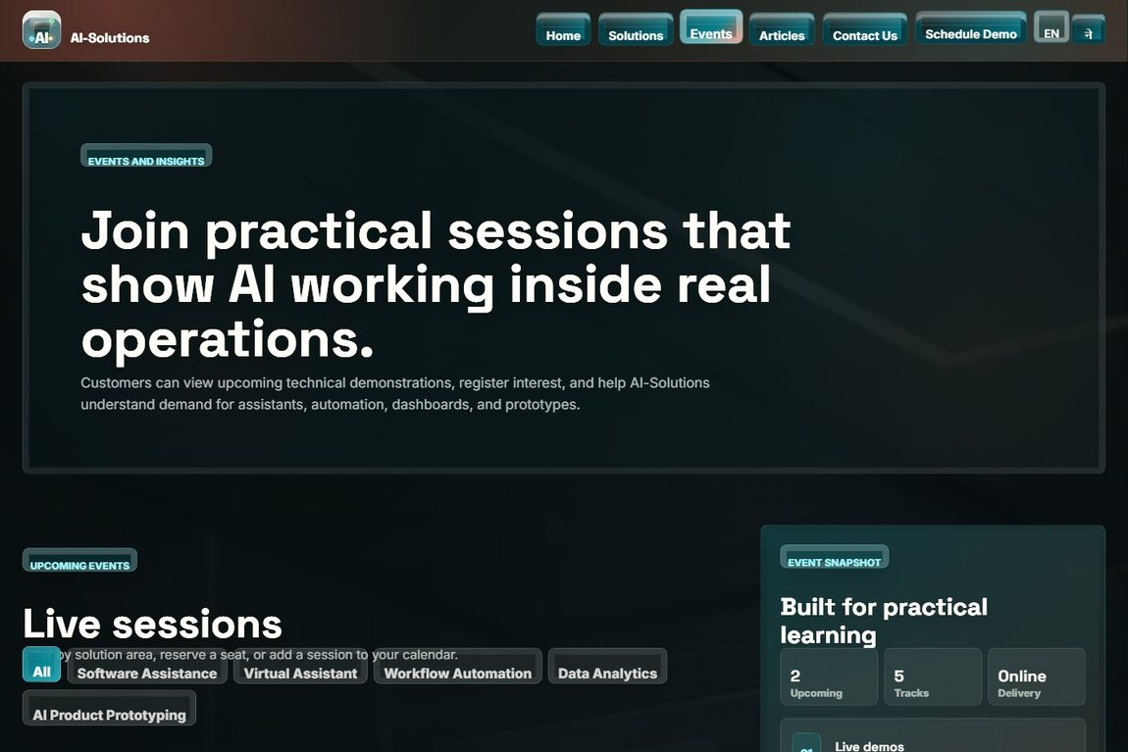

Test no. 9: Photo gallery and upcoming events
Description | Expected Result | Performed as Expected | If no, what happened? [Fixed / Unfixed]
Open the Events page to view the photo gallery and the upcoming events. | The gallery images and the list of upcoming events are displayed correctly. | Yes | —
Evidence: Screenshot of the events and gallery section.


Test no. 10: Browse solutions and filters
Description | Expected Result | Performed as Expected | If no, what happened? [Fixed / Unfixed]
Open the Solutions page and apply the capability/industry filters. | The solution list narrows to the matching solutions. | Yes | —
Evidence: Screenshot of the Solutions page with filters and solution cards.


Test no. 11: Submit a solution review and rating
Description | Expected Result | Performed as Expected | If no, what happened? [Fixed / Unfixed]
Submit a star rating and review for a solution. | The review is stored for admin moderation and a confirmation is shown. | Yes | —
Evidence: Screenshot of the solution reviews / rating area.
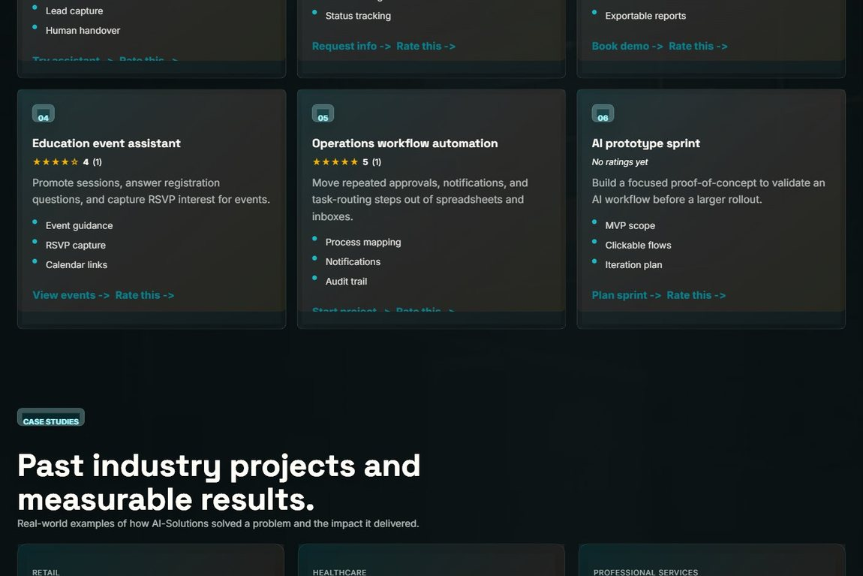

Test no. 12: Submit visitor feedback rating
Description | Expected Result | Performed as Expected | If no, what happened? [Fixed / Unfixed]
Use the visitor feedback form to leave a rating and message. | The feedback is saved and can be featured by the admin as a testimonial. | Yes | —
Evidence: Screenshot of the visitor feedback / rating form.
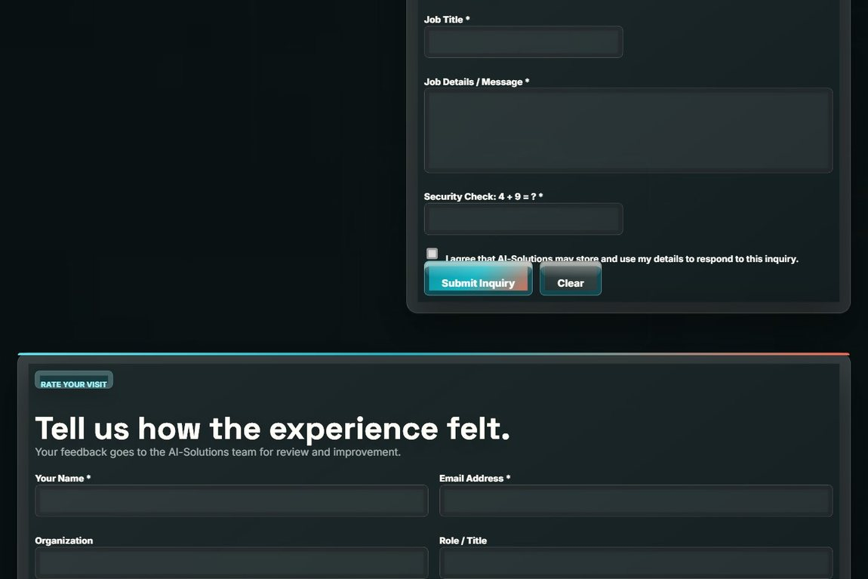

Test no. 13: Read articles and open an article
Description | Expected Result | Performed as Expected | If no, what happened? [Fixed / Unfixed]
Open the Articles page, page through it, and open a single article. | Article cards with categories and pagination display; the full article opens correctly. | Yes | —
Evidence: Screenshot of the articles listing (and article detail page).


Test no. 14: AI assistant (chatbot) response
Description | Expected Result | Performed as Expected | If no, what happened? [Fixed / Unfixed]
Ask the AI assistant about services, pricing or demos and use the quick-action buttons. | The assistant returns a relevant answer with quick actions and can route to pages. | Yes | If the AI API is unreachable on localhost, the built-in knowledge base answers automatically. [Fixed]
Evidence: Screenshot of a chatbot conversation.
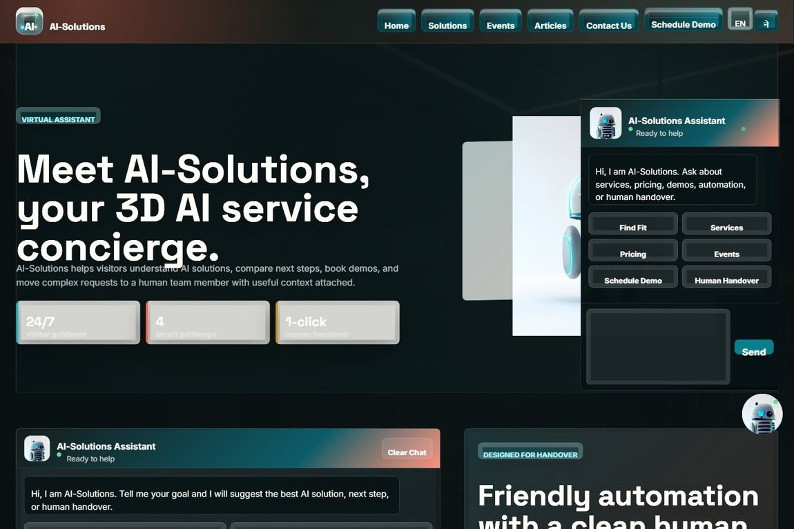

Test no. 15: Chatbot human handover
Description | Expected Result | Performed as Expected | If no, what happened? [Fixed / Unfixed]
Request a human handover from the assistant and submit the handover form. | The handover form opens pre-filled with the conversation summary; the lead is stored. | Yes | —
Evidence: Screenshot of the human-support handover form.
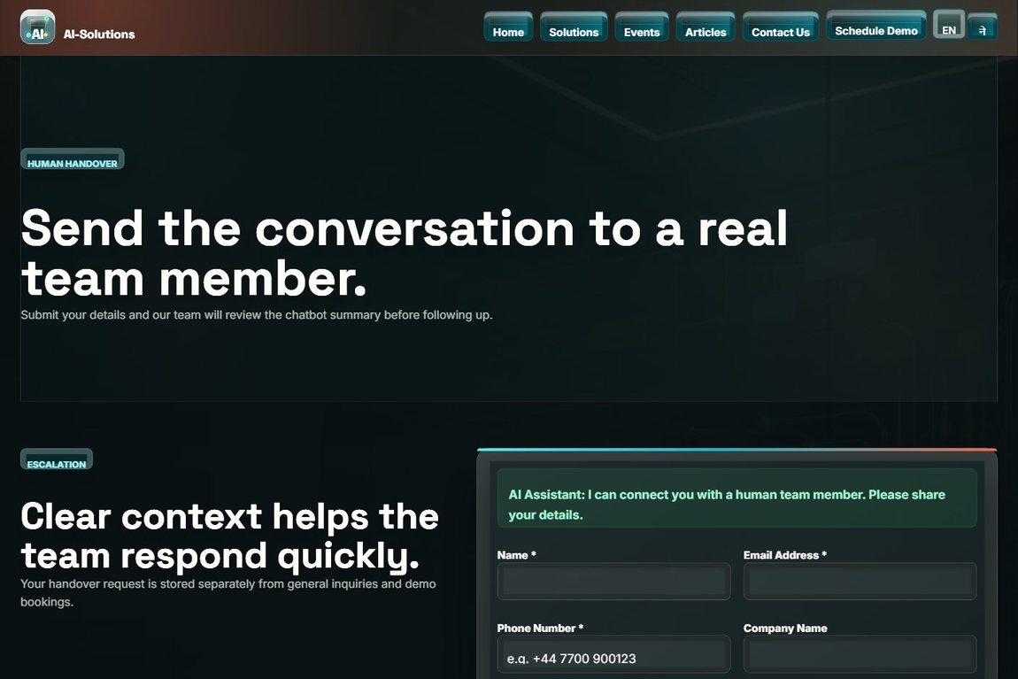

Test no. 16: Cookie consent banner
Description | Expected Result | Performed as Expected | If no, what happened? [Fixed / Unfixed]
Open the site as a first-time visitor and respond to the cookie consent banner. | The banner appears once; the choice is remembered and the banner does not reappear on the next visit. | Yes | —
Evidence: Screenshot of a public page (cookie consent banner shown on first visit).
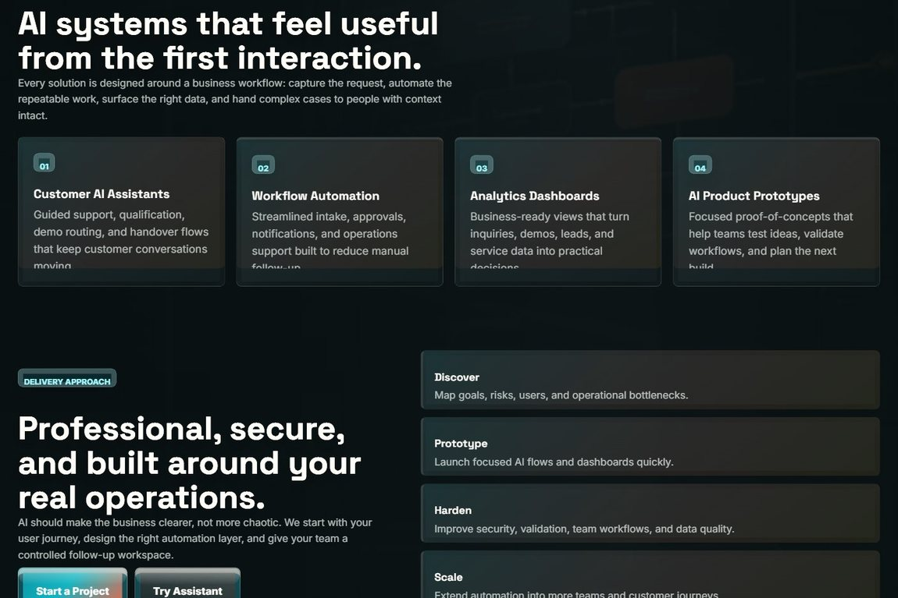

Test no. 17: Language switch (English / Nepali)
Description | Expected Result | Performed as Expected | If no, what happened? [Fixed / Unfixed]
Use the EN / ne language toggle in the navigation bar. | The configured labels and messages switch language and the choice is applied across pages. | Yes | —
Evidence: Screenshot of the navigation language toggle (EN / ne).


Test no. 18: Location map (current GPS)
Description | Expected Result | Performed as Expected | If no, what happened? [Fixed / Unfixed]
Allow location permission for the footer map on any public page. | The map re-centres on the visitor current GPS location with a place label. | Yes | The footer map first showed a fixed pin. Updated to use the browser Geolocation API with an IP-based fallback. [Fixed]
Evidence: Screenshot of the footer location map.
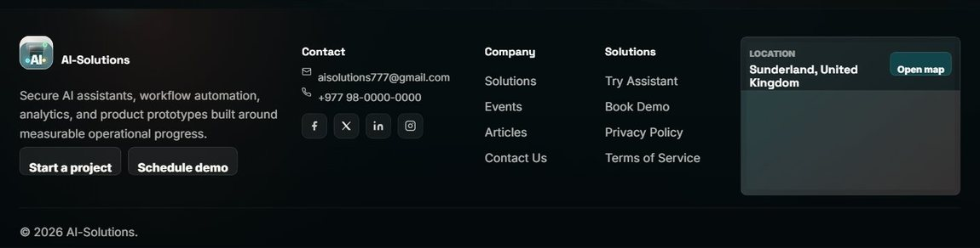

Admin-side functional requirements
Test no. 19: Admin login with wrong password
Description | Expected Result | Performed as Expected | If no, what happened? [Fixed / Unfixed]
Enter a correct username with an incorrect password on the admin login page. | Login fails with an "invalid username or password" message. | Yes | —
Evidence: Screenshot of the admin login page / failed-login message.
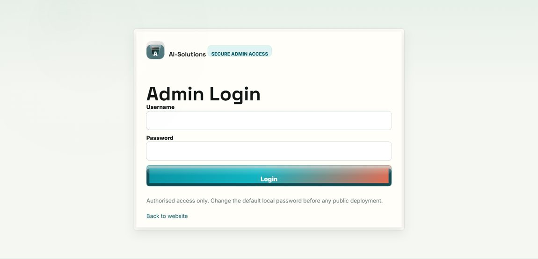

Test no. 20: Brute-force lockout
Description | Expected Result | Performed as Expected | If no, what happened? [Fixed / Unfixed]
Enter the wrong password five times in a row. | The account is temporarily locked (about five minutes) and further attempts are refused. | Yes | —
Evidence: Screenshot of the login page showing the lockout message.


Test no. 21: Admin login with valid credentials
Description | Expected Result | Performed as Expected | If no, what happened? [Fixed / Unfixed]
Log in with the correct admin username and password. | The admin dashboard opens and a session is created. | Yes | —
Evidence: Screenshot of the admin dashboard after a successful login.
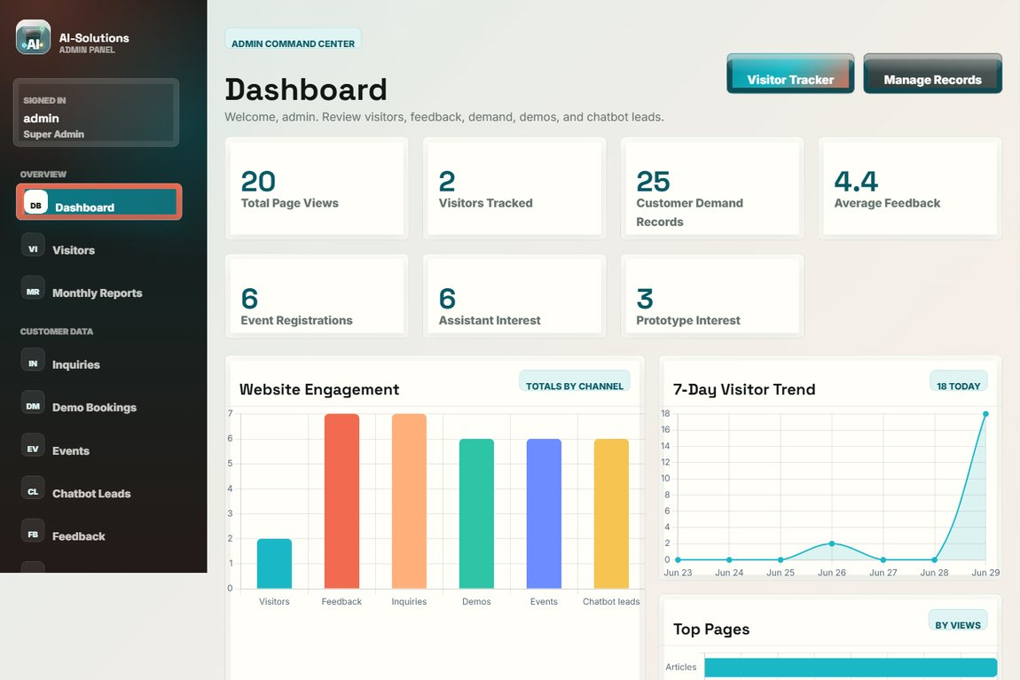

Test no. 22: Dashboard analytics and charts
Description | Expected Result | Performed as Expected | If no, what happened? [Fixed / Unfixed]
Open the dashboard and review the totals and analytics charts. | Stat cards and bar/line/doughnut charts render from the live data. | Yes | —
Evidence: Screenshot of the dashboard analytics charts.
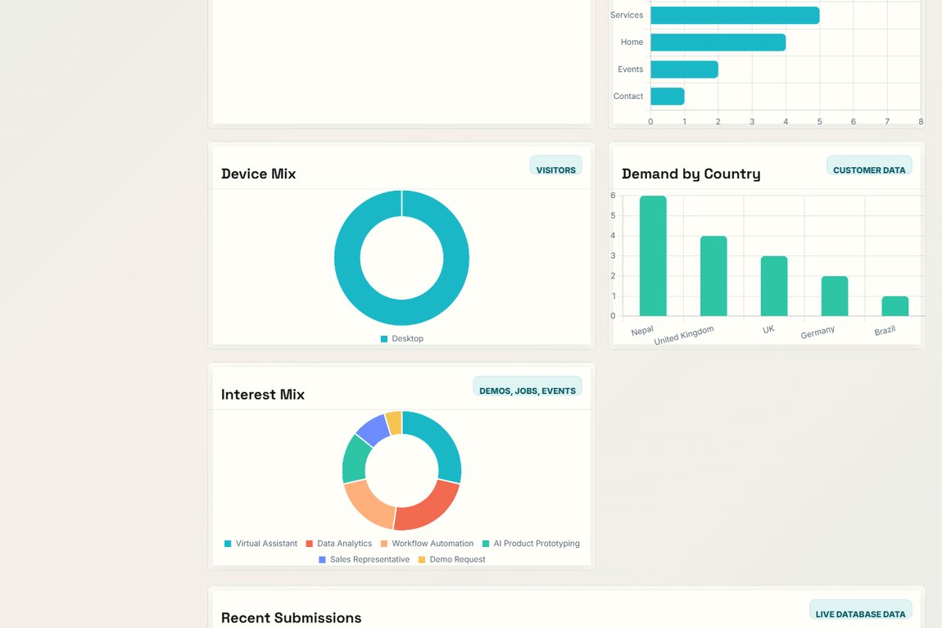

Test no. 23: View and search customer inquiries
Description | Expected Result | Performed as Expected | If no, what happened? [Fixed / Unfixed]
Open Customer Inquiries and search by name, email, company or country. | All inquiries are listed; the search filters to the matching records only. | Yes | —
Evidence: Screenshot of the inquiry records list with the search bar.
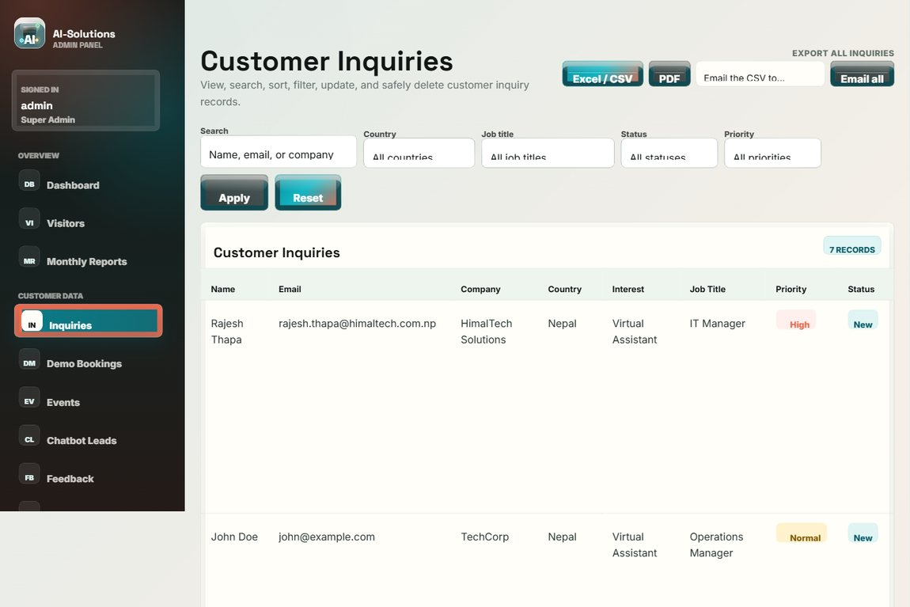

Test no. 24: Edit and delete inquiry records
Description | Expected Result | Performed as Expected | If no, what happened? [Fixed / Unfixed]
Open a record to edit its fields, status and admin note; then delete a record and confirm the prompt. | Edits are saved (updated_at set); the record is removed only after confirmation; both actions are logged. | Yes | The editor first changed only status/note. Extended it to edit every record field. [Fixed]
Evidence: Screenshot of the inquiry records with the View / Edit / Delete actions.


Test no. 25: Download inquiry CSV and PDF
Description | Expected Result | Performed as Expected | If no, what happened? [Fixed / Unfixed]
Export the inquiry records (single and all) to CSV and PDF. | Valid CSV and PDF files download and open correctly. | Yes | —
Evidence: Screenshot of the records page with the export (CSV / PDF) controls.


Test no. 26: Email a record (CSV) to the customer
Description | Expected Result | Performed as Expected | If no, what happened? [Fixed / Unfixed]
Use the Email action to send a record as a CSV attachment to the customer. | The email with the CSV attachment is sent via SMTP, or queued to the outbox if SMTP is off. | Yes | The first version attached a PDF via PHP mail() and failed on XAMPP. Changed to a CSV sent over SMTP. [Fixed]
Evidence: Screenshot of the email outbox / sent record.
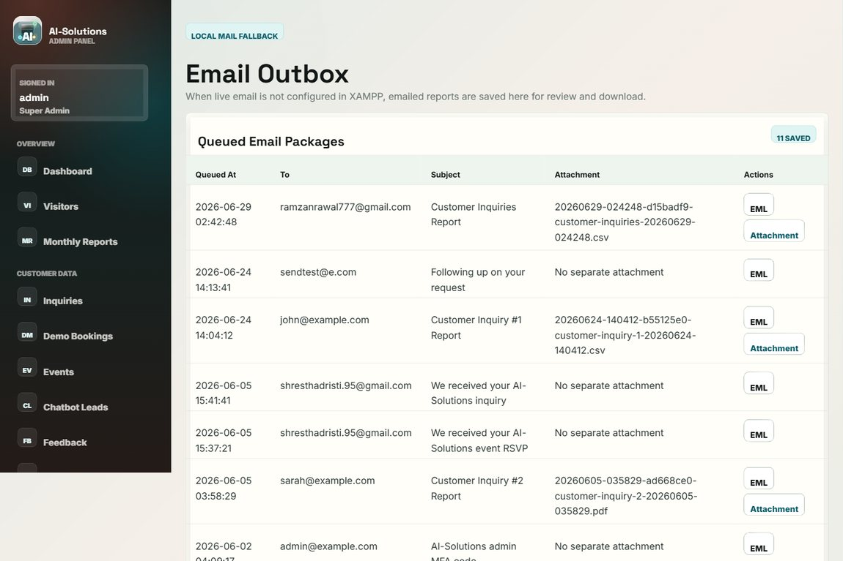

Test no. 27: Manage demo bookings
Description | Expected Result | Performed as Expected | If no, what happened? [Fixed / Unfixed]
Open Demo Bookings and manage the scheduled demo requests. | Demo bookings are listed with view / edit / delete / export options. | Yes | —
Evidence: Screenshot of the demo bookings admin page.
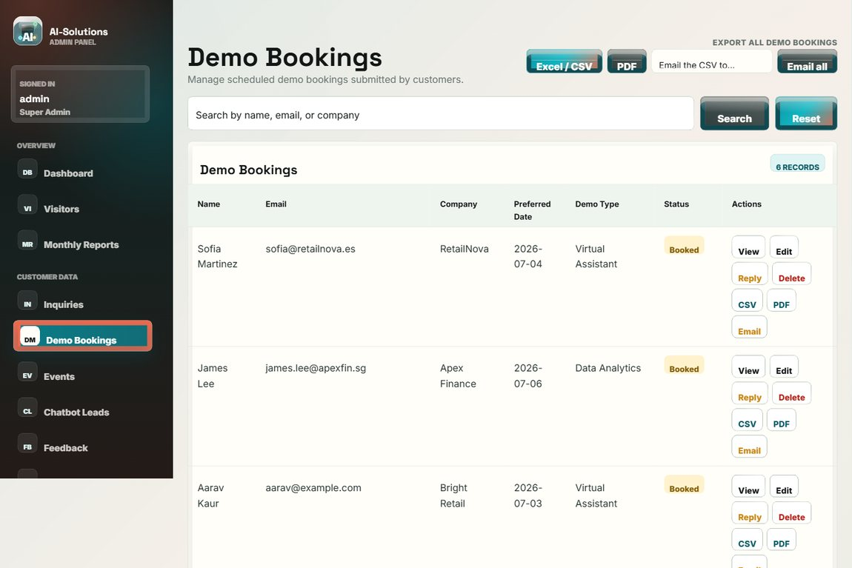

Test no. 28: Manage event registrations
Description | Expected Result | Performed as Expected | If no, what happened? [Fixed / Unfixed]
Open Event Registrations to review "Join our Events" submissions. | All event registrations are listed for review and export. | Yes | —
Evidence: Screenshot of the event registrations admin page.
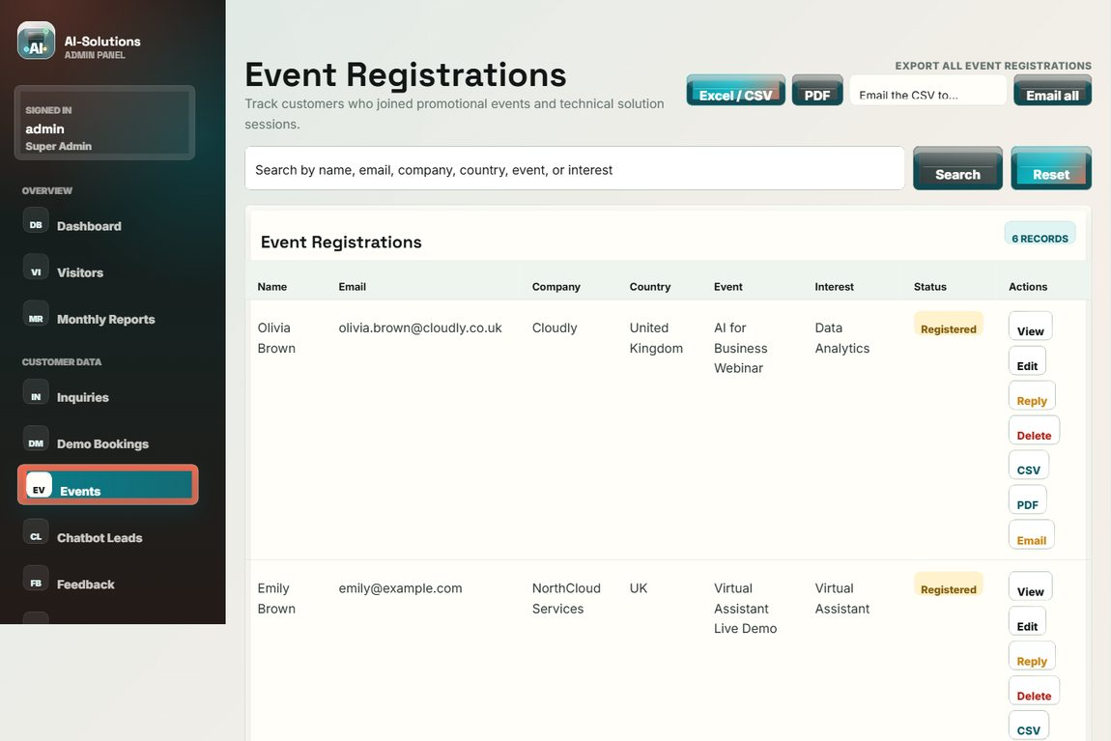

Test no. 29: Manage chatbot leads
Description | Expected Result | Performed as Expected | If no, what happened? [Fixed / Unfixed]
Open Chatbot Leads to review handover leads. | Leads captured from the assistant (topic and summary) are listed for follow-up. | Yes | —
Evidence: Screenshot of the chatbot leads admin page.
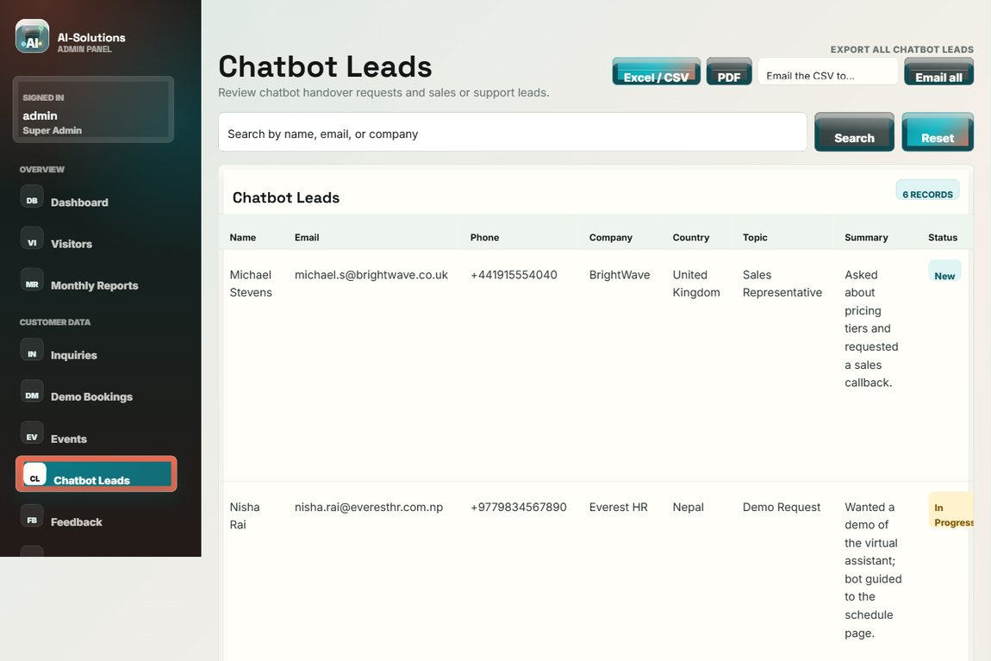

Test no. 30: Moderate visitor feedback
Description | Expected Result | Performed as Expected | If no, what happened? [Fixed / Unfixed]
Open Visitor Feedback and feature a testimonial. | Ratings and messages are listed; entries can be marked as featured testimonials. | Yes | —
Evidence: Screenshot of the visitor feedback admin page.
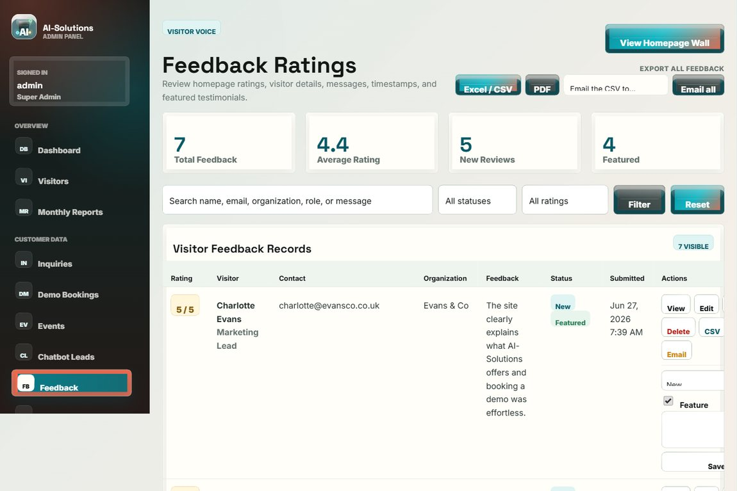

Test no. 31: Moderate solution reviews
Description | Expected Result | Performed as Expected | If no, what happened? [Fixed / Unfixed]
Open Solution Reviews to approve or remove submitted reviews. | Per-solution reviews can be moderated (approve / feature / remove). | Yes | —
Evidence: Screenshot of the solution reviews moderation page.
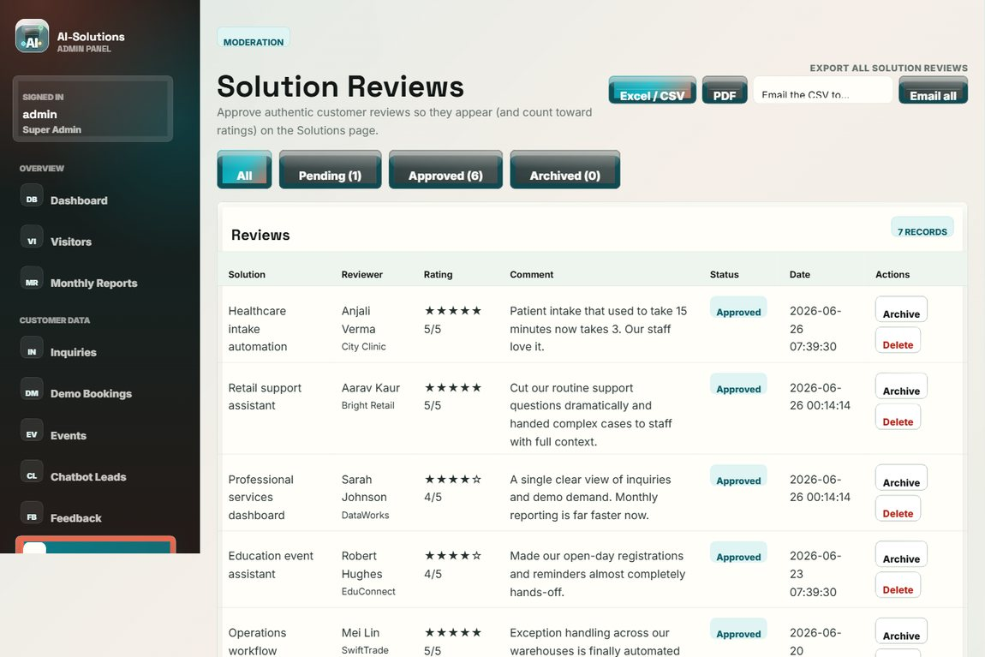

Test no. 32: Manage website content
Description | Expected Result | Performed as Expected | If no, what happened? [Fixed / Unfixed]
Use the Content Manager to create, edit and delete articles/events/content items. | Content changes are saved and reflected on the public site. | Yes | —
Evidence: Screenshot of the Content Manager.
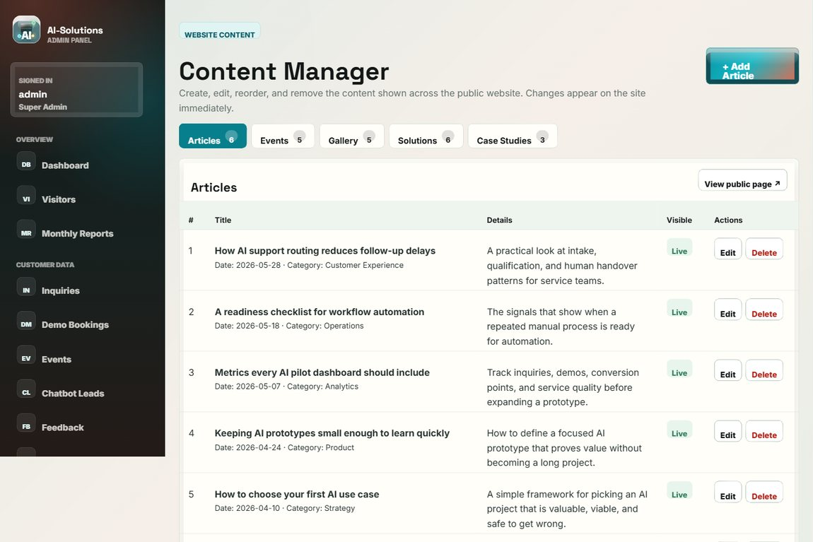

Test no. 33: Visitor tracker
Description | Expected Result | Performed as Expected | If no, what happened? [Fixed / Unfixed]
Open the Visitor Tracker after browsing public pages. | Each visit is logged with device type, browser and timestamp. | Yes | —
Evidence: Screenshot of the visitor tracker.
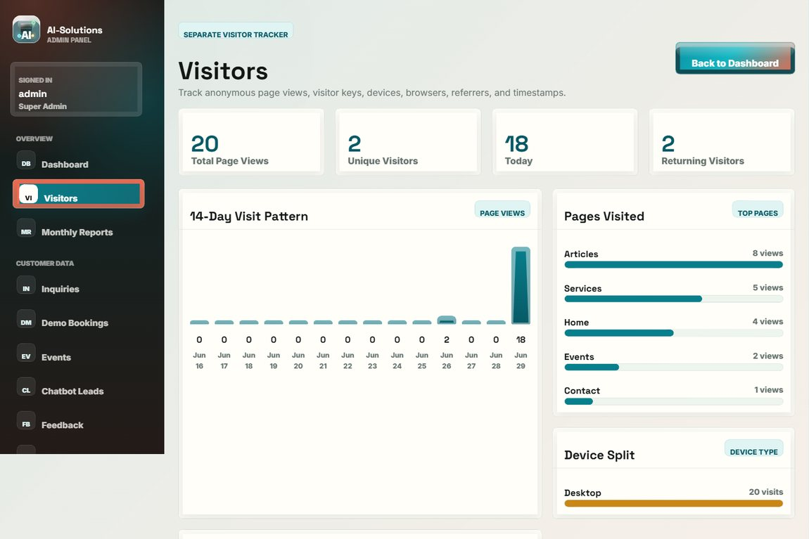

Test no. 34: Monthly report
Description | Expected Result | Performed as Expected | If no, what happened? [Fixed / Unfixed]
Open the Monthly Report. | Period metrics for customer demand are summarised. | Yes | —
Evidence: Screenshot of the monthly report.
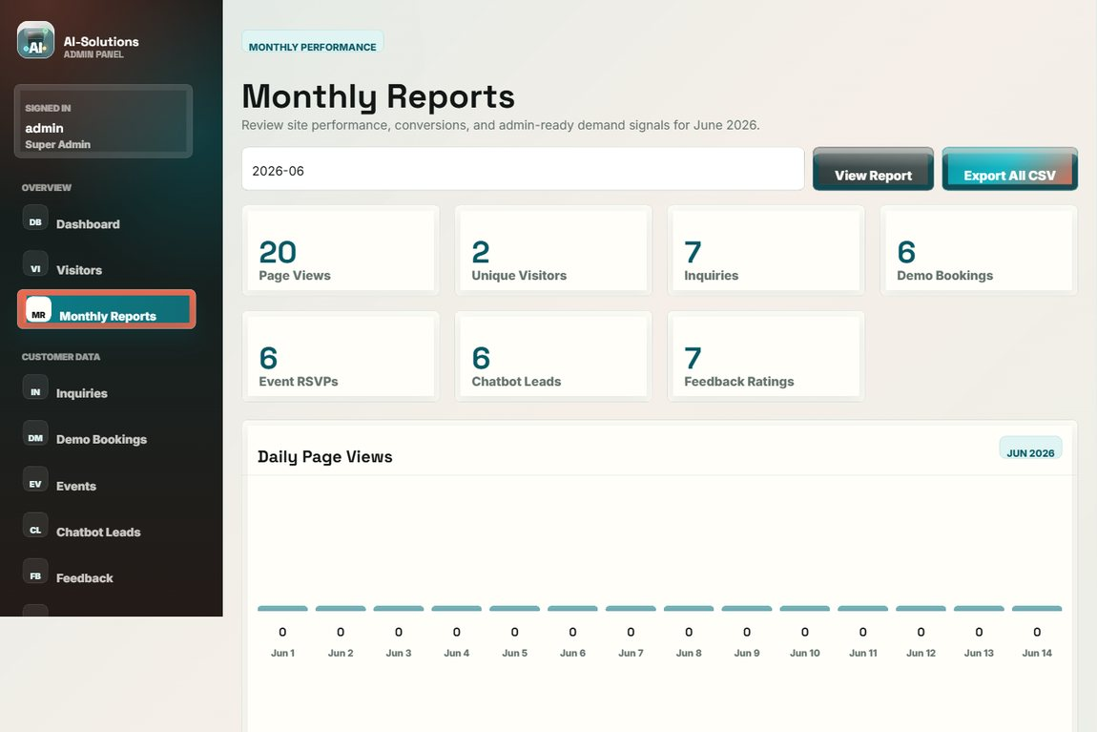

Test no. 35: Send email to a customer
Description | Expected Result | Performed as Expected | If no, what happened? [Fixed / Unfixed]
Compose and send an email to a customer from the admin panel. | The email is sent (or queued) through the configured SMTP server and the action is logged. | Yes | —
Evidence: Screenshot of the sent email recorded in the outbox.


Test no. 36: Configure SMTP settings
Description | Expected Result | Performed as Expected | If no, what happened? [Fixed / Unfixed]
Open SMTP Settings and save the mail-server configuration. | The settings are saved and the stored password is masked. | Yes | —
Evidence: Screenshot of the SMTP settings page.
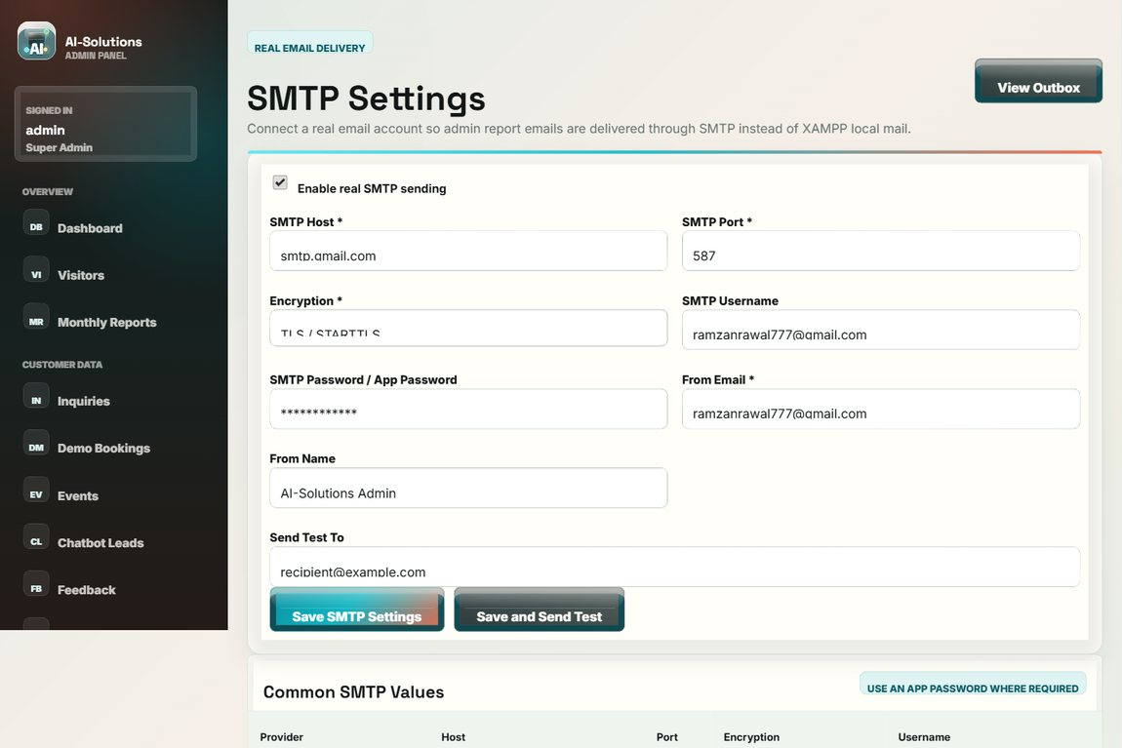

Test no. 37: Security and two-factor authentication
Description | Expected Result | Performed as Expected | If no, what happened? [Fixed / Unfixed]
Open the Security page to change the password and enable two-factor authentication. | The password can be changed and 2FA can be enabled for stronger admin protection. | Yes | —
Evidence: Screenshot of the account security / 2FA page.
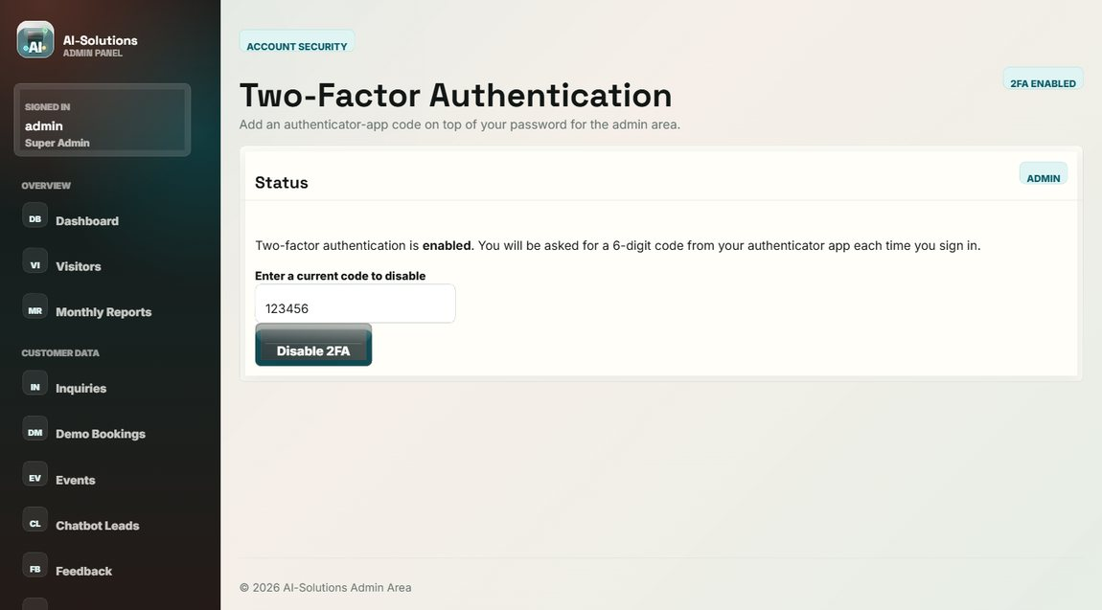

Test no. 38: Activity log (audit trail)
Description | Expected Result | Performed as Expected | If no, what happened? [Fixed / Unfixed]
Open the Activity Log to review recorded admin actions. | Logins, views, updates, deletions and exports are recorded with timestamps. | Yes | —
Evidence: Screenshot of the admin activity log.
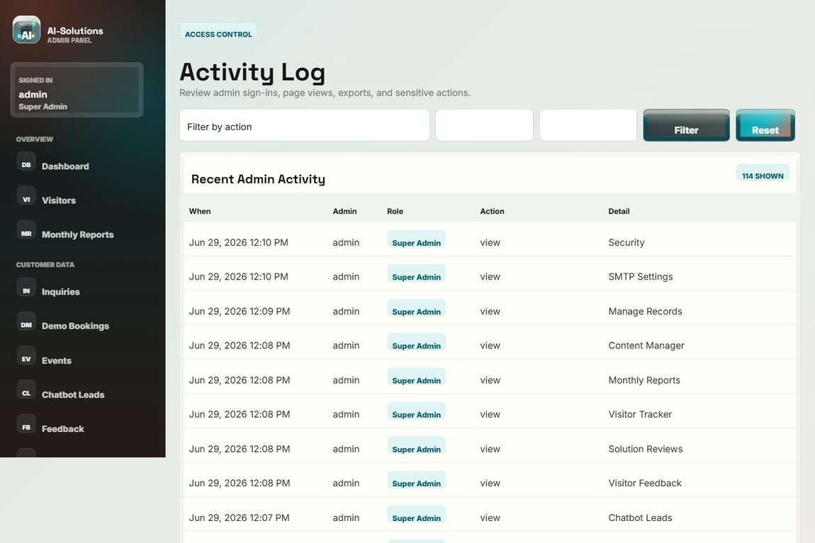

Test no. 39: Logout
Description | Expected Result | Performed as Expected | If no, what happened? [Fixed / Unfixed]
Click Logout in the admin sidebar. | The session is ended and the login page is shown; protected pages are no longer accessible. | Yes | —
Evidence: Screenshot of the login page after logout.


Non-functional requirements
Test no. 40: Responsive layout
Description | Expected Result | Performed as Expected | If no, what happened? [Fixed / Unfixed]
Open the site at desktop, tablet and mobile widths. | The layout adapts to each width and the mobile menu works; no horizontal scrolling. | Yes | —
Evidence: Screenshot of the layout (tested at desktop / tablet / mobile widths).


Test no. 41: Cross-browser compatibility
Description | Expected Result | Performed as Expected | If no, what happened? [Fixed / Unfixed]
Open the site in Google Chrome, Microsoft Edge and Mozilla Firefox. | The site renders and behaves consistently across the three browsers. | Yes | —
Evidence: Screenshot of the site rendering (verified in Chrome / Edge / Firefox).


Test no. 42: Performance / page load
Description | Expected Result | Performed as Expected | If no, what happened? [Fixed / Unfixed]
Open the public pages on the local server and observe load time. | Pages load within approximately three seconds. | Yes | —
Evidence: Screenshot of a page that loads quickly on localhost.


Test no. 43: Input security (SQL injection / XSS)
Description | Expected Result | Performed as Expected | If no, what happened? [Fixed / Unfixed]
Enter a SQL-injection string in the admin search and script text in a form field. | No breach occurs (prepared statements); script input is stored and rendered escaped. | Yes | —
Evidence: Screenshot of the search after a SQL-injection attempt (no breach).


Test no. 44: Admin session protection
Description | Expected Result | Performed as Expected | If no, what happened? [Fixed / Unfixed]
Open an admin URL directly while logged out. | The user is redirected to the login page; no admin data is exposed. | Yes | —
Evidence: Screenshot of the redirect to the login page.


Test no. 45: Accessibility
Description | Expected Result | Performed as Expected | If no, what happened? [Fixed / Unfixed]
Navigate with the keyboard and the skip link, and turn on the operating-system "reduce motion" setting. | All controls are reachable by keyboard, the skip link works, and decorative animations are switched off. | Yes | —
Evidence: Screenshot of the page used for keyboard / skip-link / reduced-motion checks.


Test no. 46: Credential and data security
Description | Expected Result | Performed as Expected | If no, what happened? [Fixed / Unfixed]
Inspect how the admin password and visitor IP addresses are stored. | The password is stored only as a bcrypt hash and visitor IP addresses are stored hashed (privacy / GDPR). | Yes | —
Evidence: Screenshot of the security page (password is hashed, never stored in plain text).


Test no. 47: CSV file format
Description | Expected Result | Performed as Expected | If no, what happened? [Fixed / Unfixed]
Export records and open the generated CSV file in a spreadsheet application. | The CSV has correct headers and one record per row; it opens cleanly in Excel. | Yes | —
Evidence: Screenshot of the export controls used to generate the CSV file.


Test no. 48: Privacy and GDPR
Description | Expected Result | Performed as Expected | If no, what happened? [Fixed / Unfixed]
Review the Privacy Policy, Terms, the consent capture on forms and the cookie banner. | Policy and terms pages exist, consent is recorded, and admin delete/export supports data rights. | Yes | —
Evidence: Screenshot of the Privacy Policy page.
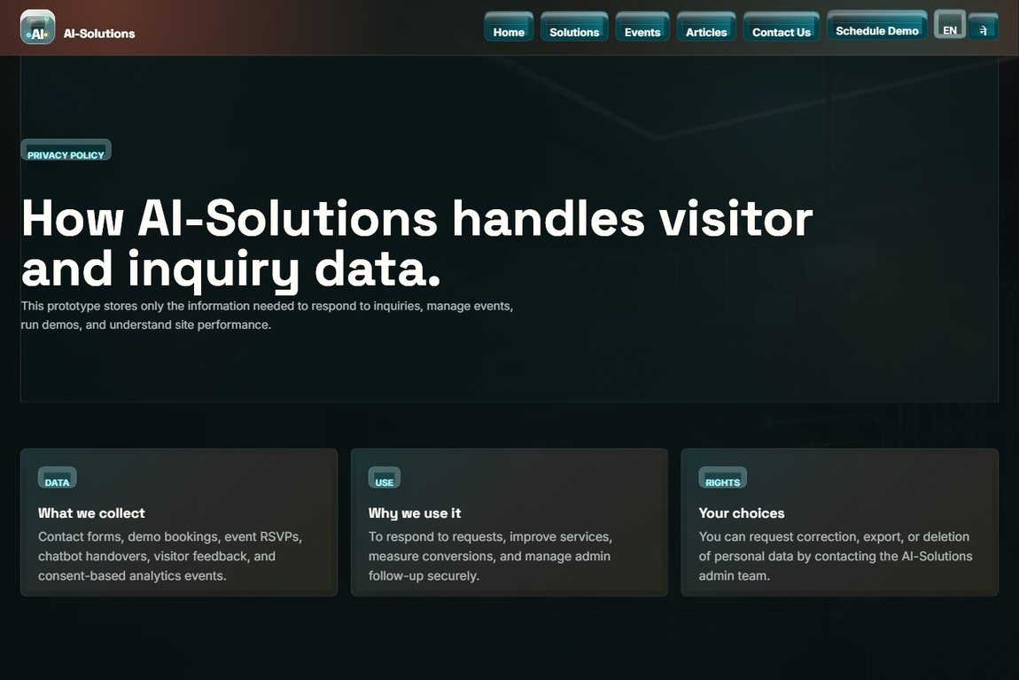

Conclusion
The black-box testing confirmed that the AI-Solutions system meets its agreed functional and non-functional requirements from both the user and administrator perspectives. Test cases were executed across every major feature - the public enquiry, booking and event journeys, the AI assistant and human handover, and the full administrative back office - and each produced the expected result, evidenced by the screenshots above. The few defects found during development, such as consent enforcement, the geolocation map and CSV email delivery, were corrected and successfully re-tested, as recorded in the results column. Validation, anti-spam, security, responsiveness, accessibility and data-privacy checks all passed, showing that the application behaves reliably and safely under both normal and invalid input. Overall, the system is stable, secure and fit for its intended purpose, and is considered ready for deployment.

