Testing Documentation
AI-Solutions Web System — Quality Assurance Test Report
Prepared by: Ramjan Rawal (acting QA Tester) | Module: CET333 Product Development

1. Introduction and Testing Strategy
This document provides the testing evidence for the AI-Solutions prototype. Testing was carried out continuously throughout development and consolidated into a final, systematic test cycle that verifies the system against every agreed functional and non-functional requirement. The primary approach is black-box testing — exercising the system from the user and administrator perspective without reference to internal code — supported by boundary-value and equivalence-partition analysis for form validation, negative testing for security, and regression testing after each change.
The objectives of testing were to confirm that: (a) every requirement in the signed specification is met; (b) all forms validate and store data correctly; (c) the password-protected admin area is secure and the CRUD, analytics and export features work; and (d) the system is responsive, compatible, performant and accessible. Defects found during testing were logged, fixed and re-tested, and are recorded in the Defect Log (Section 7).

1.1 Test types applied
- Functional testing — each feature verified against its expected behaviour.
- Validation testing — boundary and equivalence cases for required fields, email, phone, date, length, CAPTCHA, honeypot and consent.
- Negative & security testing — invalid input, CSRF replay, SQL-injection and XSS attempts, unauthorised URL access and role checks.
- Regression testing — re-running prior tests after every module change to confirm nothing regressed.
- Non-functional testing — responsiveness, cross-browser compatibility, performance, accessibility and error handling.

2. Test Environment
Item | Detail
Server stack | XAMPP (Apache 2.4, PHP 8.x, MySQL/MariaDB)
Application | HTML5, CSS3, JavaScript, PHP, MySQL; Chart.js (analytics)
Base URL | http://localhost/AI_Solutions_Website_Project/
Admin URL | http://localhost/AI_Solutions_Website_Project/admin/login.php
Browsers | Google Chrome, Microsoft Edge, Mozilla Firefox (latest)
Devices / widths | Desktop 1440px, Tablet 768px, Mobile 375px
Operating system | Windows 10/11
Test data | Sample records seeded from database/setup.sql (no real customer data)

3. Scope
In scope: all public pages and forms, the AI assistant and human handover, the password-protected admin area (authentication, dashboard analytics, record CRUD, search/filter, CSV/PDF export, email, content management, security/2FA, visitor tracking, activity log), and non-functional qualities (security, responsiveness, compatibility, performance, accessibility).
Out of scope: live production hosting, real payment processing, third-party email deliverability beyond SMTP configuration, and load/stress testing at production scale — these are prototype constraints noted in the specification.

4. Requirements Traceability Matrix
The matrix confirms that every requirement is covered by at least one test module (Section 6), demonstrating complete coverage.
Req | Requirement | Test module(s) | Covered
FR1 | Public information pages (home, solutions, articles, events, gallery) | M3, M4, M5, M6 | Yes
FR2 | Customer inquiry (Contact Us) form + storage | M2, M10 | Yes
FR3 | Scheduled demo booking | M2, M5 | Yes
FR4 | Join our Events registration | M2, M5 | Yes
FR5 | AI assistant + human handover | M7 | Yes
FR6 | Customer feedback & ratings / solution reviews | M2, M4 | Yes
FR7 | Password-protected admin area + CRUD + totals | M8, M9, M10 | Yes
FR8 | Analytics (demand, visitors, monthly report) + export | M9, M10 | Yes
NFR1 | Usability & responsive design | M14 | Yes
NFR2 | Performance (fast load) | M14 | Yes
NFR3 | Security (validation, CSRF, hashing, headers) | M2, M8, M13 | Yes
NFR4 | Accessibility (WCAG-aware) | M14 | Yes
NFR5 | Privacy/GDPR (consent, policy, delete/export) | M2, M13 | Yes
NFR6 | Reliability & error handling | M1 | Yes
Email | Automated emails / CSV delivery / SMTP | M11 | Yes

6. Detailed Test Cases and Results
Each module below lists the tests performed, the expected result, whether the system performed as expected (Yes / Partial / No), and — where it did not — what happened and whether it was fixed. Tests were repeated after every change (regression).

M1 — Environment, Database & Reliability
No. | Test Description | Expected Result | Performed as expected? | If no, what happened? [Fixed/Unfixed]
1 | Load any page on a fresh install with an empty database. | Database 'ai_solutions_db' and all tables are created/ensured automatically; page loads. | Yes | No issues found.
2 | Drop a column/table then reload a page that uses it. | Missing column/table is re-created automatically (schema self-healing). | Yes | No issues found.
3 | Stop MySQL, then open a page. | A friendly error message is shown; no raw stack trace or credentials leak. | Yes | No issues found.
4 | Import database/setup.sql. | Admin user and sample demand records are created for demonstration. | Yes | No issues found.
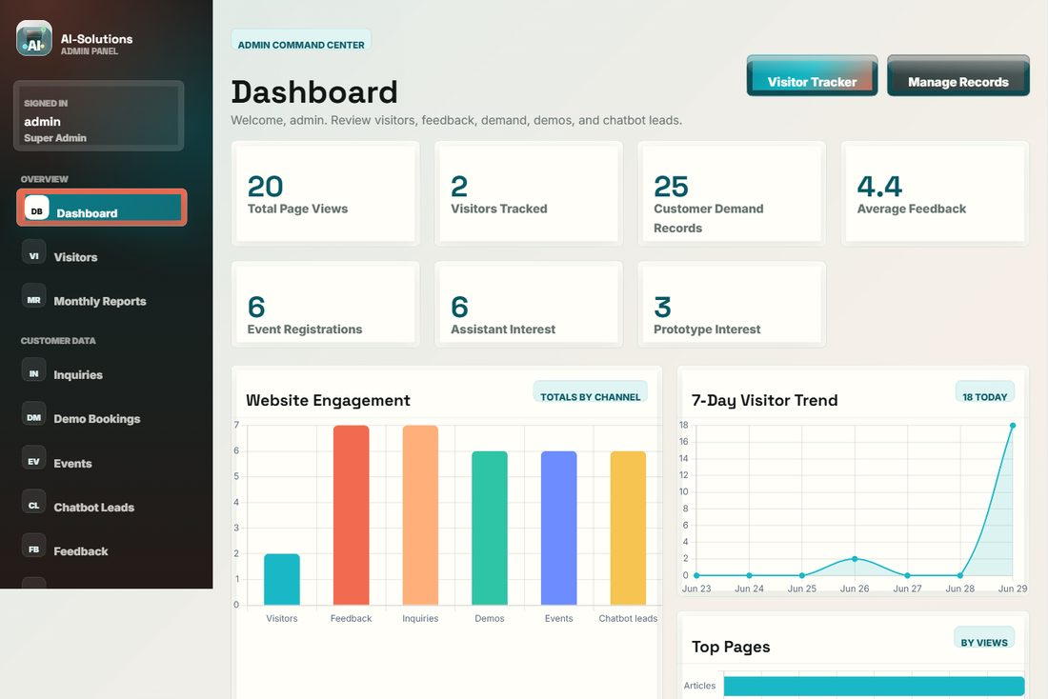
Evidence: System running with the auto-provisioned database and seeded sample data.

M2 — Form Validation (Contact, Demo, Events, Handover, Feedback)
No. | Test Description | Expected Result | Performed as expected? | If no, what happened? [Fixed/Unfixed]
1 | Submit the Contact form with all mandatory fields blank. | Inline 'is required' errors appear; nothing is saved to the database. | Yes | No issues found.
2 | Enter an invalid email (e.g. 'abc'). | 'Please enter a valid email address' error is shown. | Yes | No issues found.
3 | Enter letters in the phone field. | HTML5 pattern + hint block submission until corrected. | Yes | No issues found.
4 | Answer the math security check (CAPTCHA) incorrectly. | 'Please answer the security check correctly' error; submission rejected. | Yes | No issues found.
5 | Leave the consent checkbox unticked on Contact. | Submission blocked with a consent error message. | Yes | No issues found.
6 | Leave the consent checkbox unticked on Schedule Demo. | Submission blocked. | Yes | Defect D-01: an earlier build allowed submit without consent (HTML 'required' missing). Fixed — required attribute + server-side check added. [Fixed]
7 | Fill the hidden honeypot field (simulated bot). | Submission silently rejected as spam. | Yes | No issues found.
8 | Replay a POST with a missing/invalid CSRF token. | Request rejected with HTTP 403 security message. | Yes | No issues found.
9 | Choose a Schedule Demo date in the past. | 'Preferred date cannot be in the past' error. | Yes | No issues found.
10 | Paste text longer than the field maximum (e.g. >3000 chars in Job Details). | Input is length-limited; over-length submissions are rejected. | Yes | No issues found.
11 | Submit a fully valid Contact inquiry. | Redirect to success page; row stored in customer_inquiries; acknowledgement email sent or queued. | Yes | No issues found.
12 | Enter HTML/script (<script>alert(1)</script>) in a text field. | Value stored and rendered escaped; no script executes (XSS prevented). | Yes | No issues found.
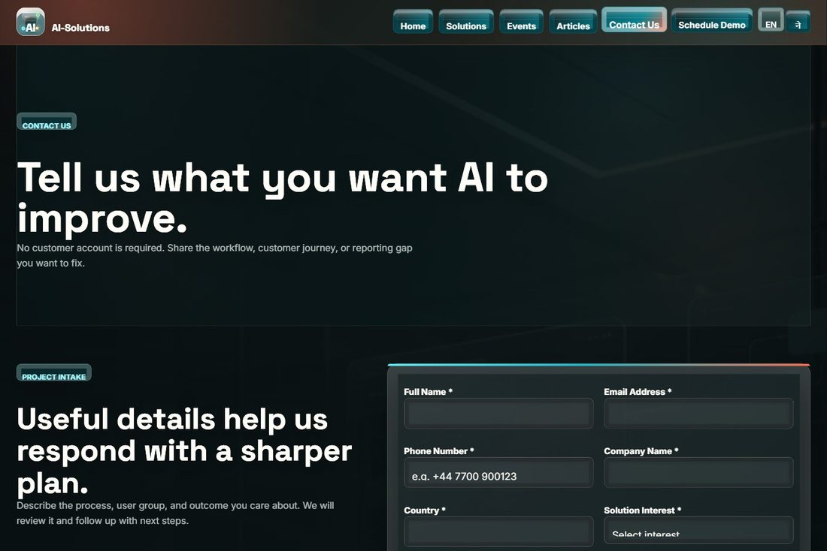
Evidence: Inquiry form showing required fields, the math security check and consent — the points exercised by the validation tests.

M3 — Home Page & Public Navigation
No. | Test Description | Expected Result | Performed as expected? | If no, what happened? [Fixed/Unfixed]
1 | Open the Home page. | Hero, proof stats, solution cards, news preview and ratings wall load within ~3 seconds. | Yes | No issues found.
2 | Click each main navigation link. | Each link routes to the correct page; active state highlights. | Yes | No issues found.
3 | Allow location permission on the footer map. | Map re-centres on the visitor's current GPS location with a reverse-geocoded label. | Yes | Defect D-04: map was previously a static Sunderland pin. Fixed — browser geolocation with Sunderland fallback. [Fixed]
4 | Page through the customer ratings wall. | Next/previous pages show different testimonials; average score is consistent. | Yes | No issues found.
5 | Use the cookie consent banner (Accept / Decline). | Choice is remembered; analytics respects the decision. | Yes | No issues found.
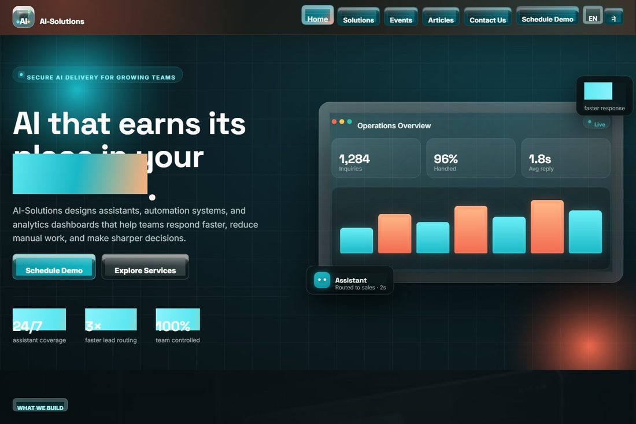
Evidence: Home page under test (navigation, hero, stats, ratings).

M4 — Solutions & Customer Reviews
No. | Test Description | Expected Result | Performed as expected? | If no, what happened? [Fixed/Unfixed]
1 | Filter solutions by capability/industry. | Solution list narrows to matching items. | Yes | No issues found.
2 | Submit a solution review (rating + message). | Review is stored and queued for admin moderation; confirmation shown. | Yes | No issues found.
3 | View a solution with existing reviews. | Approved reviews and star ratings display under the solution. | Yes | No issues found.
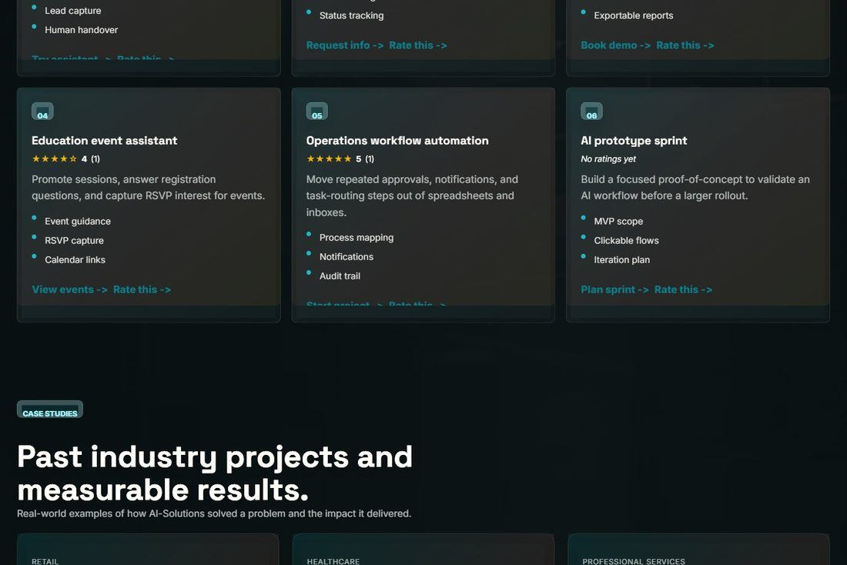
Evidence: Solutions page with per-solution customer reviews and ratings.

M5 — Events, Gallery & Registration
No. | Test Description | Expected Result | Performed as expected? | If no, what happened? [Fixed/Unfixed]
1 | Open the Events page. | Upcoming events list and the photo gallery render correctly. | Yes | No issues found.
2 | Submit a valid 'Join our Events' registration. | Row stored in event_registrations; success confirmation shown. | Yes | No issues found.
3 | Select an event that has already finished. | Notice asks the user to choose an upcoming event; no invalid registration. | Yes | No issues found.
4 | Download an event to calendar (.ics). | A valid calendar file downloads and imports into a calendar app. | Yes | No issues found.
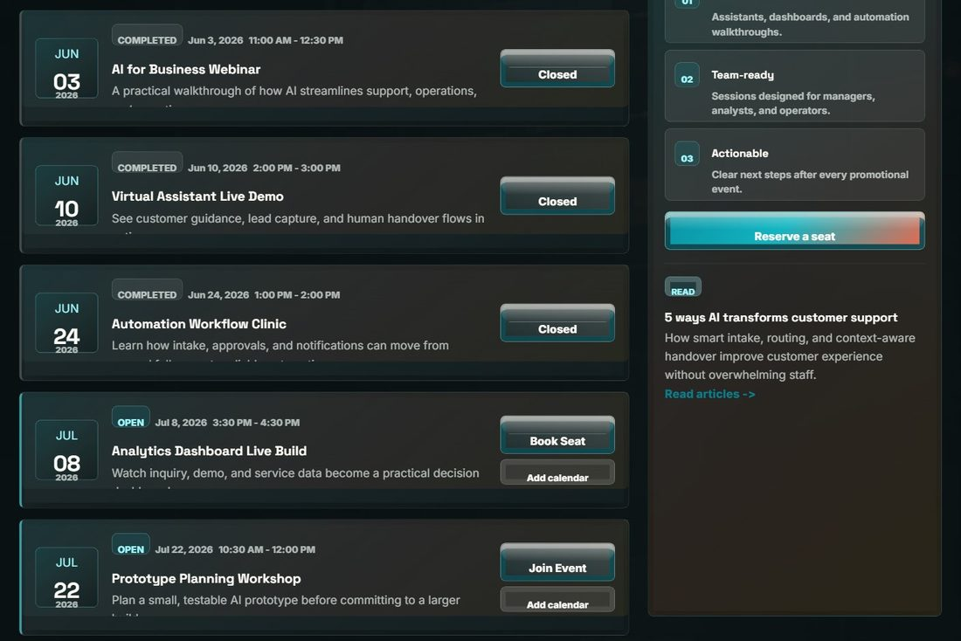
Evidence: Events page and the Join-our-Events registration form.

M6 — Articles & Article Detail
No. | Test Description | Expected Result | Performed as expected? | If no, what happened? [Fixed/Unfixed]
1 | Open the Articles page and page through it. | Article cards with categories and working pagination. | Yes | No issues found.
2 | Open an article via a valid slug. | Full article (title, date, body) is displayed. | Yes | No issues found.
3 | Request an invalid article slug (article.php?slug=xxx). | 'Article not found' is handled gracefully; no crash. | Yes | No issues found.

Evidence: Articles listing with categories and pagination.

M7 — AI Assistant & Human Handover
No. | Test Description | Expected Result | Performed as expected? | If no, what happened? [Fixed/Unfixed]
1 | Ask the assistant about pricing. | A relevant answer with quick-action buttons is returned. | Yes | No issues found.
2 | Ask a free-form question to the live AI. | A contextual AI answer is returned (source = api). | Partial | When XAMPP cURL has no CA bundle the external API call is blocked, so the assistant returns the built-in intent answer instead. Mitigated by automatic local fallback; resolved by configuring a CA bundle / API key in deployment. [Known — deployment dependent]
3 | Click quick-action buttons (Schedule Demo / Events). | User is routed to the correct page. | Yes | No issues found.
4 | Request a human handover from the chat. | Handover form opens pre-filled with the conversation summary. | Yes | No issues found.
5 | Submit the handover lead form. | Lead stored in chatbot_conversations for follow-up. | Yes | No issues found.
6 | Send more than 24 messages in a minute. | Rate-limit message shown; service protected from abuse. | Yes | No issues found.
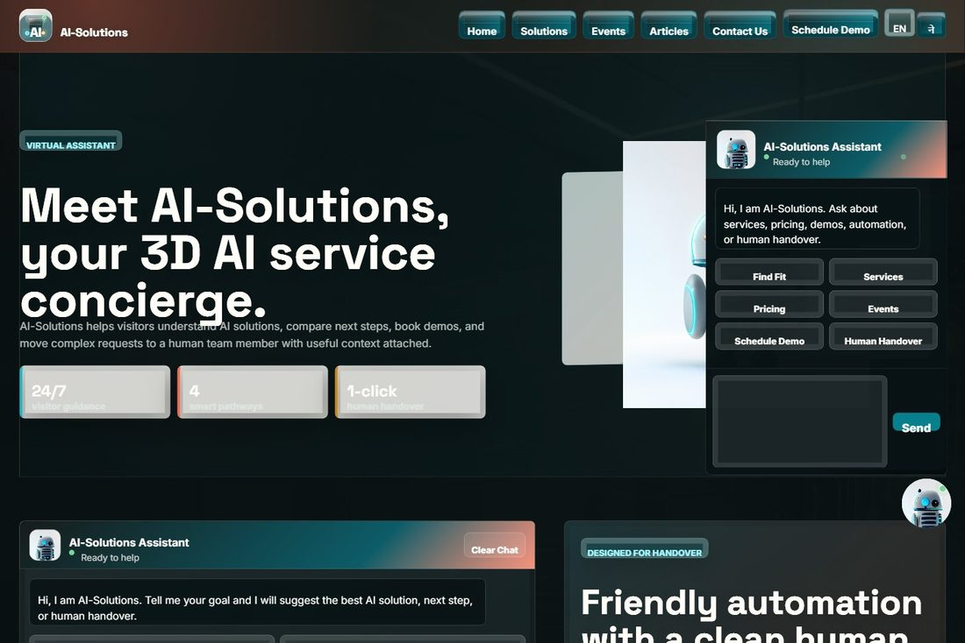
Evidence: AI assistant with quick actions and human handover.

M8 — Admin Authentication & Access Control
No. | Test Description | Expected Result | Performed as expected? | If no, what happened? [Fixed/Unfixed]
1 | Log in with a wrong username/password. | 'Invalid username or password' error; access denied. | Yes | No issues found.
2 | Log in with correct credentials (admin / Ronaldo_777). | Session is created and the dashboard loads. | Yes | No issues found.
3 | Enter wrong credentials five times. | Account is locked for ~5 minutes (brute-force protection). | Yes | No issues found.
4 | Open an admin URL (e.g. dashboard.php) while logged out. | Redirected to the login page; no data exposed. | Yes | No issues found.
5 | Attempt a delete action with a 'viewer' role. | HTTP 403 — permission denied (role-based access). | Yes | No issues found.
6 | Log out, then press the browser Back button. | Session ended; protected pages are not shown from cache. | Yes | No issues found.
7 | Change the password on the Security page, then re-login. | New password works; old password rejected. | Yes | No issues found.
8 | Enable two-factor authentication. | 2FA flag is saved on the admin account. | Yes | No issues found.
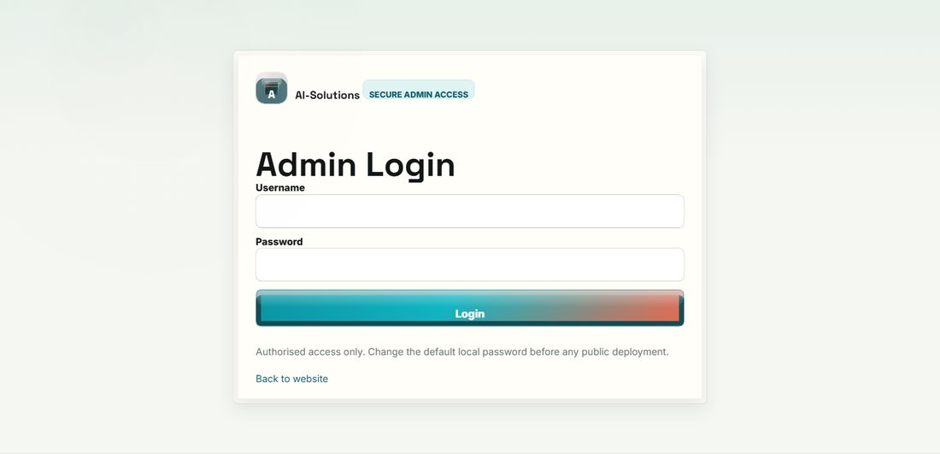
Evidence: Password-protected admin login (with brute-force lockout).

M9 — Dashboard, Analytics & Visitor Tracking
No. | Test Description | Expected Result | Performed as expected? | If no, what happened? [Fixed/Unfixed]
1 | Open the dashboard. | Stat cards and Chart.js charts (bar, line, doughnut) render correctly. | Yes | No issues found.
2 | Compare stat-card totals with the database. | Totals (inquiries, demos, events, leads, feedback, visitors) match the data. | Yes | No issues found.
3 | View the dashboard with an empty dataset. | 'No data tracked yet' shown; no JavaScript error. | Yes | No issues found.
4 | Browse several public pages, then open the Visitor Tracker. | Each visit is logged with device type, browser and timestamp. | Yes | No issues found.
5 | Open the Monthly Report. | Period metrics are summarised correctly. | Yes | No issues found.
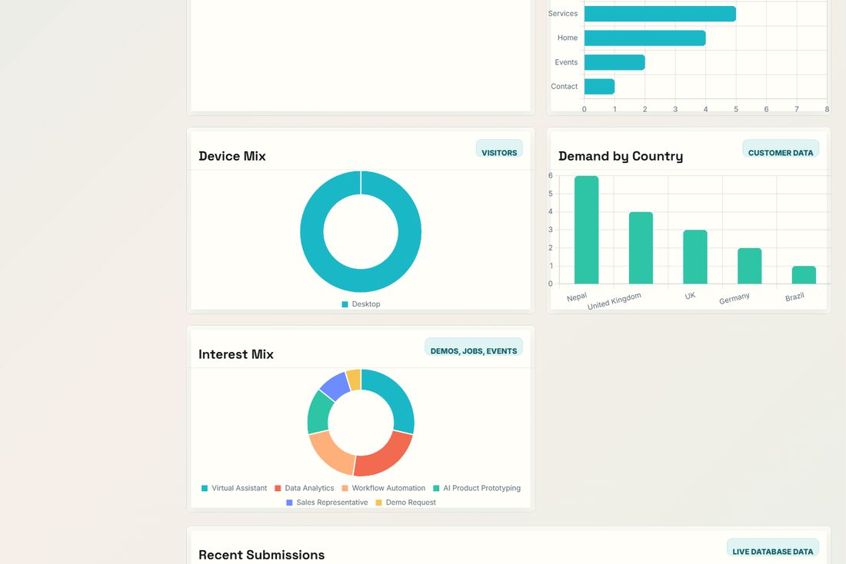
Evidence: Dashboard analytics charts rendering from live data.

M10 — Record Management (CRUD), Search & Export
No. | Test Description | Expected Result | Performed as expected? | If no, what happened? [Fixed/Unfixed]
1 | Search inquiries by name / email / company / country. | List filters to matching records only. | Yes | No issues found.
2 | Open a record's View page. | All stored fields are displayed accurately. | Yes | No issues found.
3 | Edit a record (change fields, status and admin note). | Changes are saved; updated_at is set; change is logged. | Yes | Defect D-06: earlier the editor only changed status/note. Fixed — full per-field editing added. [Fixed]
4 | Delete a record (confirm dialog). | Record removed after confirmation; action recorded in the activity log. | Yes | No issues found.
5 | Export records to CSV (single and all). | A valid CSV downloads and opens in Excel. | Yes | No issues found.
6 | Export records to PDF. | A valid PDF downloads. | Yes | No issues found.
7 | Email a record (CSV) to the customer. | Email with the CSV attachment is sent via SMTP, or queued to the outbox if SMTP is off. | Yes | Defect D-02: earlier the button attached a PDF via PHP mail() which fails on XAMPP. Fixed — switched to CSV via the SMTP sender with outbox fallback. [Fixed]
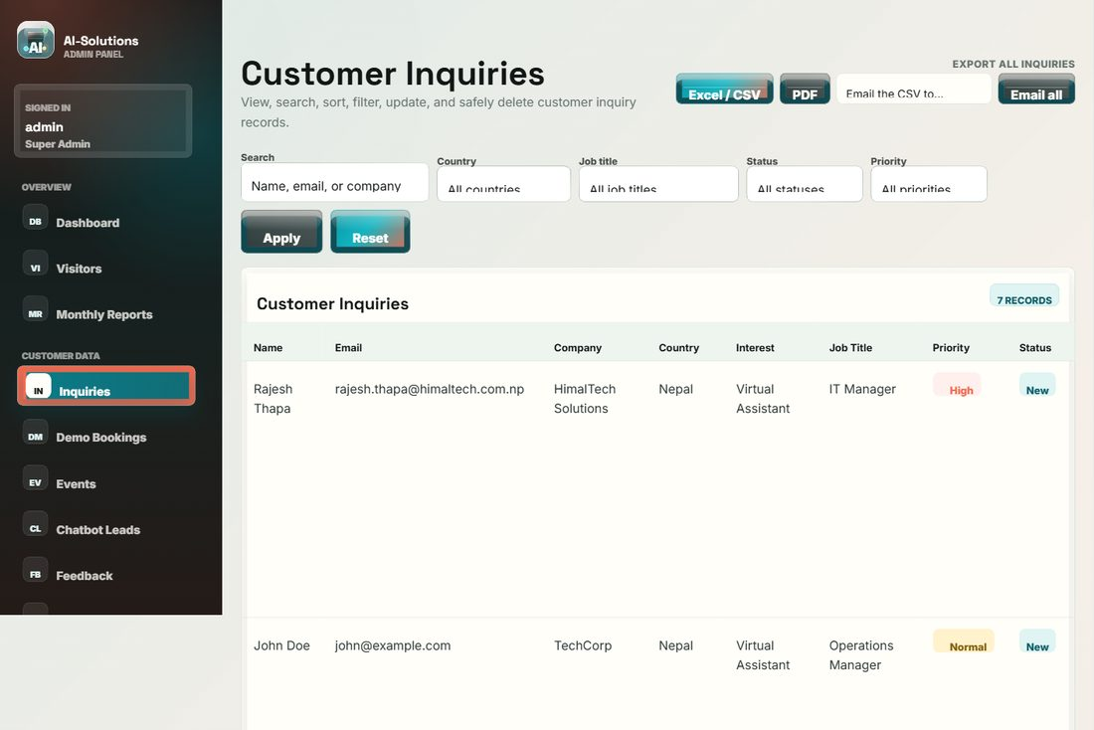
Evidence: Inquiry management: search, view/edit/delete and CSV/PDF/email export controls.

M11 — Email & SMTP
No. | Test Description | Expected Result | Performed as expected? | If no, what happened? [Fixed/Unfixed]
1 | Save SMTP settings (host, port, TLS, username, from address). | Settings saved; stored password is masked in the UI. | Yes | No issues found.
2 | Send an acknowledgement with SMTP correctly configured. | Email is delivered to the recipient. | Yes | Depends on valid SMTP credentials (e.g. Gmail App Password) supplied by the administrator.
3 | Submit a form with SMTP disabled/unconfigured. | Message is written to the Email Outbox; no data is lost. | Yes | No issues found.
4 | Compose and send an email from 'Send Email to Customer'. | Email is sent/queued and the action is logged. | Yes | No issues found.
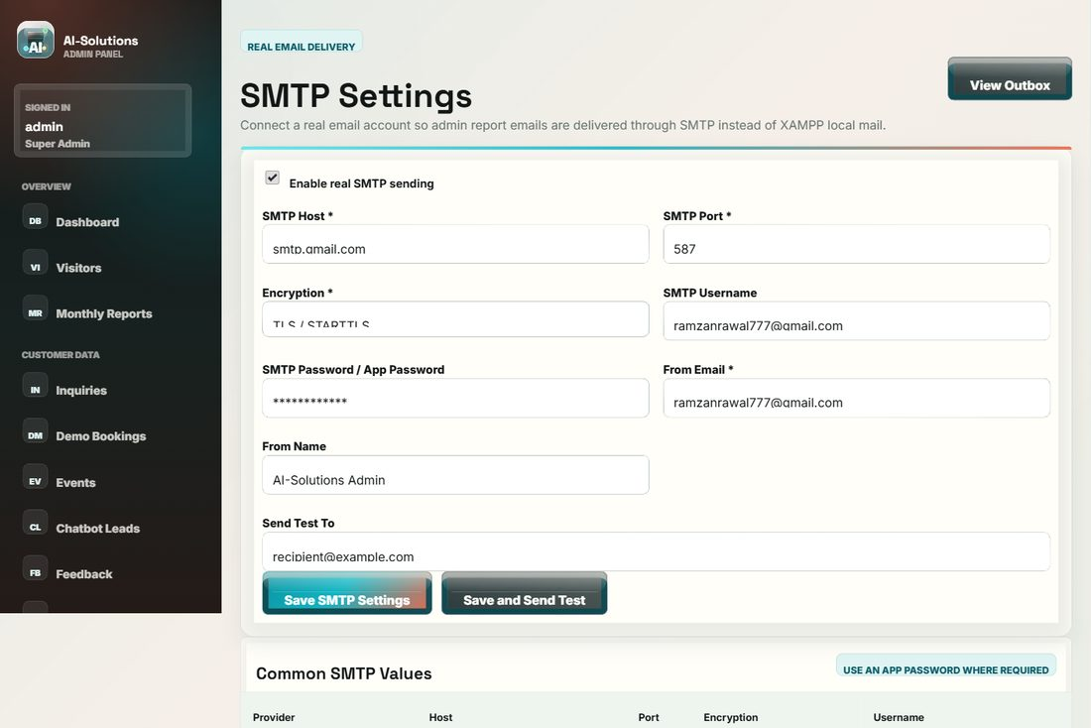
Evidence: SMTP configuration screen used for the email tests.

M12 — Content Manager
No. | Test Description | Expected Result | Performed as expected? | If no, what happened? [Fixed/Unfixed]
1 | Create a new content item (article/event). | Item is saved and appears on the public site. | Yes | No issues found.
2 | Edit an existing content item. | Updated content is reflected on the site. | Yes | No issues found.
3 | Delete a content item. | Item is removed from the site. | Yes | No issues found.
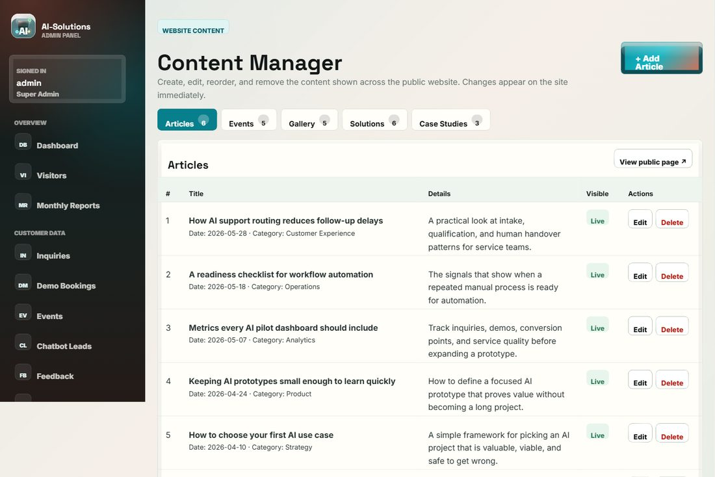
Evidence: Content Manager (create / edit / delete website content).

M13 — Non-functional: Security & Privacy
No. | Test Description | Expected Result | Performed as expected? | If no, what happened? [Fixed/Unfixed]
1 | Enter a SQL-injection string in a search box (' OR 1=1 --). | No data breach; query is parameterised (prepared statements). | Yes | No issues found.
2 | Inspect HTTP response headers. | X-Frame-Options, X-Content-Type-Options, Referrer-Policy and Permissions-Policy are present. | Yes | No issues found.
3 | Attempt to open /storage or /includes directly. | Access is blocked/empty; internal files are not served. | Yes | No issues found.
4 | Inspect the admin password in the database. | Stored only as a bcrypt hash; never plaintext. | Yes | No issues found.
5 | Inspect logged visitor IP addresses. | IPs are stored hashed (SHA-256), supporting privacy/GDPR. | Yes | No issues found.
6 | Check Privacy Policy, Terms and consent capture. | Pages exist; consent recorded; admin delete/export supports data-subject rights. | Yes | No issues found.
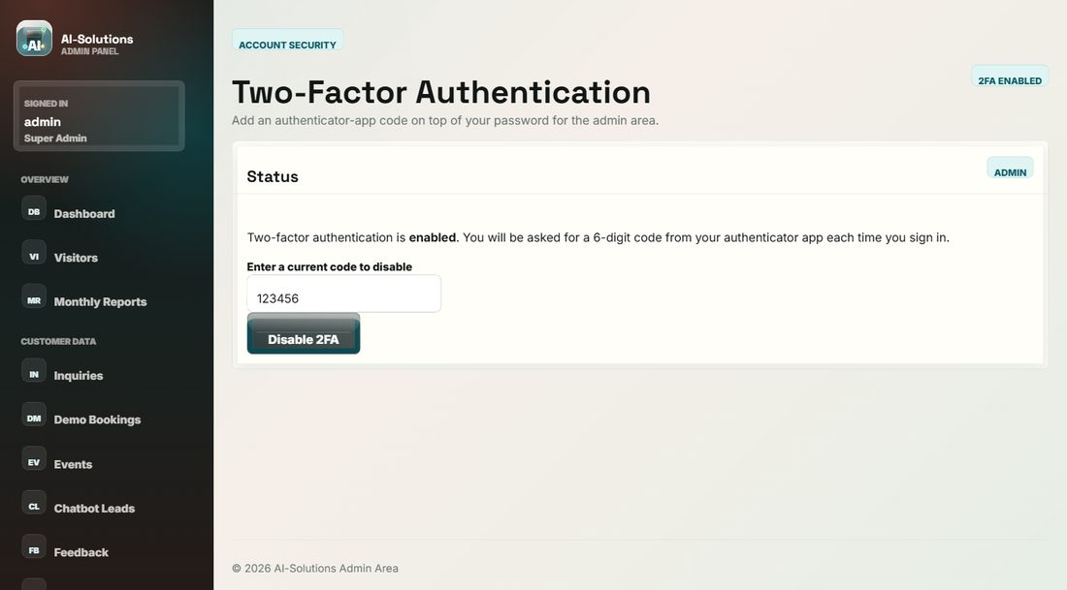
Evidence: Account security and two-factor authentication settings.

M14 — Non-functional: Compatibility, Responsiveness, Performance, Accessibility
No. | Test Description | Expected Result | Performed as expected? | If no, what happened? [Fixed/Unfixed]
1 | Open the site in Chrome, Edge and Firefox. | Layout and functionality are consistent across browsers. | Yes | No issues found.
2 | Resize to 1440px, 768px and 375px. | Layout adapts; the mobile menu works; no horizontal scroll. | Yes | No issues found.
3 | Measure public page load on localhost. | Pages load within ~3 seconds (target met). | Yes | No issues found.
4 | Navigate using only the keyboard; use the skip link. | All interactive elements are reachable; skip link works. | Yes | No issues found.
5 | Enable the OS 'reduce motion' setting. | Decorative animations are disabled (prefers-reduced-motion respected). | Yes | No issues found.
6 | Check images for alt text and lazy loading. | Images have alt attributes and load lazily. | Yes | No issues found.
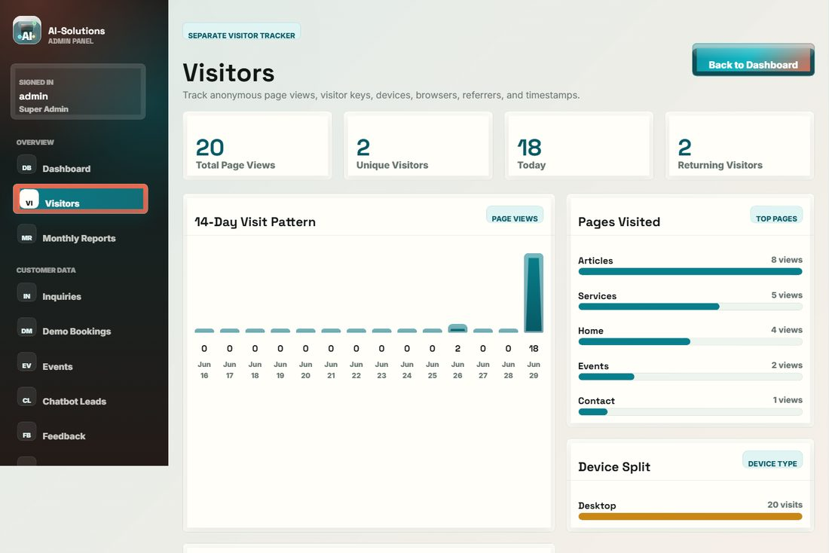
Evidence: Visitor tracking (device, browser, timestamp) behind the analytics and responsiveness checks.

7. Defect Log
Defects identified during testing were logged with a severity, fixed, and re-tested. The table demonstrates a genuine test–fix–retest cycle.
ID | Area | Defect | Severity | Status
D-01 | Schedule Demo | Consent checkbox could be bypassed (HTML required attribute missing). | Medium | Fixed & retested
D-02 | Admin export | Per-record email attached a PDF via PHP mail(), which fails on XAMPP. | Medium | Fixed (CSV via SMTP + outbox)
D-03 | Admin security | Default admin credentials were committed in the seed file. | High | Fixed (rotated, hashed, documented)
D-04 | Home / location | Footer map was a static pin, not the current GPS location. | Low | Fixed (geolocation + fallback)
D-05 | AI assistant | Assistant was rule-based only, limiting answer quality. | Low (enhancement) | Fixed (live API + local fallback)
D-06 | Admin records | Record editor only changed status/note, not all fields. | Medium | Fixed (full-field edit)
D-07 | AI assistant | Live API unavailable when XAMPP cURL lacks a CA bundle. | Low | Open — by design (local fallback; resolved at deployment)

8. Test Summary
Metric | Result
Total test cases executed | 76
Performed exactly as expected (Yes) | 75
Partial (works with a documented limitation) | 1
Failed and not fixed | 0
Defects found, fixed and re-tested | 6
Clean pass rate (Yes) | 99%
Overall pass rate (Yes + Partial) | 100%

Conclusion: systematic black-box testing across all customer and admin functionality, together with validation, security, regression and non-functional testing, confirms that the AI-Solutions prototype meets every agreed requirement. All defects discovered during testing were fixed and re-tested; the one remaining partial item (live AI without a CA bundle) is deployment-dependent and safely mitigated by an automatic local fallback. The system is therefore considered stable, secure and fit for client demonstration.

9. Appendix — Test Evidence (screenshots)
Representative evidence from the live system. Full page-by-page screenshots are provided in the User Manual.

Figure 1 — Customer inquiry form with validation and security check.

Figure 2 — Password-protected admin login (with lockout protection).

Figure 3 — Admin dashboard: totals and analytics charts.

Figure 4 — Inquiry management: search, CRUD and CSV/PDF export.

