AI-Solutions Wireframe Page List
Low-fidelity wireframes — updated to match the current AI-Solutions prototype.
W1 - Home Page: AI-Solutions Home / Landing Page Wireframe
W2 - Services Page: Software Solutions & Services Page Wireframe
W3 - Events & Gallery Page: Events & Photo Gallery Page Wireframe
W4 - Contact Us Page: Customer Inquiry / Contact Form Wireframe
W5 - Schedule Demo Page: Demo Booking Form Wireframe
W6 - AI Chatbot Page: AI Virtual Assistant Chat Interface Wireframe
W7 - Chatbot Handover Page: Human Support Handover & Lead Capture Wireframe
W8 - Admin Login Page: Password-Protected Admin Login Wireframe
W9 - Admin Dashboard Page: Admin Dashboard & Analytics Wireframe
W10 - Record Management Page: Admin Record Management & CRUD Wireframe
W11 - Articles Page: Articles & Insights / Blog Page Wireframe (added)
W1 - Home Page: AI-Solutions Home / Landing Page Wireframe
Page: index.php
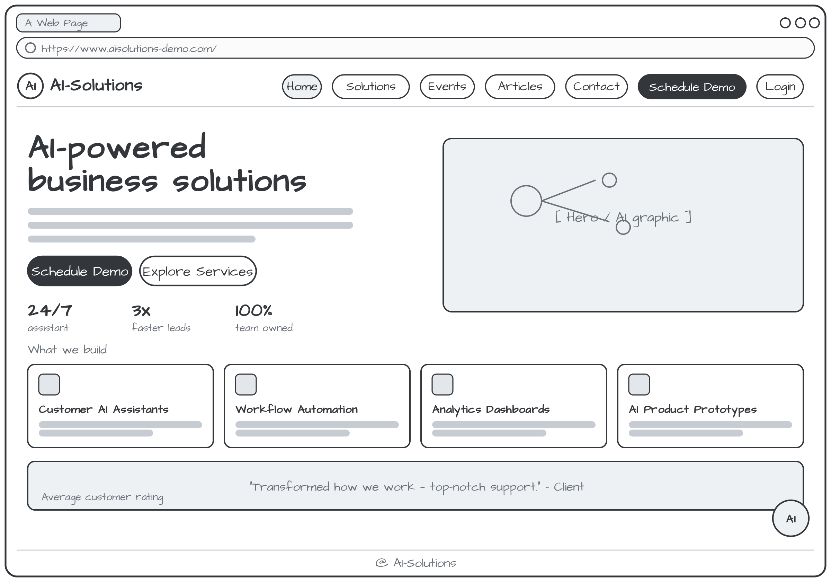
W2 - Services Page: Software Solutions & Services Page Wireframe
Page: services.php
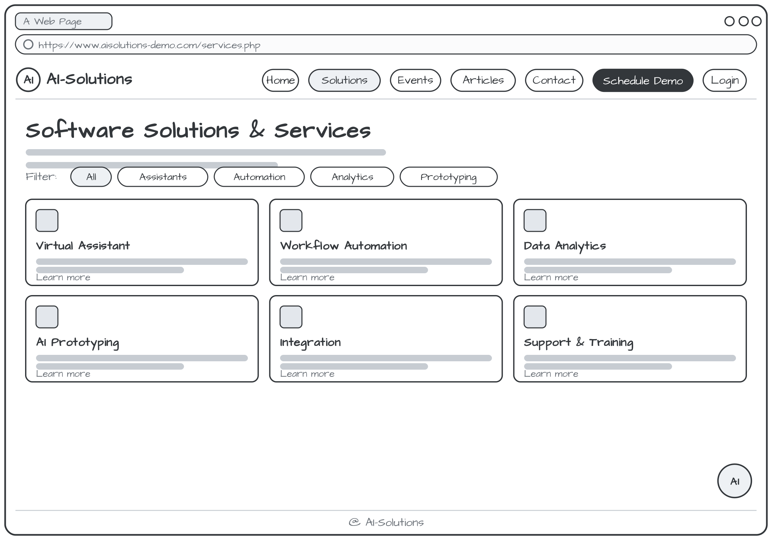
W3 - Events & Gallery Page: Events & Photo Gallery Page Wireframe
Page: events.php
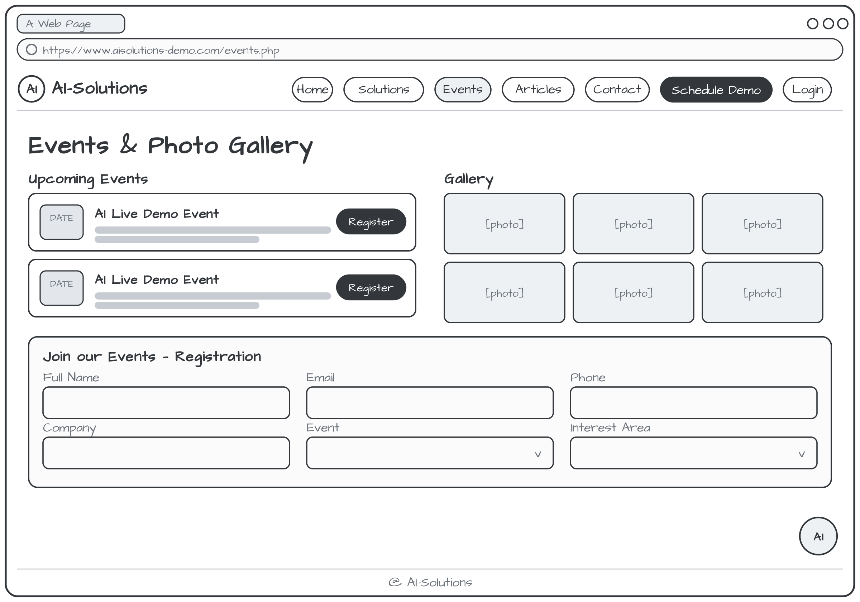
W4 - Contact Us Page: Customer Inquiry / Contact Form Wireframe
Page: contact.php
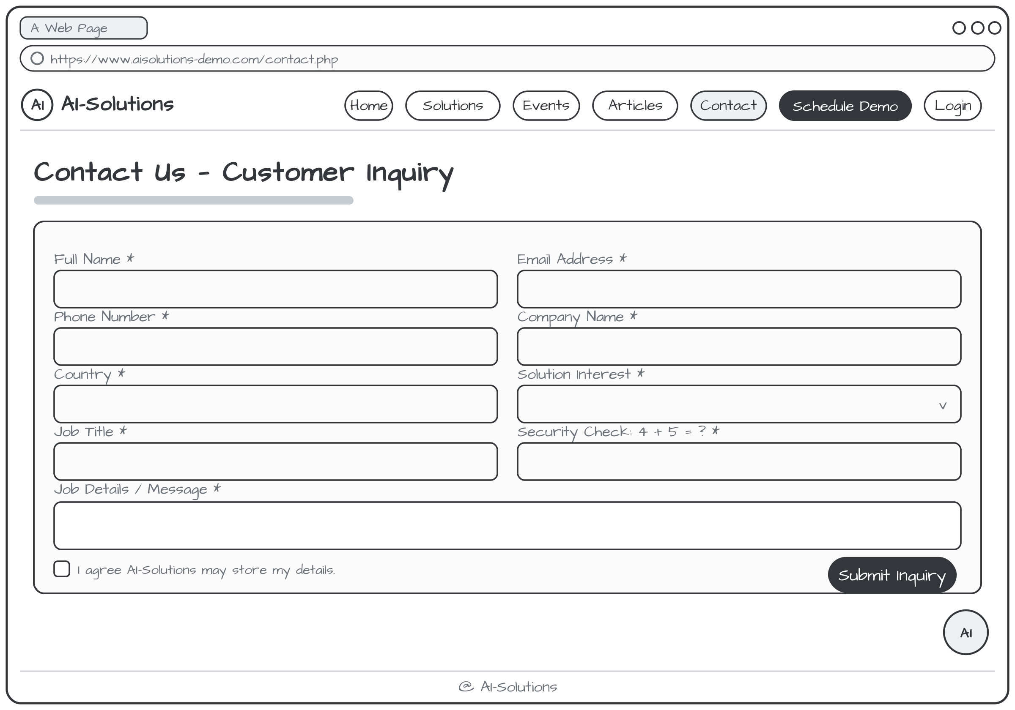
W5 - Schedule Demo Page: Demo Booking Form Wireframe
Page: schedule-demo.php
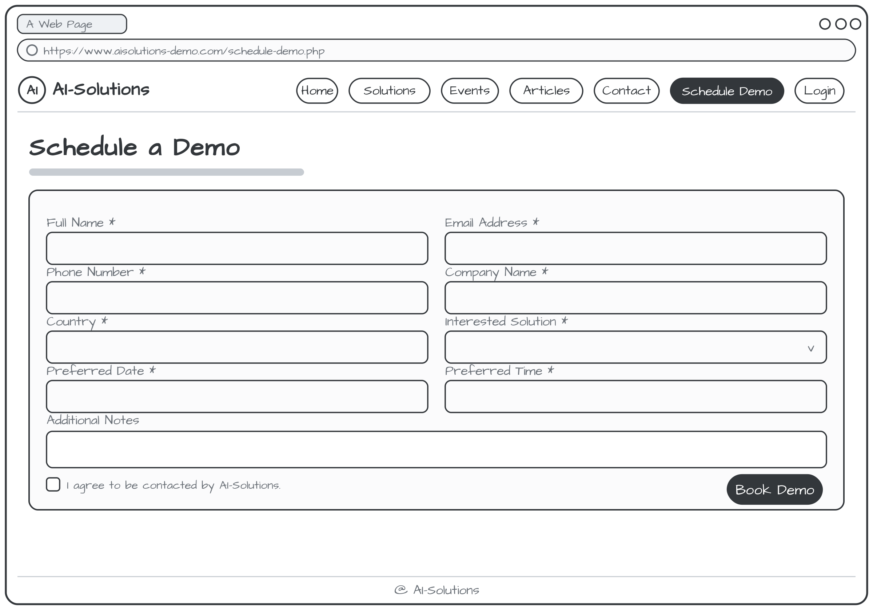
W6 - AI Chatbot Page: AI Virtual Assistant Chat Interface Wireframe
Page: chatbot.php
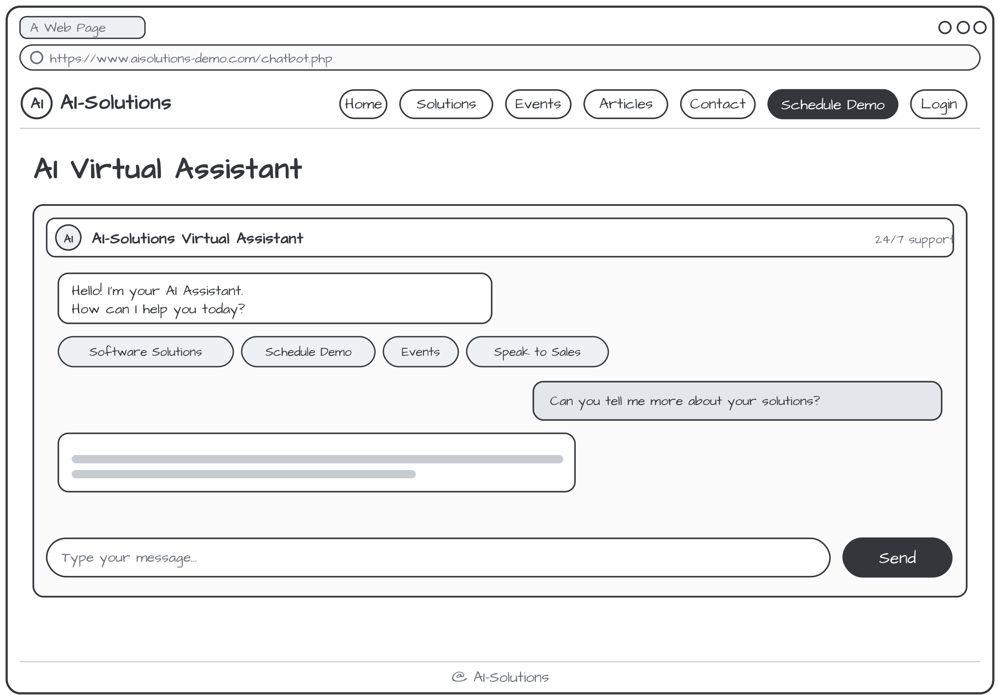
W7 - Chatbot Handover Page: Human Support Handover & Lead Capture Wireframe
Page: chatbot-handover.php
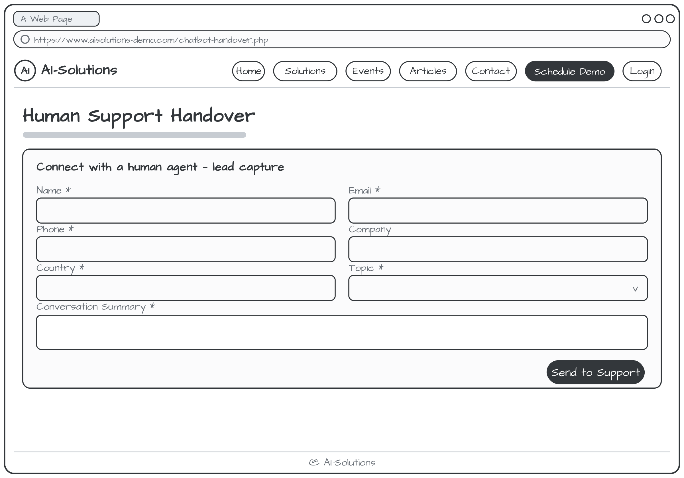
W8 - Admin Login Page: Password-Protected Admin Login Wireframe
Page: admin/login.php
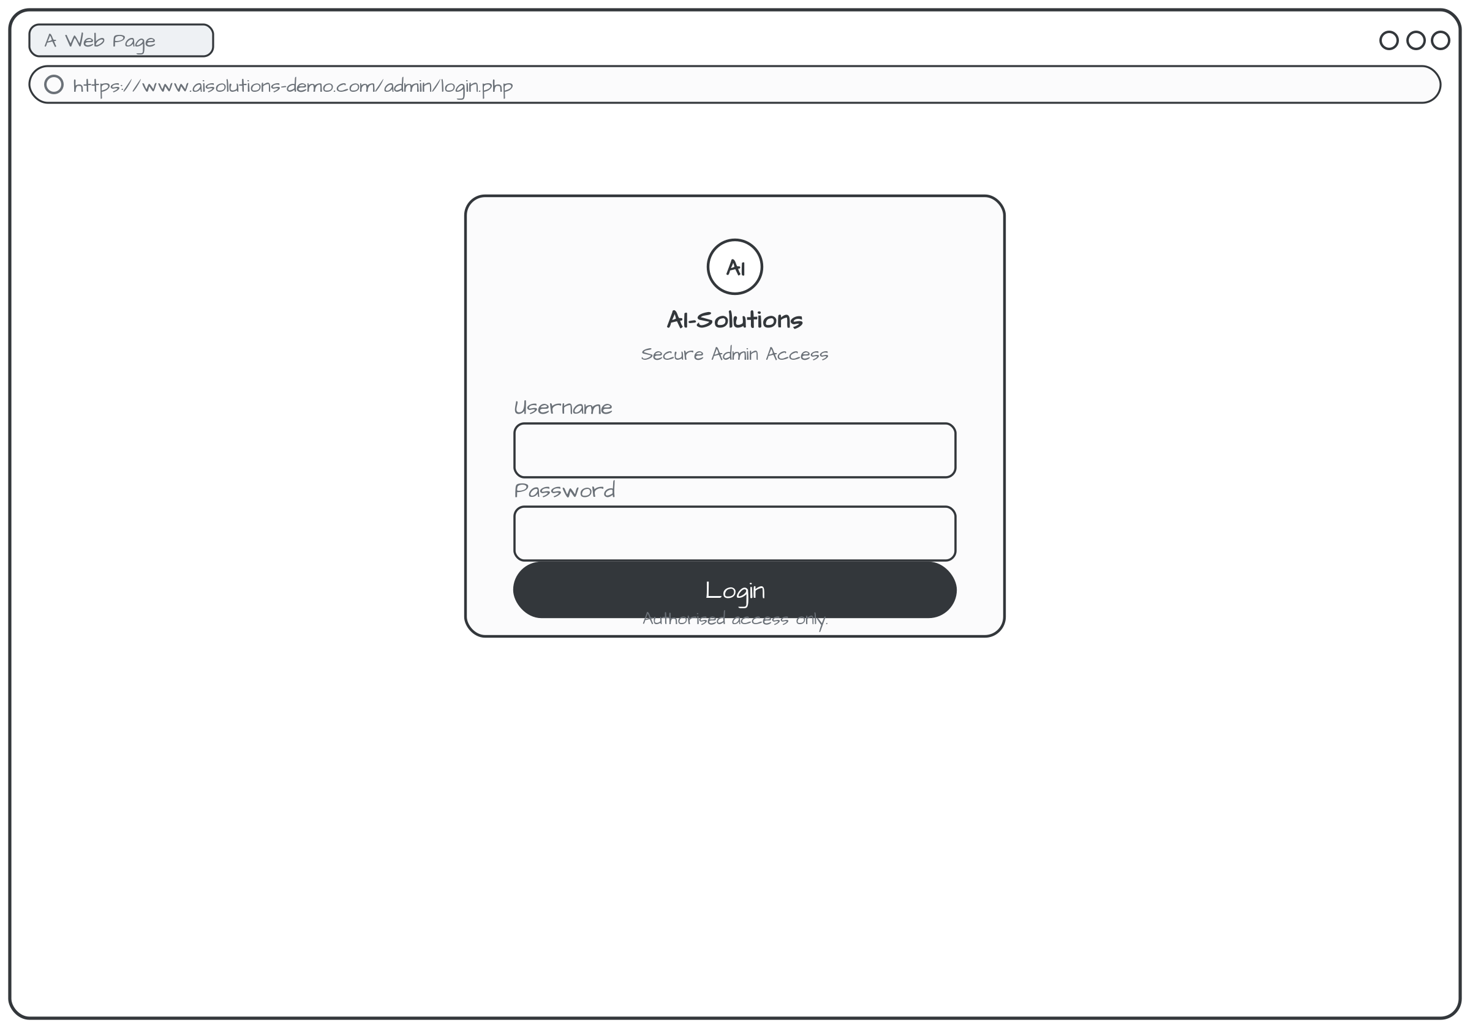
W9 - Admin Dashboard Page: Admin Dashboard & Analytics Wireframe
Page: admin/dashboard.php
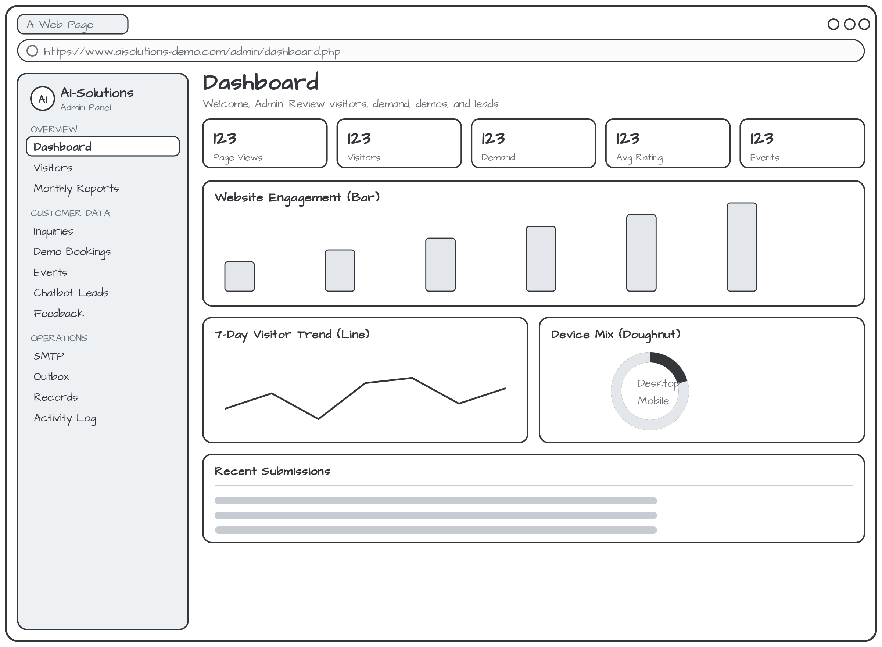
W10 - Record Management Page: Admin Record Management & CRUD Wireframe
Page: admin/manage-records.php
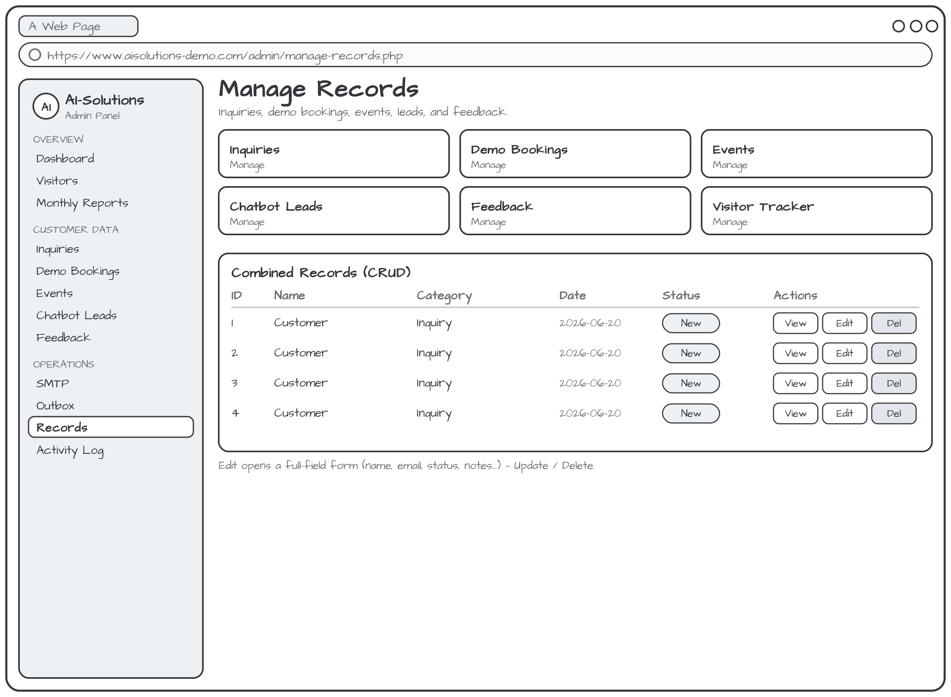
W11 - Articles Page: Articles & Insights / Blog Page Wireframe (added)
Page: articles.php
