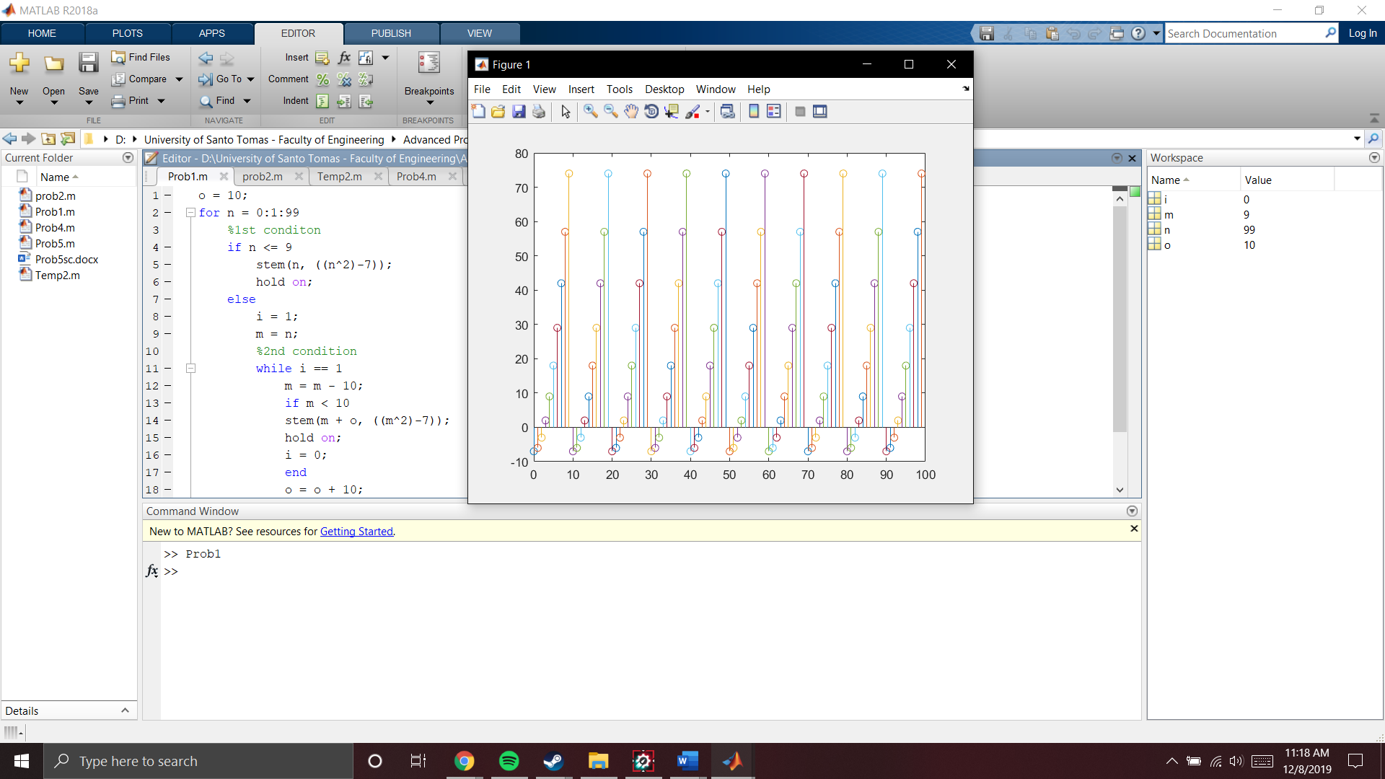

The patter repeats every 10 numbers and it is equal from it’s predecessor where it is increasing. Also there is a pattern in the negative y wherein it is increasing to the positive y.