**Sensors In Autonomous Vehicles**

Autonomous vehicles work using 4 pillars: Perception, Localization, Planning, and Control.

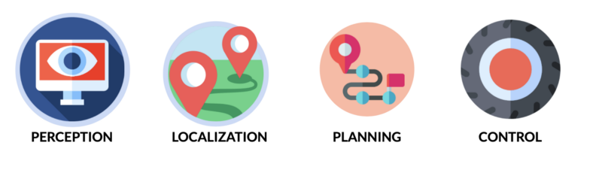

Sensors in the vehicle fall into the Perception module. Modern autonomous vehicles use numerous types of sensors to achieve the required performance. Some of the essential sensors are Cameras, RADAR, LiDAR, ultrasonic and infrared sensors, etc. We can also use microphones to detect car horns and alarms. Some sensors like the GPS falls into the localization module. We also need sensors like angle encoders, gyroscopes and speedometers to describe the state of the vehicle. In this paper we will be going to depth about three of these sensors. Namely, cameras, RADAR and LiDAR.

1.Camera:

Video images provide most of the details for the human driver but are also suitable as an input parameter for highly automated driving. It is mainly used to output bounding boxes, lane line positions, traffic lights colours, traffic signs, and many other things.

Advantages:

1. Can detect lanes, traffic lights, traffic signs, other vehicles, pedestrians etc.
2. Excellent classifier
3. Not much expensive.
4. Small size and highly portable
5. Very good spatial resolution

Disadvantages:

1. Not a good distance estimator
2. Not a good velocity estimator
3. Does not produce same efficiency in all weather (e.g., Rain)
4. Does not have a good range

2. RADAR:

RADAR stands for Radio Detection And Ranging, which means the detection and localization of objects using radio waves. 77GHZ is used for SRR (Short-range radar) applications and 24 GHZ for MRR/LRR (mid-range radar, long-range radar) applications. The SSR applications are essentially designed to replace ultrasonic sensors and to support highly automated driving. SRR applications include: Blind Spot Detection, the lane-change assistant, Rear end radar for collision warning or collision avoidance, Park Assist, Cross-traffic monitoring. Examples for MRR/LRR applications are brake Assist, emergency braking, automatic distance control.

Advantages:

1. Excellent Velocity estimator
2. Good distance estimator
3. Very good results on moving objects
4. Suitable for all weather conditions
5. Small size and portable
6. Cost-friendly
7. Has good range

Disadvantages:

1. Bad classifier (i.e., it cannot tell you what the object is)
2. Do not give good results on static objects.
3. Low spatial resolution

3. LiDAR:

Lidar is a relatively new system in the automotive sector and is beginning to gain traction. it is an acronym for Light Detection And Ranging and is a laser-based system. The system employs special procedures to provide three-dimensional images of the detected objects.

Advantages:

1. Estimate distances with high accuracy
2. Can classify objects
3. Has a very good range
4. Good spatial resolution. Can cover all 360 degrees
5. Great for SLAM (Simultaneous Localization And Mapping)
6. Can detect shape and intersections of roads

Disadvantages:

1. Highly expensive.
2. Large size and low portability.
3. Not suitable for large-scale production and deployment in the automotive sector.
4. Not a good velocity estimator
5. Not suitable for all weather conditions

**Sensor Fusion:**

In the Perception module, we need to use multiple sensors. This can either add redundancy, certainty, or to take advantage of using multiple sensors and create multiple use-cases. This creates a field we call Sensor Fusion.

As we have seen different sensors have different advantages and disadvantages. So, combining the data from multiple sensors seems like a logical solution to combine the advantages of all the sensors and provide a much better understanding of the car’s surroundings.

Some of the most popular use of sensor fusion is the combination of camera & LiDAR and RADAR and LiDAR implementing concepts like Kalman filtering , Bayesian filtering, ROI matching etc.