 | HEURISTIC EVALUATION REPORT  ITC Website — Birzeit University  COMP 332 · Human–Computer Interaction

AUTHOR  Ramzi Abu Falah | STUDENT ID  1230594 | FRAMEWORK  Nielsen’s 10 | VIOLATIONS  8 documented

EXECUTIVE SUMMARY
This report presents a heuristic evaluation of the ITC website at Birzeit University using Nielsen’s 10 Usability Heuristics. The goal is to identify usability problems that affect the user experience and to suggest possible improvements.
The ITC portal was selected because it is widely used by Birzeit students for academic and administrative services. I personally experienced difficulties using it, especially during my first year — the login option was hard to find and the system was confusing for new users. Important actions and navigation elements were not visually clear.
The evaluation focuses on violations related to navigation, visibility, consistency, error prevention, and interface design. Each issue is analyzed by the violated heuristic principle, its severity level, and a suggested design improvement.
VIOLATIONS AT A GLANCE
# | Issue | Heuristic Violated | Severity
1 | Unclear login access | Recognition Rather Than Recall | 3
2 | Poor visual hierarchy | Aesthetic and Minimalist Design | 3
3 | Inconsistent navigation placement | Consistency and Standards | 2
4 | Duplicate and broken login actions | Consistency and Standards | 4
5 | Poor first-time user guidance | Help and Documentation | 3
6 | Duplicate language selectors | Consistency and Standards | 2
7 | Long, hard-to-read course names | Aesthetic and Minimalist Design | 2
8 | Unclear submission confirmation | Visibility of System Status | 3

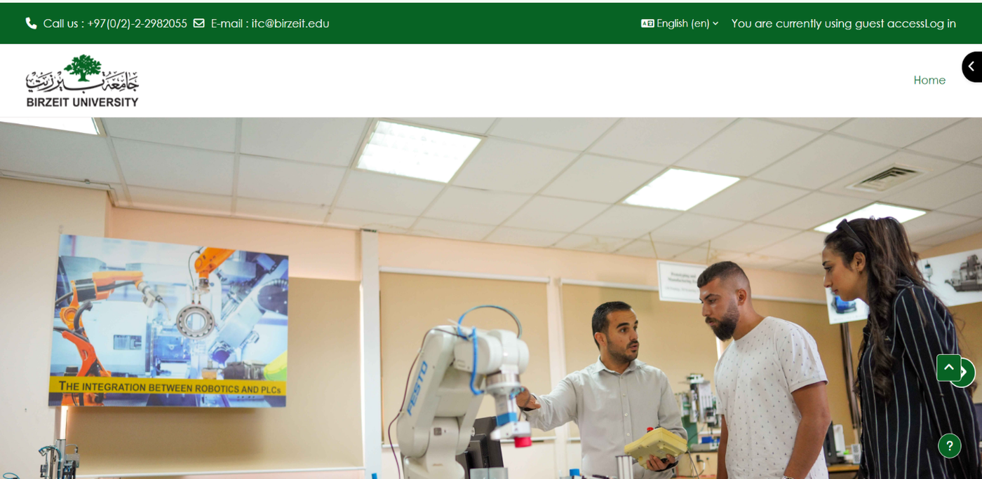

DETAILED FINDINGS
01 | Unclear Login Access  Heuristic: Recognition Rather Than Recall |  |  | SEV 3 · MAJOR
DESCRIPTION  The login option is not clearly visible for new users. The text “You are currently using guest access — Log in” appears as small text in the top bar and does not look like an important action button. |  | WHY IT’S A PROBLEM  Users should recognize important actions immediately without searching or remembering where they are located. Here, the login action is difficult to notice, especially for first-year students. | SUGGESTED FIX  Add a clear “Log In” button with a different color and larger size in the main navigation area, separated from the support contact strip.

02 | Poor Visual Hierarchy  Heuristic: Aesthetic and Minimalist Design |  |  | SEV 3 · MAJOR
DESCRIPTION  The page gives too much visual attention to the large image, while important services such as login and navigation are less visible. Main student actions are not highlighted properly. |  | WHY IT’S A PROBLEM  Users should quickly see the most important actions on a page. The current design may confuse users because decorative content is stronger than functional content. | SUGGESTED FIX  Reduce the image size and make important services more visible using clearly styled buttons, stronger spacing, and visual emphasis on key actions.

03 | Inconsistent Placement of Navigation Elements  Heuristic: Consistency and Standards |  |  | SEV 2 · MINOR
DESCRIPTION  Navigation elements and controls are placed in unusual positions around the page. Some controls appear on the left while others appear on the right, which creates confusion. |  | WHY IT’S A PROBLEM  Users expect navigation elements to follow common web design standards. Inconsistent placement makes the interface harder to learn and use. | SUGGESTED FIX  Group navigation controls in one clear and consistent area, such as the top navigation bar or a fixed sidebar.

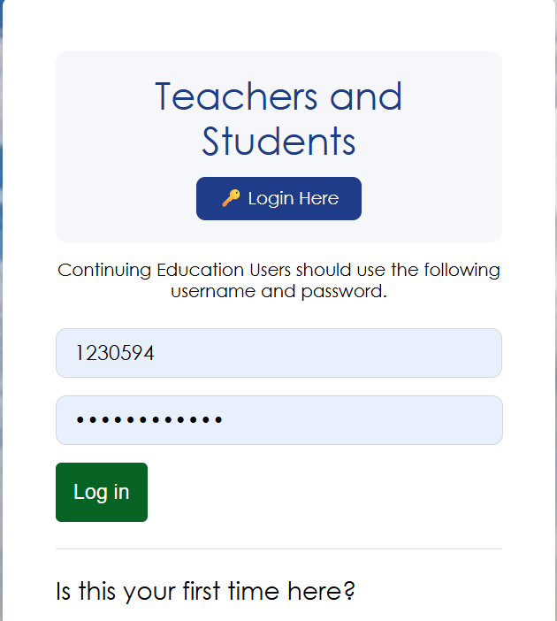

04 | Duplicate and Confusing Login Actions  Heuristic: Consistency and Standards |  |  | SEV 4 · CATASTROPHE
DESCRIPTION  The page contains two different login buttons. The “Login Here” button redirects to another page, while the green “Log in” button below does not work correctly even with valid credentials. The interface does not explain the difference. |  | WHY IT’S A PROBLEM  Users expect similar buttons to perform the same action. Two different login methods with no explanation create confusion and may prevent users from accessing the system successfully. | SUGGESTED FIX  Use only one clear and fully functional login process. Remove duplicate buttons and clearly explain the single login method.

05 | Poor Error Prevention and User Guidance  Heuristic: Help and Documentation |  |  | SEV 3 · MAJOR
DESCRIPTION  The page includes the text “Is this your first time here?” but does not clearly explain what new users should do next. There are no clear instructions for account activation, password setup, or first-time login. |  | WHY IT’S A PROBLEM  New users need clear guidance when using the system for the first time. Without instructions, users may feel lost and unable to continue. | SUGGESTED FIX  Add clear first-time login instructions covering account activation, password creation, and where to get technical support if needed.

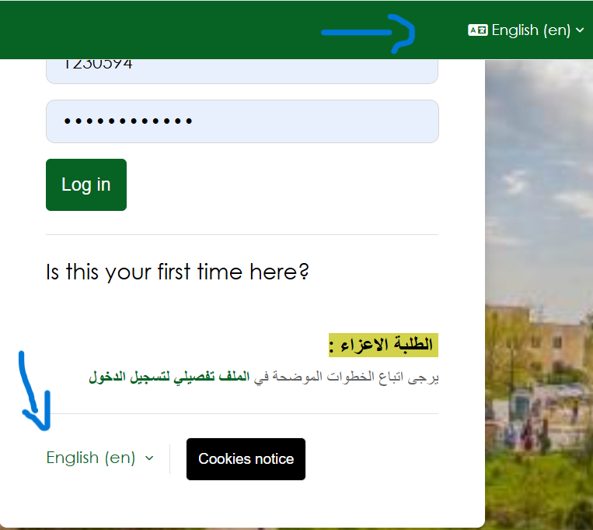

06 | Duplicate Language Selection Options  Heuristic: Consistency and Standards |  |  | SEV 2 · MINOR
DESCRIPTION  The page contains two separate language selection menus that perform the same function. One appears at the top and another at the bottom of the page. Both are labeled “English (en)” and create unnecessary duplication. |  | WHY IT’S A PROBLEM  Users expect one clear and consistent control for changing the website language. Multiple controls for the same action may confuse users and make the interface look unorganized. | SUGGESTED FIX  Keep only one language selection menu in a clear and standard location, such as the top navigation bar.

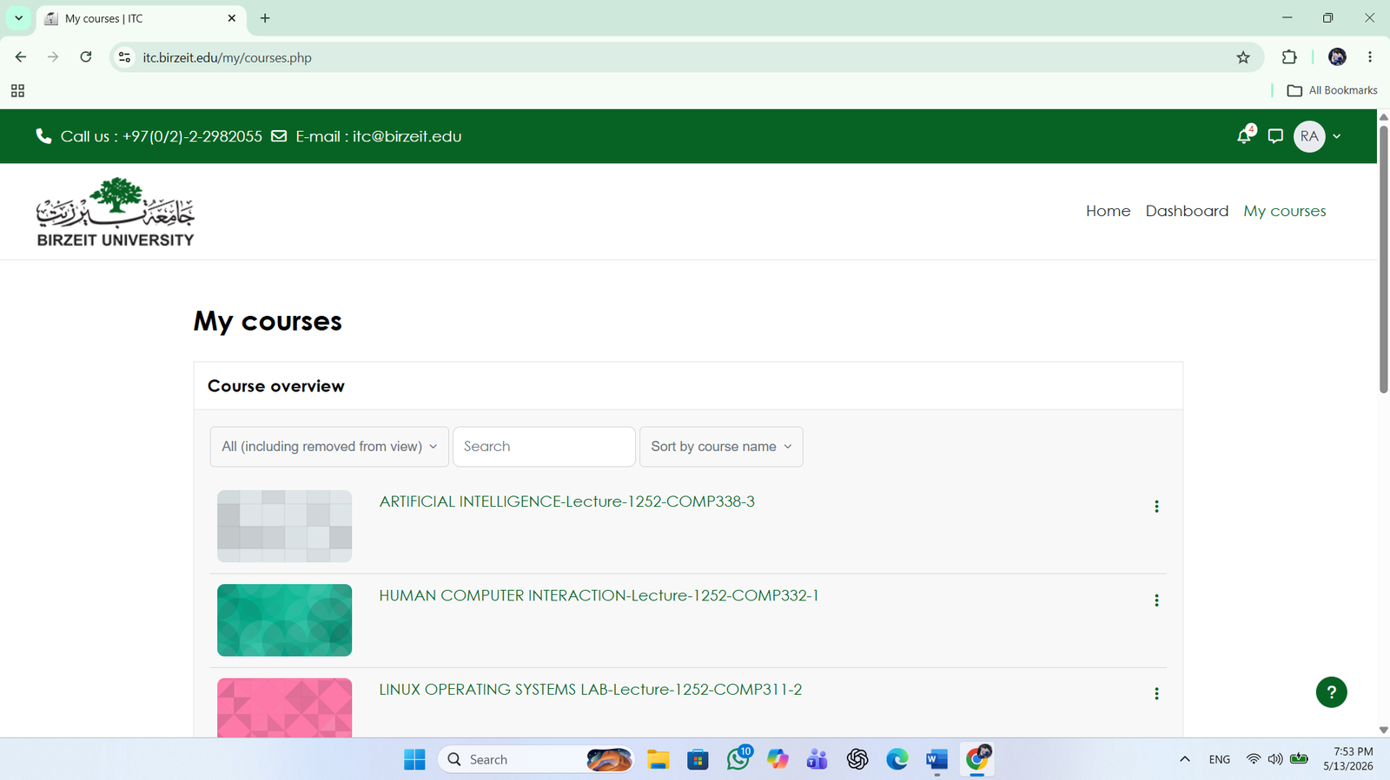

07 | Long and Hard-to-Read Course Names  Heuristic: Aesthetic and Minimalist Design |  |  | SEV 2 · MINOR
DESCRIPTION  Course names are very long and displayed in one line without clear separation between course title, section, and course code. This makes courses difficult to scan quickly. |  | WHY IT’S A PROBLEM  Users should be able to scan information easily. Long text lines increase cognitive load and make it harder for students to find their courses. | SUGGESTED FIX  Separate the course title, section number, and course code into distinct lines or labeled fields with proper spacing and typography.

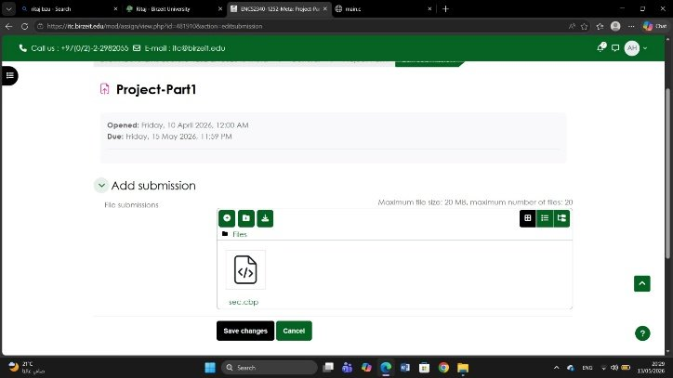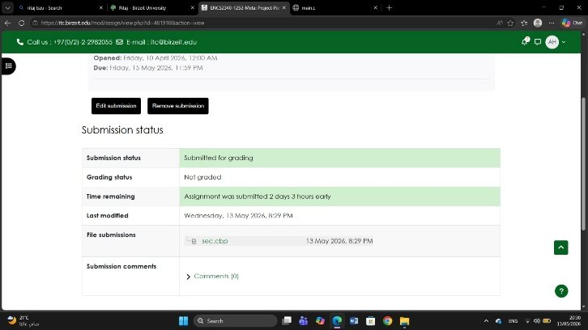

08 | Unclear Assignment Submission Confirmation  Heuristic: Visibility of System Status |  |  | SEV 3 · MAJOR
DESCRIPTION  When students upload assignment files and press “Save”, the system shows a submission alert without clearly displaying the uploaded files or asking for final confirmation. Users can still edit or remove the files after submission, which creates confusion about whether the assignment was actually submitted. |  | WHY IT’S A PROBLEM  Users need clear feedback about the current status of their submission. The system should clearly show which files were uploaded and whether the submission process is complete. The current behavior may cause stress and uncertainty for students during important submissions. | SUGGESTED FIX  Display a clear confirmation page showing the uploaded files and add a final “Confirm Submission” button before completing the process.

