BIRZEIT UNIVERSITY
Faculty of Engineering and Technology
Department of Computer Science

COMP322
Human–Computer Interaction

Phase 1 — Research and Requirements
Birzeit Ritaj Portal
Grades and Academic Record
Team
Mouath Masalmah · 1220179
Mustafa Alayasa · 1221015
Yazan Sulaiman · 1221961
Ramzi Abu Falah · 1230594

Course Instructor: Dr Hisham Ihshaish
Second Semester 2025 / 2026
Submitted: May 2026

1. Team and Topic
This report is the Phase 1 submission of a four-person team for COMP322 Human–Computer Interaction. Our chosen project is the Birzeit Ritaj Portal. Ritaj is the main online system that Birzeit students use for academic services. Our team focuses on one part of Ritaj: grades and the academic record.
Phase 1 is the Research and Requirements stage of the user-centered design cycle. Our goal is to understand who the users are and what problems they meet today, so that Phase 2 design can be based on real evidence.
Scope: three assigned flows
The team redesign is limited to three flows inside the grades and academic-record area:
- Flow 1 — Viewing Current Semester Grades
- Flow 2 — Inspecting the Cumulative Academic Record
- Flow 3 — Spotting and Querying a Course Mark Discrepancy
Registration, timetable, schedule, financial pages, and other Ritaj areas are out of scope. Some of these areas are owned by other COMP322 teams.
Why this problem matters
Grades are not only numbers. They affect course planning, scholarships, graduation timing, and how confident students feel about their progress. In all three interviews we conducted, students described moments where the grades pages made them anxious, made them refresh repeatedly, or pushed them outside Ritaj to solve a problem that Ritaj could solve. Fixing these issues would save students time and reduce avoidable stress.
Team and roles
Team Member | Student ID | Phase 1 Responsibility
Mouath Masalmah | 1220179 | Flow 1 — Viewing Current Semester Grades. Screenshots, heuristic violations, P1 interview, scenario, and requirements.
Mustafa Alayasa | 1221015 | Flow 2 — Inspecting the Cumulative Academic Record. Screenshots, heuristic violations, P2 interview, scenario, and requirements.
Yazan Sulaiman | 1221961 | Flow 3 — Spotting and Querying a Course Mark Discrepancy. Screenshots, heuristic violations, P3 interview, scenario, and requirements.
Ramzi Abu Falah | 1230594 | Final integration of the three flows into one unified report. Personas. Scenario polishing. Appendix organization. Formatting, editing, and final review.
2. Heuristic Evaluation
Each team member walked the Ritaj grades area on their own first. We then met to combine our findings, remove duplicates, and agree severity ratings together. The evaluation is wide inside the grades and academic-record area — Marks Partition, Marks Detail View, Academic Record summary, and grade-related navigation. Registration, timetable, schedule, and financial pages are not included.
We identified eleven unique violations. Each one uses Nielsen’s ten heuristics and a severity rating from 0 to 4. The rating is justified using three factors: how often students meet the problem (Frequency), how badly it affects them (Impact), and whether they learn to work around it over time or it keeps hurting them (Persistence). Annotated screenshots are in Appendix A.
Consolidated heuristic table
ID | Flow · Screen/Location | Problem | Heuristic | F / I / P | Sev | Suggested Fix
F1-01 | F1 · Grades Table | Blank cells do not show whether a mark is pending, missing, or withheld. Students cannot tell what to do next. | H1 Visibility of system status | Frequent / Major / Persists | 3 | Add a clear text label next to each cell: “Pending”, “Not uploaded”, or “Withheld”.
F1-02 | F1 · Dashboard/ Sidebar | Different labels ("Grades" vs "Semester Grades") are used for the same destination. | H4 Consistency and standards | Moderate / Minor / Eases | 2 | Standardize all labels to "Current Semester Grades."
F1-03 | F1 · Grades Table | Class-average and percentage columns appear next to personal marks. They take visual space and make scanning slower, especially on mobile. | H8 Aesthetic and minimalist design | Frequent / Minor / Eases | 2 | Make statistical data optional via a toggle button.
F1-04 | F1 Grades Page | No GPA or credit-hour summary is shown in the page header. Students have to go to another page to see their overall academic context. | H6 Recognition rather than recall | Moderate / Minor / Persists | 2 | Add a summary banner showing current GPA and credits.
F2-01 | F2 · Academic Record Summary Table | Approved, acquired, GPA-weighted, and failed hours are shown, but remaining credit hours toward graduation are not shown. | H6 Recognition rather than recall | Frequent / Major / Persists | 3 | Add a clear “Remaining credit hours” field in the academic record summary.
F2-02 | F2 · Semester dropdown only | Students can filter by one semester at a time. There is no search across all semesters to find a single course. | H7 Flexibility and efficiency of use | Low / Minor / Persists | 2 | Add a search bar above the academic record that searches across every semester.
F2-03 | F2 · Summary table | Academic terms are shown without clear explanation. First- and second-year students may struggle to understand what these terms mean. | H2 Match between system and real world | Moderate / Minor / Eases | 2 | Add small tooltips next to each term or replace with plain-language labels.
F2-04 | F2 Whole page layout | A wide summary table and a long flat course list appear on one page. This does not adapt well to mobile and makes students scroll heavily. | H8 Aesthetic and minimalist design | Frequent / Minor / Persists | 2 | Use cards, better spacing, semester sections, and a clear academic progress summary.
F3-01 | F3 · Marks Partition table | The mark’s view is read-only. There is no button or link to report a suspected error directly from the page. | H3 User control and freedom | Moderate / Major / Persists | 3 | Add a “Query this mark” action on each row that opens a pre-filled form to the instructor.
F3-02 | F3 · Marks Detail View | Instructor names are displayed as static text. There is no link to email, office hours, or a contact card from the grade row. | H6 Recognition rather than recall | Frequent / Major / Persists | 3 | Make instructor names interactive. Tap or hover opens a contact card with email and office hours.
F3-03 | F3 · Marks Partition table | Ambiguous formatting is shown for missing or delayed individual marks. Students cannot tell if the grade is pending or if the system is broken. | H1 Visibility of system status | Frequent / Minor / Eases | 2 | Replace ambiguous symbols with clear status tags: “Pending review” or “Not yet uploaded”.

Dominant problem patterns
Three patterns appear across the eleven violations. The first is status ambiguity. The portal often shows numbers or symbols without saying what they mean — blank cells (F1-01), trailing slash symbols (F3-03), the missing header summary (F1-04), and the missing remaining-hours field (F2-01) all leave the student to guess a state that the system could state directly. The second is one-way communication. The grades and marks pages are read-only and lack in-context action paths: students who spot a discrepancy cannot report it from the page (F3-01), and cannot reach the responsible instructor without leaving Ritaj entirely (F3-02). The third is cognitive and visual load. Information is present but poorly organised — labels for the same destination are inconsistent (F1-02), academic terms are shown without glossing (F2-03), statistical columns compete with personal marks (F1-03), and the academic record page does not adapt to small screens (F2-04). These three patterns also match what students told us in the interviews.
3. Exploratory User Interviews
We conducted three exploratory interviews with real Ritaj users from different years and majors. Each interview lasted between 20 and 40 minutes. We adapted the interview guide from Appendix B of the project specification (a copy is included as Appendix B of this report). Two interviews were conducted in Arabic and one was bilingual. Notes were taken during and immediately after each session. All participants are anonymized as P1, P2, and P3; their real names do not appear anywhere in this report. Full interview notes are in Appendix C and direct quotes are in Appendix D.
Participants and main pain points
Code | Year and major | Device | Main pain point | Consent
P1 | Third-year Cyber Security | Mobile phone | Blank cells in the grades table give no signal — pending, missing, or withheld all look the same. P1 keeps refreshing the page during exam season. | Signed consent obtained.
P2 | Fourth-year Computer Engineering | Mobile phone | The academic record shows everything except remaining credit hours. P2 calculates them by hand every time. | Signed consent obtained.
P3 | Fourth-year Computer Science | Laptop | After spotting a wrong midterm mark, there was no in-page way to report it. P3 had to leave Ritaj and find the instructor’s email outside the system. | Signed consent obtained.

Key findings across the three interviews
- Students check grades and academic information on the device that is easiest at the moment. P1 and P2 mainly use mobile phones, while P3 uses a laptop. This means the redesigned pages should work clearly on different screen sizes.
- Status feedback is not clear enough. P1 was confused by blank grade cells, P3 was confused by “/” symbols, and P2 could not clearly see remaining credit hours. In all cases, students had to guess information that the system could show directly.
- Manual work is common. P1 refreshed the page many times because there were no grade notifications. P2 calculated remaining credit hours by hand. P3 had to leave Ritaj and search for instructor contact information outside the grades page.
- Students suggested small but useful changes. P1 wanted clearer status labels and grade notifications. P2 wanted a remaining-credit-hours field. P3 wanted the instructor’s name to be clickable or connected to a contact card.
A note on consent: P1, P2, and P3 signed the consent form before the interview started.
4. Personas
We built two personas from the interview evidence. The names are fictional; they are not real interview participants. Each persona is a portrait of one user pattern that came out of the data. Where the persona has more than one source, every field cites the participant codes that support it.
Persona 1 — Layla Hammad
Headline | “A student who checks her grades often and feels stressed when the mark status is not clear.”
Demographics | Third-year Cyber Security student at Birzeit University. She reads Arabic and English.
Tech literacy | Comfortable with apps and online systems. She usually checks Ritaj from her phone.
Goals | 1. Know quickly if a new grade has been posted. 2. Understand if a blank mark means pending, missing, or not uploaded. 3. Ask about a wrong or unclear mark without leaving Ritaj.
Frustrations | Blank cells in the grades table make her unsure about the grade status (P1). She refreshes the page many times because she does not know if the system is updated (P1). When there is a possible mark problem, there is no clear button to ask or report it from the same page (P3).
Context of use | She checks Ritaj during normal university days, especially after exams or quizzes. She often uses her phone because it is the fastest device to open.
Representative quote | “The blank spaces make me feel anxious; I don’t know if I missed something or if the site crashed.” — P1
Evidence trail | Built mainly from P1. Supported by P3 for the problem of asking about a wrong or unclear mark.

Persona 2 — Tariq Nasser
Headline | A fourth-year engineering student who checks his academic record and needs to know his remaining credit hours clearly.
Demographics | Fourth-year Computer Engineering student at Birzeit University. He reads Arabic and English.
Tech literacy | Comfortable with Ritaj and online systems. He usually uses his phone to check his academic record.
Goals | 1. Know his cumulative GPA clearly. 2. Know how many credit hours he has completed. 3. Know how many credit hours are still remaining without manual calculation. 4. Find grades from previous semesters quickly.
Frustrations | The Academic Record page shows GPA and completed credit hours, but it does not clearly show the remaining credit hours (P2). Because of this, Tariq has to calculate the remaining hours himself. Searching for an old course grade across semesters also takes extra time.
Context of use | He checks Ritaj when he wants to review his academic progress or plan his next academic steps. He usually uses his phone because it is quick and available.
Representative quote | “Remaining hours need to be worked out by hand.” — P2
Evidence trail | Built from P2. This persona represents a senior student who uses the Academic Record page to understand GPA, completed hours, and remaining credit hours.
5. Scenarios
Three scenarios describe how the personas would realistically use the redesigned grades and academic-record area. Each one covers one assigned flow and is written as a short narrative. Both personas appear across the three scenarios.
Scenario 1 — Viewing Current Semester Grades (Layla, Flow 1)
Layla finished her Algorithms midterm two days ago. Ritaj does not send notifications when grades are posted, so during her morning commute she opens the portal on her phone for the third time today. She taps the Grades tile, scans the Marks Partition table, and sees a blank cell next to COMP432. With no status label, she cannot tell whether the mark is pending, withheld, or simply not yet uploaded. She refreshes the page twice, switches her Wi-Fi off and on, and arrives at her next class still uncertain about her result. In the redesigned system, the blank cell would carry a clear “Pending — not yet uploaded” tag, and a notification would have reached her phone when the mark was published.

Scenario 2 — Inspecting the Cumulative Academic Record (Tariq, Flow 2)
Tariq is a fourth-year Computer Engineering student at Birzeit University. One evening, he opens Ritaj to check one of his grades from a previous semester and to understand his academic progress toward graduation. He goes to the Academic Record page and looks through the list of courses. He can view his semester GPA, cumulative GPA, and completed credit-hour data, but he cannot clearly see the remaining credit hours. Because of this, he has to estimate the remaining hours himself, which reduces efficiency and creates uncertainty. In the redesigned system, Tariq would get a clearer academic-progress summary, including completed hours, remaining hours, semester GPA, cumulative GPA, and a direct way to view all grades.

Scenario 3 — Spotting and Querying a Course Mark Discrepancy (Layla, Flow 3)
Layla checks her ENCS336 marks and notices that one quiz row shows a blank space with a “/” symbol. She is worried that her submission was lost or that the instructor forgot to upload the mark. She looks for a Report or Query button near the mark, but the table is read-only. She sees the instructor’s name on the right side of the page, but it is static text and she cannot click it to send a message. With no in-page path to ask about the grade, she opens a new tab, searches the Birzeit directory for the instructor’s email, and manually writes the issue, hoping the instructor checks the message before the semester ends. In the redesigned system, a small “Query this mark” action on the row would open a pre-filled form routed to the instructor, and the instructor’s name would become a tappable contact card.

6. Measurable Usability Requirements
We wrote six measurable requirements based directly on the heuristic findings and the interviews. Each one is testable in Phase 3 with the redesigned prototype. They are mapped to the six ISO 9241-11 usability goals: effectiveness, efficiency, satisfaction, learnability, memorability, and error tolerance. The current set covers efficiency, effectiveness, and satisfaction.
ID | Requirement | Measurable target | ISO 9241-11 goal
R1 | A logged-in student locates a newly published current-semester grade. | Within 10 seconds of arriving at the grades page. | Efficiency
R2 | A student locates a grade from a selected semester. | Within 30 seconds. | Efficiency
R3 | A student reaches the responsible instructor’s contact information from a grade row. | In no more than 2 clicks. | Efficiency
R4 | Test users correctly distinguish between “pending / not uploaded”, “published / final”, and “withheld” marks using on-screen text labels alone. | 100% correct identification across test users. | Effectiveness
R5 | Test users can state their remaining credit hours toward graduation. | Within 10 seconds, without any manual calculation. | Effectiveness
R6 | Average post-task satisfaction rating for clarity of the grades and academic-record pages. | At least 4 out of 5 across test users. | Satisfaction

Learnability, memorability, and error tolerance are not directly targeted in this set. We chose to focus on the goals that map closest to the main findings: efficiency, effectiveness, and satisfaction. These goals can be revisited if Phase 3 testing shows new gaps.
Appendix A — Screenshots
The following four screenshots are the original annotated images captured by the team from the Ritaj portal during the heuristic evaluation. Each figure is referenced by the heuristic violations it supports.
Figure 1 — Ritaj dashboard navigation (Flow 1)
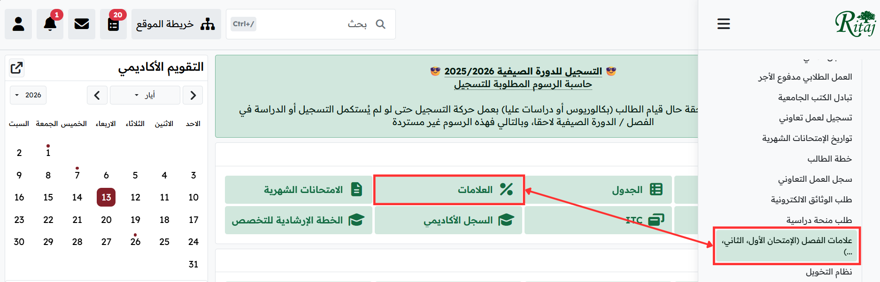
Figure 1. Ritaj dashboard navigation. The grades page can be reached from two different labels: the main dashboard Grades tile and the semester grades item in the sidebar. Supports F1-02 (inconsistent labels).
Figure 2 — Marks Partition page (Flow 1)
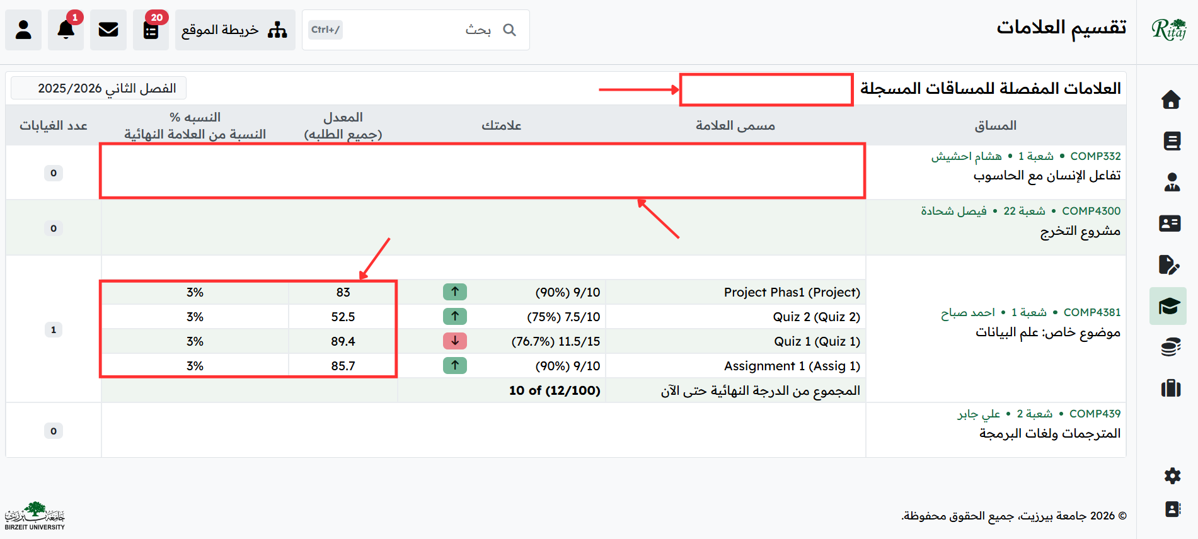
Figure 2. Marks Partition page. Red boxes highlight blank rows for two courses where the system gives no clear grade status. Statistical columns appear beside personal marks. Supports F1-01 (blank cells), F1-03 (statistical clutter), and F1-04 (no GPA summary in the header).
Figure 3 — Academic Record page (Flow 2)
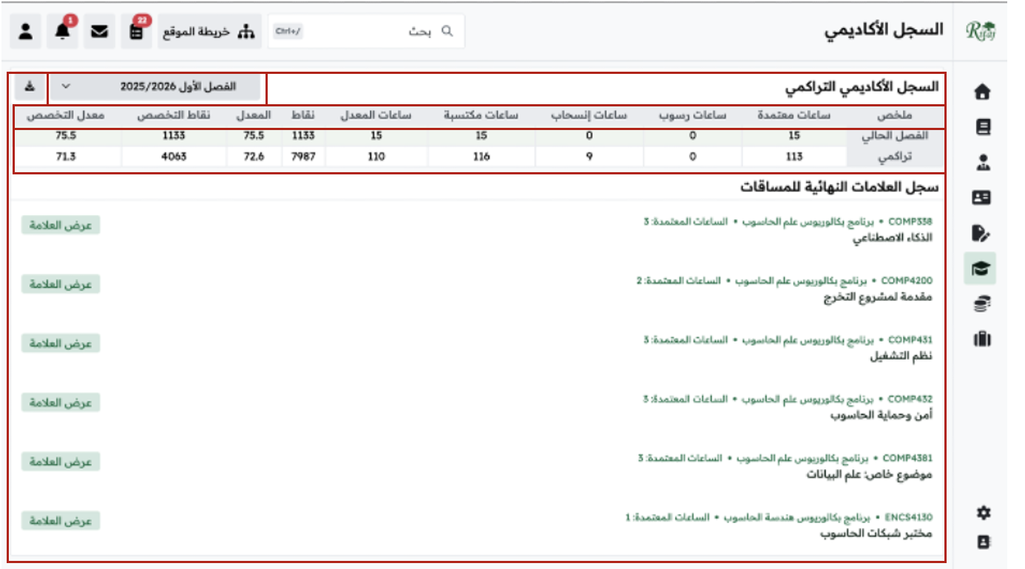
Figure 3. Academic Record page. The summary table shows approved hours, failed hours, withdrawal hours, acquired hours, GPA hours, points, and GPA, but it does not show remaining credit hours. Supports F2-01 (no remaining credit hours), F2-02 (no cross-semester search), F2-03 (unclear academic terms), and F2-04 (cluttered layout on mobile).
Figure 4 — Marks Partition for ENCS336 (Flow 3)
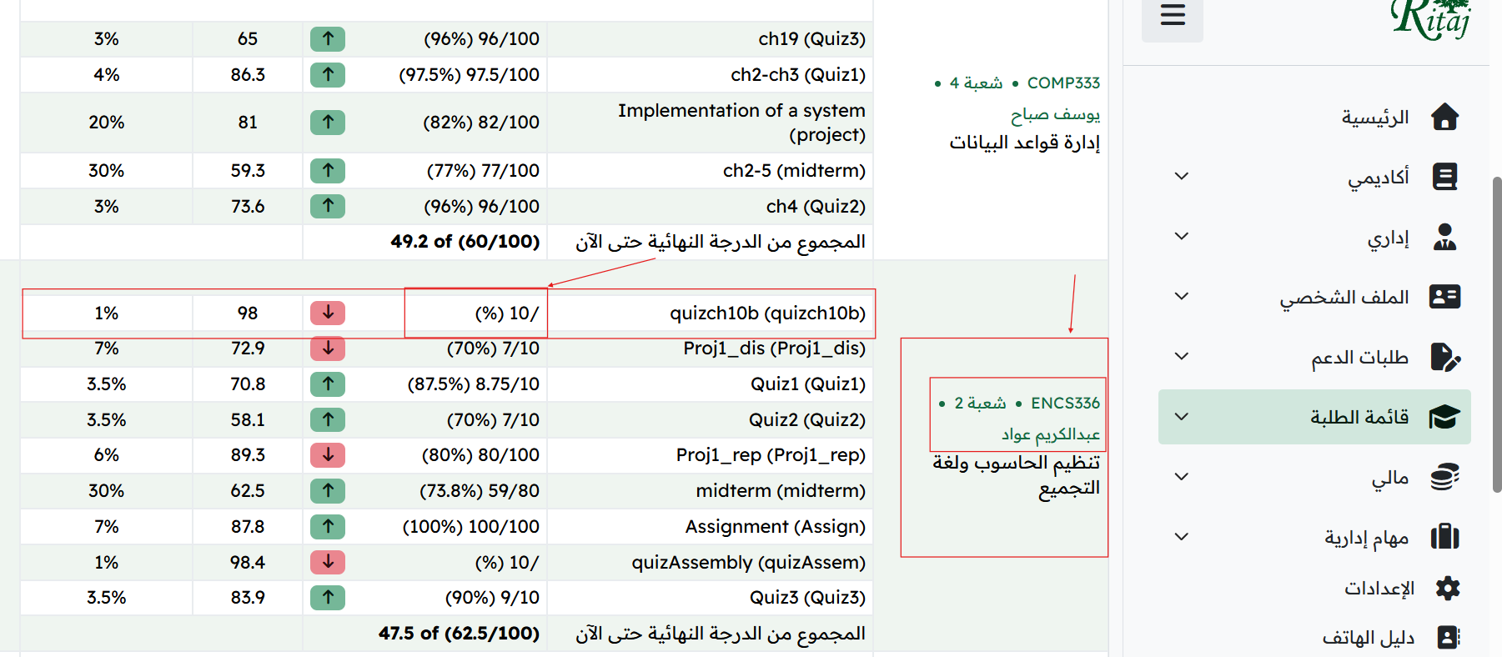
Figure 4. Marks Partition page for ENCS336. Red boxes highlight ambiguous “10/” entries and the static instructor information panel. Supports F3-01 (no in-page error reporting), F3-02 (static instructor name), and F3-03 (ambiguous slash formatting).
Appendix B — Interview Guide
We adapted the interview guide from Appendix B of the COMP322 project specification. The guide was used in Arabic for two interviews (P2, P3) and in both Arabic and English for one interview (P1).
Opening (2–3 minutes)
“Thank you for agreeing to talk with us. We are students in a Human–Computer Interaction course at Birzeit University, and we are studying the Ritaj grades and academic record area. This is not a test of you; we want to learn from your experience. You can skip any question you do not want to answer, and we can stop at any time.”
Warm-up
- Could you tell us a little about yourself? Year, major, typical week.
- How often do you check grades or the academic record on Ritaj in a typical week?
- What device do you usually use for this?
Core questions — current experience
- Can you walk us through the last time you checked your grades on Ritaj? Where were you, what were you trying to do, what device were you using?
- When you went to check, what happened? Was anything confusing?
- Have you ever seen a grade that did not look right? What did you do?
- Have you ever had to find a course from a previous semester? How did that go?
- Is there a moment that made you feel anxious or stuck?
- Is there anything Ritaj does well in this area?
- What do you wish the system did, that it does not do?
Context questions
- Where are you usually when you check grades?
- Do you ever ask another student or family member for help when something is unclear?
Closing
- Is there anything we did not ask about that you think is important?
- Would you be comfortable if we came back for a follow-up usability test in a few weeks?
- Thank you.
Appendix C — Interview Notes
Structured notes for the three exploratory interviews conducted in Phase 1. Participants are anonymized as P1, P2, and P3. Signed consent forms (where obtained) are retained by the team and are not part of this submission.
P1 Interview — Flow 1 (Viewing Current Semester Grades)
Question area | Answer
Year and major | Third-year Cyber Security student.
Device used | Mobile phone.
Last time checked grades | After a recent midterm.
Main task | Checking current-semester grades on Ritaj.
Steps followed | Logged into Ritaj on phone → opened the dashboard → tapped the grades icon → scanned the marks table.
What happened | Some grade cells were blank. P1 did not know if the grade was hidden, missing, pending, or if the system had a problem.
Status of grades clear? | No. Blank cells do not clearly explain the grade status.
Visibility of grade finality | No. P1 could not clearly tell if a grade was final, pending, or not uploaded yet.
Manual work needed | Yes. P1 kept refreshing the page because Ritaj does not send notifications when grades are posted.
Most useful part | P1 cared more about personal marks than class average or statistical columns.
Suggested improvement | Add clear status labels such as “Pending” or “Not uploaded,” and add notifications when grades are posted.
P2 Interview — Flow 2 (Cumulative Academic Record)
Question area | Answer
Year and major | Fourth-year Computer Engineering student.
Device used | Mobile phone.
Last time checked academic record | Last week, while planning next semester.
Main task | Tracking cumulative progress toward graduation: completed credits and remaining hours.
Steps followed | Logged into Ritaj → Academic → Academic Record → reviewed the summary table.
What happened | Found completed credits, GPA, points, GPA-hours, and major GPA — but no remaining hours. Had to subtract by hand against the study plan.
Status of past grades clear? | Yes, past grades are clear.
Visibility of remaining hours | No. Not shown anywhere on the page.
Manual work needed | Yes. Manual subtraction is required every visit.
Most useful part | The cumulative GPA and points display is useful.
Suggested improvement | Add a clear “remaining credit hours” field on the academic record page.
P3 Interview — Flow 3 (Querying a Course Mark Discrepancy)
Question area | Answer
Year and major | Fourth-year Computer Science student.
Device used | Laptop.
Last time checked grades | After a midterm exam grade was announced.
What was looking for | Course mark in the Marks Partition table.
Steps followed | Logged into Ritaj → Academic → Marks Partition → scanned the table.
Understood status of all marks | No. Some rows contained ambiguous formatting such as “10/”, so P3 could not tell if the mark was pending or missing.
Visibility of grade finality | No.
Contacting the instructor | Instructor name was static text. To send an email, had to leave the grades page, navigate to the course page, find the instructor’s name, and write the email separately.
Manual calculation needed | No.
Display of courses by semester / year | Acceptable.
Asked someone for help | Yes — went to the instructor’s office to resolve the issue.
Most useful part | The breakdown of percentages for each assessment item when the row is fully filled.
Suggested improvement | Make the instructor’s name a clickable hyperlink that opens an email or a contact card.
Consent for P3: P3 agreed verbally before the interview started. The signed consent form is not included in this file, so the team should get it before final submission.
Appendix D — Direct Quotes
Anonymized direct quotes from the three participants. Where the original was in Arabic, an English translation is given.
P1 — Third-year Cyber Security, mobile
“The blank spaces make me feel anxious; I do not know if I missed something or if the site crashed.” — P1
“I keep refreshing the page because I am not sure if the grade is hidden or just not posted yet.” — P1
P2 — Fourth-year Computer Engineering, mobile
“Remaining hours need to be worked out by hand.” — P2
“Add a remaining credit hours field.” — P2
P3 — Fourth-year Computer Science, laptop
“I do not know if the grade is ready like this, or if the instructor forgot to upload it.” — P3

