OpenspliceDDS Architecture white paper

Version 1.0 - August 31th, 2026



Innovation shapes the vision.
Hard work brings it to life.
Determination turns it into success."
— ZettaScale Technology

About ZettaScale

ZettaScale’s mission is to bring to every connected human and machine the unconstrained freedom to communicate, compute and store — anywhere, at any scale, efficiently and securely. We strive for excellence as engineers and humans -- we firmly believe that we can’t separate “the engineer” from “the human”. As such we embrace and promote the Seven Knightly Virtues of Courage, Justice, Mercy, Generosity, Faith, Nobility and Hope.

Contents
1. Context 1
Table of Contents 2
Overview 3
The High-level Architecture 4
Federated Architecture with Shared Memory and Network Scheduling 4
Simple Standalone/Single Process Architecture 7
Configuration Deployments 7
DDS Persistent Profile and Durability Service 9
Support/Maintenance 9
References and For More Information 9

The raise of the “Internet of Medical things” (IoMT) is driven by the need to provide greater access to healthcare services, offer greater convenience to both patients and clinicians, and most importantly, to improve innovation and reduce costs.
The use of inter-connected medical devices interacting with other IT infrastructures at hospitals requires fewer medical staff and doctors who can serve more patients with greater efficiency. The proliferation of smart connected medical devices is creating a new set of challenges with respect to how networks of devices are integrated together and how they can support the goal of interoperable real-time data sharing.
This document discusses how the OMG (Object Management Group’s) Data Distribution Service (DDS™) for RealTime Systems standard is being used to support the real-time data sharing and the medical device interoperability requirements of modern healthcare systems.

Challenges in Healthcare Informatics
The secure transfer of real-time data between medical devices, such as a patient monitor and other information systems, is critical in a clinical environment. Connecting medical devices over a computer network (which can be wired, wireless or mobile) can eliminate the need for manual data entry and enables faster and more frequent updates in order to, diminish human error and improve workflow. Healthcare systems will typically use heterogeneous medical devices supplied by a variety of vendors.
Interoperability between various medical equipment is a major challenge as different devices may use different communication protocols and proprietary data formats. We are still some way off an interoperable and Plug-andPlay architecture. Nowadays, custom engineering solutions are still required to enable information flows collection across multi-vendor network and devices. Typically, when new devices are subsequently introduced into the existing system additional bespoke interfaces are often required.
Being able to exchange data from medical devices such as a patient’s vital signs, device settings, x-ray images, infusion rates, alarm events and other to and from a medical device or healthcare information systems plays a critical role in efficiently tracking the state of a patient which in turn can be used to evaluate and plan the most appropriate treatment ensures the best clinical outcome. This also involves evaluating treatment in different clinical environments from the hospital to the home or other care centres.
In summary, the lack of real-time access or even no access to observational data by clinicians may prevent them from providing their patients with the most effective care.
The key challenges facing the Healthcare Informatics community include:
Interoperability
• Between multiple medical devices and information systems, over different network configurations (e.g. LAN or WAN (Internet/Cloud), wired, wireless or mobile)
• Among multiple healthcare interoperability standards or multiple implementations of the same standard
Performance
- Maintaining performance as number of connected devices and information systems increases
- Low latency data requirements
- Real-time data sharing and distribution
Security
- Confidentiality of patient data
- Integrity of data exchanged between devices and other systems
• Authenticity of systems and users accessing medical data
System evolution
• Plug-and-play capabilities to allow systems to evolve more easily by adding new devices into the clinical
environment
• Support for fast dynamic discovery of newly connected devices over a network
Reliability
- Avoiding single points of failure that can disrupt or compromise data connectivity and patient care

Standards and Current Practice
Regulatory organizations and industry initiatives such as Continua Health Alliance (Continua) and Integrating the Healthcare Enterprise (IHE) are working towards standardized vendor- neutral device interoperability. Acting as a unifying reference point, the IHE which is an international collaboration of vendors, healthcare providers, regulatory agencies and industry experts is working towards a set of internationally recognized
device interoperability standards. The IHE does not develop standards as such but rather develops guidelines or “integration profiles” on how to apply existing standards. The key standards relating to device connectivity and interoperability include, Health Level 7 (HL7), Digital Imaging and Communications in Medicine (DICOM), ISO/IEEE 11073 (Health Informatics, Point-of-care Medical Device Communication) and CEN/TC 251 and ISO/TC 215 (Health Informatics).
Implementers of these standards are free to use a range of different application transport protocols to support device data- sharing and message exchanges in a distributed environment. Examples include, Lower Layer Protocol (LLP), Java Message Service (JMS), Java Remote Method Invocation (RMI), Common Object Request Broker Architecture (CORBA), SOAP Simple Object Access Protocol (SOAP), Representational State Transfer (REST) and the Data Distribution Service (DDS). Figure 1 illustrates the communication architecture of a system complying with the HL7 standard using DDS. These protocols are referred to as middleware and can be used to exchange messages/data between devices in a network.
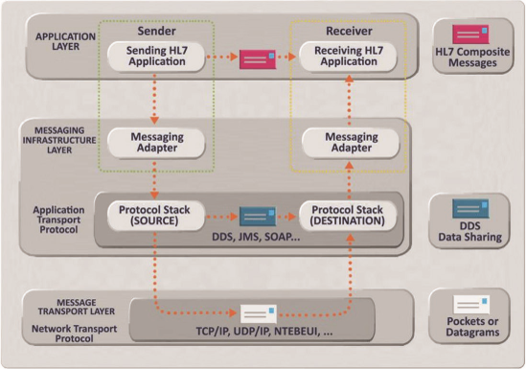
Figure 1: HL7 Using DDS
The choice of middleware is critical to meeting the requirements of next generation healthcare systems, as not all of these technologies are equal and it is important to consider the capabilities and characteristics of each before basing an implementation on one of them.

Medical Device Connectivity Uses Cases
With the rapid increase in the variety of devices from different vendors that are being deployed in clinical environments, ubiquitous connectivity and interoperable data sharing are major goals. Developing solutions that can support the following use cases ( c.f Figure 2) is critical in order to meet the growing challenges faced by the healthcare community:
• Device connectivity and data-sharing between medical devices and information systems over a Local Area Network (LAN) e.g. within a hospital or care centre. This can be over a wired or wireless LAN.
• Device connectivity and data-sharing between medical devices and Cloud-based information systems over a Wide Area Network (WAN). For example, a Central Information System hosted on a private Cloud within a hospital receiving device data from a monitor in a patients’ home over the Internet using a wired connection, or a general medical practice accessing a patient’s Electronic Medical Record (EMR) held at the local hospital via an internet connection.
• Mobile device connectivity. For example, a hospital information system receiving data from a patient monitor in an ambulance over a mobile wireless 3G, 4G or 5G internet connection.
• Medical device management, which means being able to remotely connect to a medical device usually by an institution’s clinical engineering or IT departments and accessing technical data from the device in order to locate, troubleshoot or maintain a Patient Care Device.
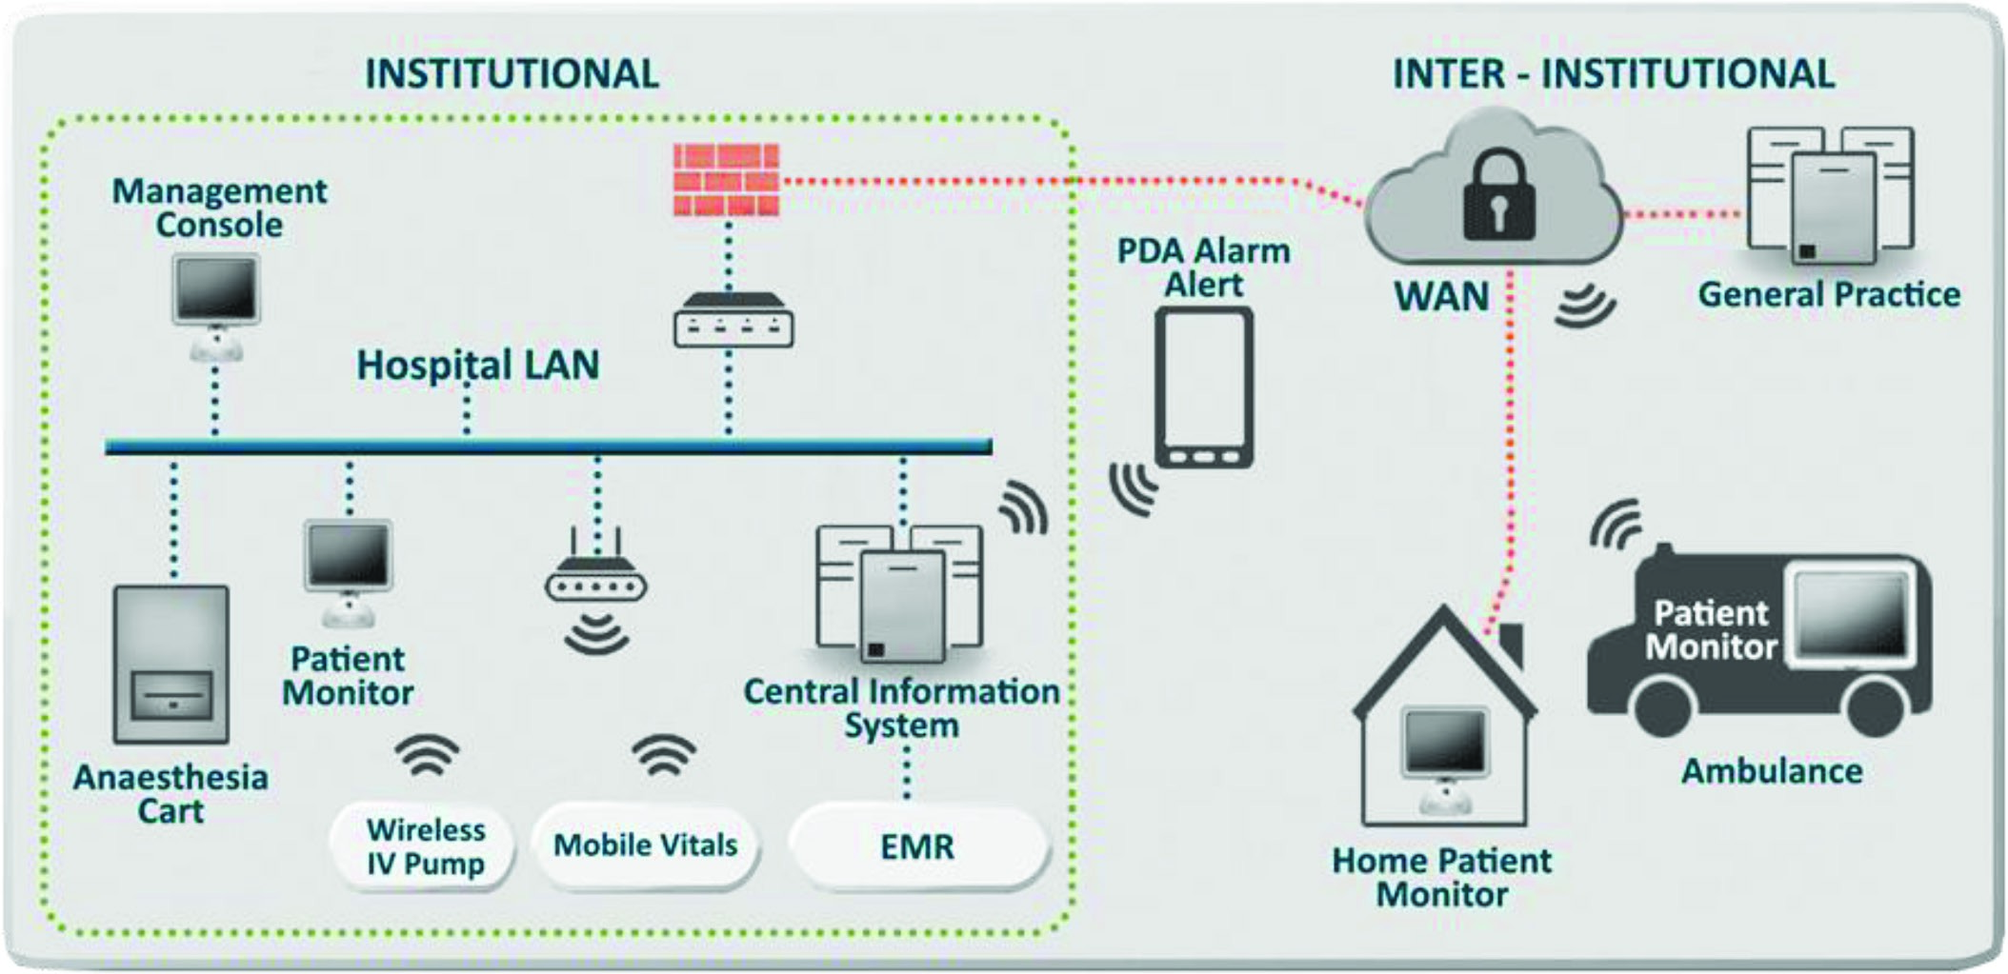
Figure 2: Ubiquitous Medical Device Connectivity

Data Distribution Service for Medical Device Connectivity
The OMG’s Data Distribution Service standard specifies a data-centric publish and subscribe model and can enable large numbers of distributed medical devices and other healthcare information systems to communicate with each other asynchronously and in real-time. It also specifies a wire protocol ensuring interoperability amongst DDS implementations from different vendors. Figure 2 illustrates the architecture of DDS.
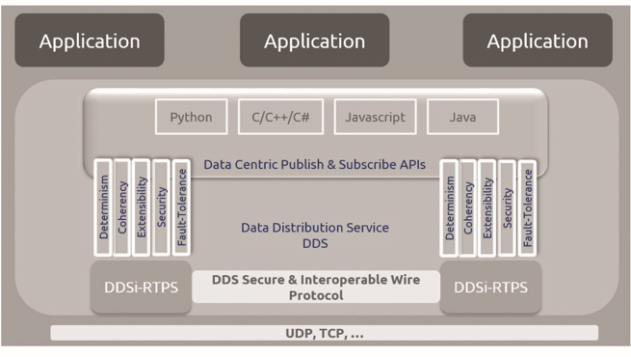
Figure 2: OMG DDS Architecture
DDS supports data-centric systems where the focus is on the timely availability of real-time information in a distributed environment. DDS implements a ‘Global-Data Space’ (GDS) as shown in Figure 4 where the unit of information is a sample of a ‘topic’, a typed data structure accompanied by a set of Quality-of-Service (QoS) profiles specifying the non-functional characteristics of the data. DDS is unique in its coverage of the non-functional aspects of the data that it can control, such as reliability, urgency, importance and persistency. DDS can therefore assure that machines in a dynamic and distributed environment get a consistent view on the shared data. DDS specifies communication interactions between publishers and subscribers that are:
• Decoupled in space (machines can be anywhere)
• Decoupled in time (delivery of data may be immediately after publication or later)
• Decoupled in flow (delivery may be reliable or best effort and with control over available network bandwidth)
These fundamental tenets of the architecture help enable complex medical systems that can scale reliably. Scalability is increased due to the multiple independent data channels identified by “keys”. This allows nodes to subscribe to many (maybe thousands) similar data streams with a single subscription. When the data arrives, the middleware can sort it by the key and deliver it efficiently. DDS has an in-built state-propagation model, so when treating data structures with values which only change occasionally, they will be transmitted only once for every update, helping to reduce network load.
The Object Management Group®’s Data Distribution Service (DDS™) standard defines:
• A Data Centric Publish Subscribe (DCPS) layer providing a set of APIs that present a coherent set of standardized “profiles” targeting real-time information-availability for domains ranging from small-scale embedded control systems right up to large-scale enterprise information management systems
- A Real-time Publish Subscribe (RTPS) wire protocol, known as DDSI-RTPS.
DDS™ is both language and OS independent. The DCPS APIs have been implemented in a range of different
programming languages including C, C++, C#, Java, Scala, Javascript and Python. Using standardized APIs helps ensure that DDS applications can be easily ported between different vendor’s implementations. DDS can be deployed on a broad range of Embedded, Mobile, and Enterprise platforms.
DDS™ also supports “Automatic Discovery” that allows DDS participants (e.g. a medical device) to declare the
information that they can provide or what data they would like to receive, in terms of topic, type and QoS. The protocol will automatically connect appropriate publishers to subscribers. This significantly simplifies the process of configuring systems with many nodes and many devices exchanging data. It also enables systems to evolve more easily by providing plug-and-play support for devices joining the network at a point in the future.
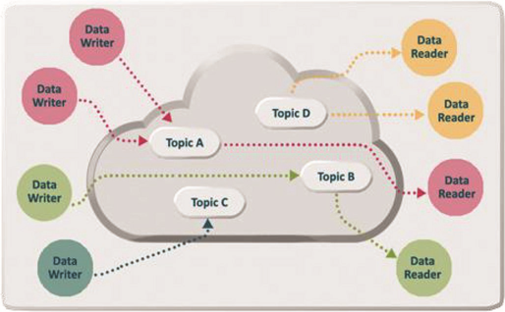
Figure 3: DDS Global Data Space
DDS™ supports both unicast and multicasting IP networks to minimize data latency between machines. It does not require a central server to broker data flows or any other special machines. In a DDS-based system data communication occurs directly between peers (Peer-to-Peer (P2P)).
DDS™ also provides WAN connectivity over the Internet. By default, DDS compliant implementations must support UDP as the underlying transport used by the DDSI wire protocol. However, a number of vendors also support DDSI implementations that can also use TCP/IP (e.g. ZETTASCALE’s DDS). DDS has the advantage that it can support low latency data sharing regardless of location. This includes device-to-device data exchanges over the Internet and large fan-outs where one medical device publishes data that is consumed by many subscriber devices or Cloud-based healthcare information systems.
Since its introduction, DDS has enjoyed rapid adoption as a standard for developing and integrating highperformance interoperable Realtime systems.
Opensplice DDS is the most advanced, complete, and widely used and Commercially supported DDS implementation. Opensplice DDS has been designed to optimally address the Realtime information distribution and management challenges posed by traditional high-performance real-time data-processing systems as well as next generation IoT, Robotics and big-data systems. The Opensplice DDS operates, both in a standalone mode and in the federated mode. In the federated mode, the DDS infrastructure lifecycle is decoupled from the applications lifecycles. In this mode, the DDS infrastructure is shared among all the applications running on the same machine. This mode allows the DDS infrastructure to achieve tremendous gain in term of resource usage, scalability and provides better determinism as the DDS infrastructure can save significant processing in term of discovery and local administration. It can also schedule the DDS data streams at the range of the entire machine, rather than letting each application accessing the network concurrently with all the other without taking into account the importance and the urgency of the data that needs to be exchanged.
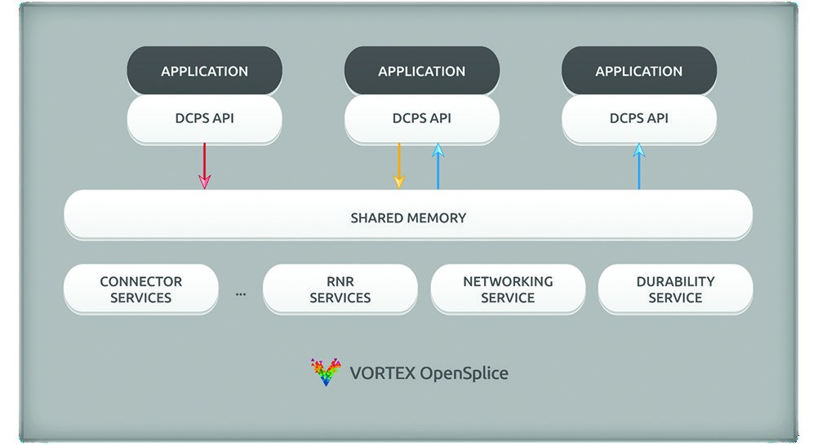
Figure 6: Opensplice DDS Shared Memory and Real-time Network Scheduler
The Federated mode with Opensplice DDS uses for instance a common shared memory segment for all the applications running on the same machine. A Network Scheduler will also orchestrate the traffic on behalf of all the DDS-aware-applications running on the same machine based upon urgency and importance of each exchanged piece of information.

OPENSPLICE DDS Benefits for Medical Device Connectivity
OPENSPLICE DDS has a number of unique features that make it ideally suited for use in Healthcare Informatics and specifically to support interoperable medical device connectivity. In particular, Opensplice DDS DDS has been designed to offer exceptional scalability and real-time network performance thanks to its unique Federated architecture, combined with ubiquitous interoperable device data sharing in heterogeneous networked environments. This includes providing support for wired and wireless LAN and WAN scale networks, including over low bandwidth networks but can take full advantage the 3G-4G and 5G bandwidth capacities.
Opensplice DDS is the only DDS implementation that gives users the choice of selecting the deployment architecture that best suits them by simply configuring the software at runtime. This allows users to change from a standalone ‘single-process’ deployment to a ‘federated’ deployment.
The federated mode-based deployment option shown in Figure 6 features ultra-low latency inter-core communication along with extreme nodal scalability. This architecture results in better scalability, more efficient data-sharing and better peer-to-peer determinism. This is particularly useful to support high performance realtime data sharing between components within a medical device (Intra-device). This differs from other DDS implementations, where library-based deployment prevents arbitration of data-flows issued by several co-located applications and related usage of machine’s communication resources.
Opensplice DDS’s real time networking scheduler allows users to fine-tune, prioritize, and bundle data across different data topics written by different applications to ensure optimal throughput, ultra-low latency while reducing CPU utilization and maximize the use of network bandwidth. The network service provides unique Real Time network scheduling capabilities to spread data in a wide large scale and secure systems using the standard DDSI-RTPS protocol. The network service supports also, Application Authentication, Access control and Authorisation and data Encryption to secure the data exchange of sensitive data in a fully interoperable way.
Opensplice DDS offers also Web connectivity through the Noje.js technology to extend the real-time DDS data space to web oriented technologies providing the medical staff with universal connectivity to their system while preserving security and integrity of the data.
Opensplice DDS can be deployed either on the scale of an Edge-based Local Area network or on the scale of the internet with connectivity to Cloud-based-systems.
The OpenSplice Tools improve the productivity of your development teams by simplifying the application modelling, testing, tuning and Monitoring of the DDS-based medical device networks and potentially the entire healthcare system. These tools enable total control over an OpenSplice based distributed environment with support for automated system testing and debugging.

Business Benefits and ROI
In today’s non-DDS-based medical devices, developers often have to create proprietary protocols to support device connectivity and data distribution with adequate scalability and real time network performance. These protocols are costly to develop and costly to maintain. OPENSPLICE DDS features such as temporal QoS, data prioritization, and support for unreliable networks have been proven to provide significant scalability and performance benefits for next generation distributed systems.
OPENSPLICE DDS can provide a powerful, high performance infrastructure for interoperable Realtime data sharing in healthcare systems composed of both networked medical devices and information systems. In addition to the technical benefits of using Opensplice DDS and Cyclone DDS, a number of commercial benefits can also be realized.
The costs to build, maintain, and update a healthcare system that uses Opensplice DDS can be reduced by enabling the system to evolve more easily and more dynamically.
A single interoperable communication architecture based on OPENSPLICE DDS can be built to support an entire suite of medical devices that share large volumes of critical data and are potentially interconnected with Edge or Cloud based infrastructures.
OPENSPLICE DDS Tools Set for monitoring a DDS-based environment makes it much easier to develop, debug, support and maintain a healthcare system using DDS. For new systems this means fast product delivery.
The OPENSPLICE DDS licensing model is designed to provide a very sensible reduction of the Total Cost of Ownership (TCO) for customer’s middleware infrastructure. This is particularly important in today’s market due to the renewed attention to technology expenditure raised by the recent pandemic crisis and the growing focus on driving carefully healthcare costs. Traditional software licenses have a very cash-flow unfriendly nature, as they demand the significant investment at the beginning of a project life-cycle. OPENSPLICE DDS subscriptions are cash-flow friendly and ensure customers to exploit the full power of the technology from day one.
ZETTASCALE also provides consultancy and a wide range of training courses ranging from beginner level up to advanced users. Our trainers and consultants are world-class domain experts and deliver great ROI by ensuring that attendees get an understanding of the technology and how to fully exploit its capabilities.

Summary
The need to boost innovation, to create more efficient healthcare services and reduce costs is driving the proliferation of smart connected medical devices. This growth is creating a new set of challenges, including how networks of devices are connected together and how they can support the goal of interoperable real-time data sharing over geographically dispersed heterogeneous networks (e.g. LAN and WAN).
Regulatory organizations and industry initiatives such as the Continua and IHE are working towards standardized vendor-neutral device interoperability. Open architecture Standards such as HL7 and ISO/IEEE 11073 have emerged to support the need for interoperable connectivity solutions in device rich clinical environments.
DDS™ is a significant technology that can be used to address many of the challenges faced by the healthcare community. DDS™ supports a publish-and-subscribe communication model and importantly was designed to support large scale Realtime data sharing. It is already used in many demanding types of mission-critical systems DDS™ also defines a secure wire-protocol so that interoperability between data producers and consumers is guaranteed even if they are based on different vendor implementations.
There is increasing use of DDS™ in next generation clinical systems to provide interoperability between network enabled smart medical devices and other information systems. With inherent support for plug-and-play, a DDSbased healthcare system can evolve much more easily and at lower cost.
OPENSPLICE DDS offering is the leading commercially supported Open-Source DDS implementation with many usecases in healthcare. It provides a fully interoperable solution that has been designed to offer exceptional scalability and real-time network performance. These are all key challenges for next generation healthcare systems. It is field proven and widely deployed in many mission-critical systems. It has a success record of being used in systems ranging from multi-processor single-board computers and extreme resource constrained devices, to large scale system of systems.
For More Information
For further information regarding Opensplice DDS Persistence Profile, please e-mail: contact@ZETTASCALEtech.com


OpenSpliceDDS
DATA-CENTRIC MIDDLEWARE FOR MISSION-CRITICAL SYSTEMS

contact@zettascale.tech | www.zettascale.tech
Copyright © 2026 ZettaScale Technology. All Rights Reserved.

